Supplementary Information
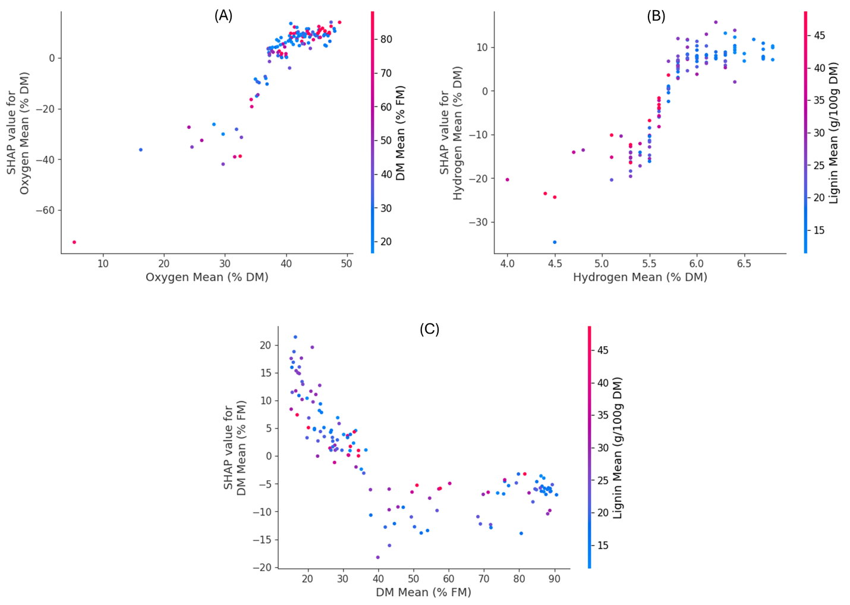
Figure S1: SHAP dependence plots for other top features. (A) Oxygen, colored by DM. (B) Hydrogen, colored by Lignin. (C) DM, colored by Lignin.

