Supporting Information
7-O-(o-CF₃-benzyl)-fangchinoline-loaded solid lipid nanoparticles with improved anti-lung cancer activity in vivo and in vitro

Xu-tao Lv^{1,2}, Yu-kai Zhang¹, Mu-xuan Wang², Jia-shu Chen¹, Xu Guo², Qing Wang², Ying-ying Chen², Jin-yue Sun^{2*}, Ning-yang Li^{3*}, Yu-fa Liu^{1*}and Chao Liu^{2*}
¹College of Chemistry, Chemical Engineering and Materials Science, Collaborative Innovation Center of Functionalized Probes for Chemical Imaging in Universities of Shandong, Key Laboratory of Molecular and Nano Probes, Ministry of Education, Shandong Provincial Key Laboratory of Clean Production of Fine Chemicals, Shandong Normal University, 88 East Wenhua Road, Jinan 250014, PR China;
²Key Laboratory of Novel Food Resources Processing, Ministry of Agriculture and Rural Affairs/Key Laboratory of Agro-Products Processing Technology of Shandong Province/Institute of Agro-Food Science and Technology, Shandong Academy of Agricultural Sciences, 202 Gongye North Road, Jinan 250100, PR China;
³College of Food Science and Engineering, Shandong Agricultural University, Tai'an, 271018, PR China
*Co-authors E-mail: liuchao555@126.com (Chao Liu), moon_s731@hotmail.com (Jin-yue Sun), liuyufa@sdnu.edu.cn (Yu-fa Liu), liny@sdau.edu.cn (Ning-yang Li)

Supporting document 1
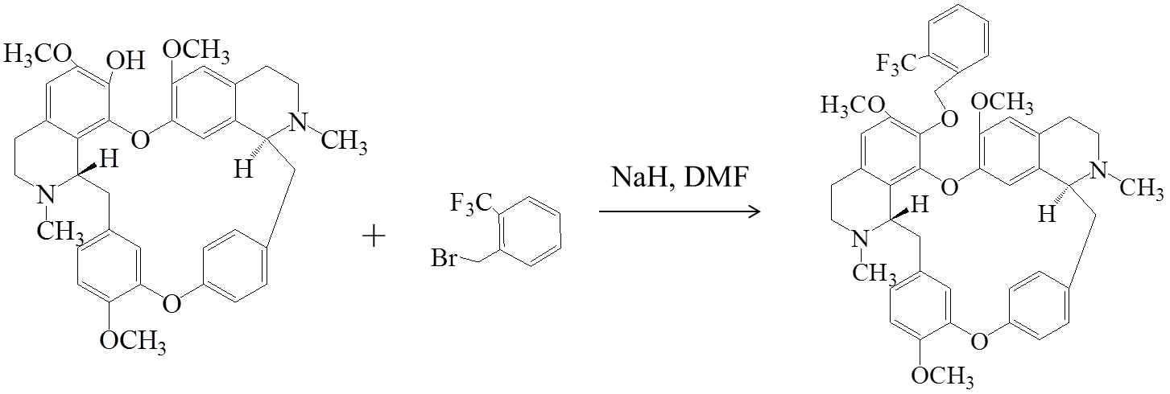

Fig. S1 (a) Synthesis of 7-O-(o-CF₃-benzyl)-Fan, reagent condition a: 2-CF₃-benzyl bromide, NaH, DMF, low temperature magnetic stirring.

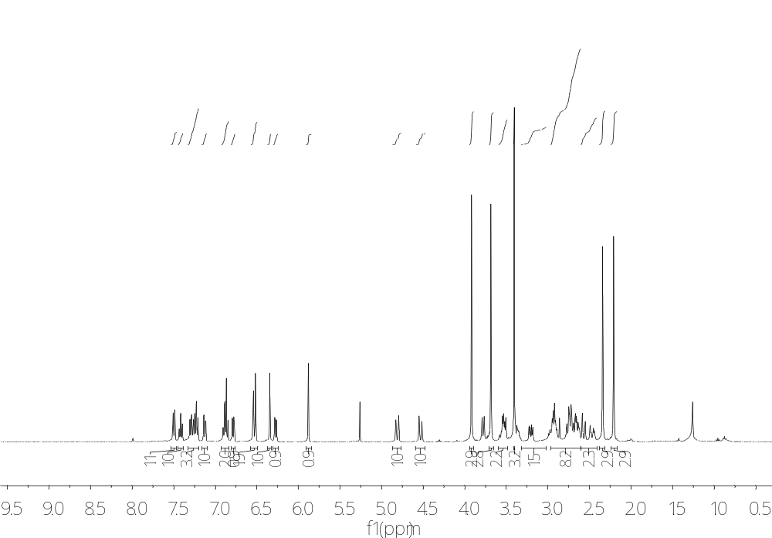
(b) ¹H-NMR of 7-O-(o-CF3-benzyl)-Fan

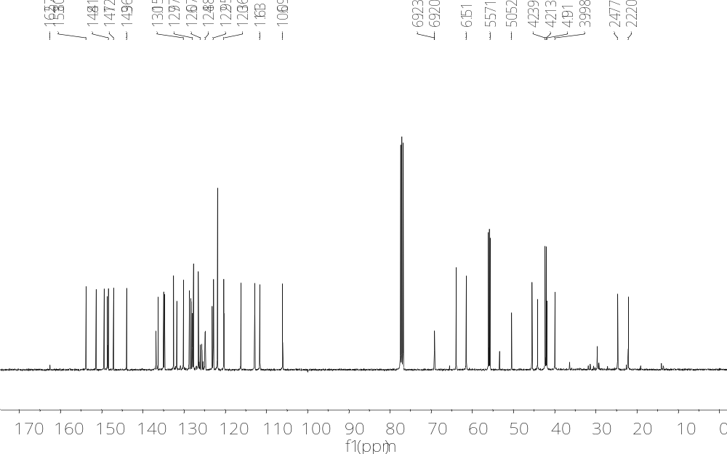
(c) ¹³C-NMR of 7-O-(o-CF₃-benzyl)-Fan

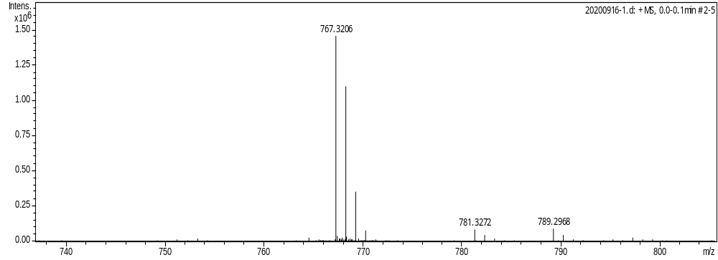(d) HR-MS of 7-O-(o-CF₃-benzyl)-Fan

Supporting document 2
Table S1. Single factor optimization process
Solution type | stearic acid (mg) | soyabean lecithin  (mg) | Drug  (mg) | tween-80  (mL) | particle size  (nm) | Zeta  (-mV)
1 | 80 | 10 | 10 | 0.16 | 156.1 | 8.19
2 | 80 | 10 | 15 | 0.16 | 151.4 | 8.61
3 | 80 | 10 | 50 | 0.16 | 736.8 | 6.90
4 | 80 | 10 | 10 | 0.08 | 142.2 | 6.39
5 | 80 | 10 | 15 | 0.08 | 207.2 | 8.74
6 | 100 | 10 | 10 | 0.08 | 132.6 | 6.45
7 | 100 | 10 | 15 | 0.08 | 238.3 | 0.39
8 | 150 | 10 | 10 | 0.16 | 37.7 | 16.8
9ª | 150 | 10 | 10 | 0.08 | 45.3 ± 4.8 | 21.6 ± 2.4
ª Under this condition, the experiment was repeated three times independently, and the results showed that the particle size of 7-O-(o-CF₃-benzyl)-Fan-SLN was stable at 45.3 nm and the Zeta potential was stable at -21.6 mV.

Supporting document 3
Table S2-1. Standard curve of 7-O-(o-CF₃-Benzyl)-Fan
concentration（µg/mL） | 10 | 20 | 50 | 80 | 100
peak area | 686.9 | 1628.3 | 4894.2 | 7826.8 | 9666.4

Standard curve of 7-O-(o-CF₃-Benzyl)-Fan

Table S2-2. Standard curve precision test result
Number of parallel | Peak area | RSD（%）
1 | 668.3 | 1.7 ª
2 | 676.5 | 1.7 ª
3 | 695.7 | 1.7 ª
4 | 688.4 | 1.7 ª
5 | 696.1 | 1.7 ª
6 | 676.3 | 1.7 ª
ª The relative standard deviation (RSD) of precision is less than 2%, indicating that the precision of the experiment meets the requirements.

