Supplement data
Metabolomics based mechanism exploration of Pulmonary Arterial Hypertension pathogenesis: novel lessons from explanted lungs

Jingjing Ding^{1#}, Chunyan Chu^{1#}, Zhengsheng Mao^{1#}, Jiawen Yang¹, Jie Wang¹, Li Hu¹, Peng Chen¹, Yue Cao¹, Yan Li¹, Hua Wan¹, Dong Wei², Jingyu Chen²*, Feng Chen^{1,3,4}*, Youjia Yu¹*

Table S1. KEGG Enrich pathway between patients and the control
X.Pathway | P value | Pathway.ID | KEGG.Names | Iron  model
Metabolic pathways | 1.50E-05 | map01100 | Spermidine; Spermine; D-ornithine;(2e)-2,5-dichloro-4-oxo-2-hexenedioic acid;Thymine;D-mannose 6-phosphate;4-pyridoxate;4-(2-aminophenyl)-2,4-dioxobutanoic acid;Caffeine;Dihydrouracil;24-hydroxycalcitriol;Gamma-linolenic acid;Calcitriol | positive
beta-Alanine metabolism | 3.52E-05 | map00410 | Spermidine;Spermine;Dihydrouracil | positive
Bile secretion | 4.12E-05 | map04976 | Spermidine;Spermine;Acetylcholine;Cefazolin | positive
Parathyroid hormone synthesis, secretion and action | 0.000174 | map04928 | 24-hydroxycalcitriol; Calcitriol | positive
Taste transduction | 0.001862 | map04742 | Acetylcholine;Aspartame | positive
Glutathione metabolism | 0.002619 | map00480 | Spermidine;Spermine | positive
Steroid biosynthesis | 0.004495 | map00100 | 24-hydroxycalcitriol; Calcitriol | positive
Pyrimidine metabolism | 0.00749 | map00240 | Thymine;Dihydrouracil | positive
Lysosome | 0.007983 | map04142 | D-mannose 6-phosphate | positive
Regulation of actin cytoskeleton | 0.009969 | map04810 | Acetylcholine | positive
Arginine and proline metabolism | 0.010639 | map00330 | Spermidine;Spermine | positive
Nicotine addiction | 0.013929 | map05033 | Acetylcholine | positive
Endocrine and other factor-regulated calcium reabsorption | 0.015903 | map04961 | Calcitriol | positive
Tuberculosis | 0.017874 | map05152 | Calcitriol | positive
D-Arginine and D-ornithine metabolism | 0.019841 | map00472 | D-ornithine | positive
Vitamin B6 metabolism | 0.021005 | map00750 | D-erythrose 4-phosphate | negative
Alanine, aspartate and glutamate metabolism | 0.021005 | map00250 | N-acetyl-l-aspartic acid | negative
Cholinergic synapse | 0.023763 | map04725 | Acetylcholine | positive
Insulin secretion | 0.023763 | map04911 | Acetylcholine | positive
Synaptic vesicle cycle | 0.023763 | map04721 | Acetylcholine | positive
Sulfur metabolism | 0.024713 | map00920 | Sulfuric acid | negative
Pentose phosphate pathway | 0.026192 | map00030 | D-erythrose 4-phosphate | negative
Phenylalanine, tyrosine and tryptophan biosynthesis | 0.026192 | map00400 | D-erythrose 4-phosphate | negative
Gastric acid secretion | 0.027669 | map04971 | Acetylcholine | positive
Pancreatic secretion | 0.029617 | map04972 | Acetylcholine | positive
Salivary secretion | 0.033501 | map04970 | Acetylcholine | positive
Folate biosynthesis | 0.042328 | map00790 | Neopterin | negative
Caffeine metabolism | 0.043144 | map00232 | Caffeine | positive
Cysteine and methionine metabolism | 0.045235 | map00270 | Sulfuric acid | negative
cAMP signaling pathway | 0.048885 | map04024 | Acetylcholine | positive

Table S2. Clinical information of the patients with iPAH or CHD-PAH.

 | iPAH(n=13) | CHD-PAH(n=5) | t | P
Gender (M/F) | 5/8 | 0/5 | - | 0.25*
Age | 29.38±2.64 | 33.20±4.78 | 0.70 | 0.51
BMI | 19.97±2.19 | 19.14±1.80 | 0.69 | 0.50
WHO FC  (Ⅰ-Ⅱ/Ⅲ-Ⅳ) | 9/4 | 4/1 | - | 0.99*
PA | 103.23±5.70 | 115.00±7.62 | 1.13 | 0.27
mPAP | 67.58±4.03 | 62.00±9.28 | 0.65 | 0.53
EF | 62.85±1.48 | 64.20±2.18 | 0.49 | 0.63
Drugs (1/>1) | 2/11 | 2/11 | 1.27 | 0.53
*Fisher exact rate

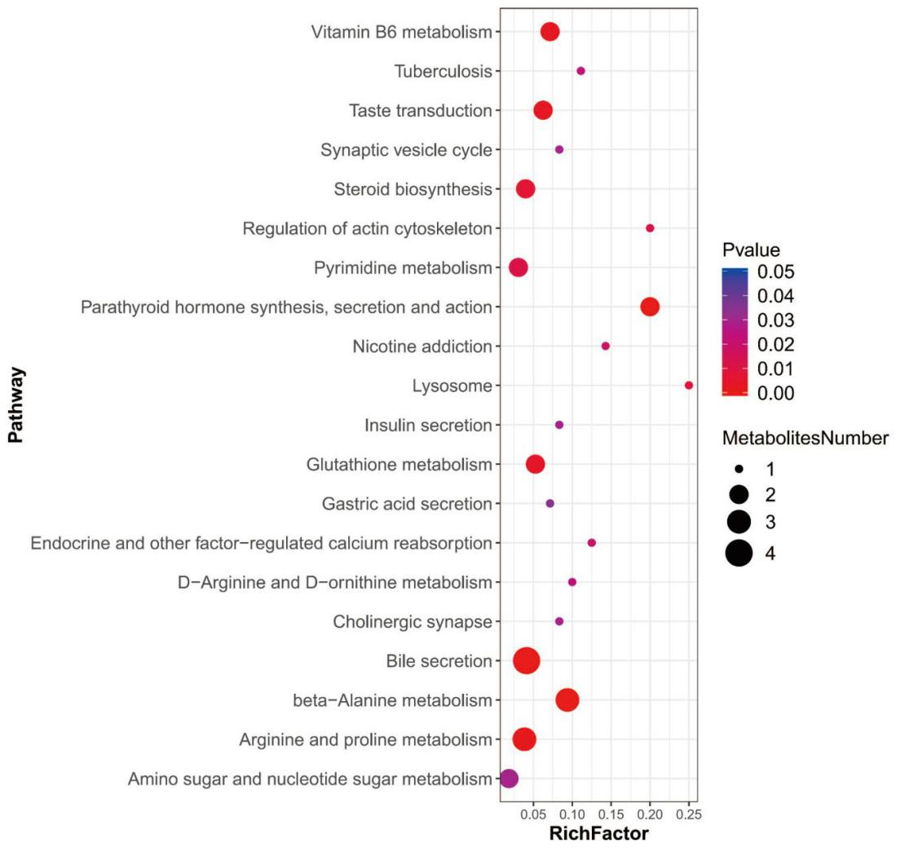
Figure S1. Bubble chart for enrichment analysis of metabolic pathways in the comparison between PAH and control.

