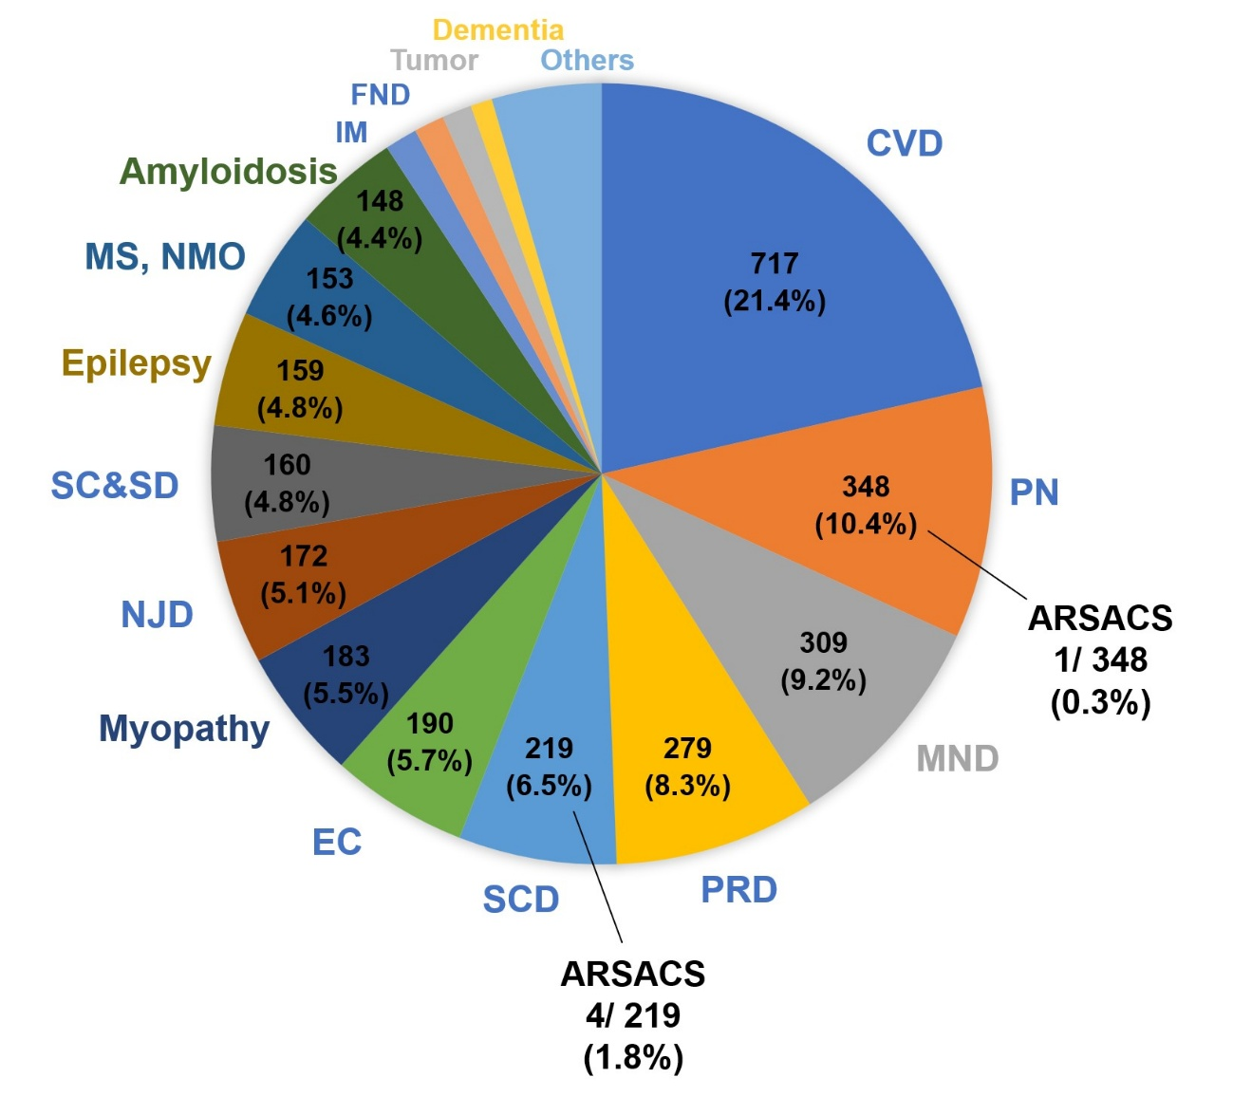
Figure S1. Distribution of ARSACS cases among newly hospitalized neurological patients. A total of five patients with ARSACS were identified among the 3,347 newly hospitalized patients, distributed across two diagnostic categories: spinocerebellar degeneration (SCD) and peripheral neuropathy (PN). Among the 219 patients in the SCD group, 4 (1.8%) were diagnosed with ARSACS. Additionally, one patient with ARSACS was identified among the 348 patients (0.3%) in the PN group. The pie chart demonstrates the overall distribution of neurological disorders in our department, with ARSACS cases highlighted within their respective diagnostic categories (SCD and neuropathy).
Abbreviations: ARSACS, autosomal recessive spastic ataxia of Charlevoix–Saguenay; CVD, cerebrovascular disease; PN, peripheral neuropathy; MND, motor neuron disease; PRD, parkinsonism and related disorders; SCD, spinocerebellar degeneration; EC, encephalitis/encephalopathy; NJD, neuromuscular junction disorder; SC&SD, spinal cord and spinal disorders; MS, multiple sclerosis; NMO, neuromyelitis optica; FND, functional neurological symptom disorder.

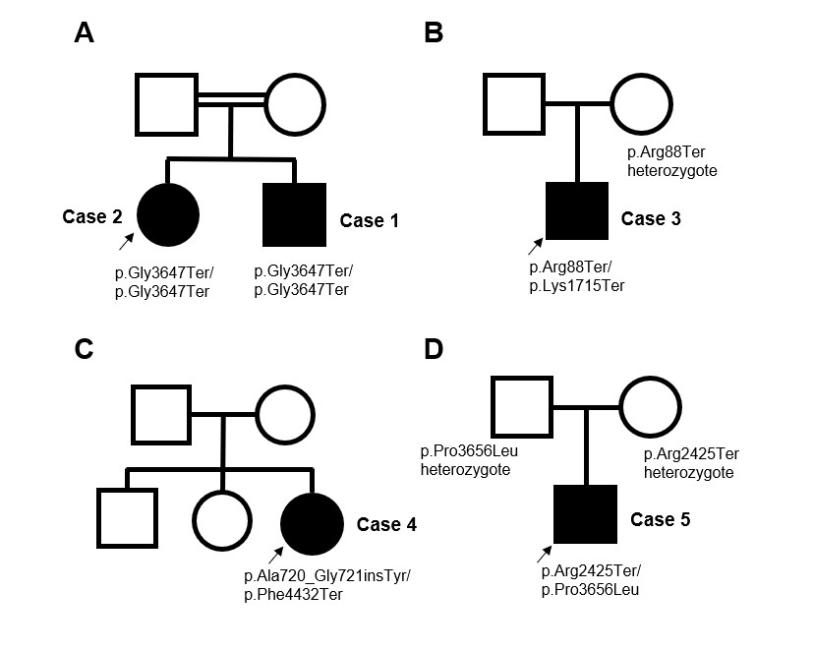

Figure S2. Pedigrees and ARSACS gene mutations in five Japanese cases from four families.
The pedigrees (A–D) shows family relationships and genetic findings in patients with ARSACS. Black symbols indicate individuals affected by ARSACS, and arrows denote probands. Family A included siblings (Cases 1 and 2) harboring homozygous mutations (c.10939 G>T). Family B had a proband (Case 3) with compound heterozygous mutations (c.262 C>T and c.5143 A>T). Family C included Case 4 with compound heterozygous mutations (c.2159_2160 insTTA and c.13294_13295 insAA). Family D included Case 5 with compound heterozygous mutations (c.7273 C>T and c.10967 C>T). Square symbols represent males, circular symbols represent females, and open symbols indicate unaffected individuals.

