Supplementary material
What do people really eat? Consolidating datasets on food consumption as a reference for analyzing dietary recommendations.
Contents
S1. Assessment of status quo intake 2
S2. The status quo intake as the reference for dietary recommendations 3
S2.1 Intake of fruit 3
S2.2 Intake of vegetables 4
S2.3 Intake of legumes 5
S2.4 Intake of nuts 5
S2.5 Intake of cereals 6
S2.6 Intake of wholegrain 7
S2.7 Intake of plant oils 7
S2.8 Intake of spreadable fats 8
S2.9 Intake of milk equivalents 9
S2.10 Intake of potatoes 10
S2.11 Intake of eggs 10
S2.12 Intake of fish 11
S2.13 Intake of poultry 12
S2.14 Intake of red meat 12
S3. Goodness of fit of the consolidation 14
S3.1 Correlation coefficient 14
S3.2 Distribution of adjustments 15
S3.3 Adjustments of market balance quantities 19
S4. References in supplementary information 20

Assessment of status quo intake

 | Grain-based products (+381 kcal) |  |  | Beverages (-12 kcal)
 | Dairy products (+183 kcal) |  |  | Coffee, cocoa, tea (-13 kcal)
 | Alcohol (+73 kcal) |  |  | Fruit and fruit products (-32 kcal)
 | Sugar products (+68 kcal) |  |  | Juices (-66 kcal)
 | Sauces (+50 kcal)
 | Fats and oils (+40 kcal)
 | Fish products (+40 kcal)
 | Meat products (+29 kcal)
 | Egg products (+27 kcal)
 | Vegetable products (+23 kcal)
 | Legumes (+5 kcal)
 | Composite dishes (+3 kcal)

Supplementary Table 1:Adjustments of energy intake per capita per day by the consolidation, per food item category in kilocalories, ordered by size and direction of adjustment. Supplement to Figure 2.

The status quo intake as the reference for dietary recommendations
In the following, we explain the different definitions of status quo intake presented in Figure 3 and discuss them for each RPC separately. The left column, “quantity of food items in closest category (survey)”, depicts the summed-up intake quantities of all food items in the FoodEx2-category that the DGE considers the closest match to the respective RPC, e.g., “egg and egg-products” for the analysis of egg intake. The DGE uses these quantities as the reference when deriving the basis of its recommendations (Schäfer et al., 2024). For some RPC, we apply different calculation methods than Schäfer et al. (2024). We explicitly mention it when this results in intake quantities that substantially differ from the DGE reference. The middle column, “intake incl. ingredients (survey & recipe data)”, depicts the intake of RPC through all food items, e.g., we account for the eggs consumed through cakes and only consider the egg content of the egg products, meaning that we exclude the oils taken in through fried eggs. The first and the second columns refer to the prior intake survey data. The right column, “intake incl. ingredient (consol. data)”, like the middle column, depicts the intake of RPC through all food items but uses the consolidated database instead of the prior intake survey data.
We separately explain the consolidation between market balance and intake quantities for each RPC. We analyze how the changes necessary to meet the optimal intake quantities determined by the DGE in Schäfer et al. (2024) (yellow line, “DGEgoal”) differ when taking food item intake (left column, “quantity of food items in closest category (survey)”) as a reference and when using RPC intake, including intake as ingredients and based on the consolidated database instead (right column, “intake incl. ingredient (consol. data)”).

Intake of fruit
The overarching category of food items that the DGE considers for fruit intake is “fruit products”. Apart from unprocessed food items (e.g., apples), there are also processed food items in this category that do not consist exclusively of fruit (e.g., 100 g of apple compote consist of 96 g of apples and 4 g of sugar). However, the associated difference is negligible. The intake quantities of food items from the category of fruit products (left column) are, therefore, almost equal to the fruit intake through these food items (red, middle column). The fruit intake through other food items (e.g., fruit salad and jam, light gray, middle column) only accounts for a small share of the total fruit intake.
The relevant categories of market balance quantities that need to be matched are apples and other fruit. These quantities are too low to match the fruit intake reported in the survey. The consolidation decreases the intake quantities of fruit through food items in the category of fruit products, suggesting an overreporting for these food items in the intake survey (right column).
Consequently, we assess the status quo intake of fruit (right column) as lower than the food items intake (left column) suggests. To meet the optimal DGE intake quantities (yellow line, “DGE goal”), the intake has to increase more than suggested in Schäfer et al. (2024).

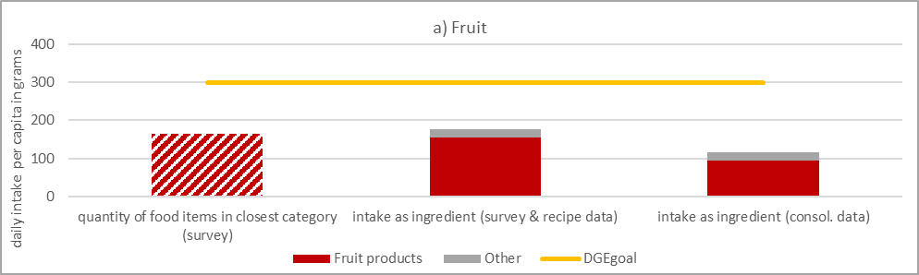
Supplementary Figure 1: Intake of fruit per capita per day in grams. Excerpt of Figure 3.

Intake of vegetables
The overarching category of food items that the DGE considers for the vegetable intake is “vegetable products”. Most food items in this category are unprocessed vegetables (e.g., tomatoes). Some processed food items in this category do not consist exclusively of vegetables (e.g., canned vegetables are also considered to contain beans). However, the associated difference is negligible. The intake quantities of food items from the category vegetable products (left column) are almost equal to the vegetable intake through these food items (green, middle column). The vegetable intake through composite dishes (e.g., mixed boiled vegetables and mixed green salad, dark gray, middle column) accounts for around one-fourth of the total vegetable intake. The intake through other food items is negligible.
The relevant categories of market balance quantities that need to be matched are tomatoes and other vegetables. These quantities are too high to match the intake of vegetables as reported in the survey. The consolidation increases the intake quantities of vegetables through food items in the category vegetable products and composite dishes, suggesting an underreporting for these food items in the intake survey (right column).
Consequently, we assess the status quo intake of vegetables (right column) to be higher than the food items intake (left column) suggests and close to the optimal DGE intake quantities (yellow line, “DGE goal”). Consequently, the intake does not have to increase as suggested in Schäfer et al. (2024) to meet the optimal DGE intake quantities.
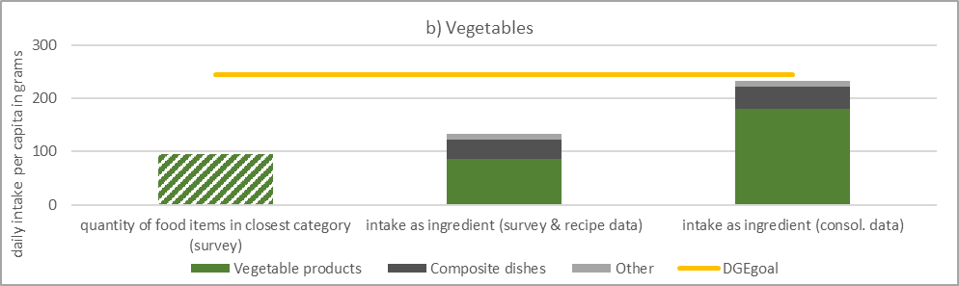
Supplementary Figure 2: Intake of vegetables per capita per day in grams. Excerpt of Figure 3.

Intake of legumes
The overarching category of food items that the DGE considers for the legume intake is “legumes”. The DGE calculates the intake of 5 g per capita per day, Schäfer et al. (2024) whereas we calculate 3.5 g (left column). This difference is explained by the calculation method. Schäfer et al. (2024) convert dried pulses into ready-to-eat quantities with the factor 1.8 (DGE, 2024). Apart from dried pulses, this category includes fresh garden peas. However, we consider fresh garden peas as vegetables, not pulses, leading to a smaller legume intake from this category (orange, middle column). Additional intake of legumes comes from food items in other categories, e.g., canned legumes (olive) and composite dishes like legume soup (light gray).
The relevant categories of market balance quantities that need to be matched are soybeans and pulses. The quantity of pulses available for human consumption on the market is too low to match the intake of pulses reported in the survey. To match the market balance and intake quantities, the intake of food items from the legume category is substantially decreased in the consolidation (orange, right column). Soybeans are not included in the food item category of legumes, but are consumed through soya drink, tofu, and similar products. The market balance quantity of soybeans is too high to match the intake of soy-containing food items. To match the quantities of soybeans available for human consumption on the market to the intake, the consolidation increases the intake of soya drink (1.5 g of soya intake through soya drink corresponds to 32 g of soya drink per capita per day).
When calculating the status quo intake by accounting for intake as ingredients in food items and using the consolidated database (2.5 g per capita per day, right column), we find it to be lower than the DGE reference (5 g). We assess the difference in converting dried pulses into edible equivalents as negligible because of the small share of dried pulses. Consequently, we find that the intake of legumes has to increase more to meet optimal DGE intake quantities (yellow line, “DGE goal”) than suggested in Schäfer et al. (2024).
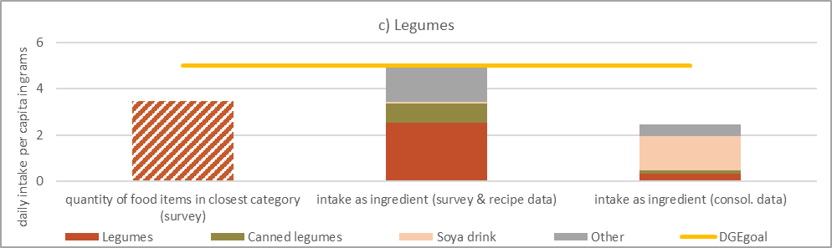
Supplementary Figure 3: Intake of legumes per capita per day in grams. Excerpt of Figure 3.

Intake of nuts
The overarching category of food items that the DGE considers for the nut intake is “nuts and oilseeds”. All food items are unprocessed nuts and oilseeds. Therefore, the intake of food items from this category (left column) and the nut intake through these food items (dark purple, middle column) are equal. Additionally, there is a considerable intake of nuts and oilseeds through nut pastes, e.g., peanut butter (light purple, middle column) and grain-based products, e.g., bread with sunflower seeds (brown, middle column). Intake from these other sources accounts for half of the total intake of nuts and oilseeds.
The relevant categories of market balance quantities that need to be matched are sunflower seeds and other vegetables, which, among others, capture nuts. These quantities are too high to match the intake of nuts reported in the survey (while simultaneously considering the intake of food items containing other vegetables). The consolidation increases the intake of nuts and oilseeds mainly through grain-based products, suggesting an underreporting for bread and rolls containing nuts and seeds in the intake survey (right column).
Consequently, we assess the status quo intake of nuts and oilseeds (right column) to be higher than the food items intake (left column) suggests. The optimal DGE intake quantities (yellow line, “DGE goal”) are already surpassed in the status quo and the intake does not haves to increase as suggested in Schäfer et al. (2024).
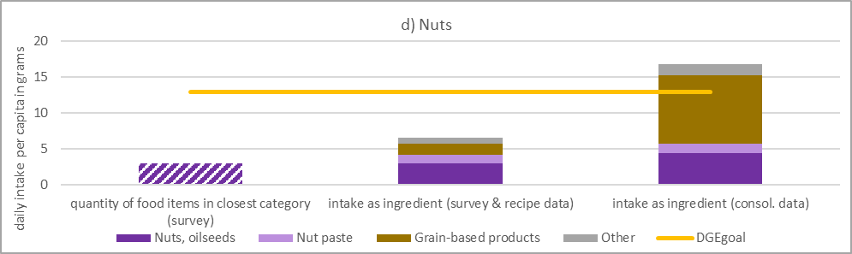
Supplementary Figure 4: Intake of nuts per capita per day in grams. Excerpt of Figure 3.

Intake of cereals
The overarching category of food items that the DGE considers for the cereal intake is “grain-based products”. This heterogeneous category contains bread, breakfast cereals, rice, fine bakery wares, and pasta. Adding up the intake quantities of this category's food items (left column), therefore, also includes other non-cereal ingredients, e.g., eggs in cakes. The DGE calculates 237 g per capita per day of intake, Schäfer et al. (2024) whereas we calculate 213 g. This difference is explained by the calculation method. Schäfer et al. (2024) weigh dry foods (pasta, rice, cereal flakes) and ready-to-eat grain-based products (bread and rolls) at 50:50 proportions (DGE, 2024). We do not include any weighing.
Cereal intake is lower when accounting only for the cereal component in these food items (brown, middle column). We also consider cereal intake through other food items (gray, middle column), but they account for a negligible share of total cereal intake.
The relevant categories of market balance quantities that need to be matched are wheat, rye, barley, oats, maize, and rice. These quantities are too high to match the intake of cereals as reported in the survey. The consolidation increases the intake of cereals through food items in and outside the category of grain-based products, suggesting an underreporting of these food items in the intake survey (right column).
As a net effect, we assess the status quo intake of cereals (right column) to be almost exactly what the food items intake (left column) suggests. Therefore, our calculation method confirms the suggestion in Schäfer et al. (2024), namely that the intake of grain-based products has to increase to meet optimal DGE intake quantities (yellow line, “DGE goal”).

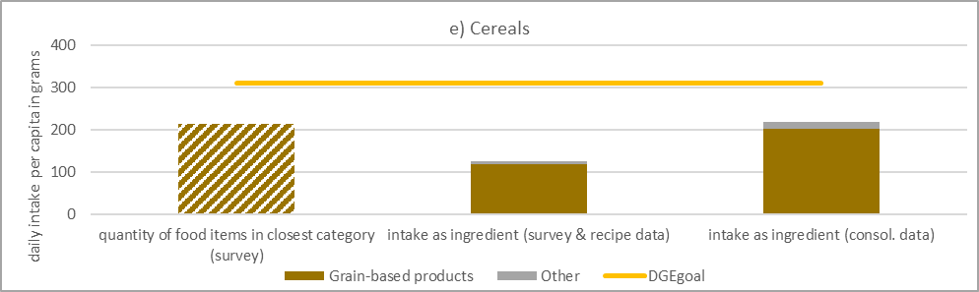
Supplementary Figure 5: Intake of cereals per capita per day in grams. Excerpt of Figure 3.

Intake of wholegrain
To calculate the intake of wholegrain using an approach consistent with the cereal intake calculation, we summed up the intake of all food items that consist primarily of wholegrain: ‘Biscuits, sweet’, ‘wheat wholemeal’, ‘rye flour, wholemeal’, ‘spelt flour, wholemeal’, ‘crisp bread, wheat, wholemeal’, ‘rye-wheat bread and rolls, wholemeal’, ‘rye bread and rolls, wholemeal’, ‘rusk, wholemeal’, ‘wheat bread and rolls, brown or wholemeal’, ‘pasta wholemeal’, ‘oat flour’, ‘wheat bran’, ‘oat groats’, ‘oat grain’, ‘oat popped’, ‘rye only bread and rolls’, ‘oat high-bran flakes’, ‘spelt flour’, ‘cereal bran’, and ‘groats’. All these food items are from the category of grain-based products (14 g, left column). The intake is lower when accounting only for the wholegrain component in these food items (9 g, brown, middle column).
The consolidation shows that the intake of grain-based products was probably underreported in the intake survey (see Figure 3.e or Supplementary Figure 5), and so was the intake of grain-based products containing wholegrain (right column).
As a net effect, we assess the status quo intake of wholegrain (right column) to be lower than the food items intake (left column) suggests. To meet optimal DGE intake quantities (yellow line, “DGE goal”), the intake has to increase slightly more than suggested in Schäfer et al. (2024).
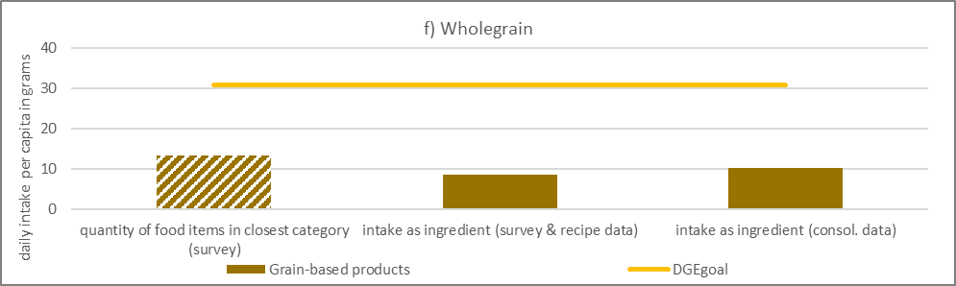
Supplementary Figure 6: Intake of wholegrain per capita per day in grams. Excerpt of Figure 3.

Intake of plant oils
The overarching category of food items that the DGE considers for the intake of plant oils is “vegetable oils”. All food items in this category are not further processed oils (left column). However, there is considerable intake of plant oils through sauces (e.g., salad dressing, dark red, middle column), grain-based products (e.g., bread, brown, middle column), and composite dishes (e.g., fried potatoes, dark gray, middle column). The direct intake of plant oils that does not come through ingredients in food items (green, middle column) only accounts for a small share of the total plant oil intake.
The relevant categories of market balance quantities that need to be matched are sunflower seed oil, rapeseed oil, soya oil, palm oil, and olives for oil making. In the data consolidation, the proportions of the different oils in the recipes were adjusted to reflect the proportions at market level. However, the combined quantities of all oils are too high to match the intake of oils as reported in the survey. The consolidation finds the intake of plant oils as ingredients in food items in the categories mentioned above to be higher (right column), suggesting an underreporting for these food items in the intake survey. Also, in the consolidated status quo consumption, the direct intake of oils only accounts for a small share of overall oil intake (green, right column).
Consequently, we assess the status quo intake of plant oils (right column) to be considerably higher than the food items intake (left column) suggests. To meet optimal DGE intake quantities (yellow line, “DGE goal”), the intake has to decrease strongly instead of increasing strongly, as suggested in Schäfer et al. (2024).
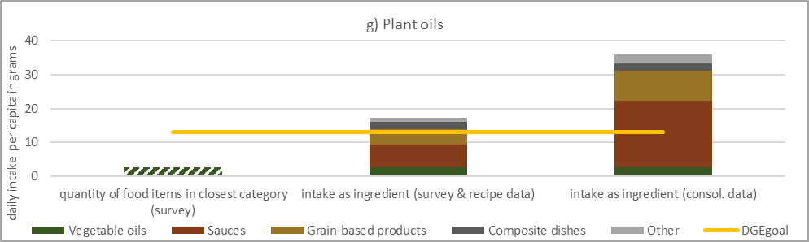
Supplementary Figure 7: Intake of plant oils per capita per day in grams. Excerpt of Figure 3.

Intake of spreadable fats
The overarching category of food items that the DGE considers for the intake of spreadable fats is “fat emulsions and blended fats”. Within this category, butter is the food item with the highest intake (light yellow, left column). Other fat emulsions are margarine or blends of butter, margarine, and oils (orange, left column). Margarine also contains ingredients like water or buttermilk. When considering strictly only the intake of spreadable fats through other fat emulsions (orange, middle column), the intake quantities are smaller than the total intake from other fat emulsions (orange, left column). There is considerable intake of spreadable fats through grain-based products (e.g., cakes, brown, middle column) and other food items (e.g., potato-based dishes, gray, middle column). The intake of spreadable fats that does not come through ingredients in food items accounts for less than half of the total intake (butter, light yellow, middle column, and other fat emulsions, orange, middle column).
The relevant categories of market balance quantities that must be matched are butter and sunflower seed oil, rapeseed oil, soya oil, palm oil, and olives for oil making. The market balance quantities for the plant oils are too high to match the margarine intake. The consolidation finds the intake of spreadable fats as ingredients in food items in the categories mentioned above to be higher (right column), suggesting an underreporting for these food items in the intake survey. However, the market balance quantity of butter is too low to match the intake of food items containing butter. The consolidation decreases the butter intake (light yellow, right column). This also points to a bias in the recipe data. The more traditional and more expensive butter is overrepresented as an ingredient, especially in fine bakery wares. In reality, plant oil-based margarine may often be used as a butter substitute. The data consolidation does not account for this bias. Consequently, the intake of spreadable fats through grain-based products may be even higher than presented here.
As a net effect, we assess the status quo intake of spreadable fats (right column) as considerably higher than the intake of the food items (left column) suggests. To meet optimal DGE intake quantities (yellow line, “DGE goal”), the intake has to decrease more strongly than suggested in Schäfer et al. (2024).
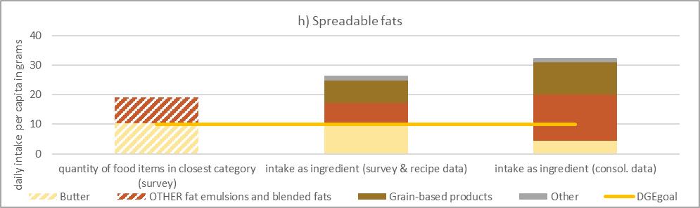
Supplementary Figure 8: Intake of spreadable fats per capita per day in grams. Excerpt of Figure 3.

Intake of milk equivalents
The overarching category of food items that the DGE considers for the milk intake is “milk and dairy products”. Within this category, the most milk equivalents are consumed through cheese (yellow, left column). The DGE calculates 451 g per capita per day of intake, Schäfer et al. (2024) whereas we calculate 312 g. This difference is explained by the calculation method. Schäfer et al. (2024) use milk equivalent coefficients that differentiate between milk, cheese, and other milk products. We use coefficients that differentiate further: milk, cheese, skimmed milk powder, whole milk powder, whey powder, cream, and concentrated milk. Intake as ingredients in food items (e.g., through coffee and cocoa beverages, in “others”, gray, or through fine bakery wares, in “grain-based products”, brown, both middle column) accounts for more than one-fourth of total intake.
The relevant categories of market balance quantities that must be matched are milk, cheese, skimmed milk powder, whole milk powder, whey powder, cream, and concentrated milk. These market balance quantities are too high to match the intake of dairy products. Hence, the consolidation increases the milk intake through food items in the categories mentioned above, suggesting an underreporting of these food items in the intake survey (right column).
Consequently, we assess the status quo intake of milk and dairy products (right column) to be considerably higher than the food items intake (left column) suggests. To meet optimal DGE intake quantities (yellow line, “DGE goal”), the intake has to be cut by almost 50% rather than increase slightly as suggested in Schäfer et al. (2024).
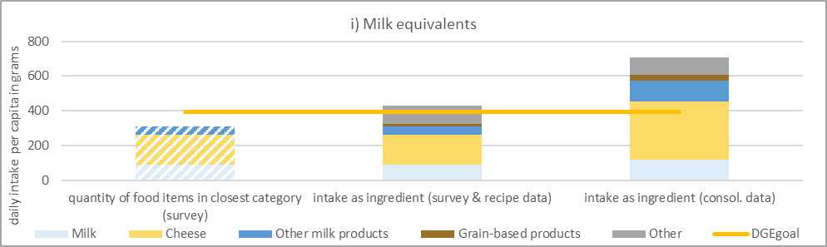
Supplementary Figure 9: Intake of milk equivalents per capita per day in grams. Excerpt of Figure 3.

Intake of potatoes
The overarching category of food items that the DGE considers for the intake of potatoes is “potatoes and similar” (left column). While this category includes ready-to-eat food items like boiled or baked potatoes, it does not cover potato-based dishes like pan-fried potatoes, potato puree, or French fries, which are captured in the category of composite dishes (dark gray, middle column). Potatoes from these food items account for around one-fourth of the total potato intake.
The relevant category of market balance quantities that must be matched is potatoes. This quantity is too high to match the potato intake. Hence, the consolidation increases the intake of potatoes, suggesting an underreporting for food items containing potatoes in the intake survey (right column).
Consequently, we assess the status quo intake of potatoes (right column) to be considerably higher than the food items intake (left column) suggests. To meet optimal DGE intake quantities (yellow line, “DGE goal”), the intake has to be cut by almost two-thirds instead of staying constant as suggested in Schäfer et al. (2024).
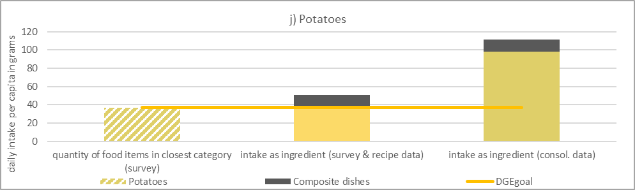
Supplementary Figure 10: Intake of potatoes per capita per day in grams. Excerpt of Figure 3.

Intake of eggs
The overarching category of food items that the DGE considers for egg intake is “eggs and egg products” (left column). While this category includes ready-to-eat food items like boiled or fried eggs, it does not cover egg-containing food items like cake or cookies. According to the intake survey, egg intake from grain-based products (brown, middle column) accounts for more than one-third of total egg intake.
The market balance quantity of eggs is too high to match the egg intake. Hence, the consolidation increases the intake of eggs, suggesting an underreporting for food items containing eggs in the intake survey (right column).
Consequently, we assess the status quo intake (right column) to be almost 3 times higher than the food items intake (left column) suggested by the intake survey. To meet optimal DGE intake quantities (yellow line, “DGE goal”), the intake has to be cut by almost two-thirds instead of staying constant as suggested in Schäfer et al. (2024).
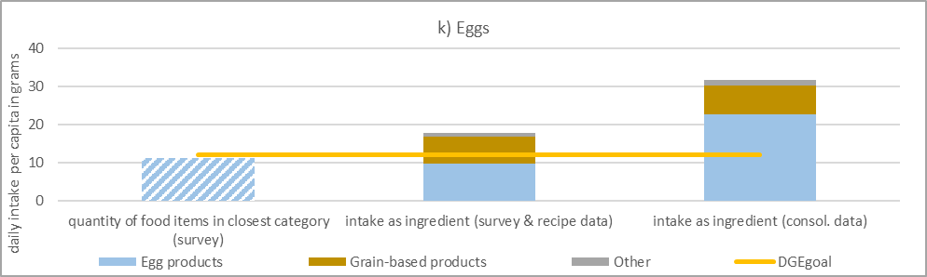
Supplementary Figure 11: Intake of eggs per capita per day in grams. Excerpt of Figure 3.

Intake of fish
The overarching category of food items that the DGE considers for fish intake is “fish and fish products” (left column). This category contains mostly ready-to-eat fish and some processed, fish-based food items (e.g., breaded fish fingers). The non-fish ingredients in the latter only account for a small fraction of the intake quantities of these food items. Therefore, the fish intake via these food items (blue, middle column) is only slightly lower than the summed-up intake quantities of these food items (left column). The fish intake through food items from other categories is negligible (gray, middle column, e.g., fish gratin).
The market balance quantities of fish differentiate between freshwater fish, saltwater fish, and other aquatic products. These quantities are too high to match the fish intake reported in the intake survey. Hence, the consolidation increases fish intake, suggesting an underreporting in the intake survey (right column).
Consequently, we assess the status quo intake of fish (right column) as more than twice as high as the food items intake (left column) suggested by the intake survey. To meet optimal DGE intake quantities (yellow line, “DGE goal”), the intake has to decrease strongly rather than increase lightly, as suggested in Schäfer et al. (2024).
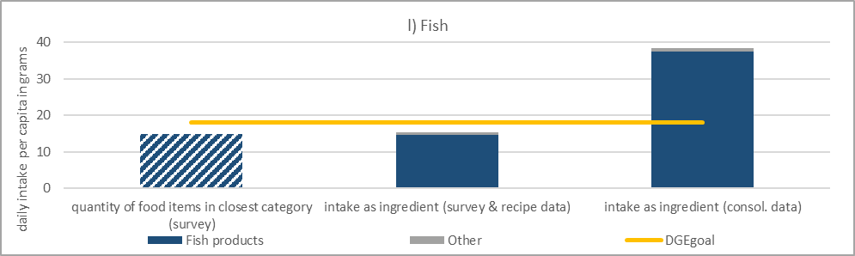
Supplementary Figure 12: Intake of fish per capita per day in grams. Excerpt of Figure 3.

Intake of poultry
The overarching category of food items that the DGE considers for the intake of poultry is “birds meat”. This category (left column) contains only fresh poultry meat. As there are no other components in these food items, the intake quantities of these food items (left column) are the same as the poultry intake through these food items (purple, middle column). The poultry intake through food items from other categories is comparatively small (e.g., sausages in processed meats, dark red, middle column) or the composite dish ‘meat soup’ (gray, middle column). Some poultry meat parts are not captured in the poultry category (e.g., poultry liver is in the category “animal liver”), but the intake quantities are negligible.
According to the intake survey, the market balance quantity of poultry available for human consumption is too high to match the poultry intake. Hence, the consolidation increases poultry intake, suggesting an underreporting of food items from this category in the intake survey (right column).
Consequently, we assess the status quo intake of poultry (right column) to be around 40% higher than the food items intake (left column) suggested by the intake survey. To meet optimal DGE intake quantities (yellow line, “DGE goal”), the intake has to stay constant instead of increasing as implied in Schäfer et al. (2024).
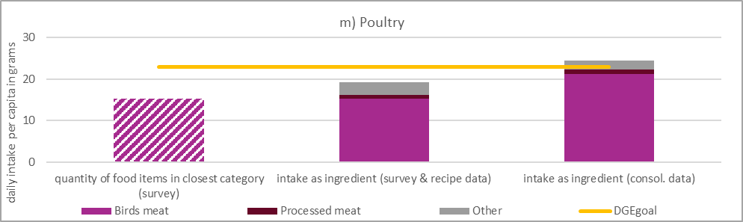
Supplementary Figure 13: Intake of poultry per capita per day in grams. Excerpt of Figure 3.

Intake of red meat
The overarching category of food items that the DGE considers for the intake of red meat is “mammals meat”. This category (left column) contains only fresh and minced meat from beef, pork, and game, like deer or hare. As there are no other components in these food items, the intake quantities of these food items (left column) are the same as the meat intake through these food items (light red, middle column). There is considerable intake of red meat as processed meats (e.g., salami, dark red, middle column), accounting for almost half of overall intake of red meat. Other sources of red meat intake include meat soup (in composite dishes, dark gray, middle column) or gravy (in others, light gray, middle column). However, they account for only a small share of the total red meat intake.
The relevant categories of market balance quantities that need to be matched are pork and beef. These quantities are slightly too high to match the red meat intake reported in the intake survey. Hence, the consolidation increases the intake of red meat, suggesting a slight underreporting for food items from the respective categories in the intake survey (right column). Game meat is not included in the market balance. Hence, the intake quantities of game meat are not adjusted during consolidation. However, they only contribute a small share of red meat consumption.
Consequently, we assess the status quo intake of red meat (right column) to be almost three times as high as the food items intake (left column) suggested by the intake survey. To meet optimal DGE intake quantities (yellow line, “DGE goal”), the intake has to decrease even more drastically than implied in Schäfer et al. (2024).
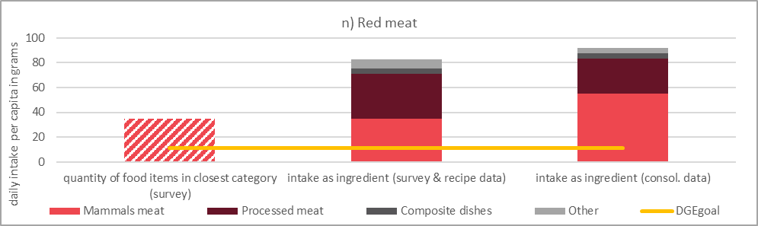
Supplementary Figure 14: Intake of red meat per capita per day in grams. Excerpt of Figure 3.

Goodness of fit of the consolidation

Correlation coefficient
Supplementary Table 2: Spearman correlation coefficient for all datasets, for the entire dataset, and separated for parts of the datasets. Number of observations in italics.
 | recipes | food intake | avoidable waste¹ |  |  | market balance | processing | non-avoidable waste¹ |  |  | meat partitioning
full dataset | 0.9877 | 0.8758 | 0.9814 |  | full dataset | 1.0000 | 0.9877 | 0.9700 |  | full dataset | 0.9923
full dataset | 4141 | 906 | 896 |  | full dataset | 44 | 749 | 278 |  | full dataset | 57
Fruit and fruit products | 0.9995 | 0.6912 | NA¹ |  | Oilseed | 1 | 1 | NA¹ |  | Beef | 0.9853
Fruit and fruit products | 124 | 73 | 73 |  |  | 2 | 5 | 2 |  |  | 20
Milk and dairy products | 0.9995 | 0.9108 | 0.7644 |  | Cereals | 1 | 0.9719 | NA³ |  | Sheep and goat | 1.0000
Milk and dairy products | 162 | 73 | 73 |  | Cereals | 6 | 72 | 0 |  | Sheep and goat | 7
Eggs and egg products | 0.9394 | 0.3333 | NA¹ |  | Other crops | 1 | 0.9976 | NA¹ |  | Pork | 0.9989
Eggs and egg products | 18 | 8 | 8 |  | Other crops | 2 | 29 | 8 |  |  | 14
Alcoholic beverages | 0.9990 | 0.7278 | NA¹ |  | Vegetables and fruit | 1 | 0.9994 | 0.8737 |  | Poultry | 0.9391
Alcoholic beverages | 168 | 39 | 39 |  | Vegetables and fruit | 8 | 406 | 162 |  | Poultry | 16
Products for non-standard diets, food imitates and food supplements | 0.9978 | 1.0000 | 0.9290 |  | Coffee, cocoa, tea | 1 | 0.7863 | NA³
 | 28 | 8 | 8 |  | Coffee, cocoa, tea | 3 | 11 | 0
Coffee, cocoa, tea and infusions | 0.9954 | 0.9052 | NA¹ |  | Meat | 1 | 0.9933 | NA³
Coffee, cocoa, tea and infusions | 49 | 24 | 24 |  | Meat | 4 | 54 | 0
Composite dishes | 0.9639 | 0.9607 | NA¹ |  | Eggs | NA¹ | 0.9550 | NA¹
Composite dishes | 953 | 60 | 60 |  |  | 1 | 7 | 1
Fish, seafood, amphibians, reptiles and invertebrates | 0.9993 | 0.9913 | NA¹ |  | Fish and aquatic products | 1 | 0.9948 | NA¹
Fish, seafood, amphibians, reptiles and invertebrates | 111 | 59 | 59 |  | Fish and aquatic products | 3 | 68 | 41
Fruit and vegetable juices and nectars (including concentrates) | 0.9989 | 0.4657 | NA¹ |  | Dairy products | 1 | NA² | 0.4655
 | 60 | 25 | 25 |  | Dairy products | 8 | 75 | 57
Grains and grain-based products | 0.9733 | 0.9429 | NA¹ |  | Oils | 1 | NA² | NA³
Grains and grain-based products | 833 | 126 | 126 |  | Oils | 5 | 7 | 7
Legumes, nuts, oilseeds and spices | 0.9997 | 0.6305 | NA¹ |  | Secondary products | 1 | 0.9890 | NA³
Legumes, nuts, oilseeds and spices | 83 | 59 | 59 |  | Secondary products | 2 | 15 | 0
Meat and meat products | 0.9986 | 0.9283 | NA¹
Meat and meat products | 630 | 93 | 87 |  | ¹ NA because the prior value is the same for all items in the category (by assumption in avoidable and non-avoidable waste)
Seasoning, sauces and condiments | 0.9825 | 0.9948 | NA¹
Seasoning, sauces and condiments | 417 | 46 | 46 |  | ² Processing of dairy products and oil is part of the CAPRI model and was therefore not included in the consolidation.
Starchy roots or tubers and products thereof, sugar plants | 1.0000 | 1.0000 | NA¹
Starchy roots or tubers and products thereof, sugar plants | 9 | 8 | 8 |  | ³ NA because prior and consolidated values are zero.
Sugar and similar, confectionery and water-based sweet desserts | 0.9977 | 0.7955 | NA¹
 | 195 | 39 | 39
Vegetables and vegetable products | 1.0000 | 0.9084 | NA¹
Vegetables and vegetable products | 145 | 114 | 114
Water and water-based beverages | 0.9963 | 0.9401 | NA¹
Water and water-based beverages | 69 | 18 | 16
Animal and vegetable fats and oils and primary derivatives thereof | 0.9596 | 0.9774 | 0.6148
 | 70 | 28 | 27
Major isolated ingredients, additives, flavours, baking and processing aids | 1.00000 | 1 | NA¹
 | 7 | 6 | 6

Distribution of adjustments
Supplementary Figure 15 visualizes the adjustment of the prior values by the consolidation presented in Table 3, grouped by dataset and extent and direction of the adjustment. Both Table 3 and Supplementary Figure 15 show that the adjustments usually cover the allowed range fully (± 20% for processing, recipes, and waste shares, -100% and +2,0000% for intake quantities). Only for the market balance dataset the allowed range (-100% and 1,000%) is not exhausted. Because the market balance dataset is considered the most accurate among the seven datasets, we parameterize the objective function so that the quantities available for human consumption at the market level are met by adjusting the other datasets instead of the market balance dataset, if possible. See Supplementary Table 3 for more details on the adjustments in the market balance dataset.
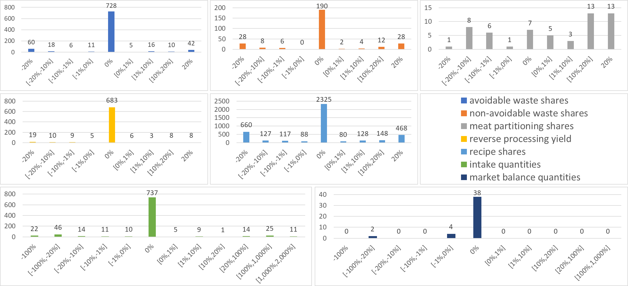
Supplementary Figure 15: Adjustments of prior data points in the consolidation, differentiated per dataset. Grouped by size and direction of adjustment.

Supplementary Figure 16 presents the adjustment by the consolidation in all seven datasets. Each part of the figure (a-f) captures the adjustments within one dataset. The gray points depict the percentage deviations between a data point's prior and consolidated value, and the yellow points depict the absolute deviations. When a point is zero, the consolidation does not adjust the value of this data point to fit into the consistent quantity flow. Supplementary Figure 16 shows that the consolidation leads to adjustments in all datasets, often covering the allowed deviation range (± 20% for processing, recipes, and waste shares (sections a-e), -100% and +infinity for intake quantities section f). The intended small adjustments in the market balance quantities can be seen in section g.
Reading help: An exemplary data point from Supplementary Figure 16.a is the avoidable waste share for the food item “Wiener sausage”. The prior value is 8.88%, meaning that this is the share of Wiener sausage lost as avoidable waste. The consolidation finds that in the consistent quantity flow, 7.11% of Wiener sausage is lost as avoidable waste. This is 1.78 percentage points less (yellow point) and 20% less (gray point) than the prior value.
The market balance quantities show stronger and more frequent decreases than increases (Table 3, Supplementary Figure 16.g, Supplementary Table 3). In contrast, the waste shares (Supplementary Figure 16.a and b) and the intake quantities (Supplementary Figure 16.f) increase more often than they decrease. This shows that the prior intake quantities are too low to fit the market balance data for most food items.
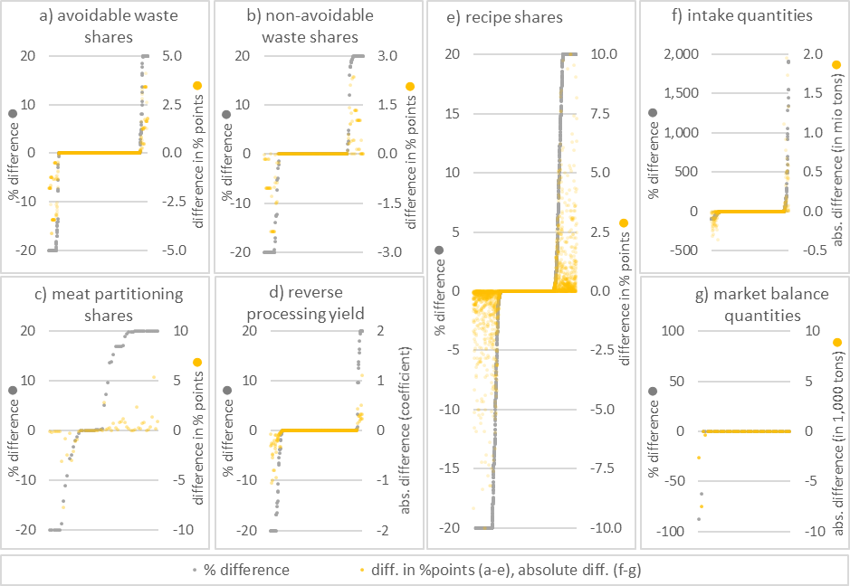
Supplementary Figure 16: Adjustments of prior data points in the consolidation, differentiated per dataset. Ordered by relative adjustments of prior values (gray points, left axis). Adjustments in percentage points (a-e) or absolute values (f-g) (yellow points, right axis).

Supplementary Figure 17 shows the same values as Supplementary Figure 16 but ordered by absolute adjustments (yellow points).
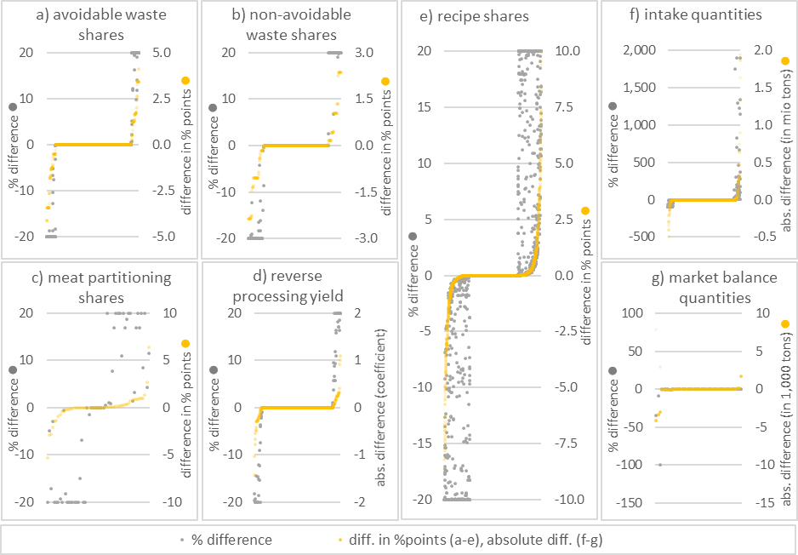
Supplementary Figure 17: The percentage and absolute difference between prior values and consolidated values for all datasets, ordered by absolute deviations of consolidated values from prior values.

Supplementary Figure 18 shows the prior and absolute values (blue and orange points), alongside the relative difference (gray points).
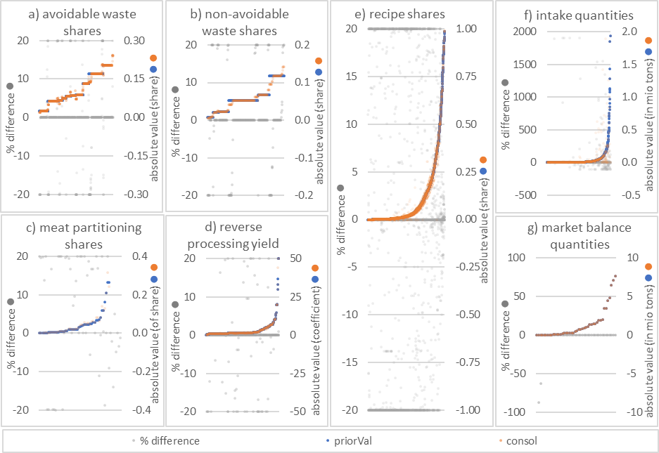
Supplementary Figure 18: Prior and consolidated values and percentage differences between them for all datasets. Ordered for prior values.

Adjustments of market balance quantities
Supplementary Table 3 shows the prior market balance quantities (“prior values”) adjusted by over ± 0.2% to fit a consistent quantity flow. The deviation between the consolidated and prior values is expressed as a percentage of the prior value (“adjustment in %”). The adjustments are negative, meaning that the market balance quantities of whey powder, other cereals and sunflower seeds are too high to fit the intake data.
However, in relative terms, the gaps are so small, we consider them to be negligible. The gap for whey powder only accounts for 0.01% of fresh milk equivalents and the gap in other cereal accounts for 0.07% of total available for human consumption at the market level.
The underrepresentation of whey powder in the recipe data can be interpreted as a bias towards home cooking. Earlier consolidation attempts found that olive oil and beef are used more frequently than the market balance quantities account for. Conversely, the cheaper alternatives, rapeseed and sunflower oil, and pork and poultry, are used very little according to the recipe data. We ad-hoc adjusted the prior recipe data by substituting all oil and muscle meat quantities with a mixture that captures the proportion of the oils, respectively, the meats as reported in the market balance, assuming perfect substitutability in all food items. In the data consolidation, we additionally allowed a more flexible adjustment of the oil composition within recipes. The substitutability of whey and milk powders is more complex, differing between food items, so we refrained from ad-hoc adjustment for those ingredients.

Supplementary Table 3: Prior quantities of raw primary commodities available for human consumption at the market level (in 1,000 tons) and adjustment after consolidation in %. All other adjustments are below 0.2% and omitted.
 | Prior value in 1,000 tons | Adjustment in %
Whey powder | 3 | -88
Other cereals | 29 | -63

References in supplementary information
DGE (Hrsg.). (2024). Interpretationshilfe_DGE_FBDG_DEundENG.pdf. https://www.dge.de/fileadmin/dok/wissenschaft/publikationen/Interpretationshilfe_DGE_FBDG_DEundENG.pdf
Schäfer, A. C., Boeing, H., Conrad, J., & Watzl, B. (2024). Wissenschaftliche Grundlagen der lebensmittelbezogenen Ernährungsempfehlungen für Deutschland. Methodik und Ableitungskonzepte. Ernährungs Umschau, 71(3), 158–166. https://doi.org/10.4455/eu.2024.009

