Supporting Document

Serum N-Glycomic Biomarkers Predict Treatment Escalation in Inflammatory Bowel Disease

Short Title: Serum N-glycans predict IBD treatment escalation

Archana Shubhakar^{1,2,*}, Bas C Jansen¹, Alex T. Adams³, Karli R Reiding^{4,5}, Nicholas T. Ventham⁶, Rahul Kalla⁶, Daniel Bergemalm⁷, Paulina A Urbanowicz¹, Richard A Gardner¹, IBD-BIOM Consortium, Jonas Halfvarson⁷, Jack Satsangi³, Daryl L Fernandes¹, Manfred Wuhrer⁴, Daniel I R Spencer^{1,*}.

1 Ludger Ltd, Culham Science Centre, Abingdon, Oxfordshire, United Kingdom;
2 Division of BioAnalytical Chemistry, VU University Amsterdam, Amsterdam, The Netherlands;
3 Translational Gastroenterology Unit, Nuffield Department of Medicine, Oxford, United Kingdom;
4 Center for Proteomics and Metabolomics, Leiden University Medical Center, Leiden, The Netherlands
5 Division of Biomolecular Mass Spectrometry and Proteomics, Utrecht University, Utrecht, The Netherlands;
6 Centre for Genomics and Experimental Medicine, Institute of Genetics and Molecular Medicine, University of Edinburgh, Edinburgh, United Kingdom;
7 Department of Gastroenterology, Faculty of Medicine and Health, Örebro University, Örebro, Sweden

* Joint corresponding authors (archana.shubhakar@ludger.com and daniel.spencer@ludger.com)

Section 1: Results
Repeatability of serum N-glycan standard analysis
Technical variation: Repeatability of serum N-glycan profiling by UHPLC after procainamide labeling is shown in Supplementary figure 1. While Supplementary Table 3 illustrates technical variation of serum N-glycan standards from a total of 18 serum standards.
Association of glycans with clinical markers
The results indicate that high-sensitivity C-reactive protein (hsCRP) correlates with derived glycan traits for both controls and IBD patients. In controls hsCRP in particular correlates with fucosylation of tetraantennary (A4F), bisection of non-sialylated non-fucosylated diantennary (A2F0S0B) and sialylation of fucosylated diantennary (A2FS) glycans (Supplementary Figure 3A). Bisection of non-sialylated diantennary (A2FS0B), sialylation of various triantennary (A3S, A3F0S, A3FS) and GalMan for non-bisected fucosylated diantennary (FA2[r6]B0G1) glycans show correlation with hsCRP for IBD patients in particular. A2FS0B showed negative association with platelets in controls. We observed that galactosylation of non-sialylated diantennary glycans (A2FS0G, A2S0G, and A2F0S0G) show negative association with hsCRP and platelets (PLT) while a positive association with Albumin (Alb) was observed in IBD patients. Also, sialylated fucosylated triantennary (A3FS) glycans showed positive association with Alb in IBD. Bisected non-sialylated diantennary (A2S0B) glycans show a positive association with platelets, a negative association of fucosylation of triantennary glycans with haemoglobin was observed and galactosylation of non-sialylated diantennary (A2S0G) glycans showed a positive association with haematocrit in IBD patients as shown in (Supplementary Figure 3B).
We investigated the association of TSNG (derived traits) with most of the commonly measured clinical parameters such as, Alb, basophils, creatinine, eosinophils, ESR, haematocrit, haemoglobin, hsCRP, lymphocytes, monocytes, neutrophils, PLTs, urea and white blood cells (WBC). Age and sex corrected generalized linear models (GLMs) were used to determine the potential correlation between each derived glycan trait and clinical parameter for controls and IBD patients. Clerc et.al studied¹ CRP and ESR associations with total plasma N-glycans and they illustrated that α2,6-linked sialylation and fucosylation of triantennary glycans showed positive association with the inflammatory markers and IgG galactosylation showed negative association in CD while UC patients showed similar trends with additional negative association with bisection.

Section 2: Discussion

Associations of glycans with IBD
Derived glycan traits are increasingly used in biomarker studies as they show high analytical robustness and provide biologically and often also clinically valid associations. Previous glycomics studies using derived trait analysis have reported a significant decrease observed in diantennary galactosylation (A2S0G, A2F0S0G and A2FS0G) in human IgG N-glycans in IBD patients when compared with controls^{2,3} and we were able to successfully replicate these findings using TSNG. Clerc et al. have studied association of plasma N-glycan derived traits within IBD and we have successfully replicated these findings in an independent cohort. We observed higher bisection in IBD patients for glycan traits such as bisection of non-sialylated diantennary (A2S0B) and bisection of non-sialylated non-fucosylated diantennary (A2F0S0B) glycans. We observed sialylation of fucosylated triantennary (A3FS) glycans were lower in both CD and UC when compared with controls. Sialylation of triantennary (A3S) glycans were lower in CD (RI% 128.73) and slightly higher levels (RI% 131.23) were observed in UC patients. Additionally, we observed an increase in antennary fucosylation in both CD and UC in comparison with controls. This is possibly due to the increase in acute phase proteins which contain triantennary and tetraantennary glycans which are mainly antennary fucosylated.^{4,5}
The methodology Clerc et. al. used included linkage-specific esterification to allow the distinction of α 2,3 - and α 2,6 - linked sialic acid moieties using matrix-assisted laser desorption/ionization-MS. The novelty of our UHPLC method allows us to differentiate presence of galactose on a specific mannose arm; i.e., diantennary fucosylated GalMan glycans (FA2[r6]G1, FA2[r6]BG1 and FA2[r6]B0G1).⁶ An increase in FA2[r6]G1 and FA2[r6]B0G1 glycans in UC patients illustrates that there is a higher level of galactose residues attached to the α1,6 - mannose arm as compared to the α1,3 – mannose arm and this novel feature helps to distinguish between CD and UC patients using serum N - glycans. Another novel finding is that we observed lower levels of bisection of fucosylated diantennary (A2FB, Figure 2F) glycans in IBD patients which has not been reported previously in IBD, though dramatic changes in fucosylation are seen in other inflammatory conditions such as liver cirrhosis where a decrease in fucosylation of bisected diantennary neutral glycans are reported.⁷
Association of glycans with clinical markers
Age, sex and age-sex interaction corrected GLMs were used to determine the potential correlation between each derived glycan trait and clinical markers for controls and IBD patients (Supplementary Figure 3; A and B). We observed similar trends with respect to galactosylation in comparison to this previous study, as it is known that very low levels of galactosylation is associated with chronic inflammation and a decrease in galactosylation is also observed with age.(^{2,8}) Inflammatory marker counts for hsCRP and PLTs are known to be elevated with acute-inflammation⁹. In agreement, we observed that galactosylation of non-sialylated diantennary glycans (A2FS0G, A2S0G, and A2F0S0G) show negative association with hsCRP and PLTs in IBD patients. (Supplementary Figure 3B). Galactosylation of non-sialylated diantennary (A2FS0G, A2S0G and A2F0S0G) glycans showed positive association with Alb and from literature it is known that Alb is a negative acute phase protein and decreased levels of Alb are produced due to systemic inflammation¹⁰. We also observed that bisected non-sialylated diantennary (A2S0B) glycans showed positive association with platelets (significant increase in platelet numbers are observed in IBD¹¹) (Supplementary Figure 3B). An increase in bisection is a commonly associated with age and IBD and this could be attributed to reduced galactosylation levels seen in IBD which acts as a substrate for glycosyltranserases for addition of bisecting GlcNAc’s (N-acetylglucosaminyltransferase III) ^{1,12}. Furthermore, we were able to identify the diagnostic ion for distinguishing bisecting GlcNAc glycan fragments from a non-galactosylated third antenna to confirm that they are bisecting diantennary glycans using LC-MS method, which is an added advantage over matrix assisted laser desorption ionization-time of flight mass spectrometry (MALDI-TOF-MS) methods, which cannot differentiate non-derivatized isomeric structures.

Materials and Methods

Section 3: Experimental

Glycan release and enrichment of serum N-glycans
Ten microliters of serum sample from the cohort was plated along with system suitability standards into 100 µL PCR plates (4titude, Surrey, UK), sealed with clear plate sealer (4titude) and subjected to heat denaturation at 100°C for 2 minutes using a PCR cycler. After the plate had cooled down to room temperature the plate seal was carefully removed and individual plates were transferred to the robot (Hamilton, Birmingham, UK). The liquid handling robot dispensed 17.5 µL of water to each sample in the PCR plate, followed by the addition of 5 µL of 5x reaction buffer (Ludger, LZ-PNGASEF-96). The PCR plate was sealed, vortexed and briefly centrifuged prior to incubation at 100°C for 10 minutes. The cooled sample plate was then transferred back to the robot deck after carefully removing the plate seal to add 1.25 µL of triton-X 100 and 1 µL of PNGase F enzyme (1 unit). The plate was sealed, vortexed, centrifuged briefly and incubated overnight at 37°C. After incubation, the plate seal was removed and the samples were dried down completely in a centrifugal evaporator at 10 mBar with no heat setting (Thermo Savant, Hampshire, UK). Twenty microliters of 1% formic acid was added to the samples, followed by a 40 minute incubation. One-hundred microliters of methanol and 300 μL of water was used to prime a protein binding membrane plate (PBM) (LC-PBM-96, Ludger Ltd) and after each wash a vacuum of −0.1 to −0.2 bar was applied by an integrated vacuum manifold to wash the membrane. After the incubation, the acidified samples were transferred to the PBM plate. Sample elution was performed by adding 100 μL of water to each well and centrifugation (3 min, 800g, 22°C) into a deep well collection plate. The entire elution process was repeated two times to have the final elution volume to be approximately 190-200 µL. The final elution of 130 µL was transferred into a non-skirted 96 well PCR plate (4titude, 4ti-0710) and dried overnight using a centrifugal evaporator (10 mBar). The remaining 70 µL elution was transferred to another 96 well PCR plate, dried and stored in the freezer for future use.
Procainamide labeling of serum N-glycans
The procainamide labeling solution was prepared according to manufacturer instructions using LT-PROC-VP24 labeling kit (Ludger Ltd, Culham, UK). The robot mixed 10 µL of water into each well on the 96 well PCR plates containing 130 µL dried and enriched sample, followed by the addition of 10 µL of dye. The PCR plates were sealed with a pierce foil using a plate sealer, and vortexed on a plate shaker. The samples were incubated at 65 °C for 1 hour and then cooled to room temperature.

Post-labeling clean-up
Excess procainamide dye was removed from the labeled samples by using a LC-PROC-96 (Ludger Ltd) plate. The clean-up plate was primed with 200 µL of 70% ethanol and a vacuum (−0.1 to −0.2 bar) was applied to the plate to wash through the wells. This process was repeated with the addition of 200 µL of distilled water and followed by addition of acetonitrile (ACN). Later 230 µL of ACN was added to the sample plate, mixed by pipetting action and 250 µL of sample mixture was dispensed into the clean-up plate and the contents of each well could pass through under gravity. After 10 minutes, a vacuum (−0.1 to −0.2 bar) was applied to elute the remaining ACN. Sample impurities were removed by washing 3 times with 200 µL of 100% ACN. After each wash step, vacuum was applied 5 minutes after applying ACN to the samples to drain the remaining ACN. Finally, the labeled and cleaned up glycans samples were eluted using 200 µL of distilled water into a deep well collection plate.

Ultra-high performance liquid chromatography (UHPLC)
110 µL of procainamide labeled glycans was mixed with 390 µL of ACN to give a final sample concentration of 78% ACN. The sample plate was sealed with a pierce silicon sealing mat using a plate sealer and t into the UHPLC carousel. 25 µL of each procainamide labeled sample was injected onto an ACQUITY UPLC BEH–glycan column (1.7 lm, 2.1 x 150 mm) at 40 °C. The glycans were separated on a Thermo Dionex Ultimate 3000 UHPLC and a U3000 fluorescence detector with excitation of 310 nm and emission of 370 nm for procainamide. Serum samples from the cohort and standards were acquired using a 70 minute gradient with 50 mM ammonium formate buffer (solvent A, pH 4.4) (Ludger Ltd) and ACN (solvent B) with a linear separation gradient of 76% - 51% of solvent B with flow rate of 0.4 ml / min. See Supplementary Table 10 for the detailed gradient running conditions.
Procainamide labeled glucose homopolymer ladder (Ludger Ltd) was used as a system suitability standard as well as a reference standard for allocation of glucose units (GU) and Chromeleon data software version 7.2 (Dionex, USA) was used for controlling the sample acquisition. A few random samples (2 UC, 2 CD and 2 HC) were subjected to fragmentation using the Bruker amaZon Speed Electron Transfer Dissociation (ETD) instrument. The Amazon Speed settings used were as follows: source temperature, 250 °C; gas flow, 10 L/min; capillary voltage, 4500 V; ICC target, 200,000; Maximum Accumulation Time, 50.00 ms; rolling average, 2; number of pre-cursor ions selected, 3; release after 0.2 min; positive ion mode; scan mode, enhanced resolution; mass range scanned, 200 to 1500; target mass, 900.

Section 4: Data Analysis
HappyTools Processing
The N-glycome from 471 measurements were analysed and all chromatograms were converted to text (txt) files using Chromeleon prior to HappyTools processing. Specifically, all the chromatograms from the cohort were calibrated using 7 analytes that were present in all the sample runs. The user defined retention time (t_{r}) and tr window (Δt_{r}) for all calibrant peaks is listed in Supplementary Table 11A. The t_{r} calibration was manually verified before with the quantitation of 47 chromatographic peaks. Quantitation parameters were acquired by manually inspecting the peak width for all 47 chromatographic peaks (47 integration peak ID’s matched to 55 actual peak ID’s), the full list of quantitation parameters can be found in Supplementary Table 11B. Peak alignment before and after t_{r} calibration using HappyTools is shown in Supplementary Figure 9.
Statistical Analysis
The relative areas for the 47 glycan peaks (105 glycoforms) were acquired by performing total area normalization. All glycans that were identified based on literature knowledge or MS² fragmentation and are shown in Supplementary Table 1. The technical and biological variation was determined using the main glycan peak (A2G2S2) from both the controls and the samples. Subsequently, derived traits of glycosylation were calculated using the relative areas (Supplementary Table 2A and 2B) and used for all further statistical analyses. Derived glycan traits are designed to reflect the activity of a single enzymatic step. For example: fucosyltransferase 8 (FUT8) transfers α1,6-linked (core) fucosylation to the innermost GlcNAc residue of an N-linked di-antennary glycan¹³ Typical glycan species that are a product of FUT8 activity include FA2, FA2B, and FA2G1 etc. For the derived trait, these species are averaged together and divided by all the di-antennary glycans in serum to yield a value for the A2F trait (fucosylated di-antennary glycans).
Likewise, the trait for A2F0S0B (bisected non-sialylated non-fucosylated diantennary glycans) is calculated as follows: A2F0S0B= (Sum of all bisected di-antennary glycans) {A2B + A2BG2} / (Sum of all di-antennary glycans) {A2B + FA2B+ A2BG2 + FA2BG2} in serum. Following from these calculations, derived traits can indicate changes in the structure/shape of the glycoproteins and relative abundances of glycoproteins. The associations between glycomics-glycomics, glycomics-IBD and glycomics-clinical parameters were determined using age and sex corrected generalized linear models. Multiple testing correction was performed using Bonferroni correction¹⁴ for an α of 0.05. Heatmaps to illustrate the associations were created using R, where the colour relates to the direction of the association and the label indicates if an association is significant. Lastly, the cox escalation data was used in a receiver operating character (ROC)¹⁵ test from which the area under the curve (AUC) was calculated. The ROC curve that yielded the maximum AUC was used to determine the sensitivity and specificity cut-off, defined as the point closest to sensitivity and specificity of 1. Significance of the ROC curves was assessed using a log-likelihood test and multiple testing correction was performed using a permutation test. Kaplan-Meier survival plots were created for the best-scoring biomarker as per the optimal sensitivity and specificity cut-offs.

Software
The following software packages were used in this study: Chromeleon version 7.2, HappyTools version provided in Supplementary Data 1 was used for the discovery cohort, while the replication cohort was processed using HappyTools (v0.1-alpha1 b181031a)¹⁶. RStudio 1.1.383 and GlycoWorkbench 2¹⁷. R packages used were: ROCR¹⁸, ggplot2¹⁹, survival and survminer. Supplementary Data 2 contains the R-Scripts that were used to create all statistical analysis and visualizations that are presented within this manuscript.
Supplemental Table 1. HPLC Peak identification. This table shows the most plausible structure of each peak that was used in this study and shows the most abundant fragments that were observed in MS², if the structure is based on fragmentation data. Structures that do not list any fragments were based on literature knowledge. 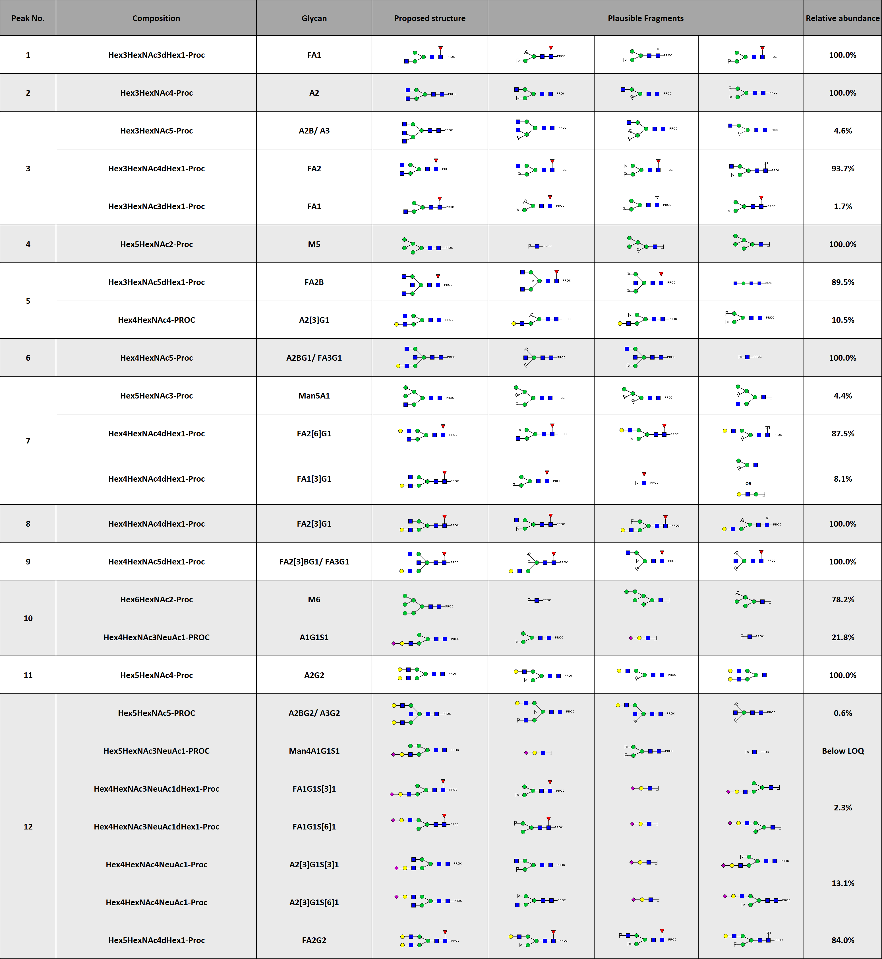

Supplemental Table 1. HPLC Peak identification. Continued.
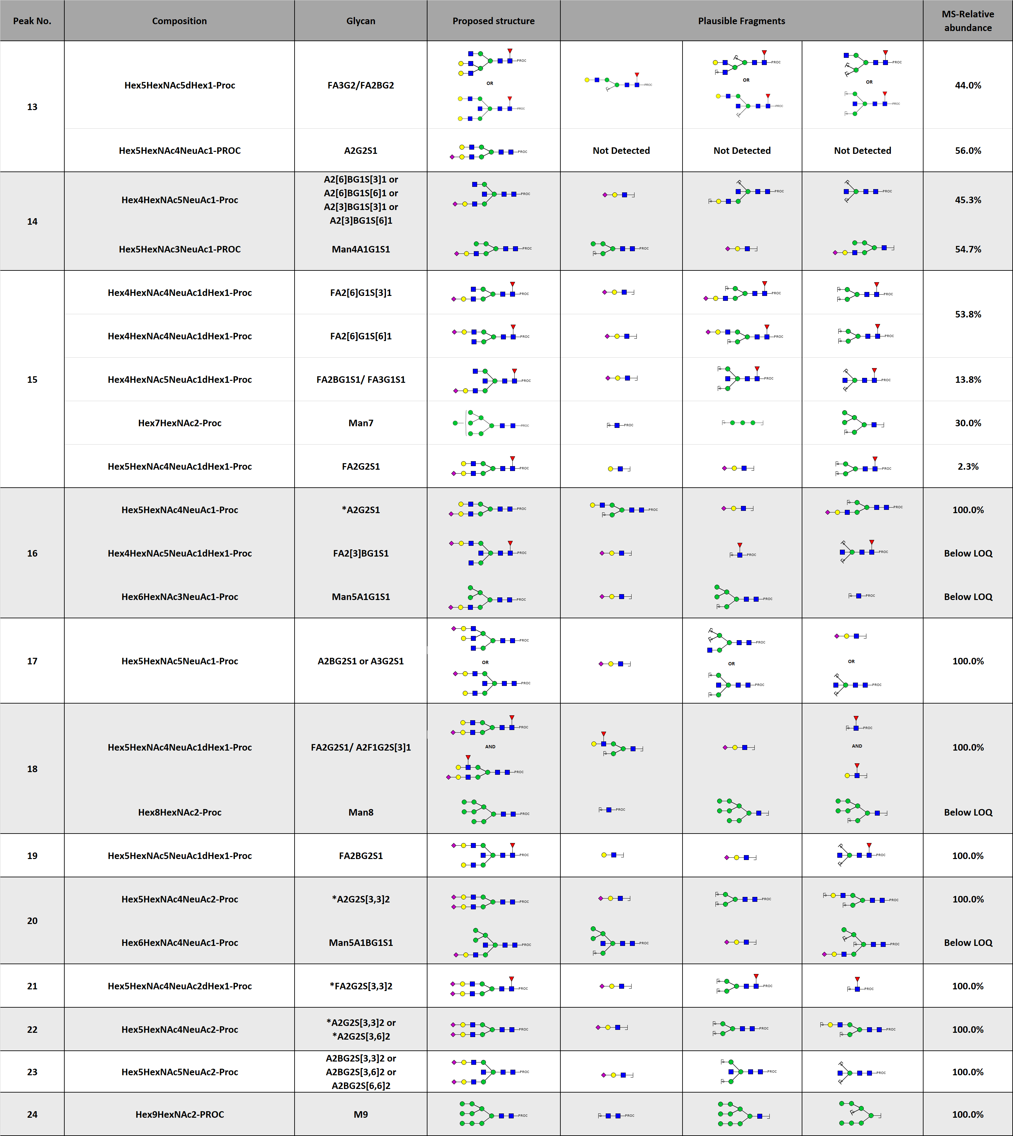

Supplemental Table 1. HPLC Peak identification. Continued. 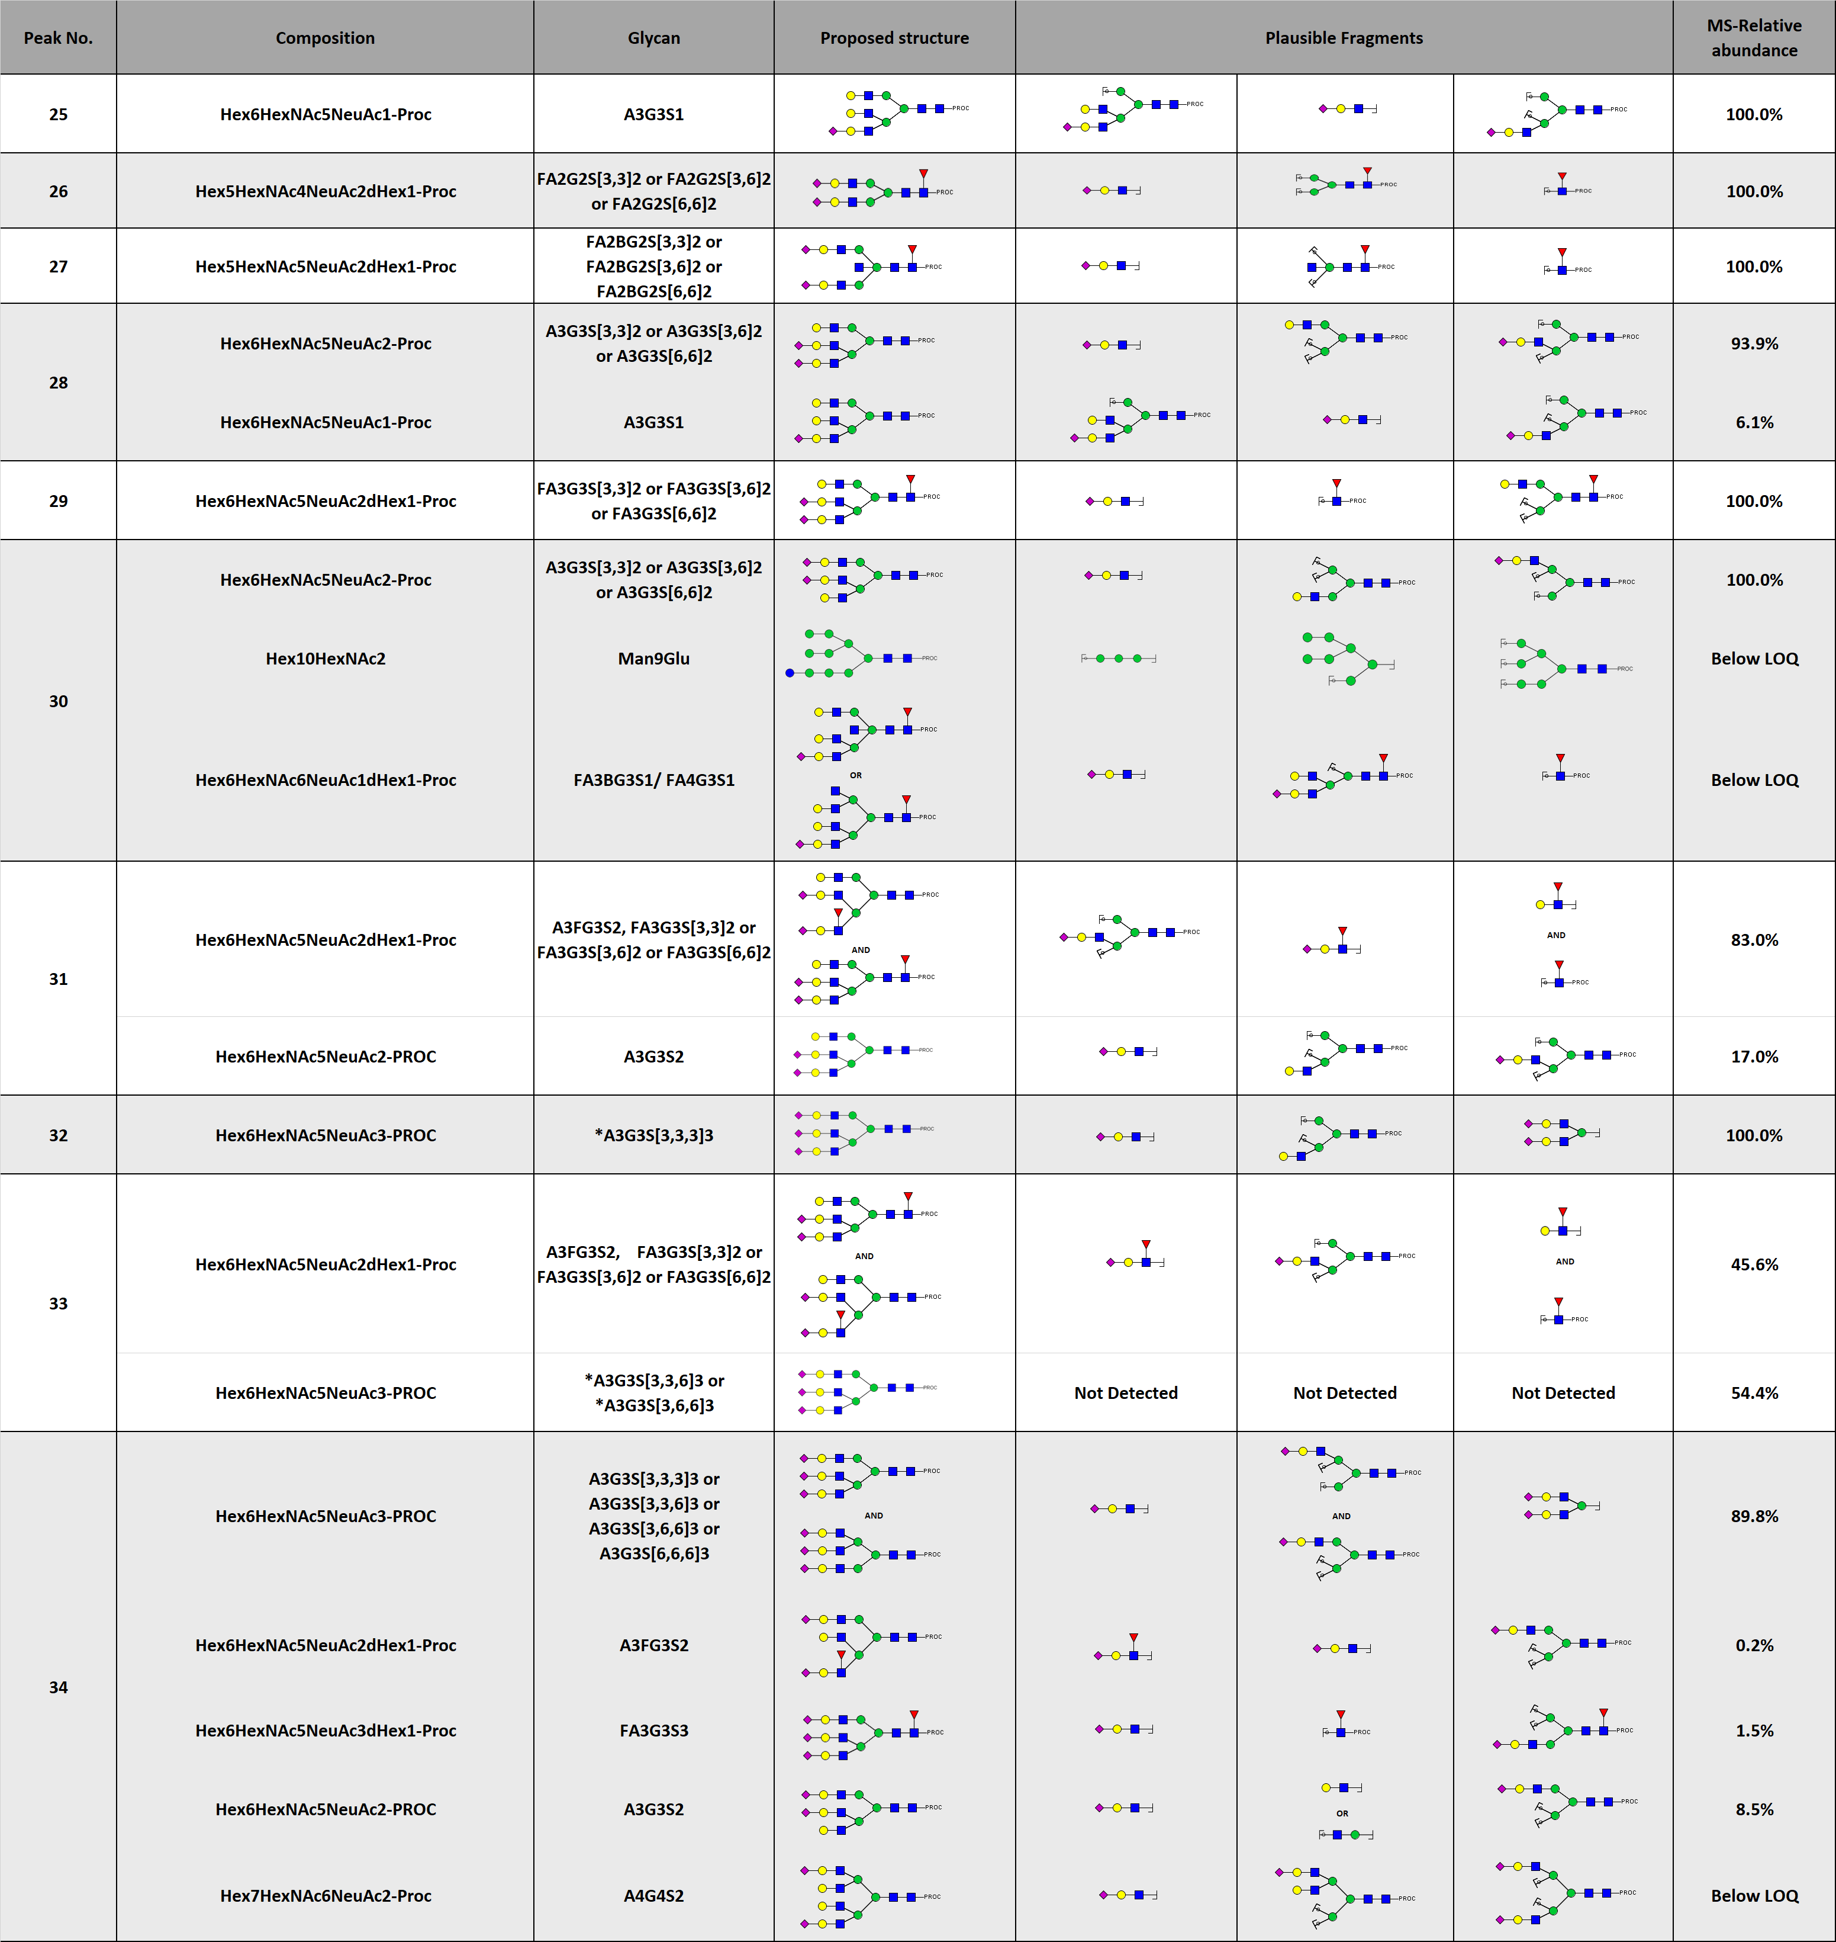

Supplemental Table 1. HPLC Peak identification. Continued. 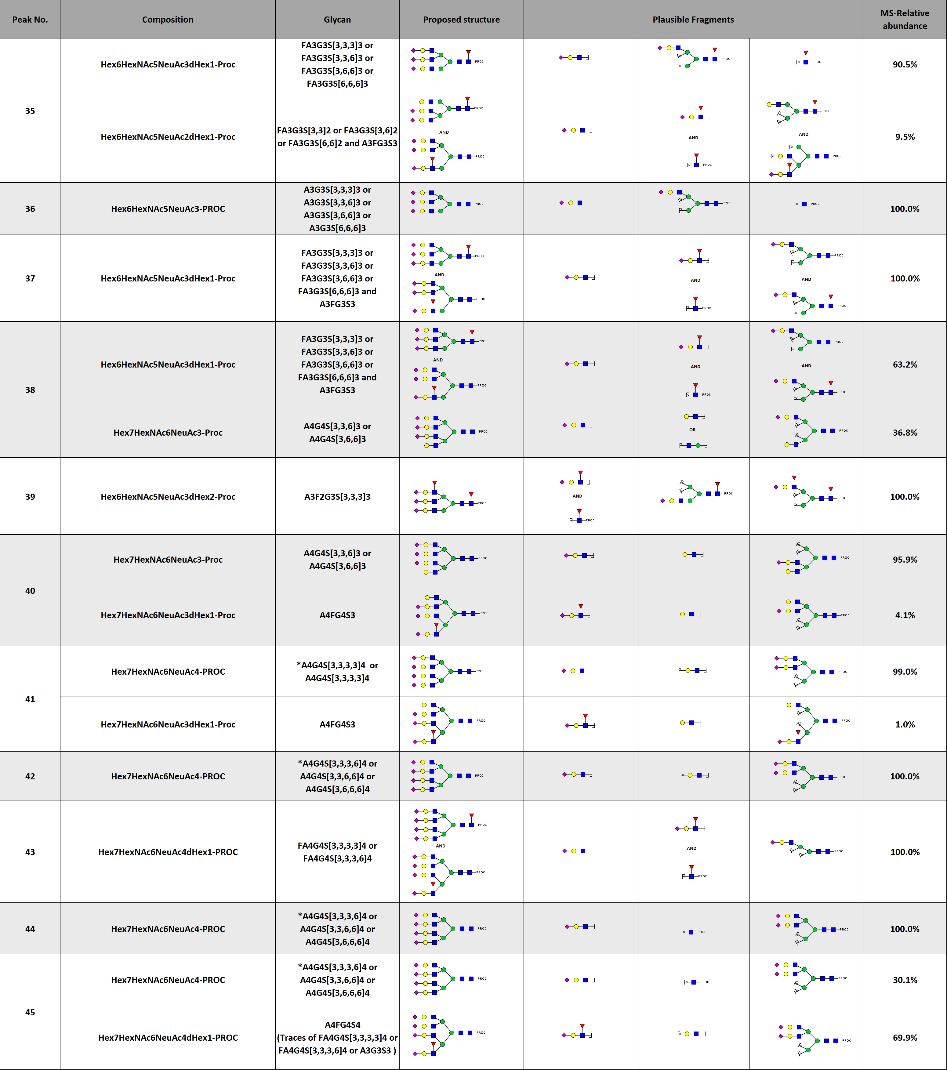

Supplemental Table 1. HPLC Peak identification. Continued.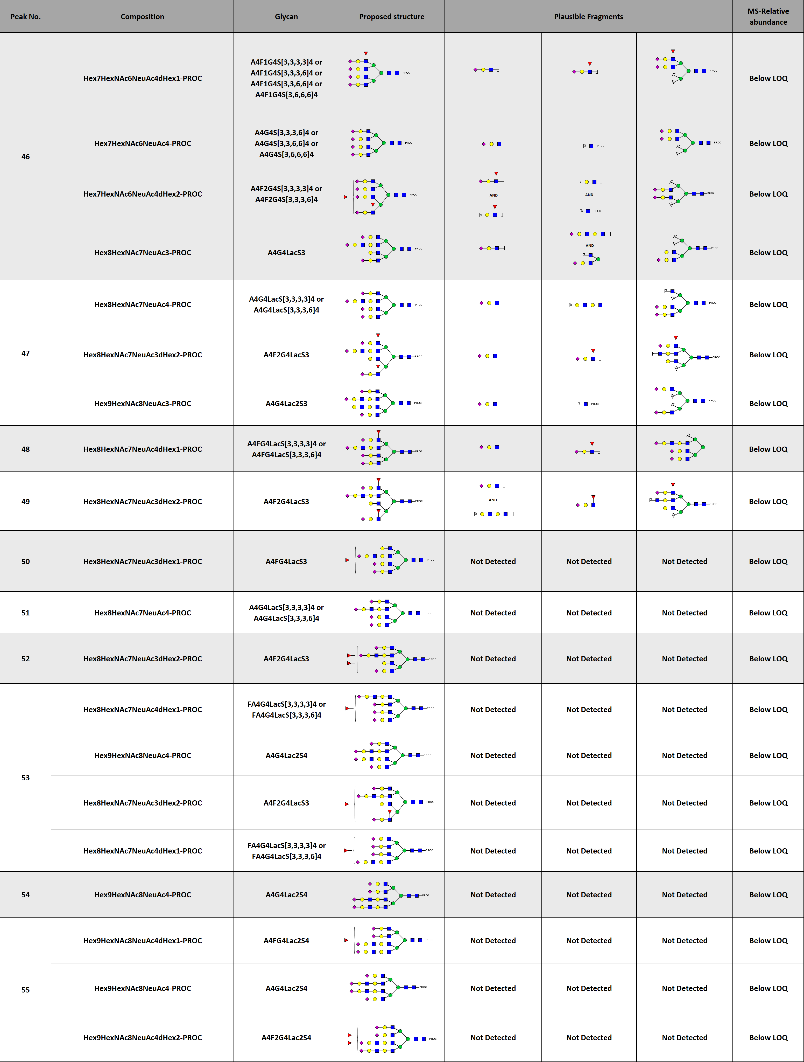
Supplementary Table 2A. LC derived trait construction table with actual peaks names used for derived trait calculation, glycan structure, composition and glycan classification (A=Antennarity, F=Fucosylation, B= Bisection, G=Galactosylation and S=Sialylation).
Supplementary Table 2A. Continued.
Supplementary Table 2B. Formulas used for calculation of LC derived traits. This table illustrates the calculations that were used to determine the derived traits of glycosylation. Each derived trait is designed to reflect the activity of a single enzymatic step, e.g., the derived trait A2F shows the percentage fucosylation of diantennary glycans which reflects fucosyltransferase activity.

Supplementary Table 2B. Continued.

Supplementary Table 3. Technical variation of serum N-glycan standards. A total of 18 serum standards was measured over 6 plates, from which the relative intensity, standard deviation and co-efficient of variation of 39 N-glycan peaks was determined. The table shows that the main glycan peak, A2G2S2 (peak 22), shows a co-efficient of variation of 1.56%.
Serum N-glycan Standard Repeatability
Peak No. | Plate 1 |  |  | Plate 2 |  |  |  | Plate 3 |  |  | Plate 4 |  |  | Plate 5 |  |  | Plate 6 |  |  | Average | SD | CV
Peak No. | Sample 1 | Sample 2 | Sample 3 |  | Sample 1 | Sample 2 | Sample 3 | Sample 1 | Sample 2 | Sample 3 | Sample 1 | Sample 2 | Sample 3 | Sample 1 | Sample 2 | Sample 3 | Sample 1 | Sample 2 | Sample 3
p3 | 1.83 | 1.65 | 1.66 | 1.57 |  | 1.58 | 1.55 | 1.53 | 1.61 | 1.57 | 1.59 | 1.52 | 1.49 | 1.66 | 1.60 | 1.60 | 1.50 | 1.71 | 1.46 | 1.59 | 0.09 | 5.45
p4 | 0.76 | 0.70 | 0.73 | 0.70 |  | 0.73 | 0.69 | 0.70 | 0.73 | 0.70 | 0.74 | 0.75 | 0.74 | 0.72 | 0.70 | 0.69 | 0.74 | 0.85 | 0.74 | 0.73 | 0.04 | 5.04
p5 | 0.45 | 0.42 | 0.39 | 0.40 |  | 0.39 | 0.39 | 0.36 | 0.38 | 0.39 | 0.37 | 0.36 | 0.36 | 0.38 | 0.36 | 0.37 | 0.31 | 0.41 | 0.34 | 0.38 | 0.03 | 8.16
p7 | 1.77 | 1.68 | 1.62 | 1.55 |  | 1.56 | 1.53 | 1.54 | 1.60 | 1.57 | 1.60 | 1.55 | 1.54 | 1.67 | 1.61 | 1.63 | 1.52 | 1.81 | 1.47 | 1.60 | 0.09 | 5.49
p8 | 0.68 | 0.64 | 0.62 | 0.58 |  | 0.58 | 0.59 | 0.58 | 0.60 | 0.60 | 0.58 | 0.56 | 0.54 | 0.61 | 0.59 | 0.58 | 0.53 | 0.64 | 0.52 | 0.59 | 0.04 | 6.72
p9 | 0.60 | 0.55 | 0.56 | 0.52 |  | 0.55 | 0.52 | 0.54 | 0.54 | 0.55 | 0.58 | 0.55 | 0.55 | 0.57 | 0.54 | 0.54 | 0.53 | 0.64 | 0.53 | 0.55 | 0.03 | 5.37
p10 | 0.98 | 0.94 | 0.93 | 0.88 |  | 0.94 | 0.89 | 0.89 | 0.92 | 0.91 | 0.95 | 0.95 | 0.92 | 0.89 | 0.88 | 0.88 | 0.89 | 1.07 | 0.91 | 0.92 | 0.05 | 5.06
p11 | 0.32 | 0.33 | 0.29 | 0.35 |  | 0.32 | 0.30 | 0.33 | 0.32 | 0.32 | 0.32 | 0.31 | 0.30 | 0.23 | 0.23 | 0.23 | 0.44 | 0.53 | 0.46 | 0.33 | 0.08 | 23.77
p12 | 1.49 | 1.43 | 1.37 | 1.35 |  | 1.34 | 1.30 | 1.33 | 1.35 | 1.36 | 1.36 | 1.33 | 1.31 | 1.37 | 1.28 | 1.31 | 1.32 | 1.66 | 1.30 | 1.36 | 0.09 | 6.60
p13 | 0.34 | 0.35 | 0.31 | 0.30 |  | 0.30 | 0.29 | 0.26 | 0.31 | 0.30 | 0.33 | 0.31 | 0.31 | 0.32 | 0.29 | 0.29 | 0.32 | 0.39 | 0.33 | 0.31 | 0.03 | 8.74
p14 | 0.57 | 0.52 | 0.54 | 0.59 |  | 0.55 | 0.55 | 0.54 | 0.55 | 0.56 | 0.61 | 0.60 | 0.59 | 0.53 | 0.55 | 0.53 | 0.65 | 0.69 | 0.68 | 0.58 | 0.05 | 8.86
p15 | 0.71 | 0.69 | 0.68 | 0.64 |  | 0.67 | 0.64 | 0.65 | 0.66 | 0.65 | 0.61 | 0.60 | 0.61 | 0.64 | 0.62 | 0.65 | 0.60 | 0.67 | 0.59 | 0.64 | 0.03 | 5.10
p16 | 9.32 | 9.14 | 8.79 | 9.46 |  | 9.31 | 8.90 | 9.10 | 8.95 | 8.70 | 8.84 | 8.78 | 8.76 | 7.82 | 7.69 | 7.65 | 10.78 | 11.46 | 10.69 | 9.12 | 1.01 | 11.11
p17 | 0.62 | 0.59 | 0.56 | 0.65 |  | 0.64 | 0.61 | 0.58 | 0.56 | 0.57 | 0.67 | 0.61 | 0.62 | 0.51 | 0.55 | 0.55 | 0.63 | 0.56 | 0.59 | 0.59 | 0.04 | 7.04
p18 | 3.90 | 3.66 | 3.66 | 3.71 |  | 3.76 | 3.62 | 3.54 | 3.63 | 3.60 | 3.65 | 3.62 | 3.59 | 3.59 | 3.48 | 3.50 | 3.64 | 3.95 | 3.62 | 3.65 | 0.12 | 3.31
p19 | 2.36 | 2.36 | 2.40 | 2.56 |  | 2.44 | 2.58 | 2.38 | 2.45 | 2.43 | 2.63 | 2.57 | 2.69 | 2.52 | 2.56 | 2.73 | 2.52 | 2.53 | 2.48 | 2.51 | 0.11 | 4.28
p20 | 4.22 | 3.97 | 4.04 | 3.89 |  | 3.99 | 3.86 | 3.94 | 3.95 | 3.96 | 3.95 | 3.91 | 3.78 | 3.97 | 3.89 | 3.73 | 3.72 | 3.83 | 3.74 | 3.91 | 0.12 | 3.16
p22 | 41.94 | 40.77 | 41.71 | 41.90 |  | 41.75 | 42.41 | 41.50 | 41.98 | 41.66 | 41.72 | 41.51 | 41.29 | 42.06 | 42.07 | 42.15 | 40.50 | 40.28 | 40.30 | 41.53 | 0.65 | 1.56
p26 | 5.84 | 5.73 | 5.91 | 5.74 |  | 5.76 | 5.80 | 5.78 | 5.89 | 5.87 | 6.17 | 6.06 | 6.01 | 6.16 | 6.10 | 6.15 | 5.71 | 5.75 | 5.65 | 5.89 | 0.17 | 2.92
p27 | 2.18 | 2.18 | 2.23 | 2.19 |  | 2.20 | 2.24 | 2.25 | 2.25 | 2.30 | 2.32 | 2.30 | 2.27 | 2.34 | 2.35 | 2.33 | 2.11 | 2.11 | 2.12 | 2.24 | 0.08 | 3.44
p28 | 1.19 | 1.31 | 1.17 | 1.26 |  | 1.26 | 1.23 | 1.29 | 1.22 | 1.24 | 1.23 | 1.21 | 1.24 | 1.07 | 1.09 | 1.08 | 1.53 | 1.46 | 1.52 | 1.26 | 0.13 | 10.56
p29 | 0.26 | 0.27 | 0.26 | 0.25 |  | 0.26 | 0.24 | 0.29 | 0.26 | 0.28 | 0.26 | 0.27 | 0.27 | 0.25 | 0.26 | 0.26 | 0.27 | 0.25 | 0.30 | 0.26 | 0.01 | 5.35
p30 | 0.13 | 0.15 | 0.14 | 0.14 |  | 0.17 | 0.14 | 0.18 | 0.15 | 0.17 | 0.18 | 0.21 | 0.20 | 0.16 | 0.15 | 0.16 | 0.18 | 0.15 | 0.21 | 0.17 | 0.02 | 14.83
p31 | 0.89 | 1.00 | 0.92 | 1.02 |  | 1.00 | 0.94 | 1.01 | 0.96 | 0.92 | 0.91 | 0.94 | 0.98 | 0.79 | 0.79 | 0.77 | 1.23 | 1.14 | 1.24 | 0.97 | 0.13 | 13.58
p32a | 0.45 | 0.58 | 0.49 | 0.53 |  | 0.48 | 0.49 | 0.53 | 0.47 | 0.49 | 0.47 | 0.46 | 0.50 | 0.42 | 0.38 | 0.40 | 0.67 | 0.61 | 0.64 | 0.50 | 0.08 | 15.61
p32b | 0.77 | 0.82 | 0.80 | 0.83 |  | 0.84 | 0.79 | 0.86 | 0.83 | 0.87 | 0.83 | 0.85 | 0.90 | 0.82 | 0.85 | 0.84 | 0.85 | 0.77 | 0.87 | 0.83 | 0.03 | 3.92
p33a | 0.23 | 0.25 | 0.25 | 0.22 |  | 0.25 | 0.21 | 0.24 | 0.24 | 0.27 | 0.24 | 0.27 | 0.27 | 0.24 | 0.24 | 0.24 | 0.25 | 0.20 | 0.26 | 0.24 | 0.02 | 7.91
p34a | 5.77 | 6.18 | 6.19 | 6.09 |  | 6.07 | 6.25 | 6.10 | 6.09 | 6.12 | 5.99 | 6.04 | 6.08 | 6.19 | 6.35 | 6.39 | 5.82 | 5.48 | 5.84 | 6.06 | 0.22 | 3.60
p34b | 0.73 | 0.79 | 0.81 | 0.80 |  | 0.79 | 0.77 | 0.87 | 0.81 | 0.85 | 0.81 | 0.82 | 0.87 | 0.87 | 0.93 | 0.88 | 0.81 | 0.72 | 0.84 | 0.82 | 0.05 | 6.43
p35 | 0.40 | 0.49 | 0.46 | 0.41 |  | 0.44 | 0.43 | 0.47 | 0.44 | 0.47 | 0.47 | 0.51 | 0.51 | 0.50 | 0.49 | 0.49 | 0.45 | 0.38 | 0.46 | 0.46 | 0.04 | 8.05
p36 | 2.07 | 2.22 | 2.28 | 1.97 |  | 1.96 | 2.22 | 2.15 | 2.04 | 2.16 | 2.04 | 2.28 | 2.01 | 2.27 | 2.17 | 2.17 | 1.93 | 1.87 | 1.96 | 2.10 | 0.13 | 6.21
p37 | 3.84 | 4.13 | 4.15 | 4.24 |  | 4.25 | 4.19 | 4.17 | 4.26 | 4.16 | 4.13 | 4.07 | 4.32 | 4.25 | 4.51 | 4.47 | 4.07 | 3.67 | 3.98 | 4.16 | 0.20 | 4.79
p38 | 0.77 | 0.92 | 0.85 | 0.91 |  | 0.90 | 0.85 | 0.95 | 0.87 | 0.92 | 0.90 | 0.83 | 0.93 | 0.93 | 1.01 | 1.01 | 0.91 | 0.76 | 0.97 | 0.90 | 0.07 | 7.56
p39 | 0.19 | 0.31 | 0.26 | 0.21 |  | 0.24 | 0.24 | 0.33 | 0.26 | 0.35 | 0.29 | 0.34 | 0.40 | 0.37 | 0.37 | 0.38 | 0.28 | 0.18 | 0.36 | 0.30 | 0.07 | 23.47
p40 | 0.23 | 0.37 | 0.28 | 0.22 |  | 0.23 | 0.24 | 0.32 | 0.26 | 0.31 | 0.21 | 0.31 | 0.30 | 0.29 | 0.29 | 0.26 | 0.29 | 0.15 | 0.31 | 0.27 | 0.05 | 18.79
p41 | 0.41 | 0.61 | 0.57 | 0.54 |  | 0.57 | 0.54 | 0.63 | 0.57 | 0.61 | 0.56 | 0.59 | 0.65 | 0.66 | 0.71 | 0.72 | 0.54 | 0.36 | 0.60 | 0.58 | 0.09 | 15.58
p42 | 0.42 | 0.66 | 0.61 | 0.38 |  | 0.41 | 0.45 | 0.58 | 0.49 | 0.63 | 0.41 | 0.59 | 0.56 | 0.64 | 0.66 | 0.57 | 0.40 | 0.17 | 0.51 | 0.51 | 0.13 | 25.35
p43 | 0.16 | 0.25 | 0.20 | 0.27 |  | 0.29 | 0.26 | 0.32 | 0.29 | 0.27 | 0.27 | 0.28 | 0.33 | 0.31 | 0.36 | 0.38 | 0.31 | 0.15 | 0.30 | 0.28 | 0.06 | 22.22
p45 | 0.18 | 0.36 | 0.28 | 0.18 |  | 0.25 | 0.25 | 0.37 | 0.27 | 0.35 | 0.23 | 0.36 | 0.40 | 0.42 | 0.47 | 0.44 | 0.24 | 0.01 | 0.32 | 0.30 | 0.11 | 37.33

Supplementary Table 4: TSNG derived trait comparison displaying the average relative intensity (RI) between HC and SC. The p-value of the age, sex and age-sex interaction corrected generalized linear model and the direction (D) of change are shown for each comparison. The table shows that there were no significant differences between healthy and symptomatic controls after Bonferroni multiple testing correction.
Derived Trait | HC  (RI %) | SC  (RI %) | p-value  (C-CD) | D
A2F | 33.2 | 32.6 | 3.9×10⁻¹ | -
A3F | 56.9 | 56.7 | 9.8×10⁻¹ | -
A4F | 15.4 | 16.1 | 2.0×10⁻¹ | -
A2B | 16.9 | 16.1 | 3.8×10⁻¹ | -
A2F0B | 8.6 | 8.2 | 2.3×10⁻¹ | -
A2FB | 37.2 | 36.4 | 7.8×10⁻¹ | -
A2S0B | 64.6 | 63.9 | 3.6×10⁻¹ | -
A2F0S0B | 83.1 | 84.1 | 8.9×10⁻¹ | -
A2FS0B | 20.0 | 18.5 | 6.0×10⁻¹ | -
A2SB | 11.4 | 11.0 | 9.8×10⁻¹ | -
A2F0SB | 2.6 | 2.5 | 9.5×10⁻¹ | -
A2FSB | 36.8 | 35.8 | 9.6×10⁻¹ | -
A2S0G | 55.4 | 56.5 | 9.1×10⁻¹ | -
A2F0S0G | 54.7 | 57.3 | 9.5×10⁻¹ | -
A2FS0G | 50.8 | 52.3 | 8.7×10⁻¹ | -
A2S | 80.0 | 81.0 | 1.2×10⁻¹ | -
A2F0S | 84.6 | 85.1 | 5.7×10⁻¹ | -
A2FS | 53.7 | 55.8 | 2.9×10⁻³ | -
A3S | 101.8 | 100.1 | 2.1×10⁻¹ | -
A3F0S | 99.1 | 96.7 | 1.5×10⁻¹ | -
A3FS | 136.4 | 133.5 | 3.9×10⁻² | -
FA2[r6]G1 | 56.7 | 56.8 | 7.9×10⁻¹ | -
FA2[r6]B0G1 | 71.8 | 73.7 | 6.5×10⁻³ | -
FA2[r6]BG1 | 35.3 | 33.2 | 4.4×10⁻¹ | -

Supplementary Table 5: Prediction of inflammatory bowel disease stratification using N-Glycan biomarkers. Various lengths of potential glycan biomarkers were evaluated to estimate the stratification potential of glycan biomarkers, the biomarker that yielded the highest AUC is presented for each length of biomarker.
Glycan biomarker length | CD vs. Controls  (AUC) | UC vs. Controls  (AUC) | CD vs. UC  (AUC)
1 | A2F0S0G  (0.85237) | A2FS0G  (0.82126) | FA2[r6]G1  (0.62032)
2 | A2F0S0G + A3FS  (0.83637) | A3F + A2F0S0G  (0.81111) | A2FS + FA2[r6]B0G1 (0.69220)
3 | A2FS0G + A3FS + FA2[r6]G1 (0.85458) | A2FB + A2FS0G + A3FS (0.83339) | A2F0SB + A2FS + FA2[r6]B0G1 (0.72421)
4 | A2S0B + A2F0S0G + A2F0S + A2FS (0.87646) | A3F + A2F0S0G + A2FS + A3S (0.84199) | A2F0S0B + A2S0G + A2FS + FA2[r6]B0G1 (0.75166)
5 | A3F + A4F + A2F0S0G + A2F0S + A2FS (0.87824) | A3F + A2SB + A2FSB + A2S0G + A3F0S (0.84042) | A4F + A2FS0B + A2FS + A3S + FA2[r6]B0G1 (0.75314)
6 | A3F + A4F + A2SB + A2F0SB + A2S0G + A3FS (0.87784) | A2F + A3F + A2F0S0B + A2S0G + A2F0S0G + FA2[r6]B0G1 (0.85565) | A2F0S0B + A2FS0B + A2SB + A2S + A2F0S + FA2[r6]B0G1 (0.74891)
7 | A3F + A4F + A2B + A2F0S0G + A2FS0G + A3F0S + FA2[r6]BG1 (0.87794) | A3F + A2S0B + A2SB + 2F0S0G + A2FS0G + A3F0S + FA2[r6]G1 (0.84432) | A3F + A2S0B + A2F0SB + A2S0G + A2F0S0G + FA2[r6]G1 + FA2[r6]BG1 (0.75251)

Supplementary Table 6. Glycomics biomarkers and the corresponding area under the curve (AUC). The AUC was determined for all combinations between 1 to 7 derived glycan traits and the corresponding AUC for each putative glycomics biomarker length are shown in the table below. The maximum AUC for each category (disease) is marked by a light grey fill.
Glycan maker no. | IBD |  | CD |  | UC
Glycan maker no. | Derived trait | AUC | Derived trait | AUC | Derived trait | AUC
1 | A2F0S | 0.73179 | A2S0B | 0.84666 | A2F0S | 0.85645
2 | A2F0S0G+A2FS | 0.84593 | A2F0B + A2S0G | 0.95666 | A2FSB+FA2[r6]G1 | 0.85307
3 | A2F0S0G+FA2[r6]B0G1+ FA2[r6]BG1 | 0.84523 | A2F0B + A2FB + A2S0G | 0.94666 | A3F + A2S0G + A3F0S | 0.92822
4 | A2F+A2S0B+A2F0S0G+A3S | 0.86484 | A2F + A2SB + A2F0SB + A2FS0G | 0.94333 | A3F + A2F0SB + A2F0S0G + A3F0S | 0.91626
5 | A2FS0B+A2FSB+A2S+A2F0S+ FA2[r6]BG1 | 0.90478 | A4F+A2FS0B+A2F0SB+A2F0S+ A2FS | 0.94642 | A3F + A2FB + A2FSB + A3S + FA2[r6]B0G1 | 0.95614
6 | A4F+A2S0B+A2F0SB+A2S0G+ A2F0S0G+A2F0S | 0.91023 | A3F + A4F + A2FS0G + A2S + A3S + A3F0S | 0.95000 | A2B + A2S0B + A2F0S0B + A2F0SB + A2FS + FA2[r6]G1 | 0.97129
7 | A4F+A2B+A2F0B+A2S0B+ A2F0SB+A2S0G+A2F0S | 0.93989 | A3F+A4F+A2B+A2F0S0G+A2F0S+A3S+A3F0S | 0.96788 | A4F+A2B+A2F0S0B+A2FS0B+ A2SB+A2FSB+A2S | 0.96418

Note: As there was no significant jump in the AUC on a log plot after 2 markers for CD (AUC 0.96), the combination of 7 derived traits with AUC of 0.97 was disregarded.

Supplemental Table 7: Survival analysis results for the best glycomics biomarker. This table shows the number of escalators and non-escalators for each group of patients, classified according to their risk-factor as predicted by age, sex, and age-sex interaction terms, corrected Cox PH models. The results show significance for all IBD patients.
Group | IBD |  | CD |  | UC
Cohort | Discovery Cohort  (Edinburgh)
Risk | Low | High | Low | High | Low | High
Escalators | 2 | 19 | 1 | 9 | 1 | 10
Non-Escalators | 58 | 3 | 28 | 2 | 36 | 2
p-value | 1.12E⁻¹² |  | 6.81E⁻⁰⁶ |  | 1.88E⁻⁰⁴
Hazard Ratio | 25.91 |  | 23.73 |  | 30.83

Supplemental Table 8: Survival analysis results combining hsCRP with the best glycomics biomarker. This table shows the number of escalators and non-escalators for each group of patients, classified according to their risk-factor as predicted by age, sex as well as age and sex interaction corrected Cox PH model. The results show significance for both IBD and CD patients, albeit the results are worse than when using only the glycomics results (Supplementary Table 9).
Category | IBD |  | CD |  | UC
Cohort | Discovery Cohort  (Edinburgh)
Risk | Low | High | Low | High | Low | High
Escalators | 1 | 15 | 4 | 4 | 4 | 4
Non-Escalators | 26 | 30 | 14 | 11 | 35 | 3
p-value | 7.01E⁻¹² |  | 2.33E⁻⁰⁵ |  | 0.10
Hazard Ratio | 9.00 |  | 1.20 |  | 5.57

Supplementary Table 9. Clinical biomarkers and the corresponding area under the curve (AUC). The AUC was determined between albumin (Alb), high sensitivity C-reactive protein (hsCRP) and a combination of the two markers. The corresponding AUC for each putative clinical biomarker is shown in the table, with the maximum AUC for each disease marked by a light grey fill.
Clinical Markers |  | AUC
 |  | IBD | CD | UC
1 | Alb | 0.62 | 0.77 | 0.57
2 | hsCRP | 0.57 | 0.55 | 0.45
3 | Alb+hsCRP | 0.57 | 0.38 | 0.30

Supplementary Table 10. UHPLC gradient for running conditions. The table lists the gradient that was used to measure all samples, including the time at which the flowrate and/or the ratio between solvent A (50mM formate buffer) and solvent B (ACN) changes are listed. The gradient starts at 76% ACN and over a period of 53.5 minutes goes to 51% ACN, during which times all observed glycans elute from the column.

Time | Flow (mL/Min) | Acetonitrile (% solvent B)
0.000 | Equilibration
0.000 | Run
0.000 | 0.400 | 76.0
53.500 | 0.400 | 51.0
55.500 | 0.250 | 00.0
57.500 | 0.250 | 00.0
59.500 | 0.250 | 76.0
65.500 | 0.250 | 76.0
66.500 | 0.400 | 76.0
70.000 | 0.400 | 76.0
70.100 | 0.020 | 76.0
70.100 | Stop run

Supplementary Table 11A: Glycan annotation, retention time and retention time window used for calibration of the IBD cohort. This table lists all glycan compositions that were used to perform retention time (t_{r}) calibration as well as the t_{r} window (Δt_{r}). The Δt_{r} was dependent on the local relative intensity of each glycan, e.g., A2G2S2 normally is the most abundant glycan peak and therefore the Δt_{r} was larger than a low abundant peak such as FA4G4S4⁴.

Glycan Annotation | Retention time  (t_{r}) | t_{r} window  (Δt_{r}) [s]
FA2 | 19.5 | 0.5
FA2G1 | 22.6 | 0.5
FA2G2 | 26.0 | 0.5
A2G2S1 | 28.7 | 1.0
A2G2S2 | 32.3 | 1.2
A3G3S3 | 37.3 | 0.65
FA4G4S4 | 42.7 | 0.4

Supplementary Table 11B: Glycan Peak ID’s, retention time and retention time windows used for glycan peak integration for all samples in the IBD discovery cohort. This table lists all chromatographic peaks (Actual peak Id) that was used for HappyTools based quantitation.
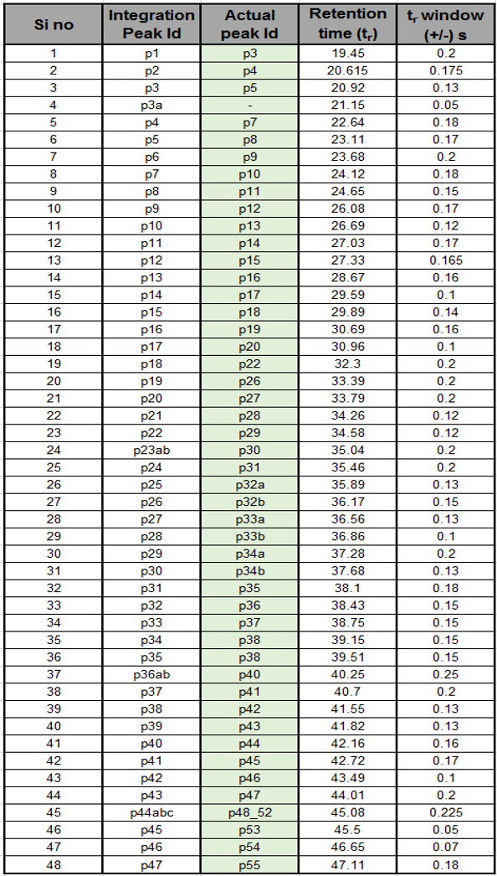

Supplementary Table 12. Demographics of patients with IBD disease escalation. A sub-group of 24 patients from the biomarker discovery study were classed as escalators either based on surgery or medical history. The tables below provide details on disease location, disease activity scores, disease behaviour and duration of follow-up.

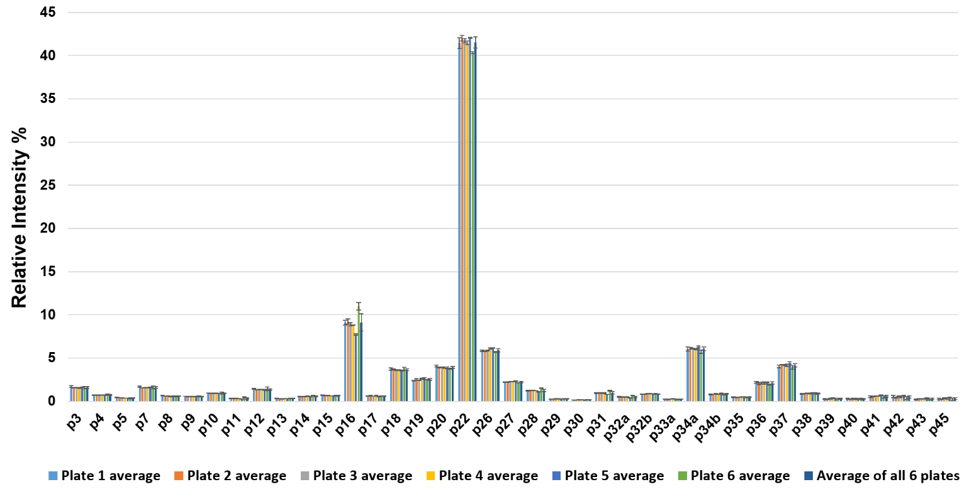
Supplementary Figure 1. Repeatability of serum N-glycan profiling by UHPLC after procainamide labeling. Eighteen serum standard samples from the same stock were dispensed into six 96 well plates (3 per plate) where serum N-glycans were released, enriched, labeled with procainamide and post-labeling clean-up was performed independently. The histogram shows a comparison of the relative intensity profiles of 39 major N-glycan peaks after total area normalization (average of triplicates from each plate and average of all 18 samples) and error bars depict standard deviation. (Refer to Supplementary Table 4A for glycan peak annotation).

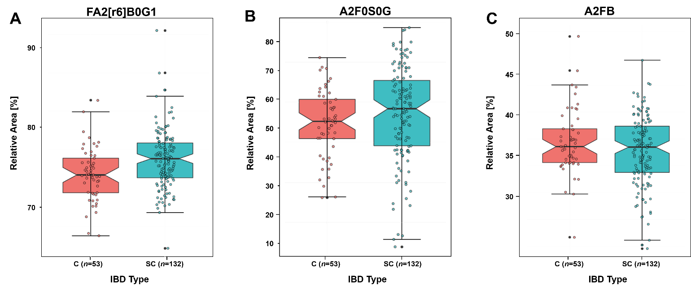
Supplementary Figure 2: Association of derived glycan traits between healthy controls (C) and symptomatic controls (SC). The boxplots illustrate that no significant differences are observed between C and SC derived glycan traits after Bonferroni multiple testing correction. Panel A, B and C are representative examples chosen from 24 derived glycan traits.
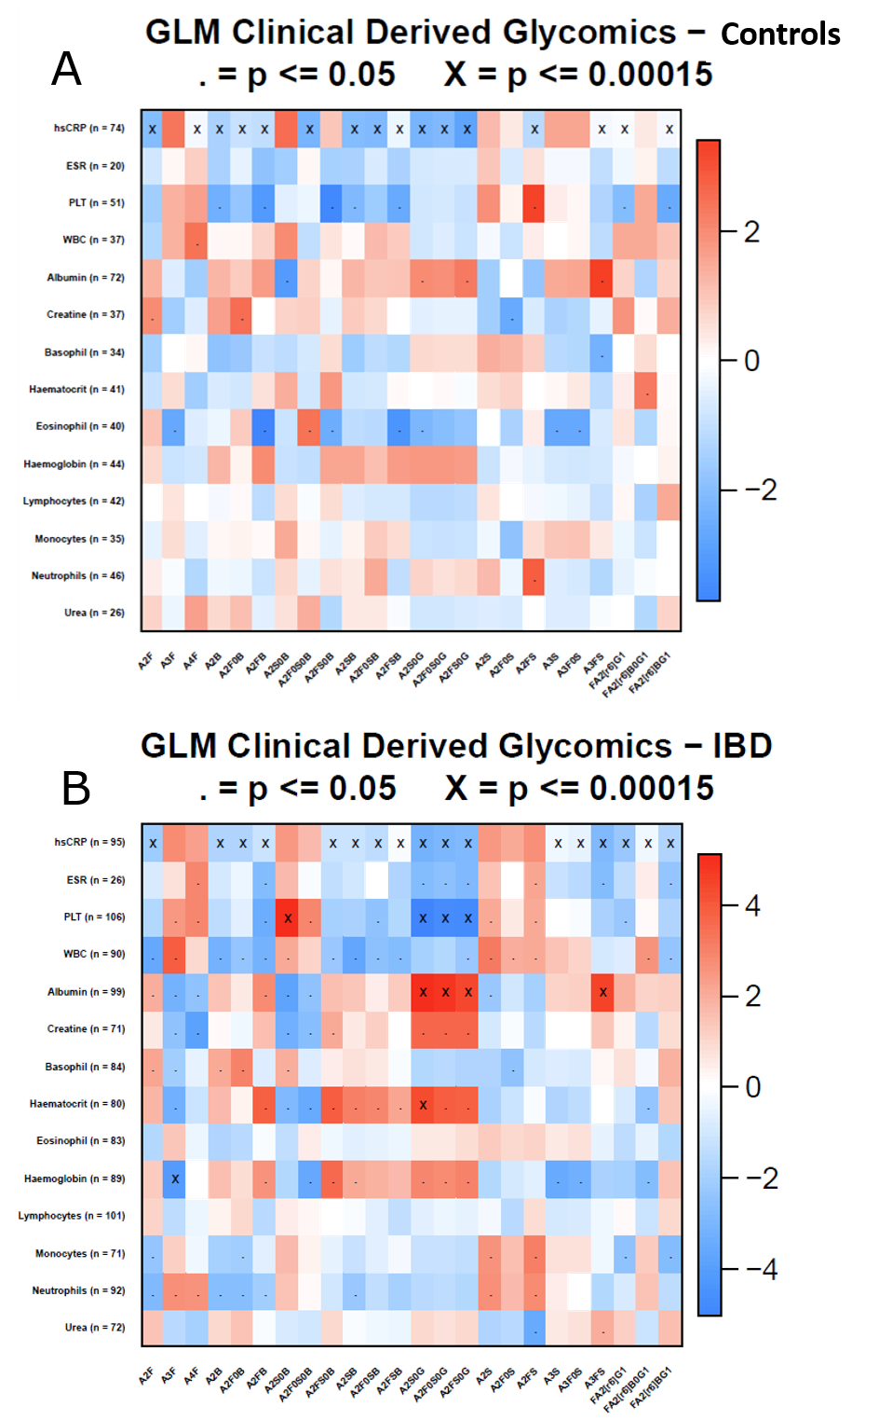

Supplementary Figure 3: Glycomics vs. clinical heatmap. Age and sex corrected generalized linear models were applied to all combinations of derived glycan traits and clinical parameters for (A) healthy controls and (B) IBD patients. Positive associations are featured in red and negative associations shown in blue (see legend for scale and for peak fitting). The direction and significance of the correlation was used to colour and label each combination, with significant correlations, where the direction of change and p-value were taken from age and sex corrected GLMs (n = 360). The results are marked with a ‘.’ if the p-value is below 0.05 and an ‘x’ if the p-value is below 1.38·10⁻⁴ (Bonferroni corrected).
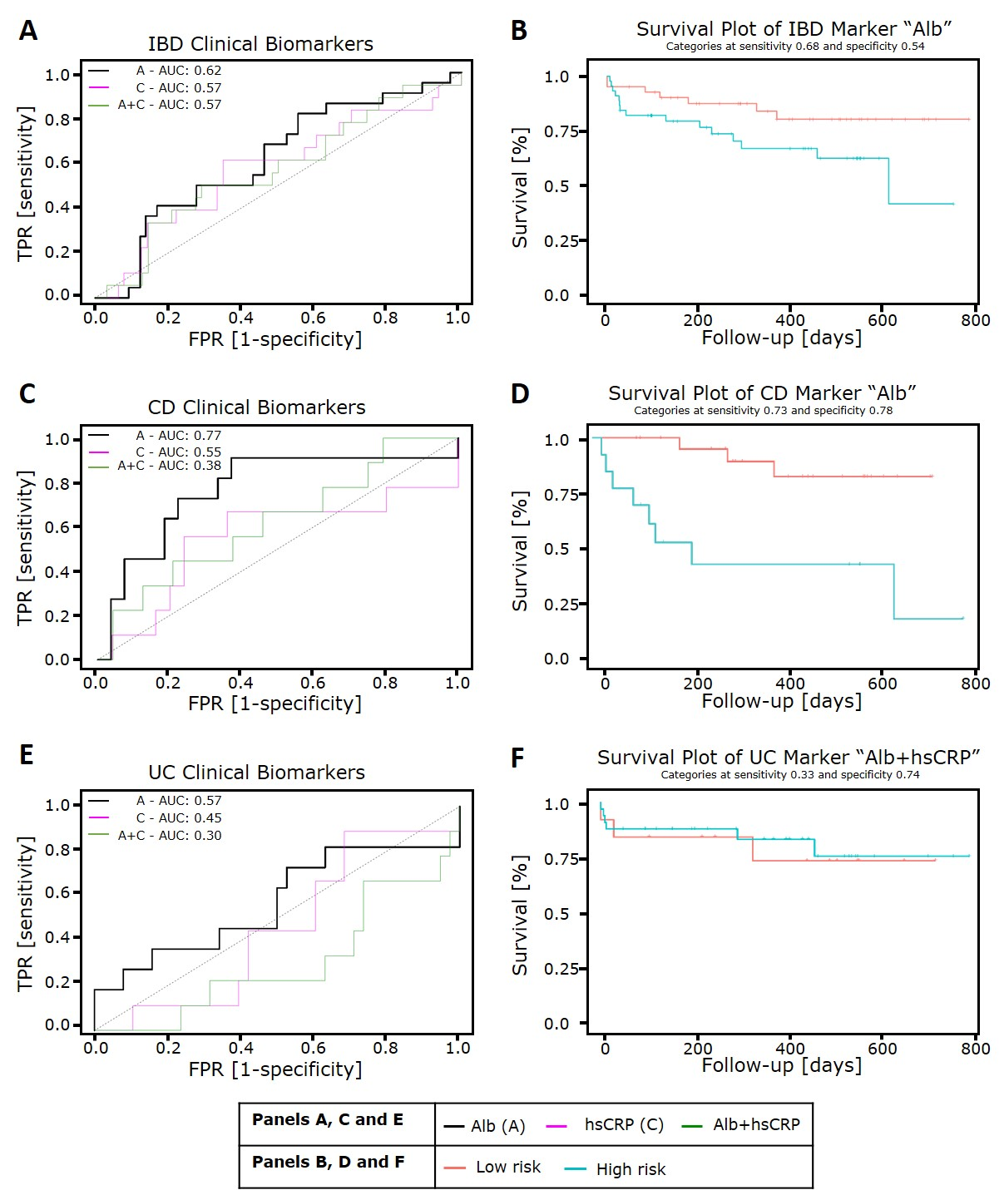
Supplementary Figure 4: ROC curves and Kaplan-Meier survival plots for prediction of escalation of disease using clinical blood biomarkers applied on IBD, CD and UC patients. Combinations between clinical blood markers (high-sensitivity C-reactive protein (hsCRP) and Albumin (Alb) where n=92), were used in leave-one-out validation. The combination that yielded the maximum area under the curve (AUC) for each length was stored to identify as the optimal clinical marker that could predict escalation of IBD. The optimal combination of blood markers that were identified by this approach were used in a Kaplan-Meier survival test, where the samples were split into two groups based on the optimal sensitivity and specificity that was determined using the ROC curve (displayed under the title as categories with cut-offs for sensitivity and specificity). (A) The optimal clinical escalation marker (black line) for IBD was shown to be Alb which yielded an AUC of 0.62. (B) Kaplan-Meier survival plot for the optimal marker for IBD. (C) The optimal clinical escalation biomarker for CD (black line) was shown to be Alb which yielded an AUC of 0.77. (D) Kaplan-Meier survival plot for the optimal marker for CD. (E) The optimal clinical escalation biomarker for UC (black line) was shown to be Alb which yielded an AUC of 0.57. (F) Kaplan-Meier survival plot for the optimal marker for UC.

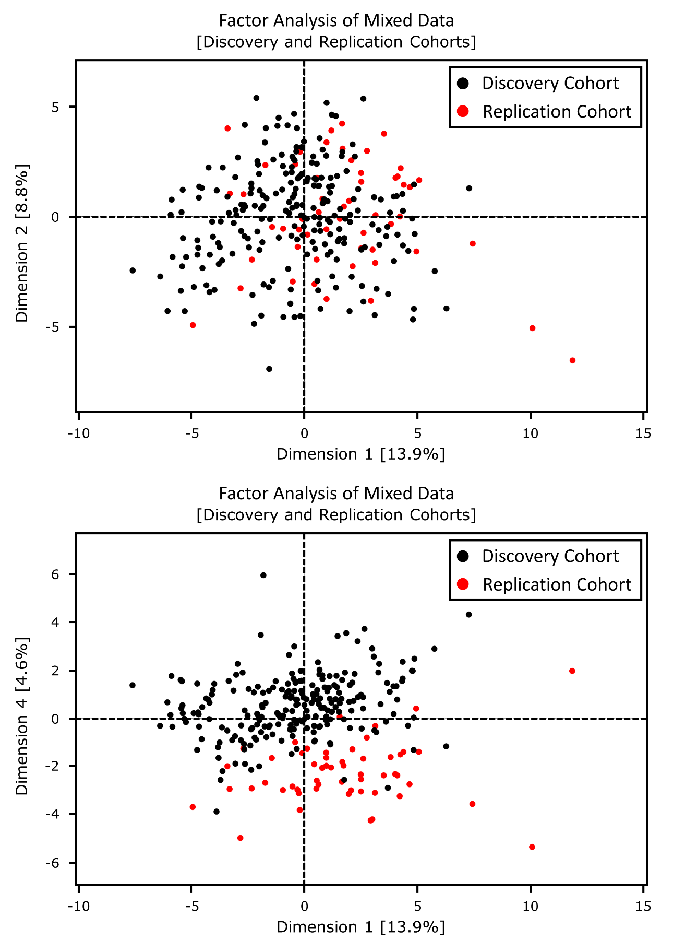
Supplementary Figure 5. Factor Analysis of Mixed Data using the discovery and replication cohorts. A combination of qualitative (sex, centre, diagnosis and escalation status) and quantitative (age, escalation time and derived traits of glycosylation) was used to assess the variation in the combined cohort. The measurements are colour coded according to the cohort they are derived from; black circles represent the discovery cohort while red circles represent the replication cohort. (A) FAMD showing the 1st and 2nd dimension that encompass 22.7% of the total variation. (B) FAMD showing the 1st and 4th dimension, where a centre effect is clearly seen on the 4th dimension with the replication cohort’s samples showing towards the negative axis while the discovery cohort’s samples are more towards the positive side.

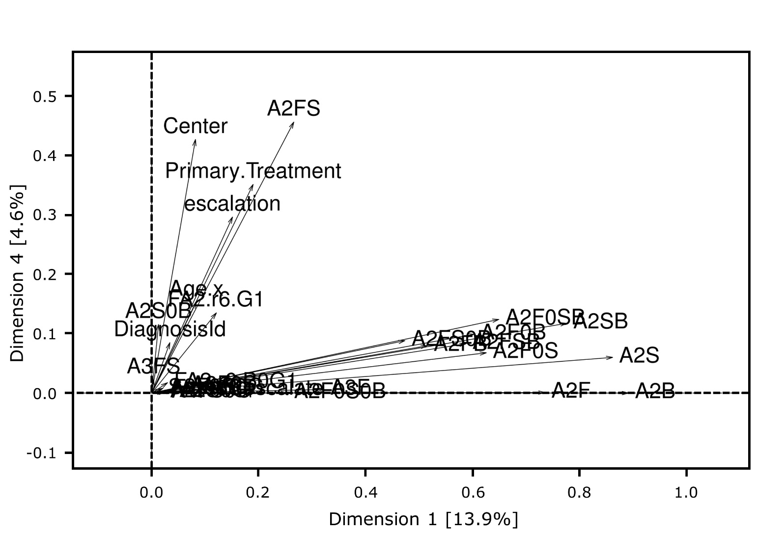
Supplementary Figure 6: Squared loadings plot of dimensions 1 and 4. The squared loadings of dimensions where the effect of the centre can be clearly seen on the 4th dimension. The centre effect is the second largest contributor to the 4th dimension with a squared loading of 0.43.

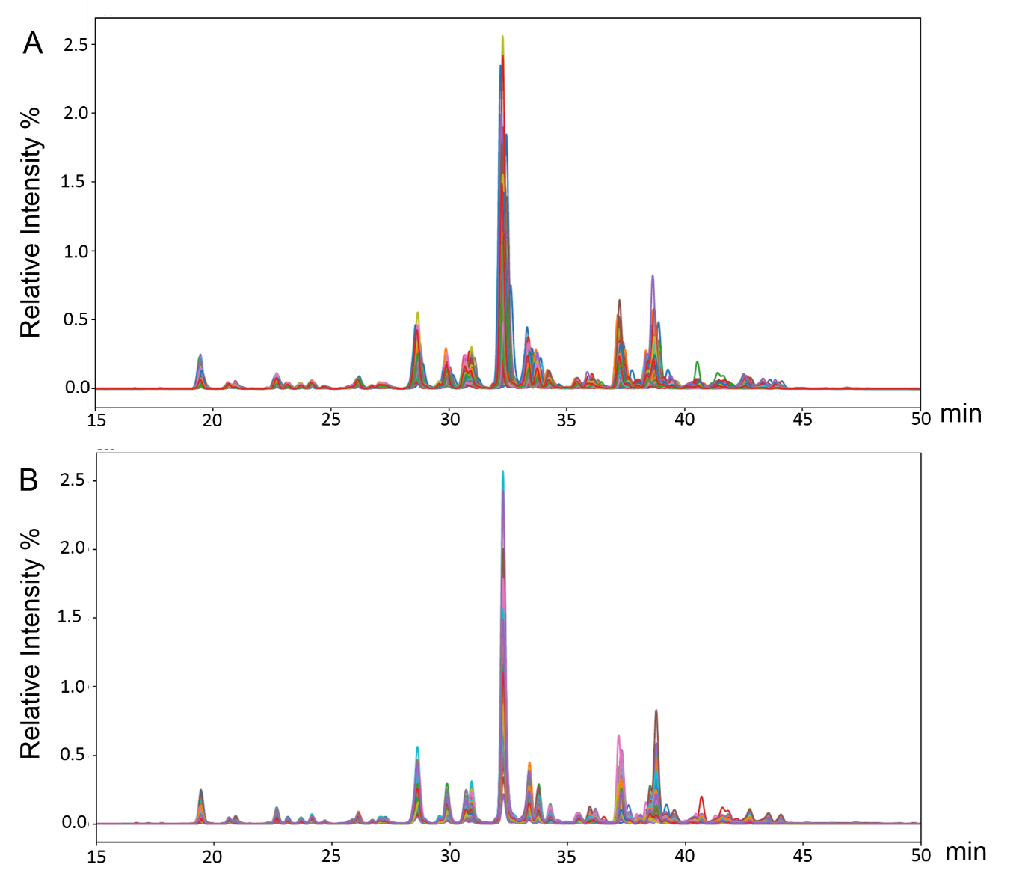

Supplementary Figure 7. A visual illustration of chromatograms overlaid prior to alignment is illustrated in Panel A, while the same chromatograms were overlaid to judge quality of calibration visually before proceeding with quantitation is shown in Panel B using HappyTools.

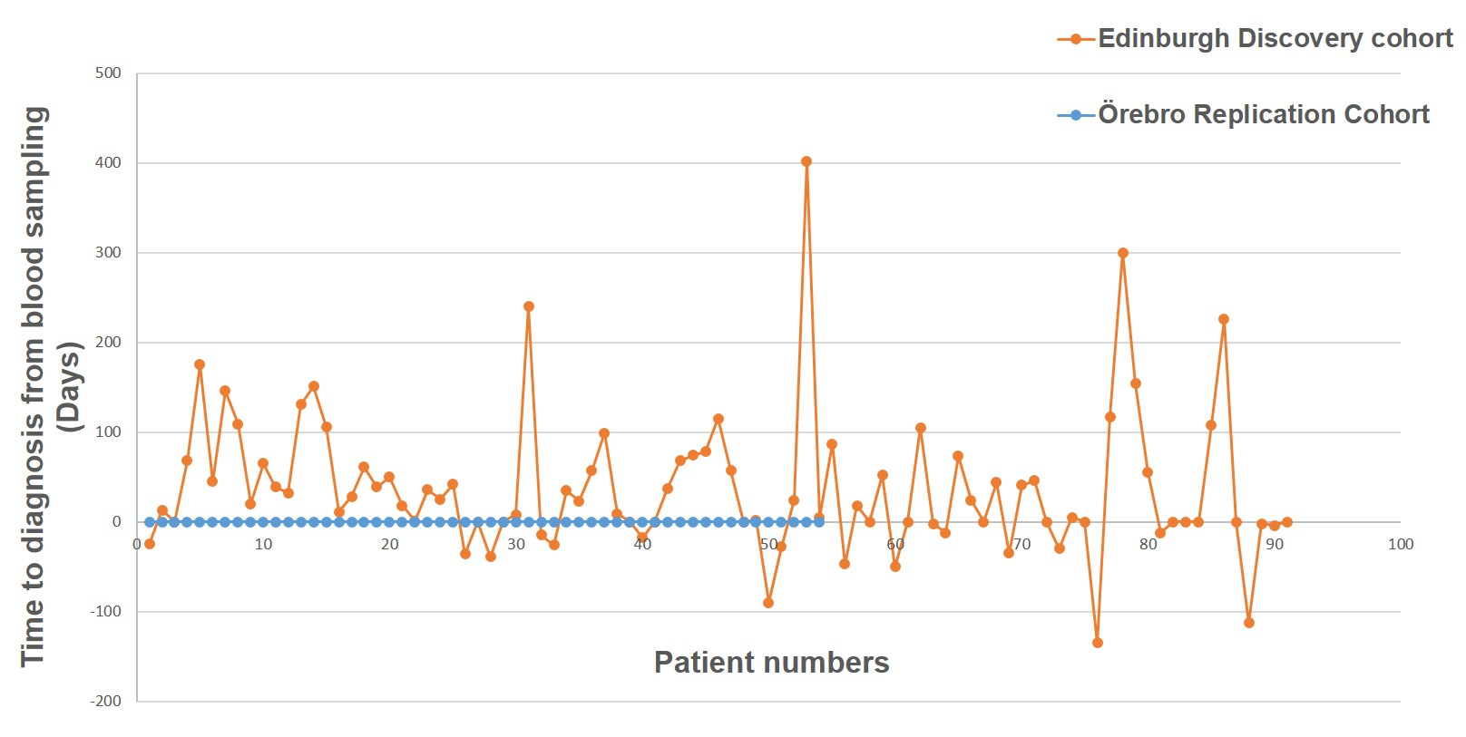
Supplementary Figure 8: Scatter plot depicting time taken to diagnose an IBD patient since their blood samples were first collected. A negative value in the scatter plot of the Edinburgh discovery cohort suggests that the blood samples were taken ‘X’ number of days prior to diagnosis when the patients were symptomatic and being investigated for IBD. Time to diagnosis is zero days for all Örebro replication cohort samples as endoscopy and blood sampling was done on the same day of diagnosis.

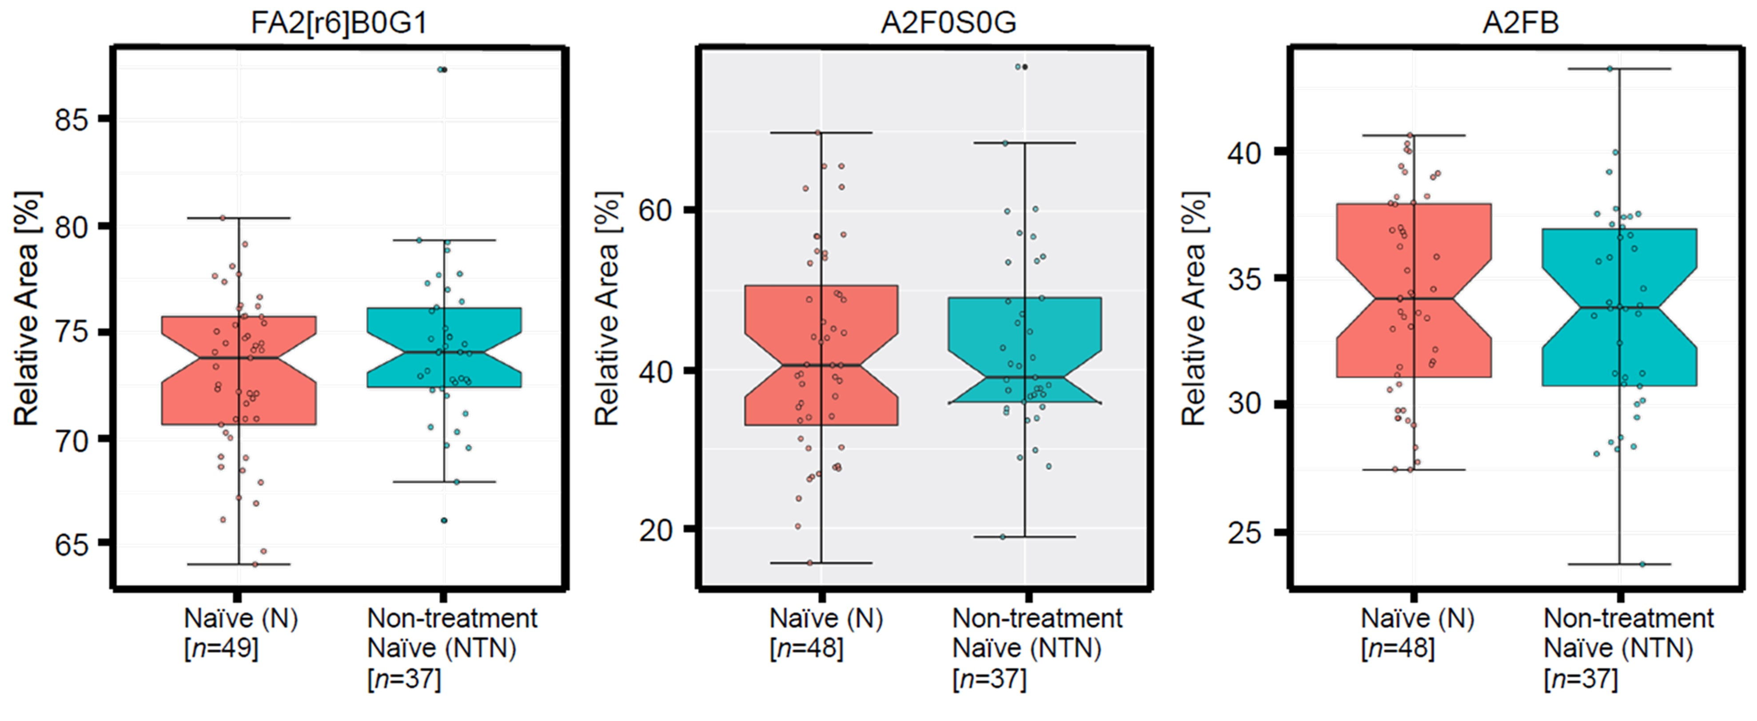
Supplementary Figure 9: Association of derived glycan traits between treatment naïve (N) and Non-treatment naïve (NTN) patients. The boxplots illustrate that no significant differences are observed between N and NTN derived glycan traits after Bonferroni multiple testing correction. Panel A, B and C are representative examples chosen from 24 derived glycan traits.

References
1. Clerc, F. et al. Plasma N -Glycan signatures are associated with features of inflammatory bowel diseases. Gastroenterology 155,829-843 (2018).
2. Trbojević Akmačić, I. et al. Inflammatory bowel disease associates with proinflammatory potential of the immunoglobulin G glycome. Inflamm Bowel Dis 21, 1237–1247 (2015).
3. Shinzaki, S. et al. IgG oligosaccharide alterations are a novel diagnostic marker for disease activity and the clinical course of inflammatory bowel disease. Am JGastroenterol 103, 1173–1181 (2008).
4. Clerc, F. et al. Human plasma protein N-glycosylation. Glycoconj J 33, 309–343 (2016).
5. Van Rooijen, J. J. M., Jeschke, U., Kamerling, J. P. & Vliegenthart, J. F. G. Expression of N-linked sialyl Le(X) determinants and O-glycans in the carbohydrate moiety of human amniotic fluid transferrin during pregnancy. Glycobiology 8, 1053–1064 (1998).
6. Reiding, K. R. et al. Serum protein N-glycosylation changes with rheumatoid arthritis disease activity during and after pregnancy. Front Med 4, 241 (2018).
7. Carré, Y., Klein, A., Mathurin, P., Michalski, J. C. & Morelle, W. Changes of serum-associated fucosylated glycoproteins and changes in glycosylation of IgA in human cirrhosis. Proteomics - Clin Appl 3, 609–622 (2009).
8. Ruhaak, L. R. et al. Targeted biomarker discovery by high throughput glycosylation profiling of human plasma alpha1-antitrypsin and immunoglobulin A. PloS one 8, e73082 (2013).
9. Fengming, Y. & Jianbing, W. Biomarkers of inflammatory bowel disease. Dis Markers 2014, 710915 (2014).
10. Khan, N., Patel, D., Shah, Y., Trivedi, C. & Yang, Y. X. Albumin as a prognostic marker for ulcerative colitis. World J Gastroenterol 23, 8008–8016 (2017).
11. Danese, S., Motte, C. de la & Fiocchi, C. Platelets in inflammatory bowel disease: clinical, pathogenic, and therapeutic implications. Am J Gastroenterol 99, 938–945 (2004).
12. Dall’Olio, F. et al. N-glycomic biomarkers of biological aging and longevity: A link with inflammaging. Ageing Res Rev 12, 685–698 (2013).
13. Falck, D. et al. Glycoforms of immunoglobulin g based biopharmaceuticals are differentially cleaved by trypsin due to the glycoform influence on higher-order structure. J Proteome Res 14, 4019–4028 (2015).
14. Sedgwick, P. Multiple significance tests: The Bonferroni method. BMJ344, e509 (2012).
15. Xia, J., Broadhurst, D. I., Wilson, M. & Wishart, D. S. Translational biomarker discovery in clinical metabolomics: An introductory tutorial. Metabolomics 9, 280–299 (2013).
16. Jansen, B. C. et al. HappyTools : A software for high-throughput HPLC data processing and quantitation. PLoS One, 13, e0200280 (2018).
17. Ceroni, A. et al. GlycoWorkbench : A tool for the computer-assisted annotation of mass spectra of gglycans. J Proteome Res, 7, 1650–1659 (2008).
18. Sing, T., Sander, O., Beerenwinkel, N. & Lengauer, T. ROCR: Visualizing classifier performance in R. Bioinformatics 21, 3940–3941 (2005).
19. Wickham,H. ggplot2 - Elegant Graphics for Data Analysis (2nd Edition). Publisher(s): Springer International Publishing, ISBN: 978-3-319-24275-0 (2016).

