Stratified Results for Clinician and Patient Statements

Clinician statements (English → Spanish)

Primary factors: No significant differences were detected for adequacy of meaning (human 4.77 vs. app 4.71; p = 0.41) or terminology accuracy (4.70 vs. 4.68; p = 0.81). In contrast, clarity was significantly higher for human translations (4.87 vs. 4.27; p = 0.003, r = 0.68).

Secondary factors: Small, inconsistent effects were seen. Completeness did not differ (4.85 vs. 4.75; p = 0.19), while cultural appropriateness showed a moderate human advantage (4.84 vs. 4.42; p < 0.001, r = 0.50). Neither grammar (4.84 vs. 4.64; p = 0.11) nor vocabulary (4.78 vs. 4.61; p = 0.20) reached significance.

Voice quality related factors: Large differences favored human interpreters for fluency (4.82 vs. 3.63; p < 0.001, r = 0.77), prosody (4.90 vs. 4.28; p < 0.001, r = 0.76), and pacing (4.87 vs. 4.31; p < 0.001, r = 0.72).

Conclusive factors: Both overall quality (4.75 vs. 4.17; p < 0.001, r = 0.60) and confidence for clinical use (4.77 vs. 4.15; p < 0.001, r = 0.61) were significantly higher for human translations.

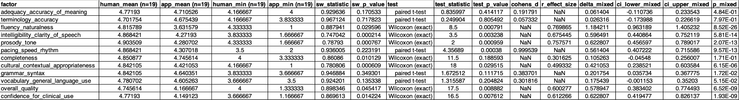
Link to table: {{attach link}}

Patient statements (Spanish → English)

Primary factors: No differences were observed in adequacy of meaning (4.87 vs. 4.68; p = 0.07) or terminology accuracy (4.95 vs. 4.83; p = 0.16). Clarity was significantly higher for human translations (4.88 vs. 4.47; p = 0.011, r = 0.58).

Secondary factors: Human interpreters scored higher on completeness (4.89 vs. 4.72; p = 0.12, not significant), cultural appropriateness (4.95 vs. 4.58; p < 0.001, r = 0.44), grammar (4.93 vs. 4.72; p < 0.001, r = 0.47), and vocabulary (4.94 vs. 4.75; p < 0.001, r = 0.48).

Voice quality related factors: Significant human advantages were observed for fluency (4.91 vs. 3.82; p = 0.002, r = 0.72), prosody (4.87 vs. 4.32; p < 0.001, r = 0.61), and pacing (4.88 vs. 4.64; p = 0.050, r = 0.45).

Conclusive factors: Both overall quality (4.89 vs. 4.32; p = 0.002, r = 0.70) and confidence for clinical use (4.88 vs. 4.29; p = 0.006, r = 0.64) were significantly higher for human interpreters.
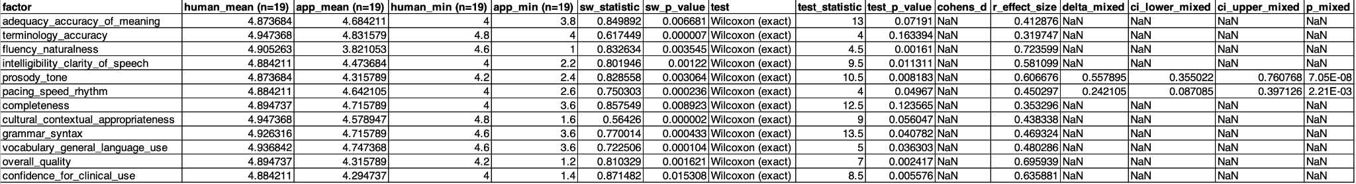
Link to table: {{attach link}}

