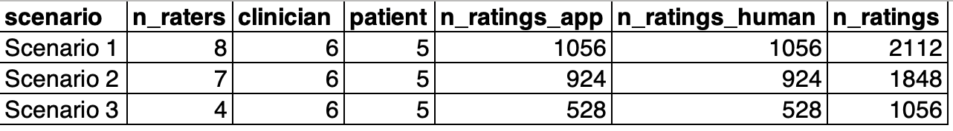
Table 1: Evaluator participation and rating distribution across scenarios: Each scenario included 11 dialogue lines (6 clinicians, 5 patients). Two AI and two human outputs per line were rated by bilingual clinicians, with totals reflecting combined evaluations for both translation arms.
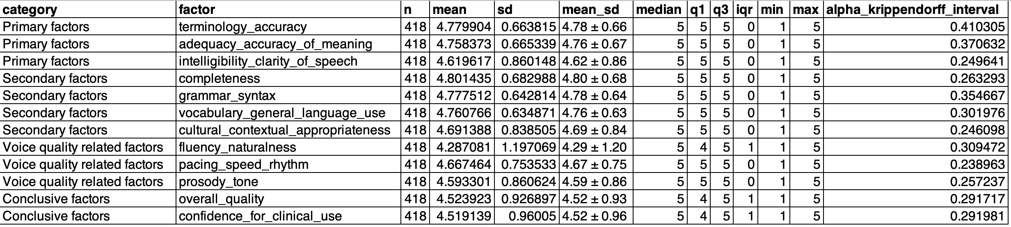
Table 2: Domain-level rating distribution and inter-rater reliability: Mean scores, variability measures, and Krippendorff’s α are shown for each translation quality domain across all evaluators and scenarios. Ratings used 5-point Likert scales (1 = poor, 5 = excellent).

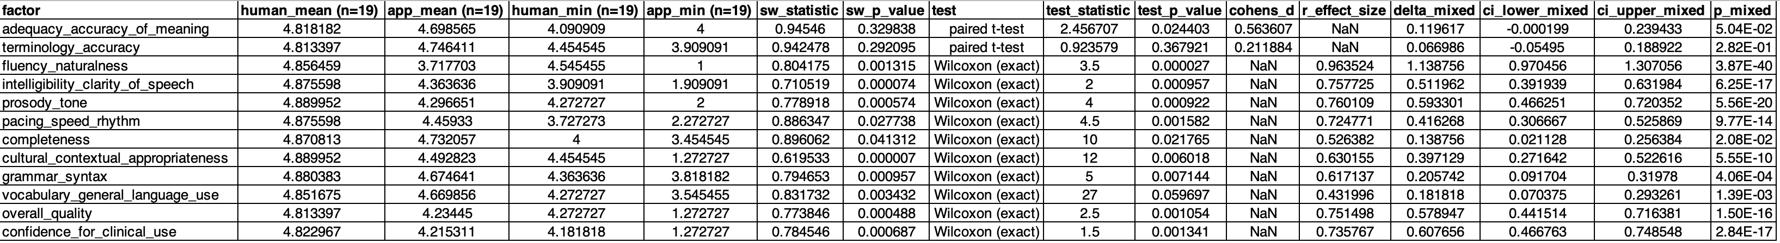

Table 3: Paired and mixed-effects comparison between human and AI translation ratings: Mean ratings, test statistics, and effect sizes are shown for each translation quality domain. Paired t-tests or Wilcoxon tests were applied based on normality (Shapiro–Wilk). Mixed-effects models included random intercepts for item (line) to account for repeated ratings. Positive Δ values indicate higher human scores.

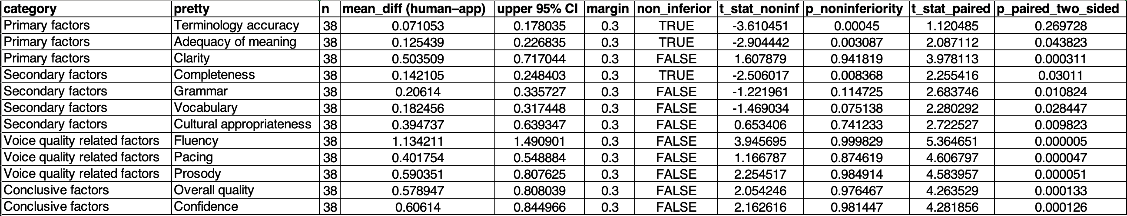

Table 4: Non-inferiority testing of AI versus human translation across quality domains: Mean differences (Human − AI), 95% confidence intervals, and non-inferiority outcomes are shown for each domain. A prespecified non-inferiority margin of 0.30 points on the 5-point scale was applied. LingualAI was considered non-inferior when the upper bound of the 95% CI was below this margin.

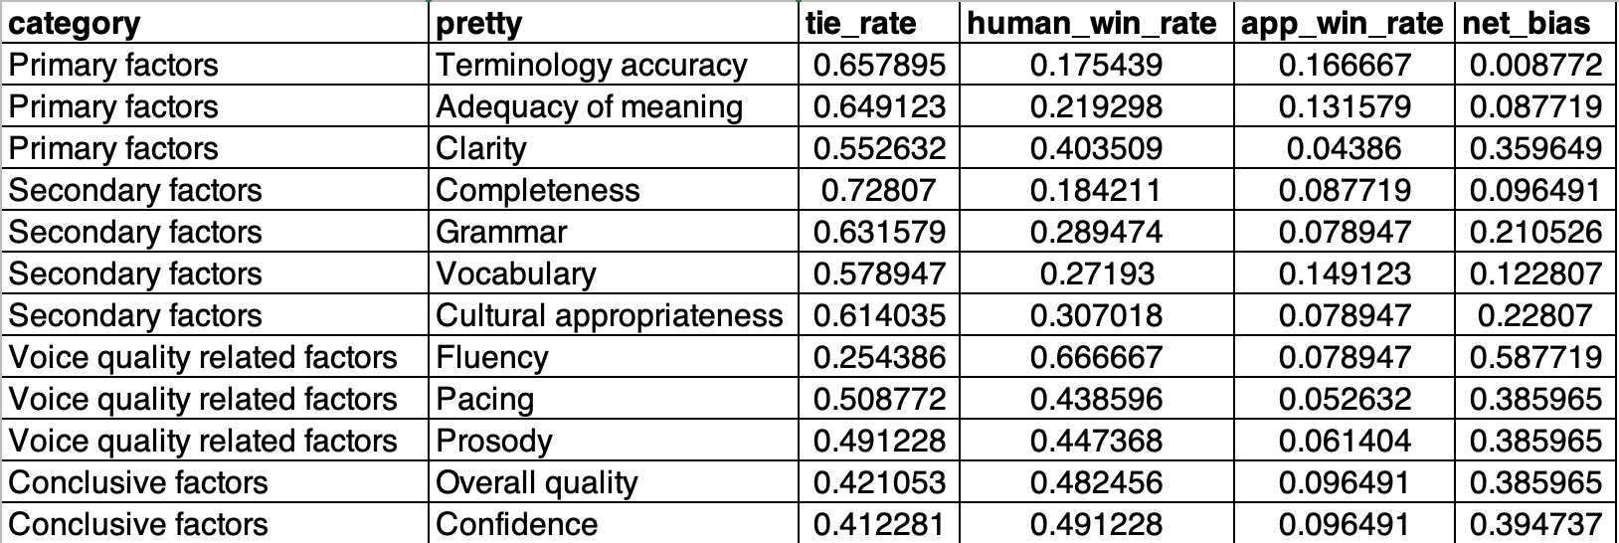

Table 5: Pairwise preference analysis between human and AI translations: Evaluator preferences are summarized as tie rates, human win rates, and AI win rates for each domain, with net bias representing the difference between human and AI win proportions. Higher net bias values indicate stronger preference for human translations. Evaluators most frequently favored human outputs for delivery-related and conclusive factors, while meaning and terminology domains showed high tie rates reflecting perceived equivalence.

