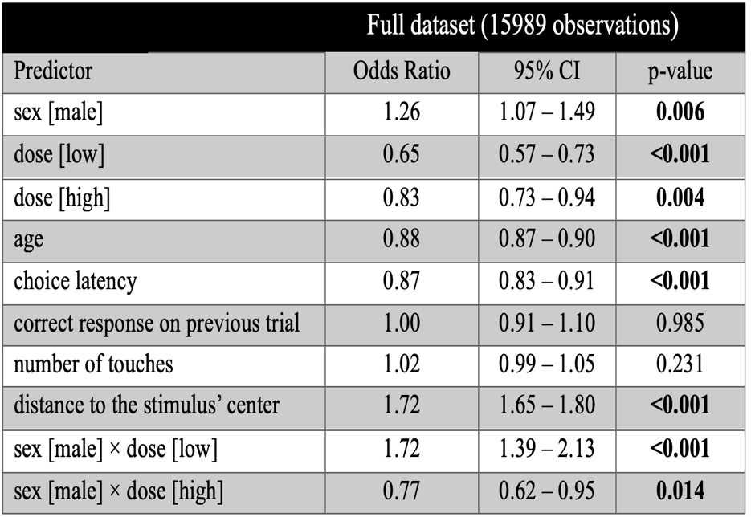
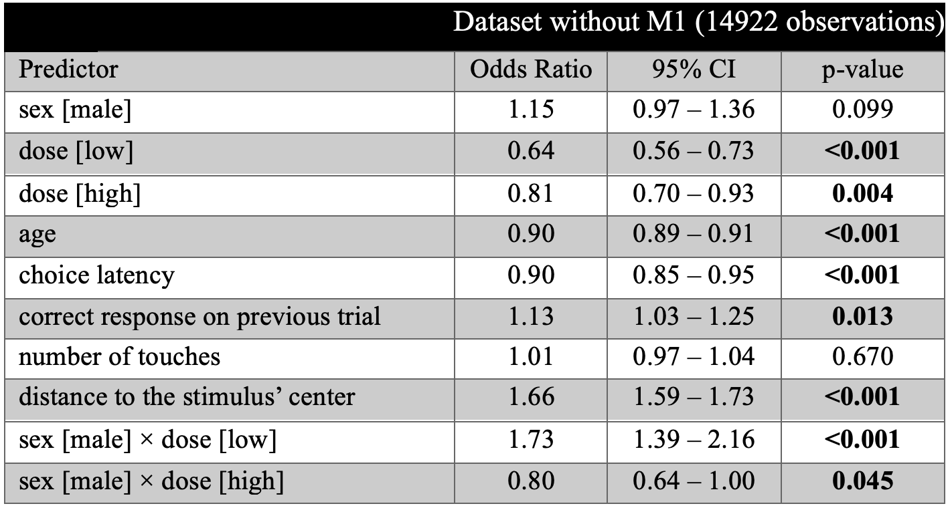
Table 1. Analysis of single trial data showing model predicted odds ratio coefficients of regressors on the probability of choosing the correct stimulus for datasets with animal M1 (full dataset) and without M1 who showed a response bias. The coefficients between 0 and 1 (exclusive) signify a negative relationship between the variable and the probability of choosing the correct stimulus. Conversely, the odds ratio of one corresponds to the absence of the relationship, and the coefficients larger than one postulate a positive association.

