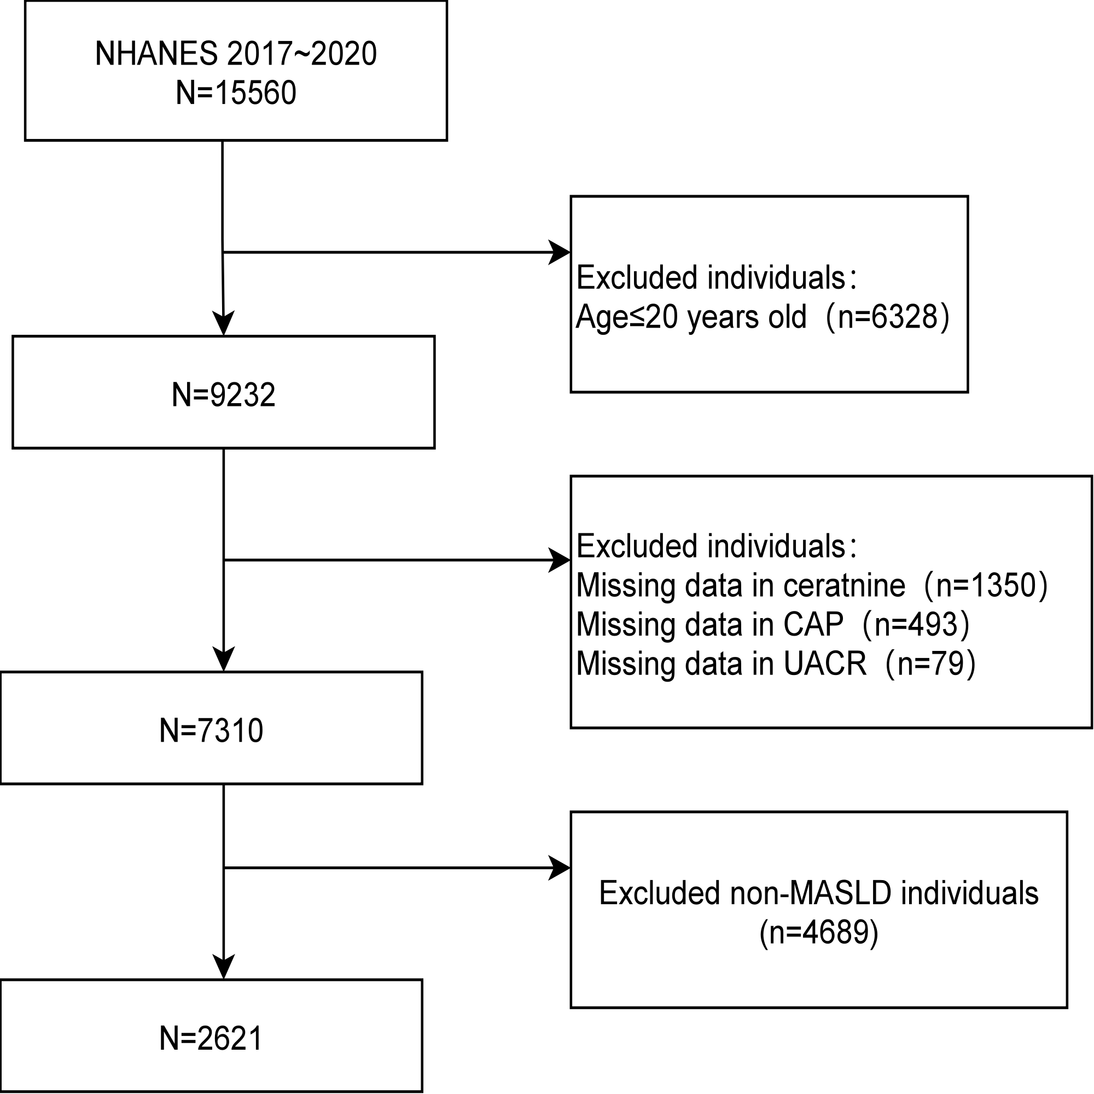
Figure S1 Flowchart of the participants’ selection from NHANES 2017-2020.
Abbreviations: NHANES, National Health and Nutrition Examination Survey; CAP, Controlled Attenuation Parameter; UACR, Urinary Albumin-to-Creatinine Ratio; MASLD, Metabolic dysfunction-associated steatotic liver disease.

Figure S2 Weighted prevelance of CKD by LSM quartile.The bars represent the weighted prevalence (%) of CKD, and the error bars indicate the 95% confidence intervals (CIs).The ranges for LSM quartiles are as follows: Q1 (2.7-4.5 kPa), Q2 (4.5-5.6 kPa), Q3 (5.6-7.1 kPa), and Q4 (7.1-32.7 kPa)
Abbreviations: CKD, chronic kidney disease; CI, confidence interval; LSM, liver stiffness measurement.

Table S1 Single-factor to Multi-factor Logistic Regression Analysis
Characteristic | OR | 95% CI |  | p-value
Age | 1.05 | 1.04, 1.06 | <0.001
Sex
Male | Ref
Female | 1.04 | 0.78, 1.40 | 0.8
Race
Hispanic | Ref
Non-Hispanic White | 1.23 | 0.88, 1.71 | 0.2
Non-Hispanic Black | 1.46 | 0.89, 2.40 | 0.13
Non-Hispanic Asian | 1.26 | 0.95, 1.69 | 0.11
Other Race | 1.71 | 0.95, 3.07 | 0.071
Education
Less than High school/GED | Ref
High school graduate/some college | 0.70 | 0.50, 0.98 | 0.041
College graduate or above | 0.37 | 0.25, 0.57 | <0.001
BMI | 1.01 | 0.99, 1.03 | 0.4
Waist | 1.01 | 1.00, 1.02 | 0.013
PIR | 0.91 | 0.83, 0.99 | 0.023
Hypertension
No | Ref
Yes | 2.88 | 2.19, 3.79 | <0.001
Diabetes
No | Ref
Yes | 4.02 | 2.98, 5.43 | <0.001
Statin_use
No | Ref
Yes | 2.30 | 1.71, 3.10 | <0.001
Current_smoker
No | Ref
Yes | 0.97 | 0.71, 1.33 | 0.9
LSM | 1.05 | 1.01, 1.09 | 0.013
LSM stage
lsm<8 | Ref
lsm>=8 | 2.05 | 1.36, 3.10 | 0.001
LSM_quartile
Q1 (LSM≤4.5) | — | —
Q2 (4.5<LSM≤5.6) | 1.00 | 0.72, 1.39 | >0.9
Q3 (5.6<LSM≤7.1) | 1.56 | 1.11, 2.19 | 0.013
Q4 (LSM>7.1) | 2.38 | 1.70, 3.33 | <0.001
TC | 1.00 | 0.99, 1.00 | 0.4
HDL-C | 0.98 | 0.97, 1.00 | 0.036
TG | 1.00 | 1.00, 1.00 | <0.001
CAP | 1.00 | 1.00, 1.01 | 0.026
HbA1c | 1.65 | 1.50, 1.81 | <0.001
AST | 1.00 | 0.98, 1.02 | >0.9
ALT | 0.99 | 0.98, 1.00 | 0.11
hs-CRP | 1.03 | 1.01, 1.05 | 0.017
eGDR | 0.75 | 0.68, 0.82 | <0.001
TB | 1.29 | 0.72, 2.32 | 0.4
Abbreviation: OR, odds ratio; CI, confidence Interval; Ref, reference group; PIR, poverty income ratio; LSM, liver stiffness measurement; TC, total cholesterol; HDL-C, high-density lipoprotein cholesterol; TG, triglycerides; CAP, controlled attenuation parameter; HbA1c, glycated hemoglobin;AST, aspartate aminotransferase; ALT, alanine aminotransferase; hs-CRP, high-sensitivity c-reactive protein; eGDR, estimated glucose disposal rate; TB, total bilirubin.

