Supplementary

S1 Data Processing and Experiments Setup
Each row of the dataset corresponds to hospital records of patients diagnosed with diabetes, who underwent laboratory sample analysis, medications, and had hospital stays of up to 14 days [40]. The dataset includes 101,766 rows, each representing an inpatient encounter, and comprises 50 features representing patient and hospital outcomes.
We used Python 3.9.13 to implement the proposed GDPR-compliant privacy pipeline and privacy-preserving algorithms. The experiments were conducted on a MacBook Air equipped with an Apple M2 chip, featuring 8 cores and 8 GB of RAM.
S1.1 Data Cleaning
S1.1.1 Missing Values
The dataset was examined for distinct values to identify any erroneous entries, such as symbols {-, ?, *, etc.). Null values were found to be represented by these erroneous entries. Subsequently, these incorrect entries were replaced with NaN to standardise the representation of missing data.
S1.1.2 Processing with Categorical Data
To simplify categorical variables with multiple levels, certain categories were combined for easier analysis and computation. Using the IDS_MAPPING file, certain numerical codes assigned to admission_type_id were consolidated into a single category labelled 1 (known type), while other values were categorised as 0 (unknown type). Similarly, admission_source_id and discharge_disposition_id} were reduced from 19 to 5 distinct categories each. The variables diag_1, diag_2, and diag_3}, which initially contained over 700 unique values documented by the ICD-9-CM codes, were categorised into 10 groups according to these codes [43].

Dataset | Noisy1 | Noisy2 | Noisy3 | Noisy4 | Noisy5 | Noisy6 | Noisy7 | Noisy8
acarbose | 0.533 | 0.447 | 0.912 | 0.435 | 0.404 | 0.000 | 0.000 | 0.000
acetohexamide | 0.563 | 0.564 | 1.000 | 1.000 | 1.000 | 0.561 | 1.000 | 1.000
admission_source_id | 0.000 | 0.000 | 0.000 | 0.000 | 0.000 | 0.000 | 0.000 | 0.000
admission_type_id | 0.000 | 0.000 | 0.000 | 0.000 | 0.000 | 0.000 | 0.000 | 0.000
change | 0.002 | 0.000 | 0.000 | 0.001 | 0.022 | 0.000 | 0.000 | 0.000
chlorpropamide | 0.380 | 0.166 | 0.912 | 0.998 | 0.575 | 0.000 | 0.000 | 0.000
diabetesMed | 0.002 | 0.272 | 0.119 | 0.769 | 0.036 | 0.000 | 0.000 | 0.000
discharge_disposition_id | 0.000 | 0.000 | 0.000 | 0.000 | 0.000 | 0.000 | 0.000 | 0.000
glimepiride | 0.684 | 0.531 | 0.733 | 0.513 | 0.690 | 0.000 | 0.000 | 0.000
glimepiride-pioglitazone | 1.000 | 1.000 | 1.000 | 1.000 | 1.000 | 0.561 | 1.000 | 0.564
glipizide | 0.748 | 0.478 | 0.966 | 0.747 | 0.481 | 0.000 | 0.000 | 0.000
glipizide-metformin | 1.000 | 0.259 | 0.417 | 0.885 | 0.867 | 0.001 | 0.036 | 0.007
glyburide | 0.742 | 0.015 | 0.497 | 0.335 | 0.805 | 0.000 | 0.000 | 0.000
glyburide-metformin | 0.849 | 0.802 | 0.442 | 0.464 | 0.946 | 0.000 | 0.000 | 0.000
insulin | 0.001 | 0.000 | 0.000 | 0.000 | 0.000 | 0.000 | 0.000 | 0.000
metformin | 0.675 | 0.292 | 0.961 | 0.098 | 0.298 | 0.000 | 0.000 | 0.000
metformin-pioglitazone | 1.000 | 0.563 | 1.000 | 1.000 | 1.000 | 1.000 | 0.566 | 0.565
metformin-rosiglitazone | 0.997 | 1.000 | 1.000 | 1.000 | 1.000 | 0.106 | 0.103 | 0.994
miglitol | 0.002 | 0.659 | 0.415 | 0.572 | 0.576 | 0.000 | 0.000 | 0.000
nateglinide | 0.087 | 0.682 | 0.687 | 0.745 | 0.773 | 0.000 | 0.000 | 0.000
pioglitazone | 0.026 | 0.720 | 0.764 | 0.169 | 0.876 | 0.000 | 0.000 | 0.000
repaglinide | 0.341 | 0.380 | 0.238 | 0.943 | 0.737 | 0.000 | 0.000 | 0.000
rosiglitazone | 0.118 | 0.463 | 0.802 | 0.077 | 0.939 | 0.000 | 0.000 | 0.000
tolazamide | 0.925 | 0.096 | 0.181 | 0.967 | 0.969 | 0.000 | 0.000 | 0.000
tolbutamide | 0.870 | 0.559 | 0.911 | 0.300 | 0.549 | 0.000 | 0.000 | 0.000
troglitazone | 0.737 | 0.737 | 1.000 | 1.000 | 0.318 | 0.318 | 0.313 | 0.314

S. Table I: Chi-square test results for noisy datasets.

Dataset | Number of Attributes (p-value < 0.05)
Noisy1 | 8
Noisy2 | 6
Noisy3 | 5
Noisy4 | 5
Noisy5 | 6
Noisy6 | 21
Noisy7 | 21
Noisy8 | 21

S. Table II: Number of attributes whose p-value is less than 0.05 in noisy datasets.
Dataset | P₂₉ Score | Minimum k value | Minimum normalized entropy l value | Maximum t value
df1 | 0 | 1 | 0 | 0.9193
df2 | 0 | 1 | 0 | 0.9193
df3 | 0 | 1 | 0 | 0.9193
df4 | 0 | 9 | 0 | 0.6942
df5 | 0 | 26 | 0 | 0.6412
df6 | 0.8358 | 221 | 0.0678 | 0.4565
df7 | 0.8367 | 221 | 0.0678 | 0.4565
df8 | 0.8321 | 221 | 0.0678 | 0.4565

S. Table III: Summary of P₂₉ Scores, minimum k values, minimum normalized entropy l values and maximum t values across datasets df1 to df8.

Dataset | P₂₉ Score | Minimum k value | Minimum normalized entropy l value | Maximum t value
df1 | 0.8058 | 13 | 0.0736 | 0.4997
df2 | 0.8042 | 13 | 0.0736 | 0.4756
df3 | 0.8202 | 28 | 0.0736 | 0.4757
df4 | 0.8304 | 62 | 0.0736 | 0.4825
df5 | 0.8375 | 195 | 0.0736 | 0.4574

S. Table IV: Summary of updated P₂₉ Scores, minimum k values, minimum normalized entropy l values and maximum t values across datasets df1 to df5.

S2 UI, UX and workflow implementation for the GDPR-compliance privacy pipeline

To ensure proper usability, UI and UX of the pipeline for the intended user groups, an integration with the existing FAIRDatabase [28] web interface was implemented. This integration focused on facilitating user understanding of GDPR compliance, the pipeline's functionalities, and the various metrics used. The UI/UX process utilized user-centered design to actively involve the user in the design process according to the guidelines in the ISO 9241-210:2019 standard [44].
Interviews were conducted to elicit UI requirements from the users of the interviews. First user groups were identified, resulting in four groups of relevant users. The prospective number of users and their importance was also registered, which resulted in a selection of five interviewees. Interviews were conducted from which a list of 21 requirements was produced. Combined with the design principles, these were used as a guide for the development of the interface. The questionnaire used in the interviews is provided in Supplementary section S2.
The developed interface was then evaluated by letting the users from different user groups utilize the interface while following a set of instructions. This was observed and any notable interactions with the interface were noted. Based on this evaluation, several recommendations were formulated for future web interface development iterations. Namely, users were not able to locate the documentation button, the expected input for the update and upload functions was unclear, and there was a lack of feedback when the update button was pressed.
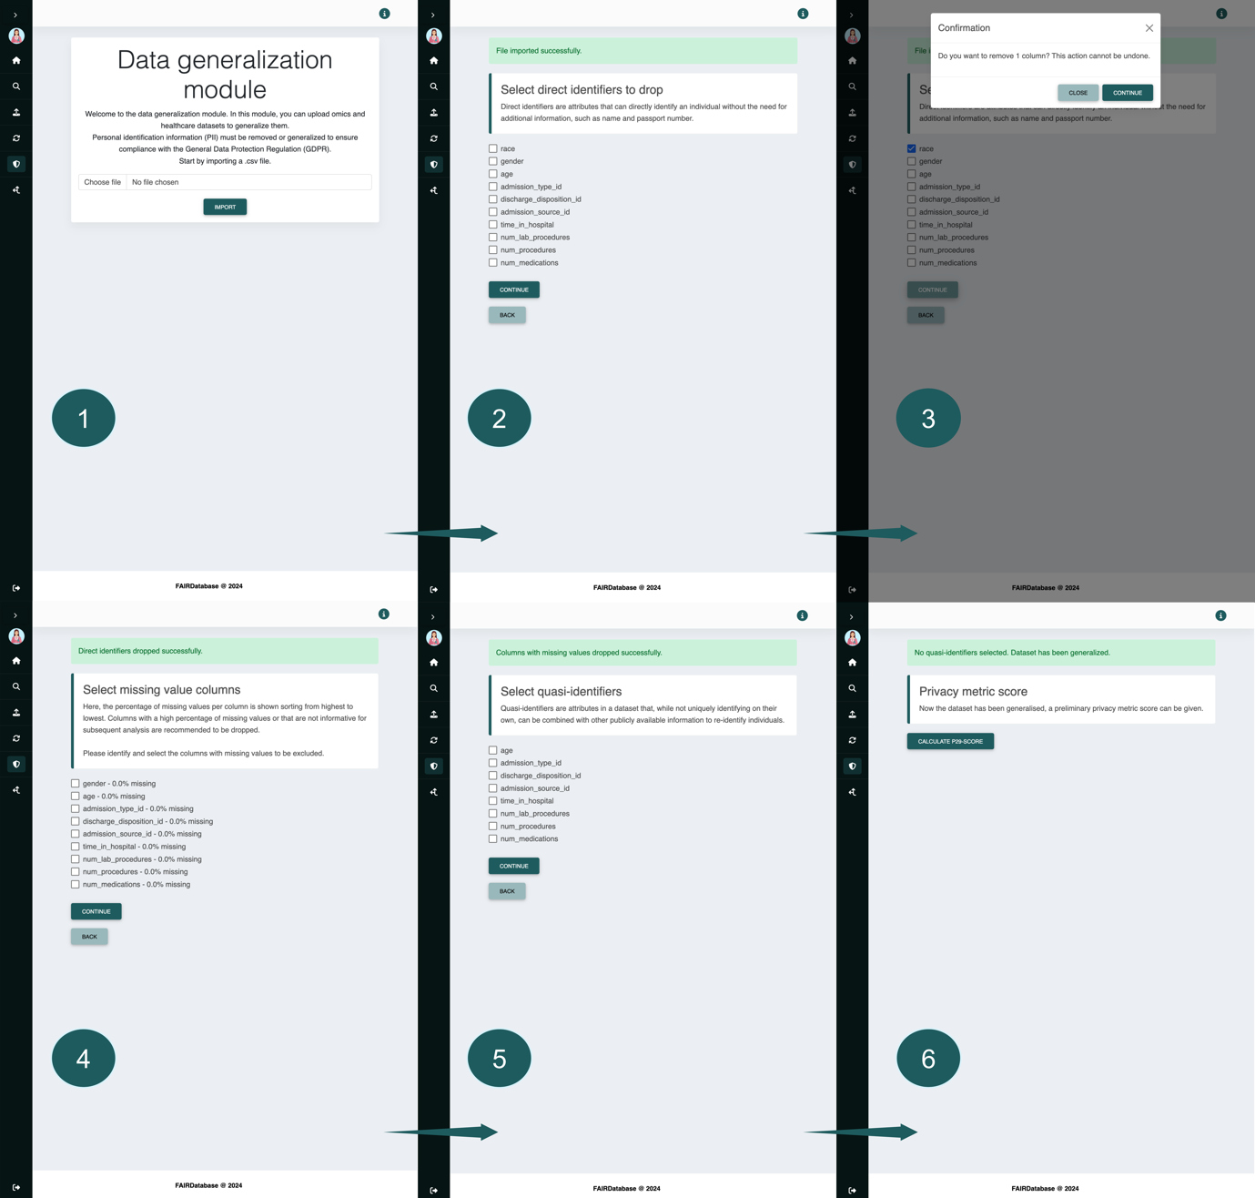
Fig. SI: Screenshots showing the UI/UX developed for the data generalisation module

S3 Interview questions
Background
- Can you tell me about your role and responsibilities in your position?
- Can you describe the typical projects or studies you’re involved in in a few sentences?
Workflow
- Walk me through your current workflow when working with microbiome data. This includes the full process of finding the data you need to access it.
- What are some challenges or pain points you encounter in your current workflow?
- What tools or software do you currently use in your research process?
  - What do you like about these tools?
  - What do you dislike about these tools?
- What features or functionalities would make your workflow easier or more efficient?
Collaboration
- How important is the concept of collaboration for you in a database? E.g. the sharing of datasets that you found, etc.
- Follow up: what features would support collaboration?
LLM integration
- How do you see an LLM (like ChatGPT) could help in your workflow?
UI&UX
- What qualities do you value most in a user interface or software application?
- What visual design elements do you find most appealing or effective in software interfaces? Think about colours, layout (simple or a lot of tools).
  - Ask about what they like in current tools
- How important is the concept of accessibility for the database? E.g. high contrast options.
- How important is it for you to easily navigate through different sections or features of a software interface?
- Do you have any preferences regarding menu structures, navigation bars, or other interface elements for accessing different functionalities? Mention examples
- Are there any specific shortcuts, keyboard commands, or other workflow optimisations you would like to see implemented in a new interface?
- How important is it for you to receive immediate feedback when performing actions or operations within a software interface? Think about loading icons, error messages and notifications
- Are there any specific UI elements or settings you would like to be able to customise in a new interface?
- Are there any usability or user experience considerations that are particularly important to you?

