Supplementary Information for the manuscript:

An alternative way to mitigate non-additionality risks of carbon credits

Min Ruan¹, Sam Fankhauser¹, Pedro Moura Costa^{1,2}, Stephen M. Smith¹

- Smith School of Enterprise and the Environment, University of Oxford, OX1 3QY, UK.
- BVRio Institute, 46 Woodstock Rd, OX2 6HT, Oxford, UK

Min Ruan
Email: min.ruan@reuben.ox.ac.uk
ORCID Identifier: https://orcid.org/0009-0003-0919-3814

Sam Fankhauser
Email: sam.fankhauser@smithschool.ox.ac.uk
ORCID Identifier: https://orcid.org/0000-0003-2100-7888

Pedro Moura Costa
Email: pedro.mouracosta@bvrio.org
ORCID Identifier: https://orcid.org/0000-0002-7569-3660

Stephen M. Smith
Email: stephen.smith@smithschool.ox.ac.uk
ORCID Identifier: https://orcid.org/0000-0002-5737-0155

Content

1. Policy Review 3
1.1 Background 3
1.2 Certification regimes 4
1.3 Additionality tests 5
2. Literature Review 7
2.1 Criticisms of carbon offsets 7
2.2 Beyond additionality 8
3. Introducing a Simplified Additionality Regime 9
4. Simulating Regulatory Performance 10
4.1 Construction of a synthetic project pool 10
4.2 Decisions by project developers 12
4.3 Decisions by the regulator 14
4.4 Project outcomes 15
5. Model Calibration 16
5.1 CDM Pipeline and voluntary registry offsets database 16
5.2 Parameter Calibration 18
6. Scenario analysis 20
6.1 The main scenario 20
6.2 Other scenarios 20
7. Sensitivity analysis 21
7.1 Differences in regulatory performance 21
7.2 Over-crediting 21
7.3 Differences in project characteristics 22
7.4 Summary 22
8. Datasets and Software 23
Figures 24
Figure 1. Visualisation of global carbon offset markets 24
Figure 2. Summary of existing additionality tests 25
Figure 3. Comparison of the existing regime and the proposed regime 26
Figure 4. Histograms of key characteristics for the CDM’s wind projects in China 27
Figure 5. Correlogram of key parameters for the CDM’s wind projects in China 28
Figure 6. Comparison of observed and actual IRRs without and with credit revenues 29
Figure 7. Different levels of regulatory quality and project outcomes under the current regime 30
Tables 31
Table 1. Symbol and description of model parameters 31
Table 2. The categories of cases under the current and proposed regimes 32
Table 3. The summary statistics of categorical variables in CDM Pipeline database 33
Table 4. The summary statistics of numerical variables in CDM Pipeline database 34
Table 5. The summary statistics of important variables in voluntary registry offset database 35
Table 6. The distribution and number of benchmark IRR by host country and project type 36
Table 7. The number of CDM projects and registration rate by host country and project type 37
Table 8. The number of VCM projects and registration rates by host country and project type 38

- Policy Review
In this section, we review the background of the carbon offset mechanism, certification regimes of main carbon offset registries, and existing additionality tests.
  - Background
Carbon offset credits have been a tool to mitigate global climate change over the past two decades. Different from cap-and-trade markets that exchange emissions allowances between polluters, offset markets entail the transfer of credits from clean projects (i.e., carbon emissions reduction and removal) that compensate for, or offset, emissions by polluters¹.
There are two main types of carbon offset programmes in terms of regulatory framework, participation requirements, and objectives. Compliance programmes are run by international or governmental regulatory bodies, for example, the Clean Development Mechanism (CDM) of the 1997 Kyoto Protocol. To fulfil legally mandated obligations, participating countries or entities must adhere to the established ‘baseline-and-credit’ rules and cap-and-trade systems², as exemplified by the European Union Emissions Trading System (EU ETS), China ETS, California Cap-and-Trade Program, and Regional Greenhouse Gas Initiative (RGGI) in the United States (US). In contrast, voluntary programmes are run by independent non-governmental organizations (NGOs), including the Verified Carbon Standard (VCS) initiated in 2005 and re-named as Verra now, the Gold Standard (GS) created by Worldwide Fund for Nature (WWF) in 2006, the American Carbon Registry (ACR) as the first private voluntary greenhouse gas (GHG) registry founded in 1996 and re-branded in 2008, and the Climate Action Reserve (CAR) established in 2001^{3–5}. Organizations or individuals can choose to offset their emissions as part of broader corporate social responsibility (CSR) efforts or personal initiatives.
Different voluntary carbon offset registries vary in terms of methodology, scope, geographical reach and alignment with compliance systems. The GS was designed to set a higher bar for voluntary offsets and emphasized the co-benefits, not limited to climate mitigation, under the framework of the United Nations’ sustainable development goals (SDGs). Each verified GS project is required to align with GS methodologies⁶ and contribute to at least three of the SDGs⁷. Different from the GS, project developers under the Verra can select an applicable methodology under any other approved GHG programme or even propose their own methodologies⁸. As such, the Verra has covered a broader range of project types across forestry and land use, energy, industrial and transportation sectors globally, including REDD+ (Reducing Emissions from Deforestation and Forest Degradation) and ozone depleting substances (ODS) recovery & destruction⁹; The Verra Registry has also been approved by the California Air Resource Board (ARB) to bridge compliance and voluntary markets since 2014^{10,11}. Besides Verra, ACR and CAR are the other two registries approved by the California ARB, but they focus on carbon offset projects mainly in North America^{5,10} and issue offset credits that can be used in the California cap-and-trade programme.
Yet one common requirement across both compliance and voluntary programmes is that all carbon offset credits, representing 1 tonne of reduced or removed CO2 or its GHG equivalent, must meet certain quality standards, get verified by a third-party auditor before issuance, and be tracked during transfer and retirement by an independent carbon credit registry³.
Carbon offsets have experienced two cycles of rapid growth over the last three decades¹². Figure 1 presents the distribution of projects and credits global carbon offsets market. The first boom in the 2000s was driven by the CDM. As the largest compliance offset programme, CDM grew fast between 2005 and 2012, and the number of issued offset credits called Certified Emissions Reductions (CERs) to clean projects in developing countries has exceeded 1 billion within a few years¹³. Yet this momentum faded in the early 2010s as scepticism grew over project quality and additionality^{14–16}. In November 2012, the CDM Registry introduced the voluntary cancellation of CERs and about 13.2 million CERs had been cancelled on the platform by project participants¹⁷ to prevent circulation of non-additional credits as of August 2024. Following the Paris Agreement in 2015 and net zero commitments around 2020, compliance and voluntary carbon markets under the Article 6 of the Agreement rebounded and reached a new peak¹⁸. The market scale of VCS first boomed and the value of voluntary carbon market (VCM) activities grew more than tenfold from 2017 to 2021¹⁹. However, concerns over non-additionality²⁰, leakage²¹, and systematic over-crediting^{22–24} are again casting doubts on the integrity of carbon offsets²⁵. In November 2024, COP29 held in Baku, Azerbaijan, adopted the decisions that aimed to further facilitate the operation of a global carbon market with stricter rules for carbon removals, methodologies and reversal risk management.
The carbon market now stands at a critical juncture. There is an ongoing discussion about how to transition the methodologies under the existing programmes to Article 6 of the Agreement²⁶ to establish a robust and reliable offset regime. Meanwhile, the fragmented governance of both compliance and voluntary offset markets indicates the urgent need for coordination, standardisation, and transparency to avoid double counting²⁷ and ensure environmental integrity².

  - Certification regimes
The existing certification regimes under the CDM and the VCM subject most projects to a rigorous and costly approval process, but differences exist in how registries interpret and implement certification.
The CDM involves multiple stakeholders and several steps in the certification process. The main stakeholders under the CDM include project developers, CDM investors or credit buyers, host governments and designated national authorities, designated operational entities (DOEs) accredited by the CDM Executive Board (EB), and the CDM EB²⁸. At first, the project developer is required to identify the project activity and prepare a Project Design Document (PDD) including but not limited to project description, baseline setting, additionality assessment, emission reduction estimates and a monitoring plan. Once the host country approves the project, the project developer is required to submit the PDD to DOEs for project validation and the DOE is responsible of making the PDD publicly available for 30 days and collecting public comments. Then, the CDM EB collects the PDD and validation reports from the DOE and it takes one month to do the completeness check and the information and reporting check²⁹. If both checks are successful, the CDM EB will proceed with the project registration and issue verified CERs²⁸.
The GS develops its own conservative methodologies for emissions reduction estimation and relies on approved third-party validation and verification bodies (VVBs) to audit the projects. Compared to CDM, all the projects under the GS must go through even more complicated certification steps⁶: 1) starting stakeholder consultation & safeguards, 2) opening a registry account and submitting stakeholder consultation report and other supporting documents for preliminary review to get “listed” status, 3) completing validation by an approved VVB with a fully completed PDD, 4) entering design certification review checks, 5) applying for verification by an accredited VVB appointed by the project developer to get “GS design certified” status, 6) following a performance review to be a “certified GS project”, and 7) undergoing design certification renewal after five years.
Similarly, the Verra project cycle also experiences stages of project listing, validation, registration, verification, and monitoring, with the audits by VVBs. To mitigate non-permanence risks, Verra updated its AFOLU (Agriculture, Forestry, and Other Land Use) buffer pool compensation agreement in January 2024³⁰. To ensure the quality of offsets called Verified Carbon Units (VCUs) as well as shortening review times, Verra has applied a new risk-based approach (RBA) since November 2024, as the result of historical data analysis and targeted process adjustments. Specifically, Verra systematically incorporates confidential risk factors associated with project characteristics (e.g., project scale, methodology, request type, jurisdiction) and define projects as low, medium, or high risk to strategically allocate focus resources³¹.
Different from assessment over the quality of individual projects, a more standardised approach was pioneered in California’s compliance offset programme with the aim to mitigate over-crediting²⁰. The standardised offset crediting adopts standard criteria to determine the eligibility and additionality of projects and quantifies GHG emission reductions based on standard baseline assumptions, emission factors and monitoring methods. Even with the setting of pre-determined project type-specific criteria, policy administrators still need substantial and ongoing oversight to screen for uncertainty under information asymmetries²⁰; In addition, the quantification methodology design requires more industry expertise as well as market and financial analysis²⁰.
Overall, the carbon offset mechanism has evolved dynamically and introduced reforms to improve credibility, transparency, and climate effectiveness. The variations across different registries also reflect different priorities and operational contexts.

  - Additionality tests
Carbon offsets must be ‘real, additional, quantifiable, permanent³², verifiable, and enforceable’. At the core of the quality standards lies the concept of additionality, that is, carbon offset projects need to create genuine climate benefits that would not have occurred under a business-as-usual scenario. Figure 2 summarises a variety of additionality tests.
Historically, there have been four generic approaches to assessing additionality employed in methodologies submitted to CDM Executive Board (EB)³³ and each of them has its own strengths and limitations:
- Barrier analysis requires demonstrating the existence of barriers (e.g., general financial risks, technological risks, general policy risks, incapability of management) that would prevent the project if not registered as a CDM activity. However, barriers are not always credible, highly subjective, vague, and difficult to validate³³. It is challenging to clearly show how non-monetary barriers can be overcome through carbon credit revenue and it is often associated with gaming by activity developers and strong controversies³⁴. Due to its frequent rejection of registration requests by the CDM EB and criticism by NGOs and researchers, barrier analysis has increasingly been seen as lacking robustness and no longer applied³⁴.
- Investment analysis requires demonstrating the proposed project activity is economically or financially less attractive than at least one credible alternative. As the barrier analysis fell out of favour, the investment test became the default approach with auditors and regulators³⁵. However, it did also face difficulty regarding the availability and transparency of financial data used in the calculation of the internal rate of return (IRR), causing risks of manipulation²⁶.
- Common practice analysis assesses the extent to which the proposed project type has already been implemented in the relevant sector and region. While it provides more objective quantitative information, project participants tend to define their technology so narrowly that no comparable projects, or only a few, are identified³³.
- Positive lists define project categories that are assumed to be additional, allowing for some false positives to simplify administrative processes. Only a small number of projects in certain regions that meet pre-specified criteria are exempt from testing and automatically qualify as offsets, with a predetermined formula to calculate emissions reductions³. While positive lists for automatic additionality offer clear benefits such as the reduction of controversial loopholes and manipulation, they struggle to account for country- or sector-specific contexts³⁶. In addition, positive lists can quickly become outdated³⁵. Under the CDM, positive lists have been slow to adapt. One case is that voluntary carbon market standards such as GS and Verra excluded grid-connected renewable energy projects in most countries due to general lack of additionality, when such projects still featured on a CDM positive list²⁶.
There are clear trade-offs between project-specific approaches and standardised approaches to determining additionality. Compared to following a set of pre-determined eligibility criteria, project-specific approaches could be more reliable and precise if applied rigorously³. However, they are time-consuming and depend too much on subjective judgements and expectations by offset programme staff and verifiers³⁶. While less burdensome, standardised approaches rely on upfront analysis to set these eligibility criteria, which also make it challenging to define objective criteria and set quantitative standards³. However, the standardised approach performs better to mitigate the risk of over-crediting, especially equipped with careful protocol-scale analysis, conservative estimation methods, ongoing monitoring of outcomes, and restriction to project types²⁰.
More recently, new initiatives shed light on the hybrid approaches for additionality tests: the combination of project-specific and standardised approaches has been highlighted to establish a robust, efficient, and high-integrity carbon offset regime²⁰. A recent study proposed three shades of additionality determination and a new stepwise approach to determine additionality²⁶. The additionality can be categorized into regulatory additionality, target additionality (or target surplus) and financial additionality. Each type of additionality should be assessed step by step using newly designed tests:
- Regulatory additionality tests require project developers to prove that the project is not mandated by law or part of the required GHG emission reductions required by national regulation. In case the actual implementation of a regulation is uncertain, an enforcement test threshold can be applied³⁷.
- Target additionality tests or ‘target surplus’ tests require project developers to prove that the types of projects do not form part of the (unconditional) Nationally Determined Contribution (NDC) target of their host country. Activities that do not go beyond the unconditional NDC targets generate a clear ‘over-selling risk’ that can undermine its own NDC achievement²⁶.
- Financial additionality tests or investment tests are similar to the existing ones: conducting a simple cost analysis (if credit sale is the project’s only revenue source), an investment comparison analysis, or a benchmark approach (if there are other savings/revenues beyond the credit sale)³⁸.
To avoid overburdening the whole process, some researchers claim that not all projects need an investment analysis²⁶. Project developers can identify and evaluate inherent financial additionality risks as well as risks to the activity implementation for the specific activity type²⁶. If one type of activity is not attractive even including all revenues and savings from any subsidies, avoided carbon taxes, or others, it can be in the positive list and exempted from the investment tests. Creating positive lists for technologies and activity types where present value of costs significantly exceeds revenues without carbon credits simplifies the determination of financial additionality and reduces transaction costs. To control country- or sector-specific factors and ensure timeliness, parties may develop their own ‘host country approval lists’ used for evaluating target surplus and update them regularly to meet the minimum quality criteria²⁶.
The new changes to carbon offset rules and procedures are not limited to the emphasis of positive lists and oversight of host countries aligned with the PA but tend to set higher restrictions for projects which are very likely to be non-additional. In 2021, GS incorporated approaches to ensure regulatory additionality, considered the need for crediting period renewal³⁹, and updated eligibility criteria deem only certain types of renewable energy activities to be additional⁴⁰. Similar to GS, Verra also restricted eligible renewable energy activities located in least developed countries (LDCs) or small island developing states (SIDs) in 2019^{41,42}.

- Literature Review
This section reviews literature on carbon offsets and implications beyond additionality.
  - Criticisms of carbon offsets
The major criticisms of carbon offset projects concern both the use and quality of credits³.
A handful of studies have criticised carbon offsetting for creating perverse incentives functioning as a ‘greenwashing’ tool⁴³, being a severely under-capitalized short-term solution⁴⁴, and discouraging decarbonisation regulation⁴⁵. More importantly, the validity of carbon offsets can be difficult to guarantee regarding their non-additionality^{20,14}, carbon leakage risk²¹, and overestimated climate benefits associated with over-crediting and inaccurate baselines^{33,22,23}.
Importantly, non-additional offsets harm this regime by distorting carbon markets, diverting funds away from genuine climate solutions and delaying the low-carbon transition with an illusion of progress. Calel and his colleagues use a sample of 1350 wind farms in India to identify wasted subsidies as evidence of misallocation of carbon offsets. Among 472 projects have been registered to receive carbon offsets under the CDM, 265 wind farms that there exist other strictly less profitable projects were built without the same subsidies¹⁴. Ironically, this indicates that at least 52% of carbon offsets from registered wind farms in India are non-additional and even random subsidy allocation through a lottery would have resulted in fewer misallocated subsidies. In the power sector, CERs issued by CDM that have both additional and contribute to sustainable development are estimated at merely 15% of the total⁴⁶.
A related concern, which has also drawn media headlines, is systematic over-crediting, which arises from inflated counterfactual baseline scenarios⁴⁷.
In California’s forest carbon offset program, awarding forest projects with carbon stocks that exceed regional averages led to 29.4% of the credits being overissued²². Strikingly, the fuel-switching project sample is over-credited by 6.3 times on average, and even the best GS’s Metered and Measured methodology for cookstove projects is still 1.3 times over-credited⁴⁸.
In studies on forestry offsets, West and his team apply a quasi-experimental synthetical control method and find that the crediting baselines established ex-ante by 12 voluntary REDD+ (Reducing Emissions from Deforestation and Forest Degradation) projects in the Brazilian Amazon tend to assume higher deforestation than counterfactual forest loss in synthetic control sites due to decreased deforestation during the early implementation phase²³. They examine the impacts of 27 REDD+ projects in six countries on three continents and find similar results: most projects accounting for 71% of carbon offset credits have not reduced deforestation, but at least 14.6 million credits have been used by individuals or organizations around the world. Even though a number of projects had effectively stopped some deforestation⁴⁹, the areas were extremely small⁴⁷.
Offset crediting agencies have responded with improved methods to strengthen the accuracy of REDD+ baselines⁵⁰. Nevertheless, the climate policy development process demands more proactive engagement of scientists to improve the resilience and robustness of carbon mitigation mechanism design⁵¹.
Therefore, extant carbon offset studies have examined the performance of carbon offset projects on several dimensions, including their actual contribution to emissions reduction, their incentives to climate mitigation activities in the short- and long- term, and their ability to provide climate finance to the developing world. Most of them came up with negative conclusions and recommended either discarding offset practices entirely or adding further complexity to the current regime.

  - Beyond additionality
Research beyond additionality has been exploring ways to improve the carbon mechanism, while some of their implications have been overlooked in practice.
Concerns have been raised since 2005 regarding the carbon offsets projects in the Indian and Chinese power sectors that might embody flaws characterized by complicated, politicized and administratively inefficient at that time⁵². Alternatively, instead of inaccurate baselines for individual projects, baselines at the multi-project level or across whole sectors based on disaggregated analysis and careful industry analysis would be another effective approach^{53–55}. This highlights the importance of heterogeneity analysis of multi-project level or sector level, rather than project level.
The interaction of different domestic and international policies varies across countries and sectors, so the context of offset projects matters. For example, generous tax incentives encourage purchases of electric vehicles in Norway⁵⁶ and renewable electricity feed-in tariffs stimulate deployment of renewable energy capacity⁵⁷. There are many more policy instruments to mitigate climate change, including mandates (e.g., renewable portfolio standards, certification), incentives (e.g., tax, subsidy, discount rebate, and loan), and markets (e.g., cap-and-trade)^{58,59}. However, previous additionality testing might be biased since it excluded domestic mitigation policies in the investment test due to the ‘E-policy rule’²⁶. Therefore, the synergic effects of the domestic policies on carbon offset projects should be evaluated together under different contexts and be updated timely once contexts have been changed.
Furthermore, the definition of additionality requires to align with methodologies that accurately or conservatively quantify climate impact. Rather than treating additionality as a binary, additionality could be looked at as a proportion of intervention groups who would likely have maintained the status quo without intervention⁴⁸.
The implications for the future carbon offset regime are not only from offset-related studies, but from research on other climate mitigation mechanisms and subsidy mechanisms.
A body of economics and policy literature has documented the cliff effect that describes unintended consequences and incentive distortions arising from sharply defined eligibility criteria in subsidy or benefit programmes^{60,61}. When eligibility hinges on strict thresholds, individuals or firms slightly above these limits face a disproportionate loss of benefits, undermining fairness and creating perverse incentives^{62,63}. Consequently, they may strategically alter their behaviour to remain eligible for subsidies, thereby causing inefficiencies and undermining policy objectives⁶⁰. The current offset regime also uses financial additionality tests to decides whether a project is financially additional or not with a threshold (i.e., a hurdle rate). Specifically, a project may be accepted or rejected if the IRR of the project is slightly below or above the benchmark IRR, which encourages the gaming behaviour (e.g., underreport IRRs) of project developers to some extent. The cliff effect reminds regulators of the need for smoother and more flexible policy mechanisms to mitigate such distortions.
Another lesson is the design of an optimal credit allocation rule to mitigate carbon leakage risk and job loss risks⁶⁴. To ensure the efficiency of industry compensation under the European Union Emissions Trading System (EU ETS), an optimal firm-level compensation scheme, equalising marginal relocation probabilities weighted by the damage caused by relocation, contributes to avoiding overallocation of carbon emission permits free of charge to carbon-intensive industries⁶⁴. Since the marginal impact on total relocation risk varies significantly across countries and sectors, Martin and his colleagues collected the data on vulnerability to carbon pricing by country and sector as well as on management practices related to climate policy through interviews⁶⁴. They found that even simple allocation rules, that use a function of easily observable firm characteristics (i.e., firm-level employment and carbon emissions alone), can significantly reduce both carbon leakage risk and job loss risk⁶⁴. This reflects a possibility to reduce financial additionality risks and activity implementation risks based on simple offset credit issuance rules, such as a function of project-level characteristics after controlling the heterogeneity of country-sector-specific contexts.
Overall, previous studies indicate that, on one hand, the context-based analysis, particularly the heterogeneity analysis of country-sector-specific contexts in terms of investment risks and supportive policies, may contribute to estimate the proportion of non-additionality projects and the urgency of subsidies from offset credits under different contexts; on the other hand, treating additionality as a continuous measure rather than a binary, may allow more flexibility to assess the quality of carbon offsets and mitigate distortions.

- Introducing a Simplified Additionality Regime
This study introduces a novel continuous additionality regime, adhering to the philosophy of ‘less is more’. Figure 3 shows the difference between the existing and the proposed regimes.
The existing offset regime defines additionality as a binary (yes-no) concept and requires offset programme verifiers to decide whether a project is additional or not, based on the submitted applications. Developers must prove the additionality of their projects through complicated and expensive regulatory tests, the outcome of which is unpredictable³. To align with the Article 6 of Paris Agreement, proposals and initiatives have introduced more stringent project-specific requirements: the project should not only be financially additional, but also be independent of mandates and beyond NDC targets to ensure regulatory and target additionality . Correspondingly, the offset regime has incorporated more approaches into the additionality assessment, testing each additionality aspect step by step. Even though the additionality tests have evolved, the assessment outcome remains unchanged: If the project passes the tests, it will receive the full share of offset credits; if it fails, the project will not receive any credits but incur sunk costs including developmental and validation fees.
In the proposed regime, we simplify a variety of additionality tests into an eligibility check and a credit allocation rule. First, we prioritise the standardised approach over the project-level additionality assessments by introducing context-based country- and project-type-specific positive inclusion lists. Like the standardised eligibility criteria in California’s carbon offset programme, these positive lists cover all eligible project activities in terms of the project type and the host country. Hence, their design relies on the analysis of domestic policies, climate targets, accumulated project development experiences and investment risks in each host country, which may involve regulatory additionality tests, target additionality tests, and common practice analysis at a country-sector level. This suggests that the proposed regime encourages more cooperation and engagement between international offset programmes and host countries to analyse country- and project-type-specific contexts under the Paris Agreement. Second, we treat additionality as a continuous measure, reflecting the share of additional credits within one context. Associated with this new definition, the decision on credit issuance is no longer yes or no, but the proportion of additional credits. Specifically, instead of setting a hurdle rate as threshold to determine the financial additionality, the number of issued credits for each project could be discounted by a factor to mitigate risks of non-additionality and over-crediting. The baseline credit rates across different project types and host countries vary due to heterogenous contexts, specifically, different additional proportions. Learning from the optimal permit allocation rule⁶⁴, a project-level credit rate may apply following a function of observable project characteristics. Since the optimal subsidy allocation rule for carbon offsets need derive from interviews with expert offset project developers and verifiers, we only apply one baseline credit rate within one country-project type-specific context in this study.
Although the country- and project type-specific positive lists and the baseline crediting rates are pre-determined and standardised, they can be dynamic rather than statics to avoid being outdated. They still require regular updates as the contexts change, for example, announcement of a new domestic subsidy policy. This allows for information transparency and consistency, manageable regulation, and flexibility and resilience of the design.

- Simulating Regulatory Performance
In order to compare the performance of additionality screening, carbon emission reduction and emission reduction efficiency between the current and proposed new additionality regimes, we propose a simple model of regulatory performance, which is then used to simulate project outcomes based on the decisions made by project developers and the regulator.
  - Construction of a synthetic project pool
We start by constructing a synthetic project pool with a full set of potential offset projects, $n∈N$. Each potential project has its own unique characteristics including initial investment cost, achievable offset price and IRRs with/without offset revenues; these project features may correlate with each other. Table 1 presents the symbol and description of all model parameters.
Because the synthetic project pool is artificial, its features are known to us, and we can measure accurately the impact of different additionality regimes. However, we wish to make the project pool as realistic as possible and thus calibrate the parameters and their correlations on historical data from the CDM Pipeline database. The model calibration approach is as follows:
Step 1: Calibrate four parameters and their correlations: (1) initial investment cost (million US$), $C_{0}$; (2) observed reported IRR without offset revenue (%), $r_{0}$; (3) observed reported increase in IRR due to offset revenue (%), $f$; and (4) offset price (US$/tCO2e): $P$; (5) correlations, $corr\left(i,j\right),i,j∈C_{0},r_{0},f,P$. Each of them is a random variable following a functional form (e.g., normal or log-normal) and their correlations are held for the distribution. With these four parameters and their correlations, we then derive other parameters from them.
Step 2: Calculate annual cash flow ($cf$), claimed IRR with offsets ($r_{1}$), annual credit revenue ($CR$), and the quantity of offsets ($Q$) respectively, based on the following equations:
$$\begin{aligned}-C_{0}+\frac{cf}{1+r_{0}}+\frac{cf}{{\left(1+r_{0}\right)}^{2}}+…+\frac{cf}{{\left(1+r_{0}\right)}^{T}}=0\#\left(1\right)\end{aligned}$$
$$\begin{aligned}r_{1}=r_{0}+f\#\left(2\right)\end{aligned}$$
$$\begin{aligned}-C_{0}+\frac{cf+CR}{1+r_{1}}+\frac{cf+CR}{{\left(1+r_{1}\right)}^{2}}+…+\frac{cf+CR}{{\left(1+r_{1}\right)}^{T}}=0\#\left(3\right)\end{aligned}$$
$$\begin{aligned}CR=P×Q\#\left(4\right)\end{aligned}$$
Step 3: Calibrate the gaming behaviours by introducing an underreported bias in IRR ($g$), i.e. the difference in reported and actual IRRs, $g= R_{0}- r_{0}$. Basically, the two probability distributions, $r_{0}$ (claimed IRR without offsets) and $R_{0}$ (actual IRR without offsets) are assumed to be of identical shape but a distance $g$ apart. The real additional proportion in this project pool, $d_{0}$, that we are interested in is the area under the actual IRR curve below the hurdle rate. Mathematically, assume $F_{R_{0}}\left(x\right)$ is the cumulative distribution function (CDF) of $R_{0}$, the additional proportion is defined as:
$$\begin{aligned}d=Pr\left(R_{0}≤\overline{R}\right)=\int_{-∞}^{\overline{R}}{f_{R_{0}}\left(x\right)}dx=F_{R_{0}}\left(\overline{R}\right)\#\left(5\right)\end{aligned}$$
assume the quantile function $Q_{R_{0}}\left(x\right)$ is the inverse function of the CDF of $R_{0}$, we can express it in another form:
$$\begin{aligned}\overline{R}={F_{R_{0}}}^{-1}\left(d_{0}\right)=Q_{R_{0}}\left(d\right)=Q_{r_{0}+g}\left(d\right)\#\left(6\right)\end{aligned}$$
then compute the gaming parameter and the actual IRR without offsets:
$$\begin{aligned}g=\overline{R}-Q_{r_{0}}\left(d\right)\#\left(7\right)\end{aligned}$$
$$\begin{aligned}R_{0}=r_{0}+g\#\left(8\right)\end{aligned}$$
given the reported data, the additional proportion we set at $d$ determines the difference in reported and actual IRRs without offsets.
Step 4: Calculate unobserved actual annual cash flow ($CF$), actual IRRs ($R_{0}, R_{1}$, $R_{2}$) and the actual change in IRR due to offset revenues under current and new additionality regime ($F_{1},F_{2}$).
In the current regime,
$$\begin{aligned}-C_{0}+\frac{CF}{1+R_{0}}+\frac{CF}{{\left(1+R_{0}\right)}^{2}}+…+\frac{CF}{{\left(1+R_{0}\right)}^{T}}=0\#\left(9\right)\end{aligned}$$
$$\begin{aligned}-C_{0}+\frac{CF+CR}{1+R_{1}}+\frac{CF+CR}{{\left(1+R_{1}\right)}^{2}}+…+\frac{CF+CR}{{\left(1+R_{1}\right)}^{T}}=\#\left(10\right)\end{aligned}$$
$$\begin{aligned}F_{1}=R_{1}-R_{0}\#\left(11\right)\end{aligned}$$
In the proposed regime, for each verified tonne of CO2, the regulator applies a crediting rate ($b$) by only issuing a fraction of offset credits and partially subsidizing the project; then project developers receive a proportion of offset credit revenue after discount, $CR×b$ and the actual increase in IRR due to offsets, $F_{2}$ will be smaller in the proposed regime.
$$\begin{aligned}-C_{0}+\frac{CF+CR×b}{1+R_{2}}+\frac{CF+CR×b}{{\left(1+R_{2}\right)}^{2}}+…+\frac{CF+CR×b}{{\left(1+R_{2}\right)}^{T}}=0\#\left(12\right)\end{aligned}$$
$$\begin{aligned}F_{2}=R_{2}-R_{0}\#\left(13\right)\end{aligned}$$
where the crediting rate, $b$, practically, is positively correlated to the proportion of additional offsets, $d_{0}$. The higher non-additionality risk (smaller $d_{0}$) under the country-sector-specific context, the lower crediting rate (smaller $b$) applied to these projects with larger discounts.
Following the four steps, the constructed synthetic project pool enables us to calibrate key parameters on realistic data and then model the decisions by project developers and the regulator endogenously as a function of project characteristics and simulate possible outcomes for the aggregate set of projects N, in terms of the regulatory system (current vs proposed additionality regime), the behaviour of decision makers (e.g., developers’ hurdle rate, the bias/stringency of the additionality test) and project characteristics (e.g. profitability with and without credits).

  - Decisions by project developers
We assume project developers maximise profit. They are guided by a payoff function, $π$, which reflects either the current rules or the proposed new rules. For each candidate project, the developer has to make two decisions under the two regimes: (1) whether to pursue the project ${(s}_{1}=1)$ or not ${(s}_{1}=0)$; (2) whether to apply for carbon offset status ${(s}_{2}=1)$ or not ${(s}_{2}=0)$.
Importantly, project developers are required to rigorously apply a relevant methodology to estimate their carbon emission reduction and prepare their PDDs to go through the development and validation stages. When entering the additionality test at the registration stage, the developmental fee, $c_{d}$ and the validation fee, $c_{v}$ are already sunk costs. The sunk cost, $\overline{c}$ is incurred regardless of the outcome of the additionality test. If the project passes the test, it can register as an offset project after paying the registration fee.
The registration fee schedule by CDM EB proposes the share of proceeds to cover administrative expenses as follows: (1) USD 0.10 per CER issued for the first 15,000 tonnes of CO2 equivalent for which issuance is requested in a given year; (2) USD 0.20 per CER issued for any amount in excess of 15,000 tonnes of CO2 equivalent for which issuance is requested in a given year; (3) The maximum registration fee payable based on this calculation shall be USD 350,000. Mathematically, the registration fee is expressed as:
$$\begin{aligned}c_{r}\left(Q\right)=\left\{\begin{aligned}Q×0.1, &Q<15,000 \\ min\{15,000×0.1+(Q-15,000)×0.2, 350,000\}, &Q≥15,000\end{aligned}\right.\#\left(14\right)\end{aligned}$$
The difference between the two regimes is that project developers are exempt from additionality testing and only need to check whether they satisfy the eligibility criteria and are covered in the positive lists. Accordingly, they no longer pay the developmental and registration fees under the new rules due to free of project design document drafting and administrative expenses. Therefore, the costs of applying for carbon offset status under the two regimes are:
$$\begin{aligned}c_{1}=c_{d}+c_{v}+c_{r}\#\left(15\right)\end{aligned}$$
$$\begin{aligned}c_{2}=c_{v}\#\left(16\right)\end{aligned}$$
The actual net present value (NPV) of the project without offsets under the two regimes is the same:
$$\begin{aligned}b_{0}=\sum_{n=1}^{T}{\frac{CF}{{\left(1+\overline{R}\right)}^{n}}}-C_{0}\#\left(17\right)\end{aligned}$$
while the present values (PVs) of the benefit of applying for carbon offset status are different:
$$\begin{aligned}b_{1}=\sum_{n=1}^{T}{\frac{CR}{{\left(1+\overline{R}\right)}^{n}}}\#\left(18\right)\end{aligned}$$
$$\begin{aligned}b_{2}=\sum_{n=1}^{T}{\frac{CR×b}{{\left(1+\overline{R}\right)}^{n}}}\#\left(19\right)\end{aligned}$$
Under the proposed regime, a certain proportion of offset benefit is secured; while under the current regime, project developers may fail to register, so the expected value of net benefit (profit) is smaller. The PVs of the net profit (𝑛𝑝) and the expected net profit (𝑒𝑛𝑝) of applying for carbon offset status are respectively:
$$\begin{aligned}{np}_{1}=\sum_{n=1}^{T}{\frac{CR}{{\left(1+\overline{R}\right)}^{n}}}-c_{r}-c_{d}-c_{v}\#\left(20\right)\end{aligned}$$
$$\begin{aligned}{enp}_{1}=q×\left(\sum_{n=1}^{T}{\frac{CR}{{\left(1+\overline{R}\right)}^{n}}}-c_{r}\right)-c_{d}-c_{v}\#\left(21\right)\end{aligned}$$
$$\begin{aligned}{np}_{2}={enp}_{2}=\sum_{n=1}^{T}{\frac{CR×b}{{\left(1+\overline{R}\right)}^{n}}}-c_{v}\#\left(22\right)\end{aligned}$$
where $q$ is the probability of a successful additionality decision, that is, the probability of securing the annual offset benefit $CR$. We will discuss decisions of regulators in the next subsection.
Under both regimes, if the PV of the expected profit of applying for carbon offset status is negative (${enp}_{1},{enp}_{2}<0$), the project developer won’t apply ${(s}_{2}=0)$. If it is positive (${enp}_{1},{enp}_{2}>0$), the project developer will consider applying for carbon offset status ${(s}_{2}=1)$.
Even if project developers apply for carbon offset status and expect to secure the offset benefit, they still have to give up pursuing/implementing the project if the project is financially unattractive and lack investments. Basically, project developers won’t pursue the project ${(s}_{1}=0)$ if the IRR with offsets is still below the hurdle rate; they will pursue the project ${(s}_{1}=1)$ only if the NPV of candidate projects with offsets is positive, in other words, the IRR with offsets is above the hurdle rate ($R_{1}, R_{2}>\overline{R}$).
Therefore, the payoff functions, $π_{i}$ ($i=1, 2$), are specified as follows:
Current binary additionality regime | New continuous additionality regime
$$max s_{1,2}\left({enp}_{1}\right)$$  $$\max{π_{1}}=s_{1,1}\left(b_{0}+s_{1,2}np_{1}\right)$$ | $$max s_{2,2}\left({enp}_{2}\right)$$  $$\max{π_{2}}=s_{2,1}(b_{0}+s_{2,2}{np}_{2})$$

  - Decisions by the regulator
Under the current regime, the regulator judges whether a project is deemed additional ($q=1$) or not ($q=0$) and decides whether to accept ($ac=1$) or reject ($ac=0$) the application. Unlike the decisions by the project developer, which are known with certainty, there is an element of randomness in regulatory decisions due to information asymmetry. Project developers have more information about project characteristics than the regulator, while the regulator can only make the decisions on observed data in reports with a probability of being fabricated.
A rational regulator will speculate the gaming behaviours and estimate the actual data on the reported data. Ideally, the perfect regulation makes all additional projects accepted (“true positives”) and all non-additional projects rejected (“true negatives”) but the regulation is not perfect. In front of incomplete information, regulators always face a statistical probability of accepting non-additional projects (“false positives”) and rejecting additional projects (“false negatives”). Practically, regulators must use their knowledge and experience to determine a certain value as the policy hurdle rate and reject IRR-above-policy-hurdle-rate projects. At a result, the regulation can be unbiased when the policy hurdle rate equals the real hurdle rate or too lenient (strict) if the policy hurdle rate is larger (smaller) than the real hurdle rate. The inclusive (exclusive) regulation will allow for more false acceptances (more false rejections). In addition, when the actual IRR without offsets of a project is near the real hurdle rate, it’s more difficult for the regulator to make a correct decision so the regulation will be inaccurate when the tests fail to distinguish whether or not a project has an IRR above the policy hurdle rate.
Since the regulator is more likely to reject a project as its profit goes up, we stipulate that the probability of a successful additionality decision ($q$) is negatively correlated with the actual IRR without offsets ($R_{0}$). We specify these properties through (the inverse of) a logistic function with a range between 0 and 1,
$$\begin{aligned}q\left(R\right)=\left\{\begin{aligned}1-\frac{1}{1+ e^{-k\left(R-R_{p}\right)}}, &k>0 \\ p, &k=0\end{aligned}\right.\#\left(23\right)\end{aligned}$$
where $k$ measures the steepness of the curve; the larger $k$, the more accurate the regulation. A flatter curve means a more unpredictable regime. For $k=0$, we get a random regulation where each project has the same probability of acceptance, independent of the project IRR; $p$ refers to the regulator’s belief in the unobserved actual additional proportion within one sector in one host country and $R_{p}$ is the inflection point; regulation is unbiased for $R_{p}= \overline{R}$; regulation is biased toward inclusion for $R_{p}> \overline{R}$ and biased toward exclusion for $R_{p}< \overline{R}$; $q$ determines the probability of getting accepted, i.e. $q=0.6$ means there is a probability of 0.6 being accepted ($ac=1$) and a probability of 0.4 being rejected ($ac=0$).
Therefore, at a country-sector level, the additional testing performance can be evaluated from two aspects of unbiasedness and accuracy; the regulatory performance has six types: 1) unbiased and accurate; 2) inclusively biased and accurate; 3) exclusively biased and accurate; 4) unbiased and inaccurate; 5) inclusively biased and inaccurate; 6) exclusively biased and inaccurate.
As the policy hurdle rate is determined by the regulator’s belief in the unobserved actual additional proportion within one sector in one host country $p$, we calibrate them on realistic data and assume that the policy hurdle rate can be estimated by the observed reported acceptance rate within this context ($AC≈p$). We then get
$$\begin{aligned}R_{p}=Q_{R_{0}}\left(p\right)≈Q_{R_{0}}\left(AC\right)\#\left(24\right)\end{aligned}$$
One reference we could consider is 56% non-additional projects among accepted wind power projects in India¹⁴. This suggests that the regulation could be even worse than random selection.
  - Project outcomes
Once we construct the synthetic project pool and the decisions by project developers and the regulator, we can run simulations to analyse the outcomes, including the proportion of each category of cases (true/false positives/negatives, unsubmitted ones) and the contribution of offset programs to global climate mitigation. More importantly, the comparison between the outcomes of the two additionality regimes provides insights for policy design and implementation.
Table 2 presents the categories of cases under the two regimes. Each project type is characterised by a particular condition.
High-IRR projects are built in any case. If they decide to game the parameters and apply for carbon offsets, the current regime may correctly reject them. However, if not, the accepted non-additional projects will receive substantial extra revenue from issued offset credits. These credits are not only wasted without contributing to carbon emission reductions but also are transferred to emitting units in other places, weakening their climate regulation. Although the proposed regime cannot exclude the non-additional projects, the credits allocated to them would be discounted and the partial crediting design would avoid giving the other party too many emission allowances.
Medium-IRR projects are additional and largely depend on offset revenues to develop. They will apply, possibly honestly, and expect to register as an offset, however, the current regime may falsely reject them due to the flawed regulation and lose opportunities to reduce global carbon emissions. In the proposed regime, a proportion of offset benefits are still secured for all validated projects.
Unattractive (low-IRR) projects cannot be built anyway and will not apply to have the additional test. The introduction of continuous additionality may make a small proportion of additional projects unattractive, but it may also mitigate the systematic over-crediting issue in the current regime and give more confidence to project developers when they negotiate with potential investors.
As a first step, we count how often each case occurs over the drawn sample. Subsequently, we translate this into environmental outcomes and development outcomes.
The annual financial flows (offset trade volume) are:
$$\begin{aligned}{Trade}_{1}={CR}_{correctly accepted}+{CR}_{falsely accepted}\#（25）\end{aligned}$$
$$\begin{aligned}{Trade}_{2}={CR}_{correctly accepted}×d+{CR}_{falsely accepted}×d\#（26）\end{aligned}$$
The emissions reductions are:
$$\begin{aligned}{Red}_{1}=Q_{correctly accepted}-Q_{falsely accepted}\#（27）\end{aligned}$$
$$\begin{aligned}{Red}_{2}=Q_{correctly accepted}-Q_{falsely accepted}×d\#（28）\end{aligned}$$
The programme climate mitigation efficiency can be calculated by:
$$\begin{aligned}{Efficency}_{i}={Red}_{i}/{Trade}_{i},i=1,2\#\left(29\right)\end{aligned}$$

- Model Calibration
  - CDM Pipeline and voluntary registry offsets database
The proposed regime requires careful analysis of country-project-type-specific contexts, specifically the heterogeneity and the additional proportion. On one hand, the less heterogeneity in one sector in one country, the easier the design of standardised credit allocation rules and eligibility criteria would be. On the other hand, the higher proportion of additional offsets within a context, the higher proportion of offset credits the regulators would like to allocate. Therefore, we need to analyse the distribution of industry-level benchmark IRRs and the registration rates in historical data.
CDM, as the world’s largest carbon offset program, provides a rich sample of the existing carbon offset projects globally. The CDM Pipeline database was retrieved from the official website of UN Environmental Programme Copenhagen Climate Centre (UNEP-CCC). It gives an overview of the CDM’s implementation as of October 2023 and covers 13,152 CDM projects that used to apply for CERs. To help take a closer look at the data, Table 3 and Table 4 present the summary statistics of the categorical and numerical variables respectively. Importantly, this database not only does disclose all registered projects (n = 8195, ~62.3%), but also include other failed projects (e.g., deregistered, provisional, rejected, validation replaced, validation terminated, validation public, withdrawn, pending publication). As the largest carbon offset programme connecting the developed and developing worlds, most of the projects are located in China (n = 5045), India (n = 3400) and Brazil (n = 764); and more than half of them are related to renewable energy, including wind (n = 3087, ~24%), hydro (n = 3035, ~23%) and biomass (n = 1514, ~11%).
The voluntary registry offset database developed by the Berkeley Carbon Trading Project covers all carbon offset projects listed by four major voluntary offset project registries, specifically, ACR, CAR, GS and VCS. We retrieved the August 2024 version of the dataset including important information on project name, status, type, location, credit issuances and retirements. Table 5 shows the summary statistics of important variables in the database. The database includes 8850 voluntary carbon offset projects from four major voluntary offset project registries with a registration rate of 72.88% on average. Among these voluntary projects, 5% were from ACR, 7% from CAR, 39% from GS, and 49% from VCS. Different from CDM, the number of carbon removal projects occupies about 6% of the data sample. In addition, five major project types are cookstoves (n = 1503), wind farms (n = 1015), improved forest management (n = 633), hydropower (n = 532) and afforestation/reforestation (n = 526). More African countries have engaged in offset projects related to clean water and cookstoves, including Uganda, Rwanda, Nigeria, Mozambique, Malawi, Madagascar, Burkina Faso, and Kenya. Meanwhile, forestry offsets play an important role in the international voluntary carbon offset market.
The benchmark IRR reflects the risk of investing in climate mitigation activities, and its distribution outlines the industry developmental situations and the heterogeneity of the context. As such, the analysis of historical data on financial metrics is beneficial to understand different contexts. Table 6 shows the distribution of the benchmark IRR and the number of unique benchmark IRRs by host country and project type under CDM for three major host countries.
First of all, the selection of benchmark IRR varies across contexts. The average benchmark IRR in different sectors across three major countries (Brazil, China, India) is distributed between 8% and 16%; by host country, it is relatively low in China (around 10%), compared to Brazil (around 13%) and India (around 15%); as for project type, it is relatively higher in Brazil’s biomass energy (14.74%) and hydro (15.31%), China’s cement (12.17%) and EE industry (12.38%) and India’s EE own generation (15.45%) and mixed renewables (16.33%). This indicates that it may be generally riskier to develop an offset project in India and Brazil than in China.
In addition, the standard deviation of the benchmark IRR varies and reflects the extent of heterogeneity. Most of them are densely distributed with a relatively small standard deviation (below 4%), except for Brazil’s biomass energy, China’s N2O, and India’s EE households, EE own generation, and transport. These categories may require further classification into sub-types to reduce heterogeneity for non-additionality risk assessments.
Lastly, the number of unique values across sectors and countries interestingly shows that project developers in China prefer to apply a standardised IRR as the benchmark, while project developers in India enjoy choosing their own unique benchmark IRRs. For example, there are only 2 unique values (mostly 8%, a few 10%) for 1614 wind farms in China, however, there are 335 unique values among 1107 Indian wind farms, though the standard deviation of 2.57% is not very high.
Regulation quality matters while relying on human judgement to identify non -additional projects and avoid credit misallocation. Table 7 presents the number of CDM projects and the registration rate by host country and project type and Table 8 shows the number of VCM projects and the registration rate by host country and project type. The reason why we examine this is that the registration rate, in other words, application success rates, can be viewed as the proportion of additional projects within a sector in a country that the offset programme regulators believe or have confidence in.
Given the overall registration rate of 62.3% (8165 out of 13152) under the CDM, it’s observed that some categories have quite a few applications (n > 10) and a high registration rate (> 75%), including Chile’s wind (n = 26, 84.62%), China’s hydro (n = 1738, 76.29%), solar (n = 175, 93.71%) and wind (n = 1614, 93.68%), Indonesia’s landfill gas (n = 13, 84.62%), Mexico’s wind (n = 38, 76.32%), Philippines’s hydro (n = 14, 78.57%), Thailand’s solar (n = 28, 100%), and Vietnam’s hydro (n = 227, 89.43%). On the contrary, the CDM EB seems to be more suspicious regarding Brazil’s biomass energy (n = 184, 26.09%), Chile’s solar (n = 47, 42.55%), China’s energy efficient own generation (n = 497, 42.05%), India’s EE own generation (n = 245, 30.61%) and methane avoidance (n = 102, 33.33%), Indonesia’s biomass energy (n = 38, 36.84%), Malaysia’s landfill gas (n =22, 40.91%), Philippines’s biomass energy (n = 20, 25%) and Thailand’s EE own generation (n = 15, 26.67%).
Given the overall registration rate of 72.88% (6450 out of 8850) under the VCM, it’s observed that certain categories exhibited high application success rates (> 90%) with quite a few applications (n > 10), including Bangladesh’s cookstoves (n = 118, 96.61%), Brazil’s biomass (n = 50, 90%), Burkina Faso’s clean water (n = 22, 100%), China’s cookstoves (n = 25, 92%), solar (n = 34, 91.18%), and biodigesters ( n = 125, 92%), India’s biodigesters ( n = 68, 91.18%), Kenya’s afforestation/reforestation (n = 15, 93.33%), Uganda’s afforestation/reforestation (n = 21, 95.24%), United States’ wind (n = 12, 100%) and landfill methane (n = 173, 90.75%). On the contrary, voluntary carbon offset registries seemed to be more suspicious regarding China’s rice emission reductions (n = 266, 10.9%), Mozambique’s cookstoves (n = 50, 40%).
The substantial difference in the registration rates shows that regulators consciously or unconsciously expect a higher additional proportion, equivalent to a higher policy hurdle rate, within some contexts. More importantly, this helps find the inconsistency in regulators’ judgement on non-additionality risks across different carbon offset registries. For example, the registration rate of Brazil’s biomass projects under the CDM was only 26.09% yet 90% under the VCM. This indicates either some significant market/policy changes in the biomass sector over time in Brazil or severe regulators’ biases towards this context in the mandatory or voluntary carbon offset market.
The statistical analysis of the CDM Pipeline and the voluntary registry offsets database delivers an informative global overview of the offset project investment and development environment, the extent of heterogeneity under different contexts, and the expectation/belief of additionality regulators. This largely benefits the design of country- and project-type-specific positive inclusion lists and the selection of baseline crediting rates. However, a key challenge remains in in assessing the robustness of additionality tests to gaming: how to identify the complete set of potential projects in one context, which is unobserved, rather than just the subset of projects which is observed from these two databases.

  - Parameter Calibration
To test the regulatory performance of two different regimes and ensure data representation and simple size, we need to select one context with rich historical data to construct the synthetical pool for simulation analysis. As such, we take the CDM’s wind projects in China for parameter calibration and model simulation in this section and the subsequent ones, since the sample size is large enough to be representative (n = 1614); these projects are relatively homogeneous involving solely the construction of wind farms ; and the CDM Pipeline provides historical data on project characteristics and specific financial metrics.
Figure 4 presents a series of histograms of key characteristics for wind projects in China. It’s clearly observed from the histograms that the benchmark IRR is 8%; the capacity is densely concentrated around 50 MW; most projects have a crediting/operating period of 7 years. An average wind project in China has an initial investment cost of 66 million USD, an IRR without CERs of 6.2%, and a 2.8% increase in IRR by selling CERs at the price of 12.5 USD/tCO2e. In addition, the observed IRR without CERs, the increase in IRR due to CER revenue, and the initial investment cost are close to a normal distribution. These projects are supposed to be additional since their submitted IRRs without CERs are below the benchmark IRR (8%). However, there are still about 10% of projects rejected by the CDM EB. This suggests that the regulators believe that a small proportion of the non-additional projects game their financial parameters to apply for carbon offsets.
Figure 5 shows a correlogram of the four parameters for the CDM’s wind projects in China: IRR % excl. CER, $r_{0}$; emission reductions, $Q$ (ktCO2e/yr); CER price, $P$ (US$/tCO2); and increase in IRR due to CER (%), $f$. The pre-offset return $r_{0}$ is negatively correlated with the offset return $f$ (correlation coefficient -0.31) and the offset price, $P$ (correlation coefficient -0.14). This indicates that the wind plants with lower IRRs can increase their IRRs more after receiving offset revenues and tend to sell their credits at a higher price. The initial investment cost is relatively independent of other variables.
Based on the observed parameters from Figure 4 and Figure 5, we therefore construct a synthetic project pool that consists of 10,000 wind projects in China each with a capacity of 50 MW; the benchmark IRR ($\overline{R}$), or the hurdle rate, is 8%; and the crediting period ($T$) is 7 years. The initial investment cost (million US$), the IRR without CERs (%), the increase in IRR due to CERs (%) and the CER price (US$/tCO2e) are each normally distributed. Mathematically, the probability density function (PDF) of these four parameters is presented as follows.
$$f_{i}\left(x\right)=\frac{1}{σ_{i}\sqrt{2π}}e^{-\frac{{\left(x-μ_{i}\right)}^{2}}{2{σ_{i}}^{2}}},i∈C_{0},r_{0},f,P$$
Using the expression form of $N\left(μ_{i},σ_{i}\right)$, the distribution of the four parameters is:
$C_{0}\sim N\left(66, 12\right)$; $r_{0}\sim N\left(6.2, 0.57\right)$; $f\sim N\left(2.81, 0.54\right)$; $P\sim N\left(12.5, 1\right)$
$corr\left(r_{0},f\right)=-0.3$; $corr\left(r_{0},P\right)=-0.15$; $corr\left(f,P\right)=0.2$; $corr\left(C_{0},j\right)=0,j∈r_{0},f,P$
then the IRR with CER (%) is distributed as $r_{1}\sim N\left(9, 0.68\right)$.
Under the main scenario, we assume that the additional proportion $d$ in the equation (5) is 0.5, which means that 50% of the project sample are non-additional. Accordingly, the gaming parameter is $g=1.8$ derived from the equation (7) and the actual IRR follows the distribution: $R_{0}\sim N\left(8, 0.57\right)$. We next assume that the crediting rate $b$ in the equation (12) is also 0.5, which means that the regulator only issues 50% of CERs to each validated project in the proposed regime.
Figure 6 visualises the distribution of observed and actual IRRs in the pool under two regimes. The observed IRRs without CERs (dark blue) are all below the benchmark IRR, and the observed IRR with CERs (dark green) are modestly above the benchmark IRR. However, given a very likely non-additional proportion of 50%, the actual IRRs without CERs (light blue) are centred around 8% and the actual IRRs with CERs (light green) are considerably above the benchmark IRR. This indicates that a number of non-additional projects can be very financially attractive with extra revenues, and the issued credits are wasted and potentially increase the emissions elsewhere. However, the actual IRRs with partial CERs (light yellow) are mostly above the benchmark IRR. This suggests that given an additional proportion of 50%, issuing only half the number of offset credits will achieve more carbon emissions reduction with fewer wasted credits.
The registration rate of China’s wind farms in the CDM Pipeline is 93.68% so the regulation may be too lenient in this case. Given the assumed additional proportion of 50%, the regulation can be described as inclusively biased since the regulator believes a very high additional proportion in China’s wind while the reality is probably not. Given the registration rate of 93.68%, we assume that the policy regulator believes 90% of wind farms in China are additional and then calculate the policy hurdle rate based on the equation (24), $R_{p}=Q_{R_{0}}\left(0.9\right)=8.73\%>\overline{R}=8\%$, which is larger than the real hurdle rate.
In addition to regulatory bias, we set the regulatory accuracy $k$ in the equation (23) at different values between 0 and 10. Figure 7 presents the functions of $q$ and $R_{0}$ with different levels of regulatory accuracy and categories of project outcomes in the current regime. In our simulation model, we assume that all projects game the system to the same extent; that is, the reported IRR is lower than the actual IRR by a constant $g$. However, project developers may not cheat or cheat differently in the real world. This makes the project-level additionality screening even harder, so the regulator may make as bad decisions as random selection ($k=0$) suggested by a previous study¹⁴.

- Scenario analysis
  - The main scenario
In our main scenario, we make the conservative but realistic assumption that the additional proportion within this context and the baseline crediting rate are both 0.5, and the policy hurdle rate is 8.73% with the regulatory accuracy of 2.5, given the overall registration rate of over 90% and the benchmark IRR of 8% for Chinese wind power projects in the CDM Pipeline.
Under the current regime, about 79.4% of projects in the pool receive the credits in which 46.8% are additional. Under the proposed regime, about 94.4% of projects in the pool receive the credits in which 49.4% are additional. The proportion of unattractive projects increases slightly due to partial (not full) crediting.
Compared to the current regime, the proposed regime contributes to smaller offset trade volume, higher real carbon emission reduction and higher emission reduction efficiency under this baseline scenario. Specifically, the annual trade volume decreases by 485,800 USD per project on average; the annual carbon emission reduction on average increases by 9,959 tonnes CO2e per project; and the emission reduction efficiency improves from 16,395 tCO2e/million USD to 53,290 tCO2e/million USD annually.

  - Other scenarios
Since the aim is to test whether the proposed regime outperforms the current one not only under the main scenario, but also under other scenarios. We design three other scenarios with different levels of regulatory quality in Figure 7 and compare the project outcomes between two regimes.
Assume that the current regulation is random ($k=0)$ and the acceptance rate is 90% for China’s wind projects. Compared to the current regime, the proposed regime also contributes to smaller offset trade volume, higher real carbon emission reduction and higher emission reduction efficiency under this scenario. Specifically, the annual trade volume decreases by 545,000 USD per wind power plant on average; the annual carbon emission reduction on average increases by 23,171 tonnes CO2e per wind power plant; and the emission reduction efficiency improves from 2,492 tCO2e/million USD to 47,503 tCO2e/million USD annually.
Assume that the current regulation is satisfying, specifically, inaccurate ($k=2.5)$ yet unbiased, then the acceptance rate is 50% given the additional proportion of 50%. Compared to the current regime, the proposed regime also contributes to smaller offset trade volume, higher real carbon emission reduction and higher emission reduction efficiency under this scenario. Specifically, the annual trade volume decreases by 310,800 USD per wind power plant on average; the annual carbon emission reduction on average increases by 2,379 tonnes CO2e per wind power plant; and the emission reduction efficiency improves from 37,815 tCO2e/million USD to 83,284 tCO2e/million USD annually.
Assume that the current regulation is nearly perfect, specifically, accurate ($k=25)$and unbiased. Compared to the current regime, the proposed regime also contributes to smaller offset trade volume and higher emission reduction efficiency but lower real carbon emission reduction under this scenario. Specifically, the annual trade volume decreases by 313,300 USD per wind power plant on average; the annual carbon emission reduction on average decreases by 20,470 tonnes CO2e per wind power plant; and the emission reduction efficiency improves from 73,992 tCO2e/million USD to 82,638 tCO2e/million USD annually. This indicates that the annual carbon emission reduction will be higher under the current regime only if the current regulatory quality is very high.

- Sensitivity analysis
We further carry out sensitivity analysis to see how the regime performances change as the parameters change. Specifically, we evaluate how the climate outcomes change in response to different regulatory performances, sizes of over-crediting, project pool characteristics.
  - Differences in regulatory performance
To analyse regime sensitivity to regulation quality, we keep the synthetic project pool unchanged ($d=0.5$) and change the regulation unbiasedness ($R_{p}$), accuracy ($k$), and crediting rate ($b$). We set the regulator’s belief in additional proportion within wind farm projects in China $p$ between 0 and 1 and the regulatory bias is measured by $p-d$ (unbiased when $p=d=0.5$); the accuracy $k$ ranges from 0 (random decision) to 10 (very accurate); and the crediting rate $b$ also varies between 0 (no subsidy) and 1 (full subsidy).
By observing the difference in annual offset trade volume and carbon emission reduction under the two regimes, the results show that 1) the offset trade volume is always lower in the continuous additionality regime; 2) a lower crediting rate is associated with a smaller offset trade volume; 3) a slightly-lower-additional-proportion crediting rate (around 0.4, less that 0.5) under the proposed regime tends to achieve the highest increase in carbon emission reduction; 4) only if the current regulation is unbiased and accurate ($p-d=0, k=10)$ and the crediting rate is far away from the additional proportion ($d<0.2$ or $d>0.6)$, the current regime with high-quality additional testing can outperform the proposed one with bad additional proportion estimates, regarding its contribution on climate mitigation.

  - Over-crediting
To simulate systematic over-crediting, we introduce an exogenous variable to the main scenario, representing a fraction of over-crediting. The over-crediting of projects can also arise from overestimation of carbon emissions reduction, as a result of inaccurate baselines and methodologies during the developmental/validation stages and tremendously harm the carbon offsetting mechanism if not addressed properly. Here, we assume a certain share of CERs are not real, i.e., they are over-issued CERs, ranging between 0% (no over-issued CERs) and 100% (all CERs are over-issued).
The average annual emission reduction per wind power plant declines to zero when 35% of offsets are over-credited under the current regime, while the emission reduction declines to zero when 50% of offsets are over-credited under the proposed regime with a crediting rate of 0.5. In addition, if the over-crediting fraction is below 65%, the climate mitigation efficiency of the proposed regime will keep higher compared to the current regime. Strikingly, if 35% of offsets are over-credited under the current regime, the offset mechanism may actually increase global carbon emissions through issuance of credits. On the other hand, the proposed regime is more flexible and resilient toward the challenge of systematic over-crediting because it can easily apply a lower crediting rate to shave the overestimated fraction off and mitigate the risk of over-crediting.

  - Differences in project characteristics
We examine the performances of the two regimes in response to the different synthetic project pools with different additional proportions when the regulation quality is certain. The change in trade volume is largely determined by the crediting rate: the higher crediting rate, the larger trade volume. However, the carbon emission reduction tends to be larger under the proposed regime when the crediting rate is close to the real additional proportion in the pool.
In addition to different additional proportions, the synthetic project pools may differ in terms of context heterogeneity. We then apply the regulation quality and the additional proportion under the main scenario but change the standard deviation of project IRRs without offsets. Since the wind farms projects in China are very homogenous and the standard deviation of the project IRRs without offsets is 0.57, we increase the heterogeneity of project characteristics by varying the standard deviation from 0 to 2 in increments of 0.1. It’s observed that the offset trade volume slightly decreases as the context becomes more heterogenous; more importantly, the proposed regime performs worse as the standard deviation increases to 1.5 compared to the current regime. This indicates that controlling the heterogeneity of the context is the prerequisite to apply the standardised approach and the proposed regime benefits from reasonable categorisation, which relies on careful disaggregated industry analysis across contexts.

  - Summary
Overall, our sensitivity analysis shows that the proposed continuous additionality regime robustly outperforms current additionality tests. First, the proposed regime reduces emissions more effectively under most scenarios, unless the regulation on current additionality tests is unbiased and very accurate. Second, it is more resilient towards over-crediting issues with a crediting rate to shave off the over-credited fraction. Third, even under high-quality regulation, setting a reasonable crediting rate near the actual additional proportion can still contribute to larger carbon emission reduction with smaller trade volume. Fourth, lowering the heterogeneity of contexts through reliable categorization benefits the regime design.
The improvements of the proposed regime are three-fold. Compared to project-level quality control through time-consuming individual assessments, a higher-level standardised assessment would be easier administratively and more efficient when controlling for context heterogeneity and varying the baseline crediting rate. A wider frame with simplified and transparent implementation guidelines may also be better for policy regulators to overcome cognitive bias. Furthermore, regardless of the additionality regime applied by the offset programme, a comprehensive understanding of specific contexts by disaggregated analysis and market/industry/data analysis is essential for either setting an unbiased expected additional proportion (policy hurdle rate) or a reasonable baseline crediting rate. The context-based regime design can effectively take investment risks, non-additionality risks, as well as domestic policies into consideration. In addition to improving the methodology of emission reduction estimation based on more climate science research, the credit allocation rules can be more transparent, flexible, and resilient. The proposed regime with a continuous measure of additionality can go beyond the artificial dilemma that projects must either be judged 0% or 100% additional, and more accurately reflects the reality that regulators need to judge projects on a spectrum.

- Datasets and Software
Dataset 1
Name: CDM Pipeline (Updated in October 2024)
Description: The CDM Pipeline gives an overview of the that were part of the Clean Development Mechanism, including Project Activities (PAs), Programmes of Activities (PoAs) and the corresponding Component Project Activities (CPAs).
Source: https://unepccc.org/cdm-ji-pipeline/
Dataset 2
Name: Voluntary Registry Offsets Database (Updated in August 2024)
Description: The database, developed by the Berkeley Carbon Trading Project, contains all carbon offset projects, credit issuances, and credit retirements listed globally by five major voluntary offset project registries—American Carbon Registry (ACR), Architecture for REDD+ Transactions (ART), Climate Action Reserve (CAR), Gold Standard, and Verra (VCS).
Source: https://gspp.berkeley.edu/berkeley-carbon-trading-project/offsets-database
Dataset 3
Name: Google Trends (Updated in October 2024)
Description: The Google Trends can capture the monthly changes in public interest in a specific search term or a specific topic (e.g., “carbon offsets and credits”) covering all categories on websites worldwide since 2004.
Source: https://trends.google.com/trends/
Software 1
Name: Carbon Offsets Additionality Materials
Description: All datasets and R scripts for replicating the results presented in all the figures and tables are publicly available on GitHub.
Source: https://github.com/Ruanancy1998/carbonoffsets_additionality.git

Figures
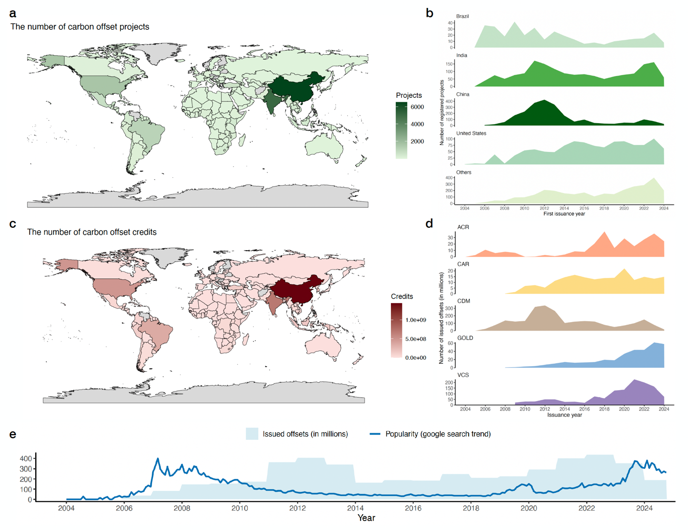
Figure 1. Visualisation of global carbon offset markets
(a) The number of projects applied for carbon offsets. (b) The number of registered projects by country (Brazil, China, India, United States, Others) by first issuance year. (c) The number of issued offsets. (d) The number of issued offsets by registry (ACR: American Carbon Registry; CAR: Climate Action Reserve; CDM: Clean Development Mechanism; GOLD: Gold Standard; VCS: Verified Carbon Standard) by issuance year, (e) Changes in public interest (Google Trends: topic: “carbon offsets and credits”, region: global) and action (issued offsets in millions) over time.

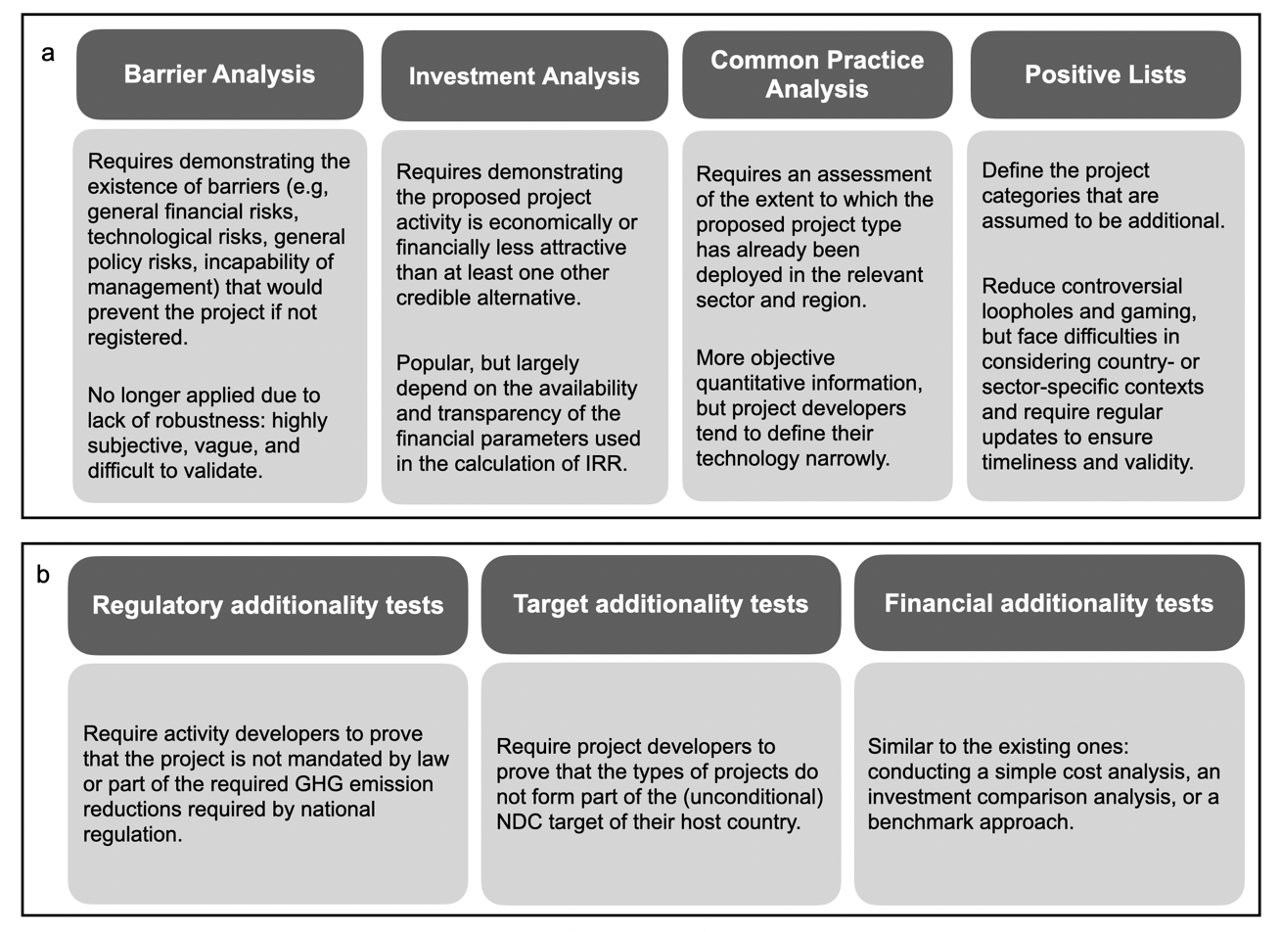
Figure 2. Summary of existing additionality tests
(a) Historic additionality tests adopted under the CDM. (b) Recent additionality tests adopted under more registries. There is a growing demand for harmonisation of certification criteria across registries that ensures quality and comparability in the global carbon market.

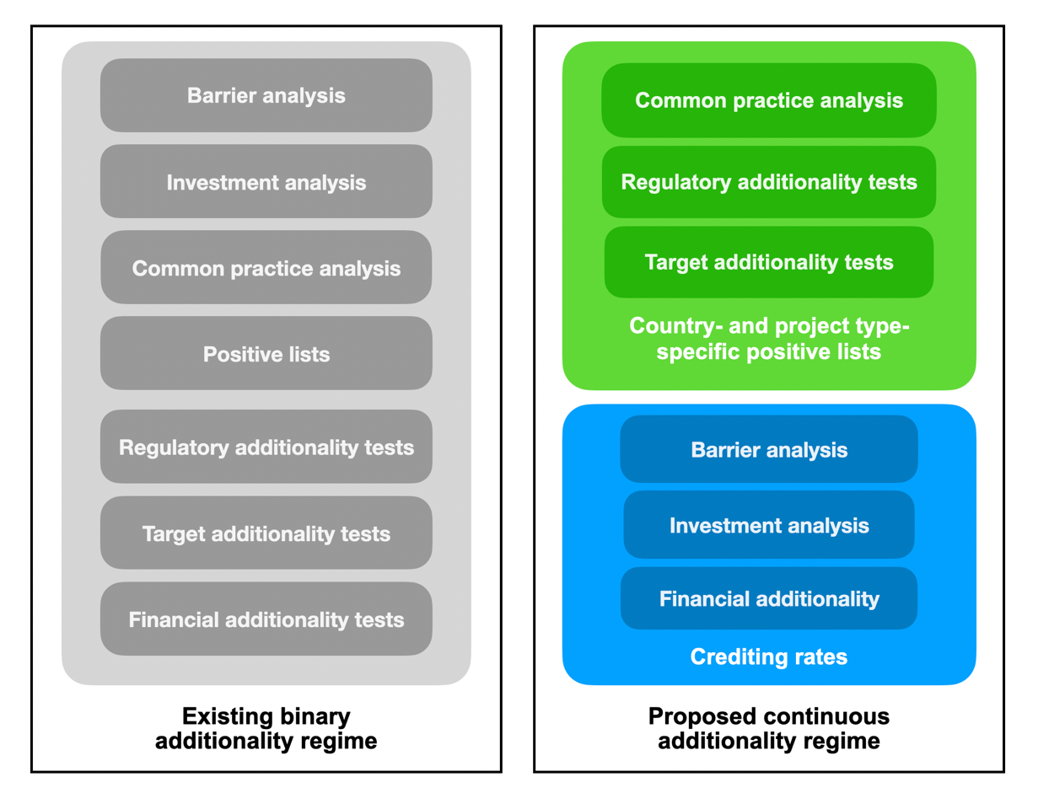
Figure 3. Comparison of the existing regime and the proposed regime
The existing binary additionality regime covers a variety of additionality tests at a project level to accept or reject projects; Our proposed continuous additionality regime with context-based positive lists associated with corresponding credit rates across project types and host countries.

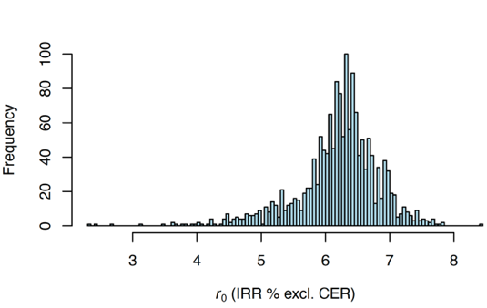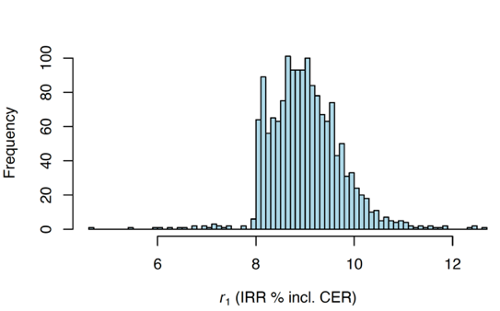
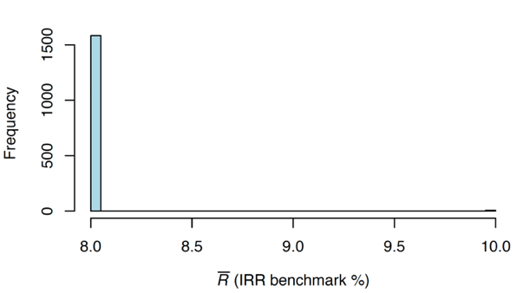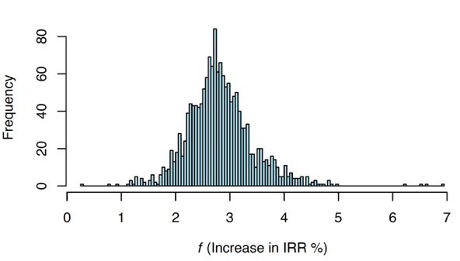
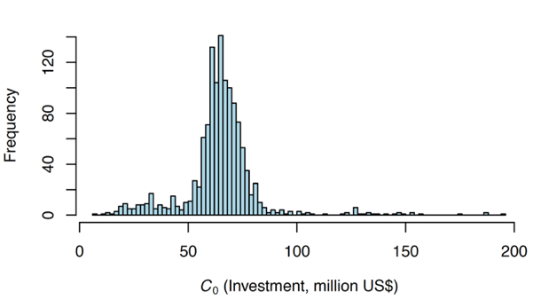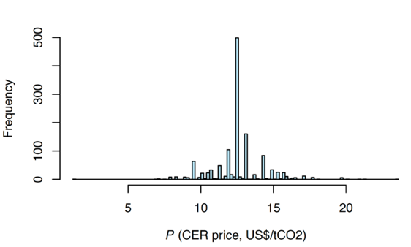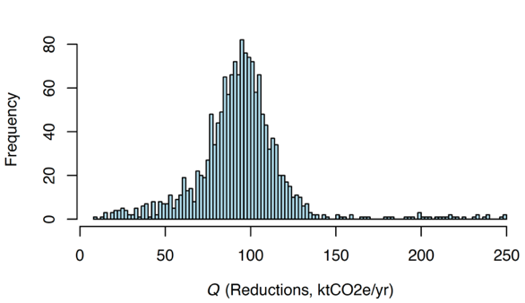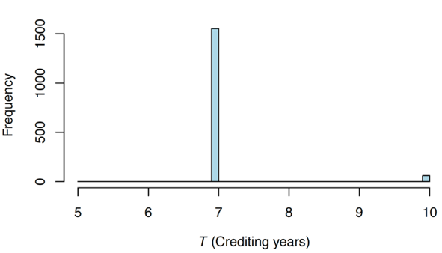
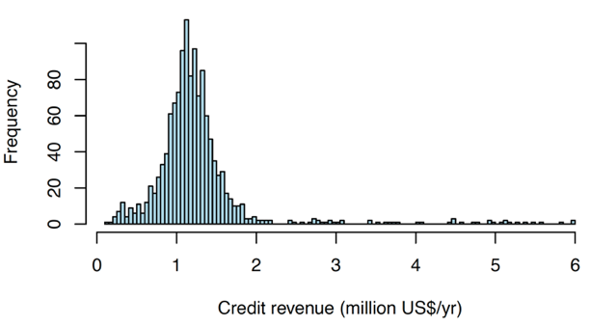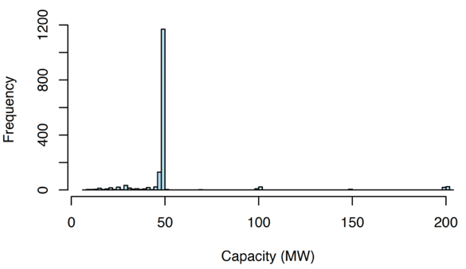
Figure 4. Histograms of key characteristics for the CDM’s wind projects in China

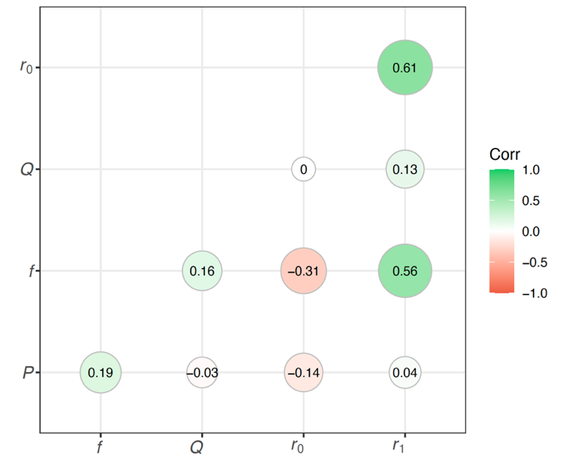
Figure 5. Correlogram of key parameters for the CDM’s wind projects in China
$r_{0}$ refers to observed reported IRR without offset revenue (%); $f$ refers to observed reported increase in IRR due to offset revenue (%); $P$ and $Q$ refer to offset price (US$/tCO2e) and quantity of issued offsets. The green (red) dots show the positive (negative) correlations between these parameters. It is observed that $corr\left(r_{0},f\right)=-0.31$; $corr\left(r_{0},P\right)=-0.14$; $corr\left(f,P\right)=0.19$.

Figure 6. Comparison of observed and actual IRRs without and with credit revenues
The dark blue curve and the dark green curve refer to the distributions of observable reported IRRs without and with credit revenues respectively. The light blue curve and the light green curve refer to the distributions of unobservable actual IRRs without and with credit revenues respectively in the current regime. It is observed that the actual IRRs with credit revenues are far higher than the hurdle rate for a majority of projects, indicating the systematic over-crediting issue. The light-yellow curve refers to the distribution of unobservable actual IRRs with discounted partial credit revenues in the proposed regime.

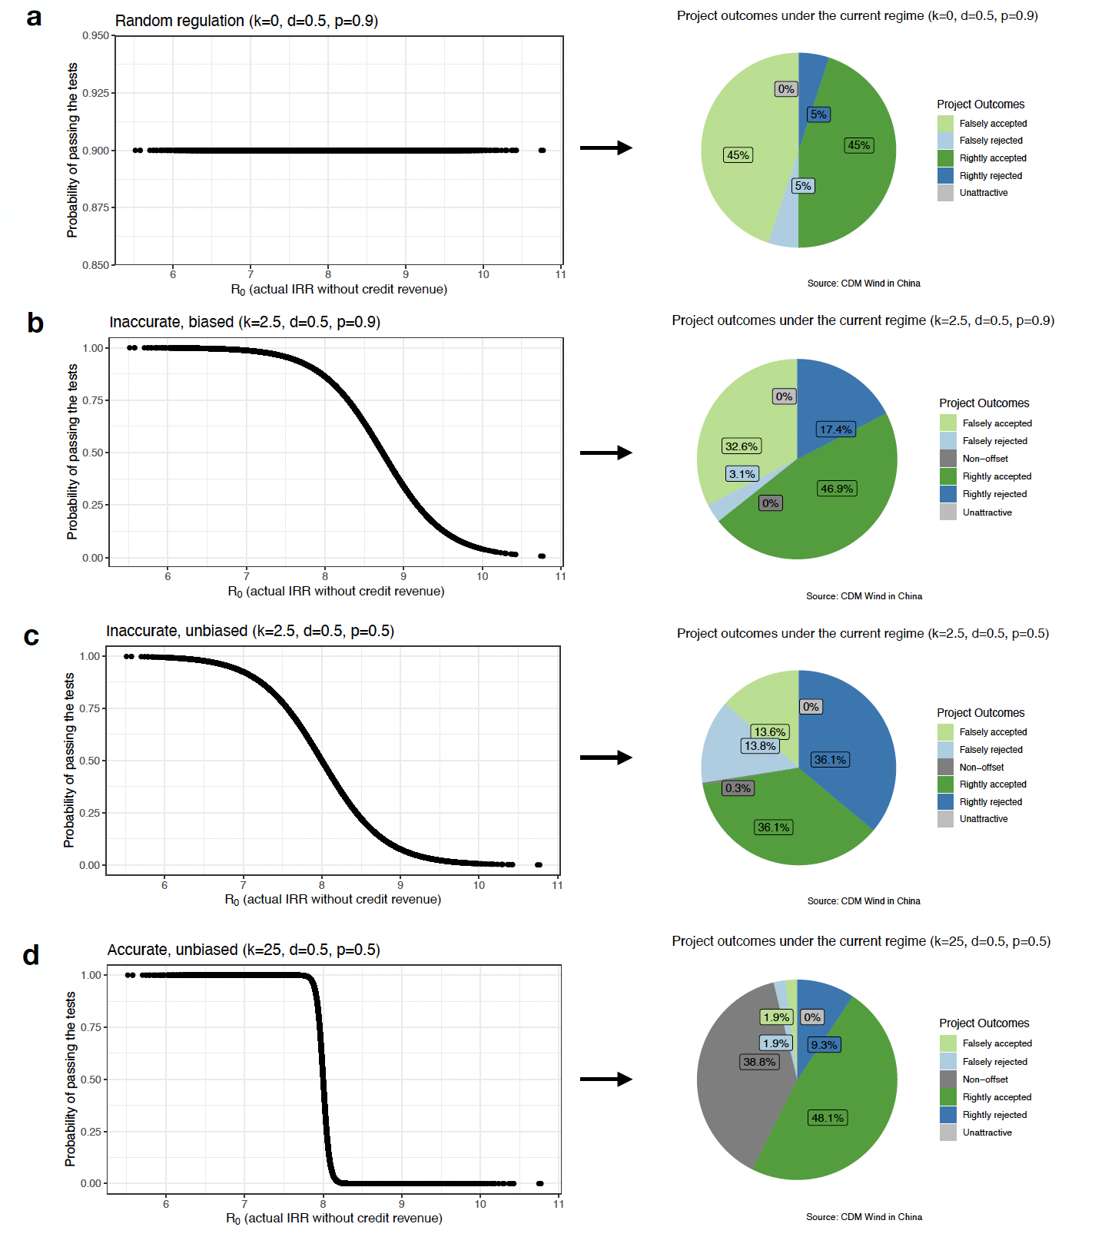
Figure 7. Different levels of regulatory quality and project outcomes under the current regime
(a) Project outcomes under random regulation (each project has the same probability of acceptance independent of its IRR). (b) Project outcomes under inaccurate and positively biased regulation (false acceptances are more likely than false rejections, i.e. the regime is too lenient). (c) Project outcomes in face of inaccurate but unbiased regulation (false acceptances and false rejections are equally likely). (d) Project outcomes under accurate unbiased regulation (regulatory quality is near-perfect; both false acceptances and false rejections are extremely rare). “Non-offset” refers to the outcome that a non-additional project does not apply for credits. Higher-quality regulation is associated with a higher proportion of non-offset projects.

Tables
Table 1. Symbol and description of model parameters
Symbol | Description
Individual project characteristics
$$C_{0}$$ | initial investment cost (million US$)
$$cf$$ | reported (observed) annual cash flow (million US$)
$$CF$$ | actual (unobserved) annual cash flow (million US$)
$$CR$$ | annual (unobserved) offset credit revenue (million US$)
$$P$$ | offset price (US$/tCO2e)
$$Q$$ | quantity of offsets issued annually, also the amount of tCO2e reduced per year
$$T$$ | length of crediting period, measured in years
Individual project financial parameters (%)
$$r_{0}$$ | reported (observed) IRR without offset revenue (%)
$$r_{1}$$ | reported (observed) IRR with offset revenue (%)
$$f$$ | reported (observed) increase in IRR due to offset revenue (%)
$$g$$ | underreported bias in IRR (%), also called the gaming parameter
$$R_{0}$$ | actual (unobserved) IRR without offset revenue (%)
$$R_{1}$$ | actual (unobserved) IRR with offset revenue under the current regime (%)
$$R_{2}$$ | actual (unobserved) IRR with offset revenue under the proposed regime (%)
$$F_{1}$$ | actual increase in IRR due to offset revenue under the current regime (%)
$$F_{2}$$ | actual increase in IRR due to offset revenue under the proposed regime (%)
$$\overline{R}$$ | benchmark IRR, also called hurdle rate
Synthetic project pool characteristics
$$AC$$ | the registration rate within one sector in one country
$$d$$ | real additional proportion within one context (country-sector-specific)
$$sd$$ | the standard deviation of actual IRR within one context
Decision parameters by the project developer and the regulator
$$s_{1}$$ | equal 1 if the project developer pursues the project, 0 otherwise
$$s_{2}$$ | equal 1 if the project developer applies for carbon offset status, 0 otherwise
$$c_{d}$$ | developmental fee
$$c_{v}$$ | validation fee
$$c_{r}$$ | registration fee
$$q$$ | probability of receiving a successful additionality decision
$$ac$$ | equal 1 if the regulator accepts the application, 0 otherwise
$$k$$ | steepness of the decision curve, measuring the accuracy of the regulation
$$R_{p}$$ | policy hurdle rate, measuring the biasedness of the regulation
$$p$$ | additional proportion believed by regulators within one context
$$b$$ | crediting rate within one context under the proposed regime (%)
Notes: For individual project financial parameters, the lowercase letters represent reported values that are observable, the uppercase letters represent actual values that are not observable due to gaming behaviours.

Table 2. The categories of cases under the current and proposed regimes
Current regime | Submitted, accepted  $${ep}_{1}>0$$ | Submitted, rejected  $${ep}_{1}>0$$ | Not submitted  $${ep}_{1}<0$$
High IRR (non-additional)  $$R_{0}> \overline{R}$$ | Falsely accepted project | Correctly rejected project | Non-offset project
Medium IRR (additional)  $$R_{1}> \overline{R}>R_{0}$$ | Correctly accepted project | Falsely rejected project | Not possible (a)
Low IRR (unattractive)  $$\overline{R}>R_{1}>R_{0}$$ | Not possible (b) | Not possible (b) | Unattractive project

Proposed regime | Submitted  $${ep}_{2}>0$$ | Not submitted  $${ep}_{2}<0$$
High IRR (non-additional)  $$R_{0}> \overline{R}$$ | Falsely accepted project | Not possible (c)
Medium IRR (additional)  $$R_{2}> \overline{R}>R_{0}$$ | Correctly accepted project | Not possible (c)
Low IRR (unattractive)  $$\overline{R}>R_{2}>R_{0}$$ | Not possible (b) | Unattractive project

Note: The grey categories are not possible because:
- If $R_{1}>\overline{R}>R_{0}$, $\sum_{n=1}^{T}{\frac{CF+CR}{{\left(1+\overline{R}\right)}^{n}}}-C_{0}-c_{r}-c_{d}-c_{v}>0>\sum_{n=1}^{T}{\frac{CF}{{\left(1+\overline{R}\right)}^{n}}}-C_{0}$, then $\sum_{n=1}^{T}{\frac{CR}{{\left(1+\overline{R}\right)}^{n}}}-c_{r}-c_{d}-c_{v}>0$, then ${enp}_{1}=q×(\sum_{n=1}^{T}{\frac{CR}{{\left(1+\overline{R}\right)}^{n}}}-c_{r})-c_{d}-c_{v}>0$ since $q<1$.
- If $\overline{R}>R_{1}>R_{0}$ or $\overline{R}>R_{2}>R_{0}$, then project developers will not apply since they still lack investments even the offset benefit is secured.
- If $R_{2}>\overline{R}$, then the project developer will apply and automatically get offset credits. Since the validation fee is negligible compared to the offset benefit, all projects will consider applying under the proposed regime unless they are unattractive.

Table 3. The summary statistics of categorical variables in CDM Pipeline database
Variable | N | Freq | Variable | N | Freq
PA/PoA | 13152 |  | Type | 13130
... PA | 12525 | 95% | ... Afforestation | 24 | 0%
... PoA | 627 | 5% | ... Agriculture | 10 | 0%
Region | 13152 |  | ... Biogas | 1 | 0%
... Africa | 616 | 5% | ... Biomass energy | 1514 | 11%
... Asia & Pacific | 10225 | 78% | ... Cement | 98 | 1%
... Europe & Central Asia | 145 | 1% | ... CO2 usage | 6 | 0%
... Latin America | 1979 | 15% | ... Coal bed/mine methane | 183 | 1%
... Middle-East | 170 | 1% | ... EE households | 274 | 2%
... multiple | 17 | 0% | ... EE industry | 342 | 2%
Number of CPAs | 627 |  | ... EE own generation | 841 | 6%
... No | 286 | 46% | ... EE service | 115 | 1%
... Yes | 341 | 54% | ... EE supply side | 213 | 2%
Number of CPAs - Article 6 eligible | 168 |  | ... Energy distribution | 41 | 0%
... No | 28 | 17% | ... Fossil fuel switch | 258 | 2%
... Yes | 140 | 83% | ... Fugitive | 119 | 1%
Status | 13152 |  | ... Geothermal | 44 | 0%
... Deregistered | 23 | 0% | ... HFCs | 27 | 0%
... Pending Publication | 174 | 1% | ... Hybrid renewables | 27 | 0%
... Provisional | 35 | 0% | ... Hydro | 3035 | 23%
... Registered | 8195 | 62% | ... Landfill gas | 652 | 5%
... Rejected | 283 | 2% | ... Methane avoidance | 1202 | 9%
... Validation Public | 431 | 3% | ... Mixed renewables | 43 | 0%
... Validation Replaced | 829 | 6% | ... N2O | 133 | 1%
... Validation Terminated | 3115 | 24% | ... PFCs and SF6 | 25 | 0%
... Withdrawn | 67 | 1% | ... Reforestation | 96 | 1%
Article 6 eligible | 13152 |  | ... Solar | 640 | 5%
... No | 9663 | 73% | ... Solar & wind | 1 | 0%
... Yes | 3489 | 27% | ... Tidal | 2 | 0%
First NDC eligible | 13152 |  | ... Transport | 75 | 1%
... No | 12319 | 94% | ... Waste | 2 | 0%
... Yes | 833 | 6% | ... Wind | 3087 | 24%
Notes: The version of this database includes some PA-related variables for the continued focus of the analysis, which is 1) which and how many CDM activities can be transitioned to the new Article 6.4 mechanism without applying new methodologies and 2) which and how many CERs issued under the CDM until the end of 2020 can be used to fulfil NDCs under the PA⁶⁶. Here, EE refers to energy efficiency; HFCs: hydrofluorocarbons; SF6: sulphur hexafluoride and PFCs: perfluorocarbons.

Table 4. The summary statistics of numerical variables in CDM Pipeline database
Variable | N | Mean | Std. Dev. | Min | Pctl. 25 | Pctl. 75 | Max
Ref. | 13152 | 3551 | 3510 | 0 | 0 | 6713 | 10749
1st period ktCO2e/yr | 13152 | 143 | 701 | 0 | 22 | 107 | 47809
2nd period ktCO2e/yr | 13152 | 15 | 169 | 0 | 0 | 0 | 11862
3rd period ktCO2e/yr | 13152 | 1.7 | 49 | 0 | 0 | 0 | 4434
Reductions (ktCO2e/yr) | 13152 | 138 | 694 | 0 | 21 | 103 | 47809
yrs. | 13152 | 8.3 | 2.1 | 0 | 7 | 10 | 40
Potential A6 Reductions (ktCO2e) | 13152 | 117 | 1093 | 0 | 0 | 5.6 | 66086
Pot_Red 2021 | 13152 | 37 | 269 | 0 | 0 | 3.3 | 13339
Pot_Red 2022 | 13152 | 29 | 250 | 0 | 0 | 0 | 15100
Pot_Red 2023 | 13152 | 22 | 249 | 0 | 0 | 0 | 15712
Pot_Red 2024 | 13152 | 17 | 243 | 0 | 0 | 0 | 16090
Pot_Red 2025 | 13152 | 12 | 144 | 0 | 0 | 0 | 8751
kCERs CP1 | 13152 | 113 | 1580 | 0 | 0 | 0 | 74928
kCERs CP2 | 13152 | 71 | 594 | 0 | 0 | 0 | 43096
Total issuance (kCERs) | 13152 | 184 | 1931 | 0 | 0 | 25 | 118025
Voluntary cancellations (kCERs) | 13152 | 12 | 171 | 0 | 0 | 0 | 10129
MW | 9848 | 55 | 200 | 0.01 | 7.5 | 50 | 7176
Full time hours | 8395 | 7687 | 69231 | 2.1 | 2109 | 5226 | 3700000
Grid emission factor tCO2e/MWh | 4848 | 0.8 | 0.21 | 0.04 | 0.71 | 0.93 | 8.1
Annual EE GWh reduced | 74 | 27 | 36 | 0.27 | 6.9 | 43 | 209
Forest size ha | 94 | 5850 | 14055 | 75 | 348 | 5386 | 106926
Investment MUS$ | 6750 | 63 | 218 | 0.031 | 7.3 | 64 | 6256
Investment US$/tCO2 | 6750 | 645 | 1665 | 0.25 | 212 | 692 | 62624
Investment US$/kW | 5956 | 1727 | 6725 | 4.5 | 984 | 1550 | 329300
IRR % excl. CER | 7309 | 7.2 | 5.6 | -88 | 5.9 | 8.9 | 99
IRR benchmark | 6676 | 11 | 3.6 | 3.6 | 8 | 13 | 49
IRR % incl. CER | 5861 | 13 | 6.7 | 0.089 | 9 | 14 | 96
CER price US$/tCO2 | 3945 | 12 | 4 | 0.22 | 10 | 13 | 124
Notes: This table implies the CDM Pipeline has some strange outliers (very likely typos) in the parameters. After comparing the outliers and the PDDs, we manually correct the typos and exclude the outliers for model calibration later and more robust analysis. Here, IRR refers to internal rate of return.

Table 5. The summary statistics of important variables in voluntary registry offset database
Variable | N | Mean | Std. Dev. | Min | Pctl. 25 | Pctl. 75 | Max
Voluntary Registry | 8850
... ACR | 457 | 5%
... CAR | 609 | 7%
... GOLD | 3437 | 39%
... VCS | 4347 | 49%
Reduction / Removal | 8850
... Impermanent Removal | 533 | 6%
... Long-Duration Removal | 17 | 0.2%
... Mixed | 948 | 11%
... Reduction | 7352 | 83%
Total Credits Issued | 8850 | 215383 | 1269590 | 0 | 0 | 86861 | 39998290
Total Credits Retired | 8850 | 116212 | 735716 | 0 | 0 | 29742 | 26317269
Total Credits Remaining | 8850 | 99170 | 676413 | -85557 | 0 | 26718 | 29597435
Total Buffer Pool Deposits | 8850 | 10442 | 152960 | 0 | 0 | 0 | 5049473
Reversals Covered by Buffer Pool | 8850 | 5.5 | 519 | 0 | 0 | 0 | 48837
Reversals Not Covered by Buffer | 8850 | 1.7 | 159 | 0 | 0 | 0 | 14934
Buffer Credits Released to Project | 8850 | 740 | 26541 | 0 | 0 | 0 | 1878938
First Year of Project (Vintage) | 4363 | 2015 | 5.3 | 1996 | 2010 | 2020 | 2024
2002 | 8850 | 14 | 1329 | 0 | 0 | 0 | 125000
2003 | 8850 | 0 | 0 | 0 | 0 | 0 | 0
2004 | 8850 | 0.056 | 5.3 | 0 | 0 | 0 | 500
2005 | 8850 | 325 | 21623 | 0 | 0 | 0 | 1898000
2006 | 8850 | 1246 | 79208 | 0 | 0 | 0 | 6086006
2007 | 8850 | 661 | 27840 | 0 | 0 | 0 | 2231178
2008 | 8850 | 994 | 41926 | 0 | 0 | 0 | 3024628
2009 | 8850 | 3438 | 61791 | 0 | 0 | 0 | 4881729
2010 | 8850 | 4553 | 66336 | 0 | 0 | 0 | 4483537
2011 | 8850 | 4810 | 52443 | 0 | 0 | 0 | 1934722
2012 | 8850 | 7453 | 103885 | 0 | 0 | 0 | 4865137
2013 | 8850 | 7733 | 139783 | 0 | 0 | 0 | 9015685
2014 | 8850 | 5560 | 78416 | 0 | 0 | 0 | 5772071
2015 | 8850 | 5401 | 62714 | 0 | 0 | 0 | 2722170
2016 | 8850 | 4080 | 46730 | 0 | 0 | 0 | 2126828
2017 | 8850 | 10844 | 250964 | 0 | 0 | 0 | 14165124
2018 | 8850 | 9687 | 151714 | 0 | 0 | 0 | 7985332
2019 | 8850 | 17225 | 269437 | 0 | 0 | 0 | 15322772
2020 | 8850 | 20764 | 199772 | 0 | 0 | 0 | 9059054
2021 | 8850 | 32220 | 300370 | 0 | 0 | 0 | 11838831
2022 | 8850 | 31136 | 322630 | 0 | 0 | 0 | 23703328
2023 | 8850 | 29423 | 235742 | 0 | 0 | 0 | 11371671
2024 | 8850 | 17814 | 151974 | 0 | 0 | 0 | 6334750
Notes: The year variables (2002-2024) refer to the number of credits issued in that year.

Table 6. The distribution and number of benchmark IRR by host country and project type
Host country |  | Type | N | mean | sd | median | min | max | Uniq_N
Brazil | Biomass energy |  | 184 | 14.74 | 4.35 | 12.4 | 11.43 | 28.52 | 12
Brazil | EE own generation |  | 14 | 12.65 | 0.91 | 12.65 | 12 | 13.29 | 2
Brazil | Energy distribution |  | 7 | 12.16 | 3.69 | 11.75 | 8.44 | 16.7 | 4
Brazil | Hydro |  | 186 | 15.31 | 3.87 | 15.52 | 7.27 | 23.31 | 70
Brazil | Landfill gas |  | 92 | 13.61 | 3.84 | 11.75 | 10.18 | 25 | 17
Brazil | Methane avoidance |  | 101 | 12.07 | 0.44 | 12.13 | 11.25 | 12.75 | 4
Brazil | PFCs and SF6 |  | 4 | 17.9 |  | 17.9 | 17.9 | 17.9 | 1
Brazil | Reforestation |  | 7 | 8.29 |  | 8.29 | 8.29 | 8.29 | 1
Brazil | Wind |  | 96 | 12.68 | 2.69 | 11.99 | 8.65 | 23.09 | 39
China | Biomass energy |  | 220 | 8.11 | 0.64 | 8 | 8 | 13 | 5
China | Cement |  | 46 | 12.17 | 1.94 | 11.5 | 11 | 16 | 3
China | Coal bed/mine methane |  | 167 | 10.68 | 2.92 | 10 | 8 | 27.67 | 10
China | EE industry |  | 24 | 12.38 | 0.96 | 13 | 10 | 13 | 4
China | EE own generation |  | 497 | 12.31 | 3.20 | 12 | 8 | 29.59 | 18
China | EE service |  | 3 | 13 |  | 13 | 13 | 13 | 1
China | EE supply side |  | 43 | 10.43 | 3.23 | 8 | 8 | 15.71 | 8
China | Energy distribution |  | 20 | 7.94 | 1.73 | 8 | 5.76 | 10 | 3
China | Fossil fuel switch |  | 53 | 8.38 | 1.54 | 8 | 8 | 15.28 | 3
China | Fugitive |  | 4 | 12 | 0 | 12 | 12 | 12 | 1
China | Geothermal |  | 3 | 10 |  | 10 | 10 | 10 | 1
China | Hydro |  | 1738 | 9.44 | 0.93 | 10 | 7 | 14.86 | 9
China | Landfill gas |  | 156 | 7.87 | 0.79 | 8 | 4.44 | 12 | 4
China | Methane avoidance |  | 149 | 10.48 | 2.34 | 11 | 7 | 16 | 9
China | Mixed renewables |  | 4 | 8 | 0 | 8 | 8 | 8 | 1
China | N2O |  | 62 | 8.47 | 4.13 | 9 | 4 | 14.82 | 4
China | PFCs and SF6 |  | 2 | 8 |  | 8 | 8 | 8 | 1
China | Reforestation |  | 8 | 9.33 | 2.31 | 8 | 8 | 12 | 2
China | Solar |  | 175 | 7.84 | 0.81 | 8 | 3.6 | 8 | 3
China | Transport |  | 10 | 12.5 | 0.71 | 12.5 | 12 | 13 | 2
China | Wind |  | 1614 | 8.01 | 0.13 | 8 | 8 | 10 | 2
India | Biomass energy |  | 659 | 13.54 | 3.55 | 13 | 10.25 | 48.86 | 71
India | EE households |  | 87 | 10.82 | 5.20 | 8 | 8 | 25 | 5
India | EE industry |  | 225 | 12.93 | 2.61 | 12.5 | 10 | 18 | 9
India | EE own generation |  | 245 | 15.45 | 4.30 | 15.08 | 8 | 26.5 | 39
India | EE service |  | 48 | 10.10 | 0.21 | 10 | 10 | 10.48 | 2
India | EE supply side |  | 77 | 14.35 | 1.96 | 14 | 11.5 | 17.69 | 13
India | Energy distribution |  | 6 | 11.5 | 0 | 11.5 | 11.5 | 11.5 | 1
India | Fossil fuel switch |  | 87 | 13.95 | 1.91 | 13.34 | 12 | 18.75 | 13
India | Fugitive |  | 23 | 14.50 | 3.32 | 13.5 | 12 | 19.01 | 3
India | Hydro |  | 329 | 13.98 | 2.37 | 13.47 | 8.25 | 26.03 | 130
India | Landfill gas |  | 61 | 13.66 | 2.11 | 12.75 | 10 | 17.67 | 14
India | Methane avoidance |  | 102 | 13.032 | 1.77 | 12.75 | 9.5 | 17.7 | 16
India | Mixed renewables |  | 13 | 16.33 | 0.92 | 16.48 | 14.99 | 17.18 | 5
India | PFCs and SF6 |  | 2 | 18.39 |  | 18.39 | 18.39 | 18.39 | 1
India | Solar |  | 211 | 14.62 | 2.82 | 14.58 | 8 | 20.83 | 34
India | Transport |  | 29 | 13.09 | 5.16 | 13 | 7.76 | 21.46 | 4
India | Wind |  | 1107 | 14.78 | 2.57 | 14.54 | 8.77 | 22.85 | 335

Table 7. The number of CDM projects and registration rate by host country and project type
Host country | Biomass energy | EE own generation | Hydro | Landfill gas | Methane avoidance | Solar | Wind
Brazil | 184 | 14 | 186 | 92 | 101 | 1 | 96
Brazil | 26.09% | 21.43% | 52.69% | 58.70% | 66.34% | 100.00% | 63.54%
Chile | 20 | 1 | 57 | 26 | 18 | 47 | 26
Chile | 60.00% | 100.00% | 59.65% | 61.54% | 38.89% | 42.55% | 84.62%
China | 220 | 497 | 1738 | 156 | 149 | 175 | 1614
China | 63.18% | 42.05% | 76.29% | 66.67% | 63.09% | 93.71% | 93.68%
India | 659 | 245 | 329 | 61 | 102 | 211 | 1107
India | 40.21% | 30.61% | 50.76% | 31.15% | 33.33% | 72.04% | 65.40%
Indonesia | 38 | 7 | 33 | 13 | 111 | 2 | 0
Indonesia | 36.84% | 14.29% | 63.64% | 84.62% | 66.67% | 50.00% | NA
Malaysia | 73 | NA | 6 | 22 | 148 | 0 | 0
Malaysia | 57.53% | NA | 83.33% | 40.91% | 56.76% | NA | NA
Mexico | 20 | 2 | 15 | 45 | 164 | 3 | 38
Mexico | 55.00% | 100.00% | 53.33% | 62.22% | 62.20% | 0.00% | 76.32%
Philippines | 20 | 2 | 14 | 11 | 72 | 1 | 7
Philippines | 25.00% | 100.00% | 78.57% | 54.55% | 58.33% | 100.00% | 42.86%
Thailand | 57 | 15 | 6 | 10 | 149 | 28 | 5
Thailand | 47.37% | 26.67% | 50.00% | 60.00% | 50.34% | 100.00% | 60.00%
Vietnam | 25 | 5 | 227 | 8 | 33 | 9 | 7
Vietnam | 72.00% | 40.00% | 89.43% | 87.50% | 69.70% | 44.44% | 85.71%
Notes: The table only shows host countries with more than 200 projects. To ensure data representation and sample size, we use the bold font here for the categories whose observations are over 1000, which can be used for our model construction and parameter calibration later.

Table 8. The number of VCM projects and registration rates by host country and project type
Host Country | Project Type | N | RRate | Host Country | Project Type | N | RRate
Bangladesh | Cookstoves | 118 | 96.61% | India | Cookstoves | 289 | 86.85%
Brazil | Hydropower | 16 | 81.25% | India | Wind | 477 | 73.38%
Brazil | Landfill Methane | 37 | 48.65% | Kenya | Afforestation/  Reforestation | 15 | 93.33%
Brazil | Afforestation/  Reforestation | 39 | 71.79% | Kenya | Clean water | 56 | 87.50%
Brazil | Biomass | 50 | 90.00% | Kenya | Cookstoves | 115 | 76.52%
Brazil | REDD+ | 109 | 73.39% | Madagascar | Cookstoves | 80 | 83.75%
Burkina Faso | Clean Water | 22 | 100.00% | Malawi | Cookstoves | 67 | 77.61%
Burkina Faso | Cookstoves | 73 | 67.12% | Mexico | Improved forest management | 281 | 58.36%
China | Biomass | 32 | 59.38% | Mozambique | Clean water | 18 | 88.89%
China | Cookstoves | 25 | 92.00% | Mozambique | Cookstoves | 50 | 40.00%
China | Mine methane capture | 32 | 87.50% | Nigeria | Cookstoves | 31 | 51.61%
China | Rice emission reductions | 266 | 10.90% | Nigeria | Clean water | 67 | 92.54%
China | Improved forest management | 72 | 41.67% | Rwanda | Clean water | 19 | 63.16%
China | Solar | 34 | 91.18% | Rwanda | Cookstoves | 90 | 81.11%
China | Afforestation/  Reforestation | 79 | 55.70% | Turkey | Solar | 20 | 80.00%
China | Sustainable agriculture | 60 | 83.33% | Turkey | Manure methane digester | 66 | 48.48%
China | Landfill methane | 87 | 81.61% | Turkey | Landfill methane | 58 | 58.62%
China | Hydropower | 116 | 73.28% | Turkey | Hydropower | 186 | 77.42%
China | Manure methane digester | 144 | 68.06% | Turkey | Wind | 177 | 83.62%
China | Biodigesters | 125 | 92.00% | Uganda | Afforestation/  Reforestation | 21 | 95.24%
China | Wind | 211 | 78.20% | Uganda | Clean water | 54 | 75.93%
India | Clean water | 24 | 54.17% | Uganda | Cookstoves | 116 | 81.90%
India | Sustainable agriculture | 41 | 68.29% | United States | Sustainable agriculture | 16 | 68.75%
India | Hydropower | 62 | 80.65% | United States | Wind | 12 | 100.00%
India | Biodigesters | 68 | 91.18% | United States | Afforestation/  Reforestation | 31 | 58.06%
India | Biomass | 118 | 61.02% | United States | Manure methane digester | 32 | 81.25%
India | Afforestation/  Reforestation | 100 | 76.00% | United States | Improved forest management | 228 | 64.91%
India | Solar | 154 | 76.62% | United States | Landfill methane | 173 | 90.75%
Notes: The table only shows the country-project-type category with more than 10 observations. To highlight contexts with low perceived non-additionality risks, we use the bold font here for the categories whose registration rates are over 90%.

References
1. Victor, D. G. & Cullenward, D. Making Carbon Markets Work. Scientific American 297, 70–77 (2007).
2. Ahonen, H.-M., Kessler, J., Michaelowa, A., Espelage, A. & Hoch, S. Governance of fragmented compliance and voluntary carbon markets under the Paris Agreement. Politics and Governance 10, 4759 (2022).
3. Broekhof, D., Gillenwater, M., Colbert-Sangree, T. & Cage, P. Securing climate benefit: A guide to using carbon offsets. (2019).
4. Bumpus, A. G. & Liverman, D. M. Accumulation by Decarbonization and the Governance of Carbon Offsets. Economic Geography 84, 127–155 (2008).
5. Lovell, H. C. Governing the carbon offset market. WIREs Climate Change 1, 353–362 (2010).
6. Certification Process Step-by-Step. Gold Standard https://www.goldstandard.org/publications/certification-process-stepbystep.
7. Projects. Gold Standard Marketplace https://marketplace.goldstandard.org/collections/projects.
8. Develop a Verified Carbon Standard (VCS) Project. Verra https://verra.org/programs/verified-carbon-standard/develop-a-vcs-project/.
9. Setting the Bar for Carbon Credit Quality. ACR https://acrcarbon.org/acr-program/.
10. Offset Project Registries | California Air Resources Board. https://ww2.arb.ca.gov/our-work/programs/compliance-offset-program/offset-project-registries.
11. California Here We Come! Verra https://verra.org/vcs-approved-as-offset-project-registry-in-california/ (2014).
12. Axelsson, K. et al. Oxford Principles for Net Zero Aligned Carbon Offsetting (Revised 2024). 1–28 https://www.smithschool.ox.ac.uk/sites/default/files/2024-02/Oxford-Principles-for-Net-Zero-Aligned-Carbon-Offsetting-revised-2024.pdf (2024).
13. Watt, R. The moral economy of carbon offsetting: ethics, power and the search for legitimacy in a new market. (University of Manchester, 2017).
14. Calel, R., Colmer, J., Dechezleprêtre, A. & Glachant, M. Do carbon offsets offset carbon? American Economic Journal: Applied Economics 17, 1–40 (2025).
15. Mason, C. F. & Plantinga, A. J. The additionality problem with offsets: Optimal contracts for carbon sequestration in forests. Journal of Environmental Economics and Management 66, 1–14 (2013).
16. Zhang, J. & Wang, C. Co-benefits and additionality of the Clean Development Mechanism: An empirical analysis. Journal of Environmental Economics and Management 62, 140–154 (2011).
17. CDM: CDM Registry. https://cdm.unfccc.int/Registry/index.html.
18. Balmford, A. et al. Realizing the social value of impermanent carbon credits. Nature Climate Change 13, 1172–1178 (2023).
19. The interplay between voluntary and compliance carbon markets. OECD https://www.oecd.org/en/publications/the-interplay-between-voluntary-and-compliance-carbon-markets_500198e1-en.html (2024).
20. Haya, B. et al. Managing uncertainty in carbon offsets: insights from California’s standardized approach. Climate Policy 20, 1112–1126 (2020).
21. Schwartzman, S. et al. Environmental integrity of emissions reductions depends on scale and systemic changes, not sector of origin. Environ. Res. Lett. 16, 091001 (2021).
22. Badgley, G. et al. Systematic over‐crediting in California’s forest carbon offsets program. Global Change Biology 28, 1433–1445 (2022).
23. West, T. A. P., Börner, J., Sills, E. O. & Kontoleon, A. Overstated carbon emission reductions from voluntary REDD+ projects in the Brazilian Amazon. Proceedings of the National Academy of Sciences 117, 24188–24194 (2020).
24. West, T. A. P. et al. Action needed to make carbon offsets from forest conservation work for climate change mitigation. Science 381, 873–877 (2023).
25. Trencher, G., Nick, S., Carlson, J. & Johnson, M. Demand for low-quality offsets by major companies undermines climate integrity of the voluntary carbon market. Nature Communications 15, 6863 (2024).
26. Michaelowa, A., Espelage, A., Kessler, J. & Singh, A. Developing an Article 6 Tool to Assess the Additionality of Mitigation Activities. https://www.carbon-mechanisms.de/fileadmin/media/dokumente/Publikationen/CMM-WG_discussion_paper_Art6_tool_additionality_final_24.05.2022.pdf (2022).
27. Lang, S., Blum, M. & Leipold, S. What future for the voluntary carbon offset market after Paris? An explorative study based on the Discursive Agency Approach. Climate Policy 19, 414–426 (2019).
28. The Clean Development Mechanism (CDM): A User’s Guide. 20–29 https://www.undp.org/sites/g/files/zskgke326/files/publications/cdmchapter2.pdf (2015).
29. CDM: Register a project activity. https://cdm.unfccc.int/Projects/pac/howto/CDMProjectActivity/Register/index.html.
30. New AFOLU buffer pool compensation agreement. Verra https://verra.org/program-notice/new-afolu-buffer-pool-compensation-agreement/ (2024).
31. Understanding verra’s new risk-based approach (RBA) to project reviews – FAQs. Verra https://verra.org/understanding-verras-new-risk-based-approach-rba-to-project-reviews-faqs/.
32. Groom, B. & Venmans, F. The social value of offsets. Nature 619, 768–773 (2023).
33. Schneider, L. Assessing the additionality of CDM projects: practical experiences and lessons learned. Climate Policy 9, 242–254 (2009).
34. Michaelowa, A. Interpreting the Additionality of CDM Projects: Changes in Additionality Definitions and Regulatory Practices over Time. in Legal Aspects of Carbon Trading: Kyoto, Copenhagen, and beyond (eds Freestone, D. & Streck, C.) 0 (Oxford University Press, 2009). doi:10.1093/acprof:oso/9780199565931.003.0012.
35. Michaelowa, A., Hermwille, L., Obergassel, W. & Butzengeiger, S. Additionality revisited: guarding the integrity of market mechanisms under the Paris Agreement. Climate Policy 19, 1211–1224 (2019).
36. Schneider, L. Is the CDM Fulfilling Its Environmental and Sustainable Development Objectives? An Evaluation of the CDM and Options for Improvement. https://www.semanticscholar.org/paper/Is-the-CDM-fulfilling-its-environmental-and-objec-Herold-Carlino/e456e07c98dd9b8c1bf13a2ead996bf0661440af (2007).
37. Ahonen, H.-M. et al. Safeguarding integrity of market-based cooperation under Article 6: additionality determination and baseline setting. Background Paper https://doi.org/10.5167/uzh-208160 (2021) doi:10.5167/uzh-208160.
38. Shishlov, I. & Bellassen, V. 10 lessons from 10 years of the CDM. 39 p. (auto-saisine, 2012).
39. Gold Standard. Aligning Gold Standard Projects with the Paris Agreement. Summary of Consultation Feedback and next Steps. https://www.goldstandard.org/sites/default/files/documents/aligning_gold_standard_projects_with_the_paris_agreement_summary_of_consultation_feedback_and_next_steps.pdf (2021).
40. Gold Standard. Gold Standard Launches Program to Support Higher Ambition in Paris Era Carbon Markets. https://www.goldstandard.org/blog-item/gold-standard-launches-program-supporthigher-ambition-paris-era-carbon-markets (2021).
41. Gold Standard. Renewable Energy Activity Requirements, Version 1.4. https://globalgoals.goldstandard.org/202-ar-renewable-energy-activity-requirements/ (2021).
42. Verra. Revision to Scope of VCS Program, Proposal for Public Consultation. https://verra.org/wp-content/uploads/2019/04/VCS-v4-Revision-to-Scope-of-VCS-Program.pdf (2019).
43. Polonsky, M., Grau, S. & Garma, R. The new greenwash? Potential marketing problems with carbon offsets. (2010).
44. Badgley, G. et al. California’s forest carbon offsets buffer pool is severely undercapitalized. Frontiers in Forests and Global Change 5, 930426 (2022).
45. Wara, M. & Victor, D. G. A Realistic Policy on International Carbon Offsets. Program on Energy and Sustainable Development Working Paper #74 http://pesd.fsi.stanford.edu/publications/a_realistic_policy_on_international_carbon_offsets (2008).
46. Kuriyama, A. & Koakutsu, K. Quantitative Assessment of Certified Emission Reductions from Non-Additional CDM Projects. https://www.iges.or.jp/en/pub/quantitative-assessment-certified-emission/en https://www.iges.or.jp/en/pub/quantitative-assessment-certified-emission/en (2016).
47. Greenfield, P. Revealed: more than 90% of rainforest carbon offsets by biggest certifier are worthless, analysis shows. The Guardian (2023).
48. Gill-Wiehl, A., Kammen, D. M. & Haya, B. K. Pervasive over-crediting from cookstove offset methodologies. Nature Sustainability 7, 191–202 (2024).
49. Guizar-Coutiño, A., Jones, J. P. G., Balmford, A., Carmenta, R. & Coomes, D. A. A global evaluation of the effectiveness of voluntary REDD+ projects at reducing deforestation and degradation in the moist tropics. Conserv Biol 36, e13970 (2022).
50. Verra. Verra Response to Guardian Article on Carbon Offsets. https://verra.org/verra-response-guardian-rainforest-carbon-offsets/ (2023).
51. Haya, B., Strong, A., Grubert, E. & Cullenward, D. Carbon offsets in California: Science in the policy development process. in Advances in Natural and Technological Hazards Research 241–254 (Springer International Publishing, Cham, 2016). doi:10.1007/978-3-319-20161-0_15.
52. Heller, T. C. & Shukla, P. R. Development and Climate: Engaging Developing Countries. Pew Center on Global Climate Change http://pesd.fsi.stanford.edu/publications/development_and_climate_engaging_developing_countries (2003).
53. Heller, T. C. et al. Baseline for carbon emissions in the Indian and Chinese power sectors: implications for international carbon trading. Program on Energy and Sustainable Development Working Paper #34 http://pesd.fsi.stanford.edu/publications/baseline_for_carbon_emissions_in_the_indian_and_chinese_power_sectors_implications_for_international_carbon_trading (2005).
54. Lazarus, M., Kartha, S. & Bernow, S. Key Issues in Benchmark Baselines for the CDM: Aggregation, Stringency, Cohorts, and Updating. (2000).
55. Shrestha, R. M. & Timilsina, G. R. The additionality criterion for identifying clean development mechanism projects under the Kyoto Protocol. Energy Policy 30, 73–79 (2002).
56. Camara, Y., Holtsmark, B. & Misch, F. Electric Vehicles, Tax Incentives and Emissions: Evidence from Norway. SSRN Scholarly Paper at https://papers.ssrn.com/abstract=4026339 (2021).
57. Radpour, S., Gemechu, E., Ahiduzzaman, M. & Kumar, A. Developing a framework to assess the long-term adoption of renewable energy technologies in the electric power sector: The effects of carbon price and economic incentives. Renewable and Sustainable Energy Reviews 152, 111663 (2021).
58. Bölük, G. & Kaplan, R. Effectiveness of renewable energy incentives on sustainability: evidence from dynamic panel data analysis for the EU countries and Turkey. Environ Sci Pollut Res 29, 26613–26630 (2022).
59. Zhou, Y., Wang, L. & McCalley, J. D. Designing effective and efficient incentive policies for renewable energy in generation expansion planning. Applied Energy 88, 2201–2209 (2011).
60. Kleven, H. J. & Waseem, M. Using notches to uncover optimization frictions and structural elasticities: theory and evidence from pakistan *. The Quarterly Journal of Economics 128, 669–723 (2013).
61. Saez, E. Do taxpayers bunch at kink points? American Economic Journal: Economic Policy 2, 180–212 (2010).
62. Bertrand, M., Mullainathan, S. & Shafir, E. A behavioral-economics view of poverty. American Economic Review 94, 419–423 (2004).
63. Currie, J. The Take Up of Social Benefits. Working Paper at https://doi.org/10.3386/w10488 (2004).
64. Martin, R., Muûls, M., de Preux, L. B. & Wagner, U. J. Industry Compensation under Relocation Risk: A Firm-Level Analysis of the EU Emissions Trading Scheme. American Economic Review 104, 2482–2508 (2014).
65. Michaelowa, A., Espelage, A., Kessler, J. & Singh, A. Developing an Article 6 Tool to Assess the Additionality of Mitigation Activities. https://www.perspectives.cc/public/publications/publication/?no_cache=1&tx_pccprojects_plugin[action]=show&tx_pccprojects_plugin[controller]=Publication&tx_pccprojects_plugin[uid]=165 (2022).
66. CDM Pipeline. UNEP-CCC https://unepccc.org/cdm-ji-pipeline/ (2023).

