Rivers beneath the surface: how riverine inputs shape sedimentation in a large peri-alpine lake
Emma Faval¹, Guillaume Cunillera¹, Jérémy Keller¹, Nathalie Dubois², David J. Janssen², Natacha Pasche¹
¹ EPFL, ENAC, Limnology Center, Lausanne, Switzerland
²Eawag, Department Surface Waters Research and Management, Dübendorf and Eawag, Switzerland

Corresponding author: natacha.pasche@epfl.ch

To be submitted to Aquatic Science

Supplementary information

Fig. S1: Mooring design of the sediment traps, composed of two cylinders.

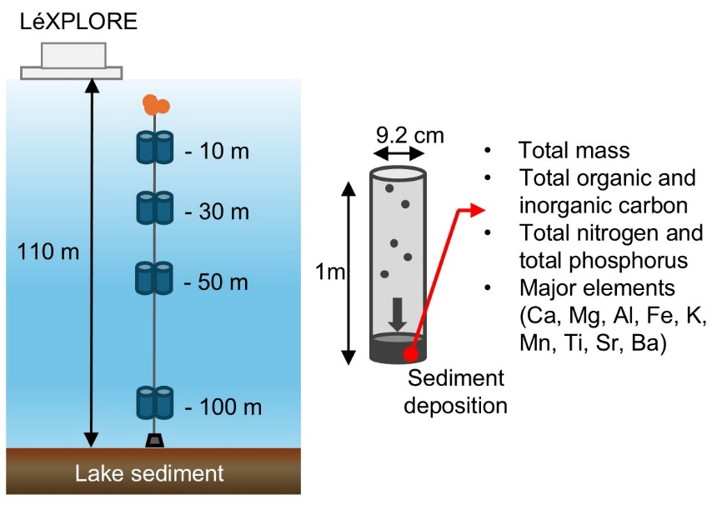

Figure S2 Total mass, TP, TN, TIC and TOC fluxes (in mg m⁻² d⁻¹) from 2020 to 2024 for 30 m, 50 m, and 100 m.
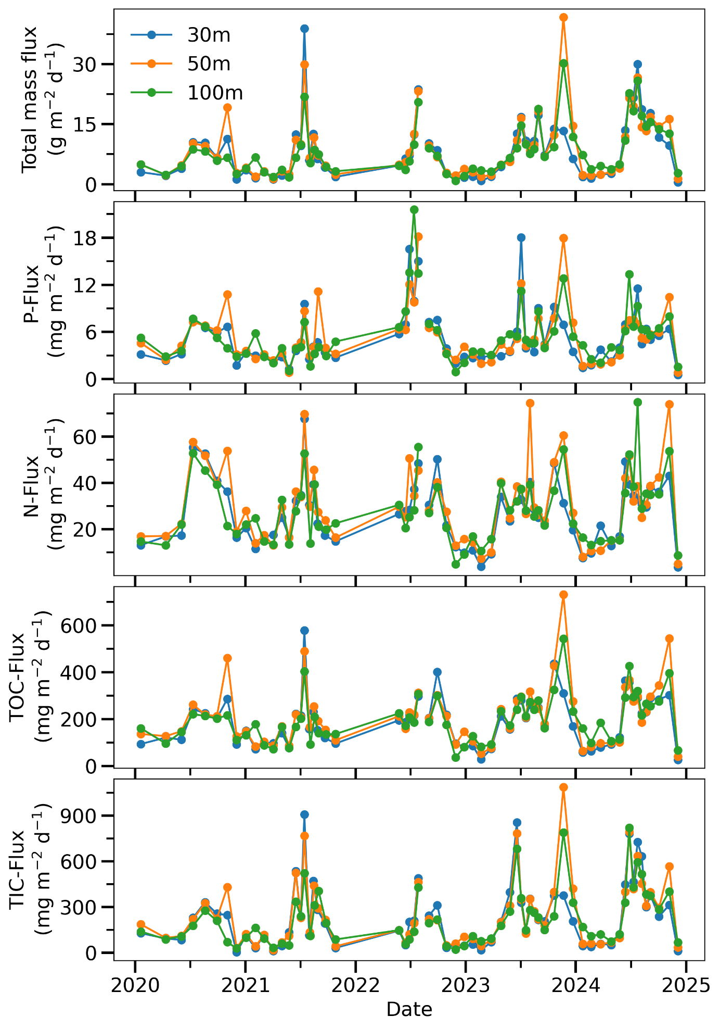

Figure S3: Fluxes in mg m⁻² d⁻¹ at 10 m (red) and for the average of 30, 50 and 100 m (blue) for total phosphorus (a), total nitrogen (b), Total organic carbon (c) and total inorganic carbon (d) for the five years

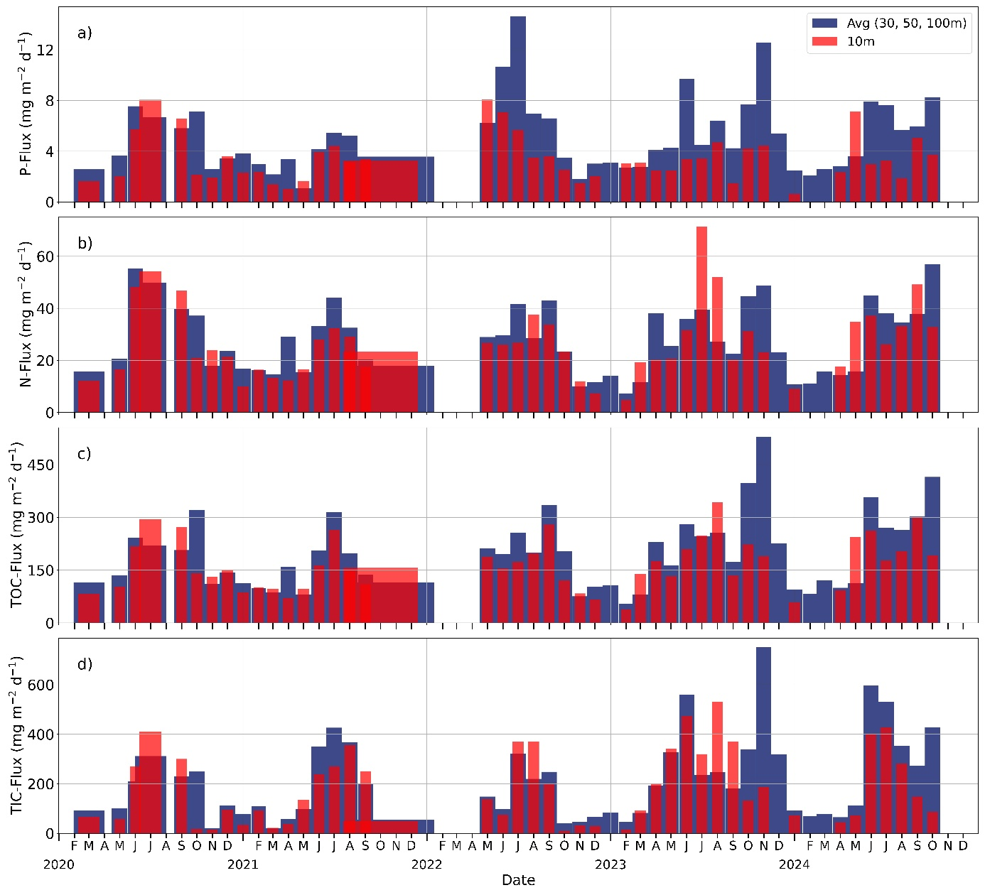

Figure S4: Turbidity profiles on 9 and 18 July 2024 from the LéXPLORE platform. Two unusual turbidity peaks were observed around 60 m depth in the 18 July profile

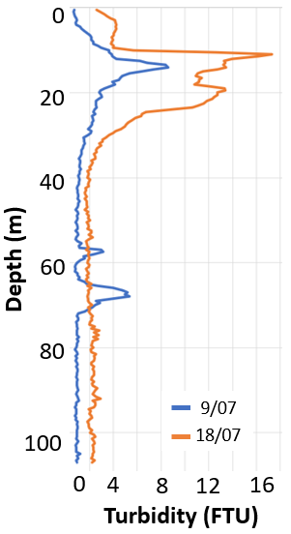
Fig. S5 meteorological conditions on the LéXPLORE platform from 1st June to 31st August 2022: a) rainfall (mm), b) average wind speed (m s⁻¹), c) average wave height (m), d) water velocities eastwards from 15 m to 80 m depth
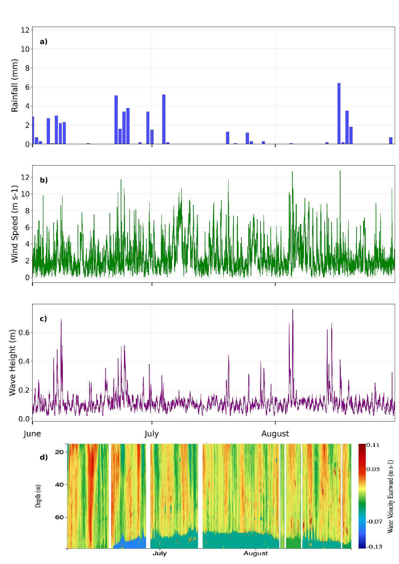

Fig. S5 Meteorological conditions on the LéXPLORE platform from 1st October to 31st December 2023: a) rainfall (mm), b) average wind speed (m s⁻¹), c) average wave height (m), d) water velocities eastwards from 15 m to 80 m depth
