Fig S1: Hourly vehicle congestion changes across continents in 2025 Q1-Q2
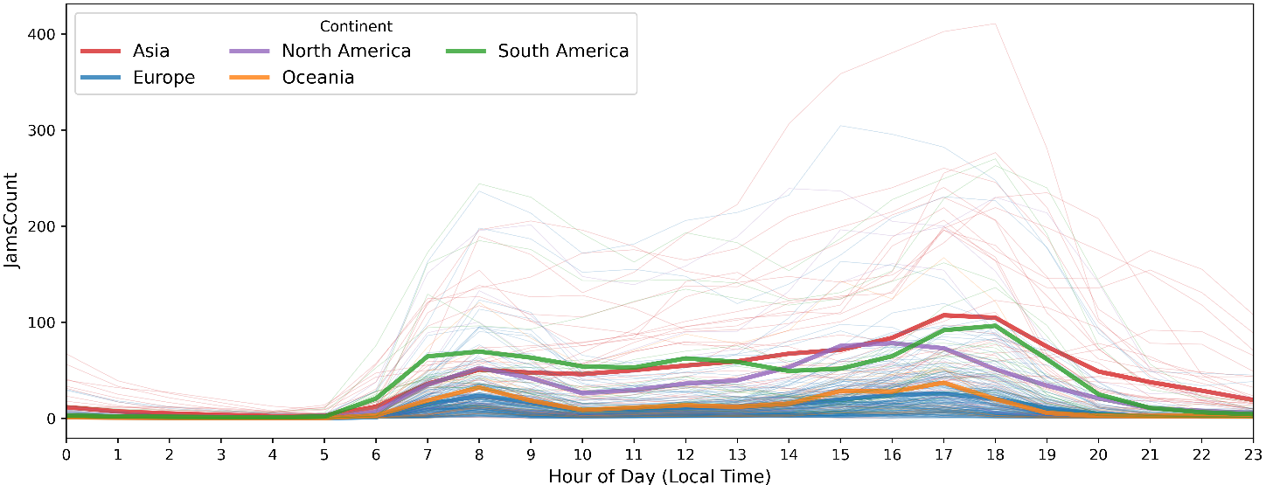
Fig. S1 illustrates the average hourly number of traffic jams across cities, and the evening rush hour is noticeably more congested than the morning rush hour. Also, the bold colored lines representing continent-level averages. A distinct bimodal diurnal pattern is evident, with a morning rush (06:00–10:00) and an evening rush (17:00–20:00), aligning with recent GPS-based reassessments of rush-hour periods¹. Because 06:00–07:00 is commonly treated as an urban “wake-up” period^{1–3}, we omit this hour from the morning-rush window in subsequent analyses.
Table S1: Cumulative monthly JTL by Continent in 2025 Q1-Q2
Continent | Jan | Feb | Mar | Apr | May | Jun
Asia | 47621.74 | 102107.7 | 164272.2 | 215886.7 | 267465.7 | 316477.7
Europe | 16923.21 | 36487.27 | 60002.01 | 81314.35 | 105357.5 | 129219.6
North America | 45071.62 | 102946.6 | 158411.1 | 211633.3 | 277141.6 | 338656.3
Oceania | 23714.11 | 63285.82 | 106491.4 | 153738.3 | 200135.1 | 242518.2
South America | 9835.08 | 30834.59 | 52173.38 | 67264.62 | 89042.27 | 104932.6

Table S2: Travel time(mins) for a 10 km trip in 2025 Q1-Q2
Continent | Period | Median | Q1 | Q3 | IQR
Asia | 2025-Q1 | 23.38 | 21.64 | 23.85 | 2.22
Asia | 2025-Q2 | 23.15 | 21.75 | 23.61 | 1.85
Europe | 2025-Q1 | 22.83 | 21.34 | 23.4 | 2.06
Europe | 2025-Q2 | 23.2 | 21.27 | 23.94 | 2.67
North America | 2025-Q1 | 24.97 | 22.37 | 27.13 | 4.76
North America | 2025-Q2 | 25.7 | 22.86 | 27.5 | 4.64
South America | 2025-Q1 | 25.58 | 23.07 | 27.37 | 4.3
South America | 2025-Q2 | 27.06 | 23.31 | 28.32 | 5.01
Oceania | 2025-Q1 | 19.94 | 19.24 | 20.6 | 1.36
Oceania | 2025-Q2 | 20.21 | 19.35 | 20.76 | 1.4

Table S3: Additional travel time(h) caused by urban congestion in 2025 Q1-Q2
Continent | Period | Median | Q1 | Q3 | IQR
Asia | All day | 50.18 | 37.59 | 76.99 | 39.4
Asia | Morning rush | 7.02 | 0.62 | 10.49 | 9.88
Asia | Evening rush | 15.07 | 9.82 | 17.08 | 7.25
Europe | All day | 93.6 | 59.37 | 114.9 | 55.53
Europe | Morning rush | 16.98 | 11.34 | 19.38 | 8.03
Europe | Evening rush | 16.18 | 13.02 | 21.32 | 8.3
North America | All day | 87.99 | 87.99 | 109.06 | 21.07
North America | Morning rush | 19.32 | 19.32 | 19.32 | 0
North America | Evening rush | 18.19 | 18.19 | 22.94 | 4.76
South America | All day | 51.4 | 24.94 | 77.47 | 52.54
South America | Morning rush | 13 | 4.15 | 16.1 | 11.95
South America | Evening rush | 12.4 | 4.24 | 17.32 | 13.08
Oceania | All day | 94.73 | 83.13 | 128.42 | 45.29
Oceania | Morning rush | 18.04 | 17.25 | 25.18 | 7.93
Oceania | Evening rush | 22.41 | 20.42 | 31.05 | 10.63

Table S4: Country-level congestion scaling exponent across different time periods
Country | Continent | Period | β (se) | R² | P-value
Japan | Asia | All-day | 0.68 ± 0.12 | 0.908 | 0.012
Japan | Asia | Non-Peak | 0.72 ± 0.13 | 0.914 | 0.011
Japan | Asia | Morning | 0.60 ± 0.13 | 0.878 | 0.019
Japan | Asia | Evening | 0.67 ± 0.13 | 0.904 | 0.013
Turkey | Asia | All-day | 1.16 ± 0.11 | 0.934 | <0.001
Turkey | Asia | Non-Peak | 1.11 ± 0.11 | 0.922 | <0.001
Turkey | Asia | Morning | 1.32 ± 0.18 | 0.867 | <0.001
Turkey | Asia | Evening | 1.18 ± 0.12 | 0.921 | <0.001
United Arab Emirates | Asia | All-day | 1.84 ± 0.21 | 0.963 | 0.003
United Arab Emirates | Asia | Non-Peak | 1.82 ± 0.21 | 0.962 | 0.003
United Arab Emirates | Asia | Morning | 1.82 ± 0.14 | 0.983 | <0.001
United Arab Emirates | Asia | Evening | 1.87 ± 0.26 | 0.945 | 0.006
Austria | Europe | All-day | 0.56 ± 0.13 | 0.852 | 0.025
Austria | Europe | Non-Peak | 0.54 ± 0.15 | 0.802 | 0.04
Austria | Europe | Morning | 0.54 ± 0.10 | 0.901 | 0.014
Austria | Europe | Evening | 0.64 ± 0.16 | 0.843 | 0.028
Belgium | Europe | All-day | 0.80 ± 0.12 | 0.847 | <0.001
Belgium | Europe | Non-Peak | 0.83 ± 0.11 | 0.885 | <0.001
Belgium | Europe | Morning | 0.67 ± 0.13 | 0.782 | <0.001
Belgium | Europe | Evening | 0.89 ± 0.17 | 0.772 | <0.001
France | Europe | All-day | 0.69 ± 0.09 | 0.718 | <0.001
France | Europe | Non-Peak | 0.75 ± 0.10 | 0.724 | <0.001
France | Europe | Morning | 0.71 ± 0.09 | 0.728 | <0.001
France | Europe | Evening | 0.60 ± 0.09 | 0.641 | <0.001
Germany | Europe | All-day | 0.93 ± 0.08 | 0.838 | <0.001
Germany | Europe | Non-Peak | 0.91 ± 0.09 | 0.821 | <0.001
Germany | Europe | Morning | 0.86 ± 0.09 | 0.788 | <0.001
Germany | Europe | Evening | 1.05 ± 0.11 | 0.799 | <0.001
Italy | Europe | All-day | 0.75 ± 0.12 | 0.615 | <0.001
Italy | Europe | Non-Peak | 0.78 ± 0.15 | 0.555 | <0.001
Italy | Europe | Morning | 0.71 ± 0.13 | 0.555 | <0.001
Italy | Europe | Evening | 0.77 ± 0.13 | 0.604 | <0.001
Netherlands | Europe | All-day | 1.00 ± 0.21 | 0.611 | <0.001
Netherlands | Europe | Non-Peak | 1.06 ± 0.20 | 0.656 | <0.001
Netherlands | Europe | Morning | 0.74 ± 0.22 | 0.435 | 0.004
Netherlands | Europe | Evening | 1.08 ± 0.22 | 0.607 | <0.001
Poland | Europe | All-day | 1.07 ± 0.20 | 0.778 | <0.001
Poland | Europe | Non-Peak | 0.90 ± 0.20 | 0.713 | 0.002
Poland | Europe | Morning | 1.09 ± 0.21 | 0.763 | <0.001
Poland | Europe | Evening | 1.82 ± 0.32 | 0.806 | <0.001
Portugal | Europe | All-day | 0.59 ± 0.08 | 0.954 | 0.004
Portugal | Europe | Non-Peak | 0.78 ± 0.09 | 0.962 | 0.003
Portugal | Europe | Morning | 0.46 ± 0.08 | 0.914 | 0.011
Portugal | Europe | Evening | 0.58 ± 0.09 | 0.932 | 0.008
Spain | Europe | All-day | 0.74 ± 0.14 | 0.537 | <0.001
Spain | Europe | Non-Peak | 0.72 ± 0.15 | 0.495 | <0.001
Spain | Europe | Morning | 0.77 ± 0.15 | 0.549 | <0.001
Spain | Europe | Evening | 0.78 ± 0.15 | 0.539 | <0.001
United Kingdom | Europe | All-day | 1.04 ± 0.20 | 0.567 | <0.001
United Kingdom | Europe | Non-Peak | 1.02 ± 0.18 | 0.616 | <0.001
United Kingdom | Europe | Morning | 1.11 ± 0.34 | 0.332 | 0.004
United Kingdom | Europe | Evening | 1.14 ± 0.23 | 0.547 | <0.001
Canada | North America | All-day | 0.89 ± 0.21 | 0.691 | 0.003
Canada | North America | Non-Peak | 0.88 ± 0.21 | 0.685 | 0.003
Canada | North America | Morning | 0.79 ± 0.24 | 0.58 | 0.01
Canada | North America | Evening | 0.99 ± 0.20 | 0.75 | 0.001
United States of America | North America | All-day | 0.86 ± 0.20 | 0.212 | <0.001
United States of America | North America | Non-Peak | 0.84 ± 0.19 | 0.217 | <0.001
United States of America | North America | Morning | 0.81 ± 0.11 | 0.453 | <0.001
United States of America | North America | Evening | 0.84 ± 0.11 | 0.453 | <0.001
Australia | Oceania | All-day | 0.86 ± 0.12 | 0.874 | <0.001
Australia | Oceania | Non-Peak | 0.83 ± 0.13 | 0.839 | <0.001
Australia | Oceania | Morning | 0.85 ± 0.10 | 0.893 | <0.001
Australia | Oceania | Evening | 0.94 ± 0.14 | 0.856 | <0.001
New Zealand | Oceania | All-day | 0.94 ± 0.20 | 0.881 | 0.018
New Zealand | Oceania | Non-Peak | 0.82 ± 0.17 | 0.88 | 0.018
New Zealand | Oceania | Morning | 1.04 ± 0.20 | 0.899 | 0.014
New Zealand | Oceania | Evening | 1.06 ± 0.26 | 0.846 | 0.027
Brazil | South America | All-day | 1.06 ± 0.22 | 0.772 | 0.002
Brazil | South America | Non-Peak | 1.24 ± 0.23 | 0.8 | 0.001
Brazil | South America | Morning | 0.95 ± 0.26 | 0.653 | 0.008
Brazil | South America | Evening | 0.92 ± 0.24 | 0.685 | 0.006

1. Liu, C., Wang, S., Cuomo, S. & Mei, G. Data analysis and mining of traffic features based on taxi GPS trajectories: A case study in Beijing. Concurr. Comput. Pract. Exp. 33, e5332 (2021).
2. Zhang, K., Batterman, S. & Dion, F. Vehicle emissions in congestion: Comparison of work zone, rush hour and free-flow conditions. Atmos. Environ. 45, 1929–1939 (2011).
3. Lu, K., Meng, H., Liu, X., Zou, D. & Li, Q. Estimating Large-Scale Urban Traffic Emissions with Incomplete Covered Traffic Flow Data—A Case of Core Areas of Guangzhou, China. Appl. Spat. Anal. Policy 18, 1–23 (2025).

