Supplementary Information for :
Altruism in a Time of Crisis: Dissociable Social Valuation and Perception during COVID-19 in the United States
Yi Luo¹, Anastasia Shuster², Dongil Chung³, Madeline O’Brien⁴, Matt Heflin², Ofer Perl², Kaustubh Kulkarni⁴, Soojung Na⁴, Vincenzo Fiore², P. Read Montague^{1,5,6,7}, Xiaosi Gu^{2,4*}
1 Fralin Biomedical Research Institute at VTC, Virginia Tech, Roanoke, VA, USA, 24016
2 Department of Psychiatry, Icahn School of Medicine at Mount Sinai, New York, NY, USA, 10029
3 Department of Biomedical Engineering, Ulsan National Institute of Science and Technology, Ulsan, South Korea
4 Nash Family Department of Neuroscience, Icahn School of Medicine at Mount Sinai, New York, NY, USA, 10029
5 Wellcome Trust Centre for Neuroimaging, University College London, London, UK
6 Department of Physics, Virginia Tech, Blacksburg, VA, USA, 24061
7 Virginia Tech-Wake Forest School of Biomedical Engineering and Mechanics, Blacksburg, VA, USA, 24061
*Correspondence author: Xiaosi Gu, PhD (xiaosi.gu@mssm.edu)

1 Supplementary Figures

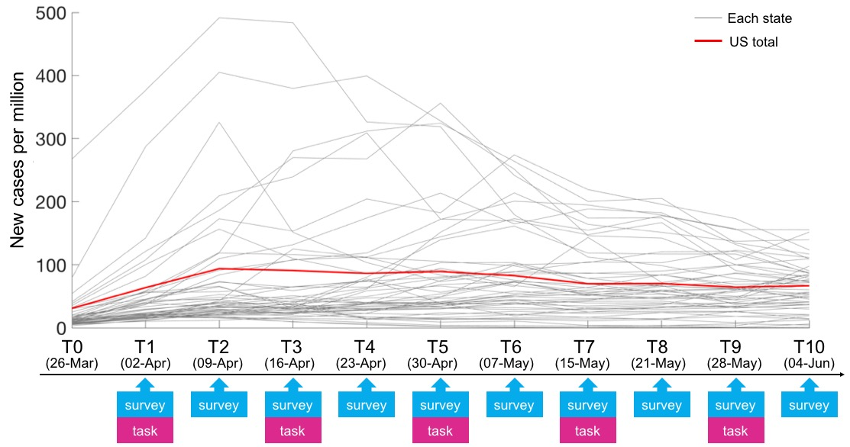
Figure S1. Complete data acquisition scheme of the study and new cases per million at each time point for the 2020 cohort.

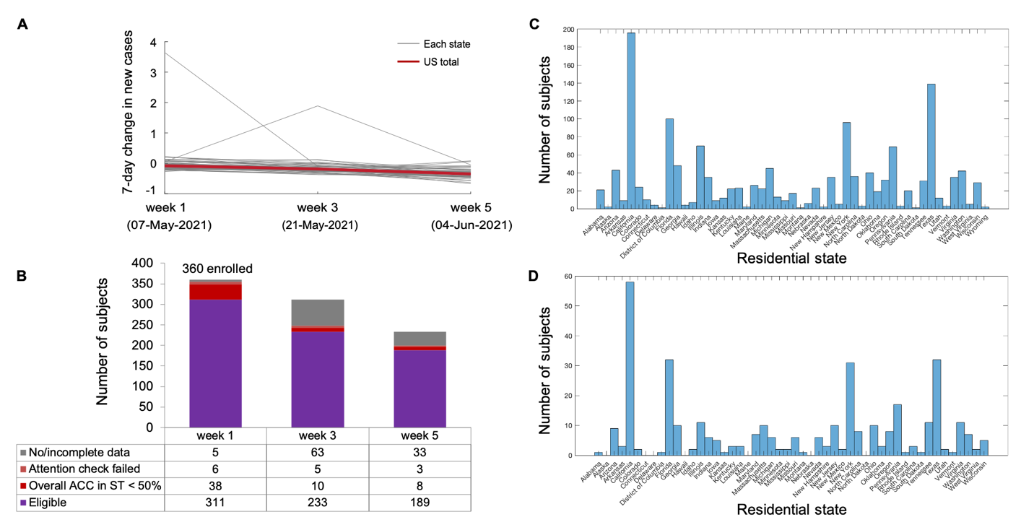
Figure S2. Data acquisition scheme and subject distribution for the 2021 cohort. A. The 7-day change in new cases over behavior acquisition time points in each state (gray lines) and the USA average (red line). B. Data acquisition scheme, dropouts and exclusions. ST, self-tagging task. C. Number of subjects in the 2020 cohort in each state. D. Number of subjects in the 2021 cohort in each state.
Figure S3. Model-based estimates for altruism in the dictator game at each time point and its association with the 7-day change in new cases in the 2021 cohort. A. The model-based weight on social welfare at each time point in the 2021 cohort. B. The model-based weight on social welfare against the 7-day change in new cases, pooling all time points in the 2021 cohort. C. The model-based weight on total social surplus at each time point in the 2021 cohort. D. The model-based weight on total social surplus against the 7-day change in new cases, pooling all time points in the 2021 cohort. E. The inverse temperature at each time point in the 2021 cohort. F. The inverse temperature against the 7-day change in new cases, pooling all time points in the 2021 cohort. Trend lines were defined by the fixed effect obtained in mixed-model regression.
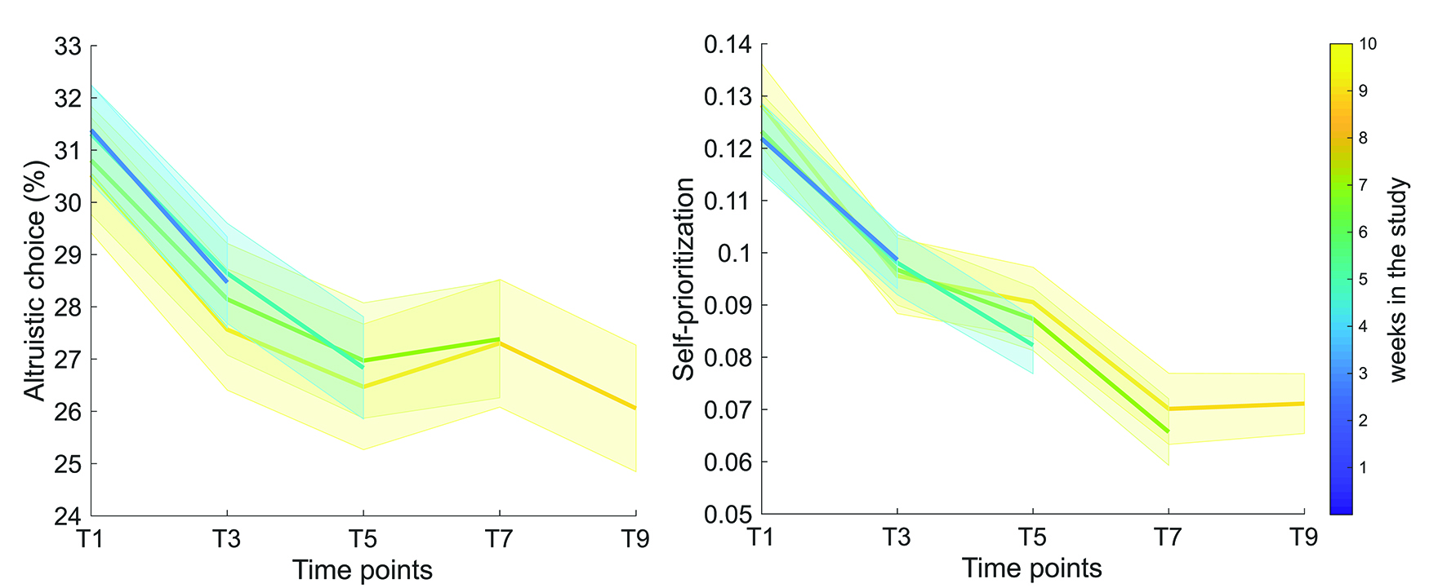
Figure S4. Altruistic choice and self-prioritization trends in different subsets of participants in the 2020 cohort. The blue line depicts altruistic choice (left panel) and self-prioritization (right panel) from participants with valid responses at both T1 and T3 (n = 891), including those who later dropped out or were excluded. The yellow line depicts scores from participants who successfully completed all task data collection during the 9 weeks (n = 497). All other lines depict intermediate subsets of participants. Shaded area represents standard error of the mean.

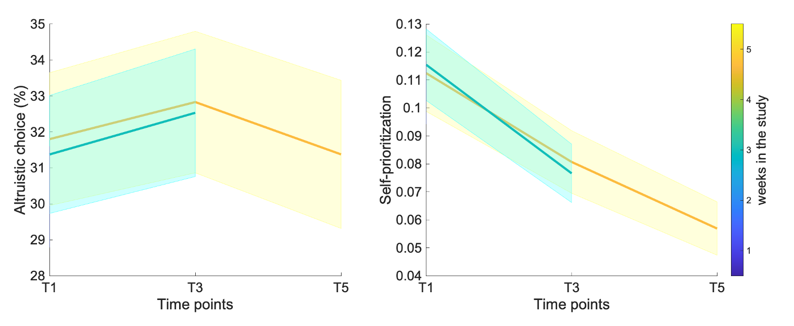
Figure S5. Altruistic choice and self-prioritization trends in different subsets of participants in the 2021 cohort. The blue line depicts altruistic choice (left panel) and self-prioritization (right panel) from participants with valid responses on both week 1 and week 3 of data collection (n = 233), including those who later dropped out or were excluded. The yellow line depicts scores from participants who successfully completed all task data collection during the 5 weeks (n = 189). Shaded area represents standard error of the mean.

2 Supplementary Tables
Table S1. linear mixed-effects regression results for altruism predicted by 7-day change in new cases in the 2020 cohort.
Predictor | β# | standard error | 95% confidence interval |  | degrees of freedom | t | p
Predictor | β# | standard error | lower | upper | degrees of freedom | t
altruistic choice ~ 7-day change in new cases + time + sex + age + (time | participant)
7-day change | 0.013 | 0.004 | 0.004 | 0.021 | 1754.0 | 2.925 | 0.003
time | -0.005 | 0.003 | -0.011 | 0.001 | 799.1 | -1.705 | 0.089
sex (female vs. male) | -0.088 | 0.020 | -0.128 | -0.048 | 497.0 | -4.336 | <0.001
sex (other vs. male) | -0.150 | 0.161 | -0.465 | 0.164 | 497.1 | -0.937 | 0.349
age | -3.60E-04 | 0.001 | -0.002 | 0.001 | 497.1 | -0.459 | 0.646
γ ~ 7-day change in new cases + time + sex + age + (time | participant)
7-day change | 0.021 | 0.007 | 0.008 | 0.034 | 1765.0 | 3.193 | 0.001
time | -0.005 | 0.004 | -0.014 | 0.003 | 828.4 | -1.249 | 0.212
sex (female vs. male) | -0.067 | 0.027 | -0.120 | -0.013 | 497.0 | -2.452 | 0.015
sex (other vs. male) | -0.224 | 0.215 | -0.644 | 0.197 | 497.0 | -1.042 | 0.298
age | -0.001 | 0.001 | -0.003 | 0.001 | 497.0 | -0.731 | 0.465
δ ~ 7-day change in new cases + time + sex + age + (time | participant)
7-day change | -0.006 | 0.006 | -0.018 | 0.007 | 1869.0 | -0.925 | 0.355
time | 0.008 | 0.004 | 0.001 | 0.016 | 901.9 | 2.215 | 0.027
sex (female vs. male) | -0.139 | 0.022 | -0.182 | -0.095 | 496.9 | -6.251 | <0.001
sex (other vs. male) | -0.233 | 0.175 | -0.575 | 0.109 | 497.0 | -1.336 | 0.182
age | -0.001 | 0.001 | -0.003 | 0.001 | 497.0 | -1.216 | 0.225
τ ~ 7-day change in new cases + time + sex + age + (time | participant)
7-day change | -0.107 | 0.044 | -0.193 | -0.021 | 1918.0 | -2.437 | 0.015
time | 0.131 | 0.025 | 0.083 | 0.179 | 961.7 | 5.306 | <0.001
sex (female vs. male) | -0.293 | 0.115 | -0.518 | -0.068 | 496.8 | -2.556 | 0.011
sex (other vs. male) | 0.630 | 0.903 | -1.139 | 2.400 | 496.9 | 0.698 | 0.485
age | 0.002 | 0.004 | -0.006 | 0.011 | 496.8 | 0.542 | 0.588
# unstandardized coefficient
Table S2. linear mixed-effects regression results for altruism predicted by new case number in the 2020 cohort.
Predictor | β# | standard error | 95% confidence interval |  | degrees of freedom |  | t | p
Predictor | β# | standard error | lower | upper
altruistic choice ~ new case number + time + sex + age + (time | participant)
new case number | -8.36E-05 | 5.79E-05 | -1.97E-04 | 3.00E-05 |  | 1433.0 | -1.445 | 0.149
time | -0.009 | 0.003 | -0.014 | -0.004 |  | 496.0 | -3.612 | <0.001
sex (female vs. male) | -0.089 | 0.020 | -0.129 | -0.048 |  | 497.0 | -4.339 | <0.001
sex (other vs. male) | -0.145 | 0.161 | -0.461 | 0.172 |  | 498.2 | -0.902 | 0.368
age | -4.38E-04 | 0.001 | -0.002 | 0.001 |  | 499.1 | -0.557 | 0.578
γ ~ new case number + time + sex + age + (time | participant)
new case number | -1.66E-04 | 8.72E-05 | -3.37E-04 | 5.07E-06 |  | 1481.0 | -1.902 | 0.057
time | -0.012 | 0.004 | -0.020 | -0.005 |  | 496.6 | -3.367 | 0.001
sex (female vs. male) | -0.067 | 0.027 | -0.120 | -0.014 |  | 497.0 | -2.457 | 0.014
sex (other vs. male) | -0.214 | 0.215 | -0.634 | 0.207 |  | 497.9 | -0.995 | 0.320
age | -0.001 | 0.001 | -0.003 | 0.001 |  | 499.0 | -0.840 | 0.402
δ ~ new case number + time + sex + age + (time | participant)
new case number | 8.15E-05 | 7.33E-05 | -6.22E-05 | 2.25E-04 |  | 1099.0 | 1.111 | 0.267
time | 0.010 | 0.003 | 0.004 | 0.017 |  | 496.9 | 3.301 | 0.001
sex (female vs. male) | -0.139 | 0.022 | -0.182 | -0.095 |  | 497.0 | -6.253 | <0.001
sex (other vs. male) | -0.241 | 0.175 | -0.583 | 0.101 |  | 498.6 | -1.380 | 0.168
age | -0.001 | 0.001 | -0.003 | 0.001 |  | 499.7 | -1.137 | 0.256
τ ~ new case number + time + sex + age + (time | participant)
new case number | 0.001 | 4.67E-04 | -3.90E-05 | 0.002 |  | 1052.0 | 1.876 | 0.061
time | 0.167 | 0.020 | 0.128 | 0.206 |  | 497.1 | 8.368 | <0.001
sex (female vs. male) | -0.293 | 0.115 | -0.517 | -0.068 |  | 497.0 | -2.557 | 0.011
sex (other vs. male) | 0.573 | 0.902 | -1.194 | 2.340 |  | 498.5 | 0.635 | 0.526
age | 0.003 | 0.004 | -0.006 | 0.012 |  | 500.0 | 0.693 | 0.489
# unstandardized coefficient

Table S3. linear mixed-effects regression results for self-prioritization in the 2020 cohort.
Predictor | β | standard error | 95% confidence interval |  |  | degrees of freedom |  | t |  | p
Predictor | β | standard error | lower | upper
self-prioritization ~ 7-day change in new cases + time + sex + age + (time | participant)
7-day change | 0.015 | 0.005 | 0.006 | 0.025 | 2153.0 |  | 3.099 |  | 0.002
time | -0.009 | 0.003 | -0.014 | -0.004 | 1605.0 |  | -3.404 |  | 0.001
sex (female vs. male) | 0.002 | 0.008 | -0.013 | 0.017 | 512.2 |  | 0.305 |  | 0.761
sex (other vs. male) | -0.067 | 0.061 | -0.187 | 0.052 | 512.3 |  | -1.111 |  | 0.267
age | 0.001 | 2.97E-04 | 0.001 | 0.002 | 512.1 |  | 4.690 |  | <0.001
self-prioritization ~ new case number + time + sex + age + (time | participant)
new case number | -8.72E-06 | 4.49E-05 | -9.68E-05 | 7.93E-05 | 1063.0 |  | -0.194 |  | 0.846
time | -0.014 | 0.002 | -0.018 | -0.010 | 1204.0 |  | -6.849 |  | <0.001
sex (female vs. male) | 0.002 | 0.008 | -0.013 | 0.018 | 512.4 |  | 0.323 |  | 0.747
sex (other vs. male) | -0.069 | 0.061 | -0.188 | 0.051 | 513.8 |  | -1.130 |  | 0.259
age | 0.001 | 2.98E-04 | 0.001 | 0.002 | 516.0 |  | 4.663 |  | <0.001
# unstandardized coefficient
Table S4. linear mixed-effects regression results for altruism predicted by self-prioritization in the 2020 cohort.
Predictor | β# | standard error | 95% confidence interval |  | degrees of freedom |  | t |  |  | p
Predictor | β# | standard error | lower | upper
altruistic choice ~ self-prioritization in new cases + time + sex + age + (time | participant)
self-prioritization | -0.009 | 0.020 | -0.047 | 0.029 | 1928.0 | -0.467 |  |  | 0.641
time | -0.009 | 0.003 | -0.014 | -0.004 | 507.1 | -3.628 |  |  | <0.001
sex (female vs. male) | -0.088 | 0.020 | -0.128 | -0.048 | 497.0 | -4.330 |  |  | <0.001
sex (other vs. male) | -0.155 | 0.161 | -0.469 | 0.160 | 497.1 | -0.964 |  |  | 0.336
age | -3.66E-04 | 0.001 | -0.002 | 0.001 | 498.1 | -0.466 |  |  | 0.641
γ ~ self-prioritization + time + sex + age + (time | participant)
self-prioritization | -0.005 | 0.030 | -0.063 | 0.053 | 1971.0 |  | -0.174 |  |  | 0.862
time | -0.012 | 0.004 | -0.020 | -0.005 | 507.6 |  | -3.342 |  |  | 0.001
sex (female vs. male) | -0.067 | 0.027 | -0.120 | -0.013 | 497.0 |  | -2.447 |  |  | 0.015
sex (other vs. male) | -0.228 | 0.215 | -0.649 | 0.193 | 497.1 |  | -1.062 |  |  | 0.289
age | -0.001 | 0.001 | -0.003 | 0.001 | 498.5 |  | -0.736 |  |  | 0.462
δ ~ self-prioritization + time + sex + age + (time | participant)
self-prioritization | -0.026 | 0.028 | -0.081 | 0.029 | 2098.0 |  | -0.914 |  |  | 0.361
time | 0.010 | 0.003 | 0.004 | 0.016 | 510.0 |  | 3.146 |  |  | 0.002
sex (female vs. male) | -0.138 | 0.022 | -0.182 | -0.095 | 497.1 |  | -6.246 |  |  | <0.001
sex (other vs. male) | -0.234 | 0.174 | -0.575 | 0.108 | 497.2 |  | -1.339 |  |  | 0.181
age | -0.001 | 0.001 | -0.003 | 0.001 | 498.9 |  | -1.165 |  |  | 0.245
τ ~ self-prioritization + time + sex + age + (time | participant)
self-prioritization | 0.165 | 0.190 | -0.209 | 0.538 | 2234.0 |  | 0.864 |  |  | 0.388
time | 0.169 | 0.020 | 0.129 | 0.208 | 511.5 |  | 8.377 |  |  | <0.001
sex (female vs. male) | -0.294 | 0.115 | -0.519 | -0.070 | 496.5 |  | -2.568 |  |  | 0.011
sex (other vs. male) | 0.666 | 0.902 | -1.102 | 2.434 | 496.7 |  | 0.738 |  |  | 0.461
age | 0.002 | 0.004 | -0.006 | 0.011 | 499.7 |  | 0.511 |  |  | 0.610
# unstandardized coefficient

Table S5. linear mixed-effects regression results for change in altruism predicted by change in self-prioritization in the 2020 cohort.
Predictor | β# | standard error | 95% confidence interval |  |  |  | degrees of freedom |  |  | t |  |  | p
Predictor | β# | standard error | lower | upper
change in altruistic choice ~ change in self-prioritization + time + sex + age + (time | participant)
change in self-prioritization | -0.022 | 0.018 | -0.058 |  | 0.014 |  |  | 1988 |  |  | -1.184 |  |  | 0.237
time | 0.007 | 0.003 | 0.001 |  | 0.014 |  |  | 1988 |  |  | 2.223 |  |  | 0.026
sex (female vs. male) | 0.012 | 0.007 | -0.002 |  | 0.027 |  |  | 1988 |  |  | 1.662 |  |  | 0.097
sex (other vs. male) | -0.084 | 0.058 | -0.197 |  | 0.029 |  |  | 1988 |  |  | -1.453 |  |  | 0.146
age | 4.78E-04 | 2.82E-04 | -7.43E-05 |  | 0.001 |  |  | 1988 |  |  | 1.696 |  |  | 0.090
change in γ ~ change in self-prioritization + time + sex + age + (time | participant)
change in self-prioritization | -0.039 | 0.028 | -0.095 | 0.017 |  | 1988 |  |  | -1.374 |  |  | 0.170
time | 0.012 | 0.005 | 0.002 | 0.022 |  | 1988 |  |  | 2.408 |  |  | 0.016
sex (female vs. male) | 0.009 | 0.011 | -0.014 | 0.031 |  | 1988 |  |  | 0.755 |  |  | 0.450
sex (other vs. male) | -0.084 | 0.089 | -0.258 | 0.090 |  | 1988 |  |  | -0.948 |  |  | 0.343
age | 3.90E-04 | 4.34E-04 | -4.60E-04 | 0.001 |  | 1988 |  |  | 0.899 |  |  | 0.369
change in δ ~ change in self-prioritization + time + sex + age + (time | participant)
change in self-prioritization | -0.027 | 0.028 | -0.081 | 0.027 |  | 1988 |  |  | -0.972 |  |  | 0.331
time | -0.011 | 0.005 | -0.021 | -0.002 |  | 1988 |  |  | -2.352 |  |  | 0.019
sex (female vs. male) | -0.008 | 0.011 | -0.029 | 0.014 |  | 1988 |  |  | -0.712 |  |  | 0.476
sex (other vs. male) | 0.004 | 0.086 | -0.165 | 0.173 |  | 1988 |  |  | 0.043 |  |  | 0.965
age | 0.001 | 4.21E-04 | 4.92E-05 | 0.002 |  | 1988 |  |  | 2.077 |  |  | 0.038
change in τ ~ change in self-prioritization + time + sex + age + ( time | participant)
change in self-prioritization | 0.289 | 0.192 | -0.087 | 0.665 |  | 1988 |  |  | 1.508 |  |  | 0.132
time | -0.095 | 0.034 | -0.161 | -0.029 |  | 1988 |  |  | -2.803 |  |  | 0.005
sex (female vs. male) | -0.074 | 0.076 | -0.223 | 0.075 |  | 1988 |  |  | -0.970 |  |  | 0.332
sex (other vs. male) | 0.368 | 0.600 | -0.808 | 1.543 |  | 1988 |  |  | 0.613 |  |  | 0.540
age | 0.000 | 0.003 | -0.006 | 0.005 |  | 1988 |  |  | -0.111 |  |  | 0.911
# unstandardized coefficient

Table S6. linear mixed-effects regression results for altruism predicted by 7-day change in new cases in the 2021 cohort.
Predictor | β# | standard error | 95% confidence interval |  | degrees of freedom | t | p
Predictor | β# | standard error | lower | upper
altruistic choice ~ 7-day change in new cases + time + sex + age + (time | participant)
7-day change | -0.017 | 0.014 | -0.045 | 0.011 | 343.6 | -1.207 | 0.228
time | -0.006 | 0.007 | -0.020 | 0.008 | 220.7 | -0.821 | 0.412
sex (female vs. male) | -0.040 | 0.036 | -0.111 | 0.032 | 188.8 | -1.090 | 0.277
age | -0.002 | 0.002 | -0.006 | 0.001 | 188.7 | -1.348 | 0.179
γ ~ 7-day change in new cases + time + sex + age + (time | participant)
7-day change | -0.028 | 0.022 | -0.071 | 0.016 | 338.4 | -1.257 | 0.210
time | -0.003 | 0.011 | -0.024 | 0.018 | 219.3 | -0.275 | 0.783
sex (female vs. male) | -0.026 | 0.047 | -0.118 | 0.067 | 189.1 | -0.545 | 0.586
age | -0.003 | 0.002 | -0.007 | 0.002 | 189.0 | -1.144 | 0.254
δ ~ 7-day change in new cases + time + sex + age + (time | participant)
7-day change | 0.019 | 0.023 | -0.027 | 0.064 | 328.7 | 0.808 | 0.420
time | 0.029 | 0.012 | 0.006 | 0.051 | 220.2 | 2.475 | 0.014
sex (female vs. male) | -0.034 | 0.038 | -0.109 | 0.040 | 188.9 | -0.909 | 0.365
age | -0.003 | 0.002 | -0.006 | 0.001 | 188.7 | -1.493 | 0.137
τ ~ 7-day change in new cases + time + sex + age + (time | participant)
7-day change | 0.008 | 0.140 | -0.267 | 0.282 | 342.3 | 0.054 | 0.957
time | 0.295 | 0.069 | 0.159 | 0.431 | 220.7 | 4.253 | <0.001
sex (female vs. male) | -0.161 | 0.198 | -0.550 | 0.227 | 189.2 | -0.815 | 0.416
age | 0.010 | 0.009 | -0.009 | 0.028 | 189.1 | 1.044 | 0.298
# unstandardized coefficient

Table S7. linear mixed-effects regression results for altruism predicted by new case number in the 2021 cohort.
Predictor | β | standard error | 95% confidence interval |  | degrees of freedom | t | p
Predictor | β | standard error | lower | upper | degrees of freedom | t | p
altruistic choice ~ new case number + time + sex + age + (time | participant)
new case number | -3.34E-07 | 1.97E-04 | -3.87E-04 | 3.87E-04 | 287.6 | -0.002 | 0.999
time | -0.002 | 0.011 | -0.023 | 0.019 | 282.7 | -0.202 | 0.840
sex (female vs. male) | -0.038 | 0.036 | -0.110 | 0.033 | 188.7 | -1.059 | 0.291
age | -0.002 | 0.002 | -0.006 | 0.001 | 188.5 | -1.380 | 0.169
γ ~ new case number + time + sex + age + (time | participant)
new case number | -4.88E-05 | 3.01E-04 | -0.001 | 0.001 | 290.5 | -0.162 | 0.871
time | 0.001 | 0.016 | -0.030 | 0.032 | 277.6 | 0.061 | 0.951
sex (female vs. male) | -0.024 | 0.047 | -0.116 | 0.068 | 189.0 | -0.515 | 0.607
age | -0.003 | 0.002 | -0.007 | 0.002 | 188.9 | -1.170 | 0.243
δ ~ new case number + time + sex + age + (time | participant)
new case number | 0.034 | 0.016 | 0.002 | 0.066 | 293.1 | 2.104 | 0.036
time | 2.27E-04 | 2.94E-04 | -3.49E-04 | 0.001 | 276.0 | 0.771 | 0.441
sex (female vs. male) | -0.037 | 0.038 | -0.111 | 0.038 | 189.4 | -0.964 | 0.336
age | -0.003 | 0.002 | -0.006 | 0.001 | 189.2 | -1.448 | 0.149
τ ~ new case number + time + sex + age + (time | participant)
new case number | -0.001 | 0.002 | -0.004 | 0.003 | 289.3 | -0.378 | 0.705
time | 0.266 | 0.097 | 0.075 | 0.456 | 300.1 | 2.726 | 0.007
sex (female vs. male) | -0.159 | 0.198 | -0.546 | 0.228 | 187.0 | -0.805 | 0.422
age | 0.010 | 0.009 | -0.009 | 0.028 | 186.8 | 1.036 | 0.302
# unstandardized coefficient

Table S8. linear mixed-effects regression results for self-prioritization in the 2021 cohort.
Predictor | β# | standard error | 95% confidence interval |  | degrees of freedom | t | p
Predictor | β# | standard error | lower | upper | degrees of freedom | t | p
self-prioritization ~ 7-day change in new cases + time + sex + age + (time | participant)
7-day change | -0.019 | 0.017 | -0.054 | 0.015 | 368.6 | -1.100 | 0.272
time | -0.006 | 0.015 | -0.035 | 0.023 | 214.7 | -0.398 | 0.691
sex (female vs. male) | 0.002 | 0.001 | 0.000 | 0.003 | 214.3 | 2.562 | 0.011
age | -0.032 | 0.009 | -0.049 | -0.015 | 281.2 | -3.700 | <0.001
self-prioritization ~ new case number + time + sex + age + (time | participant)
new case number | 1.06E-05 | 1.89E-04 | -3.61E-04 | 3.82E-04 | 288.5 | 0.056 | 0.955
time | -0.005 | 0.015 | -0.035 | 0.024 | 214.2 | -0.363 | 0.717
sex (female vs. male) | 0.002 | 0.001 | 4.13E-04 | 0.003 | 214.0 | 2.540 | 0.012
age | -0.027 | 0.011 | -0.049 | -0.005 | 361.4 | -2.444 | 0.015
# unstandardized coefficient

Table S9. linear mixed-effects regression results for altruism predicted by self-prioritization in the 2021 cohort.
Predictor | β# | standard error | 95% confidence interval |  | degrees of freedom |  | t |  | p
Predictor | β# | standard error | lower | upper |  |  |  |  | p
altruistic choice ~ self-prioritization in new cases + time + sex + age + (time | participant)
self-prioritization | 0.040 | 0.037 | -0.033 | 0.113 | 391.100 |  | 1.079 |  | 0.281
time | -0.001 | 0.006 | -0.014 | 0.012 | 195.300 |  | -0.154 |  | 0.878
sex (female vs. male) | -0.038 | 0.036 | -0.109 | 0.033 | 188.600 |  | -1.051 |  | 0.295
age | -0.002 | 0.002 | -0.006 | 0.001 | 188.900 |  | -1.408 |  | 0.161
γ ~ self-prioritization + time + sex + age + (time | participant)
self-prioritization | 0.101 | 0.057 | -0.012 | 0.214 | 412.200 |  | 1.758 |  | 0.080
time | 0.006 | 0.010 | -0.013 | 0.025 | 195.400 |  | 0.613 |  | 0.541
sex (female vs. male) | -0.024 | 0.047 | -0.116 | 0.069 | 188.500 |  | -0.505 |  | 0.614
age | -0.003 | 0.002 | -0.007 | 0.002 | 189.100 |  | -1.234 |  | 0.219
δ ~ self-prioritization + time + sex + age + (time | participant)
self-prioritization | 0.071 | 0.061 | -0.048 | 0.190 | 442.400 |  | 1.163 |  | 0.245
time | 0.026 | 0.010 | 0.006 | 0.047 | 194.900 |  | 2.529 |  | 0.012
sex (female vs. male) | -0.035 | 0.038 | -0.110 | 0.040 | 188.500 |  | -0.919 |  | 0.359
age | -0.003 | 0.002 | -0.006 | 0.001 | 189.300 |  | -1.522 |  | 0.130
τ ~ self-prioritization + time + sex + age + (time | participant)
self-prioritization | -0.266 | 0.360 | -0.973 | 0.440 | 460.200 |  | -0.739 |  | 0.460
time | 0.286 | 0.063 | 0.162 | 0.411 | 195.200 |  | 4.515 |  | <0.001
sex (female vs. male) | -0.163 | 0.198 | -0.552 | 0.225 | 188.700 |  | -0.824 |  | 0.411
age | 0.010 | 0.009 | -0.008 | 0.029 | 189.900 |  | 1.088 |  | 0.278
# unstandardized coefficient

Table S10. Monetary allocations in each trial
selfish option |  | altruistic option |  | catch trial#
self | other | self | other | catch trial#
3.5 | 4 | 2 | 19 | n
4 | 3 | 3 | 9 | n
5 | 5 | 7 | 5.5 | y
5 | 7 | 6 | 8 | y
6 | 1 | 5 | 19 | n
6 | 2 | 4 | 4 | n
6 | 3 | 5 | 11 | n
6 | 5 | 5 | 14 | n
6 | 7 | 4 | 8 | n
6 | 10 | 5 | 13 | n
7 | 1 | 6 | 16 | n
7 | 3 | 3 | 19 | n
8 | 6 | 6 | 20 | n
8 | 10 | 7 | 12 | n
9 | 2 | 6 | 17 | n
9 | 2 | 5 | 5 | n
10 | 1 | 5 | 14 | n
10 | 5 | 7.5 | 7 | n
10 | 5 | 15 | 7 | y
10 | 11 | 13 | 12 | y
11 | 4 | 2 | 20 | n
12 | 4 | 2 | 19 | n
12 | 10 | 3 | 12 | n
14 | 6 | 12 | 8.5 | n
# Four of the trials were catch trials for data quality control. n, no; y, yes.

