Genome-wide characterization of the CaCHI chitinases gene family in chickpea reveals CaCHI4’s crucial role in salt stress tolerance in plants

Yan Liang1†, Chaoni Liang1†, Fanzhen Fei1†, Minghui Yang1, Jia Liu1, Xiaoyun Zhou2, Bin Lei2*, Yigong Zhang1*

1 Xinjiang Key Laboratory of Biological Resources and Genetic Engineering, College of Life Science and Technology, Xinjiang University, Urumqi 830017, China
2 Institute of Agricultural Resources and Environment, Xinjiang Academy of Agricultural Sciences, Urumqi 830091, Xinjiang, China

†These authors have equal contributions to this study and are co-first authors.
* Correspondence: zhangyg@xju.edu.cn; leib668@xaas.ac.cn

Email:
Yan Liang: 107552301023@stu.xju.edu.cn;
Chaoni Liang: 18135905460@139.com;
Fanzhen Fei: 1393697934@qq.com;
Minghui Yang：3447349339@qq.com；
Jia Liu：2381325677@qq.com
Xiaoyun Zhou: Xiaoyunzhou77@126.com;
Bin Lei: leib668@xaas.ac.cn;
Yigong Zhang: zhangyg@xju.edu.cn

Journal name: Plant and Soil
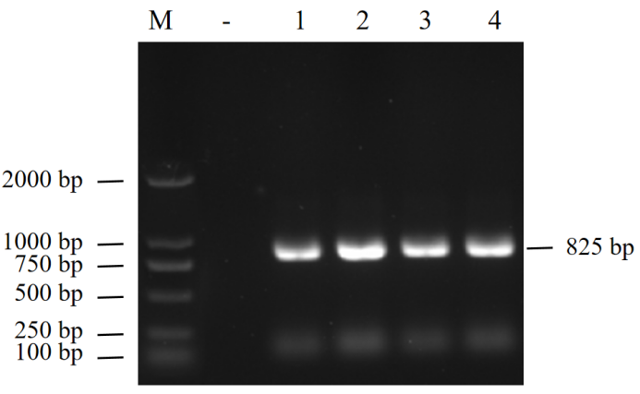
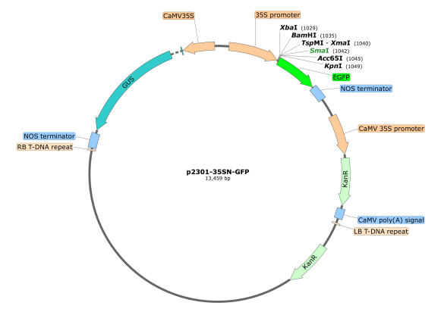
A
B
Supplementary Figure 1 Construction and schematic representation of the CaCHI4–EGFP subcellular localization vector. (A) PCR verification of the cloned CaCHI4 gene fragment (~825 bp); (B) Schematic map of the p2301-GFP plant expression vector.

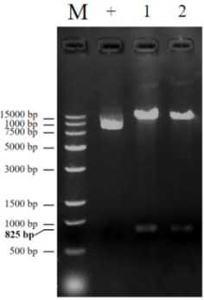
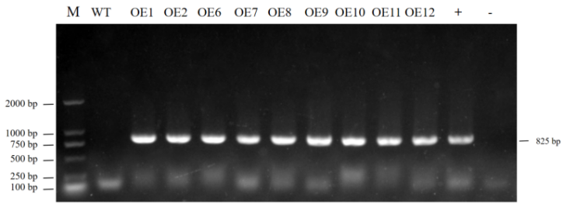
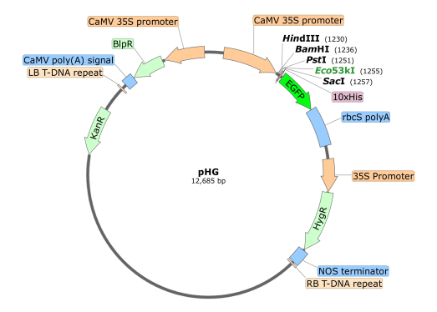
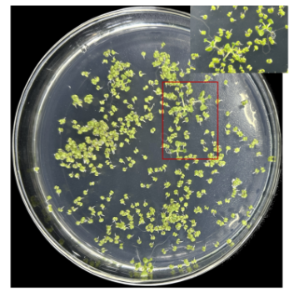
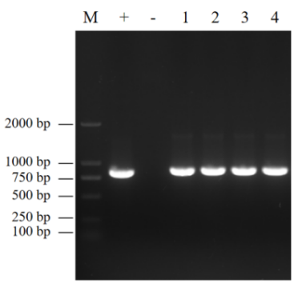
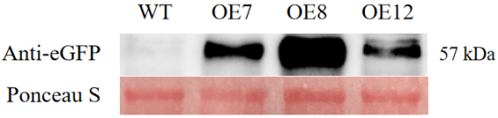
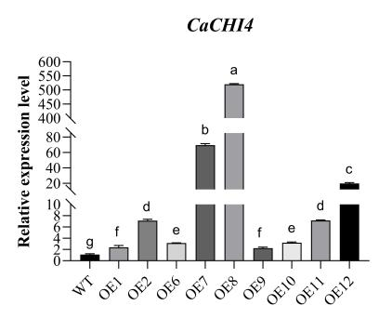
A
B
C
D
E

Supplementary Figure 2 Construction and identification of A. thaliana plants overexpressing CaCHI4. (A) Construction of pHG-CaCHI4-EGFP recombinant plasmid; (B) A. thaliana T₀ generation screening; (C) Identification of transgenic A. thaliana pHG-CaCHI4-EGFP-OE genome by PCR; (D) The relative expression level of CaCHI4 in overexpressing lines; (E) Protein level identification of overexpression lines OE7, OE8, and OE12. Values are means ± SE (n = 3). Different letters indicate significant differences between means as determined by ANOVA followed by Duncan’s multiple range test (P < 0.05). WT: Wild type A. thaliana; OE7, OE8, and OE12: Transgenic A. thaliana.

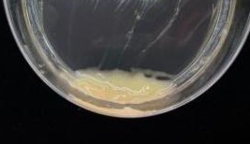
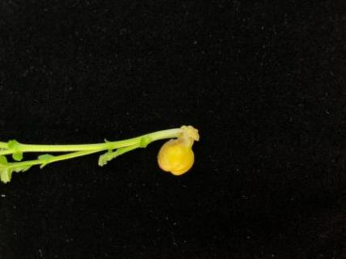
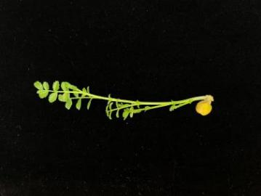
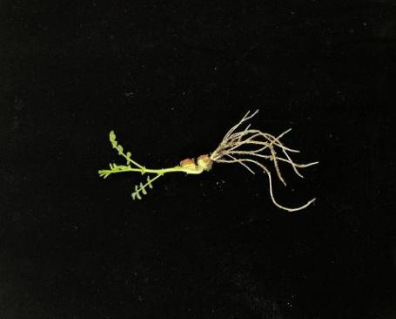
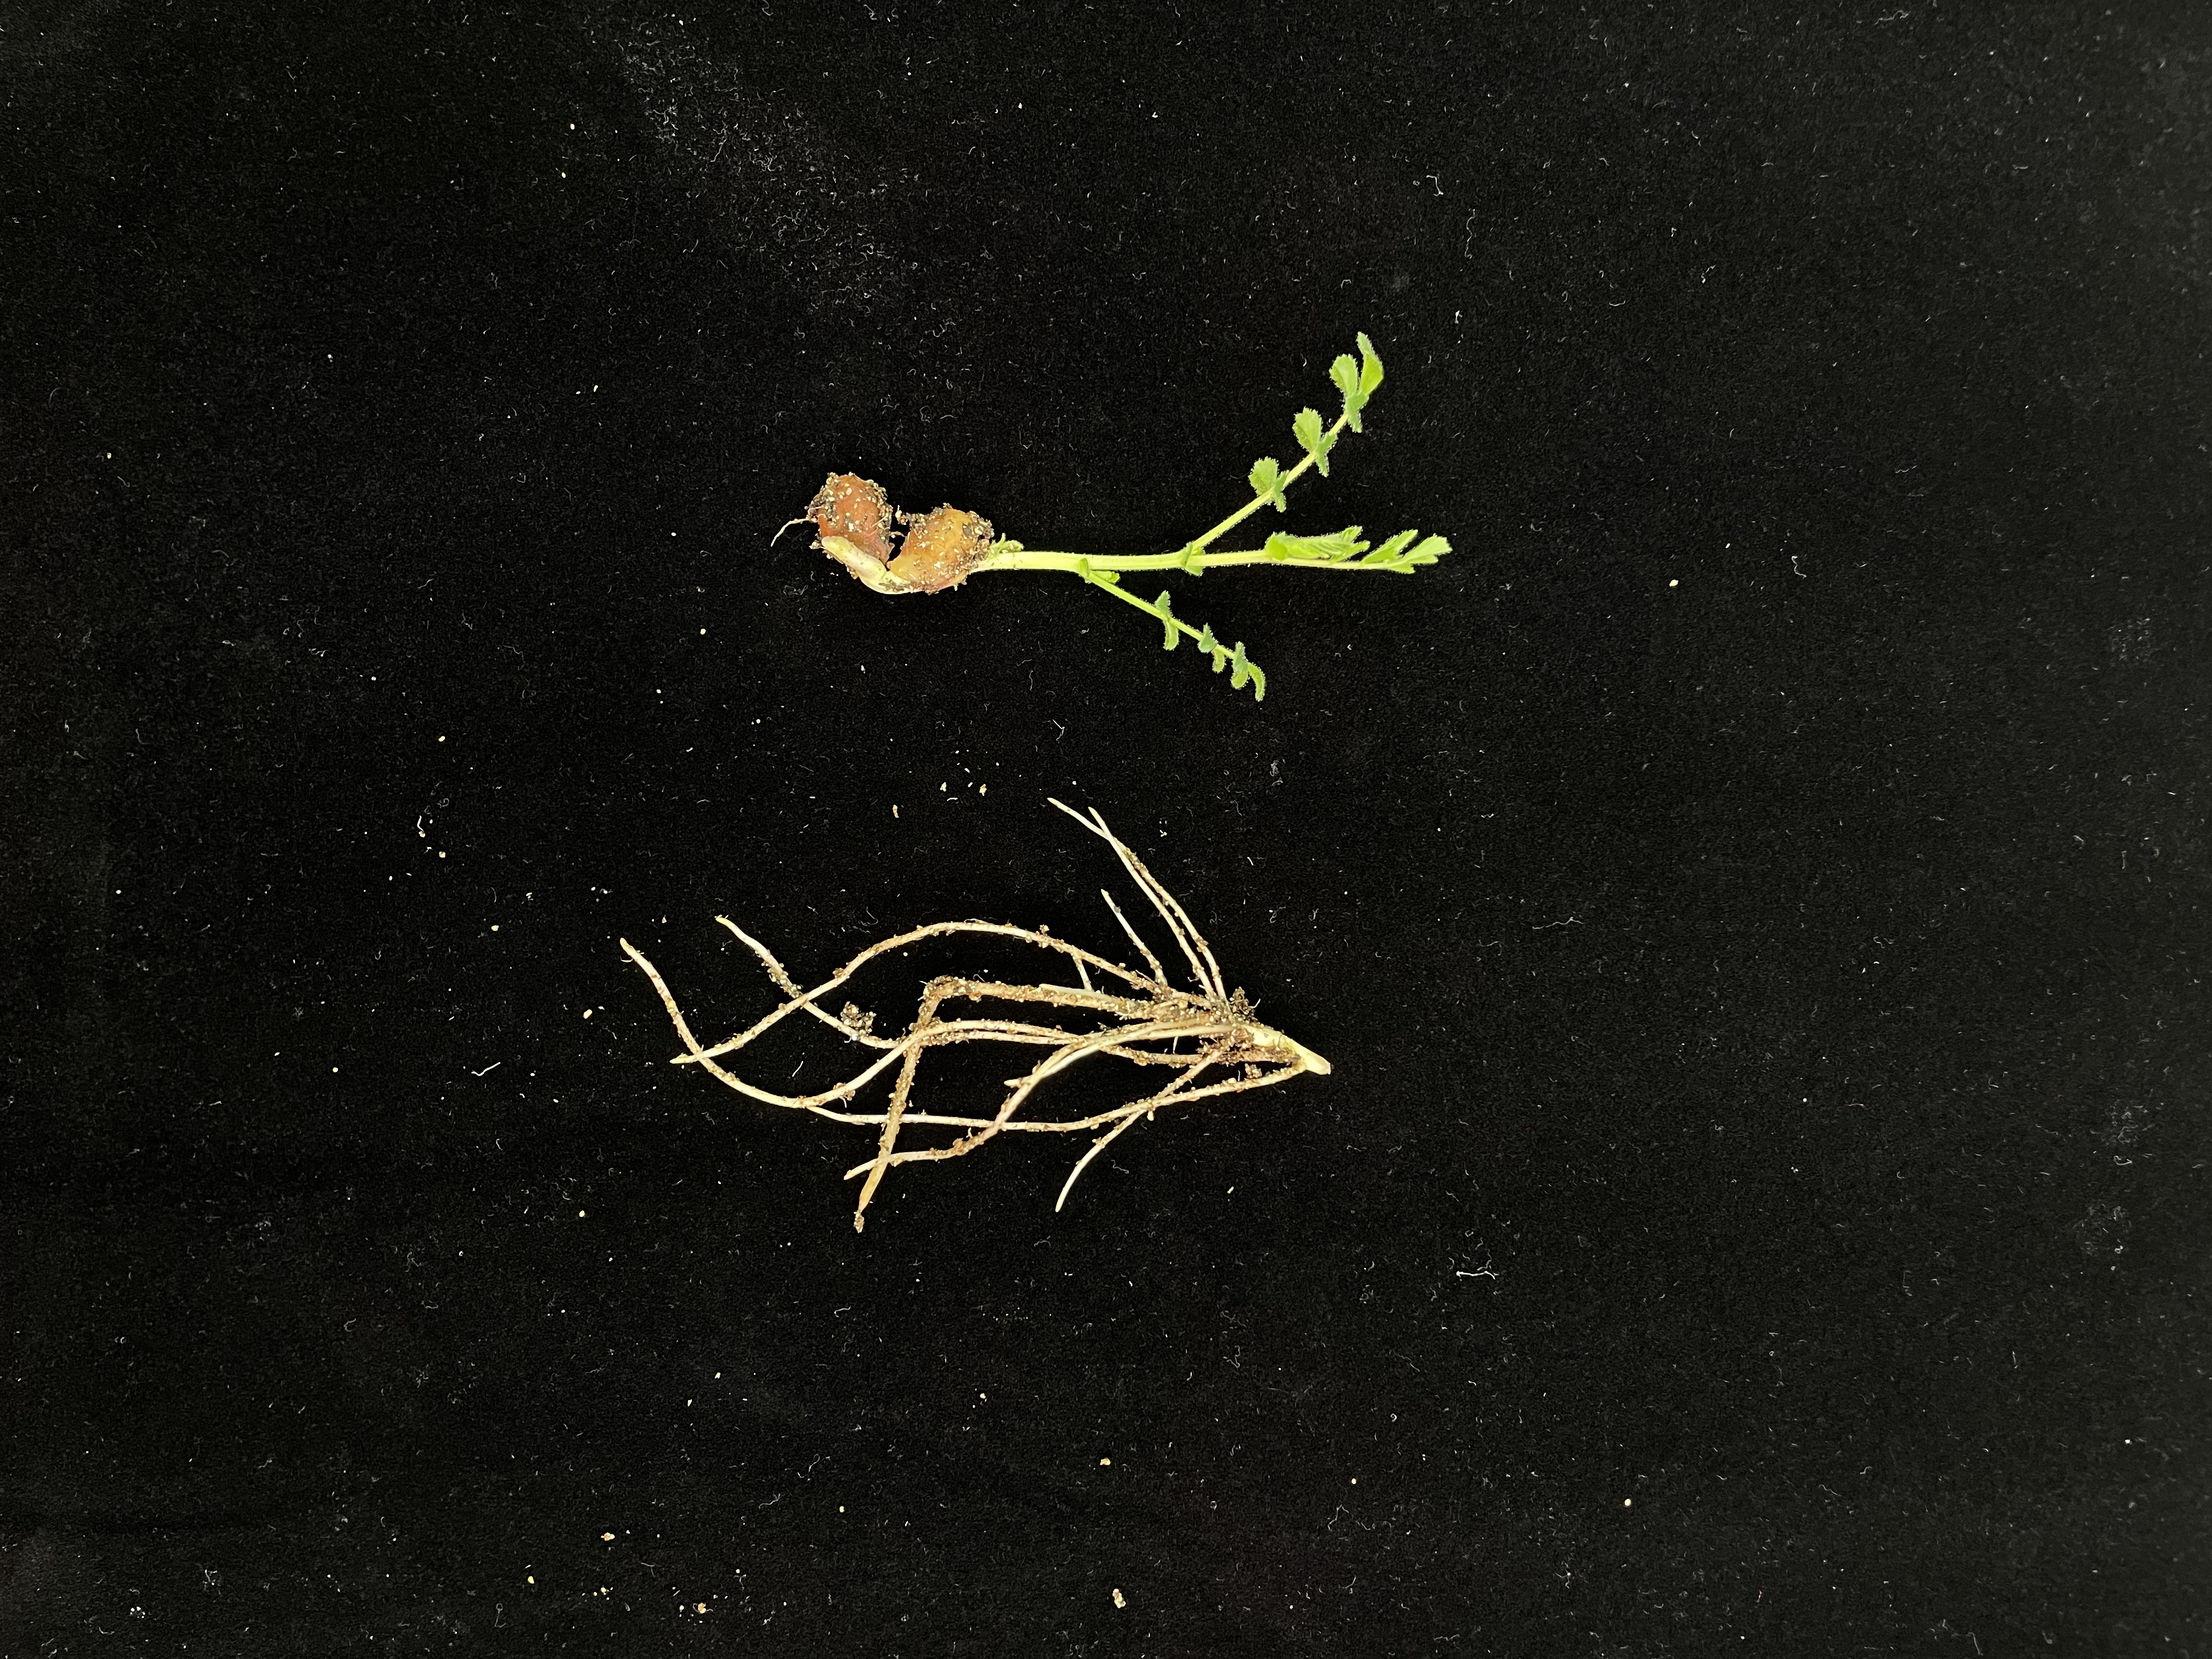
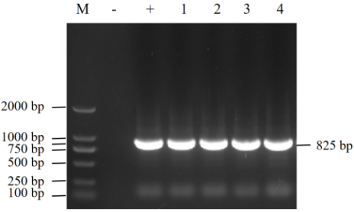
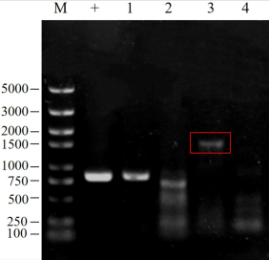
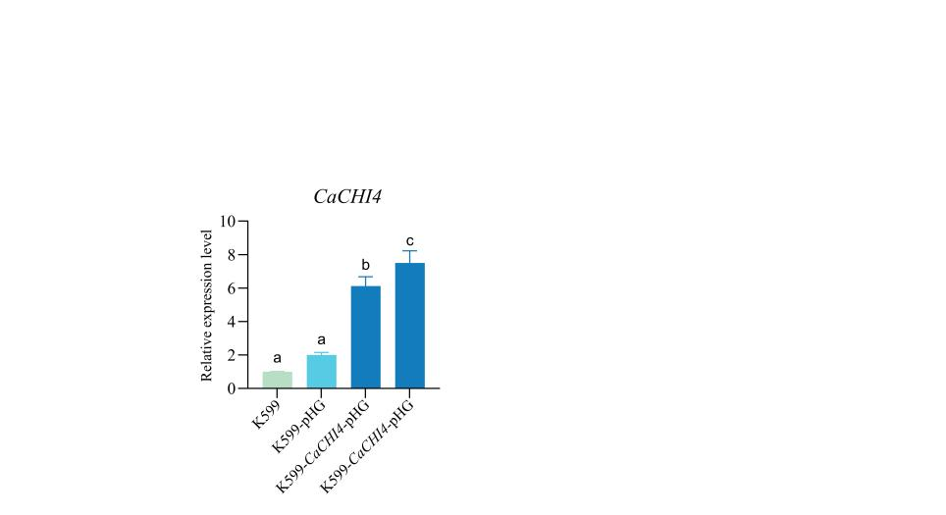
A
B
C
D

Supplementary Figure 3 K599 hairy root staining process and identification. (A) Immersion process; (B) DNA testing for CaCHI4; Lane 1: K599; Lane 2: K599-pHG; Lane 3-4: K599-CaCHI4-pHG; (C) DNA level detection of EGFP+CaCHI4; Lane 1: Full length of CaCHI4; Lane 2: EGFP; Lane 3: EGFP+CaCHI4 (lanes 1-3 template is K599-CaCHI4-pHG DNA); Lane 4: EGFP+CaCHI4 (DNA template of K599-pHG); (D) RNA level detection of CaCHI4 expression level; Values are means ± SE (n = 3). Different letters indicate significant differences between means as determined by ANOVA followed by Duncan’s multiple range test (P < 0.05).

Supplementary Table 1 CHI gene family in C. arietinum
ID | Length | MW | Hydropathicity | pI | subcellular | Class
gene11336 | 377 | 42524.08 | -0.304 | 8.29 | Chloroplast | ClassⅤ
gene13400 | 363 | 39283.91 | -0.22 | 7.72 | Mitochondrion | ClassⅤ
gene15249 | 237 | 27470.86 | -0.454 | 5.2 | Cytoplasm | ClassⅤ
gene1922 | 303 | 34635.98 | -0.35 | 4.95 | Cytoplasm | ClassⅤ
gene19513 | 769 | 87192.45 | -0.184 | 7.57 | Cytoplasm | ClassⅤ
gene19514 | 382 | 41672.43 | 0.136 | 5.77 | Chloroplast | ClassⅤ
gene20432 | 277 | 32257.67 | -0.292 | 5.65 | Cytoplasm | ClassⅤ
gene21976 | 296 | 31307.22 | 0.006 | 4.97 | Peroxisome | ClassⅢ
gene21979 | 297 | 32639.45 | 0.04 | 8.1 | Extracellular | ClassⅢ
gene22888 | 433 | 49219.91 | -0.427 | 8.72 | Cytoplasm | ClassⅤ
gene25059 | 309 | 34368.29 | -0.174 | 5.37 | Chloroplast | ClassⅤ
gene25893 | 300 | 32838.25 | -0.172 | 8.97 | Extracellular | ClassⅢ
gene2763 | 303 | 34195.37 | -0.462 | 5.31 | Cytoplasm | ClassⅤ
gene3719 | 275 | 31860.34 | -0.163 | 5.03 | Cytoskeleton | ClassⅤ
gene4079 | 294 | 31551.72 | -0.043 | 7.51 | Peroxisome | ClassⅢ
gene9430 | 301 | 0 | -0.129 | 0 | Extracellular | ClassⅢ
gene9431 | 298 | 32369.85 | -0.066 | 9.03 | Extracellular | ClassⅢ
gene9432 | 294 | 32399.73 | -0.045 | 7.6 | Chloroplast | ClassⅢ
gene1266 | 274 | 29832.12 | -0.318 | 4.74 | Vacuole | ClassⅣ
gene1267 | 138 | 14735.75 | 0.13 | 5.62 | Extracellular | ClassⅣ
gene13040 | 328 | 35472.85 | -0.301 | 7.37 | Extracellular | ClassI
gene1979 | 318 | 35018.69 | -0.249 | 7.01 | Extracellular | ClassⅡ
gene20391 | 318 | 34399.26 | -0.46 | 5.96 | Extracellular | ClassI
gene5760 | 321 | 35734.39 | -0.248 | 5.97 | Extracellular | ClassⅡ
gene7854 | 278 | 31060.39 | -0.192 | 7.5 | Extracellular | ClassⅡ

Supplementary Table 2 All primer sequences used in this paper.
Gene name | Primer | Sequence（5’-3’）
Ca18S RNA | F | ACGTCCCTGCCCTTTGTACAC
Ca18S RNA | R | CACTTCACCGGACCATTCAAT
Atactin | F | GGTAACATTGTGCTCAGTGCTGG
Atactin | R | AACGACCTTAATCTTCATGCTGC
QC-CaCHI4 | F | ATGGGAAACAAGTTACTAAAAATGT
QC-CaCHI4 | R | ACAAGTAAGATTATCACCAGGAG
SmaⅠ-CaCHI4 | F | CTCTAGAGGATCCCCATGGGAAACAAGTTACTAAAAATGT
SmaⅠ-CaCHI4 | R | TCACCATGGTACCCCACAAGTAAGATTATCACCAGGAGCA
BamHⅠ-CaCHI4 | F | TCTCTCTCAAGCTTGATGGGAAACAAGTTACTAAAAATGT
BamHⅠ-CaCHI4 | R | CTCCTGCAGCTCGAGACAAGTAAGATTATCACCAGGAGCA
q-CaCHI4 | F | GGGGGCCAAAATCCACCTAA
q-CaCHI4 | R | CGTTTGGAGTCCTCCACCA
AtPYL6 | F | GCGGGTAACGATAAGGAAGAG
AtPYL6 | R | AAGTGTTCTCGGCGAGTTTAG
AtCML41 | F | CCAAAGAAGAGCTCCGTCAA
AtCML41 | R | CCGACAGAGCCGAAGTAATG
AtRBOHB | F | GTAAGTCGTTCGGTGCTATGT
AtRBOHB | R | CAAACCTCATTGCAACCTCATC
AtWRKY27 | F | GGAAGAGGAAGAGGAGGAAGAA
AtWRKY27 | R | TCTCGATCTCTCACCGCTAAA
AtCER4 | F | GGCACCAAACGTGAAGAAAC
AtCER4 | R | CTGCTACAGAGAGTGGCTTTAC
AtNCED4 | F | TACATCCGTAACGGTCCAAATC
AtNCED4 | R | CTGCTACAGAGAGTGGCTTTAC
AtWRKY48 | F | CGTTTCTGACGAAGAGCGATA
AtWRKY48 | R | CGGTAATAGCTTCTGGGATAAGG
AtCYP707A4 | F | TACCCTGAAACCATCCGTAAAC
Continued Supplementary Table 2 All primer sequences used in this paper.
Gene name | Primer | Sequence（5’-3’）
AtCYP707A4 | R | TCCTGGTAGGTGGAGACAAT
AtGSTU3 | F | CAAGCCCATTCAGTCGTAGAG
AtGSTU3 | R | AACCGGGTTGAGTTGAAGTAG
AtHSP18.2 | F | GAGAGAGCTAGTGGGAAGTTTATG
AtHSP18.2 | R | AACCGTAAGCACACCATTCT
AtCML38 | F | GCCGTAGCTGCTGTTAGATT
AtCML38 | R | CCTTGAGCTCCATCTTCTTCTC
AtPP2 | F | GTGGTGTTCGTAGTGAAGTTAGA
AtPP2 | R | CTTGCGGTTTCTCCCAAGTA

Supplementary Table 3 Sequencing data output of each sample of A. thaliana.
Samples | Total Reads | Clean reads | Clean bases | Mapped Reads | Uniq Mapped Reads | GC Content | %≥Q30
CWT-1 | 42,178,238 | 21,089,119 | 6,294,919,104 | 41,396,344 (98.15%) | 40,414,379 (95.82%) | 45.66% | 96.61%
CWT-2 | 40,757,478 | 20,378,739 | 6,076,469,204 | 40,114,226 (98.42%) | 39,170,765 (96.11%) | 45.73% | 96.59%
CWT-3 | 40,110,786 | 20,055,393 | 5,977,675,263 | 39,492,242 (98.46%) | 38,564,321 (96.14%) | 45.58% | 96.59%
COE12-1 | 41,529,686 | 20,764,843 | 6,192,525,544 | 40,978,739 (98.67%) | 40,008,065 (96.34%) | 45.87% | 96.65%
COE12-2 | 46,544,744 | 23,272,372 | 6,942,476,643 | 45,838,677 (98.48%) | 44,738,514 (96.12%) | 45.75% | 96.61%
COE12-3 | 39,826,888 | 19,913,444 | 5,944,234,343 | 39,094,332 (98.16%) | 38,152,859 (95.80%) | 45.57% | 96.63%
SWT-1 | 43,283,894 | 21,641,947 | 6,457,518,651 | 42,540,202 (98.28%) | 41,593,573 (96.09%) | 45.27% | 96.72%
SWT-2 | 42,772,252 | 21,386,126 | 6,383,382,436 | 42,067,439 (98.35%) | 41,018,635 (95.90%) | 45.42% | 96.20%
SWT-3 | 46,810,748 | 23,405,374 | 6,972,215,435 | 46,138,009 (98.56%) | 45,100,389 (96.35%) | 45.48% | 96.59%
SOE12-1 | 41,893,698 | 20,946,849 | 6,248,291,752 | 41,263,533 (98.50%) | 40,329,864 (96.27%) | 45.51% | 96.66%
SOE12-2 | 44,046,454 | 22,023,227 | 6,569,104,108 | 43,141,723 (97.95%) | 42,141,732 (95.68%) | 45.34% | 96.65%
SOE12-3 | 42,659,014 | 21,329,507 | 6,363,820,564 | 41,938,965 (98.31%) | 40,990,397 (96.09%) | 45.28% | 96.65%
Samples: Sample analysis number; Total Reads: The number of Clean Reads, calculated on a single end basis; Clean reads: the total number of pair end reads in Clean Data; Clean bases: Clean Data total base number; Mapped Reads: Compare the number of reads to the reference genome and their percentage in Clean Reads; Uniq Mapped Reads: Compare the number of reads to the unique position of the reference genome and their percentage in Clean Reads; GC content: Clean Data GC content, which refers to the percentage of G and C bases in the total number of bases in Clean Data; ≥ Q30%: The percentage of bases with Clean Data quality values greater than or equal to 30.

