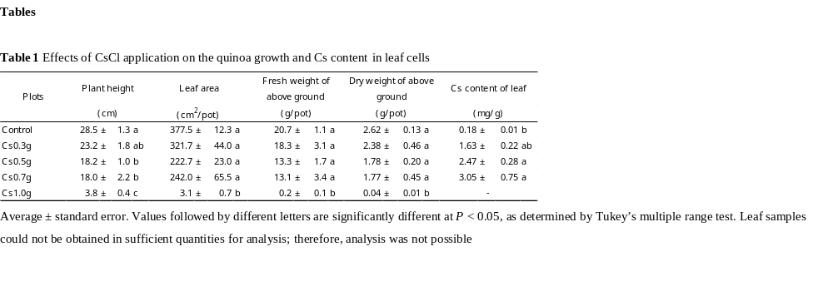

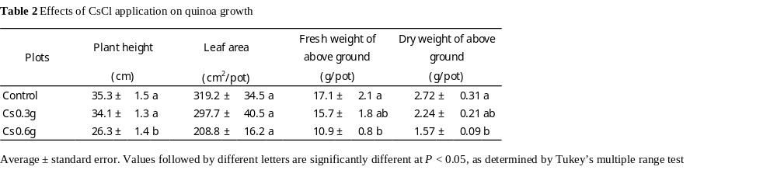

Table 3 Effects of CsCl and NaCl application on quinoa growth and Cs, Na, and K contents
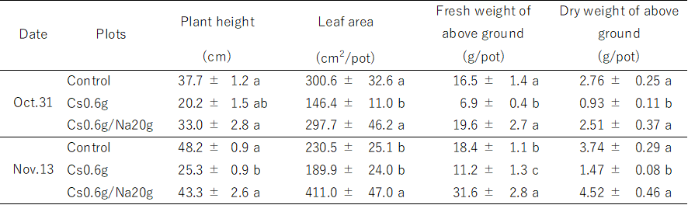
Average ± standard error
Values followed by different letters are significantly different at P≦0.05 by Tukey’s multiple test

Table 4. Effects of CsCl and NaCl application on quinoa growth.
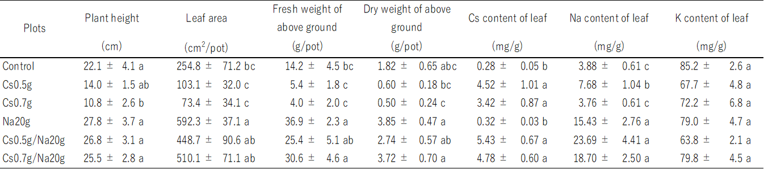
Average ± standard error. Values followed by different letters are significantly different at P < 0.05, as determined by Tukey’s multiple range test

Table 5 Effects of CsCl and NaCl application on the Cs, Na, and K content in leaf and EBC
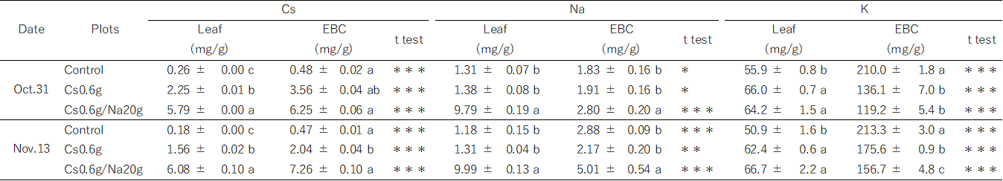
Average ± standard error
Values followed by different letters are significantly different at P≦0.05 by Tukey’s multiple test
***, **, *, Statistically significant at P≦0.001, P≦0.01, and 0.05 by t-test, respectively

