

MAKERERE UNIVERSITY

P.O. Box 7062KampalaUganda Tel: 256-41-530137• Cables: MEDMAK.

COLLEGE OF HEALTH SCIENCES
SCHOOL OF MEDICINE
DEPARTMENT OF RADIOLOGY & RADIOTHERAPY

MAGNETIC RESONANCE IMAGING FINDINGS OF YOUNG ADULTS
WITH LOW BACK PAIN AT NSAMBYA HOSPITAL

BY
DR. KOMAKECH RICHARD LUKECHA

SUPERVISORS
- DR BUGEZA SAM: SENIOR LECTURER.
MBChB (MAK) MMED RAD(MAK)

- DR EREM GEOFREY: LECTURER
MBChB (MAK) MMED RAD(MAK)

- DR MUBUUKE ALOYSIUS GONZAGA, PhD
LECTURER, SCHOOL OF MEDICINE, DEPARTMENT OF RADIOLOGY,
MAKERERE UNIVERSITY.

@ January 2020
TABLE OF CONTENTS
DECLARATION i
APPROVAL i
TABLE OF CONTENTS ii
LIST OF FIGURES vi
LIST OF TABLES vii
ABBREVIATIONS viii
OPERATIONAL DEFINITIONS. ix
ABSTRACT x
CHAPTER ONE: INTRODUCTION 1
1.1 Background. 1
1.2 Problem Statement 2
1.3 Justification 2
1.4 Research Question 3
1.5. Objectives 3
1.5.1 Broad objectives 3
1.5.2 Specific objectives 3
1.6 Conceptual frame work 4
CHAPTER TWO: LITERATURE REVIEW 5
2.1 Overview 5
2.2 Prevalence of low back pain among young adults. 5
2.3 Clinical characteristics of young adult with LBP 6
2.4 MRI findings among young adults with LBP 7
2.5 Pathogenesis/mechanism of LBP 8
2.6 Comparison of MRI findings to radiograph results 8
CHAPTER THREE: METHODOLOGY 10
3.1 Study Design 10
3.2 Study Duration 10
3.3 Study setting 10
3.4 Target population 10
3.5 Accessible population 10
3.6 Study Population 10
3.7 Sampling method 10
3.8 Sample size estimation 11
3.9 Inclusion criteria 11
3.10 Exclusion criteria. 11
3.11 Study variables 11
3.12 Data collection, analysis and management 11
3.12.1 Data collection process. 11
3.12.2 Data management 14
3.12.3 Quality control 14
3.12.4 Data analysis 15
3.13 Quality assurance. 15
3.14 Ethical Considerations 16
3.15 Study Administration 16
3.16 Dissemination plan 16
CHAPTER FOUR: RESULTS 17
4.1 Sociodemographic characteristics 17
4.2 Levels of activity 17
4.3 Pain characteristics 18
4.3. Magnetic Resonance Imaging Findings 20
CHAPTER FIVE: DISCUSSION 36
5.1 Sociodemographic characteristics 36
5.1.1 Sex 36
5.1.2 Age 36
5.1.3 Occupation and level of activity 36
5.2 Pain characteristics 37
5.2.1 Onset, Severity and nature of pain. 37
5.2.2 Duration of pain 37
5.3 Magnetic resonance imaging findings 37
5.3.1 Intervertebral disc desiccation 37
5.3.2 Intervertebral disc bulge, disc protrusion and extrusion 38
5.3.3 Spinal canal narrowing and nerve root compression. 38
5.3.4 Marginal osteophytes, Schmorls nodes, Modic changes. 39
5.3.5 Facet joint effusion and Ligamentum Flavum hypertrophy. 39
5.4 Association between clinical presentations and disc desiccation, disc bulge and osteophytes 39
5.4.1 Association of disc desiccation with the independent factors 39
5.4.2 Association of disc bulge with the independent factors 40
5.4.3 Association of osteophyte with the independent factors. 40
5.5 Study limitations 41
CHAPTER SIX: CONCLUSION AND RECOMMENDATION 42
6.1 Conclusion 42
6.2 Recommendations 42

REFERENCES 43
APPENDICES 49
APPENDIX 1: Demographic information data collection tool 49
APPENDIX II: Occupation and level of activity 50
APPENDIX III: Clinical Features Data Collection Tool 51
APPENDIX IV: Characteristics of Pain Data Collection Tool. 52
APPENDIX V: MRI features data collection tool 53
APPENDIX VII: Study Timelines 56
APPENDIX VIII: Study Budget 57
APPENDIX IX: Standard MRI protocols for lumbar-sacral spine evaluation in the young adults. 58
APPENDIX X: Informed consent: English 59
APPENDIX XI: Foomu ekkiririzibwako okwetaba mu kunoonyereza 63

LIST OF FIGURES
Figure 1: A conceptual framework for the study 4
Figure 2: Showing the possible locations of nerve root compression along the lumbar spine. 9
Figure 3: Showing the possible locations for measuring the spinal canal diameter and demonstrate normal spinal canal diammeter. 13
Figure 4: Showing grade 1 foraminal stenosis in transverse direction. 14
Figure 5: Levels of activity of patients 18
Figure 6: Facet joint effusion increased in frequency in the lower lumbar spine segment 24
Figure 7: Sagittal plane of T1W sequence, Coronal and Axial planes of T2 sequence showing misalignment, destruction of lumbar vertebral bodies at L2 and L3 and L2/L3 disc; and stenosis of spinal canal in a 33year old male patient who presented with severe low back pain and fever for two weeks. He was diagnosed with pyogenic spondylodiscitis. 31
Figure 8: Sagittal planes of T2 sequence showing Schmorls nodes in lumbar spine vertebrae at levels L1 and L3 in a 21years old male patient who presented with acute onset of low back pain. 31
Figure 9: Sagittal plane of T2 sequence showing misalignment and disc desiccation at L1/L2, L2/L3, L3/L4, L4/L5 and L5/S1 in a 34years old male patient who presented with low back pain for two months. 32
Figure 10: Sagittal and Axial planes of T2W sequence showing disc bulge and spinal canal stenoses at L4/L5 and L5/S1 in a 28years old female patient who presented with sciatica for three weeks. 32
Figure 11: Sagittal planes of T1 and T2 showing marginal osteophytes (blue arrow) at L3, L4 and L5 in a 22years old female patient who presented with low back pain for one month. 33
Figure 12: Sagittal plane of lumbar spine showing compressed fracture of anterior column of L5 vertebra 33
Figure 13 Sagittal and Axial planes of T2WI showing neuroforaminal stenosis at L4/L5 34
Figure 14 Axial plane of T2WI showing facet joint effusion at L2/L3 34
Figure 15 Axial plane of T2WI showing ligamentum flavum hypertrophy at L3 35

LIST OF TABLES
Table 1: Sociodemographic profiles of the patients 17
Table 2: Pain characterisation of the patients 19
Table 3: MRI findings of the patients 20
Table 4: Logistic regression under bivariate analysis for the association of the independent factors with disc desiccation in the patients 25
Table 5: Logistic regression under multivariate analysis for the association of the independent and the dependent variables 26
Table 6: Bivariate analysis using logistic regression for the association of the independent factors with disc bulging in the patients 27
Table 7: Multivariate analysis for the association of the independent and dependent variables using logistic regression. 28
Table 8: Bivariate analysis using logistic regression for the association of the independent factors with marginal osteophytes in the patients 29
Table 9: Multivariate analysis for the association of the independent and dependent variables using logistic regression. 30

ABBREVIATIONS
CT Computed Tomography
LBP Low Back Pain.
LS X-ray Lumbar- sacral X-ray
MR Magnetic Resonance
T1W T1 weighted MRI sequence
T2W T2 weighted MRI sequence
W.H.O World Health Organization.

OPERATIONAL DEFINITIONS.

- Low back pain: Pain limited to the region between the lower margins of the 12th thoracic vertebra and the gluteal folds, or is a subjective experience of sensory, affective and cognitive components in lower vertebral spine.
- Acute low back pain is back pain which is present for up to six weeks. It may be experienced as aching, burning, stabbing, sharp
- Chronic low back pain is pain that persists for 12 weeks or longer even after initial injury or the underlying cause of acute low back pain has been treated.
- An adult is any person older than 19 years of age unless national law defines a person as being an adult at an earlier age (W.H.O-2014).
- Young adult is any person, female and male, aged 18 to 40 years (www.usacanadaregion.org)
- Nerve root compression is when the nerve roots in the spinal cord are irritated or pinched
- Severe spinal canal stenosis is when the bony canal is less than 10mm in longitudinal diameter, mild to moderate is 10-12mm, and normal is 13-15mm
- Ligamentum flavum hypertrophy is when its thickness is more than 04mm.

ABSTRACT
Background:
LBP is a common health problem with a global prevalence of 20%(1). The annual prevalence of LBP in Africa is 57%, whereas in Uganda is 20%(2). It peaks between age 35 and 55 years(3).
Inspite of the high burden of low back pain among young adults, there is paucity of information on correlation of MRI findings to the clinical complaint in Uganda. For every 10 patients presenting with low back pain to orthopedic clinic in Nsambya hospital, at least three (03) will be young adults.
Objectives: The study aimed at determining the MRI findings and their correlation to clinical features.
Methods: This was a descriptive cross sectional study design that was carried out in Nsambya hospital, targeting young adults with LBP who presented for MR evaluation from June 2019- Jan 2020. One hundred and fifty-seven patients in the 18 - 39year age group underwent MRI lumbar spine evaluation. Lumbar-sacral spine images in sagittal, axial and coronal planes were obtained using 1.5Tesla MRI machine (Siemens, model-, Town -, County -) and respective scanning protocols. Structured data collection tool was used. STATA version 13.0 was used for data analysis. Correlation was assessed by Pearson chi square tests (Fisher’s exact test) and p-values reported at 0.05 level of significance. MR image patterns were described and grouped into frequencies and percentages.
Utility: This study was aimed at describing MRI findings among young adults with LBP in our setting and providing a basis for creation of clinical guidelines for identification and management of LBP.
Results: Of the 157 participants, 97 (61.7%) were female, 82 (52.2%) were professionals, 94 (79%) participants were involved in activities that resulted to severe pain. The most affected age group was 24 – 33years with 78 (50%) participants. Eighty-seven (55.4%) participants had pain of gradual onset and 116 (73.9%) had pain of burning nature. The mean duration of pain was four weeks. 141 (89.8%) participants had their pain relieved by lying down. 153 (97.5%) had features of degenerative disc disease.
Chi square test shows statistical association between age group of 25-34years (AOR=11.42, 95% CI=2.159-60.447 p=0.004) and 35-40 years (AOR=2.42, 95%CI=1.097-5.347 p=0.024); and disc desiccation. There is association between distribution of pain and occurrence of disc desiccation (AOR=1.23 95% CI=0.169-0.885 p=0.024).
This study also shows an association between duration of pain and developing marginal osteophytes (AOR=0.07, 95% CI=0.008-0.525 p=0.001); and an association between limb weakness and marginal osteophytes development (AOR=0.707 95% CI=0.323-1.535 p=0.39).
Conclusion: Age and pain distribution are predictors of developing disc desiccation.
Recommendation: Since disc bulge is the most common MRI finding in this study and can’t be demonstrated on plain x-ray, MRI should be considered as the modality of choice. Young adults who present with acute LBP of burning nature may be recommended for MRI evaluation because they are at a high risk of developing disc desiccation, disc bulge and osteophytes. Patients with severe LBP which radiates to the lower limbs may be recommended for MRI spine evaluation because they have a high chance of having spinal canal stenosis and nerve root compression.

CHAPTER ONE: INTRODUCTION

1.1 Background.
Low back pain is a common health problem with a global prevalence of 20% (1). The annual prevalence of LBP in Africa is 57%, whereas in Uganda is 20% (2). It peaks between age 35 and 55 years (3, 4). This high number of people having low back pain has made physicians overwhelmed by work (5, 6).
In Africa, Plain x-ray is the only available imaging modality in most primary health care centers (5). This has provided equivocal results to patients who have undergone lumbar spine evaluation (7), thereby making patients’ treatment frustrating and unrewarding (8).
Magnetic Resonance Imaging (MRI) has played a significant role in evaluating lumbar-sacral spine as it is able to show clearly any anomaly of the vertebrae, intervertebral disks, spinal cord, the neuroforamina, ligamentum flavum, facet joints and the longitudinal ligaments (4). The clinicians and most patients now prefer MRI to radiographic evaluations because of its high spatial resolution ability providing images that will offer diagnosis of a disease, monitoring treatment response and follow up of patients since it provides conclusive results. It is also used to determine extent of a disease and in follow up of patients (7). MRI is indicated in most conditions such as severe progressive neurologic deficit, persistent low back pain with features of radiculopathy, spinal stenosis, or when a patient is to undergo surgery where plain x-ray would provide inconclusive results (9).
Certain lifetime occupation and activities have influenced the development of lumbar spine degeneration diseases (10), such activities include heavy weight lifting or any work that requires over bending of waist (11). A study conducted by Takatala J. et al –2011 among Finnish young adults with low back pain using MRI found that disc degeneration (Modic changes, Shmorls bodies), disc bulge, radial tears, spondylosis and sacroiliac joint abnormality were common among sportsmen. High intensity zone lesion was more common among women whereas disc herniation was common among men; disc extrusion was least seen in both sexes. The degenerative disc findings are commonly found at L5-S1 level, whilst high intensity zone lesions are mostly seen at L4-L5 (8, 12)
The Modic changes had no gender difference with Modic type 1 being more common than type 2 (13) and were located adjacent to a disc degeneration (14). Other studies that gave similar results were conducted in Kuwait, China, USA, Sweden and UK; and found that disc degeneration was the most common MRI finding (9).

1.2 Problem Statement
The number of patients with LBP attending the orthopedic clinic in Nsambya hospital is increasing by the day; At least 24 patients with LBP attend each clinic day and 08 (32%) of which are young adults whose causes are not well understood (7). This has made physicians overwhelmed with duties (15). There are between 15 - 17 young adult patients with low back pain undergoing MRI spine evaluation every month in Nsambya Hospital (MRI medical records Nsambya hospital).
Most radiographs of patients with acute LBP have provided equivocal results besides patients undergoing unnecessary irradiation (10).

1.3 Justification
The number of young adults with LBP of known cause is increasing. The plain x-ray machine as the only available imaging modality in most primary care centers in remote areas has made treatment of LBP frustrating and unrewarding by providing equivocal results. The current prevalence of abnormal lumbar x-ray in the orthopedic clinic of Mulago hospital is 54%
The current policy on standard of care for managing low back pain by MOH-Uganda recommends that one must first establish the cause of symptoms before instituting any medical or surgical treatment. Therefore, an advanced imaging equipment other than x-ray machines should be made available especially in the provincial hospitals.
This study therefore assessed MRI as an alternative imaging modality to plain x-ray imaging in evaluating the lumbar spine. The study would also provide knowledge on prevalence of low back pain among young adults in Uganda, and guideline on when should a young adult with low back pain benefit from MRI lumbar spine evaluation. Besides diagnosing, MRI was used for determining the extent of disease, monitoring treatment response and follow up of patients, and performing of certain interventional radiology procedures.

1.4 Research Question
What are the MRI findings among young adult patients with LBP at Nsambya hospital?

1.5. Objectives

1.5.1 Broad objectives
To determine the MRI findings among young adults with LBP at Nsambya hospital from Jun 2019 to Jan 2020

1.5.2 Specific objectives
1. To describe the clinical presentation of young adult patients with LBP in Nsambya hospital.
2. To describe the MRI findings among patients presenting with LBP in Nsambya hospital.
3. To determine the association of clinical presentation of young adult patients with LBP and MRI findings in Nsambya hospital.

1.6 Conceptual frame work
- MR Imaging factors
- Quality of images
- Film reading conditions
- Artefacts
- MRI protocol

Clinical symptoms
- Sensory loss
- Deformity
- Muscle weakness and reduced power

MRI findings
- Trauma (Fractures)
- Degenerative and infective process
- Congenital anomalies
- Neoplastic process
- NORMAL FINDING
Characteristics of pain (duration and severity of symptoms

Demographics factors.
- Age, sex, occupation.

Figure 1: A conceptual framework for the study
The above conceptual framework summarizes the study as follows: The MRI findings are determined by demographic factors, chronicity and severity of pain, presence of pain and the imaging factors.

CHAPTER TWO: LITERATURE REVIEW

2.1 Overview
Low back pain is a discomfort in the lumbar spine region (16). It affects 20% of world’s adult population, scanty data has made little to be known about it in the developing world (17). It is mostly by non-specific cause, and is considered the most common cause of functional disability (18). The impact of low back pain on adolescents and young adult population is considerable(19). Low back pain is influenced by demographic, lifestyle or co-morbid factors, and health regulatory bodies have recommended diagnostic imaging studies only in patients with low back pain having severe progressive neurologic deficits or on suspicion of a serious specific underlying condition (20).

2.2 Prevalence of low back pain among young adults.
The lifetime prevalence of LBP among young adults was determined by a prospective population-based investigation of the epidemiology and found that in Uganda it is 45%, Tunisia is 28.4% and Mozambique is 28% (21). A study on pattern of MRI requests conducted in Nigeria found male gender preponderance (2, 14).
Imaging is considered in those patients who have had up to 6 weeks of medical management and physical therapy that resulted in little or no improvement in their LBP. It is also considered for those patients presenting with suspicion for serious underlying conditions, such as cauda equina syndrome, malignancy, fracture and infection (20).
Chronic low back pain prevalence increases linearly from the third decade of life on, until the 60 years of age, being more prevalent in women (22)
Several studies on young adult patients have suggested that spinal radiograph imaging is not indicated for every patient who presents with LBP (8,9). This is because the incidence of abnormal findings on lumbosacral radiographs is only 1 in every 2500 patients under the age of 50 years (10). Other disadvantages of requesting lumbosacral radiographs for uncomplicated LBP include poor correlation between patient findings and symptoms, and the increased health costs incurred without additional patient benefits (23). Mortality audit 2019 of patients who had visited MRI radiology department of Sub-Saharan countries found that request for lumbar spine evaluation was the highest in number when compared with other body parts (14). However, the prevalence of spinal MRI findings in the young adult patients in most developing countries of sub-Saharan Africa has remained unknown (8)
When assessing adolescents and young adult with back pain, it is important to consider lifestyle, psychological and social factors, because the presence of spinal pain does not necessarily equate with spinal disease. It is also essential to consider serious underlying pathology, and perform the most appropriate investigations to exclude these causes promptly, without over-investigating those patients (usually adolescents) in whom non-specific musculoskeletal pain is the cause.
Imaging studies, particularly MRI, have an important role in diagnosis of underlying pathology such as infection or malignancy.
The use of body physique to perform heavy physical work, frequent manual operations, repeated rotation of the trunk, whole body vibration or prolonged sitting to exert a mechanical impact is associated with low back pain and pain in other different body regions (24).

2.3 Clinical characteristics of young adult with LBP
Low back pain can be influenced by demographic, lifestyle and co-morbid factors. Female gender and a high level of perceived stress increase the risk of low back pain, while participation in a group exercise reduces the risk of low back pain (25).
The clinical feature of lumbar spinal stenosis is mainly neurogenic claudication with relief when lying, sitting, or flexion at the waist.
Youths and young adults may use the two‐sided (front and back) super kids body map to identify the location of their pain. Exercising during prenatal period decreases the severity of LBP.
Lumbar disc degeneration was related to symptom severity. The moderately degenerated discs were more than mildly degenerated discs to be associated with the most severe low back symptoms(26). The Female gender experiences a longer duration of pain than their male counter-part because of the nature of gender based chores they are involved in (27).

2.4 MRI findings among young adults with LBP.
There is variability in imaging outcome across different imaging modalities and techniques (28). The most common diagnoses made besides strain or muscle spasm associated LBP in a patient with low back pain are scoliosis and degenerative disc disease (29). The following are MRI findings in low back pain; Modic changes, Schmorls bodies, neoplastic lesions, congenital vertebral variants, spondylosis and sacroiliac joint abnormality in athletes (30). Neuro-cysticercosis will show as a cystic intra-parenchymal lesion, with a rim enhancement, focal cord enlargement and signs of edematous change. It may also show a ring-shaped with eccentric dot - scolex of larvae (8). During trauma, ligament injuries are characterized by increased signal intensity. Facet joint capsule will appear widened with increased fluid signal (3).
Traumatic disc herniation is commonly associated with vertebral fracture dislocations and hyperextension injuries of the spine, and are caused by injuries to annulus fibrosus with nucleus pulposus herniation. It can cause compression of spinal cord leading to central cord syndrome in some cases (4). There is involvement of two columns in spinal instability. The back pain may be due to spinal nerve root lesion (5). Injured blood vessels will demonstrate an intimal flap, pseudoaneurysm dissection with intramural hematoma, complete occlusion, active extravasation, or arteriovenous fistula formation (6). They are seen as irregularity or loss of normal flow void on long TE sequences such as T2W images (7).
Pathological fractures due to malignancy will be characterized by involvement of the entire vertebral body by abnormal bone marrow edema, extension into posterior elements, convex appearance of the posterior vertebral wall, involvement of the surrounding soft tissue, and the presence of other bony lesions.
In a study from Finland on a group aged 20-22 years, Takatalo et al. [8] found a 47% prevalence of degeneration diseases of lumbar spine. Savage et al. [48] from UK compared MRI features between 2 age groups (20 to 30 years versus 31 to 59 years) in the 20 to 30-years-age group, they found that 34% of subjects had disc diseases on MRI compared to 59% in the older age group. A study on Chinese juveniles (13 to 20 years) reported 35% of spinal disc degeneration [47]. Osama Al-Saeed et al. [13] from Kuwait also compared MRI features between the cases and control groups (16 to 29 years), they found that 64% had disc degeneration.

2.5 Pathogenesis/mechanism of LBP
The underlying mechanisms of low back pain are still unclear. Acute low back pain is characterized by muscle spasms; however, it is not clear if the muscle activation is a primary or a secondary event (31). Chronic low back pain, degeneration of the intervertebral disc is considered to be the most important pain source (32), but also other spinal column structures, complexity of nervous system and psychological factors are involved (33, 34). Traditionally, back pain and radicular (sciatic) symptoms have been attributed to mechanical compression of neural tissue by herniated disc material and to inflammation caused by exposure of the nerve roots to disc tissue (13, 35); Low‐grade infection within the intervertebral disc by anaerobic bacteria may also be responsible. The development of Modic changes in the corresponding adjacent vertebral endplates has also been suggested as an indicator of infection (36).

2.6 Comparison of MRI findings to radiograph results
The up to-date diagnostic accuracy among the new imaging modalities like MRI, CT, and myelography as of today is unknown (37). The MRI is more superior to plain x-ray in terms of quality of images produced (38). Therefore, requesting for MRI scans early in the patient journey can save considerable time, improve care, and deliver cost savings. One survey found that the positive predictive value (PPV) of ordering MRIs before first consultation was 84%, Negative predictive value (NPV) was 56% with the sensitivity and specificity being 82 and 59%, respectively (39). The American College of Physicians and American Pain Society therefore came out with a joint clinical practice guideline on the diagnosis and management of low back pain. Which includes; 1. Clinicians should not routinely obtain imaging or other diagnostic tests in patients with nonspecific low back pain. 2. Clinicians should perform diagnostic imaging and testing for patients with low back pain when severe or progressive neurologic deficits are present or when serious underlying conditions are suspected on the basis of history. 3.Clinicians should evaluate patients with persistent low back pain and signs or symptoms of radiculopathy or spinal stenosis with magnetic resonance imaging, only if they are potential candidates for surgery or epidural steroid injection (9, 40).

2.7 Anatomy of lumbar spine
The spine consists of ligaments (including longitudinal ligaments, ligamentun flavium, inter-spinous and supra-spinous ligaments), the vertebrae (consisting of the vertebral body, transverse processes, pedicle, spinal canal, laminae, and spinous process), the intervertebral discs, facet joints, the spinal cord with cauda equine and the filum terminale, nerves, blood vessels and muscles. The lumbar spine connects with the thoracic spine above at the thoracolumbar junction and the sacral spine below at the at the lumbosacral joint.
There are four levels of nerve compression in patients with symptoms of nerve root compression(41),
1. Disc level: This is the most common area where nerves are compressed mostly by herniated discs and less frequently due to spinal stenosis.
2. Lateral recess level: This is the area below the disc where the nerve runs more laterally towards the foramen. Narrowing of the lateral recess is caused by facet arthrosis, usually in combination with hypertrophy of the flavum ligament and bulging of the disc.
3. Foramen level: This is the area between two pedicles where the nerve leaves the spinal canal. Narrowing of the foramen is seen in facet arthrosis, spondylolisthesis and foramina disc herniation usually a migrated disc from a lower level.
4. Extra-foraminal level: This is the area lateral to the foramen. Nerve compression in this area is uncommon, but is sometimes caused by a laterally herniated disc.
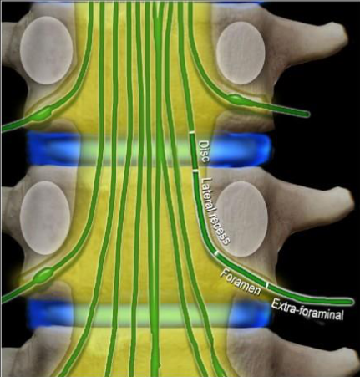 (Guen YL et al. Skeletal Radiology).

Figure 2: Showing the possible locations of nerve root compression along the lumbar spine.

CHAPTER THREE: METHODOLOGY
3.1 Study Design: This was a cross-sectional descriptive study in which images of young adults with LBP were reviewed.

3.2 Study Duration
The study was conducted for a period of nine months from June 2019 – March 2020.

3.3 Study setting
The study was conducted in the department of radiology of Nsambya Hospital. The hospital offers both outpatient and in-patient services. It is a 361-bed capacity private-not-for-profit hospital located in the southern part of Kampala city approximately 3 kilometers from the city center. It has a radiology department equipped with 1.5Tesla Siemens MRI, 128 slides CT machine, 04 ultrasound machines, conventional x-ray machine and mammography machine. The department on average receives 86 patients with low back pain for MRI evaluation every month and between 15 - 17 will be young adult patients. However, this number increases during national inter school’s/Universities sports seasons.

3.4 Target population
All young adults with LBP who needed MRI lumbar spine evaluation at Nsambya Hospital

3.5 Accessible population
All young adult patients with LBP who attended the radiology department of Nsambya Hospital for MRI lumbar spine evaluation.

3.6 Study Population
Young adult patients were referred to radiology department for MRI lumbosacral spine evaluation from June 2019 to March 2020.

3.7 Sampling method
Consecutive sampling of young adults who are to undergo MRI lumbosacral spine evaluation after referral to the department

3.8 Sample size estimation
The required sample size was obtained using the sample size estimation for descriptive studies, using formula to measure characteristic in terms of a proportion: N= 4(Z)² P (1-P)/ d²
Where N= sample size, P= pre-study estimates of the proportion of young adults to be measured, results of fact-finding study in Nsambya (12%), Zα= Standard normal deviate at 95% confidence interval corresponding to 1.96, d=Total width of the expected confidence interval
N= 163 participants.

3.9 Inclusion criteria
All young adults between the age of 18 and 39 years who had lumbosacral spine MRI evaluation done at Nsambya Hospital.

3.10 Exclusion criteria.
Images with no patient’s identity or wrong sequences were used.

3.11 Study variables
3.11.1 Independent variables were socio-demographic factors, imaging factors and duration of pain.
3.11.2 Dependent variables were MRI findings which included trauma (fractures), degenerative and infective process, congenital anomalies, neoplastic process or normal finding.

3.12 Data collection, analysis and management

3.12.1 Data collection process.
This study was conducted on 157 patients complaining of LBP with or without sciatica who were referred to the radiology department for MRI examination of the lumbar spine from June 2019 to Jan 2020.

Study procedure
The patients were recruited at the MRI room reception station and written informed consent were obtained. The following information on participants were obtained and recorded: Age, Sex, Clinical detail and physical activity. The patients ages were stratified in 05years interval. The severity of pain was determined subjectively using numeric rating scale. Patients were asked to circle numbers equally spaced on a page or verbally rate pain intensity using a scale of 0–10, in which 0 represents “no pain” and 10 represents “the worst pain imaginable”. Determining functional impairment also assessed severity of pain. The activity level of the participants was classified as routine, moderate and intense. Patients whose work involved activity that did not strain their back or lived sedentary lifestyle were classified as routine. Those who indulged in regular exercise like jogging or occasional weight lifting were classified as moderate activity, and patients who besides their daily routine work still performed regular daily exercise or weight lifting were classified as high activity.
Imaging technique
Each MRI scan of the lumbar spine was performed with a 1.5 Tesla MRI machine (Siemens Medical Systems, model - Espree, Town - Henkestr, County - Erlangen) using a dedicated receive – only spine coil, and a standard protocol specification for young adult in sagittal T1, T2, T2 STIR, T2 myelo, sequences. Coronal / axial reformats at levels T12-S1 were obtained. In suspected neoplastic and inflammatory processes the images were acquired in T1 with Contrast, and gradient echo (GRE) sequences.
All the MRI images were viewed at the picture archiving and communication system (PACS) GE (Centricity, GE Medical Systems) workstations. The corresponding radiological reports were made by the principal investigator and supervised by two consultant radiologists with substantial experience in neuroradiology imaging. Any difference in opinion was settled by consensus
The following standardized terms were used to classify the discs in the images: Normal, bulge, protrusion, extrusion, migration and sequestration. Nerve compression, thecal sac compression or spinal canal stenosis was obtained. Findings unrelated to disc abnormalities such as alignment, longitudinal ligament disruption, vertebral body mineralization, Modic changes, Schmorls nodes, marginal osteophytes, facet arthropathy, Ligamentum flavum hypertrophy and paravertebral area abnormality were also reported. There was Facet joint arthropathy and. Ligamentum flavum hypertrophy if they measured more than 04mm in diameter.
The lumbar spine canal stenosis was determined by dividing the canal into supra-pedicular, pedicular and infra-pedicular regions at each vertebral segment in sagittal plane. The severity of stenosis was determined quantitatively by measuring diameter of the canal. (mild < 25%, moderate >25 but < 50%, and severe >50% narrowing) (42). The AP diameter of the normal lumbar spinal canal varies widely from 15 to 27 mm. Lumbar stenosis results from an AP spinal canal diameter of less than 12 mm in some patients; a diameter of 10 mm is definitely stenotic and may be a primary source of symptoms.
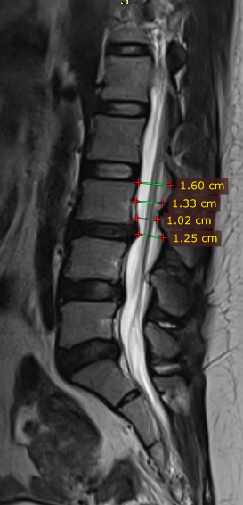 (Courtesy of Nsambya hospital).

Figure 3: Showing the possible locations for measuring the spinal canal diameter in sagittal sections. It is demonstrating a canal diameter of 16mm at supra-pedicular, 13.3mm at pedicular, and 10.2mm at the infra-pedicular location.

The lumbar foraminal stenosis was determined qualitatively by grading the stenosis as grade 0 when there was actual absence of foraminal stenosis; grade 1 was a mild foraminal stenosis and showed perineural fat obliteration in the two opposing directions, vertical or transverse; grade 2 was a moderate foraminal stenosis and showed perineural fat obliteration in the four directions without morphologic change, both vertical and transverse directions; and grade 3 was severe foraminal stenosis and showed nerve root collapse or morphologic change (43).
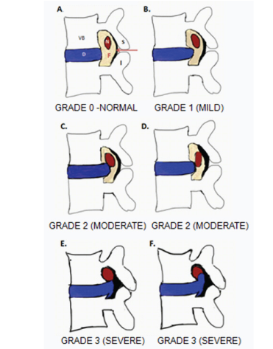 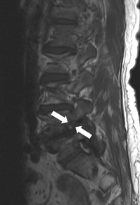[S Lee et al - American Journal].

Figure 4: Schematic diagram is showing the perineural fat surrounding the nerve root in grade zero stenosis. Grade one (mild) stenosis is showing partial loss of the perineural fat whereas grade two (moderate) and grade three (severe) stenosis are showing circumferential loss of perineural fat. The T1-weighted sagittal MRI image is showing a partial loss of the epidural fat surrounding the nerve root in the left neuroforamen at L4/L5.

The information obtained was entered into the data collection tool by the study Principal Investigator (PI) or research assistant.
Data was captured for every image during the study period. The data collection form was de-identified to exclude any unique identifier that would reveal the identity of the image. All study data forms were checked for accuracy, completeness and consistency regularly and any identified errors was corrected on the spot. All forms with completed data were sorted, and coded with unique study identifiers then filed prior to data entry. Data entry was done using a tool developed using epi-info version 7, incorporated with in-built quality and logical checks, validated and the errors were corrected by cross checking with the hard copy data forms.

3.12.2 Data management
Data was obtained using a semi-structured data collection tool and entered into an Excel spreadsheet. All subsequent analysis was made on a copy of the frozen data using STATA version 13.0 software.

3.12.3 Quality control
The data in its analyzable form was saved into a password-protected computer. A unique identifier was created to anonymize all study data and saved in a form that didn’t reveal the identity of the participants. Missing data were assessed for the nature of missing information before any analysis is executed. Multiple imputations will be done to assess the effect of missing data.

3.12.4 Data analysis
Frequency and proportions of variable were determined using descriptive statistics. Continuous variables were summarized in median and inter quartile range. Median and interquartile ranges were used because the data were not normally distributed.
Multiple logistic regression analysis was done using Stata 13.0 to find clinical and MR factors associated with spine image characteristics. Odds ratios (ORs)) were calculated to measure the effect of an independent variable on the outcome variable. Bivariate analysis, for independent variables was used and those which have p-values less than 0.2 at 95% confidence intervals were considered for multivariate analysis. Interaction and confounding were assessed in the regression model to determine the factors that are associated with low back pain. Variables with p < 0.05 was considered statistically significant.

3.13 Quality assurance.
To ensure that quality was maintained, all research assistants were trained in data collection procedures before data collection process starts. The data collection tools were pretested through a pilot study targeting 10 participants to ensure its effectiveness in capturing the intended data. For reproducibility, a 1.5Tesla Siemens MRI machine was used and a standard operating procedure (SOP) prepared, disseminated and training conducted to ensure a standardized quality. Two consultant radiologists and specialist radiologist reviewed all images of the lumbar spines, and any disagreement was settled by consensus.
All data forms were checked for completeness and consistency on a daily basis. All collected data were coded with unique identifiers to replace participants’ true identity (names), and entered using an appropriate database with in-built logical and quality checks. Hard copies of study data were kept in a securely locked cabinet, which was only accessed by a few authorized study team members. Similarly, all soft copy data had limited access (password protected) and was backed in several safe locations to avoid accidental loss of data.

3.14 Ethical Considerations
Permission to conduct the study was sought from, and granted by the Department of Radiology. Institutional approval for the study was sought from the Makerere University School of Medicine Research and Ethics Committee. All study activities and procedures were conducted per Good Clinical and Laboratory Practice. All patients were briefed about the study; background, aim, risks, benefits and expectations for participation before being consented to participate. Written informed consent (in English or local language) were sought from each of the prospective participants in the study prior to enrolment and data collection. All data and results generated from this study were kept confidential and were only accessed by a few authorized personnel. Illegible participants were advised on the next step according to the routine standard practice at the department.

3.15 Study Administration
Principal Investigator (PI) was responsible for overall planning and implementation of the study including publications. He was responsible for training of research assistants.
Research Assistants were responsible for recruitment of patients, administering informed consent and organizing data collection at the radiology units. The Research Assistants also did compilation of study report.
Research Assistants were university graduate, with field project work experience. They were responsible for working out survey logistics, data editing and data entry under the guidance of a biostatistician. Supervisors were responsible for overall supervision of the project.

3.16 Dissemination plan
A copy of the dissertation is to be submitted to; Department of Radiology and Radiotherapy, Sir Albert Cook Library-College of Health Sciences, and Directorate of Research and Graduate Training of Makerere University. Additionally, results will be presented in conferences and a manuscript will be prepared from the study findings and published in a peer-reviewed journal

CHAPTER FOUR: RESULTS

4.1 Socio-demographic characteristics
A total of 157 patients were recruited in this study. The median age of the participants was 33 (range: 18 to 40) years. Majority of the patients were female (n= 83, 52.9%) and professionals (n= 82, 52.2%). Of the 82 professionals, 32 (20.3%) were teachers, 27 (17.0%) were police officers, 13 (8.5%) were doctors and 10 (6.4%) were nurses and others. Table 1 summarizes the socio-demograhic characteristics of the participants.

Table 1: Sociodemographic profiles of the patients
Variable | Frequency  (n=157) | Percentage  (%)
Sex  Female  Male | 83  74 | 52.9  47.1
Age, median (IQR) | 33 (29-38)
18-22  23-27  28-32  33-37  38-42 | 13  24  40  38  42 | 08.2  15.3  25.5  24.2  26.8
Occupation
Housewife  Students  Business  Professional (formally employed). | 12  24  39  82 | 7.6  15.3  24.8  52.2

4.2 Levels of activity
Of the 157 participants, 86(55%) got involved in moderate activities, 38(24%) were involved in intense activities whereas 33(21%) were involved in routine activities.

Figure 5: Levels of activity of patients

4.3 Pain characteristics
All patients had LBP of varying onset and severity. Eighty-seven (55.4%) participants had gradual onset of pain whereas 70 (44.6%) had sudden onset; 129 (82.2%) participants suffered from severe pain and most of which were burning in nature (n=116, 73.9%). Majority of the patients had radiating pains (n=97, 61.8%) that was frequently aggravated by bending down (n=67, 42.7%) and alleviated by lying down (n=141, 89.8%).
The median duration of pain was 4 weeks, with a minimum duration of 1 week and maximum of 14 weeks. Sixty-seven (42.7%) had acute pain whereas ninety (57.3%) patients had chronic pain. Six (3.8%) patients had lower limb weakness; 4 (66.7%) had weakness of both lower limbs, 1 (16.7%) each had weakness on the left or right lower limb. Only one (0.6%) patient had sensory loss. Table 2 summarizes the pain characteristics of the participants.

Table 2: Pain characterisation of the patients
Variable | Frequency  (n=157) | Percentage  (%)
Duration of pain
≤6 weeks  > 6 - 11weeks  > 12 weeks | 80  25  52 | 50.9  15.9  33.2
Onset of pain
Gradual  Sudden | 87  70 | 55.4  44.6
Side of the back affected
Left  Right  Both | 17  29  111 | 10.8  18.5  70.7
Quality of pain
Aching  Burning | 41  116 | 26.1  73.9
Severity of pain
Mild  Moderate  Severe | 00  28  129 | 00  17.8  82.2
Aggravating factors
Bending  Sitting  Standing | 67  64  27 | 42.7  40.8  17.2
Alleviating factors
Walking  Sitting  Lying down | 7  9  141 | 4.5  5.7  89.8
Distribution
Localised  Radiating | 60  97 | 38.2  61.8

4.3. Magnetic Resonance Imaging Findings
Of the 157 patients, 123 (73.6%) reported to have had lumbar spine evaluation using plain x-rays before the MRI. Table 3 below summarises the key MRI findings of the patients.

Table 3: MRI findings of the patients
Variable | Frequency | Percentage
Normal lumbar vertebral alignment  Yes  No | N= 157  142  15 | 90.4  9.6
Intervertebral disc desiccation  Yes  No | N=157  65  92 | 41.4  58.6
Level of intervertebral disc desiccation  T12/L1  L1/L2  L2/L3  L3/L4  L4/L5  L5/S1 | N= 65  2  6  11  17  43  49 | 3.1  9.2  16.9  26.2  66.2  75.4
Intervertebral disc bulge  Yes  No | N=157  49  108 | 31.2  68.8
Level of intervertebral disc bulge  L1/L2  L2/L3  L3/L4  L4/L5  L5/S1 | N=49  34  36  40  48  49 | 69.2  73.1  81.3  98.7  100
Severity of disc bulge  L1/L2  Mild  Moderate  Severe  L2/L3  Mild  Moderate  Severe  L3/L4  Mild  Moderate  Severe  L4/L5  Mild  Moderate  Severe  L5/S1  Mild  Moderate  Severe | N=49  48  1  1  47  1  1  34  13  02  10  20  18  08  18  23 | 98.7  0.7  0.7  96.1  2.6  1.3  70.6  26.1  3.3  20.3  41.2  38.6  16.3  37.3  46.4
Schmorl’s node  Yes  No | N=157  16  141 | 10.2  89.8
Schmorl’s node position  Anterior  T12  L1  L2  L5  Posterior  L2  L3  L5 | N=16  8  1  2  1  4  8  2  3  3 | 50  12.5  25.0  12.5  50.0  50  12.5  37.5  37.5
Spinal canal narrowing  Mild  Moderate  Severe | N=15  12  02  01 | 81.5  14.0  4.5
Nerve root compression  Yes  No | N=157  39  118 | 25  75
Nerve root compression  Bilateral  Unilateral | N=39  30  09 | 76.1  23.9
Marginal osteophytes  Yes  No | N= 157  50  107 | 31.8  68.2
Levels of marginal osteophytes  L1  L2  L3  L4  L5 | N=50  21  34  42  40  40 | 42.0  68.0  84.0  80.0  80.0

Intervertebral disc bulges were observed in 49 (31.2%) patients. Intervertebral disc (IVD) protrusion was observed in 48 (1.9%) patients at levels L3/L4, L4/L5 and L5/S1. Only five patients had extrusion at L2/L3 IVD. Three (1.9%) had IVD migration at levels L4/L5 (n=2) and L5/S1 (n=1). One patient had an IVD fracture at L1/L2. None of the patients suffered IVD sequestration.
Schmorl’s node was observed in 16 (10.2%) participants. Majority (n=8, 50%) of the participants had nodes in L5; 5 of the nodes were on the anterior segment and 3 were on the posterior segment of L5.
Severe spinal canal narrowing (<10mm) was observed in 01 (4.5%) participant. Thirty-nine (25%) patients had nerve root compression, majority of which were bilateral (n=30, 76.1%). None of the participants had vacuum phenomenon. All participants had 5 lumbar vertebrae. Seven patients had increased intensities of the bone marrow substance, 4 of which were Modic type 2 and 3 were type 1. Six patients had reduced body heights (L5 = 4, T12 = 1 and T11 = 1).
Seventy-five (47.8%) patients had facet joint effusions at the following levels; L1/L2 (n=1, 1.3%), L2/L3 (n= 6, 8%), L3/L4 (n=31, 41.3%), L4/L5(n=67, 89.3%), and L5/S1 (n= 67, 89.3%). Of the 157 participants, 115 (73.2%) had long ligament distortion; 51 (44.4%) patients had posterior distortion, 64 (55.7%) had both posterior and anterior distortion with none having an isolated anterior distortion. Paravertebral area was affected in only 3 (1.9%) participants.
Conus medullaris was at the level of L1/L2 in a majority (n=147, 93.6%) of the patients. However, 10 patients had conus at either the level of T12 (n=9) or L2 (n=1). No posterior element abnormality was observed in all the patients. Loss of normal lumbar lordosis was observed in 102 (65%) participants; 90 (88.2%) were hypo-lordosis, 10 (9.8%) were straightening and 2 (2.0%) were reversed. No tumour or space occupying lesion was observed in the spinal cord, thecal sac or vertebrae.
Five (3.2%) patients had vertebral body destruction at the level of L5 (n=1), L4 (n=2), L3 (n=1) and L1 (n=1). Twenty (12.7%) patients had ligamentum flavum hypertrophy. None of the patients had a developmental vertebral anomaly.
LBP of gradual onset (79%), severe (61%), burning in nature, and radiating (87%) to the lower limbs was observed in patients with spinal canal stenosis and nerve root compression due to protrusion and extrusion.

Figure 6: Facet joint effusion increased in frequency in the lower lumbar spine segment
4.4: Correlation between MRI finding and clinical characteristics
Under bivariate analysis, age of the patients and distribution of pain were associated with disc desiccation. The age group of 23-35 years was associated with presence of disc desiccation. The risk of the patients to be found with disc desiccation was increasing with age. Patients in the age group of 23-35 years were 1.81 times more likely to develop disc desiccation than those in the age group of 18-22 years and the difference between the two age groups was statistically significantly different (p = 0.002). those in the age group of 35-40 years were 2.22 times more likely to develop disc desiccation compared to other age groups and the difference was statistically significant (p = 0.022). Distribution of pain was also predicting the occurrence of disc desiccation under bivariate analysis in this study. Those who were presenting with radiating pain were 2.58 times more likely to have disc desiccation than those with localized low back pain (49 cases versus 17 cases) and the difference was statistically significant (p = 0.006).

Table 4: Logistic regression under bivariate analysis for the association of the independent factors with disc desiccation in the patients
 |  | Disc desiccation
Variables |  | Yes | No | 95% CI | COR | P
Age (Years) | 18-24 | 2 | 17 | 1 | 1
Age (Years) | 25-34 | 29 | 48 | 2.427-53.940 | 1.81 | 0.002
Age (Years) | 35-39 | 35 | 26 | 1.123-4.423 | 2.22 | 0.022
Sex | Male | 30 | 47 | 0.413-1.473 | 0.78 | 0.443
Sex | Female | 36 | 44 | 0.413-1.473 | 0.78 | 0.443
Occupation | Formal | 37 | 47 | 0.721-2.576 | 1.36 | 0.34
Occupation | Informal | 29 | 44 | 0.721-2.576 | 1.36 | 0.34
Onset | Gradual | 40 | 47 | 0.758-2.738 | 1.44 | 0.265
Onset | Sudden | 26 | 44 | 0.758-2.738 | 1.44 | 0.265
Type of pain | Acute | 49 | 76 | 0.260-1.243 | 0.57 | 0.54
Type of pain | Chronic | 17 | 15 | 0.260-1.243 | 0.57 | 0.54
Duration of pain | ≤10 | 59 | 86 | 0.148-1.618 | 0.49 | 0.234
Duration of pain | >10 | 7 | 5 | 0.148-1.618 | 0.49 | 0.234
Site of pain | Unilateral | 24 | 28 | 0.658-2.514 | 1.286 | 0.462
Site of pain | Bilateral | 42 | 63 | 0.658-2.514 | 1.286 | 0.462
Quality of pain | Aching | 15 | 26 | 0.353-1.531 | 0.74 | 0.411
Quality of pain | Burning | 51 | 65 | 0.353-1.531 | 0.74 | 0.411
Severity of pain | Moderate | 11 | 14 | 0.464-2.605 | 1.10 | 0.828
Severity of pain | Severe | 55 | 71 | 0.464-2.605 | 1.10 | 0.828
Limb weakness | Yes | 4 | 2 | 0.510-16.163 | 0.51 | 0.213
Limb weakness | No | 62 | 89 | 0.510-16.163 | 0.51 | 0.213
Sensory loss | Yes | 1 | 0 | 0.207-2.922 | 0.24 | 0.2315
Sensory loss | No | 64 | 91 | 0.207-2.922 | 0.24 | 0.2315
Pain distribution | Radiating | 49 | 48 | 1.297-5.139 | 2.58 | 0.006
Pain distribution | Localized | 17 | 43 | 1.297-5.139 | 2.58 | 0.006

When the two independent factors (age and distribution of pain) were subjected to multivariate analysis (Table 2) after controlling for all other independent factors, it was found that, both factors remained predictors of the outcome (disc desiccation). The risk of the patients with age group 25-34 years was 11.42 times more than those in the age group of 18-24 years and the difference was statistically significant (p = 0.004). Likewise, the odds of the patients in the age group of 35-40 years to develop disc desiccation was 2.42 more than those in the age group of 18-24 years and the difference was statistically significant (p = 0.029). Distribution of pain among the patients continued to be associated with disc desiccation in the study. The risk of patients with radiating low back pain was 1.23 times more than those with localized low back with statistical significance difference (p = 0.024).

Table 5: Logistic regression under multivariate analysis for the association of the independent and the dependent variables
 |  | Disc desiccation
Variables |  | Yes | No | 95% CI | AOR | P
Age (Years) | 18-24 | 2 | 17 | 1 | 1
Age (Years) | 25-34 | 29 | 48 | 2.159-60.447 | 11.42 | 0.004
Age (Years) | 35-39 | 35 | 26 | 1.097-5.347 | 2.42 | 0.029
Pain distribution | Radiating | 49 | 48 | 0.169-0.885 | 1.23 | 0.024
Pain distribution | Localized | 17 | 43 | 0.169-0.885 | 1.23 | 0.024

None of the independent factors that were associated with presence of disc bulging in the patients for both bivariate and multivariate analyses showed statistical significance (Table 3). However, two of the variables analyzed permitted multivariate analysis to be performed due to the reason that, they had p values that were not exceeding 0.2 in bivariate analysis.

Table 6: Bivariate analysis using logistic regression for the association of the independent factors with disc bulging in the patients
 |  | Disc bulging
Variables |  | Yes | No | 95% CI | COR | P
Age (Years) | 18-24 | 5 | 15 | 1 | 1
Age (Years) | 25-34 | 21 | 56 | 0.203-16.113 | 0.701 | 0.584
Age (Years) | 35-39 | 24 | 37 | 0.413-3.273 | 0.641 | 0.665
Sex | Male | 21 | 56 | 0.353-1.375 | 0.696 | 0.297
Sex | Female | 28 | 52 | 0.353-1.375 | 0.696 | 0.297
Occupation | Informal | 27 | 54 | 0.623-2.417 | 0.449 | 0.554
Occupation | Formal | 22 | 54 | 0.623-2.417 | 0.449 | 0.554
Onset | Gradual | 30 | 57 | 0.999-1.072 | 1.029 | 0.297
Onset | Sudden | 19 | 51 | 0.999-1.072 | 1.029 | 0.297
Type of pain | Acute | 37 | 88 | 0.311-1.579 | 0.701 | 0.391
Type of pain | Chronic | 12 | 20 | 0.311-1.579 | 0.701 | 0.391
Duration of pain | ≤10 weeks | 44 | 101 | 0.184-2.077 | 0.610 | 0.420
Duration of pain | >10 weeks | 5 | 7 | 0.184-2.077 | 0.610 | 0.420
Site of pain | Unilateral | 28 | 34 | 0.622-2.567 | 0.341 | 0.517
Site of pain | Bilateral | 21 | 74 | 0.622-2.567 | 0.341 | 0.517
Quality of pain | Aching | 17 | 24 | 0.885-3.908 | 0.349 | 0.101
Quality of pain | Burning | 32 | 84 | 0.885-3.908 | 0.349 | 0.101
Severity of pain | Moderate | 11 | 14 | 0.810-4.662 | 0.339 | 0.137
Severity of pain | Severe | 38 | 94 | 0.810-4.662 | 0.339 | 0.137
Limb weakness | Yes | 3 | 3 | 0.444-11.737 | 0.438 | 0.323
Limb weakness | No | 46 | 105 | 0.444-11.737 | 0.438 | 0.323
Sensory loss | Yes | 1 | 1 | 0.261-2.901 | 0.331 | 0.314
Sensory loss | No | 48 | 107 | 0.261-2.901 | 0.331 | 0.314
Pain distribution | Yes | 29 | 68 | 0.428-1.702 | 0.853 | 0.652
Pain distribution | No | 20 | 40 | 0.428-1.702 | 0.853 | 0.652

When multivariate analysis was done, none of the two variables, quality of pain and severity of pain were statistically significant (Table 7).

Table 7: Multivariate analysis for the association of the independent and dependent variables using logistic regression.
 |  | Disc bulging
Variables |  | Yes | No | 95% CI | AOR | P
Quality of pain | Aching | 17 | 24 | 0.815-5.079 | 0.329 | 0.128
 | Burning | 32 | 84
Severity of pain | Moderate | 11 | 14 | 0.845-5.380 | O.319 | 0.109
 | Severe | 38 | 94

Marginal osteophytes were the other MRI findings examined in this study and their presence were associated with the different independent factors included in this study (Table 4). Only duration of LBP was the predictor of marginal osteophytes under bivariate analysis. Patients who had low back pain for the duration more than 10 weeks were 99.93% more likely to be diagnosed with marginal osteophyes than those who had low back pain for ≤10 weeks and the difference was statistically significant (p = 0.006). Occupational and limb weakness both showed marginal association with marginal osteophytes (p = 0.06). There were more patients with informal occupation (37 patients) who had marginal osteophytes compared to 35 patients with formal occupation who had marginal osteophytes, however, the difference was not statistically significant (p = 0.06) and they were 20% more likely to have marginal osteophytes (Table 8).

Table 8: Bivariate analysis using logistic regression for the association of the independent factors with marginal osteophytes in the patients
 |  | Marginal osteophytes
Variables |  | Yes | No | 95% CI | COR | P
Age (Years) | 18-24 | 6 | 13 | 1
Age (Years) | 25-34 | 38 | 39 | 0.618-5.471 | 0.35 | 0.27
Age (Years) | 35-39 | 28 | 33 | 0.444-1.707 | 0.53 | 0.68
Sex | Male | 35 | 42 | 0.517-1.815 | 0.97 | 0.92
Sex | Female | 37 | 43 | 0.517-1.815 | 0.97 | 0.92
Occupation | Formal | 35 | 46 | 0.428-1.504 | 0.8 | 0.49
Occupation | Informal | 37 | 39 | 0.428-1.504 | 0.8 | 0.49
Onset | Gradual | 34 | 53 | 0.286-1.022 | 0.54 | 0.06
Onset | Sudden | 38 | 32 | 0.286-1.022 | 0.54 | 0.06
Type of pain | Acute | 54 | 71 | 0.270-1.294 | 0.59 | 0.19
Type of pain | Chronic | 18 | 14 | 0.270-1.294 | 0.59 | 0.19
Duration of pain | ≤10 weeks | 61 | 84 | 0.008-0.525 | 0.07 | 0.001
Duration of pain | >10 weeks | 11 | 1 | 0.008-0.525 | 0.07 | 0.001
Site of pain | Unilateral | 26 | 26 | 0.659-2.498 | 1.29 | 0.46
Site of pain | Bilateral | 46 | 59 | 0.659-2.498 | 1.29 | 0.46
Quality of pain | Aching | 21 | 20 | 0.655-2.732 | 1.34 | 0.42
Quality of pain | Burning | 51 | 65 | 0.655-2.732 | 1.34 | 0.42
Severity of pain | Moderate | 14 | 11 | 0.868-3.842 | 1.62 | 0.27
Severity of pain | Severe | 58 | 74 | 0.868-3.842 | 1.62 | 0.27
Limb weakness | Yes | 5 | 1 | 0.715-54.952 | 6.27 | 0.06
Limb weakness | No | 57 | 84 | 0.715-54.952 | 6.27 | 0.06
Sensory loss | Yes | 0 | 1 | 1.613-2.162 | 1.87 | 0.35
Sensory loss | No | 72 | 83 | 1.613-2.162 | 1.87 | 0.35
Pain distribution | Yes | 48 | 49 | 0.766-2.821 | 1.47 | 0.25
Pain distribution | No | 24 | 36 | 0.766-2.821 | 1.47 | 0.25
After adjusting for other covariates in multivariate analysis, duration of pain became not predictive of marginal osteophytes (p = 0.96) although there were more patients with marginal osteophytes (61 cases) among those who had low back pain ≤10 weeks compared to the ones who had low back pain for the duration of >10 weeks (Table 9).

Table 9: Multivariate analysis for the association of the independent and dependent variables using logistic regression.
 |  | Marginal osteophytes
Variables |  | Yes | No | 95% CI | AOR | P
Onset of pain | Gradual | 49 | 48 | 0.548-2.782 | 0.45 | 0.61
Onset of pain | Sudden | 17 | 43 | 0.548-2.782 | 0.45 | 0.61
Type of pain | Acute | 54 | 71 | 0.368-3.254 | 0.48 | 0.87
Type of pain | Chronic | 18 | 14 | 0.368-3.254 | 0.48 | 0.87
Duration of pain | ≤10 weeks | 61 | 81 | 0.219-4.921 | 0.49 | 0.96
Duration of pain | >10 weeks | 11 | 1 | 0.219-4.921 | 0.49 | 0.96
Limb weakness | Yes | 5 | 1 | 0.323-1.535 | 0.707 | 0.39
Limb weakness | No | 57 | 84 | 0.323-1.535 | 0.707 | 0.39

SOME OF THE COMMON MRI FINDINGS

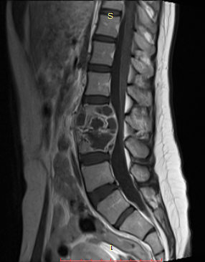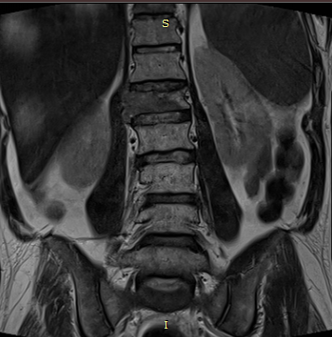

Figure 7: T1W sequence in Sagittal plane and T2W sequence in Coronal plane showing multiple irregularly shaped thick rim enhancing lesions involving the bodies of vertebrae L2 and L3, and the intervertebral disc L2/L3 with associated spinal canal stenosis, para-spinal space involvement and longitudinal ligaments disruption.

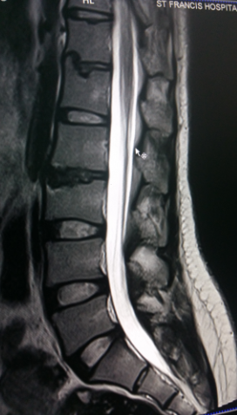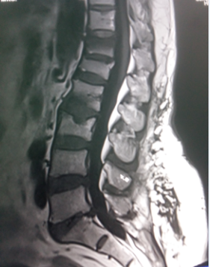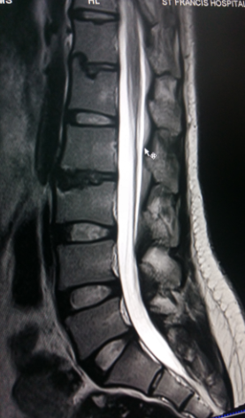

Figure 8: T2W sequence in Sagittal plane showing disc desiccation at L2/L3 and Schmorls node (blue arrow) at vertebrae L1 and L3.

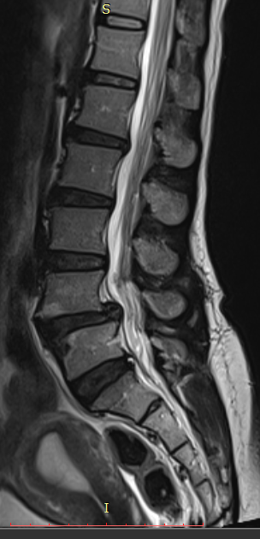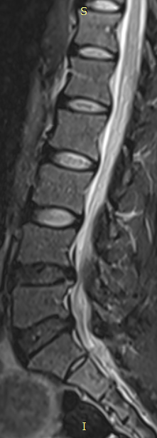

Figure 9: Sagittal plane of T2 sequence showing misalignment with disruption of both anterior and posterior vertebral lines at L4/L5 and L5/S1; and disc desiccation at L1/L2, L2/L3, L3/L4, L4/L5 and L5/S1 in a 34years old male patient who presented with low back pain for two months.

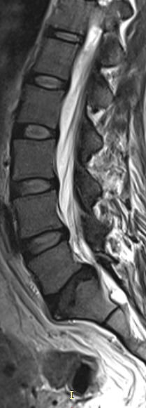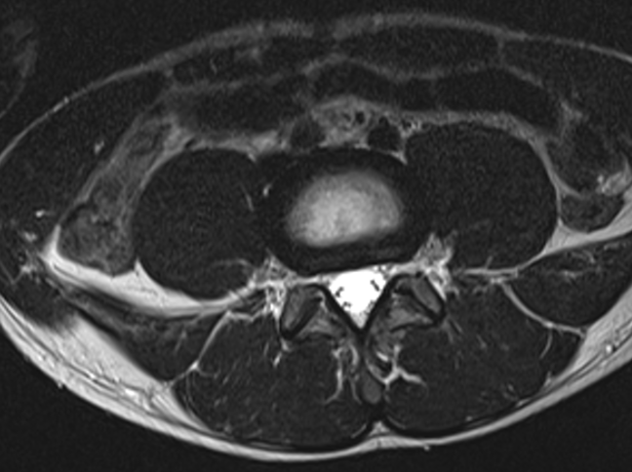

Figure 10: Sagittal and Axial planes of T2W sequence showing bilateral broad based disc bulge and spinal canal stenosis (blue arrow) at L4/L5 and L5/S1 in a 28years old female patient who presented with sciatica for three weeks.

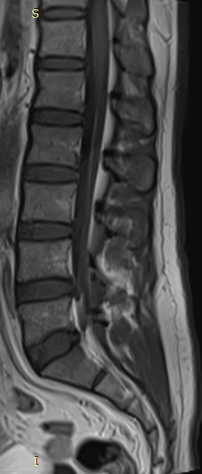

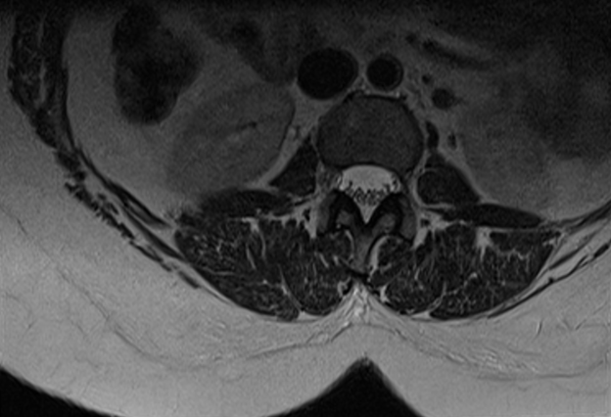

Figure 11: T1W and T2WI in Sagittal plane; and Axial plane of T1WI showing new bone formation [osteophytosis] (blue arrows) at the margins of L3, L4 and L5 in a 22years old female patient who presented with low back pain for one month.
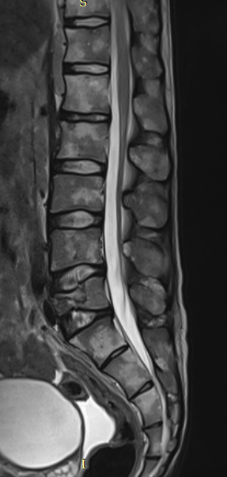

Figure 12: Sagittal plane of lumbar spine showing compressed fracture of anterior column of L5 vertebra (blue arrow).

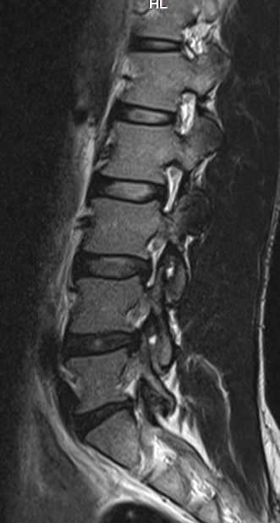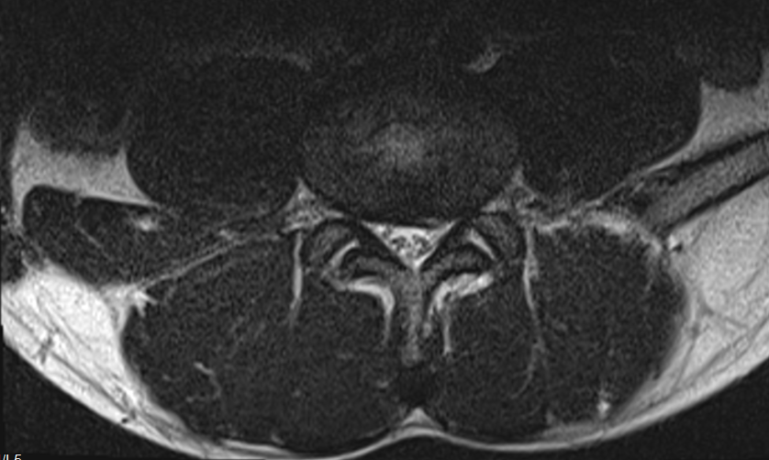

Figure 13 Sagittal and Axial planes of T2WI showing bilateral thinning out of the nerve roots with associated partial loss of epidural fat in the neuroforamina at L4/L5 (blue arrows).

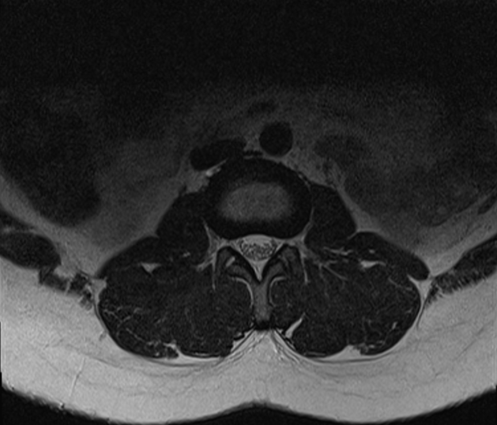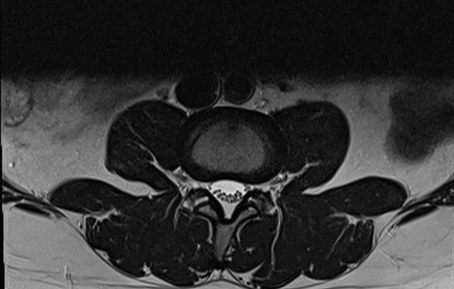

Figure 14 Axial plane of T2WI showing bilateral facet joint effusion at L2/L3

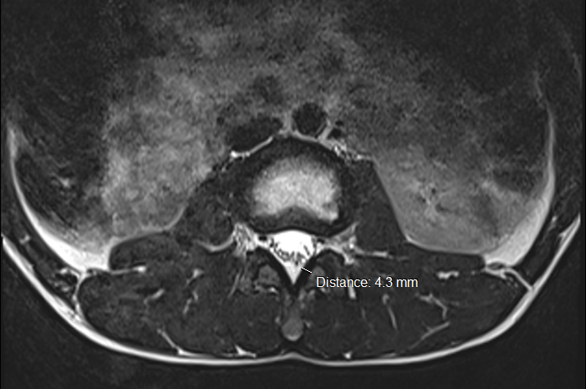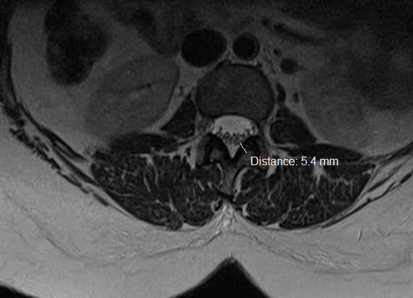

Figure 15 Axial plane of T2WI showing ligamentum flavum hypertrophy at L3

CHAPTER FIVE: DISCUSSION

5.1 Sociodemographic characteristics

5.1.1 Sex
This study found a slight female dominance over male with a ratio of 1:1.6. This finding is in line with studies which were conducted in Finland by Calvo-Munoz et al (44) and Takatalo et al (26) whereby more females were found to have disc desiccation than males. Also in another study by Sundell CG et al (27) reported more females with disc desiccation than males (17). This is because the females involve themselves in more vigorous activities such as long hours of field work and household chores (45)

5.1.2 Age
The finding of the median age of 33 years in this study is close to the finding of studies done in Finland among young adults with disc desiccation and marginal osteophytes which reported median age of 32 years (26). Another study done in Kuwait reported a mean age of 33years (13, 17).
The finding of the age group 25-34years in this study is similar to the findings of studies done in USA and Brazil among athletes with lumbar spine osteophytes which reported age range of 20-30years (6,9).
The literature shows that older people tend to have degenerative disc disease because of involvement in physical activities that requires repetitive movements at the back (22), or repetitive trauma to the lumbar spine and normal aging process (30).

5.1.3 Occupation and level of activity
This study found that participants with formal employment were the most affected by low back pain. This finding is in line with a finding of a study which was conducted in USA by Emel Yilmaz et where he found that degeneration disc disease (37%) was common among people with formal employment (24). Another study in Uganda by Aremu Babatunde et al found most health workers (45%) have ever complained of back pain (5).The literature shows lack of exercise and obesity are risk factors to developing low back pain (16). However, Long hours of standing, physical trauma and performing of exertional work may cause degeneration disc disease(24).

5.2 Pain characteristics

5.2.1 Onset, Severity and nature of pain.
This study found that severe pain of gradual onset and burning in nature was common among the participants. This finding is in line with findings of a study conducted in Finland by Calvo-Munoz et al which found that severe burning pain of gradual onset was common among young adults (26, 44). The literature shows that pain of gradual onset is common among people with degenerative disc disease where the bulging discs irritate the adjacent nerve sheath (25). Similarly, anomalous spinal column structures, complexity of nervous system and psychological factors may also produce pain of gradual onset (19). Slow growing lesion produces pain of gradual onset as it impinges the nerve roots (46).

5.2.2 Duration of pain
The study found pain of more than ten weeks as the most common among participants. This finding is in line with findings of a study conducted in Sweden by Sundell CG et al which found that low back pain of more than 30 days was the most common among the participants (27). Other studies conducted in USA by Olsen TL et al and Brazil by Isaacs DM et al, found that low back pain of more than ten weeks’ duration was common among patients who had degeneration disc disease (19,23,24). The literature shows that disc degeneration disease presents with chronic pain that may last more than 10 weeks (15). In Uganda most patients will visit their physician only when the pain has become severe (3).

5.3 Magnetic resonance imaging findings

5.3.1 Intervertebral disc desiccation
This study found discs with low signal intensity on T2WI [65 (41.4%)] to be more common among participants. This finding is in line with finding of a study conducted in Kuwait by Osama Al-saeed et al where he found that disc desiccation was common among the patients with low back pain (13). Another study conducted in Finland by Calvo-Munoz et al also found that disc desiccation was very common especially in lower lumber spine segment (44). Literature shows that intervertebral disc desiccation is the most common imaging feature found among patients with low back pain(47). This is because body weights and strenuous activities subjects stress to the lumbar spine thereby squeezing out fluid which is in the nucleus pulposus (4). Naturally, the discs become desiccated when the patients become old. The hydration status of normal intervertebral discs also changes by the time of the day where they will appear hyper-intense in the morning and become hypo-intense in the evening on T1W sequences (47).

5.3.2 Intervertebral disc bulge, disc protrusion and extrusion
This study found that disc bulge [49(31.2%)] was common among patients with lower lumbar pain. This finding is in line with studies conducted in Sweden, by Sundell CG et al, and Finland by Calvo-Munoz I et al in 2018 where they found that disc bulge was very common among patients with back pain (27, 44). Literature shows that disc bulge is found in areas of maximum stress along the spinal column where compression forces on the discs cause nucleus pulposus materials to be squeezed out (5). Hyperextension injuries of the lumbar spine can cause circumferential or focal bulge of disc materials (48).
This study found that disc protrusion(1.9%) and extrusion(0.6%) were not common, this finding is in line with a finding of a study conducted in Sweden by Sundell CG et al where he found that disc protrusion (7%) and extrusion were not common (27). This is because one needs to get involved in a more severe spinal injury so as to acquire disc herniation (5).

5.3.3 Spinal canal narrowing and nerve root compression.
This study found spinal canal narrowing [15(9.5%)] and nerve root compression [39(24.8%)] to be less common among patients. This finding is in line with finding of a study conducted in Sweden, by Sundell CG et al where he found few patients to be having nerve root exit stenosis(12%) in the lower lumbar spine segment(27). The finding of this study is also in line with another study conducted in Nigeria by Doualla M. et al and found that few patients had spinal canal stenosis (11%)(17).
The literature shows spinal canal and nerve root stenosis are common among patients having disc protrusion, marginal osteophytes, hypertrophied ligamentum flavum, facet joint effusion, abundant epidural fat or abnormalities of vertebra, thecal sac and spinal cord. They cause stenosis of both spinal canal and nerve root exit foramen at the levels of disc, lateral recess, foramen and extra-foramina areas (18). People who are involved in heavy weight lifting or riding on bumpy rough roads can develop spinal canal and neuroforamina stenosis (20).

5.3.4 Marginal osteophytes, Schmorls nodes, Modic changes.
The finding of this study is in line with the findings of studies conducted in Sweden, by Sundell CG et al and in Finland by Calvo-Munoz where they found marginal osteophyte (37%) to be less common among patients who had LBP (27, 44). Literature shows that osteophytes are only observed in degenerative disease (25).
The findings of this study is also in line with findings in another study conducted in Nigeria by Adekamni et al where he found that Schmorls nodes (10.2%) and Modic changes (4.5%) were not common among patients (11, 12). Modic change was 12% in Finland whereas 6.6% in Denmark (44). This is because these conditions require violent activities involving repetitive movements of the back (49).

5.3.5 Facet joint effusion and Ligamentum Flavum hypertrophy.
The finding of facet joint effusion in this study [75(47.8%)] is not close to findings in studies conducted in Kuwait by Osama Saeed et al and in Sweden by Sundell CG et al where they found that facet joint effusion [7 (1.6%)] and [13 (4.1%)] respectively (13, 27). This may be because of geographical difference due to arid environment in Kuwait, or the patients are involved in less stressful activities.
The finding of ligamentum flavum [ 20(12.7%)] is comparable to finding in a study conducted in Brazil by Ferreira G et al where he found [ 36(15.2%)] patients having hypertrophic ligamentum flavum (6). A similar study conducted in USA also found a comparable number (13%) of patients having hypertrophic ligament (40, 42). Literature shows that normal aging process and facet joint arthrosis can cause fibrosis and hypertrophy of ligamentum flavum. The variation in the findings between this study and other previous studies is due to difference in chronicity of fibrosis of ligamentum flavum.

5.4 Association between clinical presentations and disc desiccation, disc bulge and osteophytes

5.4.1 Association of disc desiccation with the independent factors
This study found an association between age group of 25-34years and 35-40 years (AOR=11.42, 95% CI=2.159-60.447 p=0.004) and (AOR=2.42, 95%CI=1.097-5.347 p=0.024) and disc desiccation. This meant that the aged 25-34 are almost 2.5 times more likely to develop disc desiccation. These findings were in agreement with another study conducted in Kuwait, which found that those aged 23-30 were twice as likely to have disc desiccation (AOR= 1.08, 95% CI =0.94-1.23, P < 0.267) (13). Another study which was carried out in Finland also found that those above 20 years old were twice more likely to develop disc desiccation ( AOR= 95%CI= p= ) (26). This is because of wear and tear of these body tissues in susceptible patients as one becomes older in age.
This study also found an association between distribution of pain and occurrence of disc desiccation (AOR=1.23 95% CI=0.169-0.885 p=0.024). This meant that the patient with a radiating pain had 1.23 more chance of developing disc desiccation. These findings were in agreement with another study conducted in Kuwait ( AOR= 95%CI= p=), which found that those with radiating pain were twice as likely to have disc desiccation (13).
This study. However, found no association between disc desiccation and sex (COR=0.78 95%CI=0.413-1.473 p=0.443), Occupation (COR= 1.36 95%CI=0.721-2.576 p=0.34) and onset of pain (COR=1.44 95%CI=0.758-2.738 p=0.265).

5.4.2 Association of disc bulge with the independent factors
This study found that there is no association between disc bulge and the independent variables such as age (COR=0.333 95%CI=0.199-58.002 p=0.403), sex (COR=0.974 95%CI=0.939-1.010 p=0.239), occupation, pain onset, duration of pain, type of pain, site of body affected by pain, quality of pain, severity of pain, limb weakness, sensory loss and pain distribution. Other studies conducted in Kuwait and Sweden also found that there was no association such as age (Adjusted OR= 1.08 95% CI= 0.94 - 1.23 p-value= 0.267), sex (Adjusted OR= 1.07 95% CI= 0.35 - 3.32 p-value= 0.900). However, finding of a study conducted in Northern Finland by Takatalo et al found an association between disc bulge and male sex (p= 0.036). A similar study conducted in Nigeria by Ademola Joseph Adekanmi et al found association between disc bulge and patient’s age to be statistically significant (p=0.01).

5.4.3 Association of osteophyte with the independent factors.
This study found that there was association between duration of pain and developing marginal osteophytes (AOR=0.07, 95% CI=0.008-0.525 p=0.001).
The study also found an association between limb weakness and marginal osteophytes development (AOR=0.707 95% CI=0.323-1.535 p=0.06)

5.5 Study limitations
The sample size was small to give a general picture of Uganda’s population.

CHAPTER SIX: CONCLUSION AND RECOMMENDATION

6.1 Conclusion
Pain lasting more than 10 weeks is the most common clinical presentation among patients with LBP.
Disc contour irregularity, disc desiccation and loss of disc height are the most common findings in patients who present with severe LBP of acute onset in this study.

Disc bulge is the most common MRI finding in patients with LBP.
Disc desiccation is common among patients above 24years of age who present with LBP. However, there is no association between sex, occupation and activity levels with disc desiccation.
Disc bulge and marginal osteophytes show no association with age, occupation and activity levels.

LBP which is radiating in nature is the most common finding in patients with disc protrusion in this study.
Severe burning pain of gradual onset is common among patients with severe disc bulge and osteophytes.

6.2 Recommendations
Since disc bulge is the most common MRI finding in this study and can’t be demonstrated on plain x-ray, MRI should be considered as the modality of choice in patients with LBP lasting more than 10 weeks regardless of the age.
Young adults who present with acute LBP of burning nature may be recommended for MRI evaluation because they are at a high risk of developing disc desiccation, disc bulge and osteophytes.
Patients with severe LBP which radiates to the lower limbs may be recommended for MRI spine evaluation because they have a high chance of having spinal canal stenosis and nerve root compression.

REFERENCES
1. Hoy D, Bain C, Williams G, March L, Brooks P, Blyth F, et al. A systematic review of the global prevalence of low back pain. Arthritis & Rheumatism. 2012;64(6):2028-37.
2. Fatoye F, Gebrye T, Odeyemi I. Real-world incidence and prevalence of low back pain using routinely collected data. Rheumatology international. 2019;39(4):619-26.
3. Aremu A, Olaniyan LT. Prevalence and factors associated with low back pain among healthcare workers in kibuli Muslim hospital kampala, Uganda. 2017.
4. Mousavi SJ, Akbari ME, Mehdian H, Mobini B, Montazeri A, Akbarnia B, et al. Low back pain in Iran: a growing need to adapt and implement evidence-based practice in developing countries. Spine. 2011;36(10):E638-E46.
5. Abdulmujeeb A, Olaniyan L. Prevalence and factors associated with low back pain among healthcare workers in Kibuli Muslim Hospital Kampala, Uganda. Epidemiology (Sunnyvale). 2017;7(1):1-5.
6. Ferreira G, Costa LM, Stein A, Hartvigsen J, Buchbinder R, Maher CG. Tackling low back pain in Brazil: a wake-up call. Brazilian journal of physical therapy. 2019;23(3):189-95.
7. Galukande M, Muwazi S, Mugisa DB. Aetiology of low back pain in Mulago Hospital, Uganda. African health sciences. 2005;5(2):164-7.
8. Takatalo J, Karppinen J, Niinimäki J, Taimela S, Näyhä S, Järvelin M-R, et al. Prevalence of degenerative imaging findings in lumbar magnetic resonance imaging among young adults. Spine. 2009;34(16):1716-21.
9. Flynn TW, Smith B, Chou R. Appropriate use of diagnostic imaging in low back pain: a reminder that unnecessary imaging may do as much harm as good. journal of orthopaedic & sports physical therapy. 2011;41(11):838-46.
10. Yang S, Kim W, Choi KH, Yi YG. Influence of occupation on lumbar spine degeneration in men: the Korean National Health and Nutrition Examination Survey 2010–2013. International archives of occupational and environmental health. 2016;89(8):1321-8.
11. Adekanmi AJ, Bello TO, Atalabi OM, Jimoh KO, Ogunseyinde OA. Magnetic resonance imaging of lumbosacral intervertebral discs in nigerians with low back pain. West African Journal of Radiology. 2017;24(1):61.
12. Samartzis D, Karppinen J, Mok F, Fong DY, Luk KD, Cheung KM. A population-based study of juvenile disc degeneration and its association with overweight and obesity, low back pain, and diminished functional status. JBJS. 2011;93(7):662-70.
13. Al-Saeed O, Al-Jarallah K, Raeess M, Sheikh M, Ismail M, Athyal R. Magnetic resonance imaging of the lumbar spine in young arabs with low back pain. Asian spine journal. 2012;6(4):249.
14. Al-Saeed O, Al-Jarallah K, Raeess M, Sheikh M, Ismail M, Athyal R. Magnetic resonance imaging of the lumbar spine in young arabs with low back pain. Asian spine journal. 2012;6(4):249-56.
15. Ayanniyi O, Mbada CE, Muolokwu CA. Prevalence and profile of back pain in Nigerian adolescents. Medical Principles and Practice. 2011;20(4):368-73.
16. Galukande M, Muwazi S, Mugisa B. Disability associated with low back pain in Mulago Hospital, Kampala Uganda. African health sciences. 2006;6(3):173-6.
17. Doualla M, Aminde J, Aminde LN, Lekpa FK, Kwedi FM, Yenshu EV, et al. Factors influencing disability in patients with chronic low back pain attending a tertiary hospital in sub-Saharan Africa. BMC musculoskeletal disorders. 2019;20(1):25.
18. Hartvigsen J, Hancock MJ, Kongsted A, Louw Q, Ferreira ML, Genevay S, et al. What low back pain is and why we need to pay attention. The Lancet. 2018.
19. Olsen TL, Anderson RL, Dearwater SR, Kriska AM, Cauley JA, Aaron DJ, et al. The epidemiology of low back pain in an adolescent population. American journal of public health. 1992;82(4):606-8.
20. Wáng YXJ, Wu A-M, Santiago FR, Nogueira-Barbosa MH. Informed appropriate imaging for low back pain management: A narrative review. Journal of orthopaedic translation. 2018.
21. Foster NE, Anema JR, Cherkin D, Chou R, Cohen SP, Gross DP, et al. Prevention and treatment of low back pain: evidence, challenges, and promising directions. The Lancet. 2018.
22. Meucci RD, Fassa AG, Faria NMX. Prevalence of chronic low back pain: systematic review. Revista de saude publica. 2015;49:73.
23. Isaacs DM, Marinac J, Sun C. Radiograph use in low back pain: a United States Emergency Department database analysis. The Journal of emergency medicine. 2004;26(1):37-45.
24. Yilmaz E, Dedeli O. Effect of physical and psychosocial factors on occupational low back pain. 2014.
25. Calvo-Muñoz I, Kovacs FM, Roqué M, Gago Fernández I, Seco Calvo J. Risk Factors for Low Back Pain in Childhood and Adolescence. The Clinical journal of pain. 2018;34(5):468-84.
26. Takatalo J, Karppinen J, Niinimäki J, Taimela S, Näyhä S, Mutanen P, et al. Does lumbar disc degeneration on magnetic resonance imaging associate with low back symptom severity in young Finnish adults? Spine. 2011;36(25):2180-9.
27. Sundell CG, Bergström E, Larsén K. Low back pain and associated disability in Swedish adolescents. Scandinavian journal of medicine & science in sports. 2019;29(3):393-9.
28. O’Sullivan JW, Muntinga T, Grigg S, Ioannidis JP. Prevalence and outcomes of incidental imaging findings: umbrella review. Bmj. 2018;361:k2387.
29. Yang S, Werner BC, Singla A, Abel MF. Low back pain in adolescents: a 1-year analysis of eventual diagnoses. Journal of Pediatric Orthopaedics. 2017;37(5):344-7.
30. Davis P, Williams H. The investigation and management of back pain in children. Archives of Disease in Childhood-Education and Practice. 2008;93(3):73-83.
31. Wand BM, O'Connell NE. Chronic non-specific low back pain–sub-groups or a single mechanism? BMC musculoskeletal disorders. 2008;9(1):11.
32. Freburger JK, Holmes GM, Agans RP, Jackman AM, Darter JD, Wallace AS, et al. The rising prevalence of chronic low back pain. Archives of internal medicine. 2009;169(3):251-8.
33. Cox JM. Low back pain: mechanism, diagnosis and treatment: Lippincott Williams & Wilkins; 2012.
34. Cavanaugh JM, Ozaktay AC, Yamashita HT, King AI. Lumbar facet pain: biomechanics, neuroanatomy and neurophysiology. Journal of biomechanics. 1996;29(9):1117-29.
35. Cavanaugh JM, Ozaktay AC, Yamashita T, Avramov A, Getchell TV, King AI. Mechanisms of low back pain: a neurophysiologic and neuroanatomic study. Clinical Orthopaedics and related research. 1997(335):166-80.
36. Fisher TJ, Osti OL. Do bacteria play an important role in the pathogenesis of low back pain? ANZ journal of surgery. 2015;85(11):808-14.
37. Hayden JA, Ogilvie R, Stewart SA, French S, Campbell S, Magee K, et al. Development of a clinical decision support tool for diagnostic imaging use in patients with low back pain: a study protocol. Diagnostic and Prognostic Research. 2019;3(1):1.
38. Kim J-H, van Rijn RM, van Tulder MW, Koes BW, de Boer MR, Ginai AZ, et al. Diagnostic accuracy of diagnostic imaging for lumbar disc herniation in adults with low back pain or sciatica is unknown; a systematic review. Chiropractic & manual therapies. 2018;26(1):37.
39. Sammer MB, Jarvik JG. Imaging of adults with low back pain in the primary care setting. Evidence-Based Imaging: Springer; 2006. p. 294-318.
40. Chou R, Qaseem A, Snow V, Casey D, Cross JT, Shekelle P, et al. Diagnosis and treatment of low back pain: a joint clinical practice guideline from the American College of Physicians and the American Pain Society. Annals of internal medicine. 2007;147(7):478-91.
41. Lee S, Lee JW, Yeom JS, Kim K-J, Kim H-J, Chung SK, et al. A practical MRI grading system for lumbar foraminal stenosis. American Journal of Roentgenology. 2010;194(4):1095-8.
42. Guen YL, Joon WL, Hee SC, Kyoung-Jin O, Heung SK. A new grading system of lumbar central canal stenosis on MRI: an easy and reliable method. Skeletal radiology. 2011;40(8):1033-9.
43. Pfirrmann CW, Dora C, Schmid MR, Zanetti M, Hodler J, Boos N. MR image–based grading of lumbar nerve root compromise due to disk herniation: reliability study with surgical correlation. Radiology. 2004;230(2):583-8.
44. Calvo-Muñoz I, Kovacs FM, Roqué M, Gago Fernandez I, Seco Calvo J. Risk Factors for Low Back Pain in Childhood and Adolescence. The Clinical journal of pain. 2018;34(5):468-84.
45. Abdalkader M, Guermazi A, Engebretsen L, Roemer FW, Jarraya M, Hayashi D, et al. MRI-detected spinal disc degenerative changes in athletes participating in the Rio de Janeiro 2016 Summer Olympics games. BMC Musculoskeletal Disorders. 2020;21(1):1-8.
46. Foster NE, Anema JR, Cherkin D, Chou R, Cohen SP, Gross DP, et al. Prevention and treatment of low back pain: evidence, challenges, and promising directions. The Lancet. 2018;391(10137):2368-83.
47. Hartvigsen J, Hancock MJ, Kongsted A, Louw Q, Ferreira ML, Genevay S, et al. What low back pain is and why we need to pay attention. The Lancet. 2018;391(10137):2356-67.
48. Wáng YXJ, Wu A-M, Santiago FR, Nogueira-Barbosa MH. Informed appropriate imaging for low back pain management: A narrative review. Journal of orthopaedic translation. 2018;15:21-34.
49. Jarvik JG. Imaging of adults with low back pain in the primary care setting. Neuroimaging Clinics. 2003;13(2):293-305.

APPENDICES

APPENDIX 1: Demographic information data collection tool
Study ID: ___________ Date of examination ……………..
Demographic information
Age | Sex
Age | M | F
18-22
23-27
28-32
33-37
38-40

APPENDIX II: Occupation and level of activity

Occupation | Level of activity
Occupation | Mild | Moderate | High activity
House wife
Student
Business
Professional

APPENDIX III: Clinical Features Data Collection Tool

Study ID: ………………………… Date of examination……………

Duration of symptoms.

DURATION(WEEKS). |  | SITE AFFECTED
 |  | Right | Left | Both
0 -2
2 – 4
4 – 6
6 – 8
8 – 10
10 – 12
> 12

APPENDIX IV: Characteristics of Pain Data Collection Tool.

Study ID: ………………………… Date of examination……………

CHARACTER | DESCRIPTION
Onset
Quality
Severity
Aggravating factors
Alleviating factors
Associated factors
(Weakness or sensory loss)
Distribution
Barriers to pain assessment

APPENDIX V: MRI features data collection tool

STUDY ID NUMBER: …………Date of examination………………

MRI FEATURES | No | Yes.
Normal number of lumbar vertebra
Loss of lumbar lordosis
Normal Alignment
Normal vertebral body mineralization
Normal vertebral body height
Vertebral body fractures
Marginal osteophyte
Modic changes
Disc desiccation
Disc bulge
Disc protrusion
Disc extrusion

Disc migration

Disc Sequestration
Intervertebral disc vacuum phenomenon
Shmorls nodes
Radial disc Fracture
Spinal canal stenosis
Nerve root compression
Ligamentum flavum hypertrophy
Posterior element abnormality
Developmental anomaly
Others (Specify)

APPENDIX VI: Numeric Pain Rating Scale

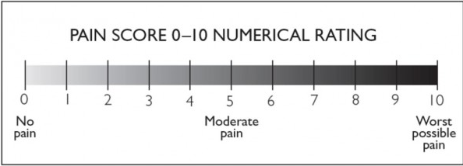
(Courtesy of National Institute of Clinical Studies (2011) Emergency Care Pain Management Manual).

APPENDIX VII: Study Timelines

Study Activities | 2019 |  |  |  |  |  |  |  |  |  | 2020
 | March | April | May | June | July | August | Sept | Oct | Nov | Dec |  | Jan | Feb
Proposal development
Ethical approval
Data collection
Data analysis
Thesis writing
Dissemination

APPENDIX VIII: Study Budget
Item | Quantity | Unit Cost (USH) | Total Cost
Dissemination proposal to department and IRB | 15 | 25,000 | 375,000
Personnel:  - Research assistant | 3 | 10,000 per patient | 5,070,000
Equipment & Communication  - Mobile telephone air time  -Movement of PI | 3  1 |  | 300,000  1,000,000
Stationery  -Ream of paper  - Printing paper  - Photocopying  -Marker  - Pens  - Box file  -DVD  External hard drive  Computer set  Printer | 02  2000  500  4 boxes  10  2  300  1  1  1 | 30,000  100  50  10,000  3000  5000  2000 | 60,000  200,000  250,000  40,000  30,000  10,000  600,000  300,000  2,000,000  600,000
Training & Meetings  - Research assistants training | 2 days | 100,000 | 600,000
Data Management & analysis |  | 1,000,000 | 1,000,000
Printing and dissemination of the Report | 15 | 25000 | 375,000
Snacks to participants | 300 | 2000 | 600,000
TOTAL |  |  | 13,010,000

APPENDIX IX: Standard MRI protocols for lumbar-sacral spine evaluation in the young adults.
The local MRI protocols include the followings on a 1.5Tesla Siemens machine.
1. Degenerative spine disease: Sagittal T1SE, Sagittal T2FSE, graphically prescribed angled axial PD/T2FSE, angled T1 stacked axial sequences. No IV contrast.
2. Trauma: Sagittal T1 SE, Sagittal FSEIR, Axial T2 FSE with fat sat. Target axials to abnormality. TI myelogram will be performed on request
3. Tethered cord: Sagittal T1 SE, Sagittal T2 FSE, Axial T1 SE T10-S2, using inter-slice gap as needed. No IV contrast
4. Coronal plane will be performed on all protocols.
TI myelogram will be performed on request.

APPENDIX X: Informed consent: English
MRI FINDINGS AMONG YOUNG ADULT PATIENTS WITH LOW BACK PAIN AT NSAMBYA HOSPITAL
Investigator: Dr. Komakech Richard Lukecha (MBChB) from the Department of radiology and radiotherapy, Makerere University college of Health Sciences, P.O BOX 7072, Kampala; Mobile: 0782603361 Email: 36komakech@gmail.com
Introduction:
We are carrying out a research study on MRI findings among young adult patients with low back pain. You are being requested to participate in this study.
Background and Rationale for the study
Low back pain is a very common health problem worldwide. This has made the clinicians to get overwhelmed by the patient numbers making them to go against the clinical practice guidelines on its diagnosis and management. This has in turn made treatment of low back pain very frustrating and unrewarding because the pathological causes of patients’ symptoms are missed
These days most clinicians and patients prefer MRI lumber spine evaluations, substituting it for radiographic evaluations. However, the prevalence of spinal MRI findings in this age group remains unknown This study will therefore provide insight and knowledge on prevalence of possible causes of LBP among the young adults, and will be used to design an appropriate spine MRI imaging protocols to optimize the use of equipment and other resources.
Purpose:
This study is aimed at quantifying the MRI finding to clinical symptoms of LBP in our setting and providing a basis for creation of clinical guidelines and hopefully influence policy on
identification and management of LBP.

Procedures:
Clinical data will be obtained from patient’s medical record file. 48 images will be acquired using 1.5 Tesla Siemens Medical Systems with specifications for standard protocols for young adult patients.
The images will be reviewed at picture archiving and communication system (PACS; GE Centricity, GE Medical Systems) workstations by two radiologists, and their findings will be recorded.
The information obtained will be entered in the data collection tool by the study Principle Investigator (PI) or research assistant.
Data will be captured in a continuous manner and all study data forms will be checked for accuracy, completeness and consistency regularly. Data entry will be done using a tool developed using epi-info version 7, incorporated with in-built quality and logical checks, validated and the errors will be corrected by cross checking with the hard copy data forms.
Duration the research participant will take in the research project:
The research participant will spend 15-20 minutes with the principal investigator or research assistants during the research project.
Study participants:
Young adult patients (18-39years) who will have been referred to radiology department for MRI lumbosacral spine evaluation from April 2019 to March 2020. 48 participants are expected to be involved in the study and each will be required to be active in only one day.
Risks/Discomforts:
The study carries minimal risks to the patients.
Benefits:
There is no direct benefit. However, the patients image results will be communicated to him/her in both soft and hard copies.

Confidentiality:
all patient’s data and image results generated from this study will be coded and kept confidential. It will only be accessed by the principal investigator and his two assistants; and the supervisors. The patients with positive image result will be advised on the next steps according to the routine standard practice at the department.
Alternatives:
We are not aware of any appropriate lumber spine evaluation that can be used to assess the pathological causes of patient’s symptoms of LBP besides the one that we are going to perform on you. You will receive all routine care regardless of whether you participate or not in this study.
Cost:
The principal investigator will only meet the cost of a DVD/CD for each participant for storage of his or her image results.
Compensation for participation in the study:
There are no arrangements to cater for any compensation during the conduct of the study. However, each participant will receive one thousand shillings only (1000/=) as a token of appreciation.
Statement of voluntariness:
Participation in this proposed study will be voluntary and a participant may join on his or her own free will. Any participant has the right to withdraw from the study at any time without penalty.
Dissemination of results:
The research participants will continuously be getting feedback on findings and progress of the study. Any new information that will affect the study or data that has clinical relevance to research participants will be made available to research participants and/or their health care providers.
Ethical approval:
Permission to conduct the study will be sought from the Department of Radiology. Institutional approval for the study will be sought from the Makerere University School of Medicine Research and Ethics Committee. All study activities and procedures will be conducted per Good Clinical and Laboratory Practice. All participants will be briefed about the study; background, aim, risks, benefits and expectations for participation before being consented to participate. Written informed consent will be sought from each of the prospective participants in the study prior to enrolment and data collection.
Contacts in case of more information
In case of any other thing you want to know about the study, feel free to call me Dr Komakech Richard Lukecha on telephone number 0782603361 or my supervisors Dr Bugeza Sam on 0772574453 or Dr Erem Geoffrey on 0772-676316 (Department of radiology and radiotherapy).
Participant’s Rights
For questions regarding the rights or any other ethical issue concerning you, contact Professor Ocama Ponsiano, the chairman School of Medicine Research and Ethics Committee on telephone number 0772-421190.
STATEMENT OF CONSENT.
........................................................................... has described to me what is going to be done, the risks, the benefits involved and my rights regarding this study. I understand that my decision to participate in this study will not alter my usual medical care. In the use of this information, my identity will be concealed. I am aware that I may withdraw at any time. I understand that by signing this form, I do not waive any of my legal rights but merely indicate that I have been informed about the research study in which I am voluntarily agreeing to participate. A copy of this form will be provided to me.
Name ………………………………………………………………………….
Signature/thumb print of participant …………………………. Date ………………………….
Name………………………Signature of witness (if applicable) ……………Date…………….
Name ……………………………………. Signature of interviewer/Person obtaining informed consent….………………………… Date ………………….

APPENDIX XI: Foomu ekkiririzibwako okwetaba mu kunoonyereza
Omutwe gw’okunoonyereza: Ebiva mu kukebera abavubuka abato abalina obulwadde bw’okulumwa omugongo nga tukozesa enkola ya MRI mu ddwaliro e Nsambya
Omunoonyereza: Dr. Komakech Richard Lukecha (MBChB) okuva mu kitongole ekiyitibwa Department of Radiology and Radiotherapy,College of Health Sciences, mu Yunivaasite e Makerere P.O.BOX 7072, Kampala; ku ssimu nnamba: 0782603361, Email: 36komakech@gmail.com
Ennyanjula:
Tuli mukukola kunoonyereza okukwata kw’ebyo ebivudde mu kukebera abavubuka abalina obulumi mu migongo nga tukozeseza ekyuma ekiyitibwa MRI.

Ebikwata ku kunoonyereza n’ensonga lwaki kukolebwa.
Okulumwa omugongo kizibu kinene mu by’obulamu okwetoloola ensi yonna. Omuwendo gw’abalwadde gusukiridde ku basawo ekibaletedde okuva ku nkola egobererwa mu kukebera n’okujjanjaba abalwadde. Kino kireese ennyiike n’obutali bumativu mu kujjanjaba emigongo egiruma kubanga ekiviirako obulumi buno tebimanyibwa. Ennaku zino abasawo n’abalwadde abasinga bettanira nnyo okukebera omugongo ekitundu ekyawansi nga bakozesa enkola eyitibwa MRI mu kifo kya X-ray. Wabula, ebiva mu kukebera emigongo mu balwadde abali mu myaka egy’ekivubuka tebimanyiddwa. N’olw’ekyo, okunoonyereza kuno kujja kutuwa okumanya ebyo ebiviirako okulumwa omugongo mu bavubuka abato era ng’okumanya kuno kujja kukozesebwa mu kugunjaawo enkola esaanidde enegobererwa mu kukebera emigongo nga tukozesa enkola eya MRI, n’okukozesa obulungi ebyuma bino n’ebikozesebwa ebirala.

Ekigendererwa ky’okunoonyereza:
Okunoonyereza kuno kugendereddwamu okumanya omuwendo gw’ebifaananyi bya MRI ebiraga obukosefu bw’okulumwa omugongo mu mbeera yaffe n’okutekawo omusingi ogw’okubaga amateeka agagobererwa mu kujjanjaba abalwadde n’esuubi ery’okuluŋŋamya enkola egobererwa mu kuzuula abalwadde n’okujjanjaba obulumi bw’omugongo.

Ebinaakolebwa mu kunoonyereza:
Ebikwata ku bujjanjabi bw’abalwadde bijja kufunibwa okuva mu fayiro zabwe ez’eddwaliro era abavubuka abawera amakumi anna mu munaana abalwadde b’emigongo bajja kukubibwa ebifaananyi nga tukozesa ekyuuma kya MRI ekiyitibwa 1.5 Tesla Siemens Medical system. Ebifaanayi bino bijja kwekenenyezebwa abakugu babiri era ebyo ebinazuulibwa bijja kuwandiikibwa

Ebikukwatako n’ebirala by’onotubuulira bijja kujjuzibwa Omunoonyereza oba omumyuka ku foomu ejjuzibwako ebyo ebikunganyiziddwa.
Ebifa ku kunoonyereza bijja kukunganyizibwa nga tetuwumuzaamu okumala akabanga era foomu zonna ezinakozesebwa mu kunoonyereza zijja kukeberebwa okukakasa nti zijjuziddwa bulungi era mu bujjuvu. Ebikukwatako mukunoonyereza bijja kuyingizibwa mu kompyuta nga tukozesa enkola emanyiddwa nga Epi-Info.

Ebbanga eyeetabye mu kunoonyereza ly’anamala nga yeetaba mu kunoonyereza:
Okunoonyereza kujja kukolebwa okumala ebbanga lya mwaka gumu, okuva mu mwezi gwa April 2019 okutuusa mu mwezi gwa March 2020.

Abaneetaba mu kunoonyereza:
Abaneetaba mu kunoonyereza bajja kubeera balwadde nga bavubuka, wakati wemyaka 18 okutuuka ku 39 abanabeera basindikiddwa mu kitongole kya Radiology okukeberebwa enkizi okuva mu mwezi gwa April mu mwaka gwa 2019 okutuuka mu mwezi gwa March mu mwaka gwa 2020.
Abavubuka amakuni anna mu munaana (48) bebasuubirwa okwetaba mu kunoonyereza kuno era buli omu ajja kwenyigira mu kunoonyereza kuno olunaku lumu lwokka.

Obuzibu n’okukalubirirwa okusuubirwa mu kunoonyereza:
Okunoonyereza kuno tekulina bulabe butiisa eri balwadde.

Okuganyulwa okusuubirwa mu kunoonyereza:
Tewajja kuba kuganyulwa mu butereevu okuva mu kunoonyereza kuno, wabula, ebiva mu bifaananyi bijja kubabuulirwa mu mpapula wamu nebili ku kompyuta.

Obwatwekisize/Okukuuma ebyaama:
Ebikwata ku kunoonyereza kuno n’ebifaananyi byonna ebinakubibwa bijja kukuumibwa nga byakyaama era bijja kutunulwamu omunoonyereza omukulu nabayambi be ababiri. Omulwadde alina ekifaanayi ekiraga obukosefu ajja kuweebwa amagezi ku kiki ekiddako okusinziira ku nkola nga bweri mu kitongole ekivunanyizibwa kukuba ebifaananyi.

Enkola endala eyinza okweyambisibwa:
Tetumanyiiyo kukebera kulala kutuukiridde okuyinza kukozesebwa okuzuula ensonga ezivaako okulumwa omugongo, okujjako enkola gyetugenda okukozesa okukukebera mu kunoonyereza kuno. Ojja kuweebwa obujjanjabi bwonna obwabulijjo newankubadde onobeera nga teweetabye mu kunoonyereza.

Eby’okusasulira: Ebinaasasulirwa byonna mu ng’okunoonyereza kukolebwa bijja kukolebwako omunoonyereza omukulu.

Okuliyirirwa olw’okwenyigira mu kunoonyereza: Tewali nteekateeka yonna kuliyirira muntu yenna mu kunoonyereza kuno, wabula, buli yetabye mu kunoonyereza ajja kuweebwa nnusu lukumi (1000l=) ng’akasiimo .

Endagiriro z’abo b’oyinza okutuukirira okumanya ebisingawo ku kunoonyereza
Bw’oba olina ekibuuzo oba ekintu ekirala kyonna kyoyagala okumanya ku kunoonyereza kuno, oli waddembe okukubira Dr. Komakech Richard Lukecha ku ssimu nnamba 0782603361 oba bakama bange Dr. Bugeza Sam ku ssimu nnamba 0772574453 oba Dr Eremu Geoffrey ku ssimu nnamba 0772676316 okuva mu kitongole ekiyitibwa Department of Radiology and Radiography.

Obwakyeyaglire bw’okwetaba mu kunoonyereza:
Okwetaba mu kunoonyereza kuno kujja kuba kwakyeyagalire, era oyo anakwetabamu ajja kukwenyigiramu nga tawalirizibwa. Omuntu yenna aneetaba mu kunooyereza alina eddembe okuva mu kunoonyereza kuno obudde bwonna awatali kubonerezebwa.

Okubuulira bekikwatako ebyo ebivudde mu kunoonyereza:
Abaneetaba mu kunoonyereza bajja kutegezebwanga ebizuuliddwa okuva mu kunoonyereza nna wa okunoonyereza wekunaaba kutuuse. Singa wanabaawo ebipya ebinazuulibwa nga bikosa okunoonyereza oba nga bya mugaso eri obujjanjabi bw’abo abeetabye mu kunoonyereza, bino bijja kubategezebwa oba okutegezebwa abo ababajjanjaba.
Okuweebwa olukusa:
Olukusa okukola okunoonyereza kuno kujja kufunibwa okuva mu kitongole ekiyitibwa Department of Radiology wamu n’okuva mu kakiiko akalungamya okunoonyereza era akakwasisa empisa akayitibwa School of Medicine Research and Ethics Committee okuva mu Yunivaasite e Makerere. Byonna ebinakolebwa mu kunoonyereza bijja kukolebwa nga tugoberera amateeka agafuga okunoonyereza n’awakebererwa abantu. Bonna abaneetaba mu kunoonyereza bajja kutegeezebwa ebyo ebikwata ku kunoonyereza, ebigendererwa, obuzibu obusuubirwa, okuganyulwa n’ebyo ebibasuubirwamu nga tebanakkiriza kwetaba mu kunoonyereza. Okkukiriza nga kuli mu buwandiike kujja kufunibwa okuva ku buli aneetaba mu kunoonyereza nga tanawandiikibwa mu kunoonyereza na kubuuzibwa bibuuzo.

Bw’oba olina ebibuuzo ebikwata ku ddembe lyo n’empisa ezigobererwa mu kunonyereza, oyinza okutuukirira Pulofeesa Ocama Ponsiano-Ssentebe w’akakiiko akayitibwa School of Medicine Research and Ethics Committee ku ssimu nnamba 0772-421190

OKUKKIRIZA OKWETABA MU KUNOONYEREZA
..........................................................................., anyinyinyodde ebyo ebigenda okukolebwa mu kunoonyereza kuno, obuzibu obusuubirwa, okuganyulwa n’eddembe lyange mu kunoonyereza kuno. Ntegedde nti okusalawo kwange okwetaba mu kunoonyereza kuno tekujja kuleetawo nkyukakyuka mu bujjanjabi bwenfuna bulijjo. Mu kukozesa ebyo byonna bye naababuulira, amannya gange tegajja kwatuukirizibwa. Nkimanyi nti nnyinza okuva mu kunoonyereza kuno obudde bwonna. Era nkitegedde nti bwenteeka omukono gwange ku foomu eno, mba ssiwaddeyo ddembe lyange nalimu nga bwe limpeebwa mu mateeka, wabula okulaga obulazi nti ntegeezeddwa ku kunoonyereza kwe nzikirizza okwenyigiramu awatali kuwalirizibwa. Kkopi ya foomu eno ejja kumpeebwa.
Amannya g’eyeetabye mu kunoonyereza ……………………………………………………...
Omukono/Ekinkumu kye………………………………………Ennaku z’omwezi……………
Amannya g’omujulizi…………………………………………
Omukono gwe………………………....................................... Ennaku z’omwezi…………….
Amannya g’oyo akoze ku ffoomu eno …………………….
Omukono gwe……………………… …………… Ennaku z’omwezi ……………

