Supporting information for
Reversible formation of coordination bonds in Sn-based metal-organic frameworks for high-performance lithium storage

Jingwei Liu,¹ Daixi Xie,¹ Xiufang Xu,¹ Luozhen Jiang,² Rui Si,² Wei Shi,¹ and Peng Cheng¹

¹Key Laboratory of Advanced Energy Materials Chemistry (MOE), Renewable Energy Conversion and Storage Center, College of Chemistry, Nankai University, Tianjin 300071, China
²Shanghai Synchrotron Radiation Facility, Shanghai Institute of Applied Physics, Chinese Academy of Sciences, Shanghai 201204, China
Correspondence: shiwei@nankai.edu.cn (W.S.) and sirui@sinap.ac.cn (R.S.).

Table of Contents
Supplementary Figure 1. (a) Coordination environment of Sn²⁺ ion in Sn₂(dobpdc). (b) 3D structure of Sn₂(dobpdc) along the b axis. (c) The 1D chain linked by hydroxyl groups along the c axis. | 4
Supplementary Figure 2. Simplified topological structure of Sn₂(dobdc) and Sn₂(dobpdc). | 4
Supplementary Figure 3. PXRD patterns. Simulated and experimental PXRD patterns of Sn₂(dobdc) (a) and Sn₂(dobpdc) (b). Insert: the optical photographs of the crystals for electrolyte stability tests. | 5
Supplementary Figure 4. TGA patterns. | 5
Supplementary Figure 5. The in situ variable-temperature PXRD patterns for Sn₂(dobdc) and Sn₂(dobpdc). | 6
Supplementary Figure 6. Cycling performances of Sn₂(dobdc) (a) and Sn₂(dobpdc) (b) electrodes at 500 mA g⁻¹. | 6
Supplementary Figure 7. Calculated lithium storage sites of the organic ligands of Sn₂(dobdc) (a) and Sn₂(dobpdc) (b). | 7
Supplementary Figure 8. Kinetics and quantitative analysis of Li⁺ storage mechanism. | 8
Supplementary Figure 9. The GITT results. (a, b) GITT curves for Sn₂(dobdc) and Sn₂(dobpdc). (c) The values of (∆E_{s}/∆E_{τ})². (d) Diffusion coefficients calculated from GITT versus state of discharge of Sn₂(dobdc) and Sn₂(dobpdc). | 9
Supplementary Figure 10. Schematic diagrams of the pore surfaces of Sn₂(dobdc) (a) and Sn₂(dobpdc) (b) calculated by Material Studio. | 10
Supplementary Figure 11. In situ PXRD and ex situ FTIR analysis of Sn₂(dobdc) electrode. | 11
Supplementary Figure 12. Selected in situ PXRD patterns at the different states of Sn₂(dobdc) (a) and Sn₂(dobpdc) (b) electrodes during the first two cycles. | 12
Supplementary Figure 13. XAFS results. (a) Synchrotron Sn K-edge XANES spectra of pristine Sn₂(dobpdc), Sn foil, standard SnO and SnO₂. Inset: enlarged spectra at Sn K-edge. (b) Sn K-edge k³-weighted FT-EXAFS spectra of pristine Sn₂(dobpdc), Sn metal, SnO and SnO₂. | 13
Supplementary Figure 14. (a) Synchrotron Sn K-edge XANES spectra of pristine Sn₂(dobpdc), after the fifth fully discharged, and after the fifth fully charged. (b) Sn K-edge k³-weighted FT-EXAFS spectra of pristine Sn₂(dobpdc), after the fifth fully discharged, and after the fifth fully charged. (c) Corresponding EXAFS fitting results of (b). | 14
Supplementary Figure 15. Ex situ HRTEM images at different states during the second lithiation-delithiation cycle of Sn₂(dobpdc). | 15
Supplementary Figure 16. HRTEM images of pristine Sn₂(dobdc) (a) and Sn₂(dobpdc) (b) powders. | 15
Supplementary Figure 17. FTIR spectra. | 16
Supplementary Figure 18. Morphology characterizations. | 16
Supplementary Table 1. Comparison of recent MOFs as anodes for LIBs | 17
Supplementary Table 2. Crystal data and structural refinement parameters for Sn₂(dobdc) and Sn₂(dobpdc). | 18
Supplementary Table 3. Selected bond lengths (Å) and angles (º) for Sn₂(dobdc) and Sn₂(dobpdc). | 19
Supplementary Table 4. Cartesian coordinates of Li₈dobdc and Li₁₂dobpdc for DFT calculation. | 20, 21
Supplementary Table 5. Calculated capacities and utilization efficiencies of Sn₂(dobdc) and Sn₂(dobpdc). | 22
Supplementary Table 6. Sn K-edge EXAFS fitting results. | 23
Supplementary Table 7. Selected Sn-based anodes and other typical anode materials for LIBs | 24
Supplementary References. | 25-27

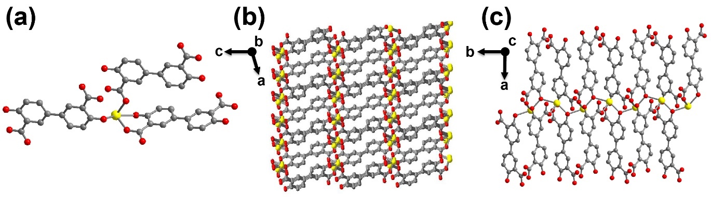

Supplementary Figure 1. (a) Coordination environment of Sn²⁺ ion in Sn₂(dobpdc). (b) 3D structure of Sn₂(dobpdc) along the b axis. (c) The 1D chain linked by hydroxyl groups along the c axis. The yellow, gray and red balls represent Sn, C and O atoms, respectively.

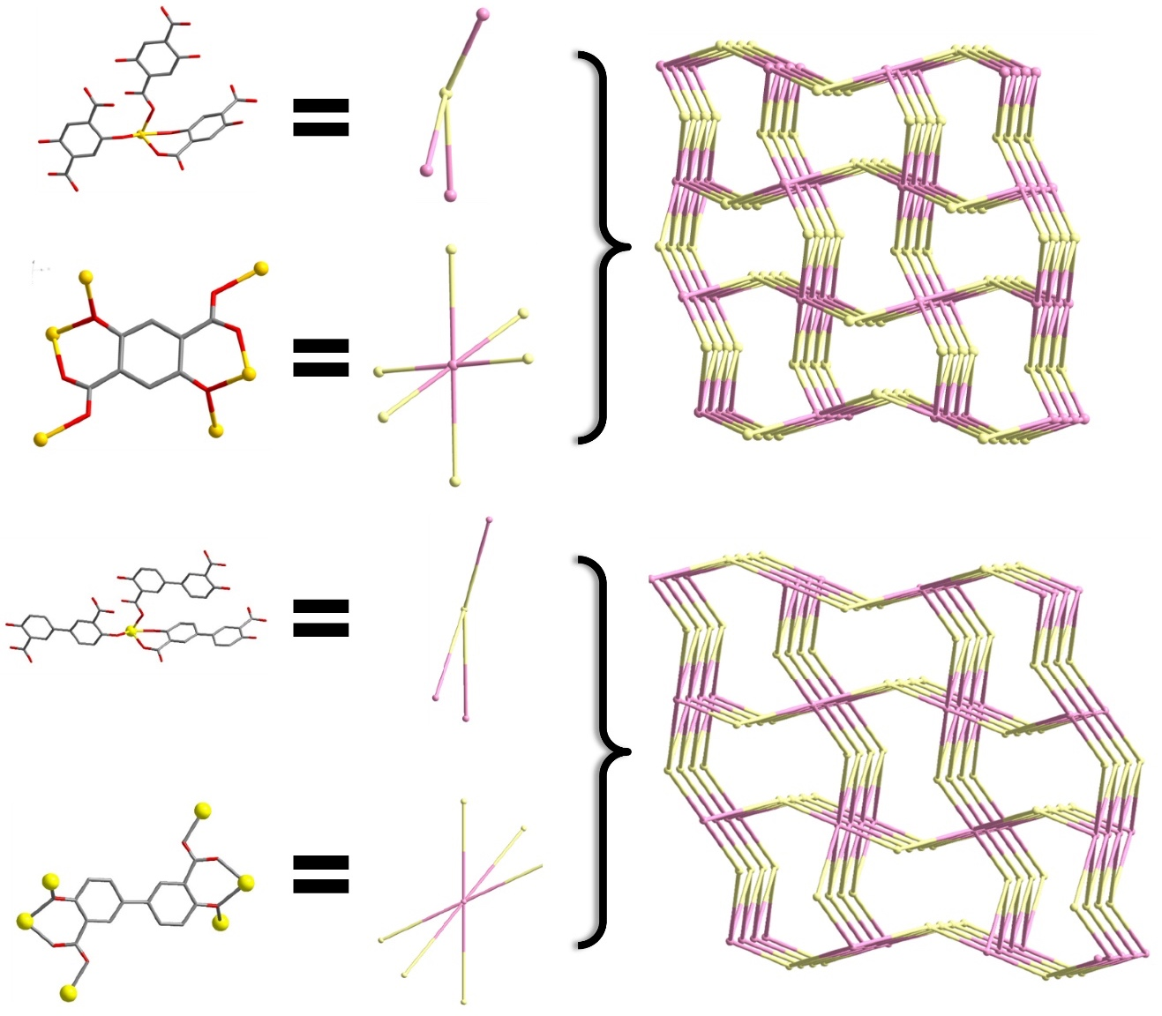
Supplementary Figure 2. Simplified topological structure of Sn₂(dobdc) and Sn₂(dobpdc). The framework can be viewed as a (3,6)-connected rtl net with the short (Schläﬂi) vertex symbol of {4·6^{^2}}₂{4^{^2}·6^{^10}·8^{^3}}.

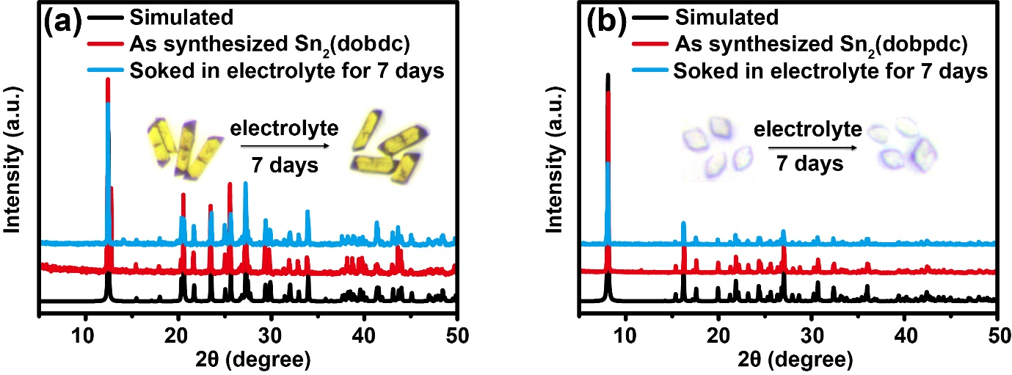
Supplementary Figure 3. PXRD patterns. Simulated and experimental PXRD patterns of Sn₂(dobdc) (a) and Sn₂(dobpdc) (b). Insert: the optical photographs of the crystals for electrolyte stability tests.

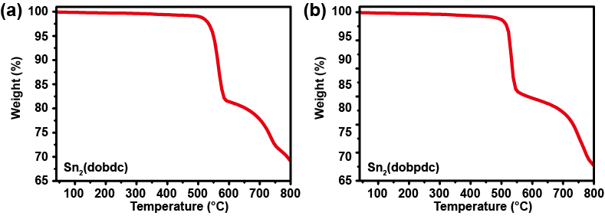
Supplementary Figure 4. TGA patterns. TGA curves of Sn₂(dobdc) (a) and Sn₂(dobpdc) (b).

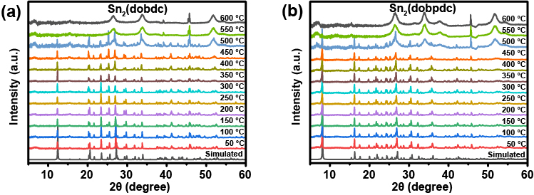
Supplementary Figure 5. PXRD patterns. The in situ variable-temperature PXRD patterns for Sn₂(dobdc) (a) and Sn₂(dobpdc) (b) measured on a Pt sample platform under N₂ atmosphere in the temperature ranges of 50-600 °C. The peaks observed at ca. 46.3 degree is from the Pt sample platform.

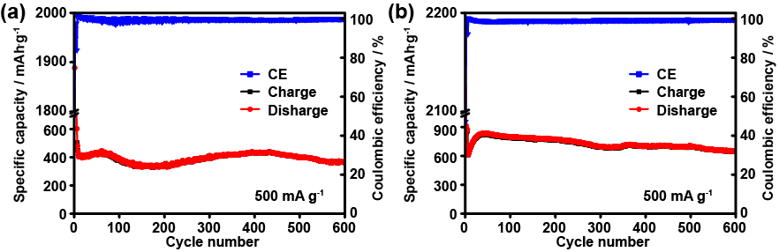
Supplementary Figure 6. Cycling performances of Sn₂(dobdc) (a) and Sn₂(dobpdc) (b) electrodes at 500 mA g⁻¹. The reversible capacities of Sn₂(dobdc) and Sn₂(dobpdc) electrodes can maintain at 400 and 650 mAh g⁻¹ after 600 cycles, respectively.

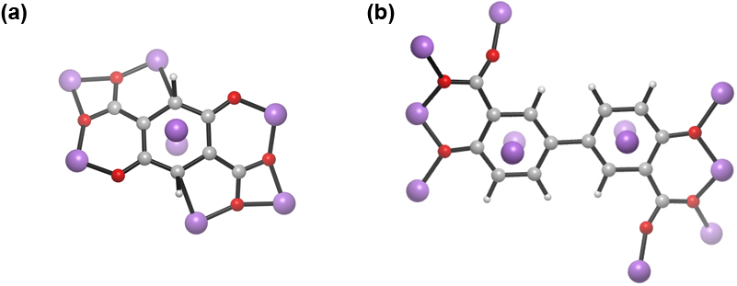
Supplementary Figure 7. Calculated lithium storage sites of the organic ligands of Sn₂(dobdc) (a) and Sn₂(dobpdc) (b).

Theoretical capacity calculation: take the case of Sn₂(dobdc), the structure unit of Sn₂(dobdc) can reversibly alloy 8.8 Li⁺ ions with 2.0 Sn and insert 8.0 Li⁺ ions with one organic ligand including the insertion to functional groups and the superlithiation of the aromatic ligand. Theoretical capacity is calculated by the equation: C_{theo} = nF/3.6M, where n is the number of electrons transferred, F is the Faraday constant, M is the relative molecular mass (g/mol).

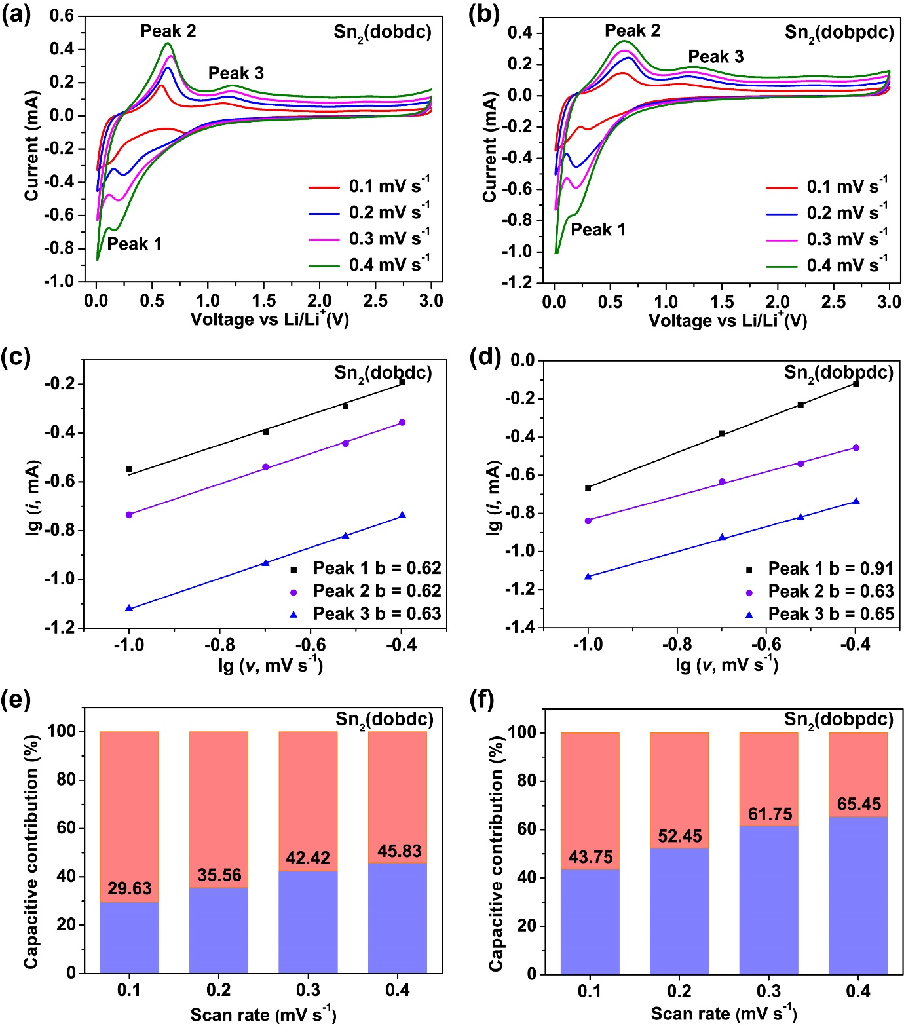
Supplementary Figure 8. Kinetics and quantitative analysis of Li⁺ storage mechanism. CV curves of Sn₂(dobdc) (a) and Sn₂(dobpdc) (b) electrodes at different scan rates. The corresponding plots of log (peak current) vs. log (scan rate) at each peak of Sn₂(dobdc) (c) and Sn₂(dobpdc) (d). The capacitive contributions of Sn₂(dobdc) (e) and Sn₂(dobpdc) (f) at different scan rates.

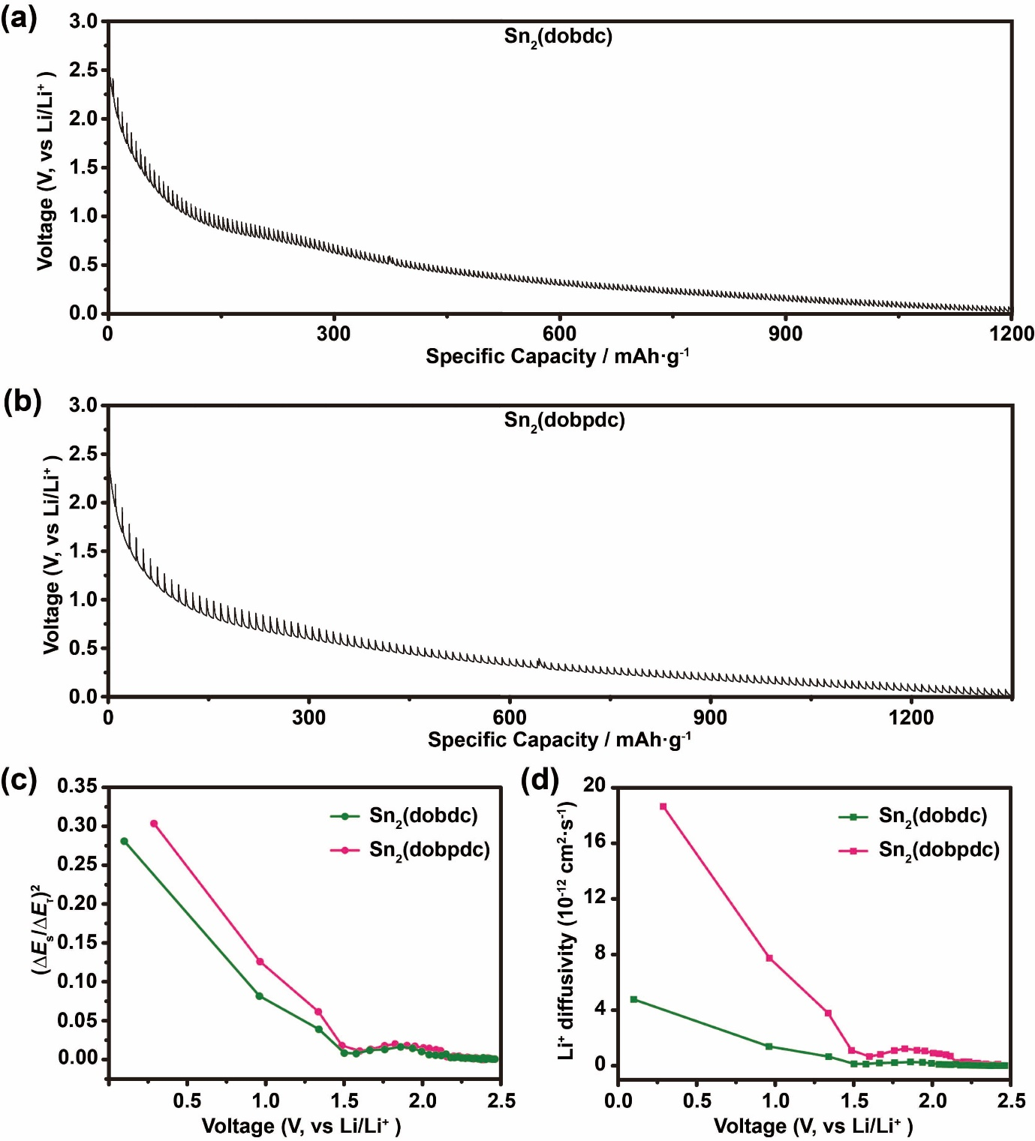
Supplementary Figure 9. The GITT results. (a, b) GITT curves for Sn₂(dobdc) and Sn₂(dobpdc). (c) The values of (∆E_{s}/∆E_{τ})². (d) Diffusion coefficients calculated from GITT versus state of discharge of Sn₂(dobdc) and Sn₂(dobpdc).

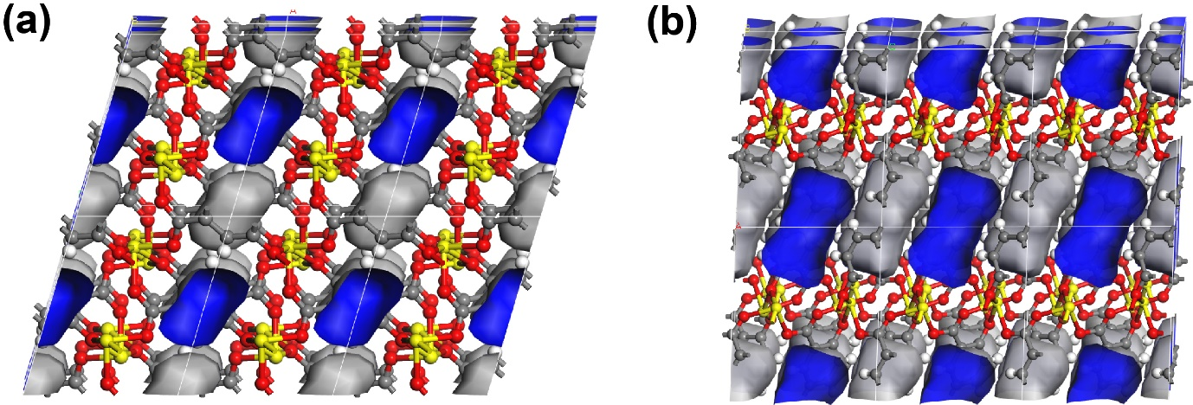
Supplementary Figure 10. Schematic diagrams of the pore surfaces of Sn₂(dobdc) (a) and Sn₂(dobpdc) (b) calculated by Material Studio. It is noteworthy that the void space (13.6%) for Sn₂(dobpdc) is significantly larger than that (5.2%) of Sn₂(dobdc), which is attributed to the expanded organic linker. Thus, the calculated surface area (89.75 m²/g) of Sn₂(dobpdc) is higher than that (51.56 m²/g) of Sn₂(dobdc), which is beneficial for facilitating mass/charge transport and interface interaction. For these two Sn-MOFs, the shortest distances of the slits are less than 2 Å, which are both inaccessible for the gases including N₂, CO₂, Ar for the experimental surface area measurement.

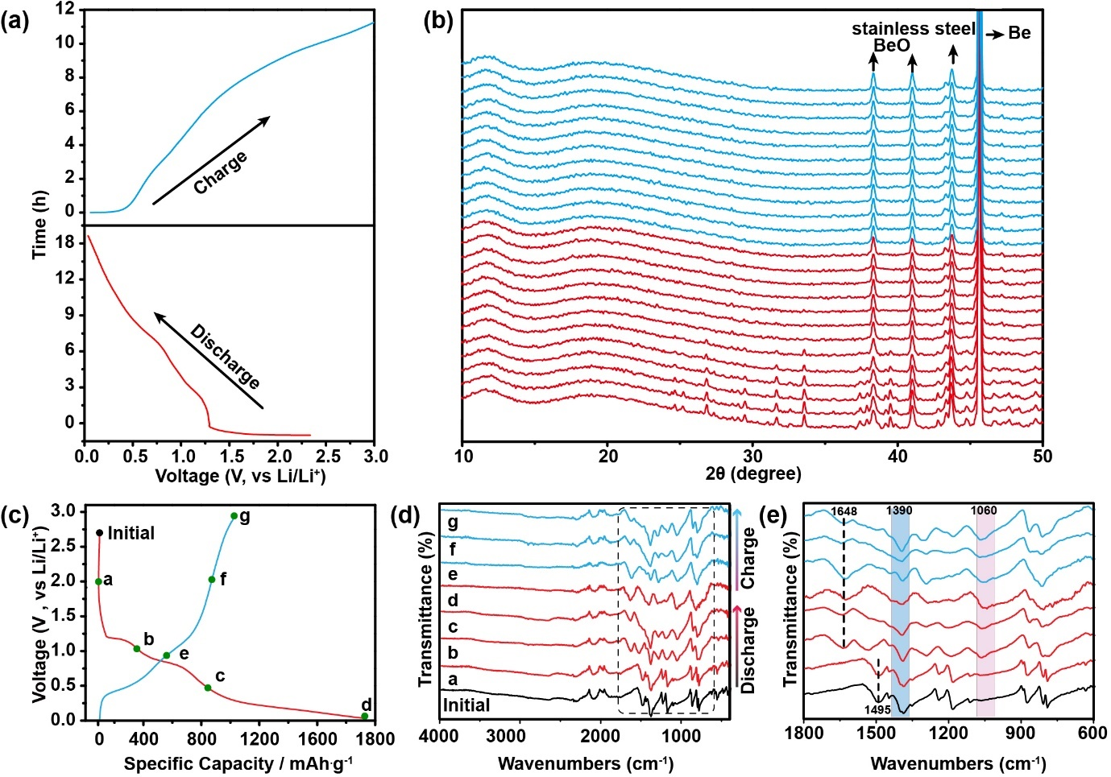
Supplementary Figure 11. In situ PXRD and ex situ FTIR analysis of Sn₂(dobdc) electrode. (a) Discharge-charge profile of Sn₂(dobdc) at 50 mA g⁻¹ in the first cycle. (b) In situ PXRD of Sn₂(dobdc) collected at different discharge-charge states corresponding to the process in S11a. (c) Discharge-charge profile of Sn₂(dobdc) at 100 mA g⁻¹ in the first cycle. (d) Ex situ FTIR spectra at selected states. (e) Magnification of FTIR spectra at the range from 600 to 1800 cm⁻¹.

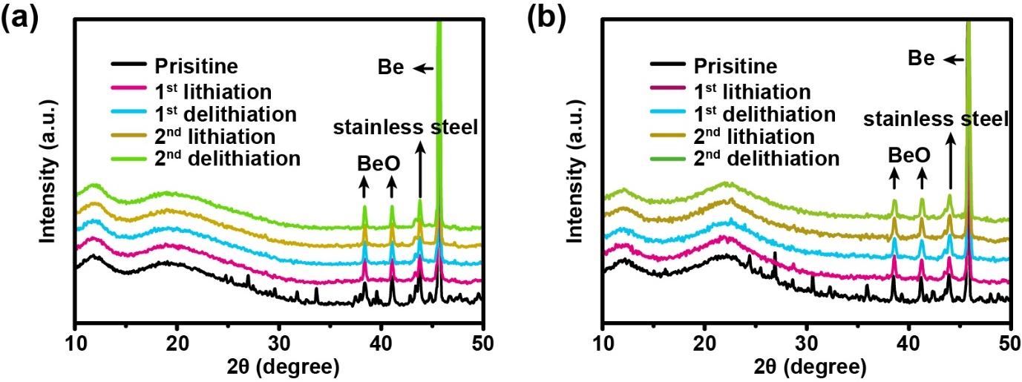
Supplementary Figure 12. Selected in situ PXRD patterns at the different states of Sn₂(dobdc) (a) and Sn₂(dobpdc) (b) electrodes during the first two cycles.

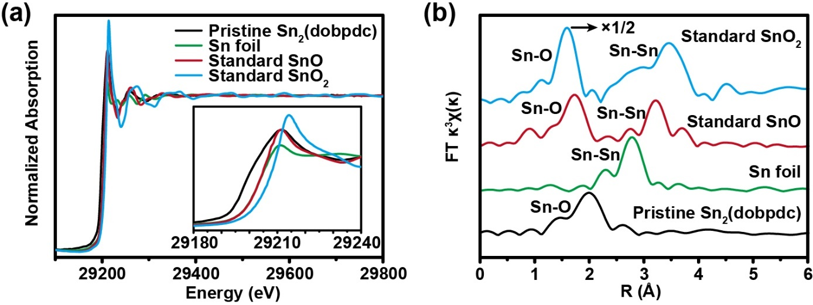
Supplementary Figure 13. XAFS results. (a) Synchrotron Sn K-edge XANES spectra of pristine Sn₂(dobpdc), Sn foil, standard SnO and SnO₂. Inset: enlarged spectra at Sn K-edge. (b) Sn K-edge k³-weighted FT-EXAFS spectra of pristine Sn₂(dobpdc), Sn metal, SnO and SnO₂ (the EXAFS intensity of SnO₂ is shown at half value).
As shown in Supplementary Figure13a, the XANES spectra of Sn foil, standard SnO and SnO₂ are much different from that of the pristine Sn₂(dobpdc), probably because of the formation of SnO₄ coordination environment in the Sn₂(dobpdc). However, the Sn²⁺ state in pristine Sn₂(dobpdc) can be clearly identified because the intensity of white line in Sn₂(dobpdc) is very close to that of main peak in SnO. The Fourier transformations (FT) of k³-weighted for EXAFS oscillations for the radial structure functions of pristine Sn₂(dobpdc), Sn foil, standard SnO and SnO₂ are demonstrated in Supplementary Figure 13b. The pristine Sn₂(dobpdc) exhibits the characteristic Sn-O coordination with intensive peak at around 2.13 Å, which coincides well with the lengths of Sn-O bonds obtained from the single crystal X-ray diffraction data (Supplementary Table 3). The absence of Sn-Sn bonds suggests that there were no metal Sn in pristine Sn₂(dobpdc) sample.

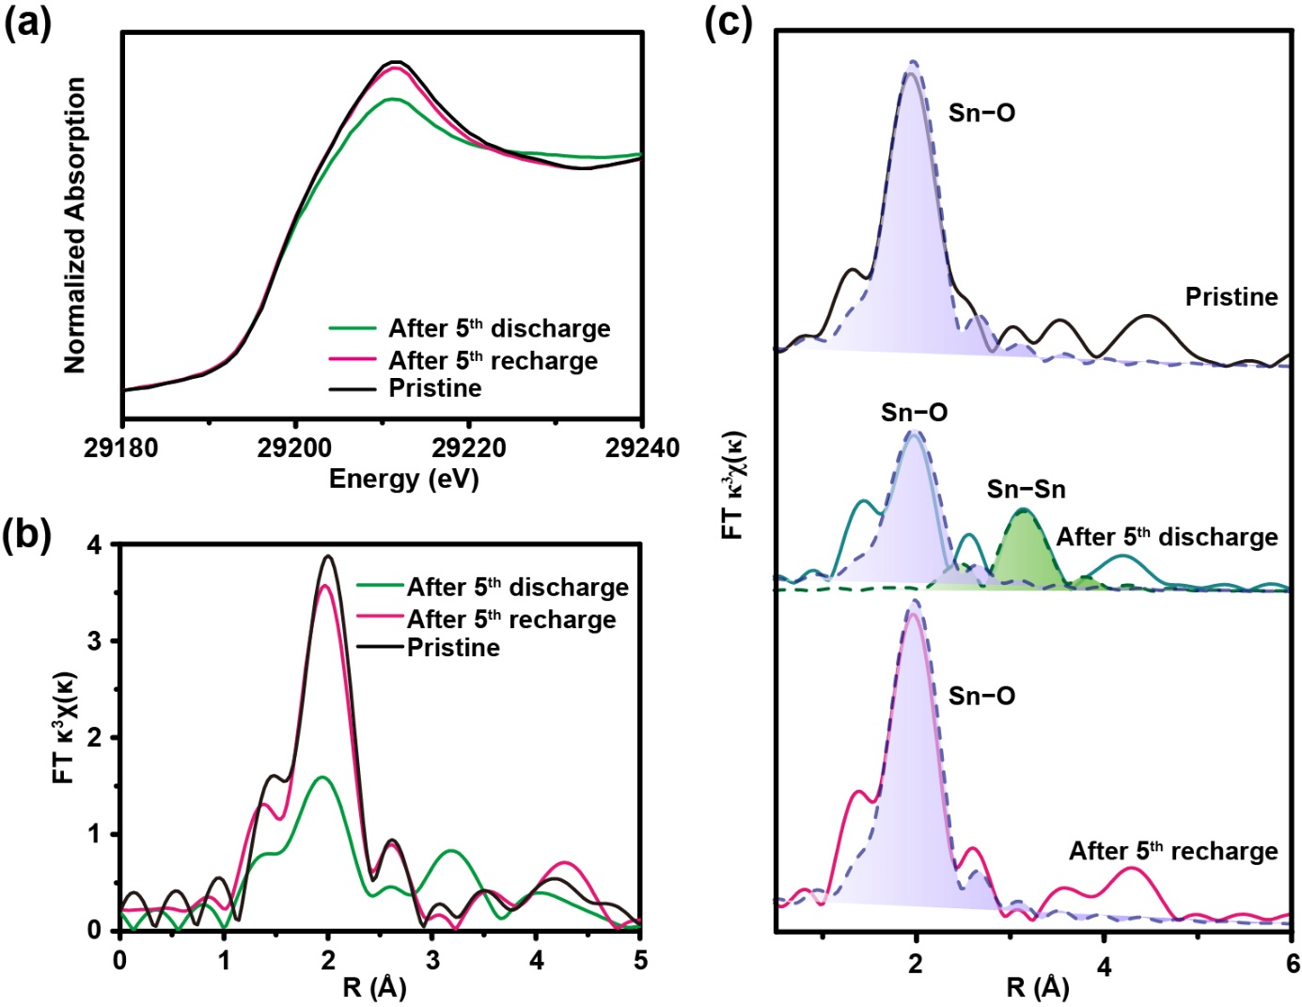
Supplementary Figure 14. (a) Synchrotron Sn K-edge XANES spectra of pristine Sn₂(dobpdc), after the fifth fully discharged, and after the fifth fully charged. (b) Sn K-edge k³-weighted FT-EXAFS spectra of pristine Sn₂(dobpdc), after the fifth fully discharged, and after the fifth fully charged. (c) Corresponding EXAFS fitting results of (b).

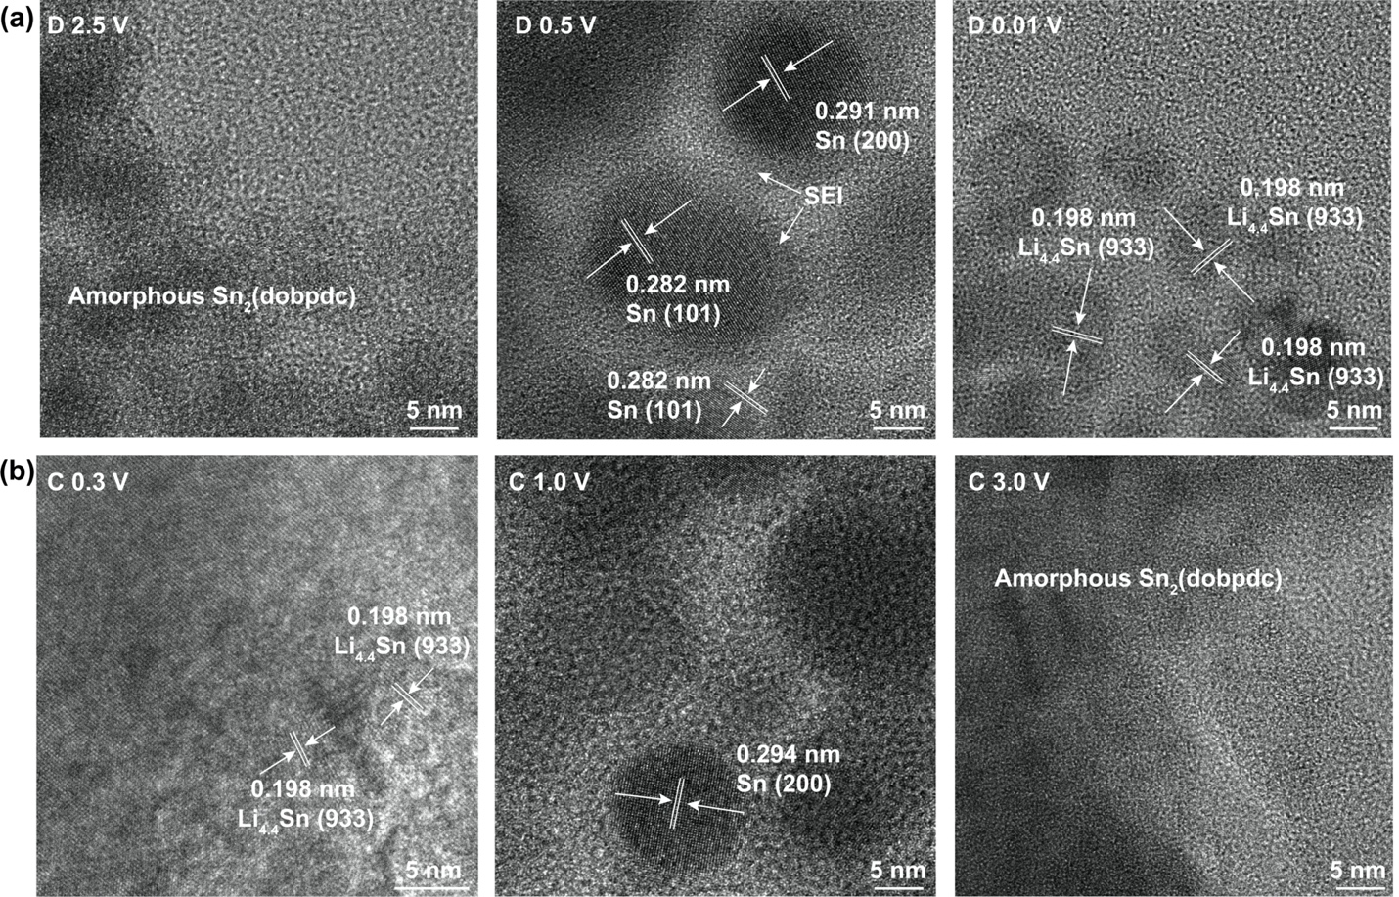
Supplementary Figure 15. Ex situ HRTEM images at different states during the second lithiation-delithiation cycle of Sn₂(dobpdc). (a) HRTEM images of Sn₂(dobpdc) in a pristine state, discharged to 0.7 V and discharged to 0.01 V. (b) HRTEM images of Sn₂(dobpdc) after being charged to 0.3 V, charged to 1.0 V and charged to 3.0 V.

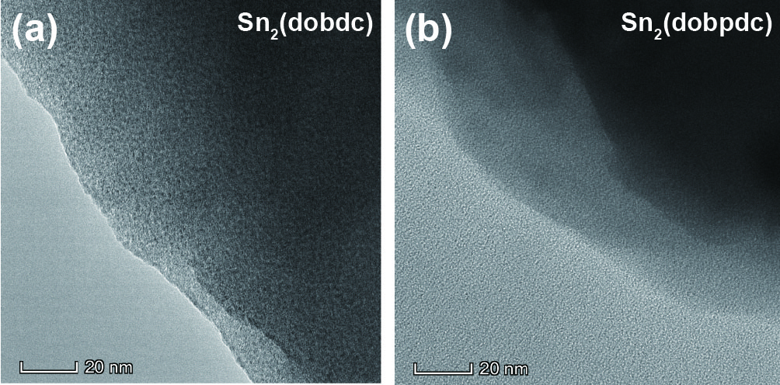
Supplementary Figure 16. HRTEM images of pristine Sn₂(dobdc) (a) and Sn₂(dobpdc) (b) powders.
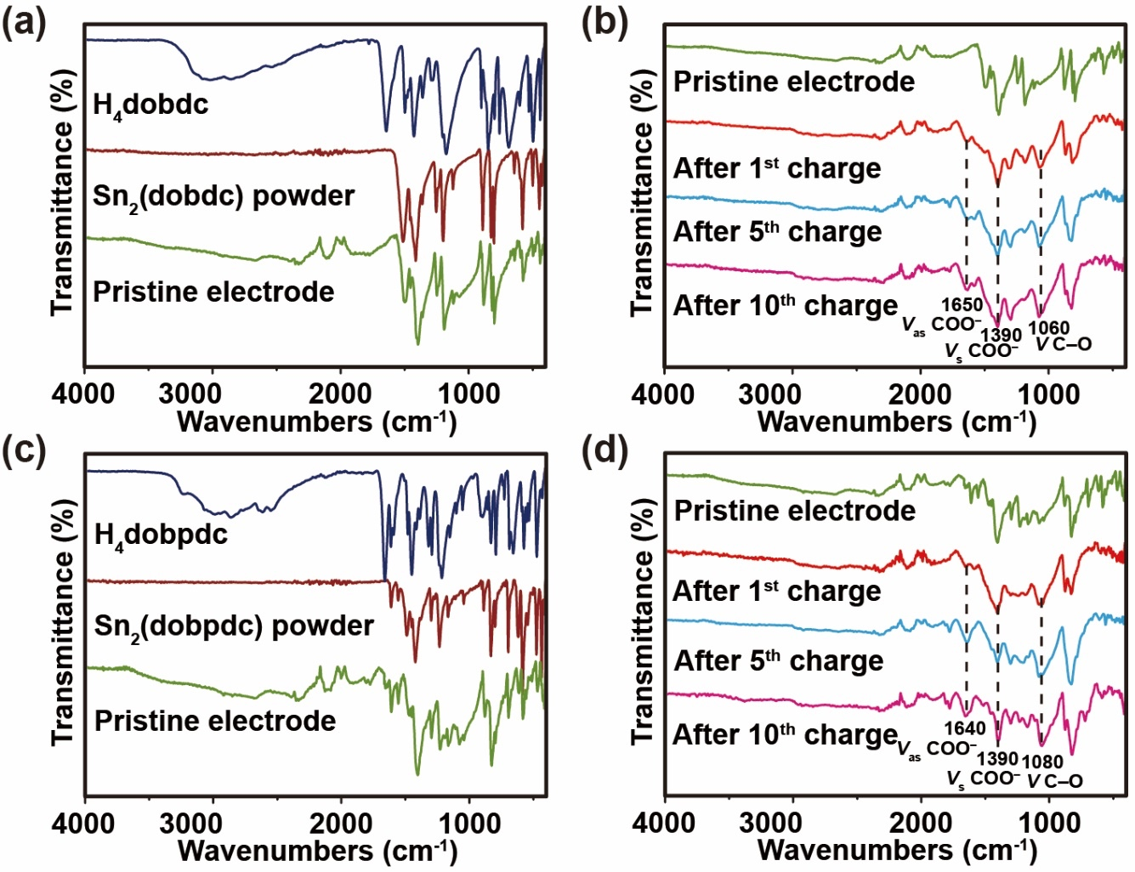
Supplementary Figure 17. FTIR spectra. Ex situ FTIR spectra of Sn₂(dobdc) at different states before (a) and after cycling (b). Ex situ FTIR spectra of Sn₂(dobpdc) before (c) and after cycling (d).
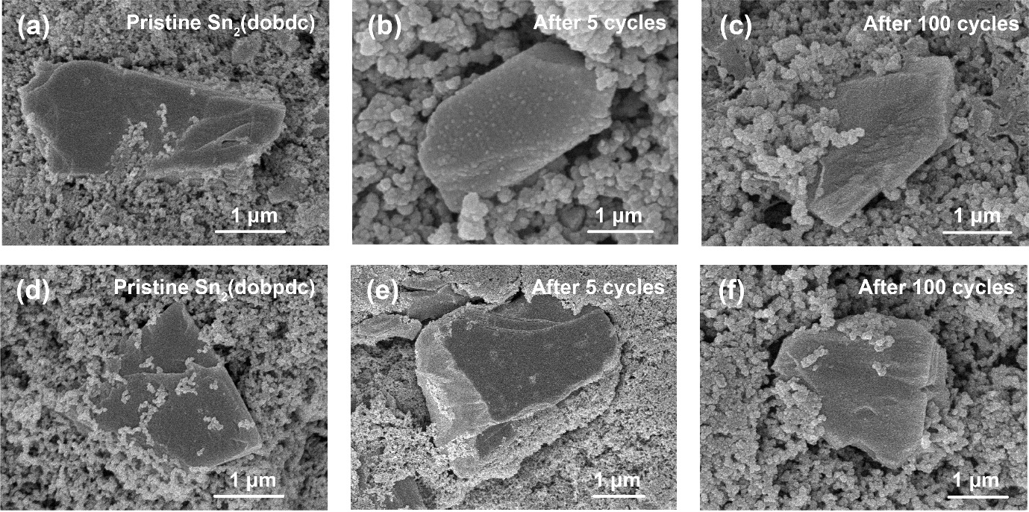
Supplementary Figure 18. Morphology characterizations. SEM images of Sn₂(dobdc) (a-c) and Sn₂(dobpdc) (d-f) collected at different states.

Supplementary Table 1. Comparison of recent MOFs as anodes for LIBs.
MOFs | RC (mAh g⁻¹) /  CR (mA g⁻¹) | Cycle number | Refs.
Sn₂(dobdc) | 731 / 200 | 200 | This work
Sn₂(dopbdc) | 1018 / 200 | 200 | This work
Mn-UMOFNs | 1187 / 100 | 100 | S1
Mn-BDC | 974 / 100 | 100 | S2
CoBTC-EtOH | 856 / 100 | 100 | S3
Mn-BTC | 694 / 100 | 100 | S4
NENU-507 | 640 / 100 | 100 | S5
[Co₃(L¹)(N₃)₄] | 580 / 100 | 200 | S6
[Co₄L²(N₃)(H₂O)₂] | 595 / 100 | 200 | S6
[Mn₄L²(N₃)₆(H₂O)₂] | 595 / 100 | 200 | S6
Ni-UMOFNs | 546 / 100 | 100 | S1
[Mn₂(L¹)(N₃)₂(H₂O)₂]·3H₂O | 358 / 100 | 200 | S6
[Cd(HTCPPA)·2H₂O]_{n} | 302 / 100 | 100 | S7
Cu₃(BTC)₂ | 474 / 383 | 50 | S8
Co₂(OH)₂BDC | 650 / 50 | 100 | S9
Ni-MOF | 620 / 100 | 100 | S10
Mn(3,5-PDC) 2H₂O | 554 / 100 | 240 | S11
Mn(2,5-FDC) 3H₂O | 436 / 100 | 206 | S11
[Co(C₈H₄O₄)₄]_{n} | 700 / 60 | 100 | S12
Zn₃(HCOO)₆ | 560 / 60 | 60 | S13
Co₃(HCOO)₆ | 410 / 60 | 60 | S13
NNU-11 | 750 / 50 | 200 | S14
Co-LCP | 545 / 50 | 50 | S15
Mn-LCP | 390 / 50 | 50 | S16
Ni-Me₄bpz | 120 / 50 | 100 | S17
RC: Reversible capacity. CR: Current Rate.

Supplementary Table 2. Crystal data and structural refinement parameters for Sn₂(dobdc) and Sn₂(dobpdc).
 | [Sn₂(dobdc)]_{n} | [Sn₂(dobpdc)]_{n}
Formula | C₄HO₃Sn | C₇H₃O₃Sn
Fw | 215.76 | 253.78
Temp, K | 120.00(10) | 120.00(10)
Crystal syst | Monoclinic | Monoclinic
Space group | P2₁/c | P2₁/c
a, Å | 7.4141(3) | 10.8951(3)
b, Å | 7.5679(2) | 7.5313(2)
c, Å | 9.1100(3) | 8.8733(3)
α, deg | 90 | 90
ß, deg | 106.603 | 92.329(3)
γ , deg | 90 | 90
V, Å³ | 489.84 | 727.49(4)
Z | 4 | 4
Dc, g/cm³ | 2.925 | 2.317
μ, mm⁻¹ | 5.107 | 3.458
Data/ parameter | 857 / 73 | 1277 / 100
obs reflns | 2814 | 4619
θ range, ° | 7.126 - 50.002 | 6.578 - 49.992
R_{int}/GOF on F² | 0.0418 / 1.021 | 0.0468 / 1.063
R₁, wR₂[I>2σ (I)] | 0.0232, 0.0407 | 0.0253, 0.0417
R₁, wR₂(all data) | 0.0329, 0.0447 | 0.0340, 0.0463
max/min, e Å⁻³ | 0.58 / -0.68 | 0.64 / -0.65

Supplementary Table 3. Selected bond lengths (Å) and angles (º) for Sn₂(dobdc) and Sn₂(dobpdc).
Sn₂(dobdc)
Sn1-O3¹ | 2.195(3) | O3¹-Sn1-O1 | 80.18(12)
Sn1-O2 | 2.183(3) | O3¹-Sn1-O1² | 78.00(12)
Sn1-O1² | 2.382(3) | O2-Sn1-O3¹ | 85.59(13)
Sn1-O1 | 2.222(3) | O2-Sn1-O1² | 72.67(12)
 |  | O2-Sn1-O1 | 77.00(12)
 |  | O1-Sn1-O1² | 143.65(7)
Symmetry transformations used to generate equivalent atoms: ¹+X, 3/2-Y, -1/2+Z; ²1-X, 1/2+Y, 1/2-Z; ³+X, 3/2-Y, 1/2+Z; ⁴1-X, -1/2+Y, 1/2-Z; ⁵2-X, 1-Y, 1-Z.

Sn₂(dobpdc)
Sn1-O3¹ | 2.181(3) | O3¹-Sn1-O1 | 81.59(11)
Sn1-O2 | 2.116(8) | O3¹-Sn1-O1² | 79.55(10)
Sn1-O1² | 2.104(6) | O2-Sn1-O3¹ | 83.28(10)
Sn1-O1 | 2.065(6) | O2-Sn1-O1² | 71.45(9)
 |  | O2-Sn1-O1 | 77.56(10)
 |  | O1-Sn1-O1² | 145.23(6)
Symmetry transformations used to generate equivalent atoms: ¹+X, 3/2-Y, -1/2+Z; ²1-X, 1/2+Y, 1/2-Z; ³+X, 3/2-Y, 1/2+Z; ⁴1-X, -1/2+Y, 1/2-Z; ⁵-X,1-Y,1-Z.

Supplementary Table 4. Cartesian coordinates of Li₈dobdc and Li₁₂dobpdc for DFT calculation.

Cartesian coordinates for Li₈dobdc
Element | Coordinates
Element | X | Y | Z
O | 3.726424 | 0.642739 | -0.275760
O | 3.221470 | -1.498581 | -0.535850
O | 1.553859 | 2.322339 | 0.518391
C | 2.801745 | -0.279485 | -0.226161
C | 0.572344 | -1.289576 | 0.365570
H | 0.986574 | -2.141050 | 0.917040
C | 0.854192 | 1.262153 | 0.343834
C | 1.450358 | -0.072227 | 0.132073
O | -3.726232 | -0.642573 | -0.275118
O | -3.221079 | 1.498458 | -0.536083
O | -1.553319 | -2.322564 | 0.516312
C | -2.801689 | 0.279541 | -0.225703
C | -0.571766 | 1.290659 | 0.363537
H | -0.986094 | 2.142178 | 0.914961
C | -0.853179 | -1.262169 | 0.342710
C | -1.449865 | 0.072574 | 0.132276
Li | -0.012742 | -0.000714 | 2.057254
Li | 0.001254 | 0.000401 | -1.458559
Li | 1.979344 | -2.798545 | -0.592796
Li | 4.939017 | -0.725681 | -0.724666
Li | 3.318525 | 2.345750 | 0.273871
Li | -3.317545 | -2.346947 | 0.270346
Li | -4.938512 | 0.726246 | -0.726475
Li | -1.976776 | 2.796661 | -0.597628

Cartesian coordinates for Li₁₂dobpdc
Element | Coordinates |  |  | Element | Coordinates
Element | X | Y | Z | Element | X | Y | Z
O | -4.03291 | -2.31359 | 0.23475 | H | 0.13111 | -2.38594 | 0.0588
O | -5.55591 | -0.76408 | -0.2938 | C | 0.70888 | -0.27231 | -0.01423
O | -4.64352 | 1.96555 | 0.17109 | Li | -5.16576 | 3.83152 | 0.20041
C | -4.32359 | -1.10101 | 0.00652 | Li | -6.83905 | -1.8848 | -1.166
C | -3.25277 | -0.07899 | 0.04194 | Li | -4.25966 | -3.99602 | 0.89521
C | -3.45999 | 1.38327 | 0.07717 | Li | 4.25864 | 3.99389 | -0.90035
C | -2.29117 | 2.18649 | 0.03403 | Li | 6.83421 | 1.89492 | 1.17198
H | -2.40942 | 3.26436 | 0.05628 | Li | 5.16276 | -3.83246 | -0.22732
C | -1.8479 | -0.56388 | 0.08046 | Li | -6.16543 | 0.87377 | 0.28646
H | -1.7434 | -1.63788 | 0.10716 | Li | -1.97473 | 0.94335 | 1.93406
C | -0.93925 | 1.6708 | -0.02928 | Li | 6.169 | -0.87739 | -0.25511
H | -0.13137 | 2.3859 | -0.06896 | Li | 1.9815 | -0.93278 | -1.93685
C | -0.70876 | 0.27233 | 0.01154 | Li | -2.17049 | 0.90793 | -1.86423
O | 4.03437 | 2.31286 | -0.2354 | Li | 2.16796 | -0.92024 | 1.86355
O | 5.55426 | 0.76479 | 0.30524
O | 4.64368 | -1.96578 | -0.17212
C | 4.32378 | 1.10082 | -0.00262
C | 3.25285 | 0.07874 | -0.04077
C | 3.46008 | -1.38331 | -0.07897
C | 2.29104 | -2.18655 | -0.04033
H | 2.40921 | -3.26437 | -0.06519
C | 1.84816 | 0.56395 | -0.07986
H | 1.74371 | 1.63803 | -0.10351
C | 0.93919 | -1.67086 | 0.02306

Supplementary Table 5. Calculated capacities and utilization efficiencies of Sn₂(dobdc) and Sn₂(dobpdc).
MOFs | Sn₂(dobdc) | Sn₂(dobpdc)
Theoretical number of Li uptake in organic ligand | 8 | 12
Theoretical number of Li uptake in metal center | 8.8 | 8.8
Theoretical Capacity (mAh g⁻¹) | 1044 | 1099
Reversible Capacity at 200 mA g⁻¹ (mAh g⁻¹) | 731 | 1018
Utilization Efficiency (%) | 70.0 | 92.6

Supplementary Table 6. Sn K-edge EXAFS fitting results (R: distance; CN: coordination number; σ²: Debye-Waller factor; ΔE₀: inner potential correction; D: discharge; C: charge) for Sn₂(dobpdc) electrode.
Sample | Sn-O |  | Sn-Sn |  | σ² (Å²) | ΔE₀ (eV)
Sample | R (Å) | CN | R (Å) | CN | σ² (Å²) | ΔE₀ (eV)
Pristine | 2.13±0.02 | 3.7±0.7 | ⎯ | ⎯ | 0.01(Sn-O)  0.015(Sn-Sn) | 11±1(Sn-O)  3±1(Sn-Sn)
D 1.5 V | 2.14±0.02 | 2.8±0.5 | ⎯ | ⎯ | 0.01(Sn-O)  0.015(Sn-Sn) | 11±1(Sn-O)  3±1(Sn-Sn)
D 0.01 V | ⎯ | ⎯ | 2.92±0.03 | 6.3±1.2 | 0.01(Sn-O)  0.015(Sn-Sn) | 11±1(Sn-O)  3±1(Sn-Sn)
C 0.6 V | ⎯ | ⎯ | 2.93±0.03 | 2.5±0.6 | 0.01(Sn-O)  0.015(Sn-Sn) | 11±1(Sn-O)  3±1(Sn-Sn)
C 3.0 V | 2.14±0.02 | 2.7±0.4 | ⎯ | ⎯ | 0.01(Sn-O)  0.015(Sn-Sn) | 11±1(Sn-O)  3±1(Sn-Sn)
5th full discharge | 2.15±0.02 | 1.8±0.3 | 2.95±0.02 | 3.1±0.8 | 0.01(Sn-O)  0.015(Sn-Sn) | 11±1(Sn-O)  3±1(Sn-Sn)
5th full charge | 2.15±0.02 | 3.5±0.6 | ⎯ | ⎯ | 0.01(Sn-O)  0.015(Sn-Sn) | 11±1(Sn-O)  3±1(Sn-Sn)

Supplementary Table 7. Selected Sn-based anodes and other typical anode materials for LIBs
Active materials | Structure or type | Preparation method | RC / CR | Cycle number | Refs.
Sn₂(dobdc) | Sn atoms anchored on organic ligands | One-step hydrothermal method | 731 / 200 | 200 | This work
Sn₂(dopbdc) | Sn atoms anchored on organic ligands | One-step hydrothermal method | 1018 / 200 | 200 | This work
3D Sn scaffold | Sn hollow spheres | Multistep  templating | 885 / 200 | 200 | S18
TiO₂-Sn@CNFs | Nano-Sn dispersed in carbon nanofibers  and TiO₂ pipes | Electrospinning and atomic layer deposition | 831 / 100 | 200 | S19
Co–Sn intermetallic  electrodes | Highly ordered mesoporous Co_{x}Sn_{y} framework | Nanoreplication method | 530 / 50 | 50 | S20
SnO₂-Fe-G nanocomposites | SnO₂-Fe aggregates binding on graphite nanosheets | Two-step ball milling | 1338 / 200 | 400 | S21
Sn@C nanoboxes | Sn nanoparticles encapsulated in hollow carbon nanobox | Sacrificial template method | 810 / 200 | 500 | S22
Polydopamine -coated SnO₂ | SnO₂ nanocrystals coated with polydopamine | Sacrificial template method | 921 /200 | 300 | S23
SnO₂@MOF/graphene composite. | SnO₂ nanoparticles packed into Al-MOF wrapped by graphene | Wet impregnation method and assembly process | 450 / 1000 | 1000 | S24
Porous hard carbons | Insertion type | Thermal annealing  method | 310 / 5000 | 10000 | S25
Fe₂O₃ microboxes | Conversion type | Thermal annealing  method | 950 / 200 | 30 | S26
Co₃O₄ | Conversion type | Hybrid assembly and chemical reduction approaches | 1000 / 74 | 130 | S27
RC: Reversible capacity (mAh g⁻¹). CR: Current Rate (mA g⁻¹)
Supplementary References:
S1 Li, C. et al. Ultrathin Manganese-Based Metal-Organic Framework Nanosheets: Low-Cost and Energy-Dense Lithium Storage Anodes with the Coexistence of Metal and Ligand Redox Activities. ACS Appl. Mater. Interfaces 9, 29829–29838 (2017).
S2 Hu, H. P. et al. A thermally activated manganese 1,4-benzenedicarboxylate metal organic framework with high anodic capability for Li-ion batteries. New J. Chem. 40, 9746–9752 (2016).
S3 Li, C. et al. High anodic performance of Co 1, 3, 5-benzenetricarboxylate coordination polymers for Li-ion battery. ACS Appl. Mater. Interfaces 8, 15352–15360 (2016).
S4 Maiti, S., Pramanik, A., Manju U., Mahanty, S. Reversible lithium ltorage in manganese 1,3,5-benzenetricarboxylate metal-organic gamework with high capacity and rate performance. ACS Appl. Mater. Interfaces 7, 16357–16363 (2016).
S5 Wang, Y. Y. et al. Diamondoid-structured polymolybdate-based metal–organic frameworks as high-capacity anodes for lithium-ion batteries. Chem. Commun. 53, 5204–5207 (2017).
S6 Gong, T., Lou, X., Gao, E., Hu, B. Pillared-layer metal–organic frameworks for improved lithium-ion dtorage performance. ACS Appl. Mater. Interfaces 9, 21839–21847 (2017).
S7 Lin, X. M. et al. Lithium-ion-battery anode materials with improved capacity from a metal-organic framework. Inorg. Chem. 55, 8244–8247 (2016).
S8 Maiti, S., Pramanik, A., Manju, U., Mahanty, S. Cu₃(1,3,5-benzenetricarboxylate)₂ metal-organic framework: a promising anode material for lithium-ioMn battery. Microporous Mesoporous Mater. 226, 353–359 (2016).
S9 Gou, L. et al. One-pot synthesis of a metal–organic framework as an anode for Li-ion batteries with improved capacity and cycling stability. J. Solid State Chem. 210, 121–124 (2014).
S10 Zhang, Y. et al. A nickel-based metal-organic framework: a novel optimized anode material for Li-ion batteries. Mater. Lett. 161, 712–715 (2015).
S11 Fei, H. L., Liu, X., Li, Z. W., Feng, W. J. Metal dicarboxylates: new anode materials for lithium-ion batteries with good cycling performance. Dalton Trans. 44, 9909-9914 (2015).
S12 Wang, L. P. et al. Metal organic framework derived cobalt dicarboxylate as a high capacity anode material for lithium-ion batteries. Energy Technol. 5, 634–642 (2017).
S13 Saravanan, K., Nagarathinam, M., Balaya P., Vittal, J. J. Lithium storage in a metal organic framework with diamondoid topology–a case study on metal formats. J. Mater. Chem. 20, 8329–8335 (2010).
S14 Huang, Q. et al. A highly stable polyoxometalate-based metal-organic framework with π-π stacking for enhancing lithium ion battery performance. J. Mater. Chem. A 5, 8477–8483 (2017).
S15 Shi, C. D. et al. Synthesis of cobalt-based layered coordination polymer nanosheets and their application in lithium-ion batteries as anode materials. RSC Adv. 6, 4442–4447 (2016).
S16 Liu, Q. et al. Manganese-based layered coordination polymer: synthesis, structural characterization, magnetic property, and electrochemical performance in lithium-ion batteries. Inorg. Chem. 52, 2817–2822 (2013).
S17 An, T. et al. A flexible ligand-based wavy layered metal–organic framework for lithium-ion storage. J. Colloid Interf. Sci. 445, 320–325 (2015).
S18 Liu, J. et al. High volumetric capacity three-dimensionally sphere-caged secondary battery anodes. Nano Lett. 16, 4501–4507 (2016).
S19 Mao, M. et al. Pipe-wire TiO₂-Sn@carbon nanofibers paper anodes for lithium and sodium ion batteries. Nano Lett. 17, 3830–3836 (2017).
S20 Park, G. O. et al. Discovering a dual-buffer effect for lithium storage: durable nanostructured ordered mesoporous Co-Sn intermetallic electrodes. Adv. Funct. Mater. 26, 2800–2808 (2016).
S21 Hu, R. et al. Stabilizing the nanostructure of SnO₂ anodes by transition metals: a route to achieve high initial coulombic efficiency and stable capacities for lithium storage. Adv. Mater. 29, 1605006 (2017).
S22 Zhang, H. et al. Tailored yolk-shell Sn@C nanoboxes for high-performance lithium storage. Adv. Funct. Mater. 27, 1606023 (2017).
S23 Jiang, B. et al. Polymer-templated formation of polydopamine-coated SnO₂ nanocrystals: anodes for cyclable lithium-ion batteries. Angew. Chem. Int. Ed. 56, 1869–1872 (2017).
S24 Gao, C. et al. Optimized assembling of MOF/SnO₂/Graphene leads to superior anode for lithium ion batteries. Nano Energy 74, 104868 (2020).
S25 Lv, W. et al. Peanut shell derived hard carbon as ultralong cycling anodes for lithium and sodium batteries. Electrochim. Acta 176, 533–541 (2015).
S26 Zhang, L. et al. Formation of Fe₂O₃ microboxes with hierarchical shell structures from metal-organic frameworks and their lithium storage properties. J. Am. Chem. Soc. 134, 17388–17391 (2012).
S27 Yang, S., Feng, X., Ivanovici, S., Mullen, K. Fabrication of graphene-encapsulated oxide nanoparticles: towards high-performance anode materials for lithium storage. Angew. Chem. Int. Ed. 49, 8408–8411 (2010).

