Supplemental Material

Table S1 Breakpoints for the selected pollutants.
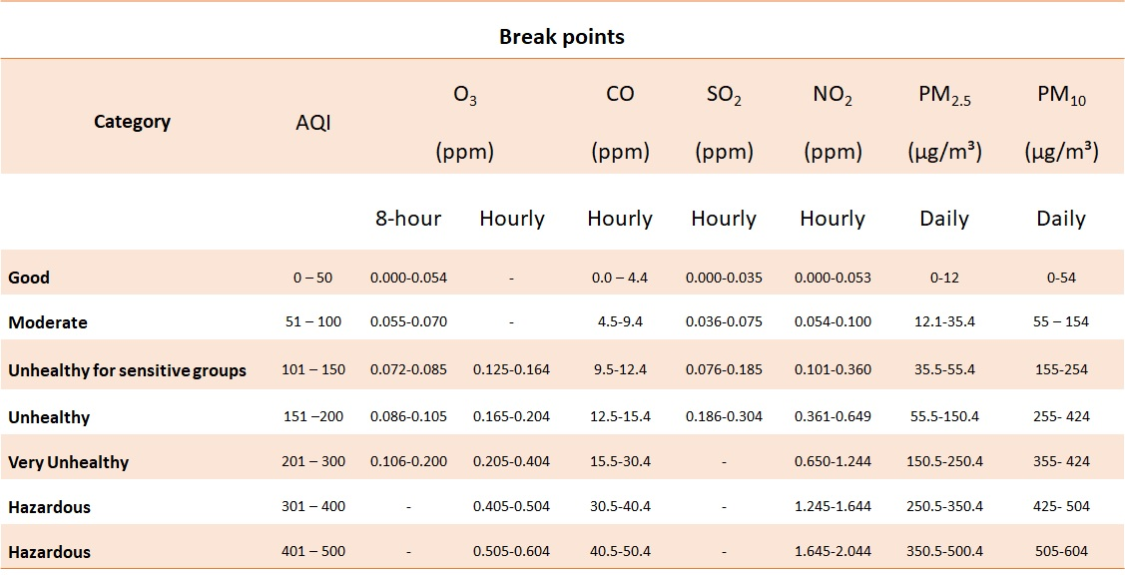

Table S2 Degree of similarity or discrepancy in the concentrations of air pollutants among the selected residential, traffic, and work sites during the selected study periods.

Period | Pollutant |  | Residential site (M-station)  Concentration | Traffic site  (F-station)  Concentration | Work site  (K-station)  Concentration | Residential and work  CD | Residential and traffic  CD | Traffic and work  CD
Lockdown period | CO | Mean | 0.20 | 0.33 | 0.18 | 0.50 | 0.20 | 0.61
Lockdown period | CO | Max | 1.55 | 3.25 | 0.81 | 0.50 | 0.20 | 0.61
Lockdown period | CO | Min | 0.01 | 0.01 | 0.09 | 0.50 | 0.20 | 0.61
Lockdown period | NO | Mean | 1.66 | 13.87 | 5.08 | 0.36 | 0.46 | 0.49
Lockdown period | NO | Max | 51.20 | 275.40 | 63.90 | 0.36 | 0.46 | 0.49
Lockdown period | NO | Min | 0.10 | 0.10 | 0.05 | 0.36 | 0.46 | 0.49
Lockdown period | NO₂ | Mean | 13.19 | 18.68 | 11.20 | 0.53 | 0.33 | 0.46
Lockdown period | NO₂ | Max | 62.10 | 77.20 | 92.75 | 0.53 | 0.33 | 0.46
Lockdown period | NO₂ | Min | 1.80 | 0.70 | 0.10 | 0.53 | 0.33 | 0.46
Lockdown period | NO_{x} | Mean | 14.55 | 30.69 | 23.58 | 0.53 | 0.39 | 0.48
Lockdown period | NO_{x} | Max | 110.40 | 331.10 | 119.00 | 0.53 | 0.39 | 0.48
Lockdown period | NO_{x} | Min | 1.70 | 0.50 | 0.10 | 0.53 | 0.39 | 0.48
Lockdown period | SO₂ | Mean | 2.11 |  | 2.53 | 0.57 | - | -
Lockdown period | SO₂ | Max | 16.43 | - | 30.50 | 0.57 | - | -
Lockdown period | SO₂ | Min | 0.01 |  | 0.30 | 0.57 | - | -
Lockdown period | PM₁₀ | Mean | 179.49 | 173.80 | 155.73 | 0.32 | 0.26 | 0.33
Lockdown period | PM₁₀ | Max | 1185.59 | 1099.35 | 1292.80 | 0.32 | 0.26 | 0.33
Lockdown period | PM₁₀ | Min | 44.54 | 47.95 | 13.33 | 0.32 | 0.26 | 0.33
Lockdown period | PM_{2.5} | Mean | 52.42 | 49.07 | 60.98 | 0.04 | 0.27 | 0.09
Lockdown period | PM_{2.5} | Max | 306.50 | 267.03 | 309.05 | 0.04 | 0.27 | 0.09
Lockdown period | PM_{2.5} | Min | 12.40 | 15.01 | 12.48 | 0.04 | 0.27 | 0.09
Unrestricted periods | CO | Mean | 0.33 | 0.67 | 0.26 | 0.40 | 0.21 | 0.56
Unrestricted periods | CO | Max | 1.21 | 3.12 | 0.89 | 0.40 | 0.21 | 0.56
Unrestricted periods | CO | Min | 0.02 | 0.02 | 0.10 | 0.40 | 0.21 | 0.56
Unrestricted periods | NO | Mean | 4.75 | 32.01 | 7.08 | 0.12 | 0.43 | 0.49
Unrestricted periods | NO | Max | 81.50 | 310.90 | 90.15 | 0.12 | 0.43 | 0.49
Unrestricted periods | NO | Min | 0.10 | 0.10 | 0.10 | 0.12 | 0.43 | 0.49
Unrestricted periods | NO₂ | Mean | 24.48 | 29.92 | 20.31 | 0.56 | 0.17 | 0.57
Unrestricted periods | NO₂ | Max | 69.90 | 73.50 | 60.65 | 0.56 | 0.17 | 0.57
Unrestricted periods | NO₂ | Min | 6.70 | 7.00 | 0.15 | 0.56 | 0.17 | 0.57
Unrestricted periods | NO_{x} | Mean | 29.10 | 61.67 | 27.30 | 0.56 | 0.23 | 0.66
Unrestricted periods | NO_{x} | Max | 143.50 | 358.10 | 133.45 | 0.56 | 0.23 | 0.66
Unrestricted periods | NO_{x} | Min | 6.90 | 8.20 | 0.10 | 0.56 | 0.23 | 0.66
Unrestricted periods | SO₂ | Mean | 1.54 | - | 2.70 | 0.60 | - | -
Unrestricted periods | SO₂ | Max | 9.58 | - | 33.85 | 0.60 | - | -
Unrestricted periods | SO₂ | Min | 0.06 | - | 0.65 | 0.60 | - | -
Unrestricted periods | PM₁₀ | Mean | 235.29 | 206.97 | 144.80 | 0.27 | 0.32 | 0.22
Unrestricted periods | PM₁₀ | Max | 960.08 | 542.20 | 414.35 | 0.27 | 0.32 | 0.22
Unrestricted periods | PM₁₀ | Min | 65.55 | 40.01 | 74.50 | 0.27 | 0.32 | 0.22
Unrestricted periods | PM_{2.5} | Mean | 60.09 | 57.71 | 33.62 | 0.24 | 0.34 | 0.33
Unrestricted periods | PM_{2.5} | Max | 166.48 | 159.97 | 90.90 | 0.24 | 0.34 | 0.33
Unrestricted periods | PM_{2.5} | Min | 17.75 | 6.11 | 15.22 | 0.24 | 0.34 | 0.33

Table S3 GAMEP and USEPA air pollutant standards.

Pollutant | GAMEP Std. | USEPA Std. | Averaging Time
Nitrogen Dioxide (NO₂) | 0.35 ppm | 0.1 ppm | 1 h
Nitrogen Dioxide (NO₂) | 0.05 ppm | 0.053 ppm | Annual
Ozone (O₃) | 0.12 ppm | 0.12 ppm | 1 h
Ozone (O₃) | 0.08 ppm | 0.075 ppm | 8 h
Particulate Matter (PM₁₀) | 340 µg/m³ | 150 µg/m³ | 24 h
Particulate Matter (PM₁₀) | 80 µg/m³ | --- | Annual
Particulate Matter (PM_{2.5}) | 35 µg/m³ | 35 µg/m³ | 2 h
Particulate Matter (PM_{2.5}) | 15 µg/m³ | 15 µg/m³ | Annual
Sulfur Dioxide (SO₂) | 0.28 ppm | 0.075 ppm | 1 h
Sulfur Dioxide (SO₂) | 0.14 ppm | 0.14 ppm | 24 h
Sulfur Dioxide (SO₂) | 0.03 ppm | 0.03 ppm | Annual
Carbon Monoxide (CO) | 32 ppm | 35 ppm | 1 h
Carbon Monoxide (CO) | 8.1 ppm | 9 ppm | 8 h

