Supplementary Figures
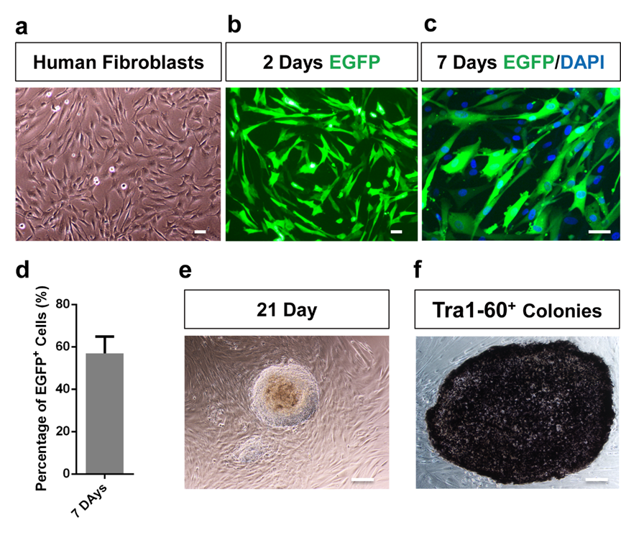
Supplementary data Fig.1 | Characterization of human fibroblast reprogramming system.
a, Cultured primary human fibroblasts, scale bar, 100 µm. b, EGFP expression in human fibroblasts at 2 days after transfected with EGFP plasmid, scale bar, 100 µm. c, EGFP expression in fibroblasts colocalized with DAPI at 7 days after transfection with EGFP vector, scale bar, 100 µm. d, Percentage of EGFP positive cells at 7 days after transfection. e, hiPSC colonies after culture for 21 days, scale bar, 200 µm. f, TRA-1-60 positive colonies after culture for 21 days, scale bar, 200 µm.

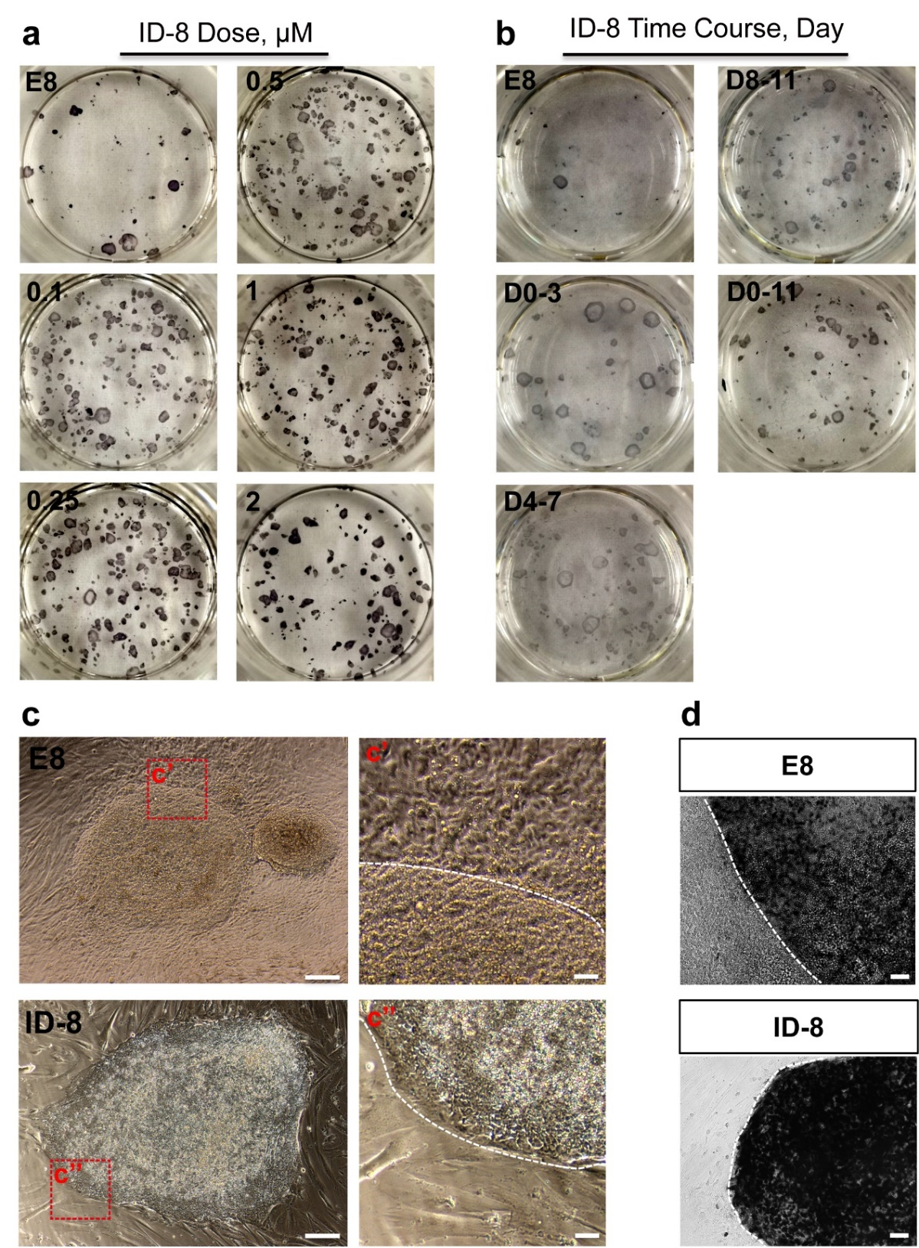
Supplementary data Fig.2 | Dose and time-course treatment of ID-8 in human somatic cell reprogramming.
a, Representative images of TRA-1-60 positive colonies with different ID-8 doses. b, Representative images of TRA-1-60 positive colonies at 500 nM concentration of ID-8 in different stages. c, Left: iPSC colonies of E8 control and ID-8 treatment group, right: c’ the enlarged image of red box in colonies of E8 control indicated that have much intermediated stage cells around the colonies, c’’ represent clear edge of colonies in ID-8 group, scale bar, left: 200 µm, right: 50 µm. d, TRA-1-60 positive colonies of E8 control and ID-8 treatment group, scale bar, 50 µm.

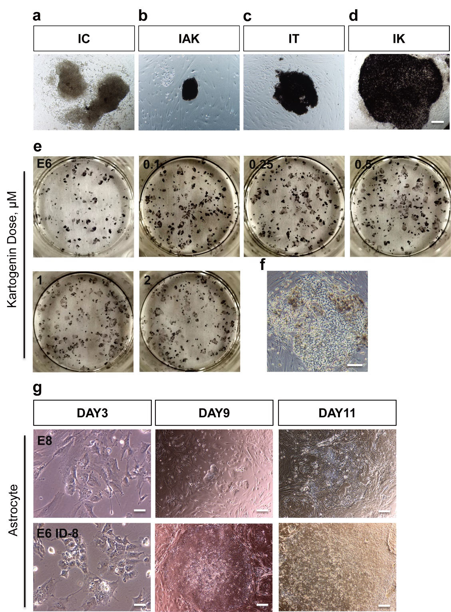
Supplementary data Fig.3 | Testing compounds for the expansion of pluripotent stem cells at reprogramming stage and ID-8 reprogramming in human astrocytes.
a-d, Primary screening of different compounds for the expansion of pluripotent stem cells at reprogramming stage, I (ID-8, 500 nM), AK (1-azakenpaullone, 500 nM), T (Tacrolimus, 20 pM), K (Kartogenin, 500 nM), scale bar, 100 µm. e, representative images of TRA-1-60 positive colonies with different kartogenin concentration treatment in combined with ID-8 for day 7 to day 21. f, iPSC colonies in the condition of 2 µM Kartogenin treatment showed differentiated cells, scale bar, 100 µm. g, Representative images showed different stages of human astrocyte reprogramming into iPSCs, scale bar, left: 50 µm, center and right: 200 µm.

Supplementary data Fig.4 | Testing small molecule treatment for maintaining pluripotent stem cells.
a, Primary screening of different chemicals for maintaining pluripotent stem cells, including SB20 (SB203580, 1 μM), Go (Go6983, 1 μM), SP (SP600125, 5 mΜ), Dora (Doramapimod, 2 μM), T (Tacrolimus, 20 pM), AK (1-azakenpaullone, 500 nM), scale bar, 100 µm. b-c, Dorsal cortical organoid slice staining showed SOX2/MAP2 and PAX6/TUJ1 positive neuronal progenitors. d, Ventral organoid slice showed NKX2.1/TUJ1 positive neuronal progenitor cells. Scale bar, b and c: 50 µm, d: 100 µm.

Supplementary data Fig.5 | Testing small molecules TZDs, DCA and 2-DG in fibroblast reprogramming.
a, Representative images of TRA-1-60 positive colonies with different Thiazolidinediones (TZDs) concentration treatment. b, Statistical results of different TZDs dose treatment. c, Representative images of TRA-1-60 positive colonies with different Sodium dichloroacetate (DCA) concentration treatment. d, Statistical results of different DCA dose treatment. e, Representative images of TRA-1-60 positive colonies in small molecule 2-Deoxy-D-glucose (2-DG) treated fibroblast cells.

