Supplementary Materials
Methods of the Meta-analysis
Search Strategy
A comprehensive literature search was conducted across the following databases from inception to May 2025: PubMed, Embase, Cochrane Library, Web of Science, CNKI, and Wanfang Data. The search strategy was constructed using the PECOS framework:
P (Population): Critically ill patients aged ≥18 years admitted to the intensive care unit (ICU) and receiving renal replacement therapy (RRT);
E (Exposure): All clinical, vital sign, laboratory, or treatment-related risk factors associated with hypotension during RRT;
C (Comparator): Patients undergoing RRT who did not develop hypotension;
O (Outcome): Occurrence of hypotension during RRT, as defined by each original study (e.g., MAP decline, need for intervention);
S (Study Design): Observational studies, including prospective and retrospective cohort studies as well as case-control studies, that reported on risk factors for RRT-related hypotension and provided effect estimates or data suitable for calculation.
Inclusion Criteria
Studies were included if they met the following criteria:
- Adult patients (≥18 years old) admitted to the ICU;
- Undergoing any form of RRT, including continuous renal replacement therapy (CRRT), intermittent hemodialysis (IHD), or sustained low-efficiency dialysis (SLED);
- Explicitly reported the occurrence of hypotension during RRT;
- Provided effect estimates (e.g., odds ratio [OR], relative risk [RR], hazard ratio [HR]) or raw data sufficient for calculating such estimates regarding risk factors for RRT-associated hypotension;
Study design was observational or a randomized controlled trial.
Exclusion Criteria
Studies were excluded if they met any of the following:
- Case reports, narrative reviews, theoretical papers, or studies lacking sufficient data for effect estimation;
- Narrative reviews, expert opinions, commentaries, or conference abstracts;
- Animal studies, or studies involving pediatric or obstetric populations;
- Studies exclusively including chronic maintenance hemodialysis patients;
Studies with incomparable or non-standardized definitions of exposures or interventions that were not suitable for pooled analysis.
Study Selection and Screening
Reference management software (EndNote) was used to manage, screen, and remove duplicate records. After duplicates were excluded, two independent reviewers screened the titles of all retrieved articles to eliminate case reports, reviews, conference papers, protocols, and correspondences. Next, abstracts were reviewed to confirm eligibility based on inclusion and exclusion criteria. Finally, the full texts of the remaining articles were read to determine final inclusion. Throughout the screening process, two reviewers independently assessed the studies. Any disagreements regarding study inclusion were resolved through discussion and consensus. If consensus could not be reached, a third reviewer was consulted to make the final decision.
Data Extraction
A standardized eight-item data extraction form was used to collect relevant information from each included study under the following categories: 1) First author, 2) Year of publication, 3) Country, 4) Sample size, 5) Study population characteristics ,6) Definition of hypotension, 7) Reported risk factors for hypotension, 8) Raw data available for effect size calculation.
Quality Assessment of Included Studies
The quality of the included studies was evaluated by two independent researchers. To ensure consistency and reliability, cross-validation was used, and any disputes were resolved with the involvement of a third researcher. All assessors had backgrounds in epidemiology and statistics, ensuring the effectiveness of the evaluation process. All studies were evaluated using the Newcastle-Ottawa Scale (NOS). The NOS evaluates the quality of non-randomized studies based on three broad perspectives: the selection of the study groups (0-4 points), the comparability of the groups (0-2 points), and the ascertainment of either the exposure or outcome of interest (0-3 points). A study can be awarded a maximum of one star for each numbered item within the Selection and Exposure categories, and a maximum of two stars can be given for Comparability. The total NOS score ranges from 0 to 9 points, with scores of ≤ 4 indicating low-quality studies, 5-6 indicating medium-quality studies, and ≥ 7 indicating high quality studies.
Statistical Analysis
Meta-analyses were conducted using Stata software (version 15.1). The metan command was used to construct forest plots, providing a visual representation of the association strength between each risk factor and RRT-related hypotension, along with their 95% CIs. R software was also employed for forest plot summarization and visualization. Heterogeneity across studies was assessed quantitatively using the I² statistic. When I² < 50%, a fixed-effects model was applied. When substantial heterogeneity was detected (I² ≥ 50%), a random-effects model was used to perform the pooled analysis.

Supplementary Table S1.
A detailed search strategy for PubMed is provided as an example.
Search | PUBMED
#1 | Renal Replacement Therapy[MeSH Terms]
#2 | (((((((((((Renal Replacement Therapy[Title/Abstract]) OR (Replacement Therapy, Kidney[Title/Abstract])) OR (Kidney Replacement Therapies[Title/Abstract])) OR (Replacement Therapies, Kidney[Title/Abstract])) OR (Therapies, Kidney Replacement[Title/Abstract])) OR (Therapy, Kidney Replacement[Title/Abstract])) OR (Kidney Replacement Therapy[Title/Abstract])) OR (Replacement Therapy, Renal[Title/Abstract])) OR (Renal Replacement Therapies[Title/Abstract])) OR (Replacement Therapies, Renal[Title/Abstract])) OR (Therapies, Renal Replacement[Title/Abstract])) OR (Therapy, Renal Replacement[Title/Abstract])
#3 | （#1） OR （#2）
#4 | (Critical Care[MeSH Terms]) OR (Intensive Care Units[MeSH Terms])
#5 | ((((((((Critical Care[Title/Abstract]) OR (Care, Critical[Title/Abstract])) OR (Intensive Care[Title/Abstract])) OR (Care, Intensive[Title/Abstract])) OR (Intensive Care Units[Title/Abstract])) OR (Intensive Care Unit[Title/Abstract])) OR (Unit, Intensive Care[Title/Abstract])) OR (ICU Intensive Care Units[Title/Abstract])
#6 | （#4） OR（#5）
#7 | Hypotension[MeSH Terms]
#8 | (((((Hypotension[Title/Abstract])) OR (Blood Pressure, Low[Title/Abstract])) OR (Hypotension, Vascular[Title/Abstract])) OR (Low Blood Pressure[Title/Abstract])) OR (Vascular Hypotension[Title/Abstract])
#9 | (#7) OR (#8)
#10 | ((#3) AND (#6)) AND (#9)

Supplementary Table S2.
Characteristics and quality assessment of studies included in the meta-analysis.
Author | Country | Year | Sample size | Participants | Definition of Hypotension | Risk Factors | Quality of Evidence
Bitker (2016) [1] | France | 2016 | 47 | Critically ill adults with AKI requiring IHD | MAP ＜ 65 mm Hg. | ⑨⑫⑱㉗ | 9
Kelly (2021) [2] | USA | 2021 | 786 | Critically ill adults with AKI requiring RRT | VIS ≥ 18. | ㉘㉙㉚㉟ | 9
Chazot (2021) [3] | France | 2021 | 42 | Critically ill adults with KDIGO stage 3 AKI, initiated on CRRT (<24 h) | MAP ＜ 65 mmHg;  Or fluid administration;  Or initiation/increased dosage of vasopressors;  Or discontinuation / decrease of net ultrafiltration rate on CRRT. | ①②④⑦⑨⑫⑬⑭⑮⑯⑰⑱⑲⑳㉑㉒㉓㉕㉘㉙㉚㉛㉜㉞ | 9
Kompotiatis (2023) [4] | Italy | 2022 | 977 | Critically ill adults with AKI receiving first-time CRRT | MAP < 60 mm Hg;  Or SBP < 90 mm Hg;  Or a decline in SBP > 40 mm Hg;  Or the need for a positive fluid balance more than 500 ml;  Or initiation/increased dosage of vasopressors. | ①②③⑨⑰㉑㉒㉕ | 8
Da Hora Passos (2024) [5] | Brazil | 2024 | 187 | Critically ill adults with KDIGO stage 3 AKI receiving first-time IHD | MAP ＜ 65 mm Hg. | ⑦⑫⑰⑱⑲㉒㉘㉚ | 9
Nie (2024) [6] | China | 2024 | 140 | Patients aged ≥14 years who received CRRT for ≥2 days | SBP < 90 mmHg;  Or MAP < 60 mmHg;  Or a decrease of SBP > 40 mmHg;  Or a decrease of MAP ≥ 30 mmHg;  Or initiation/increased dosage of vasopressors. | ①⑰㉘㉟㉔㉖ | 7
Ling (2021) [7] | China | 2021 | 226 | Critically ill adults receiving CRRT | SBP ≤ 90 mmHg;  Or a decrease of SBP ≥ 20mmHg;  Or MAP ≤ 60mmHg;  Or a decrease of MAP ≥ 10 mmHg; Or the need for a positive fluid balance more than 500 ml;  Or initiation/increased dosage of vasopressors. | ⑰㉘ | 7
Chen (2024) [8] | China | 2021 | 82 | Patients with sepsis-associated AKI receiving CRRT | SBP ≤ 90mmHg;  Or a decrease of SBP ≥ 20mmHg;  Or DBP ≤ 60mmHg;  Or a decrease of DBP ≥ 10 mmHg;  Or MAP ≤ 60mmHg;  Or a decrease of DBP ≥ 10 mmHg;  Or initiation/increased dosage of vasopressors. | ⑥⑨㉓㉔ | 6
Li (2022) [9] | China | 2022 | 90 | Critically ill adults with AKI receiving CRRT | SBP ≤ 90mmHg;  Or a decrease of SBP ≥ 20mmHg;  Or DBP ≤ 60mmHg;  Or a decrease of DBP ≥ 10 mmHg. | ①⑤⑰㉓㉔㉘ | 7
Wang (2025) [10] | China | 2024 | 90 | Critically ill adults with AKI receiving first-time CRRT | SBP ≤ 90mmHg;  Or a decrease of SBP ≥ 20mmHg;  Or DBP ≤ 60mmHg;  Or a decrease of DBP ≥ 10 mmHg;  Or MAP ≤ 60mmHg. | ⑩⑬㉓㉘ | 5
① Age, ② Gender, ③ Body mass index (BMI), ④ Body weight, ⑤ Diabetes mellitus, ⑥ Coronary artery disease, ⑦ Sepsis, ⑧ CKD vs AKI, ⑨ SOFA score at ICU admission, ⑩ BNP, ⑪ Ultrasonographic cardiac findings, ⑫ MAP before RRT, ⑬ SBP before RRT, ⑭ DBP before RRT, ⑮ Heart rate before RRT, ⑯ CVP before RRT, ⑰ Use of vasopressors before RRT, ⑱ Positive passive leg raising test before RRT, ⑲ Use of mechanical ventilation at RRT initiation, ⑳ PiCCO-derived hemodynamic parameters, ㉑ Arterial pH before RRT, ㉒ Lac before RRT, ㉓ Hemoglobin before RRT, ㉔ Serum albumin before RRT, ㉕ Fluid balance before RRT, ㉖ CO₂CP, ㉗ Time from ICU admission to RRT initiation, ㉘ Net ultrafiltration rate, ㉙ Blood flow rate, ㉚ Dialysate/replacement fluid flow rate, ㉛ Temperature of replacement fluid, ㉜ Duration of RRT, ㉝ Use of high bicarbonate replacement fluid, ㉞ Time since last hypotensive episode, ㉟ Serum calcium before RRT initiation
BMI: Body mass index, CKD: Chronic kidney disease, AKI: acute kidney injury, SOFA: sequential organ failure assessment, BNP: B-type natriuretic peptide, MAP: Mean arterial pressure, SBP: Systolic blood pressure. DBP: Diastolic blood pressure, CVP: Central venous pressure, Lac: Lactate, RRT: Renal replacement therapy, CO₂CP: Carbon dioxide combining power, IHD: Intermittent hemodialysis, VIS: vasopressor-inotropic score, CRRT: Continue renal replacement therapy.

References
- Bitker L, Bayle F, Yonis H, Gobert F, Leray V, Taponnier R, et al. Prevalence and risk factors of hypotension associated with preload-dependence during intermittent hemodialysis in critically ill patients. Crit Care 2016;20:44. https://doi.org/10.1186/s13054-016-1227-3.
- Kelly YP, Sharma S, Mothi SS, McCausland FR, Mendu ML, McMahon GM, et al. Hypocalcemia is associated with hypotension during CRRT: a secondary analysis of the Acute Renal Failure Trial Network Study. J Crit Care 2021;65:261–7. https://doi.org/10.1016/j.jcrc.2021.07.008.
- Chazot G, Bitker L, Mezidi M, Chebib N, Chabert P, Chauvelot L, et al. Prevalence and risk factors of hemodynamic instability associated with preload-dependence during continuous renal replacement therapy in a prospective observational cohort of critically ill patients. Ann Intensive Care 2021;11:95. https://doi.org/10.1186/s13613-021-00883-9.
- Kompotiatis P, Shawwa K, Jentzer JC, Wiley BM, Kashani KB. Echocardiographic parameters and hemodynamic instability at the initiation of continuous kidney replacement therapy. J Nephrol 2023;36:173–81. https://doi.org/10.1007/s40620-022-01400-2.
- da Hora Passos R, Coelho FO, Caldas JR, Dosde Santos GalvãoMelo EB, de Carvalho Farias AM, Messeder OHC, et al. Predicting intradialytic hypotension in critically ill patients undergoing intermittent hemodialysis: a prospective observational study. Intensive Care Med Exp 2024;12:82. https://doi.org/10.1186/s40635-024-00676-x.
- Nie A, Zhang S, Cai M, Yu L, Li J, Su X. Incidence and associated factors for hypotension during continuous renal replacement therapy in critically ill patients. Int J Nurs Pract 2024;30:e13296. https://doi.org/10.1111/ijn.13296.
- Ling L, Zhao ZH, Qiu LH, Feng B. Incidence and influencing factors of hypotension during continuous renal replacement therapy in critically ill patients. J Nurs Train 2021;36:1048–52. https://doi.org/10.16821/j.cnki.hsjx.2021.11.019.
- Chen H. Predictive value of hemoglobin, SOFA score, and APACHE II score combined for hypotension after CRRT in SA-AKI patients. MA thesis, Chengde Medical University; 2024.
- Li J. Study on risk factors and preventive nursing of hypotension in patients with acute kidney injury during continuous renal replacement therapy. Chin Gen Pract Nurs 2022;20:1836–9. https://doi.org/10.12104/j.issn.1674-4748.2022.13.029.
- Wang LY, Chen H, Zhou JX, Ju P, Zhang T. Influencing factors and predictive value of CRRT-related hypotension in acute kidney injury patients. Jilin Med J 2025;46:629–33. https://doi.org/10.3969/j.issn.1004-0412.2025.03.038.

Supplementary Table S3.
Comparison of baseline characteristics among the training set, testing set, and external validation set.
Variable | Train  (n=940) | Test  (n=402) | External  (n=133) | P
Gender M (%) | 558 (59.4) | 255 (63.4) | 72 (54.1) | 0.133
Age (years) | 63.83 (52.52, 75.09) | 64.54 (53.26, 73.38) | 76.00 (69.00, 82.00) | <0.001
Congestive heart failure (%) | 353 (37.6) | 148 (36.8) | 31 (23.3) | 0.006
Peripheral vascular disease (%) | 146 (15.5) | 71 (17.7) | 46 (34.6) | <0.001
Dementia (%) | 13 (1.4) | 6 (1.5) | 12 (9.0) | <0.001
Chronic pulmonary disease (%) | 249 (26.5) | 102 (25.4) | 16 (12.0) | 0.001
Liver disease (%) | 337 (35.9) | 161 (40.0) | 27 (20.3) | <0.001
Diabetes (%) | 348 (37.0) | 154 (38.3) | 61 (45.9) | 0.145
Cancer (%) | 129 (13.7) | 56 (13.9) | 21 (15.8) | 0.813
Vasoactive drugs (%) | 636 (67.7) | 270 (67.2) | 57 (42.9) | <0.001
PH | 7.32 (7.24, 7.38) | 7.32 (7.26, 7.38) | 7.36 (7.27, 7.43) | 0.001
Lactate (mmol/L) | 1.80 (1.20, 3.52) | 1.90 (1.30, 3.90) | 1.80 (1.40, 3.00) | 0.236
Map (mmHg) | 75.00 (68.00, 84.00) | 75.00 (68.00, 82.75) | 82.00 (73.33, 95.33) | <0.001
SBP (mmHg) | 115.00 (103.00, 128.00) | 113.00 (103.00, 128.75) | 120.00 (109.00, 138.00) | 0.004
ICU to RRT initiation (hours) | 49.90 (19.07, 119.03) | 43.91 (19.48, 100.29) | 25.50 (5.82, 121.17) | 0.032
RRT Modality IHD (%) | 218 (23.2) | 94 (23.4) | 5 (3.8) | <0.001
Hypotension (%) | 689 (73.3) | 295 (73.4) | 55 (41.4) | <0.001
IHD: intermittent hemodialysis, MAP: mean arterial pressure, SBP: systolic blood pressure.
Supplementary Figure S1.
PRISMA flow diagram of study selection for the meta-analysis.
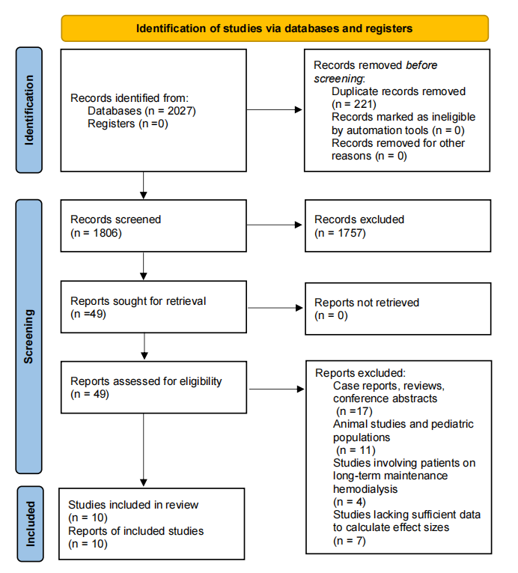

Supplementary Figure S2.
Forest plots of the meta-analysis and rationale for feature inclusion/exclusion.
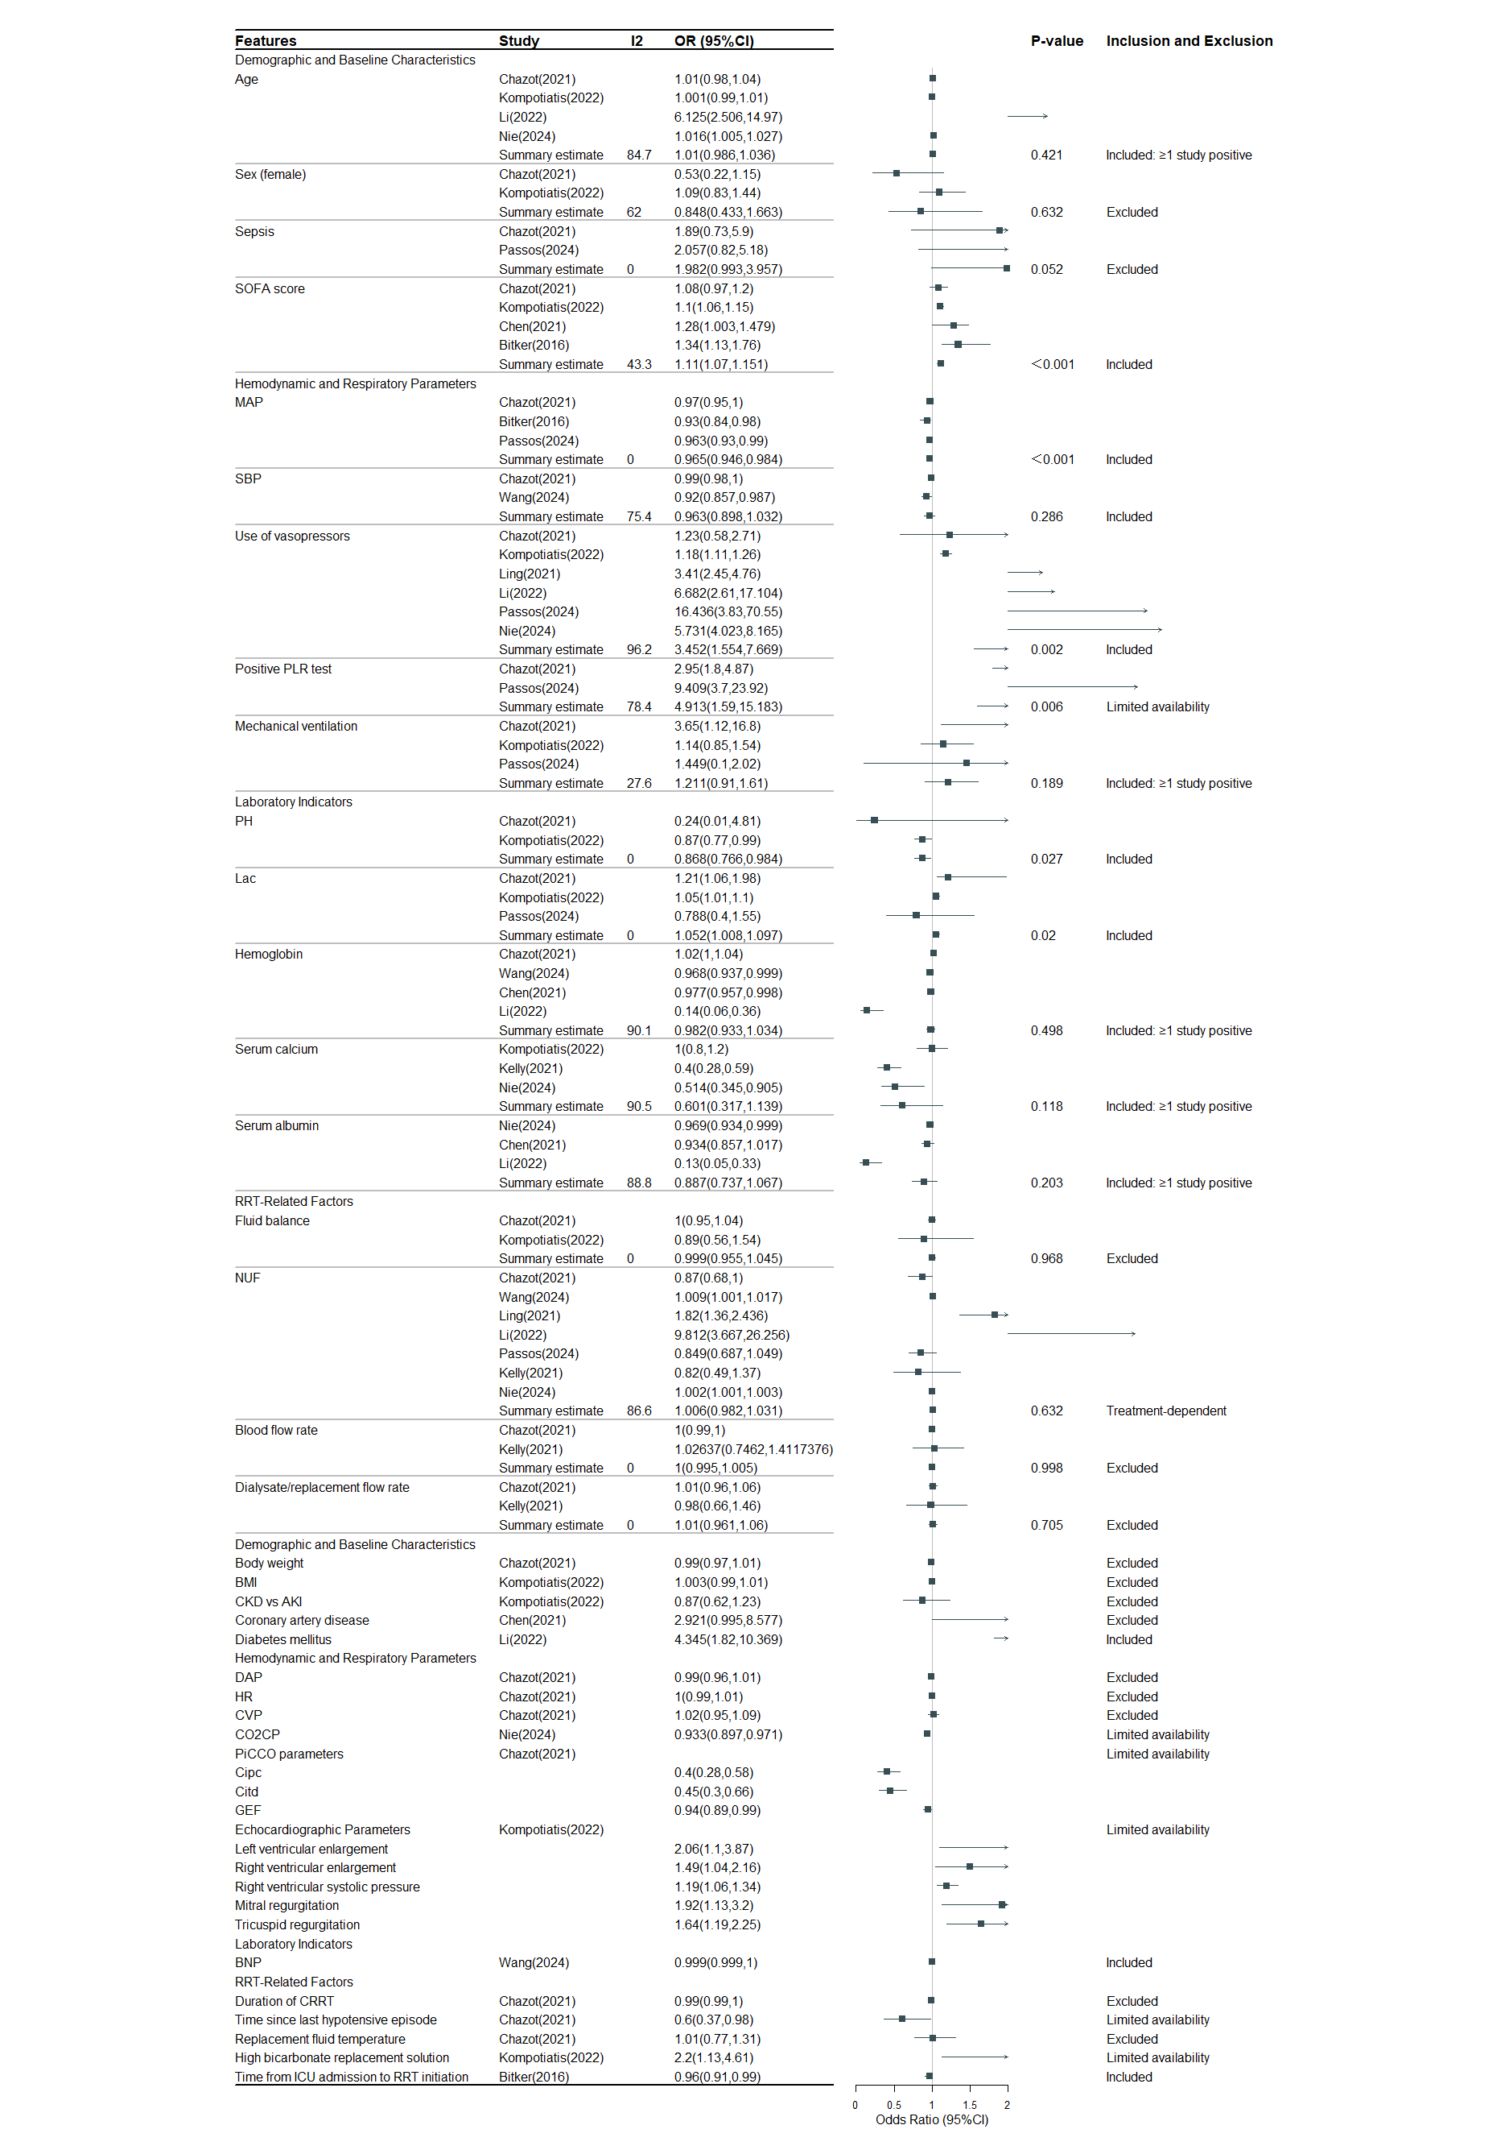
SOFA: Sequential organ failure assessment, MAP: Mean arterial pressure, SBP: Systolic blood pressure, PLR: Passive leg raising, Lac: Lactate, RRT: Renal replacement therapy, Net ultrafiltration rate, BMI: Body mass index, CKD: Chronic kidney disease, AKI: acute kidney injury, DBP: Diastolic blood pressure, HR: Heart rate, CVP: Central venous pressure, CO₂CP: Carbon dioxide combining power, Picco: Pulse contour cardiac output, Cipc: Cardiac index by pulse contour, Citd: Cardiac index by thermodilution, Gef: Global ejection fraction , BNP: B-type natriuretic peptide, CRRT: Continue renal replacement therapy.

Supplementary Figure S3.
LASSO regression coefficient path plot.
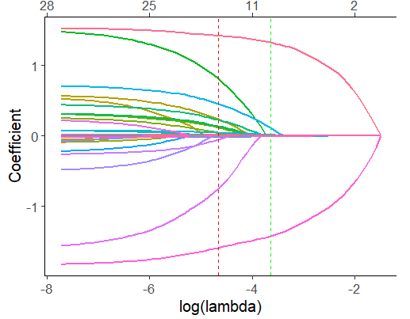

Supplementary Figure S4.
Tuning parameter (λ) selection process for LASSO regression.
