Appendix S1. Supplemental Figures and Tables
Journal name: Ecology
Manuscript title: Field warming increases body size of nocturnal slugs by extending their daily activity time in an alpine meadow
Xingyu Zhou¹, Xiaoli Hu¹, Ying Feng¹, Shuang Xiang², Youjun Chen³, Yuxia Zhang¹, Nico Eisenhauer^{4,5}, Shucun Sun^{1*}
Figure S1 The biomass of forbs (a) and graminoids (b) in both non-warmed and warmed chambers. The warming effects among different years were determined by Fisher–Pitman permutation tests. ns, no significant; * P < 0.05. The statistical parameters (Z and P values) are shown in Supplementary Table S4.
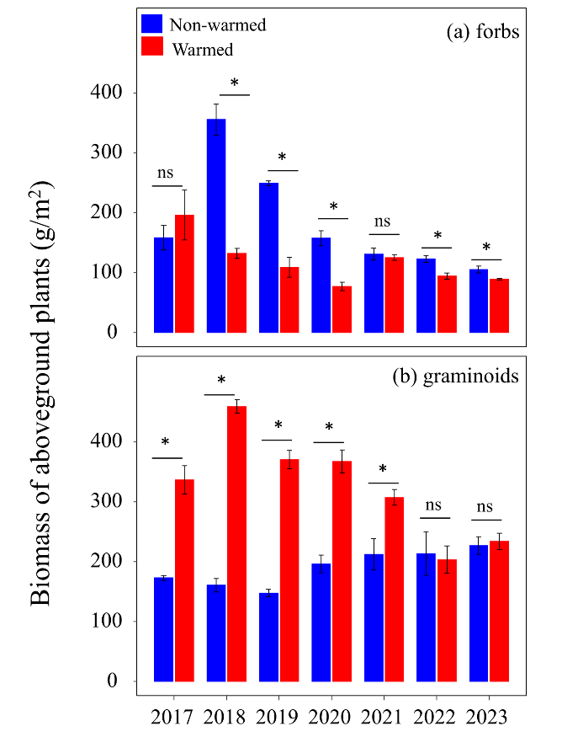
Figure S2 Temperature variation inside and outside the small open top chambers during the complementary small-scale experiment. The daily mean temperature was 15.49 °C and 15.93 °C outside and inside the chamber, respectively. The temperature increased by 0.80 °C during the nighttime (19:00–6:00) and by 0.07 °C during the daytime (6:00–19:00) inside the chamber.
Table S1 Summary of the parameters (Asmy, Xmid, Scal and R²) used in the logistic regression.
Year | Treatment | Chamber identity | Asmy | Xmid | Scal | P | R²
2022 | Warmed | 1 | 157.936 | 3.745 | 0.302 | <0.001 | 0.511
2022 | Warmed | 2 | 290.944 | 4.009 | 0.254 | <0.001 | 0.874
2022 | Warmed | 3 | 484.837 | 4.235 | 0.34 | <0.001 | 0.899
2022 | Non-warmed | 1 | 121.219 | 3.875 | 0.268 | <0.001 | 0.626
2022 | Non-warmed | 2 | 186.841 | 3.953 | 0.273 | 0.004 | 0.623
2022 | Non-warmed | 3 | 147.369 | 3.862 | 0.21 | <0.001 | 0.712
2023 | Warmed | 1 | 226.991 | 3.892 | 0.194 | <0.001 | 0.629
2023 | Warmed | 2 | 202.883 | 4.169 | 0.657 | <0.001 | 0.564
2023 | Warmed | 3 | 294.826 | 4.067 | 0.461 | <0.001 | 0.582
2023 | Non-warmed | 1 | 295.018 | 4.266 | 0.289 | <0.001 | 0.733
2023 | Non-warmed | 2 | 252.831 | 4,585 | 0.609 | <0.001 | 0.561
2023 | Non-warmed | 3 | 182.843 | 4.234 | 0.443 | <0.001 | 0.493

Table S2 The scientific names and functional groups of plant species in the slug dietary composition for both warmed and non-warmed chambers.
No. | Family | Latin names | Functional group
1 | Gentianaceae | Gentianopsis paludosa | Forbs
2 | Ranunculaceae | Trollius farreri | Forbs
3 | Ranunculaceae | Anemone rivularis | Forbs
4 | Ranunculaceae | Delphinium caeruleum | Forbs
5 | Polygonaceae | Rheum pumilum | Forbs
6 | Umbelliferae | Angelica sinensis | Forbs
7 | Umbelliferae | Tongoloa Wolff | Forbs
8 | Compositae | Saussurea nigrescens | Forbs
9 | Rosaceae | Potentilla anserina | Forbs
10 | Geraniaceae | Geranium pylzowianum | Forbs
11 | Ranunculaceae | Ranunculus tanguticus | Forbs
12 | Commelinaceae | Commelina diffusa | Forbs
13 | Caryophyllaceae | Cerastium arvense | Forbs
14 | Rubiaceae | Galium aparine | Forbs
15 | Compositae | Artemisia frigida | Forbs
16 | Rosaceae | Geum aleppicum | Forbs
17 | Rubiaceae | Galium verum | Forbs
18 | Leguminosae | Lathyrus quinquenervius | Forbs
19 | Cruciferae | Draba nemorosa | Forbs
20 | Compositae | Ajania przewalskii | Forbs
21 | Scrophulariaceae | Euphrasia pectinata | Forbs
22 | Iridaceae | Iris tectorum | Forbs
23 | Polygonaceae | Polygonum viviparum | Forbs
24 | Gramineae | Deschampsia caespitosa | Graminoids
25 | Gramineae | Poa annua | Graminoids
26 | Gramineae | Ptilagrostis mongholica | Graminoids
27 | Gramineae | Agrostis clavata | Graminoids
28 | Gramineae | Koeleria macrantha | Graminoids
29 | Gramineae | Festuca ovina | Graminoids

Table S3 Summary of statistical analyses for figures. The t value and P value for the Figure 1, 2, 3, 6 are shown. P-values in bold when < 0.05.
Variables | Year/Date | Z/t | P
Activity duration of slug in the daytime | 2022 | 0.464 | 0.679
Activity duration of slug in the daytime | 2023 | -1.244 | 0.107
Activity duration of slug in the nighttime | 2022 | -1.596 | 0.051
Activity duration of slug in the nighttime | 2023 | -1.446 | 0.034
Fresh weight of slug | 2022/6/29  2022/7/10  2022/7/25  2022/8/18  2022/9/7  2023/6/15  2023/6/25  2023/7/05  2023/7/15  2023/7/25  2023/8/9  2023/8/19  2023/9/2 | -1.653  -2.086  -1.765  -0.101  -1.526  -1.138  -2.036  -1.909  -1.879  -1.812  -0.633  -1.354  -1.552 | 0.049  0.019  0.039  0.136  0.033  0.128  0.021  0.028  0.030  0.035  0.264  0.047  0.050
Abundance of slug | 2017 | -0.225 | 0.411
Abundance of slug | 2018 | 1.649 | 0.951
Abundance of slug | 2019 | -1.964 | 0.025
Abundance of slug | 2020 | -1.964 | 0.025
Abundance of slug | 2021 | -1.964 | 0.025
Abundance of slug | 2022 | -1.526 | 0.053
Abundance of slug | 2023 | -1.964 | 0.025
Body size of slug in the complementary experiment | 2024/8/8 | 0.125 | 0.451
Body size of slug in the complementary experiment | 2024/8/15 | 1.494 | 0.073
Body size of slug in the complementary experiment | 2024/8/25 | 1.861 | 0.037
Activity duration in the complementary experiment (daytime) | 2024 | -1.762 | 0.039
Activity duration in the complementary experiment (nighttime) | 2024 | -2.058 | 0.019
Biomass of forbs | 2017 | -0.839 | 0.402
Biomass of forbs | 2018 | 2.173 | 0.029
Biomass of forbs | 2019 | 2.173 | 0.029
Biomass of forbs | 2020 | 2.104 | 0.035
Biomass of forbs | 2021 | 0.551 | 0.582
Biomass of forbs | 2022 | 1.979 | 0.048
Biomass of forbs | 2023 | 1.821 | 0.034
Biomass of graminoids | 2017  2018  2019  2020  2021  2022  2023 | -2.145  -2.224  -2.212  -2.152  -1.904  0.262  -0.392 | 0.016  0.013  0.013  0.016  0.028  0.603  0.347

