Supplementary Data

Detail Explanation of Materials and Methods
Quantitative real-time PCR (qRT-PCR) analysis
Total RNA from collected cells was isolated using Qiazol lysis reagent (Qiagen, Hilden, Germany) and reverse transcribed into cDNA using the ReverTra Ace kit (Toyobo, Osaka, Japan). The quantitative RT-PCR reaction was performed using Thunderbird SYBR qPCR mix (Toyobo, Osaka, Japan) on the Roche LightCycler 96 thermal cycler. Primer sets used for qPCR are listed in Table 1. The PCR conditions were as follows: initial activation at 95ºC for 1 min; followed by 40 cycles of denaturation at 95ºC for 15 s, annealing at 60ºC for 30 s, and extension at 72ºC for 30 s. A melting curve analysis was done by cycling at 95ºC for 15 s, 60ºC for 60 s, and 95ºC for 1 s. Melting peaks were assessed to ensure single product amplification. The expression level was quantified based on copy number. The copy number of each sample was calculated using a standard curve generated by plotting the quantification cycle (Cq) value against known copy numbers of a linear DNA standard. The target gene copy numbers were subsequently normalized to reference genes: 18S rRNA for HaCaT cell samples and GUSB for dermal fibroblast samples.
Table 1. Lists of primer pairs used in this study.
Gene | Sequence (5’ – 3’) | NCBI Accession Number
BMAL1 | F - GACAACGAACCAGACAATGAG | NM_001178
BMAL1 | R - GTGCCGAGAAACATATTCCATAG | NM_001178
PER3 | F - CTGGAGAATGATACGGCAGAC | NM_016831.4
PER3 | R - CCATGAGAAAACTGGGGCTG | NM_016831.4
18sRNA | F - CGCCGCTAGAGGTGAAATTC | NR_003286.4
18sRNA | R - CGAACCTCCGACTTTCGTTCT | NR_003286.4
GUSB | F - GCTGGCTACTACTTGAAGATG | NM_001284290
GUSB | R - AAACAGATCACATCCACATACG | NM_001284290
COL1 | F - CCTGGAAAGAATGGAGATGATGG | NM_000088
COL1 | R - CCAAACCACTGAAACCTCTGT | NM_000088
COL3 | F - AAAGATGGAGAATCAGGTAGAC | NM_000090.4
COL3 | R - GTCCTTTCATACCAGGGAATC | NM_000090.4
MMP1 | F - GAAACCCTGAAGGTGATGAAG | NM_002421.4
MMP1 | R - CCTGTAGGTCAGATGTGTTTG | NM_002421.4
MMP2 | F - TGATCTTGACCAGAATACCATC | NM_004530
MMP2 | R - GTAGCCAATGATCCTGTATGT | NM_004530
SIRT1 | F - GGCAAAGGAGCAGATTAGTAG | NM_012238
SIRT1 | R - ACAAGAACTAGAGGATAAGACG | NM_012238
NAMPT | F - CTTCTGGTAACTTAGATGGTCTG | NM_005746.3
NAMPT | R - TGCTACTGTATCTGTTCCTTTG | NM_005746.3
TJP1 | F - GAAGGAGTTGAGCAGGAAATC | NM_003257
TJP1 | R - CACATCACCAAAGGACTCAG | NM_003257
OCLN | F - GCTTCAGTTGGTGTTGTGAG | NM_001205255.1
OCLN | R - GATGGCATGGTGTAGTGTAG | NM_001205255.1

Statistical analysis
Statistical analysis was performed in Graphpad Prism software (version 10.5.0 for Mac OS, GraphPad Software, Boston, Massachusetts USA) or R Studio version 4.3.1. Data was reported as mean ± standard error of mean (SEM). The statistical comparison was conducted using an unpaired t-test for comparing two groups. The statistical significance was defined as p-value < 0.05. A Pearson correlation analysis was done in R using “Hmisc” package. The circadian rhythm analysis was done using cosinor analysis in GraphPad Prism, with the following equation [17] :
$$Y=MESOR +Amplitude×cos⁡(Frequency×X+Phaseshift)$$
MESOR = a baseline level of the rhythm
Amplitude = the difference between the maximum data with the MESOR
Frequency = the frequency is calculated as 0.2618 radians per hour for a 24-hour period
Phaseshift = the timing adjustment of the rhythm relative to a reference cycle, such as peak or trough time
For cosinor analysis, parameters were considered to have a circadian rhythm if the value of R² $≥$0.2. Furthermore, the R² value represents the strength of the circadian rhythmicity, where a higher value indicates a more robust circadian rhythm.

Animal
ICR mice, aged 6–9 months old, were purchased from Sankyo Labo (Tokyo, Japan). The age of a mouse is equal to 30–40 years old of human age [1]. Mice were kept under a specific pathogen-free facility at the Institute of Science Tokyo. The mice were maintained in an environment with the following conditions: temperature (22 ± 2°C), humidity (60 ± 5%), and a 12-hour light/12-hour dark. The light was turned on at 7:00 am and turned off at 7:00 pm. Mice had access to food and drink ad libitum. The animal experiments were conducted in accordance with the Guide for the Care and Use of Laboratory Animals approved by the Ethical Committee of the Institute of Science, Tokyo: D2022024.

Blue Light Irradiation on Mice

The hair on the back of mice was shaved using an electric razor and shaving cream Veet (Reckitt Benckiser, Canada). Similar blue light LED settings to those in the cell culture experiment were used. Blue light LEDs were installed on top of the cage to target the back (dorsal area) of the mouse skin. Blue light irradiation was done for 1 hour from 21:00–22:00 (at the beginning of active phase).

Mouse Skin Impedance
Skin impedance measurements were done using the Nevisense (SciBase, Sweden), a diagnostic tool to assess skin barrier function based on the electrical impedance spectroscopy (EIS) method. Nevisense measures the skin’s resistance against electrical signals at frequencies ranging from 1 kHz to 2.5 MHz at four depth settings across 10 permutations. The skin’s resistance represents the skin barrier function and can be influenced by tissue condition. In this study, the MIX value from the Nevisense was used to describe the skin barrier performance. MIX value refers to the ratio of impedance at low and high frequencies. Low-frequency electric signals can penetrate deeper into the skin, while high-frequency electric signals only reach the surface of the skin. Therefore, the MIX value covers the skin barrier function across all layers of the skin. Moreover, the MIX value positively correlated with the skin barrier function[2].
First, the back of the skin was moisturized with a saline swab. Then, a probe was applied with gentle pressure to the surface of the skin. Measurement was done for approximately 8 seconds. The skin impedance was measured every 6 hours for 24 hours. During measurement, mice were euthanized with isoflurane to minimize the mice movement.
Results
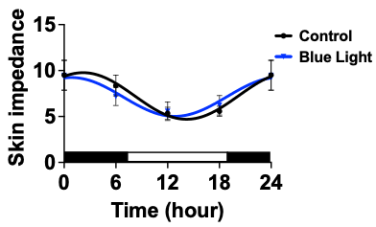
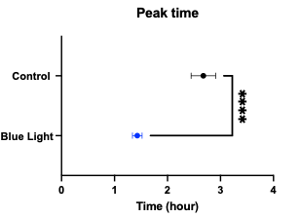
All mice showed peak time of skin impedance during the late dark phase (1-3 am), indicating that the mouse skin barrier performed best during the active phase. Interestingly, blue light irradiation advanced the peak time of skin impedance by about 1 hour, compared to the control group. There were no significant changes in MESOR, amplitude, and average level of skin impedance.
B
A

Figure 1. The effects of blue light irradiation on skin impedance. The mouse was exposed to blue light at 9 -10 pm. The light intensity was similar to that described in the cell culture experiment. The skin impedance of the mouse was measured every 6 hours for 24 hours in blue light and the control group (A). Peak time of skin impedance in control vs blue light (B). Data was taken from 2 independent experiments (n = 6 for control; n=8 for blue light). Significance difference between groups was analyzed by an unpaired T-test. *p-value < 0.05.

[1] Flurkey, Currer, and Harrison. (2007). The mouse in biomedical research. In: James G. Fox (ed.), American College of Laboratory Animal Medicine series. Elsevier. Amsterdam, Boston.
[2] L. Huygen, P. M. Thys, A. Wollenberg, J. Gutermuth, and I. K. Krohn, ‘Skin Barrier Function Assessment: Electrical Impedance Spectroscopy Is Less Influenced by Daily Routine Activities Than Transepidermal Water Loss’, Ann Dermatol, vol. 36, no. 2, pp. 99–111, Apr. 2024, [Online]. Available: https://doi.org/10.5021/ad.23.052

Reference

Supplementary Files for Western Blot
Dermal Fibroblasts – BMAL1
Control
Blue Light
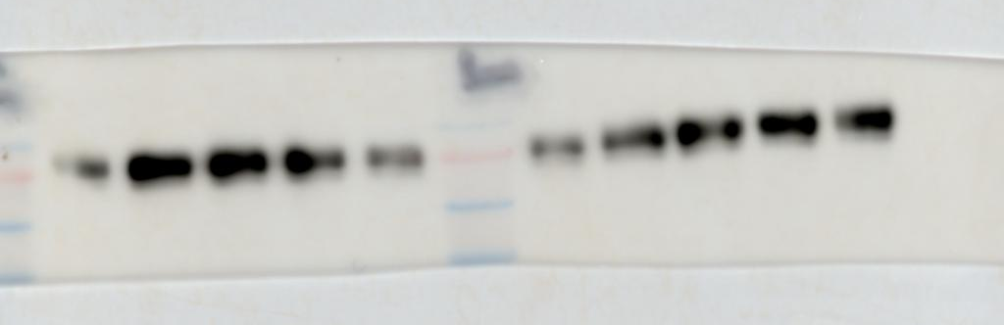
18
12
6
24
100 kDa
75 kDa
0
24
18
12
6
0
60 kDa
50 kDa

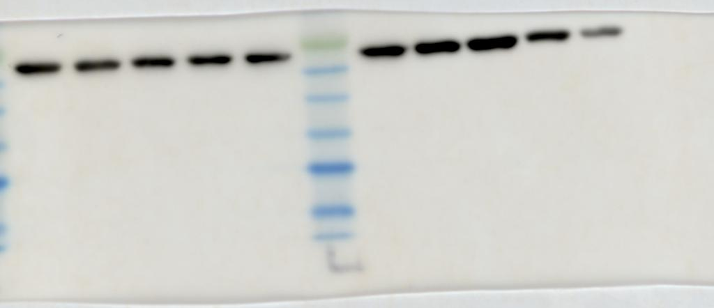
Dermal Fibroblasts – GAPDH
10 kDa
15 kDa
20 kDa
25 kDa
30 kDa
35 kDa
40 kDa
24
24
18
18
6
12
12
6
0
0
Blue Light
Control

HaCaT cells – BMAL1
Control
Blue Light
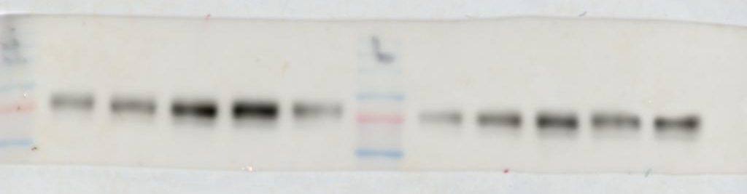
60 kDa
75 kDa
100 kDa
24
24
18
18
12
12
6
6
0
0

HaCaT cells – GAPDH
50 kDa
Control
Blue Light
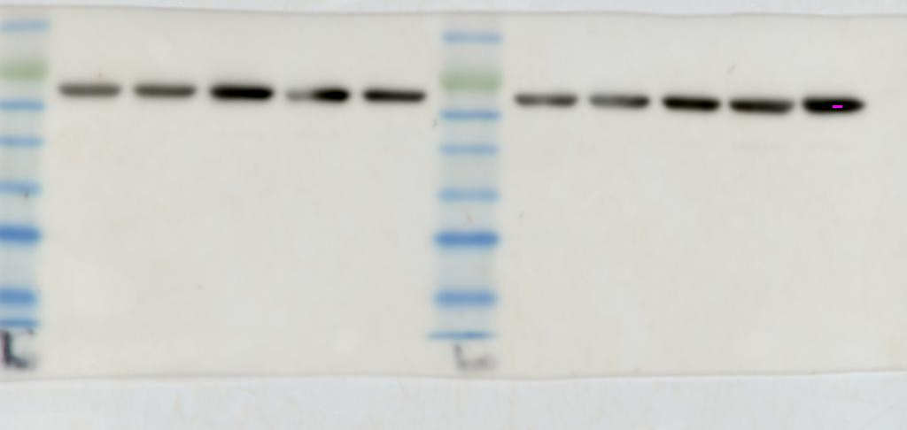
40 kDa
35 kDa
30 kDa
25 kDa
20 kDa
15 kDa
10 kDa
24
24
18
18
12
12
6
6
0
0

Supplementary Files for Western Blot
SDS gel image for dermal fibroblasts
Blue Light
Control
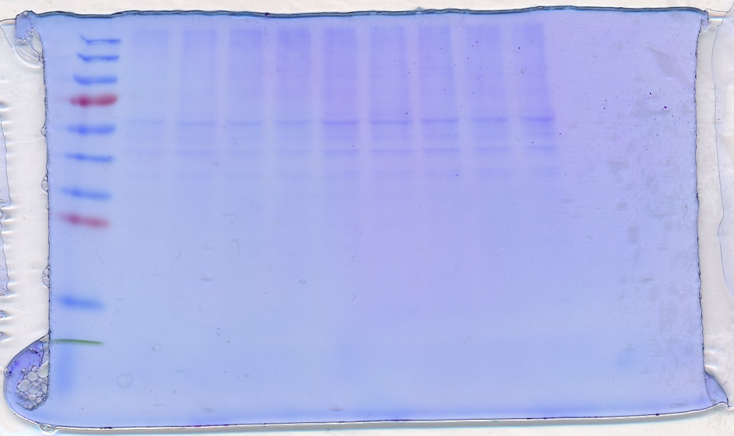
24
18
12
6
24
18
12
6
0

SDS gel image for HaCaT cells
Blue Light
Control
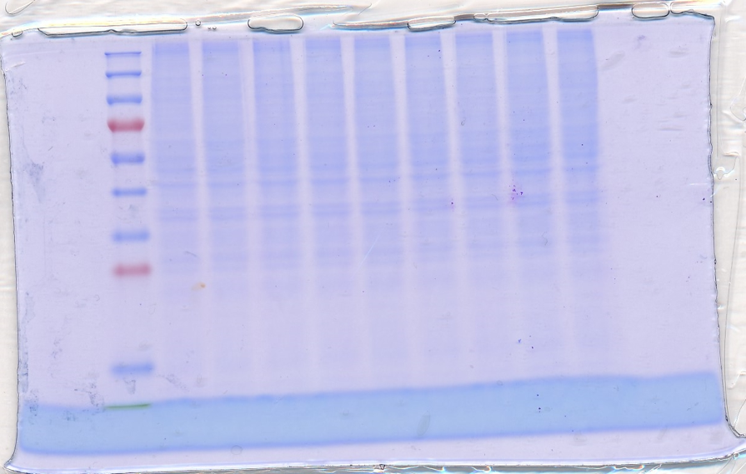
24
18
12
6
24
18
12
6
0

