Supplementary Online Content

Evaluation of the Role of Near-Infrared Autofluorescence in Identifying Parathyroid Glands during Thyroid Surgery by Measuring Intraoperative Parathyroid Hormone in Fine-Needle Aspiration Biopsy Washings

eTable 1. Comparing the sensitivity and accuracy of NIRAF with vision in identifying parathyroid glands

eTable 2. Paired-samples t-test of fluorescence intensity in different tissues

eFigure 1. Fluorescence imaging device and operating environment

eFigure 2. Test strip and parathyroid hormone detector for measuring intraoperative parathyroid hormone in fine-needle aspiration biopsy washings

eTable 1. Comparing the sensitivity and accuracy of NIRAF with vision in identifying parathyroid glands

Method | Identified PGs No. | Undiscovered PGs No. | Sensitivityª
NIRAF | 568 | 28 | 95.30%
Vision | 517 | 79 | 86.74%

Method | Correctly identified tissues No. | Misidentified tissues No. | Accuracy^{b}
NIRAF | 764 | 77 | 90.84%
Vision | 567 | 274 | 67.42%

PGs parathyroid glands；
a The sensitivity of NIRAF was significantly higher than vision in 596 parathyroid glands, P<.001
b The accuracy of NIRAF was significantly higher than vision in 841 suspected parathyroid tissues. P<.001

eTable 2. Paired-samples t-test of fluorescence intensity in different tissues

 |  | Paired fluorescence intensity difference value
Paired group | Paired No. | Mean±SD | 95%CI | t | P value
Parathyroid-thyroid | 331 | 10.96±16.42 | 9.18-12.73 | 12.14 | <.001
Parathyroid-Fat | 266 | 26.49±15.46 | 24.63-28.36 | 27.94 | <.001
Parathyroid-lymph node | 167 | 40.30±15.02 | 38.00-42.59 | 34.68 | <.001

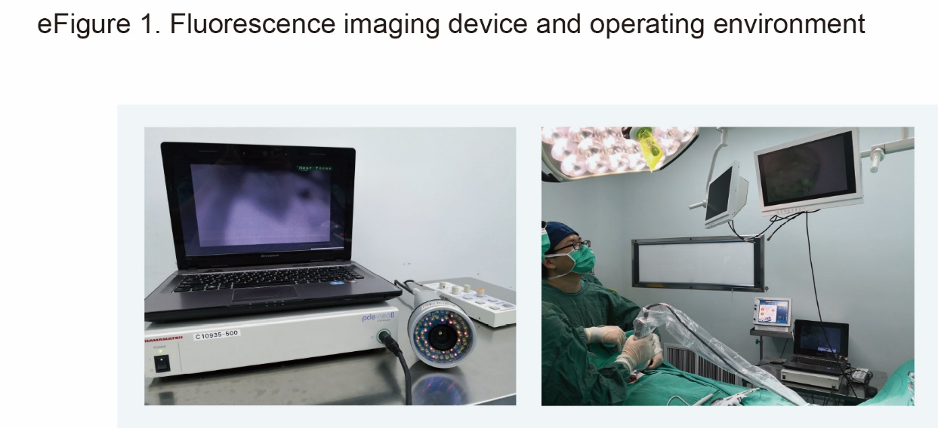

The operating room illuminated by LED light sources does not need to turn off the light, only need to remove the operating lamp, but the operating room illuminated by halogen lamp needs to turn off the light source. During the NIRAF imaging process, it is necessary to avoid the camera shooting of the surgery field, which will cause the flicker of the fluorescent image. The electrocautery should be used with caution during the operation to reduce the generation of eschar, which has extremely strong autofluorescence under fluorescent imaging.

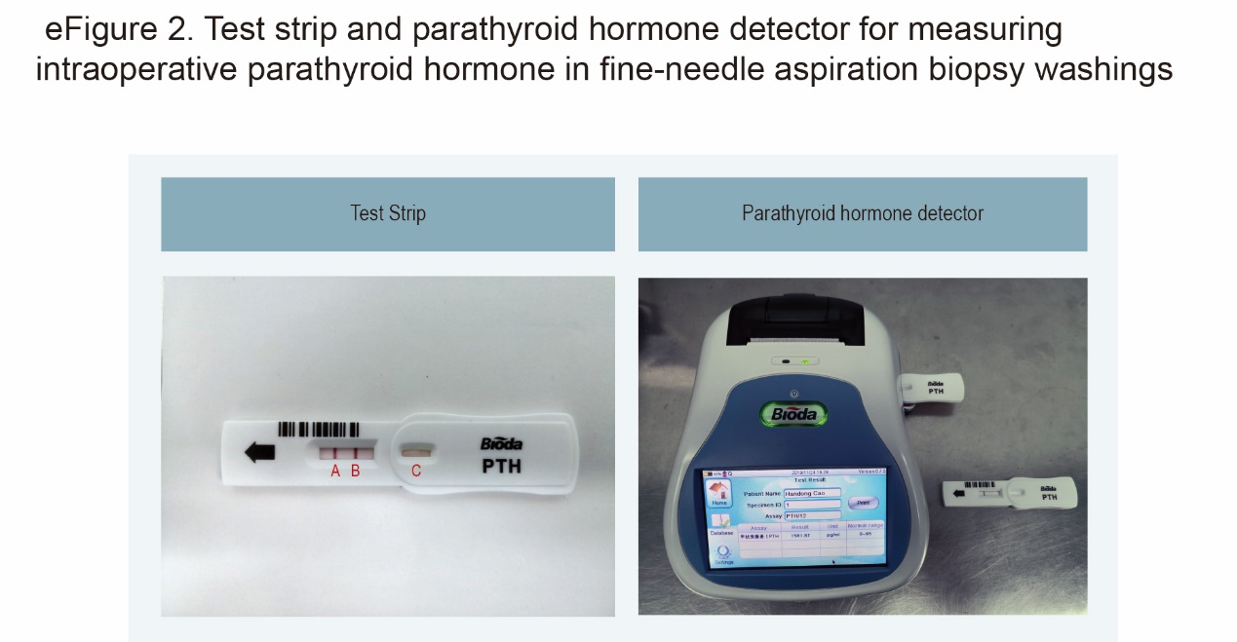

- Control line B. Test line C. Reaction zone
The test line requires a 10-minute incubation time to reach a stable final result, but in most cases, the test line can turn red in a shorter time with a positive result. Parathyroid hormone detector is not needed if exact values are not required

Video 1. Intraoperative near-infrared autofluorescence imaging of parathyroid glands
The NIRAF probe is wrapped with a sterile lens cover, and the surgeon holds the NIRAF probe with one hand to perform fluorescence imaging of the surgical field. The operating room lighting can be kept after removing the surgical lamp from the surgical field.

Video 2. Measuring intraoperative parathyroid hormone in fine-needle aspiration biopsy washings of the suspicious parathyroid gland
The suspicious tissue with strong fluorescence intensity was punctured with a 1 ml syringe containing 0.1 ml saline and then to drip the 0.1 ml saline through the needle onto the reaction area of the test strip.

