Supplementary Materials
Supplementary Figure 1. Flow Chart

Table S1: Informal Helping Behaviors

“In the last 12 months, have you done any of these things, unpaid, for someone who was not a relative?”

1. Keeping in touch with someone who can’t get out and about
2. Doing shopping, collecting pension, or paying bills
3. Cooking, cleaning, laundry, gardening, other household jobs
4. Decorating or any kind of home or car repairs
5. Babysitting or caring for children
6. Providing personal care for someone who is sick of frail
7. Looking after a property or pet for someone who is away
8. Writing letters of filling in forms
9. Representing someone, for example, to a doctor or council department
10. Transporting or escorting someone

In

Table S2. Characteristics of Sample by Prosocial Behaviors

 | Informal Helping |  |  | Formal Volunteering
 | No | Yes | Missing | No | Yes | Missing
n | 3143 | 3307 | 99 | 4425 | 2035 | 89
Prosocial Intentions | 21.72 (5.44) | 23.19 (4.97) | 23.33 (1.15) | 22.01 (5.40) | 23.51 (4.76) | 25.00 (NA)
Missing | 414 (13.2) | 256 (7.7) | 96 (97.0) | 533 (12.0) | 145 (7.1) | 88 (98.9)
Volunteering (%)
No Volunteering | 2551 (81.2) | 1864 (56.4) | 10 (10.1) | 4425 (100.0) | 0 (0.0) | 0 (0.0)
Volunteering | 592 (18.8) | 1442 (43.6) | 1 (1.0) | 0 (0.0) | 2035 (100.0) | 0 (0.0)
Missing | 0 (0.0) | 1 (0.0) | 88 (88.9) | 0 (0.0) | 0 (0.0) | 89 (100.0)
Informal Helping | 0.00 (0.00) | 2.33 (1.49) | NA | 0.87 (1.33) | 1.90 (1.84) | 0.03 (0.32)
Missing | 0.00 (0.00) | 0.00 (0.00) | 99 (100) | 1 (1.01) | 10 (10.1) | 88 (88.9)
Sociodemographics
Sex (%)
Female | 1667 (53.0) | 1978 (59.8) | 48 (48.5) | 2471 (55.8) | 1180 (58.0) | 42 (47.2)
Male
Age | 66.74 (10.36) | 65.55 (8.59) | 71.91 (12.89) | 66.47 (9.91) | 65.40 (8.55) | 72.11 (13.11)
White (%) | 3065 (97.5) | 3238 (97.9) | 94 (94.9) | 4319 (97.6) | 1994 (98.0) | 84 (94.4)
Marital Status (%)
Married / Partnered | 2112 (67.2) | 2214 (66.9) | 64 (64.6) | 2874 (64.9) | 1457 (71.6) | 59 (66.3)
Divorced / Separated | 338 (10.8) | 412 (12.5) | 11 (11.1) | 540 (12.2) | 213 (10.5) | 8 (9.0)
Never Married | 160 (5.1) | 210 (6.4) | 3 (3.0) | 255 (5.8) | 116 (5.7) | 2 (2.2)
Widowed | 533 (17.0) | 471 (14.2) | 21 (21.2) | 756 (17.1) | 249 (12.2) | 20 (22.5)
Educational Attainment (%)
No Formal Qualifications | 978 (31.1) | 662 (20.0) | 46 (46.5) | 1394 (31.5) | 251 (12.3) | 41 (46.1)
School Certificate Level | 733 (23.3) | 780 (23.6) | 14 (14.1) | 1077 (24.3) | 438 (21.5) | 12 (13.5)
A Levels or Equivalent | 679 (21.6) | 894 (27.0) | 15 (15.2) | 993 (22.4) | 582 (28.6) | 13 (14.6)
University Degree or Higher | 753 (24.0) | 971 (29.4) | 24 (24.2) | 961 (21.7) | 764 (37.5) | 23 (25.8)
Work Status (%)
Employed | 1158 (36.8) | 1155 (34.9) | 26 (26.3) | 1599 (36.1) | 718 (35.3) | 22 (24.7)
Looking after home | 205 (6.5) | 223 (6.7) | 10 (10.1) | 298 (6.7) | 132 (6.5) | 8 (9.0)
Retired | 1739 (55.3) | 1900 (57.5) | 61 (61.6) | 2472 (55.9) | 1171 (57.5) | 57 (64.0)
Unemployed | 41 (1.3) | 29 (0.9) | 2 (2.0) | 56 (1.3) | 14 (0.7) | 2 (2.2)
Wealth | 302,258 (455,552) | 395,744 (989,840) | 253,742 (249,924) | 289,889 (516,350) | 481,006 (1,146,891) | 249,856 (251,658)
Health Factors
Diabetes (%) | 210 (6.7) | 183 (5.5) | 2 (2.0) | 295 (6.7) | 100 (4.9) | 0 (0.0)
Hypercholesterolemia (%) | 697 (22.2) | 724 (21.9) | 0 (0.0) | 962 (21.7) | 459 (22.6) | 0 (0.0)
Hypertension (%) | 954 (30.4) | 890 (26.9) | 4 (4.0) | 1315 (29.7) | 532 (26.1) | 1 (1.1)
Probable Depression (%) | 499 (15.9) | 411 (12.4) | 0 (0.0) | 716 (16.2) | 193 (9.5) | 1 (1.1)
Healthy Diet (%) | 916 (29.1) | 1127 (34.1) | 0 (0.0) | 1310 (29.6) | 732 (36.0) | 1 (1.1)
Moderate Alcohol (%) | 1467 (46.7) | 1772 (53.6) | 3 (3.0) | 2081 (47.0) | 1161 (57.1) | 0 (0.0)
Physical Activity Level (%)
Sedentary | 219 (7.0) | 58 (1.8) | 26 (26.3) | 254 (5.7) | 24 (1.2) | 25 (28.1)
Low | 773 (24.6) | 639 (19.3) | 28 (28.3) | 1079 (24.4) | 337 (16.6) | 24 (27.0)
Moderate | 1541 (49.0) | 1838 (55.6) | 35 (35.4) | 2246 (50.8) | 1135 (55.8) | 33 (37.1)
High | 610 (19.4) | 772 (23.3) | 10 (10.1) | 846 (19.1) | 539 (26.5) | 7 (7.9)
Current Smoker (%) | 448 (14.3) | 372 (11.2) | 11 (11.1) | 663 (15.0) | 158 (7.8) | 10 (11.2)

Table S3. Spearman Correlations Between Measures of Prosociality
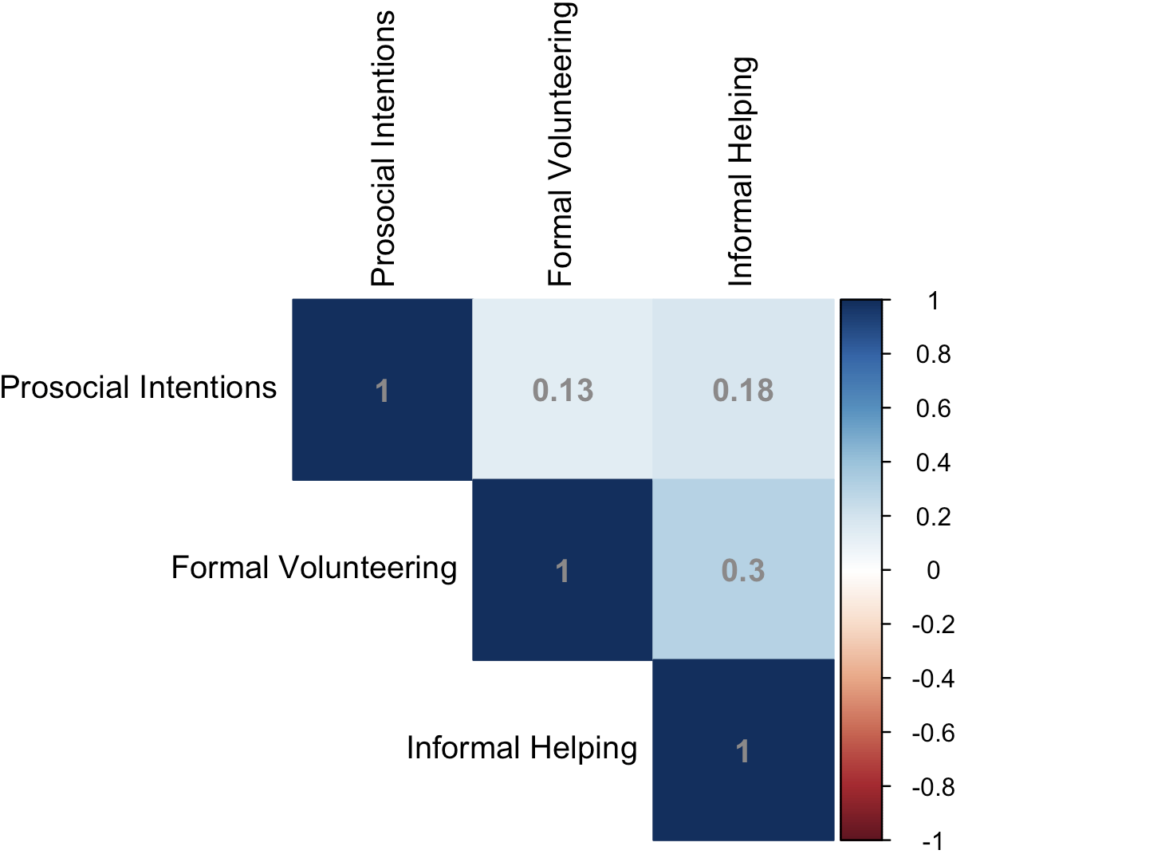

Table S4. Associations between Meeting Multiple Forms of Prosociality and Time to Cardiovascular Event
Number of Prosociality Forms | Cases / person-years | Model 3 | Model 4
0 | 169 / 6,687 | Ref | Ref
1 | 321 / 15,140 | 0.91 (0.76, 1.10) | 0.92 (0.77, 1.12)
2 | 225 / 15,501 | 0.69 (0.57, 0.85) | 0.73 (0.59, 0.89)
3 | 117 / 8,885 | 0.65 (0.51, 0.83) | 0.70 (0.54, 0.89)
Continuous (per form) | 831 / 46,297 | 0.85 (0.79, 0.91) | 0.87 (0.81, 0.94)
Note. Estimates are Hazards Ratios (95% CI) with each exposure treated separately. Model 3 adjusts for age, sex, race, marital status, educational attainment, current work status, and wealth. Model 4 is Model 3 + depression, diabetes, hypertension, hypercholesterolemia, smoking, diet, physical activity, and alcohol consumption.

Table S5. Effect Modification of Prosocial Intentions on Associations between Prosocial Behaviors and Time to Cardiovascular Event
 | Low Prosocial Intentions |  | High or Medium Prosocial Intentions |  | Interaction P-Value
 | Cases / person-years | Estimate (95% CI) | Cases / person-years | Estimate (95% CI)
Formal Volunteering
Never | 269 / 10,740 | Ref | 352 / 19,479 | Ref
Occasionally | 9 / 996 | 0.54 (0.28, 1.06) | 31 / 2,907 | 0.79 (0.55, 1.15) | 0.32
Frequently | 48 / 2,856 | 0.69 (0.50, 0.94)* | 124 / 9,254 | 0.81 (0.66, 1.01) | 0.03
Informal Helping | 326 / 14,592 | 0.97 (0.88, 1.07) | 507 / 31,640 | 0.93 (0.88, 0.99)* | 0.73

Note. Estimates are Hazards Ratios (95% CI) coming from stratified analyses. Estimates for formal volunteering and informal helping are from independent models, each adjusting for age, sex, race, marital status, work status, educational attainment, and wealth. Interaction P-Values come from models that adjust for the covariates from Model 3 as well as interaction terms between continuous prosocial intentions and the respective prosocial behavior. *p < 0.05, **p <0.001.

Table S6. Associations between Multiple Forms of Prosociality and Time to Cardiovascular Event with Simultaneous Adjustment of Exposures
Prosociality Measure | Cases / person-years | Model 3 | Model 4
Intentions
Low | 424 / 14,587 | Ref | Ref
Medium | 314 / 14,813 | 0.83 (0.70, 0.98) | 0.84 (0.71, 0.99)
High | 342 / 16,828 | 0.87 (0.73, 1.02) | 0.86 (0.73, 1.02)
Volunteering Frequency
Never | 727 / 33,717 | Ref | Ref
Occasionally | 44 / 4,248 | 0.73 (0.52, 1.01) | 0.73 (0.53, 1.01)
Frequently | 189 / 12,936 | 0.77 (0.65, 0.93) | 0.81 (0.67, 0.97)
Informal Helping | 960 / 50,869 | 0.96 (0.91, 1.01) | 0.97 (0.92, 1.02)
Note. Estimates are Hazards Ratios (95% CI) with each exposure treated separately. Model 3 adjusts for age, sex, race, marital status, educational attainment, current work status, and wealth. Model 4 is Model 3 + depression, diabetes, hypertension, hypercholesterolemia, smoking, diet, physical activity, and alcohol consumption.

Table S7. Prosociality and Time to Cardiovascular Events Lagging Two Years
Prosociality Measure | Cases / person-years | Model 3 | Model 4
Intentions | 670 / 34,931 | 0.95 (0.88, 1.02) | 0.95 (0.88, 1.03)
Volunteering Frequency
Never | 581 / 25,141 | Ref | Ref
Occasionally | 36 / 3,280 | 0.69 (0.49, 0.97) | 0.71 (0.50, 0.99)
Frequently | 149 / 9,915 | 0.73 (0.60, 0.88) | 0.78 (0.65, 0.95)
Informal Helping | 764 / 38,298 | 0.94 (0.89, 0.99) | 0.96 (0.91, 1.01)

Note. Estimates are Hazards Ratios (95% CI). Model 3 adjusts for age, sex, race, marital status, work status, educational attainment, wealth. Model 4 adjusts for covariates in Model 3 +depression, diabetes, hypertension, hypercholesterolemia, smoking, diet, physical activity, and alcohol consumption.

Prosociality Measure | Cases / person-years | Model 3 | Model 4 | Model 5
Intentions
Low | 424 / 14,587 | Ref | Ref | NA
Medium | 314 / 14,813 | 0.83 (0.70, 0.98) | 0.85 (0.72, 1.00) | NA
High | 342 / 16,828 | 0.86 (0.73, 1.01) | 0.86 (0.73, 1.02) | NA
Formal Volunteering
No | 727 / 33,717 | Ref | Ref | Ref
Yes | 233 /17,184 | 0.75 (0.64, 0.88) | 0.80 (0.68, 0.94) | 0.80 (0.68, 0.94)
Informal Helping
No | 512 / 23,745 | Ref | Ref | Ref
Yes | 448 / 27,123 | 0.88 (0.78, 1.01) | 0.94 (0.82, 1.07) | 0.95 (0.82, 1.10)
Table S8. Alternative Measures of Prosociality and Time to Cardiovascular Events

Note. Estimates are Hazards Ratios (95% CI) with each exposure treated separately. Model 3 adjusts for age, sex, race, and marital status, educational attainment, current work status, and wealth. Model 4 is Model 3 + depression, diabetes, hypertension, hypercholesterolemia, smoking, diet, physical activity, and alcohol consumption. Model 5 is Model 4 + prosocial intentions.

