Title: The multifaceted mpox outbreaks in the Democratic Republic of the Congo, January 2024 – August 2025

Supplementary Information

Section 1: Characteristics of laboratory testing
Here we describe and analyze the testing capacity over the reporting period, including the differences and evolution of test positivity by area and age groups. Tests are performed by a laboratory network throughout the country using conventional PCR testing and GeneXpert PCR. Throughout this section, sampling percentages are calculated as the number of cases sampled (based on case-based laboratory data) divided by the number of cases reported through the syndromic surveillance system for the geographic unit. Since this calculation draws from two separate data sources, date misalignments may lead to discrepancies. Test positivity is calculated as the number of positive PCR samples out of the total tested for each geographic unit. Confidence intervals are calculated via the binomial distribution.
Between January 2024 and August 2025, laboratory testing trends for suspected mpox cases in DRC show significant variation across time, geographic units, and age groups, reflecting evolving surveillance dynamics and the epidemiology of mpox within the country. Nationally, sampling coverage increased through mid-2024 but declined after the PHEIC declaration in August 2024, coinciding with a surge in case detection. The subsequent drop in the proportion of suspected cases reflects the challenge of maintaining testing rates during periods of high incidence. At the same time, the positivity rate declined, partly driven by the increase in testing volume after the PHEIC. Positivity has remained near 50% since August 2024, while the proportion of suspected cases tested has increased through 2025. Wider confidence intervals in certain months reflect smaller sample sizes or higher variability in test results.
Sampling percentages are not shown for Kinshasa, where all suspected cases are sampled. North Kivu is also excluded due to inconsistent syndromic reporting over time. South Kivu and endemic provinces exhibited moderate and fluctuating testing coverage over the study period. Over the study period, test positivity rates for mpox were consistently highest among individuals aged 15 and older across geographic units. Kinshasa demonstrated the highest and most sustained positivity, particularly among adults. In South Kivu, test positivity was initially very high, then gradually declined over time across all age groups. In North Kivu, test positivity was initially high among adults aged 15 years and older and low among children aged 0-14 years, but over time, rates among adults converged with all age groups consistently reporting between 25% and 50% positivity in 2025. A notable exception occurred in June 2025, when positivity briefly spiked to around 75% across all ages before returning to prior levels.
Table S1.1: Number of syndromic mpox cases reported by province
Province | All cases | Deaths
Sud-Kivu | 33344 | 53
Sankuru | 17646 | 217
Tshuapa | 14380 | 452
Sud-Ubangi | 11354 | 54
Equateur | 10219 | 417
Nord Kivu | 8897 | 3
Tshopo | 7119 | 326
Kinshasa | 6439 | 19
Bas Uele | 5468 | 178
Kasai | 3507 | 79
Tanganyika | 3099 | 3
Mongala | 2537 | 69
Maindombe | 1306 | 55
Maniema | 1221 | 6
Nord Ubangi | 846 | 7
Kongo Central | 830 | 3
Lomami | 771 | 0
Ituri | 741 | 4
Kwilu | 322 | 8
Kwango | 315 | 4
Haut Katanga | 272 | 1
Haut Uele | 218 | 5
Haut Lomami | 204 | 7
Kasai Central | 100 | 4
Kasai Oriental | 66 | 2
Lualaba | 64 | 0
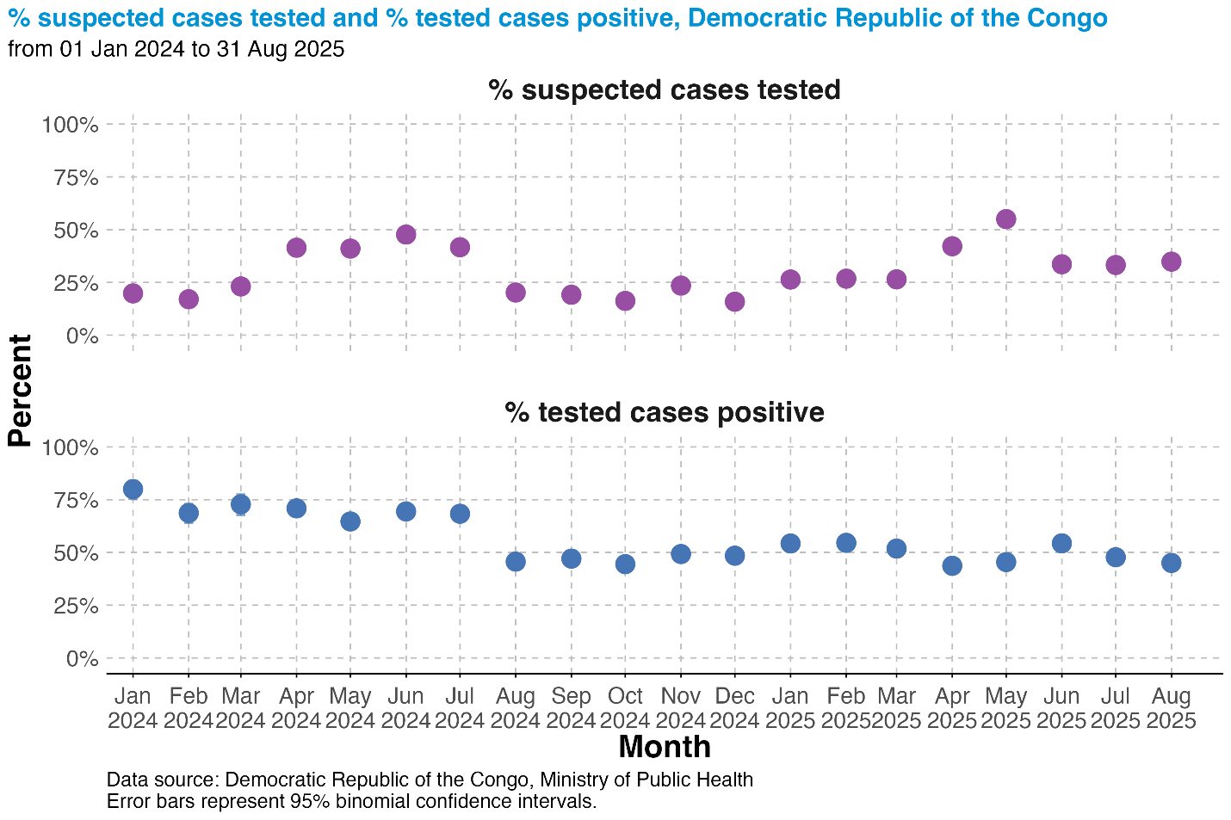
Figure S1.1: Proportion of suspected cases and proportion of cases testing positive, Democratic Republic of the Congo.
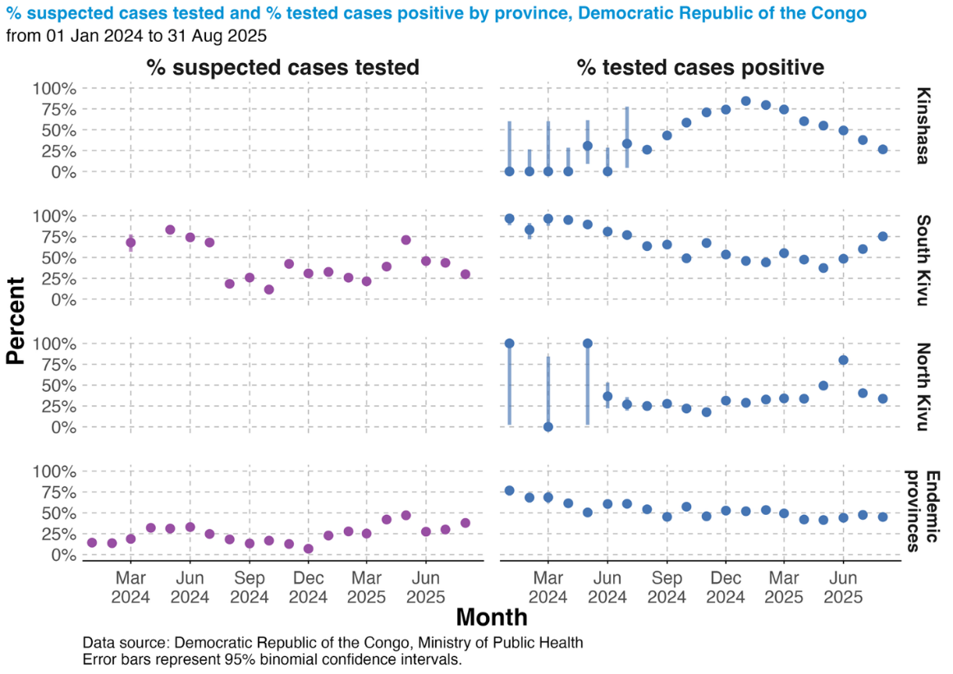
Figure S1.2: Proportion of suspected cases and proportion of cases testing positive in key geographic areas.

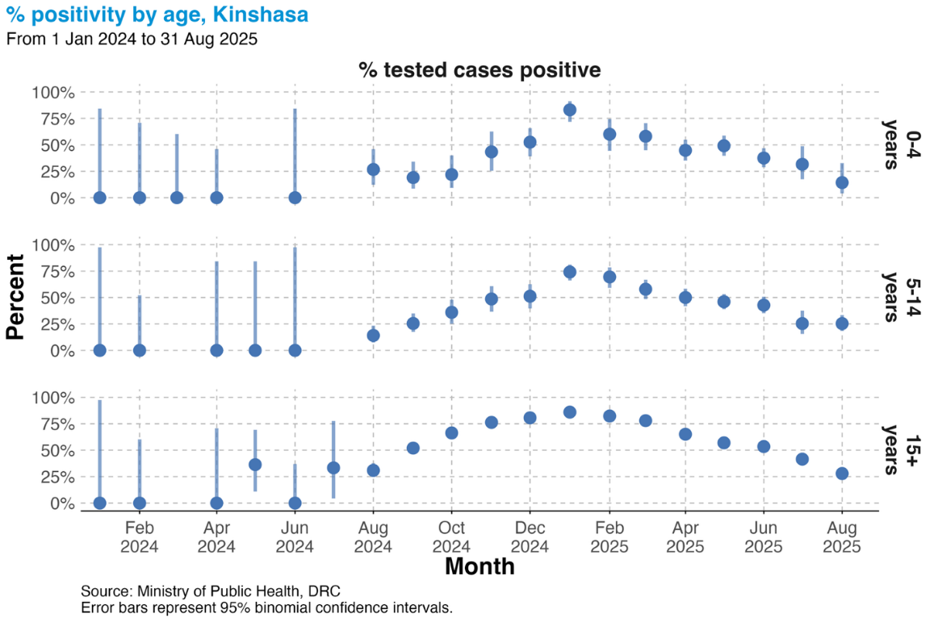
Figure S1.3: Proportion of suspected cases and proportion of cases testing positive by age group, Kinshasa.
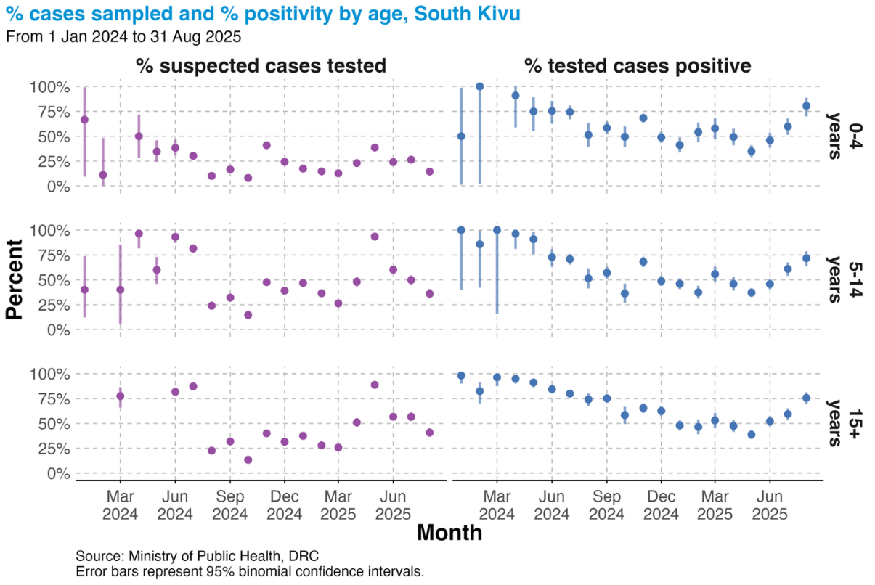
Figure S1.4: Proportion of suspected cases and proportion of cases testing positive by age group, South Kivu.
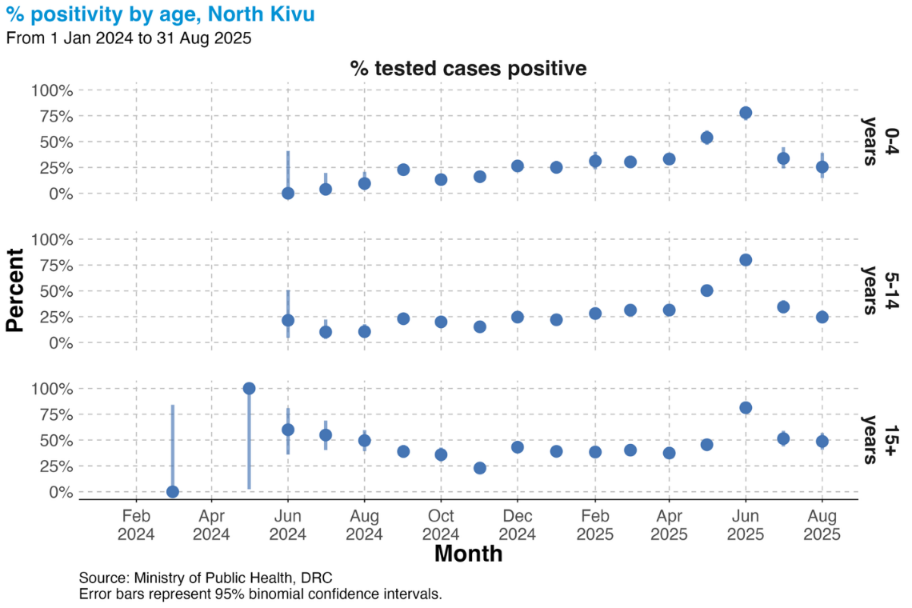
Figure S1.5: Proportion of suspected cases and proportion of cases testing positive by age group, North Kivu.
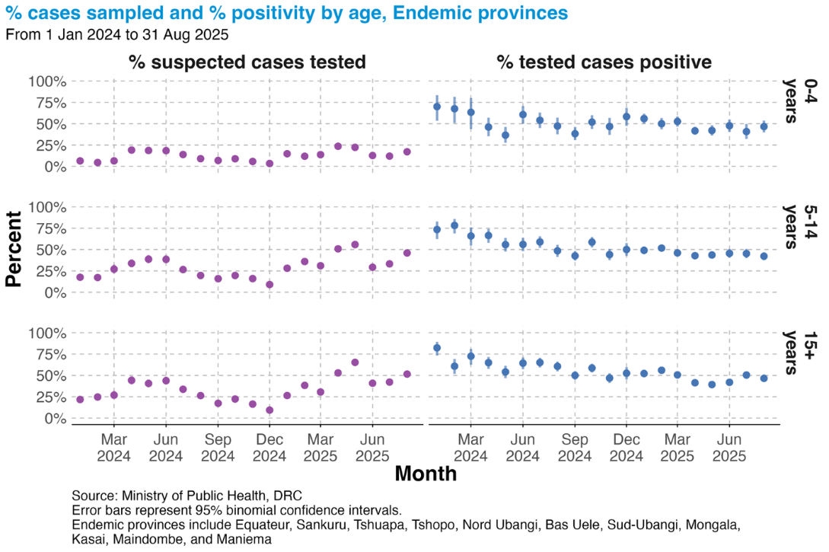
Figure S1.6: Proportion of suspected cases and proportion of cases testing positive by age group, endemic provinces.

Section 2: Age and sex characteristics over time and trends, at health zone and provincial levels.
Here we explore a range of more detailed analyses of age and sex characteristics and trends at the health zone level.
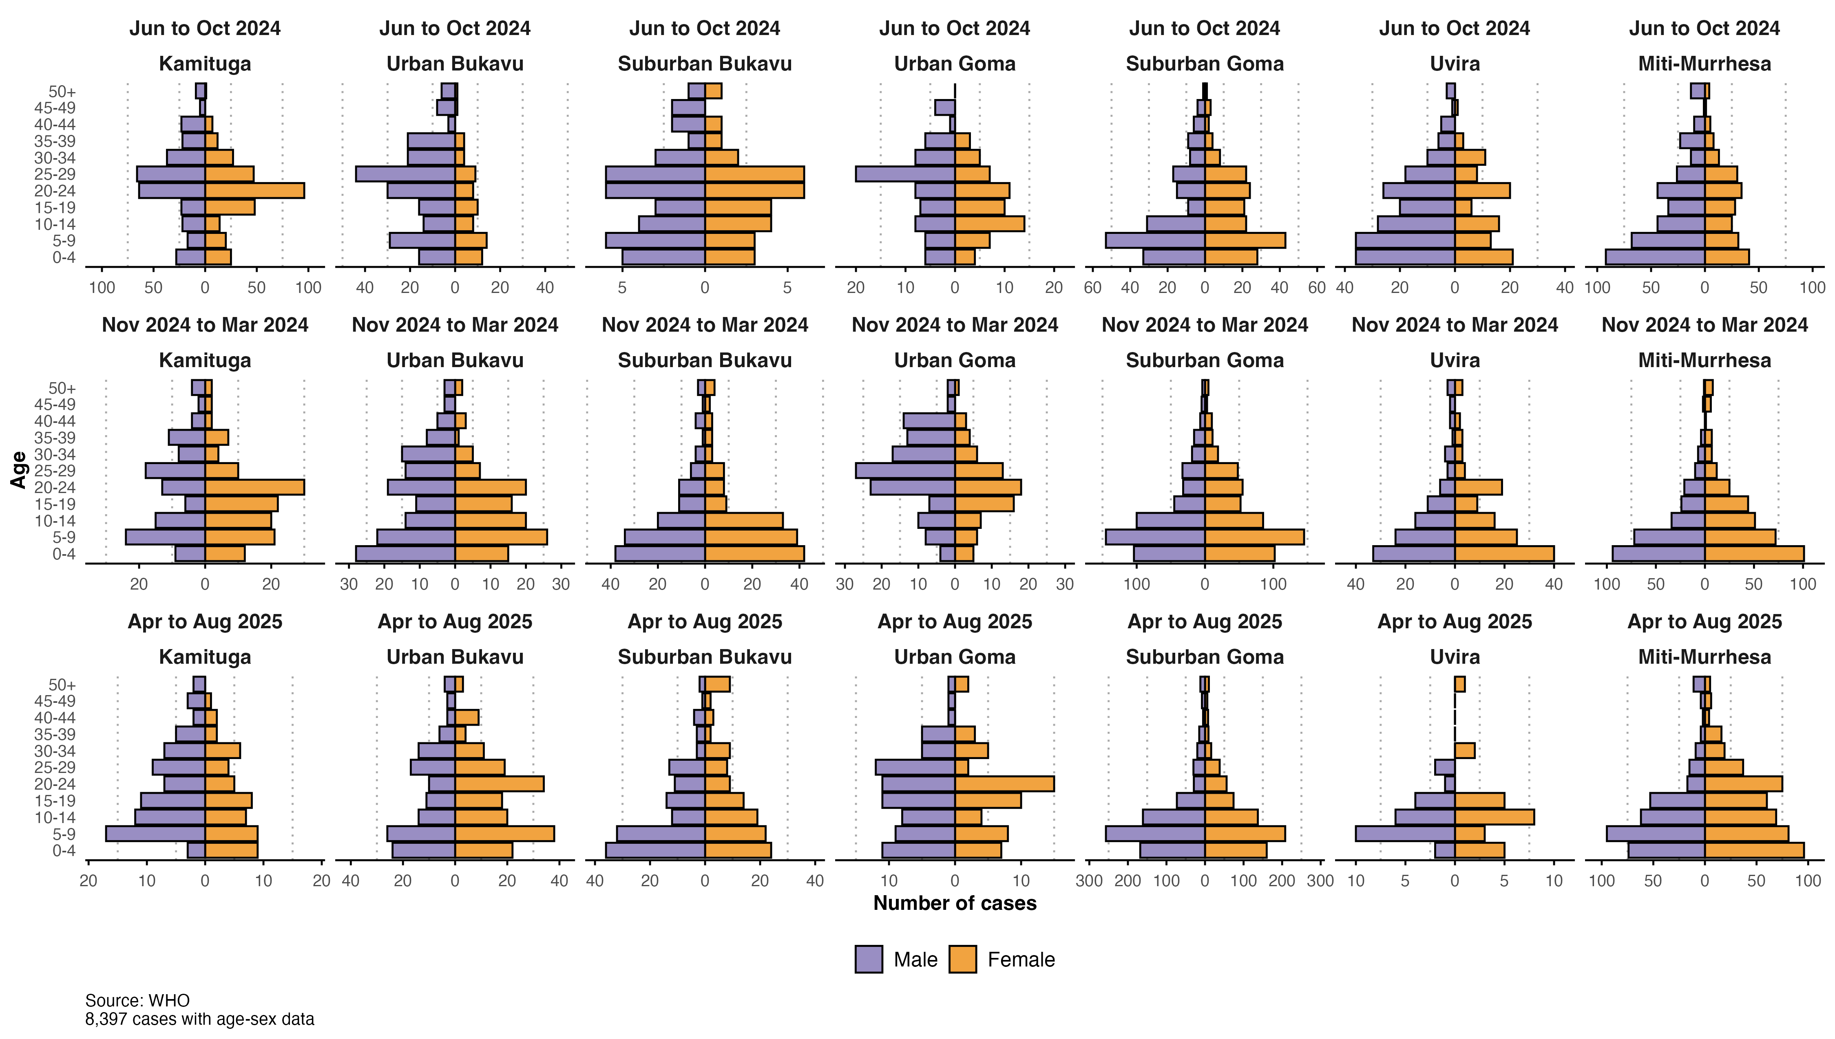
Figure S2.1: Age and gender of confirmed cases shown over three time periods, for selected areas of North and South Kivu. Urban Bukavu contains Bagira-Kasha, Ibanda, and Kadutu health zones. Suburban Bukavu contains Kabare, Walungu, Mubumbano, and Nyantende health zones. Suburban Goma includes Karisimbi and Nyiragongo health zones (both include numerous IDP camps). All other areas contain a single health zone.
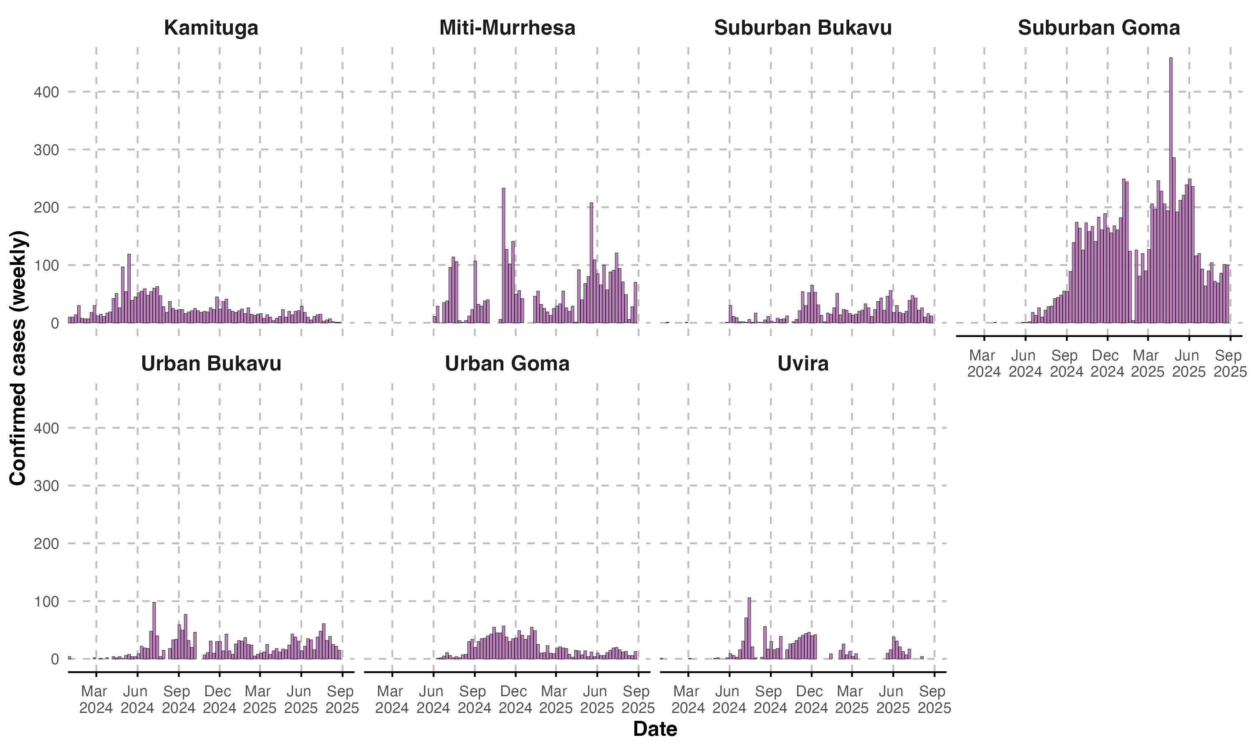
Figure S2.2: Trends in confirmed cases for selected areas of North and South Kivu. Urban Bukavu contains Bagira-Kasha, Ibanda, and Kadutu health zones. Suburban Bukavu contains Kabare, Walungu, Mubumbano, and Nyantende health zones. Suburban Goma includes Karisimbi and Nyiragongo health zones (both include numerous IDP camps). All other areas contain a single health zone.
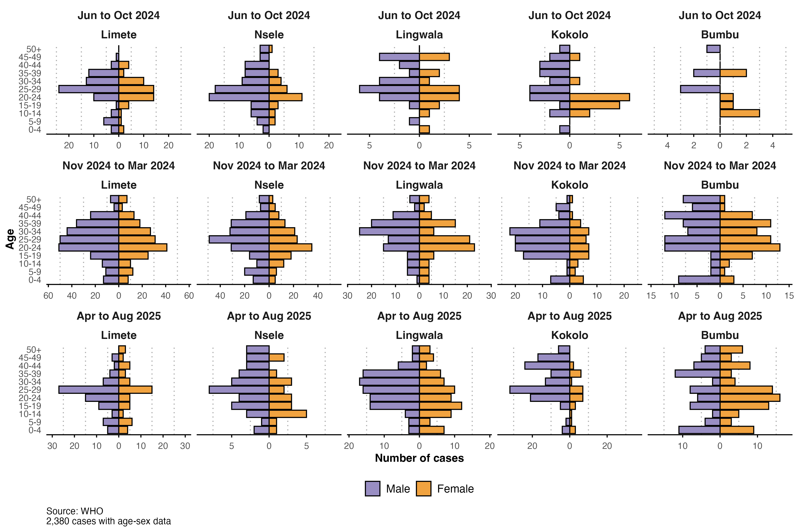
Figure S2.3: Age and gender of confirmed cases shown over three selected time periods, for the top five reporting health zones in Kinshasa.
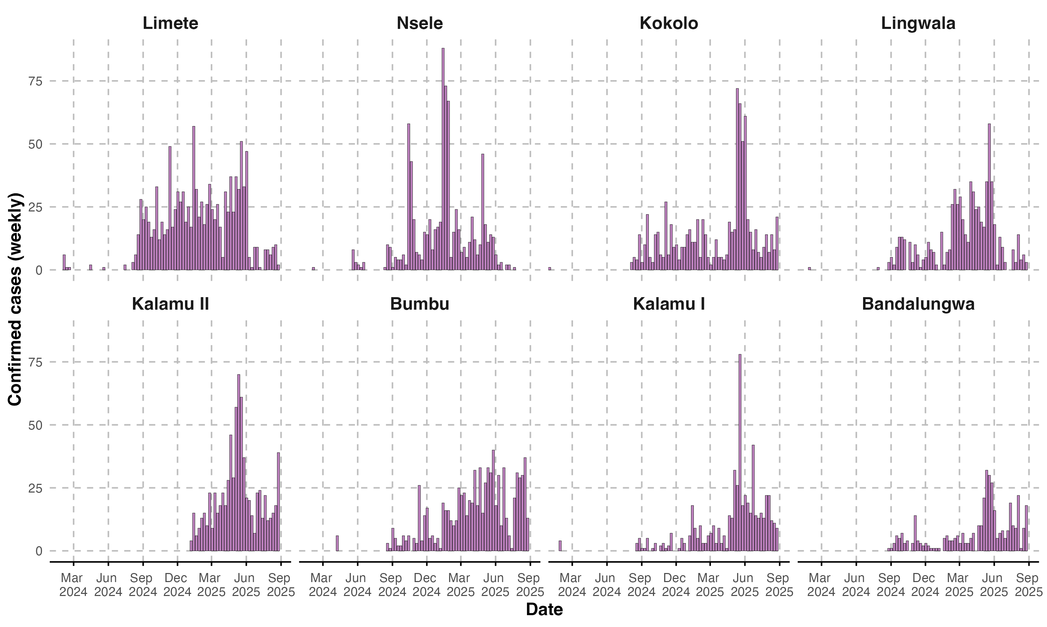
Figure S2.4: Trends in confirmed cases for the top eight reporting health zones in Kinshasa.
Table S2.1: Cumulative incidence rate ratios (IRRs) by age group and geography
 | Endemic provinces |  | Kinshasa |  | North and South Kivu
Age group | Cases | IRR (95% CI)¹ | Cases | IRR (95% CI)¹ | Cases | IRR (95% CI)¹
0-4 | 1,516 | 0.80 (0.75 - 0.87) | 326 | 0.78 (0.67 - 0.91) | 2,176 | 1.16 (1.08 - 1.23)
5-9 | 1,757 | 1.06 (0.98 - 1.13) | 302 | 0.84 (0.72 - 0.98) | 2,162 | 1.34 (1.26 - 1.43)
10-14 | 1,319 |  | 335 |  | 1,479
15-19 | 939 | 0.88 (0.81 - 0.96) | 543 | 1.48 (1.30 - 1.70) | 1,155 | 0.94 (0.87 - 1.01)
20-24 | 797 | 0.94 (0.86 - 1.02) | 907 | 2.45 (2.16 - 2.77) | 1,389 | 1.39 (1.30 - 1.50)
25-29 | 653 | 0.90 (0.82 - 0.98) | 1,024 | 3.53 (3.12 - 3.99) | 1,025 | 1.34 (1.23 - 1.45)
30-34 | 527 | 0.83 (0.75 - 0.91) | 713 | 3.00 (2.63 - 3.41) | 624 | 1.17 (1.07 - 1.28)
35-39 | 406 | 0.77 (0.69 - 0.86) | 613 | 3.12 (2.73 - 3.56) | 420 | 0.88 (0.79 - 0.99)
40-44 | 263 | 0.63 (0.55 - 0.72) | 424 | 2.57 (2.22 - 2.96) | 223 | 0.54 (0.47 - 0.62)
45-49 | 179 | 0.50 (0.43 - 0.59) | 198 | 1.39 (1.16 - 1.65) | 140 | 0.44 (0.37 - 0.53)
50+ | 283 | 0.29 (0.25 - 0.33) | 207 | 0.64 (0.54 - 0.76) | 216 | 0.22 (0.19 - 0.25)
¹Incidence rate ratio (IRR) of mpox cases in the endemic provinces, North and South Kivu, and Kinshasa compared to the 10-14 year age group.

Section 3: Transmission parameters
This section provides early estimates of the serial interval and age specific mixing matrices for the regions of interest.
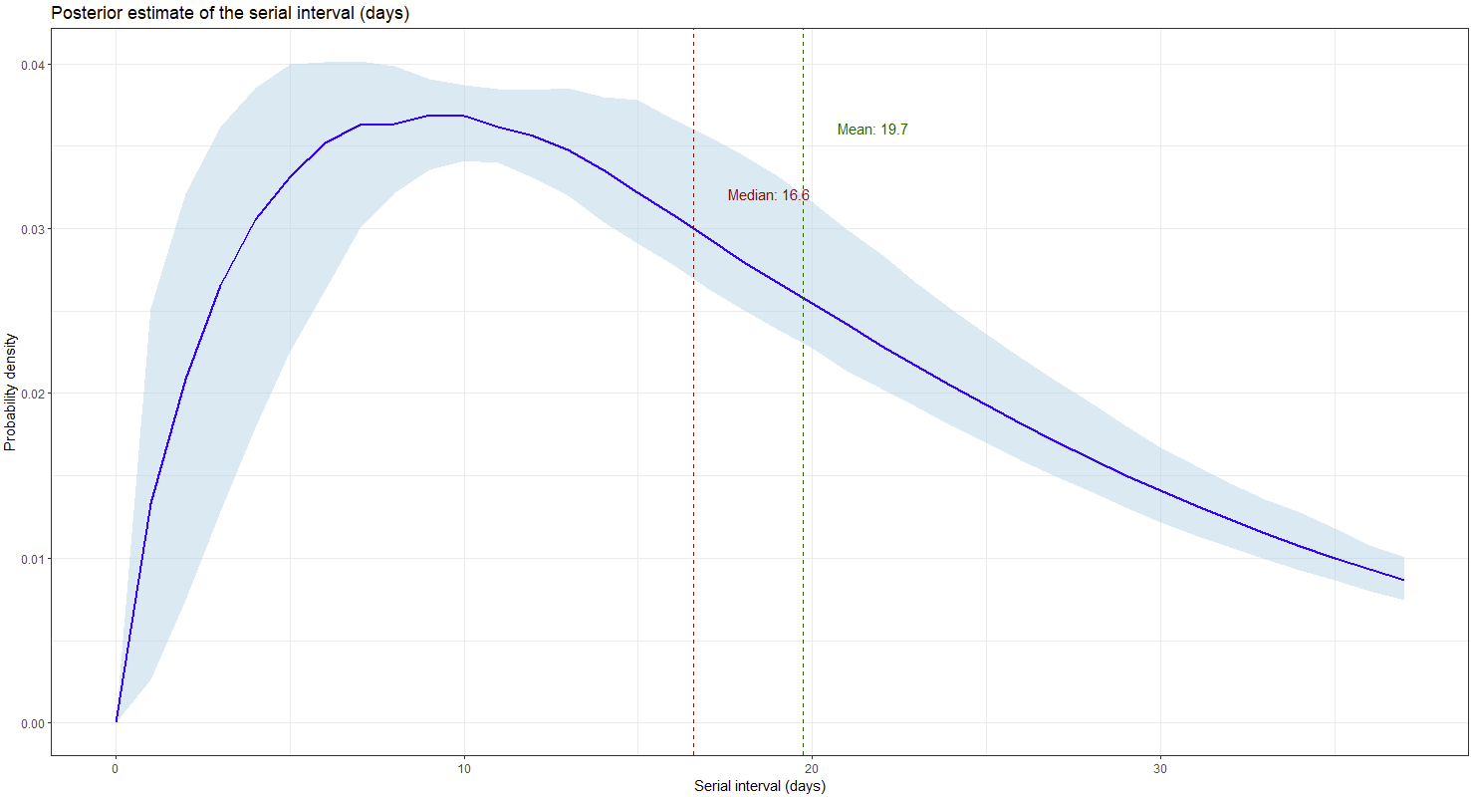
Figure S3.1: Distribution of the serial interval
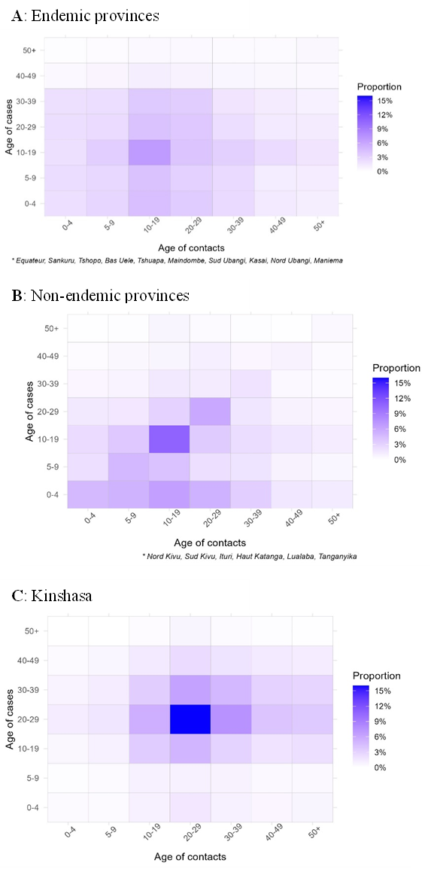
Figure S3.2: Mixing patterns of confirmed mpox cases and their reported contacts in different areas of the Democratic Republic of the Congo, January 2024-August 2025.

Section 4: Clade Ib affected urban areas
Epi curves and age/sex pyramids of urban areas affected by clade Ib MPXV.
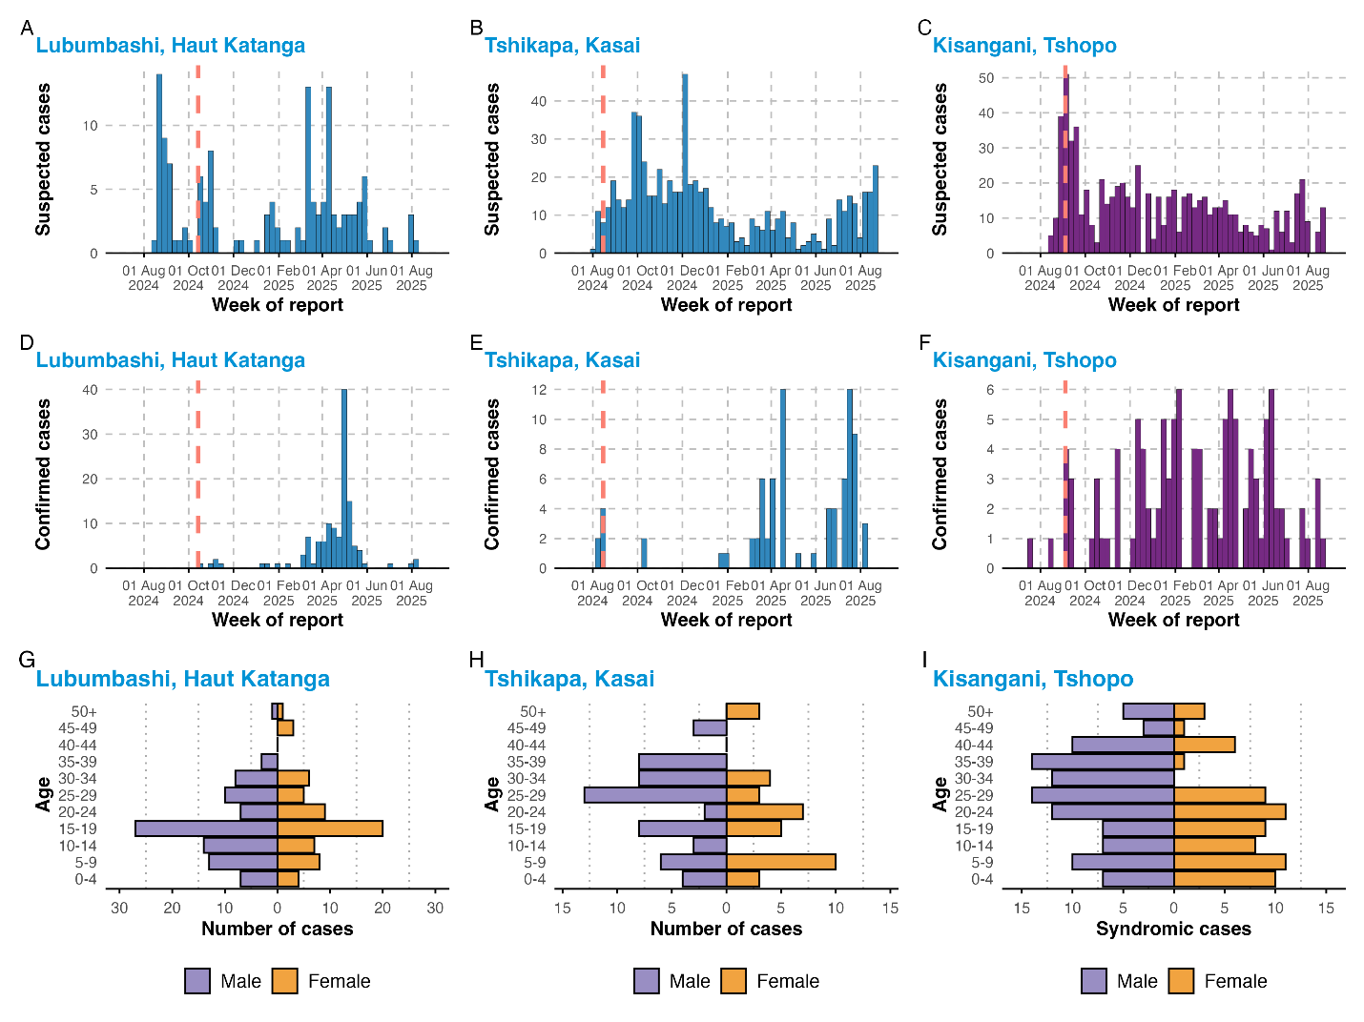
Figure S4.1: Characteristics of cases in urban areas outside of Kivu/Kinshasa affected by clade Ib MPXV. Characteristics of cases in urban areas outside of Kivu/Kinshasa affected by clade Ib MPXV. A-F: Suspected (A-C) and confirmed (D-F) cases of mpox in cities from August 2024 to August 2025. Red line indicates the date of first detection of clade Ib MPXV in the city. Not all suspected cases are tested. G-H: Demographics of confirmed cases in cities.

Section 5: Vaccination
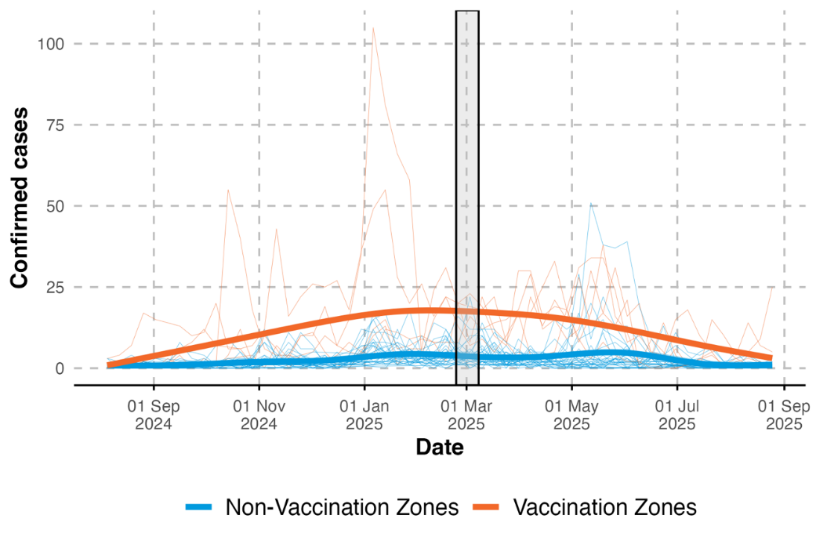
Figure S5.1 Comparison of aggregated smoothed trends (bold lines) and individual health zone trends (background lines) in health zones where vaccination occurred versus not with timing of vaccination highlighted (black box).

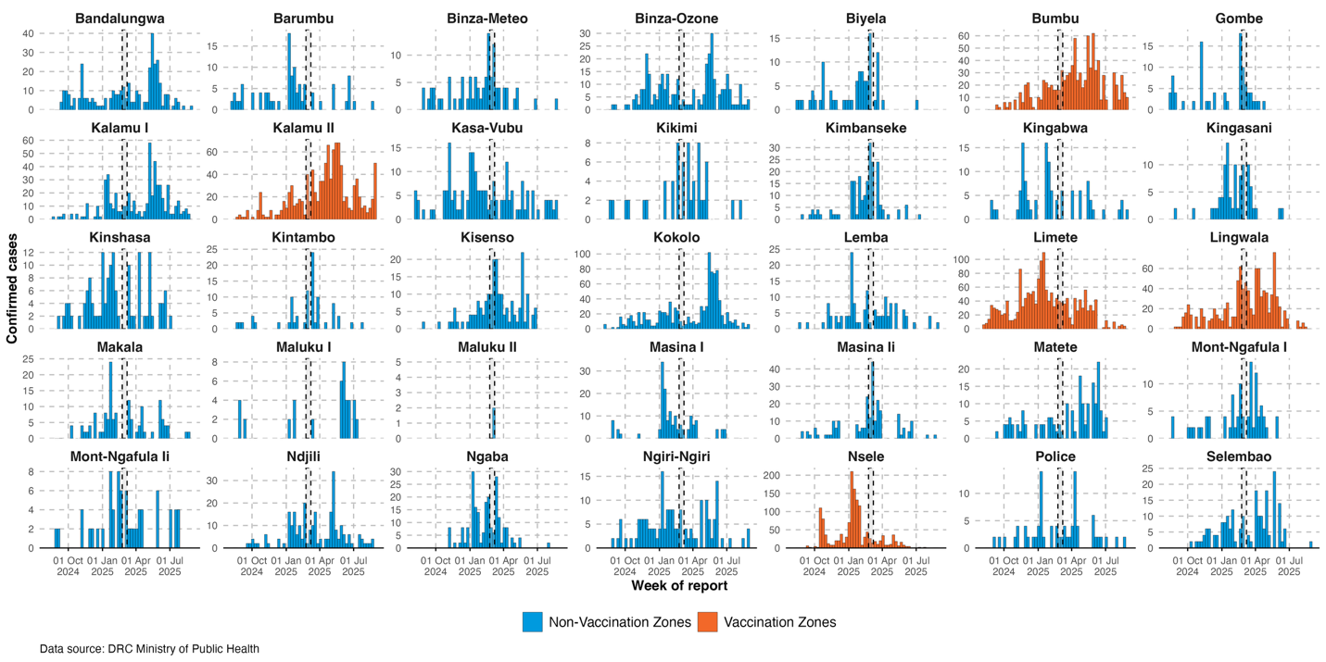
Figure S5.2 Epidemic curves of health zones in Kinshasa, by vaccination status with timing of vaccination campaign highlighted (black box).

