Supplementary Information

Comprehensive Evaluation of Transition Metal Doped Ni₃N to Construct High-Efficiency Hydrogen Evolution Catalyst

Meng Wang ^{1,2}, Zepeng Lv ^{1,2}, Xuewei Lv ^{1,2}, Qian Li ^{3,4}, Jie Dang ^{1,2,}*
Meng Wang, Zepeng Lv, Prof. Xuewei Lv, & Jie Dang
¹ College of Materials Science and Engineering, Chongqing University, Chongqing, Chongqing, 400044, PR China
² Key Laboratory of Vanadium-Titanium Metallurgy and New Materials, Chongqing
University, Chongqing, 400044, PR China
E-mail: jiedang@cqu.edu.cn
Qian Li
³ National Engineering Research Center for Magnesium Alloys, Chongqing University, Chongqing, 400044, PR China
⁴ State Key Laboratory of Advanced Special Steels & Shanghai Key Laboratory of Advanced Ferrometallurgy, School of Materials Science and Engineering, Shanghai University, Shanghai 200444, PR China.
Experimental Section
Synthesis of Co,V-Ni₃N: Co,V-doped nanosheets were prepared on nickel foam via a two-step method. Firstly, nickel foam substrate was pretreated with 3M HCl to remove the oxide layer and impurity on the surface, and then cleaned by deionized water and ethanol for several times. Secondly, nickel foam supported Co,V doped nickel hydroxide nanosheets were synthesized by a modified hydrothermal reaction. Typically, 0.05 mmol NH₄VO₃, 0.05 mmol Co(NO₃)₂·6H₂O, 0.90 mmol Ni(NO₃)₂·6H₂O, 5 mmol of CO(NH₂)₂ and 2 mmol NH₄F were dissolved in 20 mL deionized water under stirring to form a homogeneous solution. The solution and a piece of nickel foam (NF, 2cm*3cm) were transferred into a 50 mL Teflon-lined autoclave, sealed and kept at 120 ℃ for 8h, to obtain dual doped nickel hydroxide (Co,V-Ni(OH)₂) nanosheets array, which was further cleaned with water and ethanol, respectively. Finally, the nanosheets was fabricated by nitridation of the prepared cobalt doped nickel hydroxide nanosheets in a tube furnace system at 450 ℃ for 2h under the high purity NH₃ atmosphere which was named as Co,V-Ni₃N.
Synthesis of Co,Cr-Ni₃N: 0.05 mmol Cr(NO₃)₂·9H₂O, 0.05 mmol Co(NO₃)₂·6H₂O, 0.90 mmol Ni(NO₃)₂·6H₂O, 5 mmol of CO(NH₂)₂ and 2 mmol NH₄F were dissolved in 20 mL deionized water under stirring to form a homogeneous solution. Other steps were the same as that for Co,V-Ni₃N.
Synthesis of Cr,V-Ni₃N: 0.05 mmol NH₄VO₃, 0.05 mmol Cr(NO₃)₂·9H₂O, 0.90 mmol Ni(NO₃)₂·6H₂O, 5 mmol of CO(NH₂)₂ and 2 mmol NH₄F were dissolved in 20 mL deionized water under stirring to form a homogeneous solution. Other steps were the same as that for Co,V-Ni₃N.
Synthesis of single doped Ni₃N: V-Ni₃N, Cr-Ni₃N, Co-Ni₃N, Mn-Ni₃N, Mn-Ni₃N, W-Ni₃N and Fe-Ni₃N were synthesized by using NH₄VO₃, Cr(NO₃)₂·9H₂O, Co(NO₃)₂·6H₂O, Mn(NO₃)₂·4H₂O, Na₂MoO₄, Na₂WO₄ and Fe(NO₃)₂·9H₂O, respectively. Transition metal doping can be adjusted by changing the type of transition metal salts. The molar ratio of transition metal salt to Ni(NO₃)₂·6H₂O is 0.05 mmol : 0.95 mmol. Other steps were the same as that for Co,V-Ni₃N.
Synthesis of Ni₃N: The pure Ni₃N was also synthesized with similar procedure by using 1 mmol Ni(NO₃)₂·6H₂O, 5 mmol of CO(NH₂)₂ and 2 mmol NH₄F.
Synthesis of Pt/C electrode: The corresponding commercial 20 wt% Pt/C powder were dipped on Ni foam for the comparison experiment. Pt/C electrode as a reference was prepared by the following method: 21.5 mg of commercial Pt/C was mixed with 110 μl of deionized water, 106 μl of alcohol and 5 μl of nafion to form a slurry, then which was dropped on the NF (1×1 cm²) and dried at room temperature.
Materials characterization: To analyze the samples composition and microstructure, X-ray diffraction (XRD) was conducted on a PANalytical X’Pert Powder (Panalytical B.V.). Field-emission scanning electron microscopy (FESEM) analysis was performed on the JEOL JSM-7800F to characterize the surface morphologies. High-resolution transmission electron microscopy (HRTEM), high-angle annular dark-field scanning transmission electron microscopy (HAADF-STEM), and energy-dispersive spectroscopy (EDS) mapping were performed on the Talos F200S. X-ray photoelectron spectroscopy (XPS) experiments were performed on the ESCALAB250Xi, and all of the XPS binding energies were calibrated using the contaminant carbon (C1S) as a reference. Ultraviolet Photoemission Spectroscopy (UPS) experiments were collected at ThermoFisher ESCALAB 250Xi. Electron paramagnetic resonance (EPR) spectra were measured by Bruker A300 spectrometer at 20 °C. ICP- OES analysis was conducted using an Optima 8000 instrument.
Electrochemical measurement: All electrochemical measurements were performed on CHI660E electrochemical work station (Shanghai Chenhua Instrument Co., Ltd., China) by using the typical three-electrode set-up at 25℃. Transition metal doped Ni₃N was used directly as the work electrode (1 cm⁻² electrode area), and a Hg/HgO electrode and a graphite rod served as the reference electrode and the counter electrode, respectively. For the HER in alkaline media, all the potentials were recorded with respect to the reversible hydrogen electrode (RHE) using equation (E_{RHE} = E_{Hg/HgO} + 0.098 + 0.059* pH), where E_{RHE} is the potential referred to RHE and E_{Hg/HgO} is the practically applied voltage window. Linear sweep voltammograms (LSV) were tested at a scan rate of 2 mV s⁻¹ in 1M KOH after 30 cyclic voltammetry (CV) testing. The onset potential was defined as the potential required when the current density of 1 mA cm⁻². AC impedance measurements were carried out from 0.001 Hz to 100 0000 Hz with the amplitude of 5 mV. In HER measurements, all polarization curves were iRs-corrected (90%) using the equation: E_{iRs-corrected} = E – iRs, where E is the original potential, Rs is the solution resistance, i is the corresponding current, and E_{iRs-corrected} is the iRs-corrected potential. The electrochemically active surface area (ECSA) was estimated by measuring the capacitive current associated with double-layer charging from scan-rate dependence of CVs and the scan rates were 10-60 mV s⁻¹. The polarization curves before and after cycling are recorded under quasi-equilibrium conditions at a scan rate of 2 mV s⁻¹. The capacitance current was measured within the potential range of the non-Faraday region. For the HER a in alkaline seawater, all the potentials were recorded with respect to the reversible hydrogen electrode (RHE) using equation (E_{RHE} = E_{Hg/HgO} + 0.098 + 0.059* 13.1).
Estimation for the TOF: The TOF values were calculated using the equation: TOF_{HER} = I/Q, where I is the current measured in LSV and voltammetric charges (Q) were obtained from CV curves in 1 M KOH (pH = 14) at a scan rate of 60 mV s⁻¹. Q = It = IU/v = 1/v∫ UI, where t is the time, U and I are the voltage and current of the CV curve, ∫ UI is the integral area of the CV curve, and v is the scan rate of 60 mV s⁻¹.
Computational details: Plane-wave density functional theory (DFT) calculations were performed on CASTEP code of the Materials Studio package of Accelrys Inc. Generalized gradient approximation (GGA) in the form of Perdew–Burke–Ernzerhof (PBE) functional was employed for the DFT exchange correlation energy and ultrasoft pseudo-potentials are used for the core electrons. A plane-wave basis set with an energy cutoff energy of 500 eV was assigned. The force atomic relaxation was 0.01 eV Å⁻¹. The Ni₃N (001) surface was modeled by a periodic five-layer slab repeated in 2×2 surface unit cell with a vacuum width of 15 Å between the slabs along the Z axis, where all atoms were fully relaxed. The water adsorption energy E_{H2O} is calculated by E_{H2O} = E_{(surf+H2O)}-E_{(surf)} -E_{H2O}, where E_{(surf+ H2O)} and E_{(surf)} are the total energies of the surface with and without the H₂O adsorbate, and E_{(H2O)} is the energy of a free water molecule. Additionally, the hydrogen adsorption free energy △G_{H*} is calculated by △G_{H*} = E_{(surf+H)}-E_{(surf)-}1/2E_{(H2)}+△E_{ZPE}-T△S, where △E_{ZPE} and △S are the difference in the zero-point energy and entropy between the adsorbed H atom and the gaseous phase H₂. At T=289.15 K, △G_{H*} can be calculated by △G_{H*} =E_{(surf+H)}-E_{(surf)}- 1/2E_{(H2)}+0.24 eV.¹⁻³
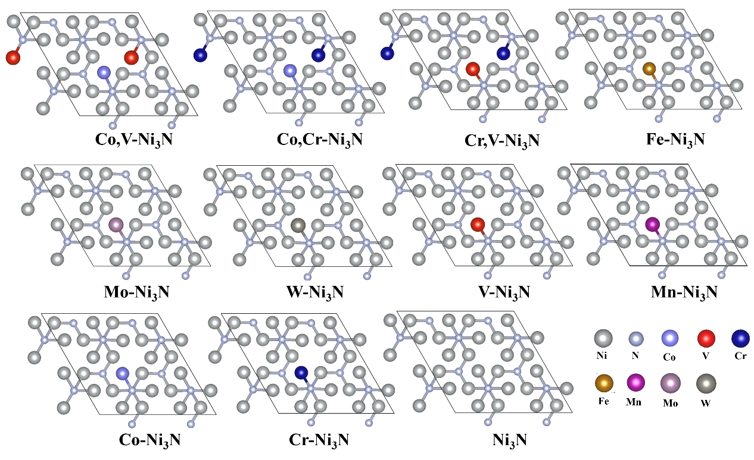 Supplementary Figure 1. Optimized calculation model constructed by replacing Ni with corresponding transition metal elements.
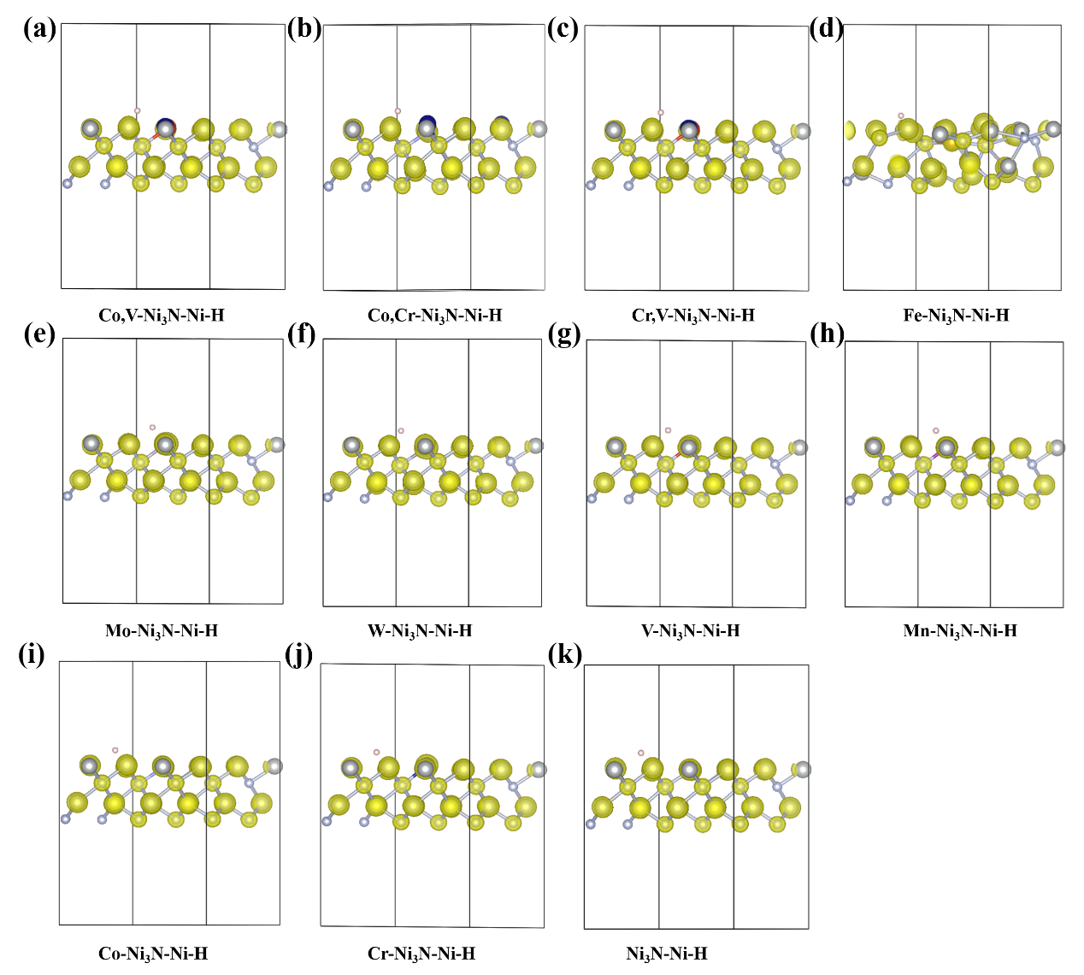
Supplementary Figure 2. Optimized calculation model of hydrogen adsorption (Ni-H).
Supplementary Table 1. Hydrogen adsorption energy of samples.
 | Co,V-Ni₃N | Co,Cr-Ni₃N | Cr,V-Ni₃N | Fe-Ni₃N
ΔG_{H*} (eV) | -0.076 | 0.078 | -0.111 | 0.479
 | Mo-Ni₃N | W-Ni₃N | V-Ni₃N | Mn-Ni₃N
ΔG_{H*} (eV) | -0.225 | -0.312 | 0.102 | -0.146
 | Co-Ni₃N | Cr-Ni₃N | Ni₃N
ΔG_{H*} (eV) | -0.117 | 0.098 | 0.363

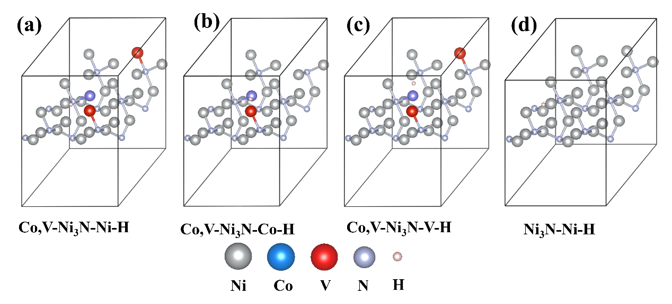
Supplementary Figure 3. Optimized calculation model of hydrogen adsorption on Ni, Co and V of Co,V-Ni₃N.
Supplementary Table 2. Gibbs free energy of adsorbed hydrogen during hydrogen reduction reaction on Co,V-Ni₃N, Co, Cr-Ni₃N and Cr,V-Ni₃N.
 | Ni-H | Co-H | V-H | Cr-H
Co,V-Ni₃N | -0.076 | -0.126 | -0.196 | ——
Co,Cr-Ni₃N | 0.078 | 0.17 | —— | -0.093
Cr,V-Ni₃N | -0.111 | —— | 0.162 | -0.143

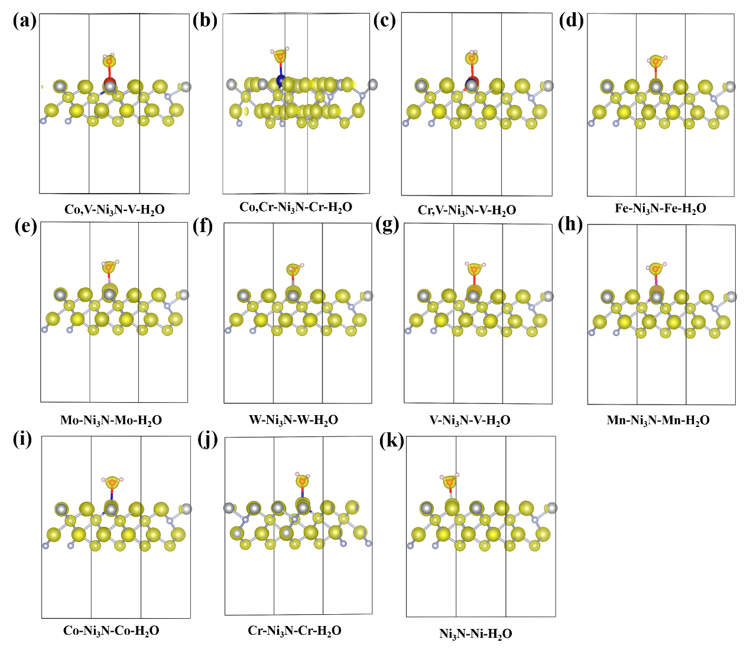
Supplementary Figure 4. Optimized calculation model of water molecule adsorption.
Supplementary Table 3. Water adsorption energy of samples.
 | Co,V-Ni₃N | Co,Cr-Ni₃N | Cr,V-Ni₃N | Fe-Ni₃N
ΔG_{H2O*} (eV) | -0.197 | 0.229 | -0.068 | 0.202
 | Mo-Ni₃N | W-Ni₃N | V-Ni₃N | Mn-Ni₃N
ΔG_{H2O*} (eV) | -0.176 | -0.139 | -0.265 | -0.646
 | Co-Ni₃N | Cr-Ni₃N | Ni₃N
ΔG_{H2O*} (eV) | 0.195 | 0.138 | 0.561

Supplementary Table 4. Gibbs free energy of adsorbed water molecule during hydrogen reduction reaction on Co,V-Ni₃N, Co, Cr-Ni₃N and Cr,V-Ni₃N.
 | Ni-H₂O | Co- H₂O | V- H₂O | Cr- H₂O
Co,V-Ni₃N | 0.601 | 0.581 | -0.197 | ——
Co,Cr-Ni₃N | 0.692 | 0.557 | —— | 0.229
Cr,V-Ni₃N | 0.645 | —— | -0.068 | 0.192

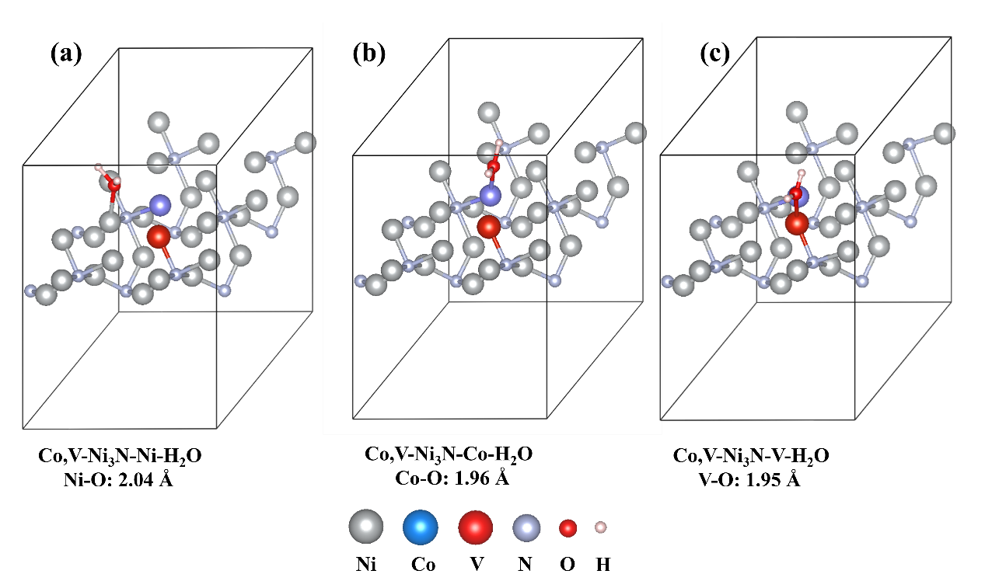
Supplementary Figure 5. Optimized calculation model of water molecule adsorption on Ni, Co and V of Co,V-Ni₃N.
As shown in Figure 5, an enforced interaction between bare Co,V-Ni₃N and H₂O with a N–O bond length of 2.04 Å could be identified. When the water molecule forms a bond with V, the V–O bond length was apparently shortened to 1.95 Å, signifying the increased V–O binding strength and strengthening the ability to adsorb water molecule.
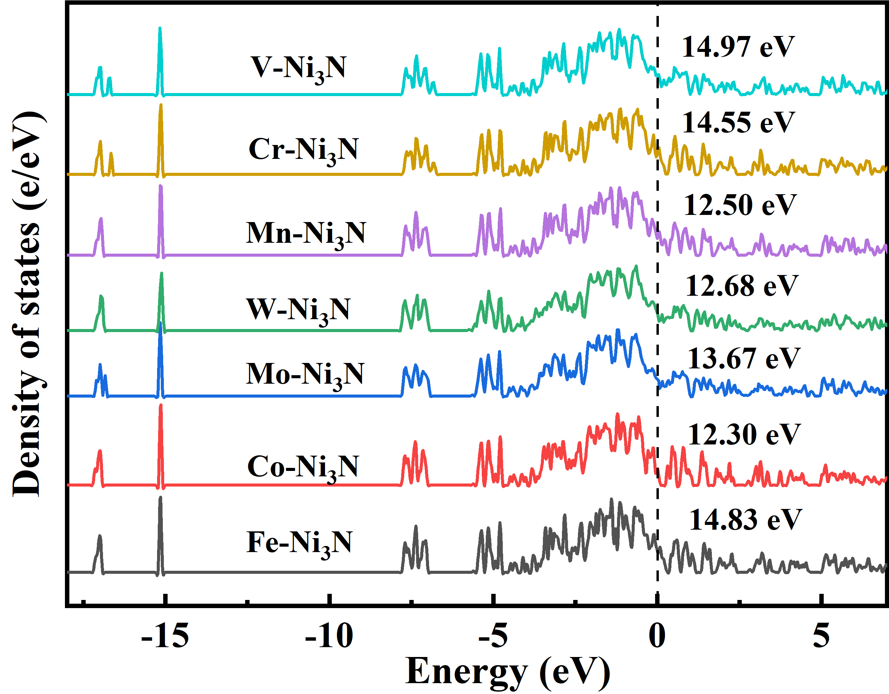
Supplementary Figure 6. DOS of catalysts.
DOS corresponds to the conductivity of the catalysts. According to the DOS result, we can obtain that the conductivity trend. This confirms that transition metal doping will generally increase the conductivity of catalysts.
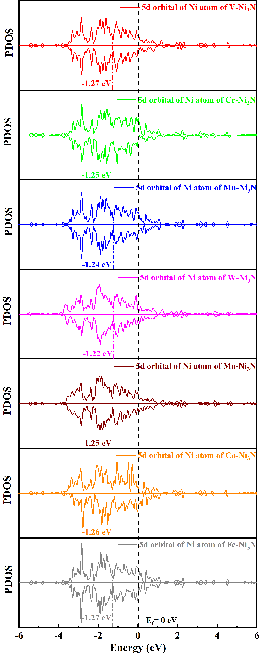
Supplementary Figure 7. D-band center of catalysts.
According to the d-band theory, it suggests more electron filling (higher occupation, down-shifting) of anti-bonding states between adsorbate and catalyst’s d band, leading to a weakened interaction between adsorbate and surface.
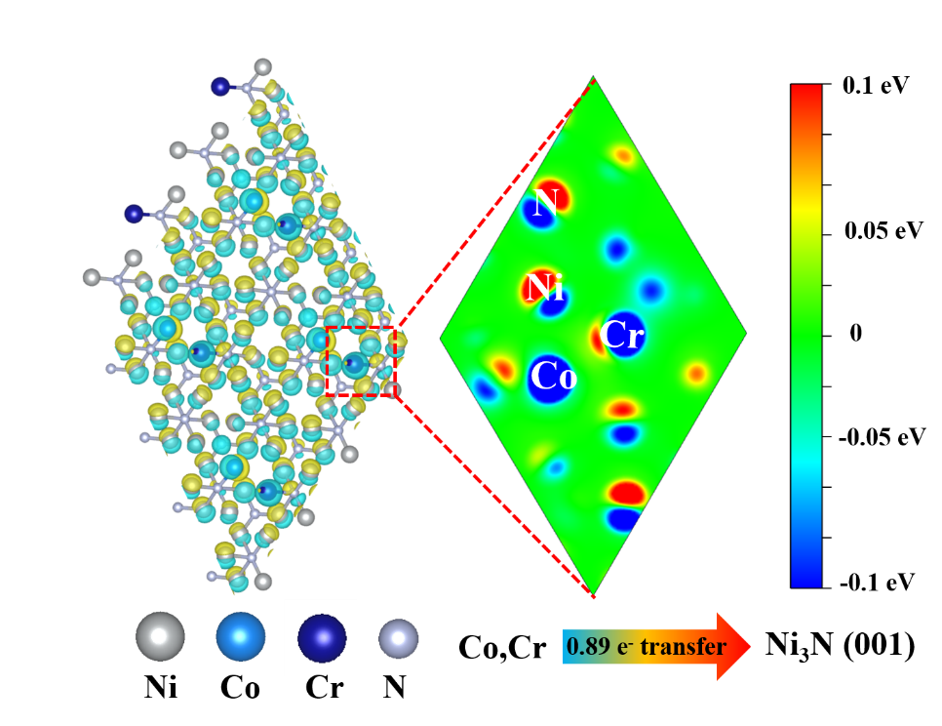
Supplementary Figure 8. Charge density redistribution of the Co,Cr-Ni₃N constructed by replacing Ni with Co,Cr, resulting in 0.29 e₋ transfer from Co,Cr to Ni₃N.
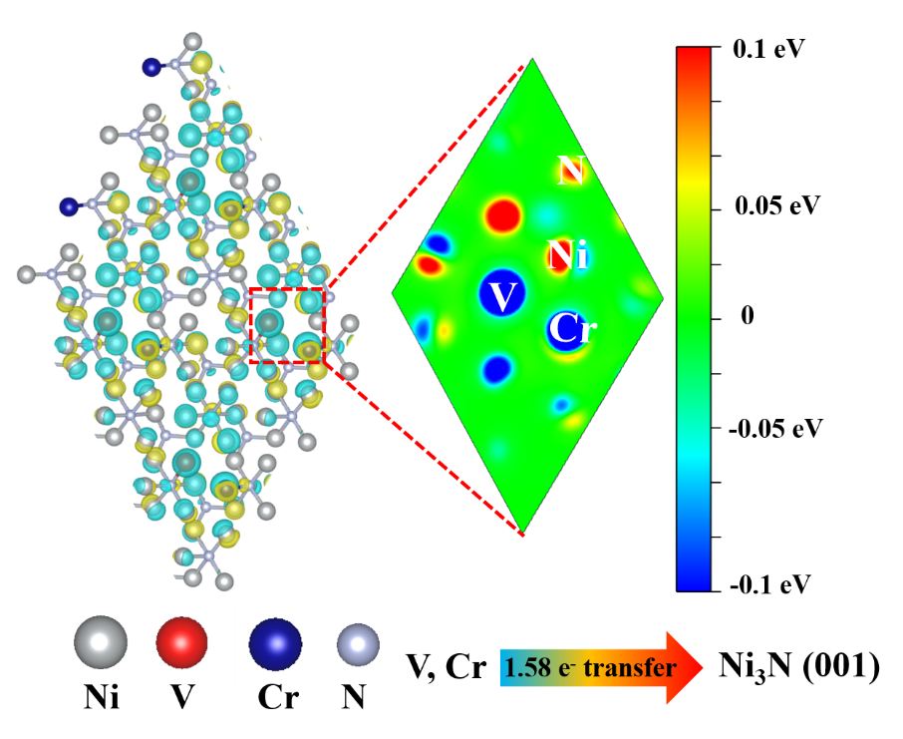
Supplementary Figure 9. Charge density redistribution of the Cr,V-Ni₃N constructed by replacing Ni with Cr,V, resulting in 1.58 e₋ transfer from Cr,V to Ni₃N.
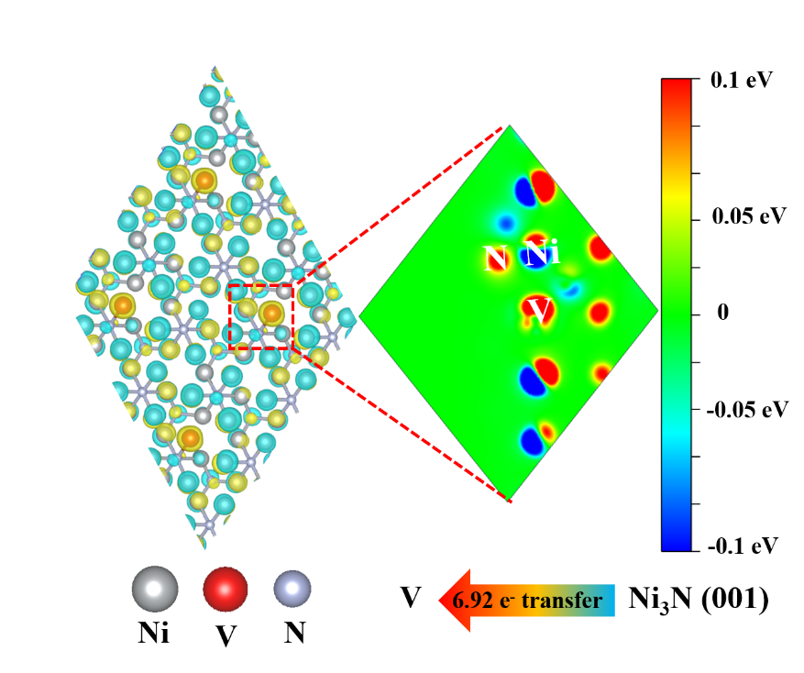
Supplementary Figure 10. Charge density redistribution of the V-Ni₃N constructed by replacing Ni with V, resulting in 6.92 e₋ transfer from Ni₃N to V.
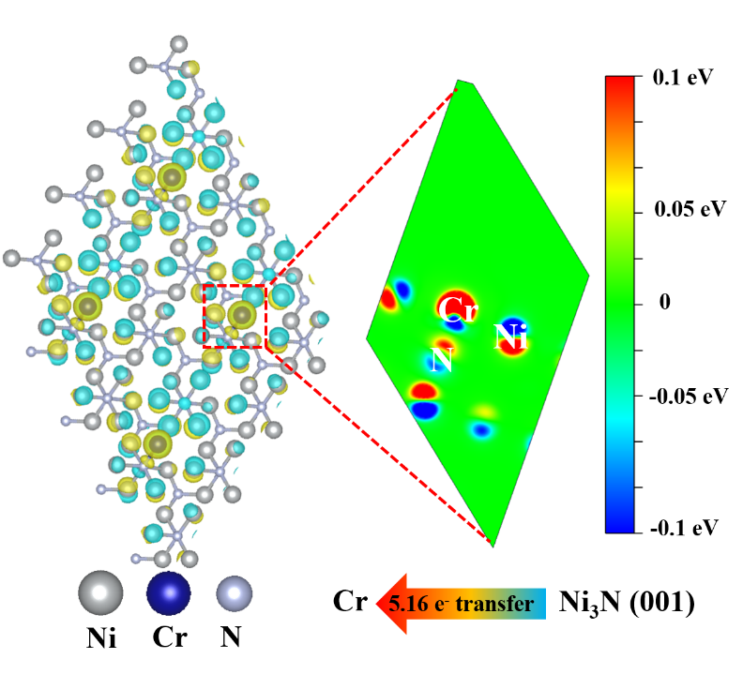
Supplementary Figure 11. Charge density redistribution of the Cr-Ni₃N constructed by replacing Ni with Cr, resulting in 5.16 e₋ transfer from Ni₃N to Cr.
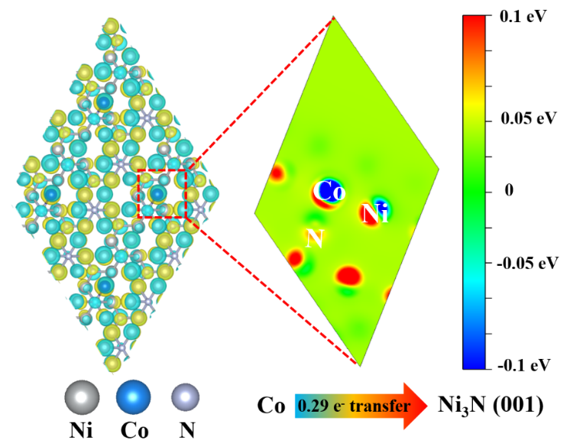
Supplementary Figure 12. Charge density redistribution of the Co-Ni₃N constructed by replacing Ni with Co, resulting in 0.29 e₋ transfer from Co to Ni₃N.
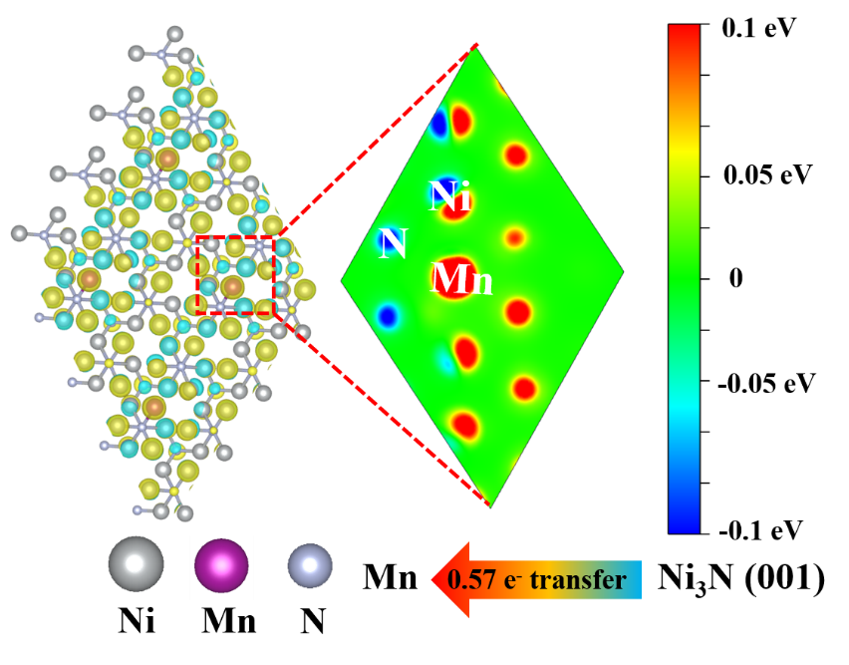

Supplementary Figure 13. Charge density redistribution of the Mn-Ni₃N constructed by replacing Ni with Mn, resulting in 0.57 e₋ transfer from Ni₃N to Mn.
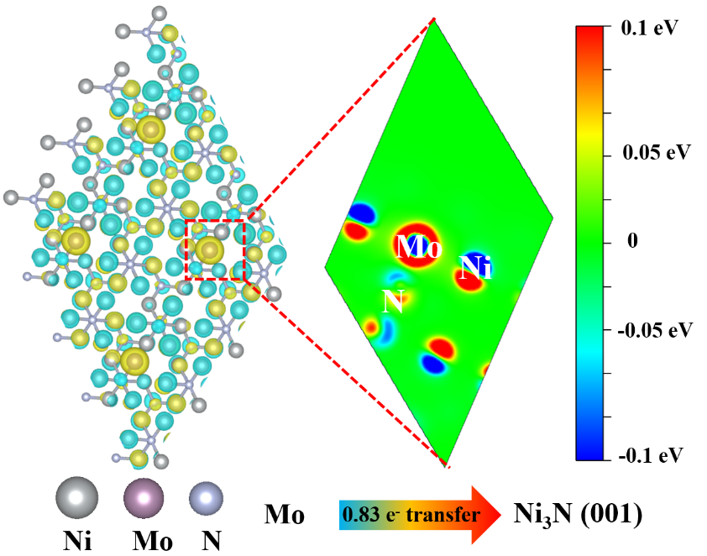
Supplementary Figure 14. Charge density redistribution of the Mo-Ni₃N constructed by replacing Ni with Mo, resulting in 0.83 e₋ transfer from Mo to Ni₃N.
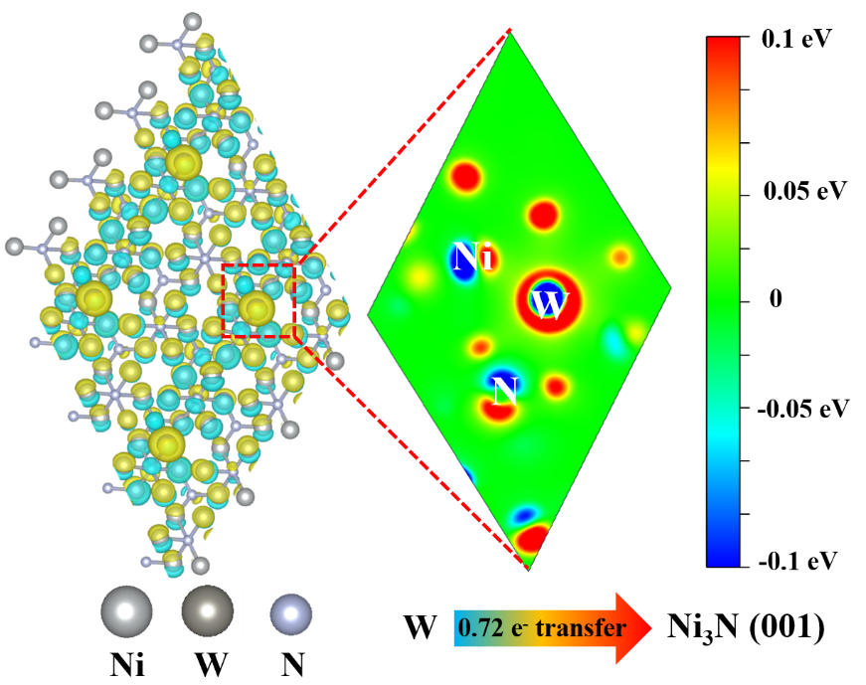
Supplementary Figure 15. Charge density redistribution of the W-Ni₃N constructed by replacing Ni with W, resulting in 0.72 e₋ transfer from W to Ni₃N.
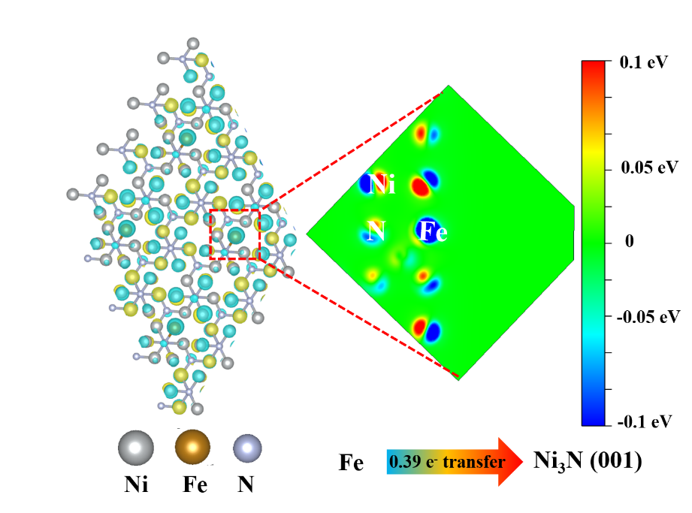
Supplementary Figure 16. Charge density redistribution of the Fe-Ni₃N constructed by replacing Ni with Fe, resulting in 0.39 e₋ transfer from Fe to Ni₃N.
Supplementary Table 5. The specific integral area value of radar chart.
samples | Co,V-Ni₃N |  | Co,Cr-Ni₃N |  | Cr,V-Ni₃N
area | 0.99 |  | 0.52 |  | 0.75
samples | V-Ni₃N | Cr-Ni₃N |  | Co-Ni₃N |  | Mn-Ni₃N |  | Mo-Ni₃N | W-Ni₃N | Fe-Ni₃N
area | 1.15 | 0.76 |  | 0.34 |  | 0.66 |  | 0.47 | 0.28 | 0.12

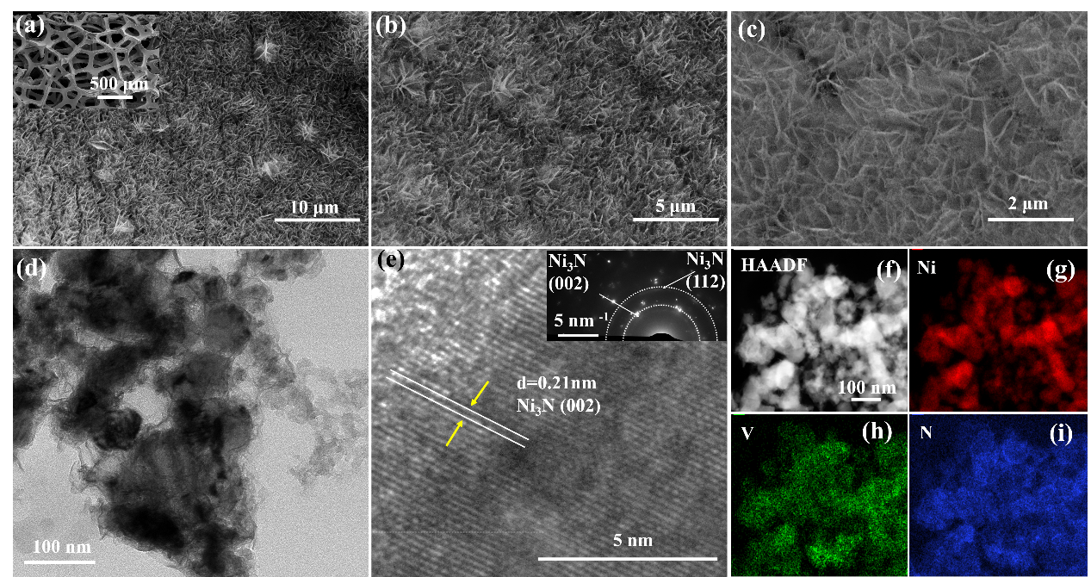
Supplementary Figure 17. (a-c) SEM of V-Ni₃N; (d) TEM, and (e) HRTEM images of the prepared Co,V-Ni₃N nanosheets; inset: SAED. (f-i) HAADF-STEM image and the elemental mapping images of Ni, V and N.
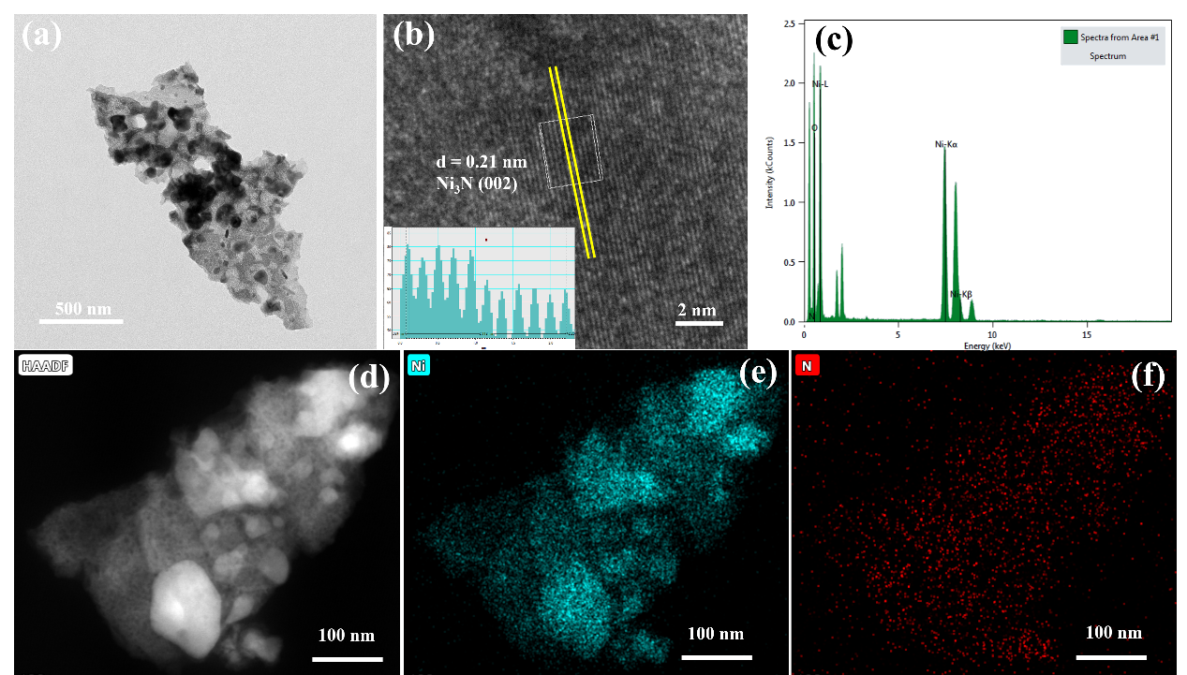
Supplementary Figure 18. (a-b) TEM images of Ni₃N; (c) EDS spectrum and atomic ratios of Ni₃N; (d-f) HAADF-STEM image and the elemental mapping images of Ni and N of Ni₃N.
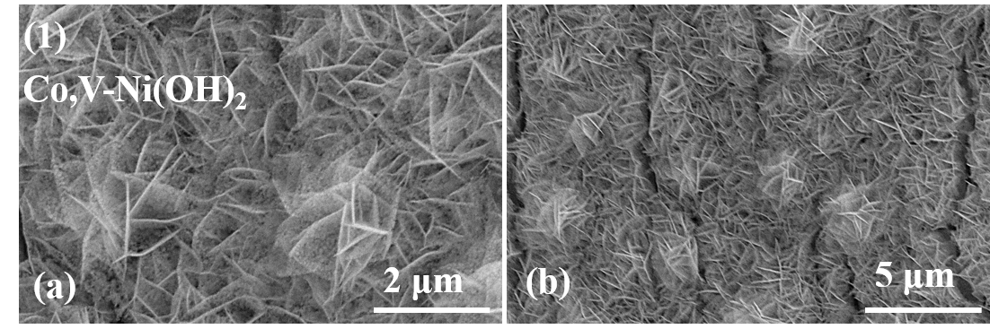
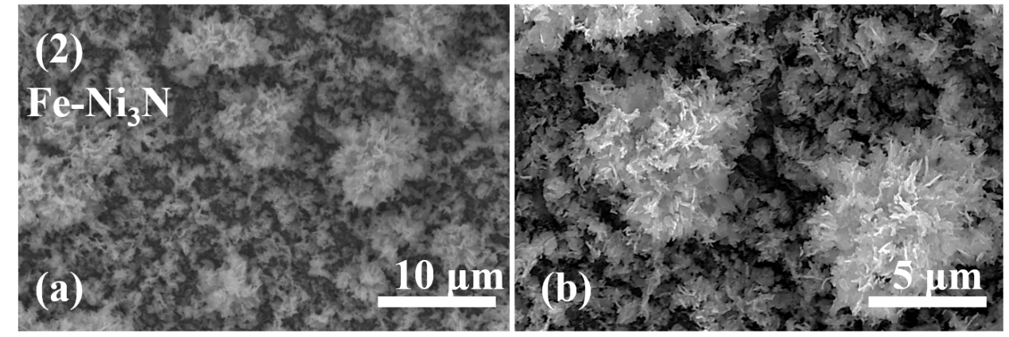
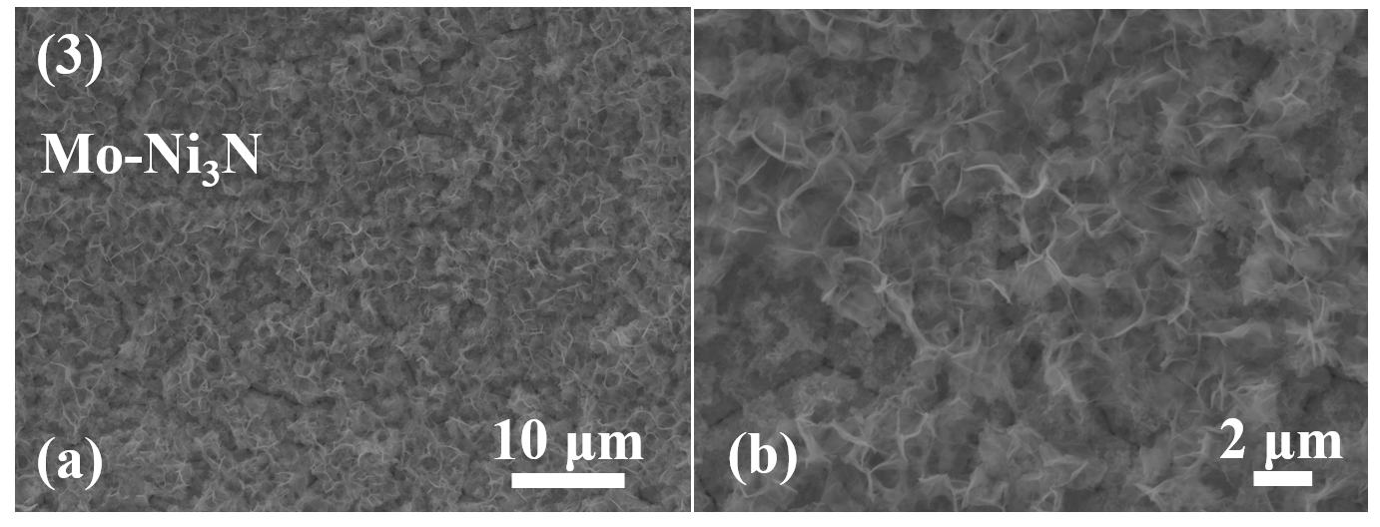
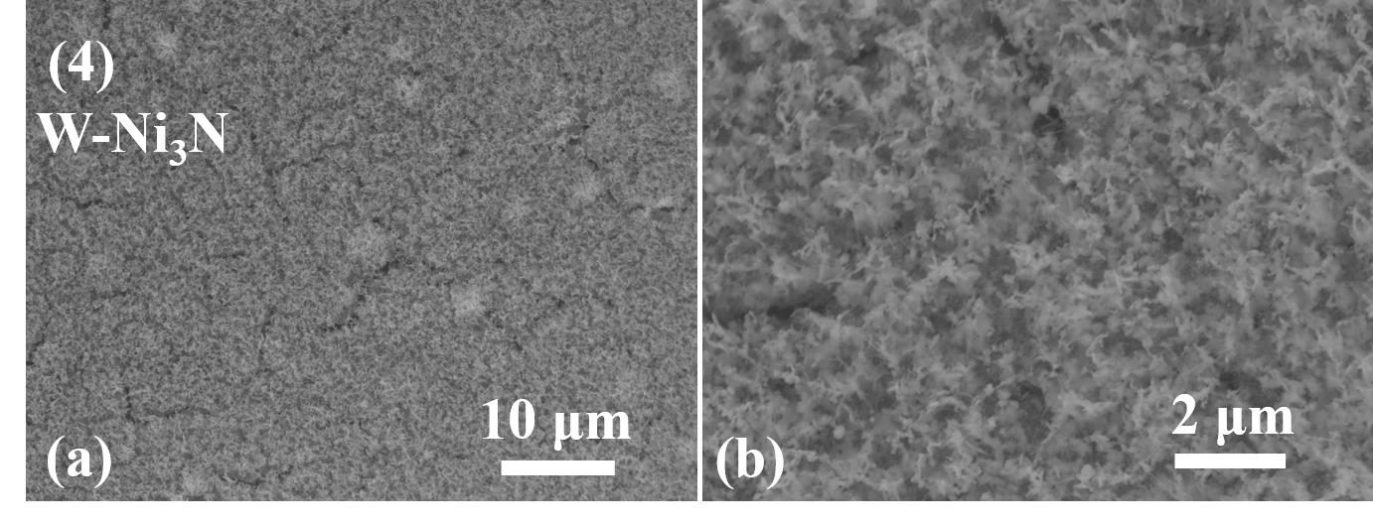
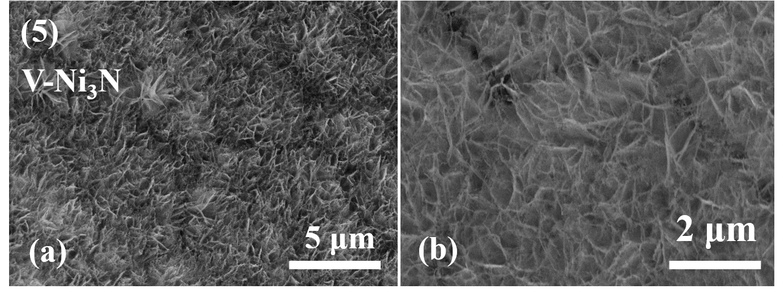
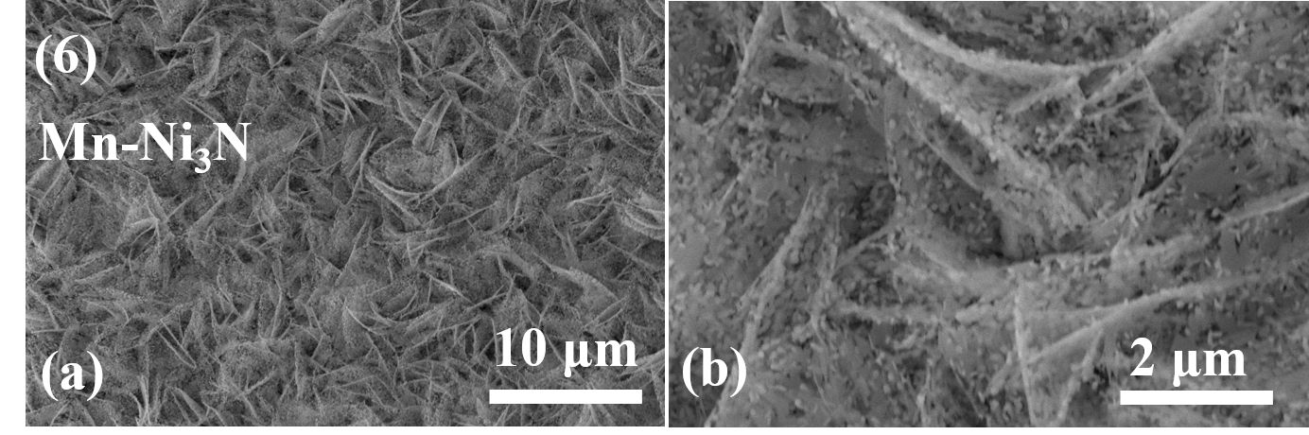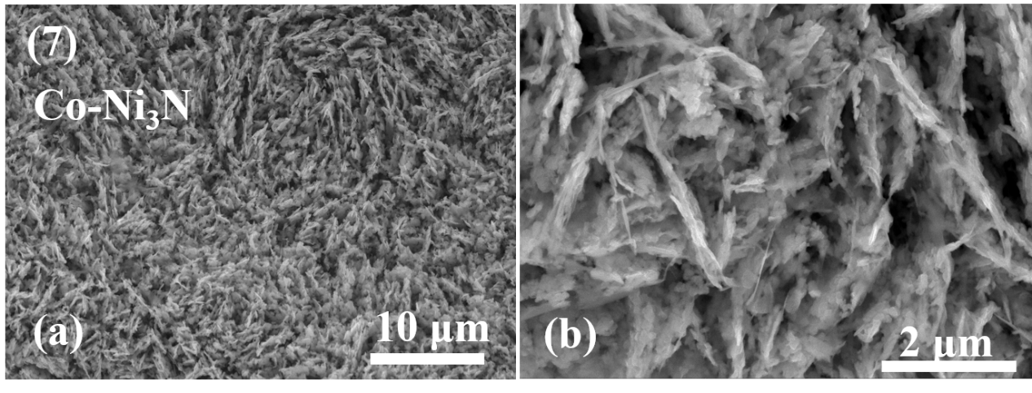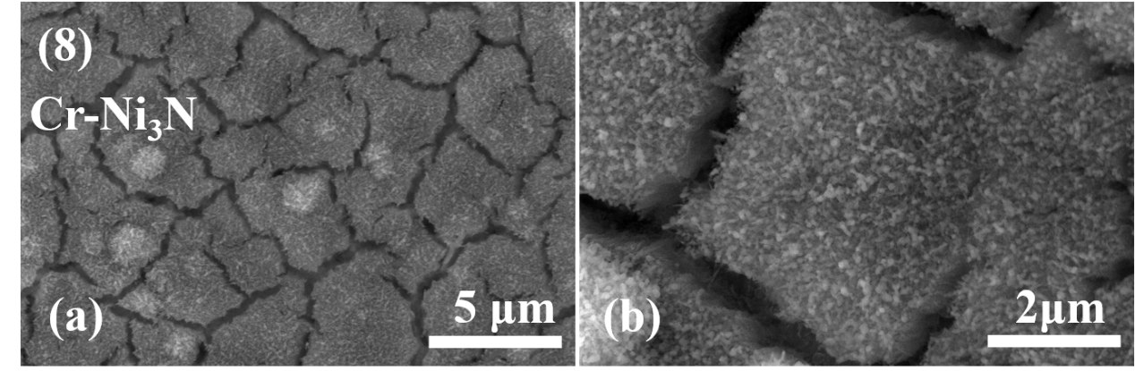
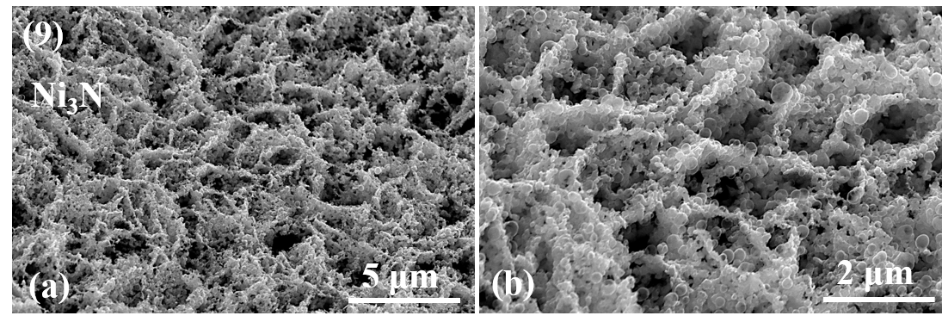
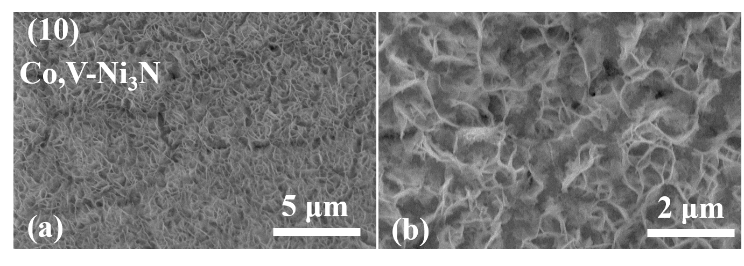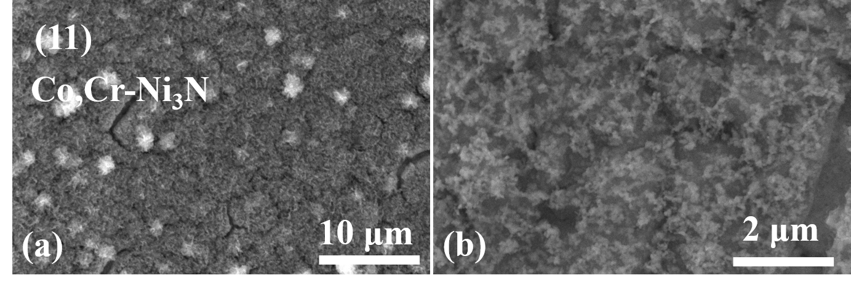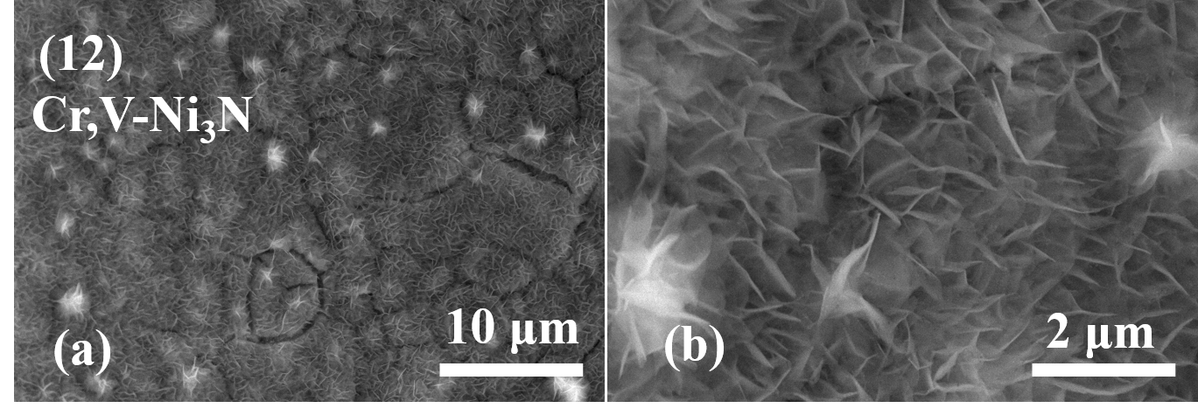
Supplementary Figure 19. SEM images of (1) Co,V-Ni(OH)₂ and (2-12) transition metal doped Ni₃N, respectively.
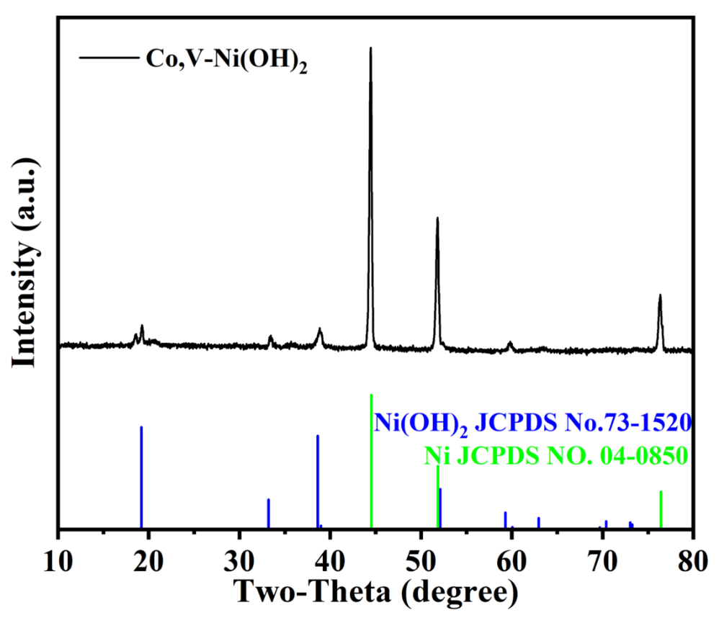
Supplementary Figure 20. XRD pattern of Co,V-Ni(OH)₂.
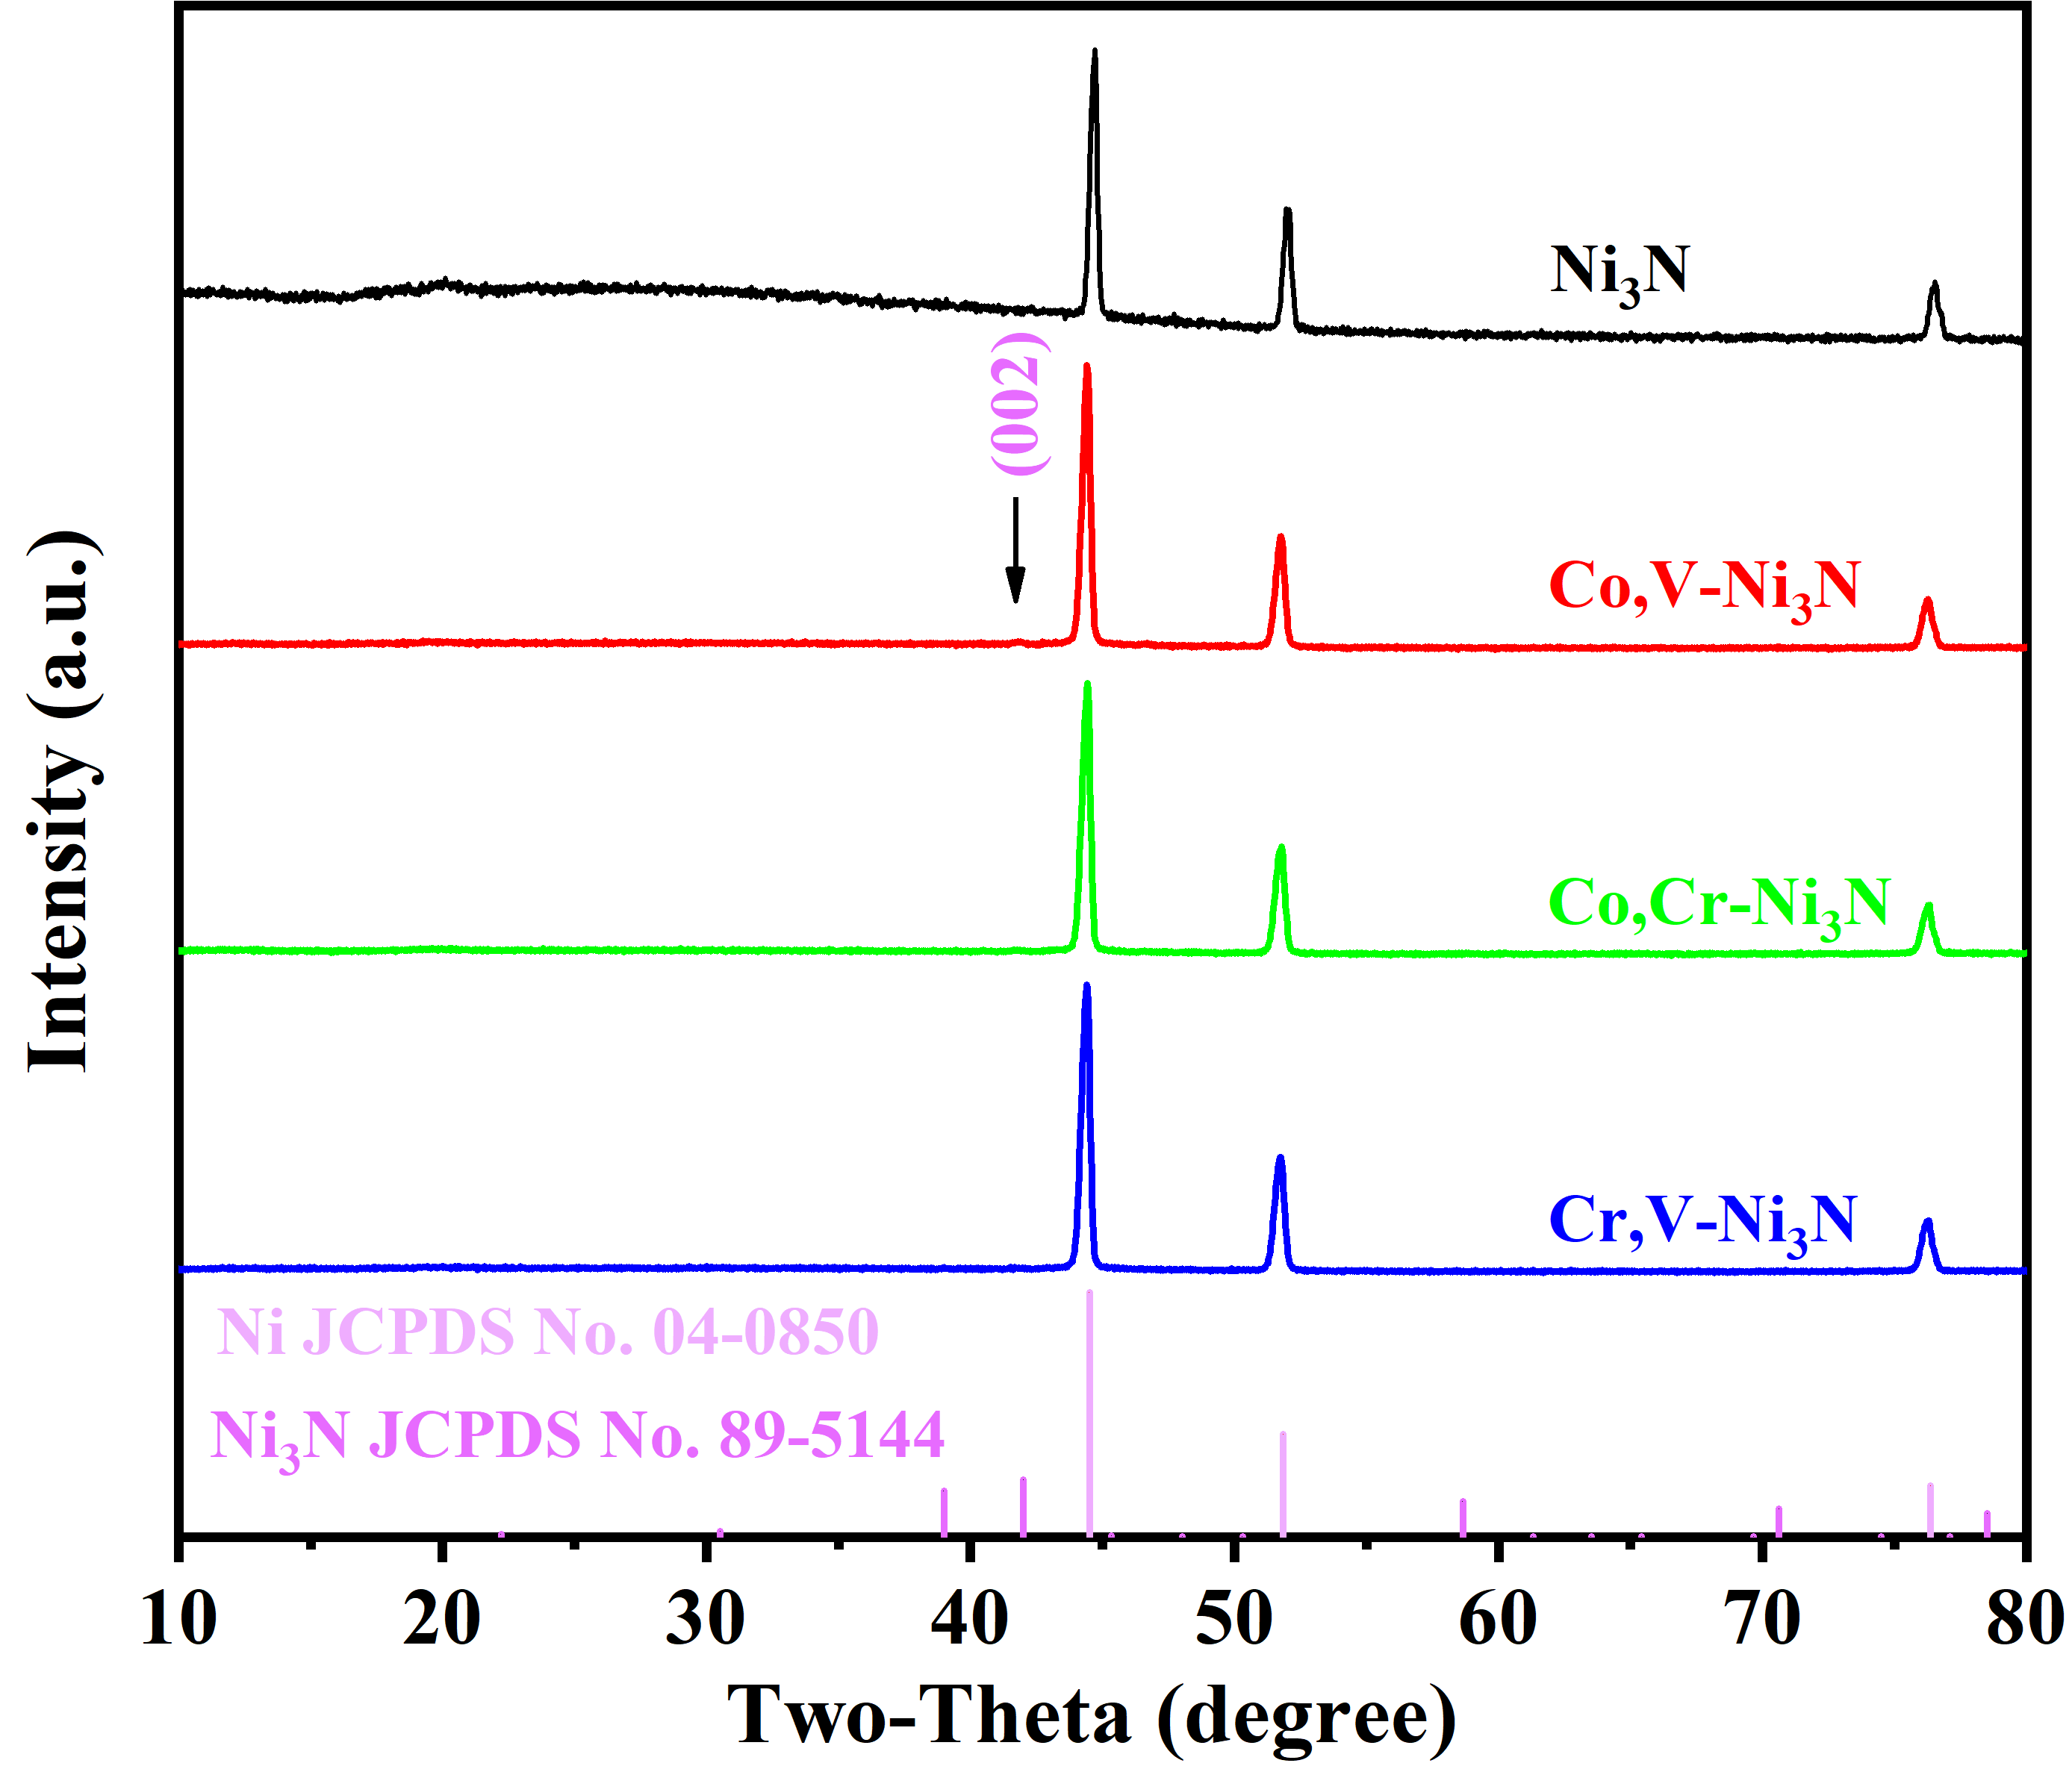
Supplementary Figure 21. XRD patterns.
According to the latest research, when the nitriding temperature is higher than 350 °C, part of the Ni₃N on the catalyst surface is decomposed, which is the cause of the disappearance of some peaks. ^{4,5} XRD pattern of Co,V-Ni₃N shows a faint 002 plane which is consistent with TEM results.
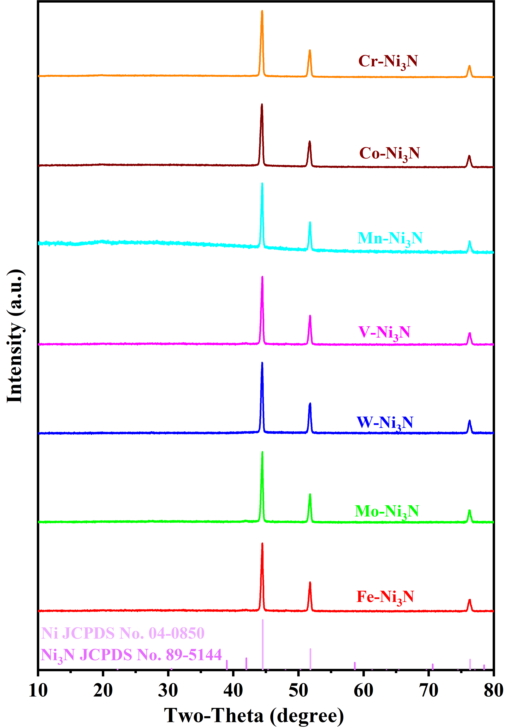
Supplementary Figure 22. XRD patterns.
Supplementary Table 6. Details of the crystal structures of Ni₃N, Ni(OH)₂, and Ni.
Samples | Crystal | Space group | a (Å) | c (Å)
Ni₃N (JCPDS No.89-5144) | Hexagonal | P6322(182) | 4.616 | 4.298
Ni(OH)₂ (JCPDS No.73-1520) | Hexagonal | P-3m1 (164) | 3.114 | 4.617
Ni (JCPDS No.04-0850) | Cubic | Fm-3m(225) | 3.524 | 3.524
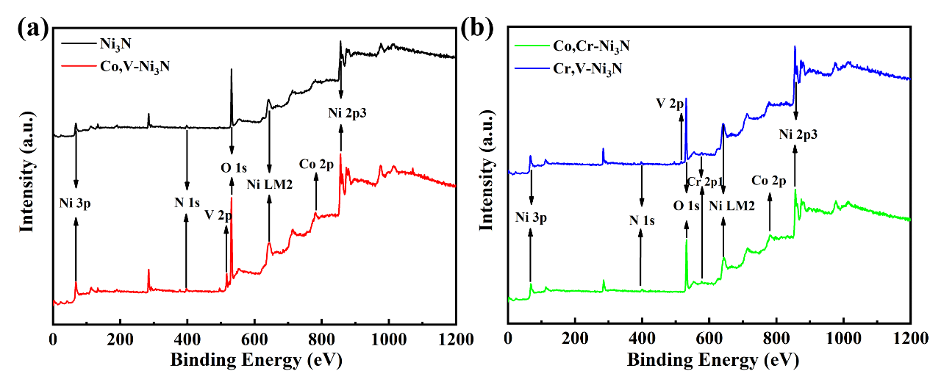
Supplementary Figure 23. (a) XPS survey spectrums of Ni₃N and Co,V-Ni₃N; (b) XPS survey spectrums of Co,Cr-Ni₃N and Cr,V-Ni₃N.
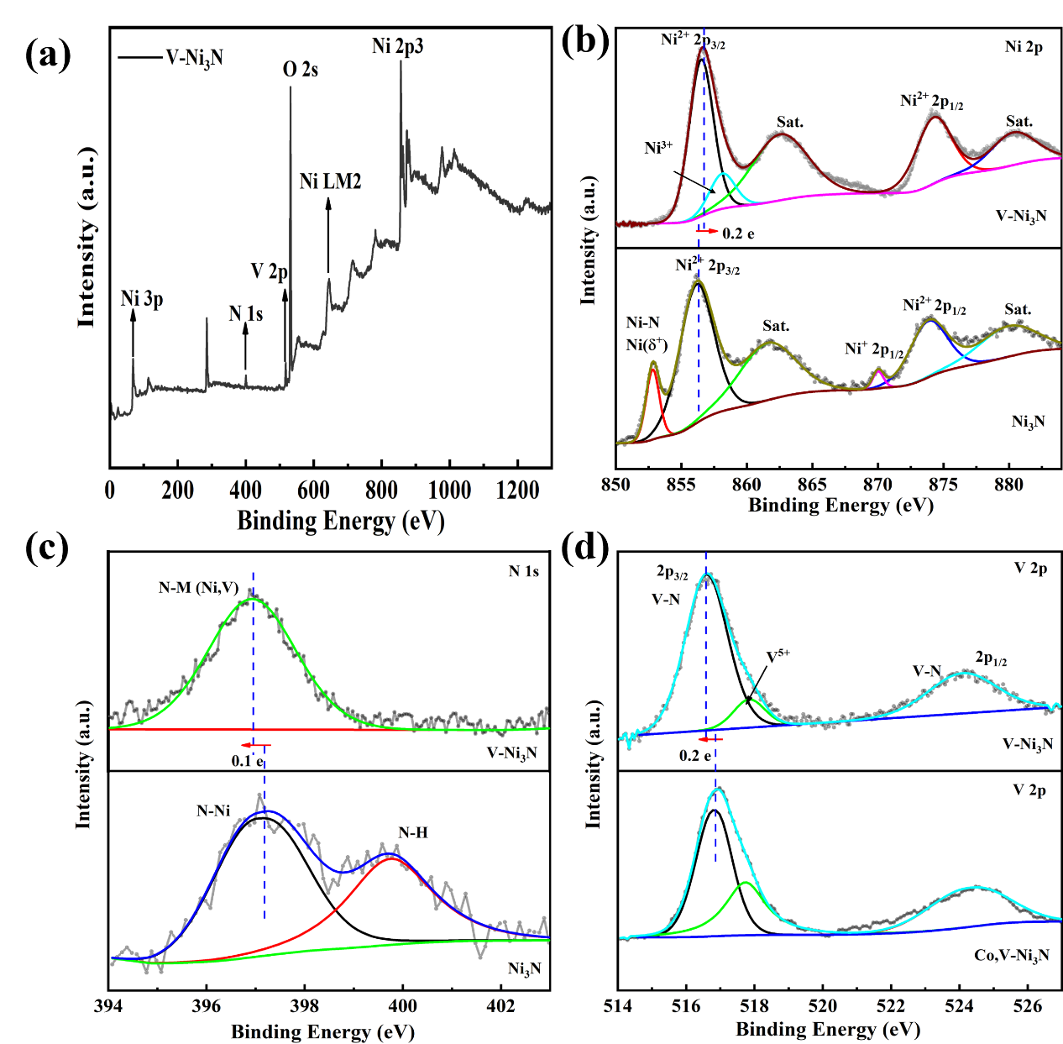
Supplementary Figure 24. XPS survey spectrums of V-Ni₃N; High-resolution XPS spectra of Ni (b), N (c) and V (d).
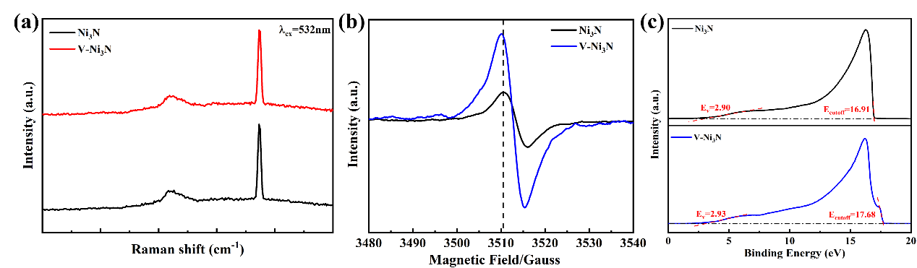
Supplementary Figure 25. (a) Raman spectra, (b) EPR spectra and UPS spectra (c).
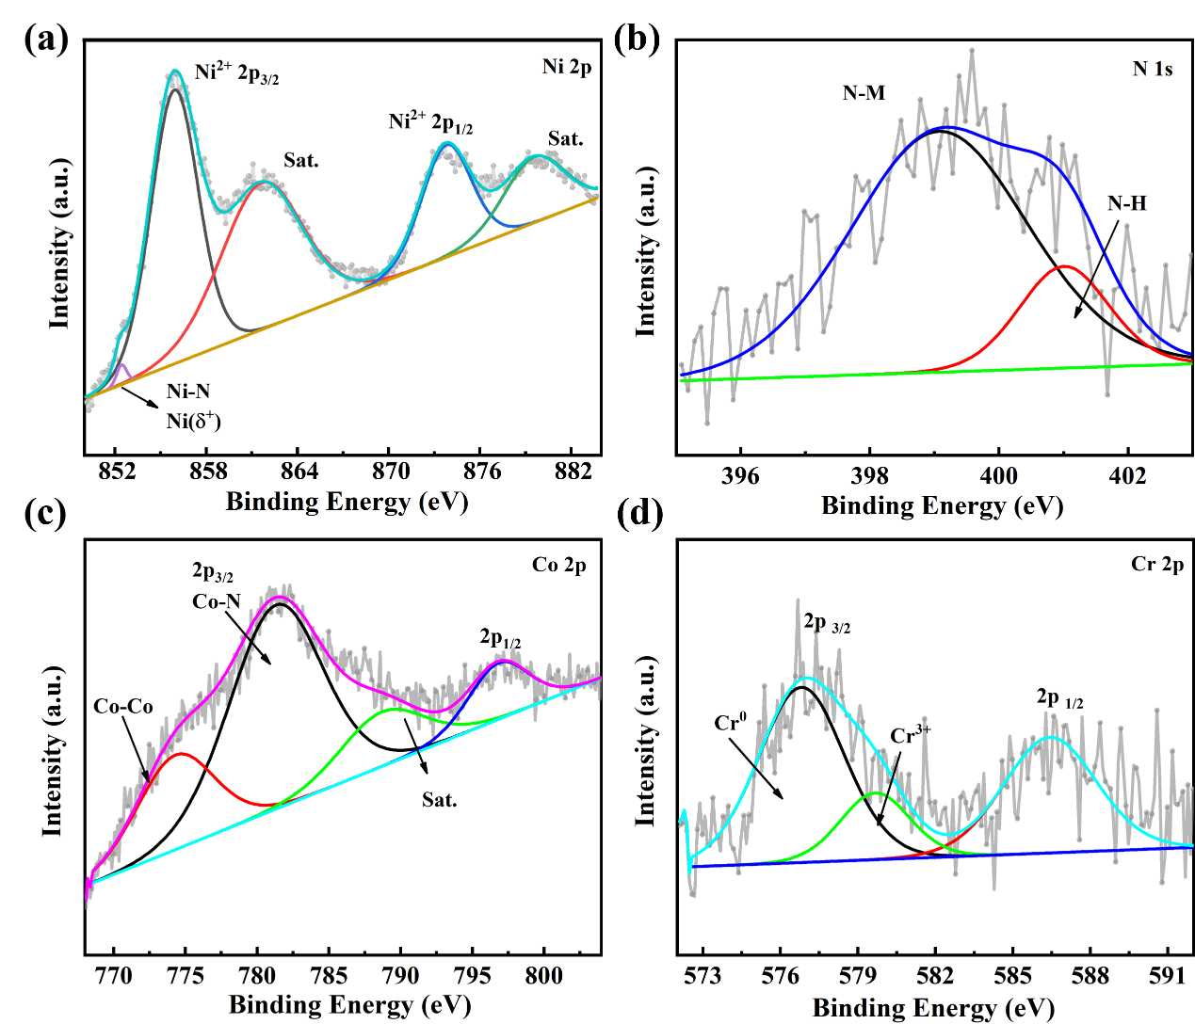
Supplementary Figure 26. High-resolution XPS spectra of Ni (a), N (b), Co (c) and Cr (d) of Co,Cr-Ni₃N.
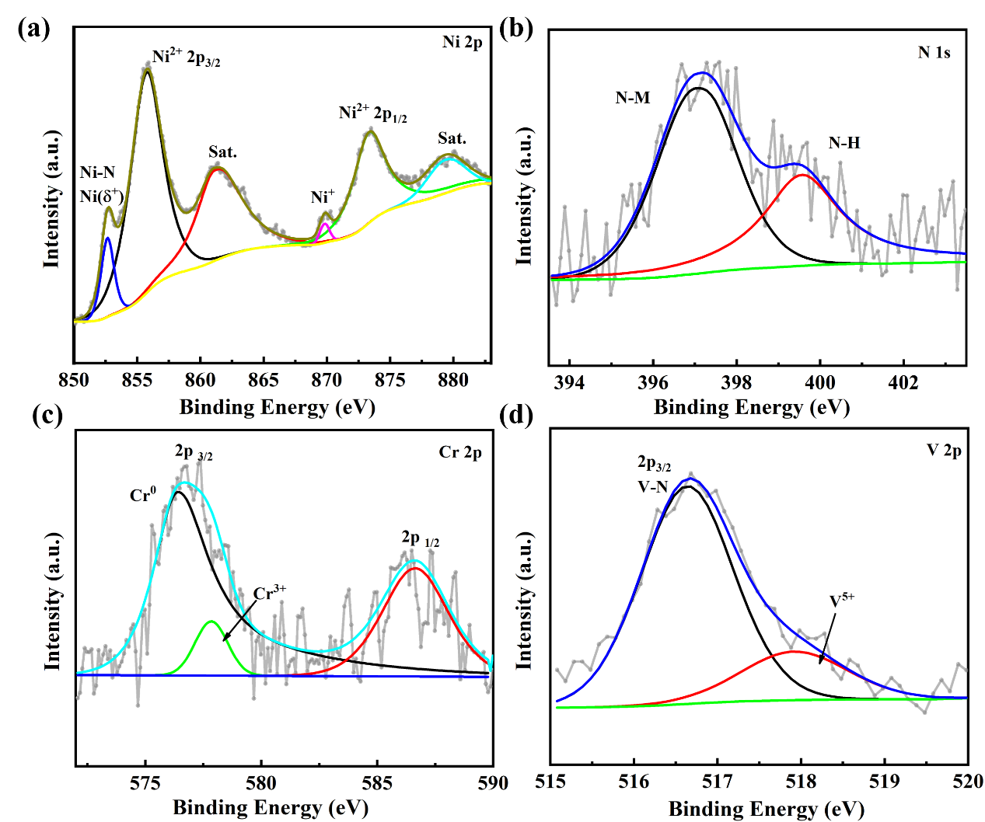
Supplementary Figure 27. High-resolution XPS spectra of Ni (a), N (b), Cr (c) and V (d) of Cr,V-Ni₃N.
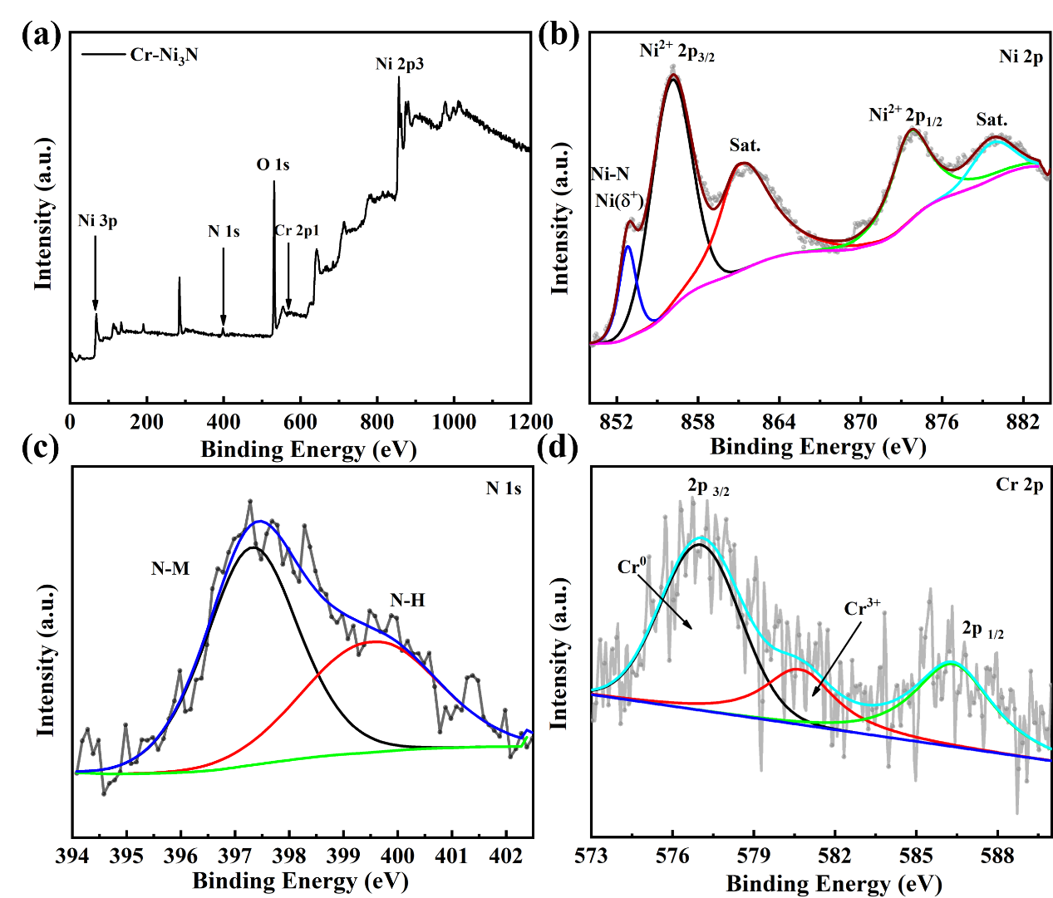
Supplementary Figure 28. XPS survey spectrums of Cr-Ni₃N; High-resolution XPS spectra of Ni (b), N (c) and Cr (d).
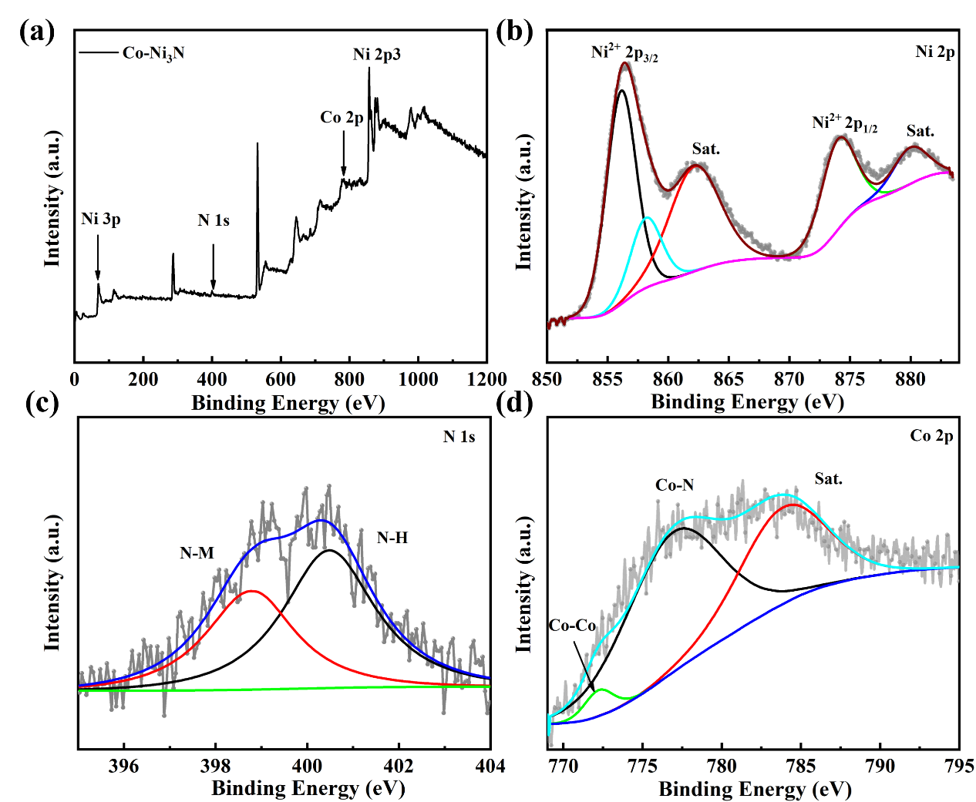
Supplementary Figure 29. XPS survey spectrums of Co-Ni₃N; High-resolution XPS spectra of Ni (b), N (c) and Co (d).
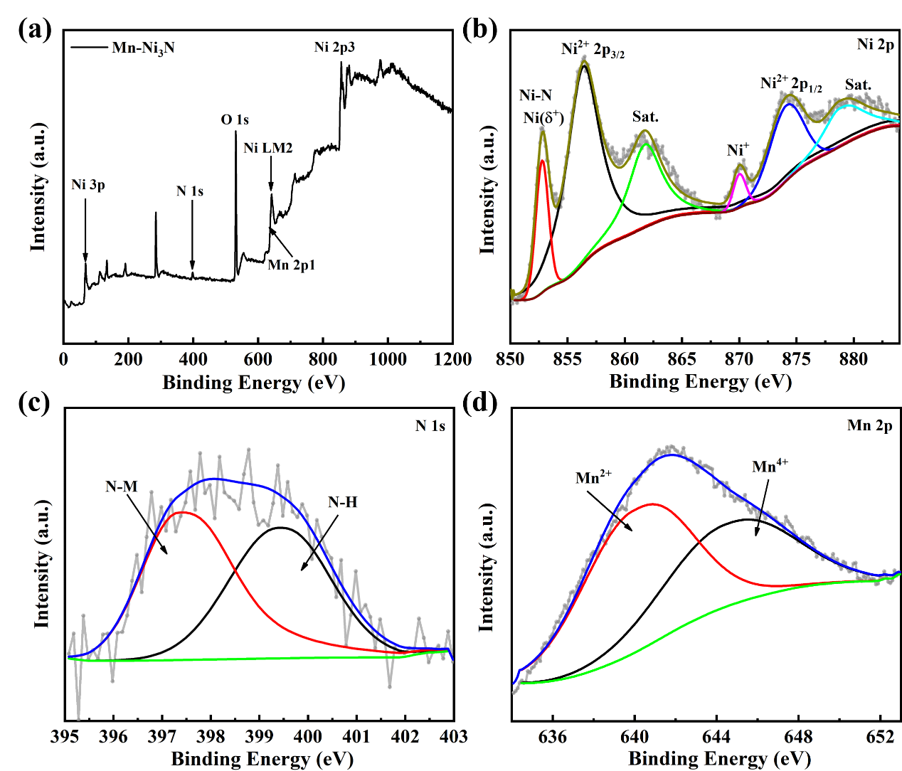
Supplementary Figure 30. XPS survey spectrums of Mn-Ni₃N; High-resolution XPS spectra of Ni (b), N (c) and Mn (d).
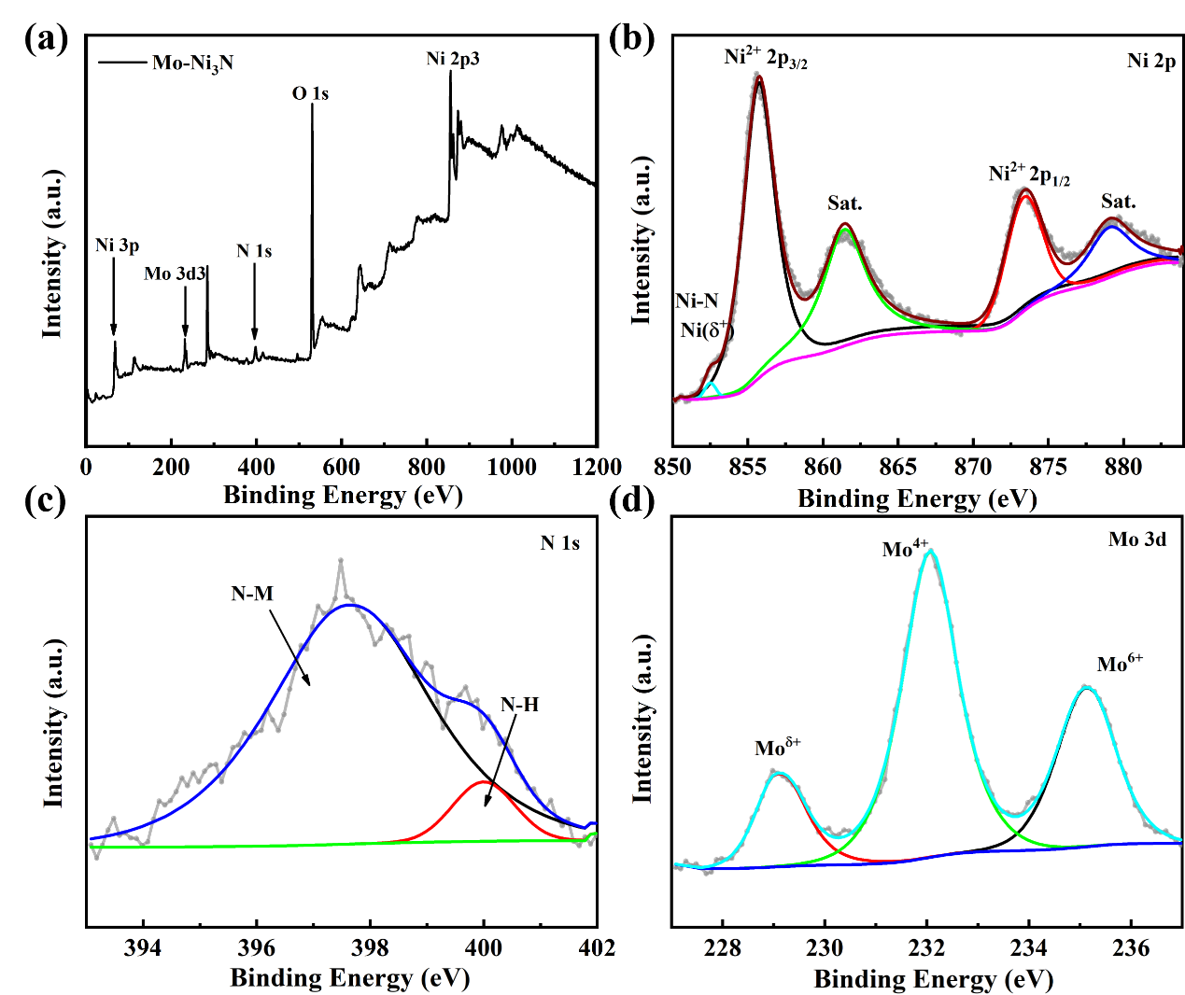
Supplementary Figure 31. XPS survey spectrums of Mo-Ni₃N; High-resolution XPS spectra of Ni (b), N (c) and Mo (d).
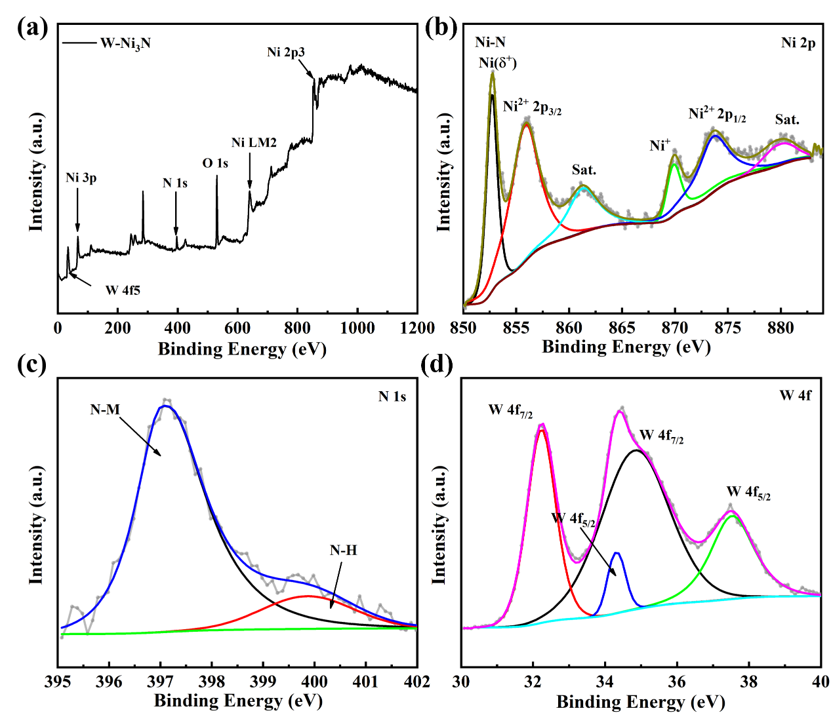
Supplementary Figure 32. XPS survey spectrums of W-Ni₃N; High-resolution XPS spectra of Ni (b), N (c) and W (d).
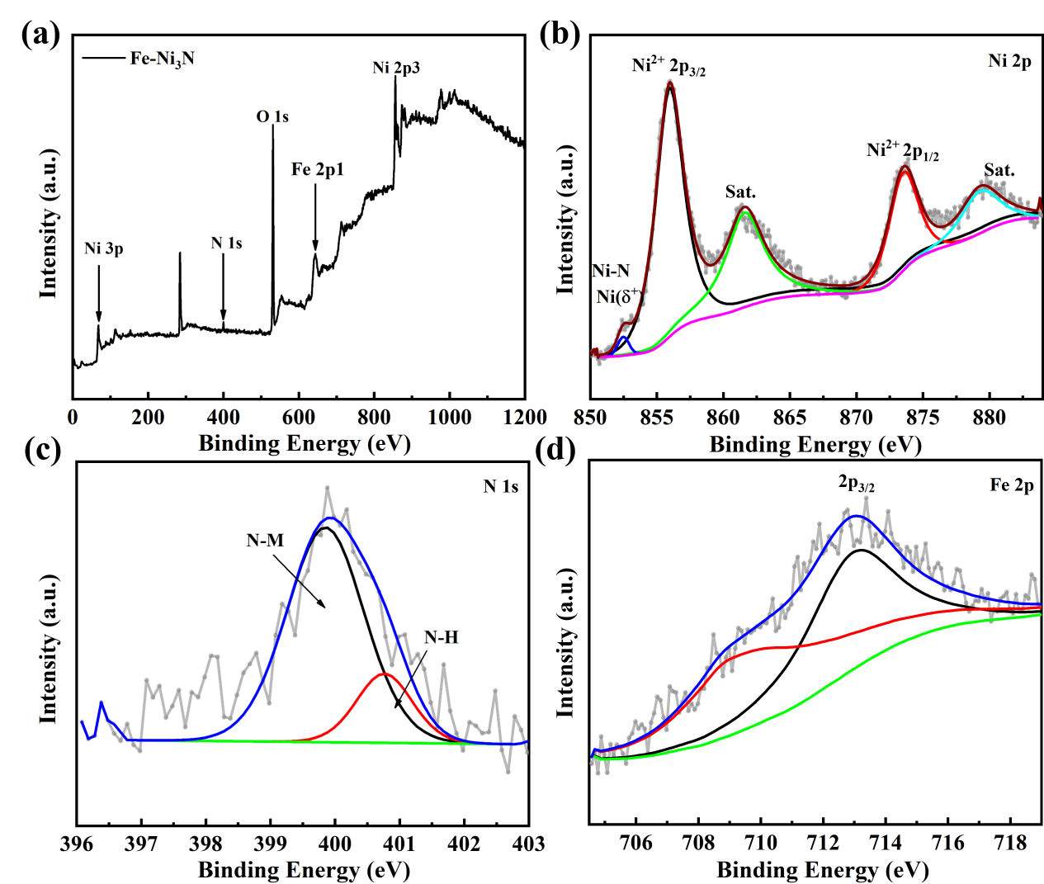
Supplementary Figure 33. XPS survey spectrums of Fe-Ni₃N; High-resolution XPS spectra of Ni (b), N (c) and Fe (d).
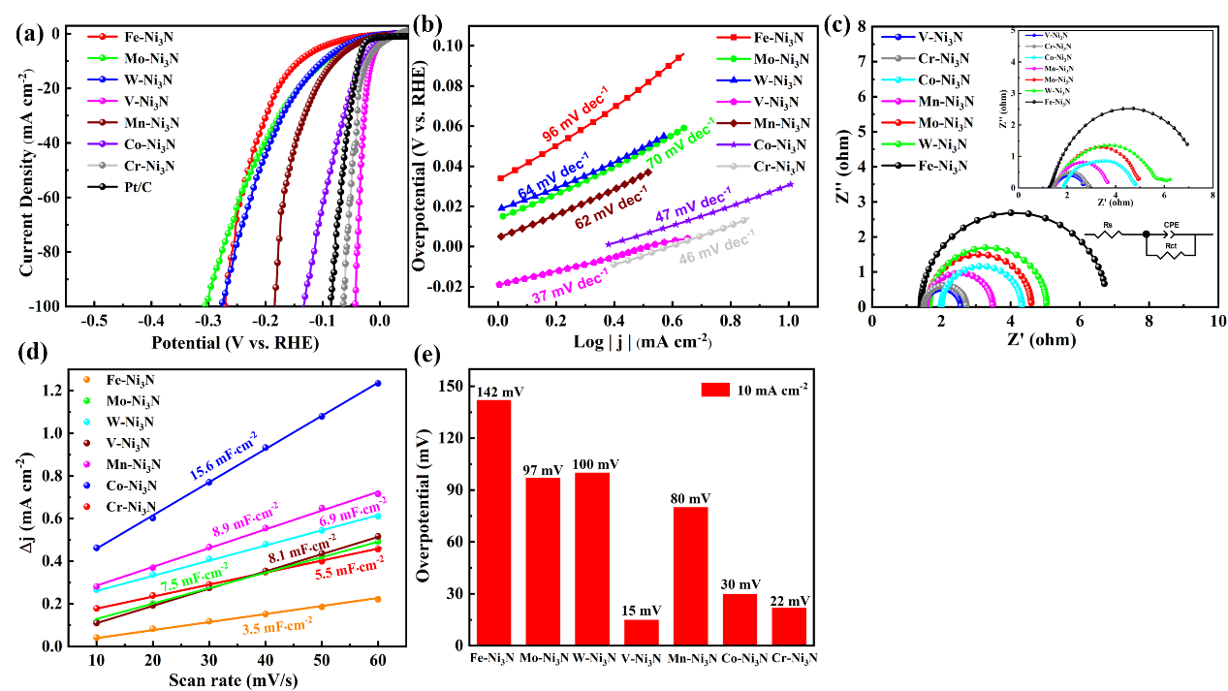
Supplementary Figure 34. (a) LSV curves in 1 M KOH, (b) Tafel plots derived from the polarization curves, and (c) the Nyquist plots (inset: magnified image). (d) The C_{dl} values of the different samples. (e) HER performance comparison.
The overpotential at 10 mA cm⁻² of V-Ni₃N, Cr-Ni₃N, Co -Ni₃N, Mn-Ni₃N, Mn-Ni₃N, W-Ni₃N and Fe-Ni₃N are 15, 22, 30, 80, 97, 100 and 142 mV, respectively (Figure 32a). The charge transfer resistance (R_{ct}) of V-Ni₃N, Cr-Ni₃N, Co -Ni₃N, Mn-Ni₃N, Mn-Ni₃N, W-Ni₃N and Fe-Ni₃N are 1.1, 2.32, 1.2, 1.92, 2.99, 3.39 and 5.38 Ω, which is considerably lower than those of counterparts (Cr-Ni₃N, Co -Ni₃N, Mn-Ni₃N, Mn-Ni₃N, W-Ni₃N and Fe-Ni₃N). Notably, this finding indicates that the Cr-Ni₃N, Co -Ni₃N, Mn-Ni₃N, Mn-Ni₃N, W-Ni₃N and Fe-Ni₃N show much more sluggish interfacial electronic transfer kinetics which are consistent with their poorer catalytic activities.
Supplementary Table. 7 Sample masses after different processing stages.
Sample | Mass of substrate  (mg) | Sample area  (cm²) | Mass density  (mg cm⁻²)
Co,V-Ni₃N | 37.2 | 1*1*2=2 | 1.85
Co,V-Ni(OH)₂ | 35.1 | 1*1*2=2 | 0.8
NF | 33.5 | 1*1*2=2 | -
V-Ni(OH)₂ | 34.6 | 1*1*2=2 | 0.55
V-Ni₃N | 36.9 | 1*1*2=2 | 1.7
Table 7 is the sample masses after different processing stages.
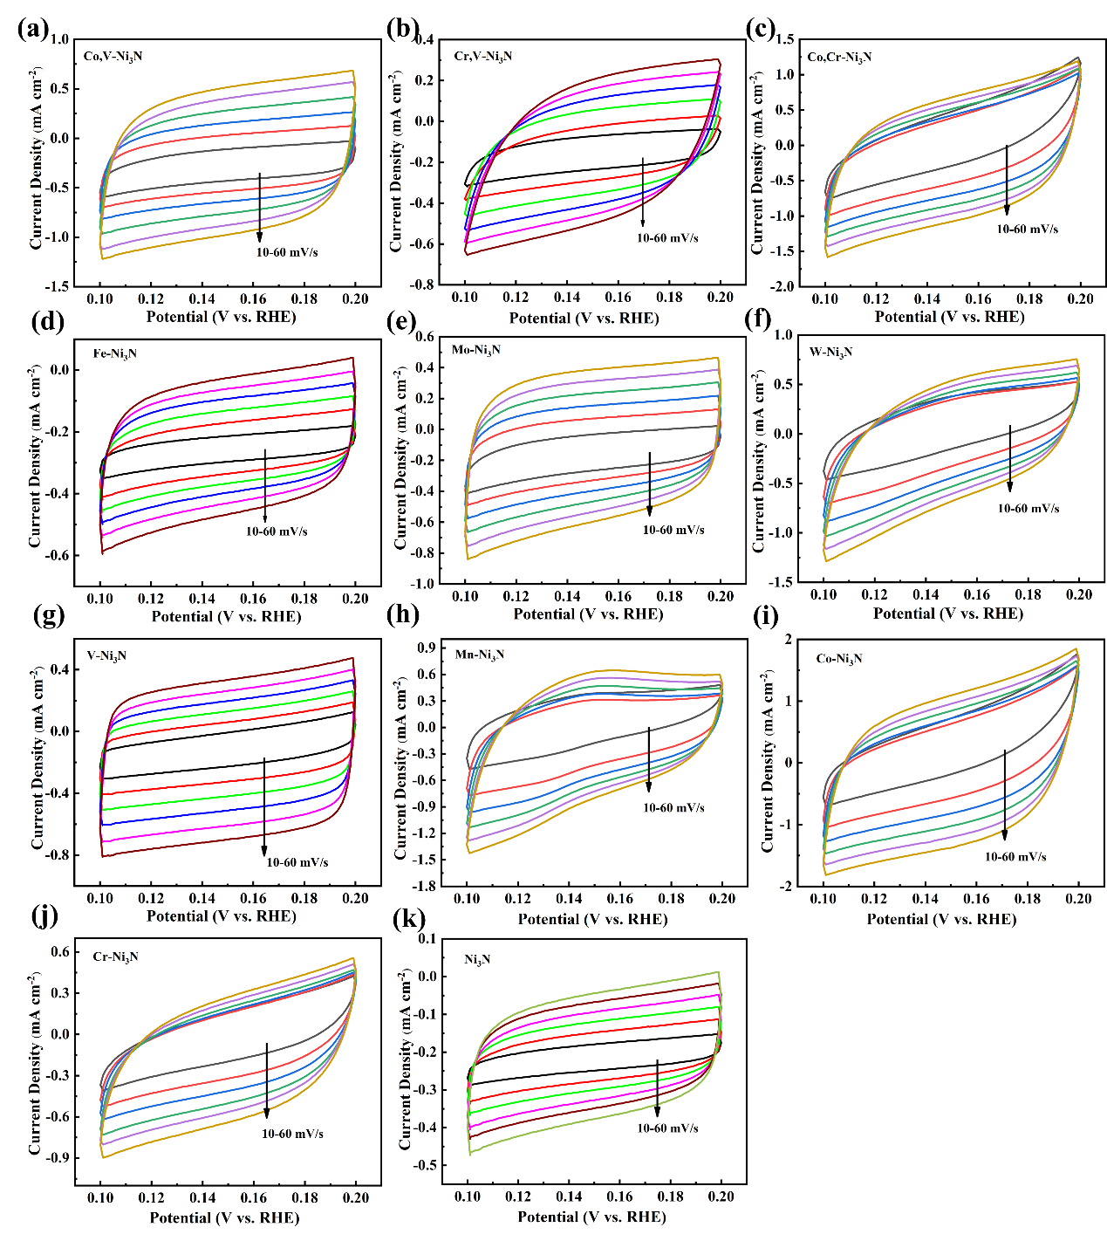
Supplementary Figure. 35 Cyclic voltammetry curves recorded in 1 M KOH at scan rates of 10, 20, 30, 40, 50, and 60 mV s⁻¹.
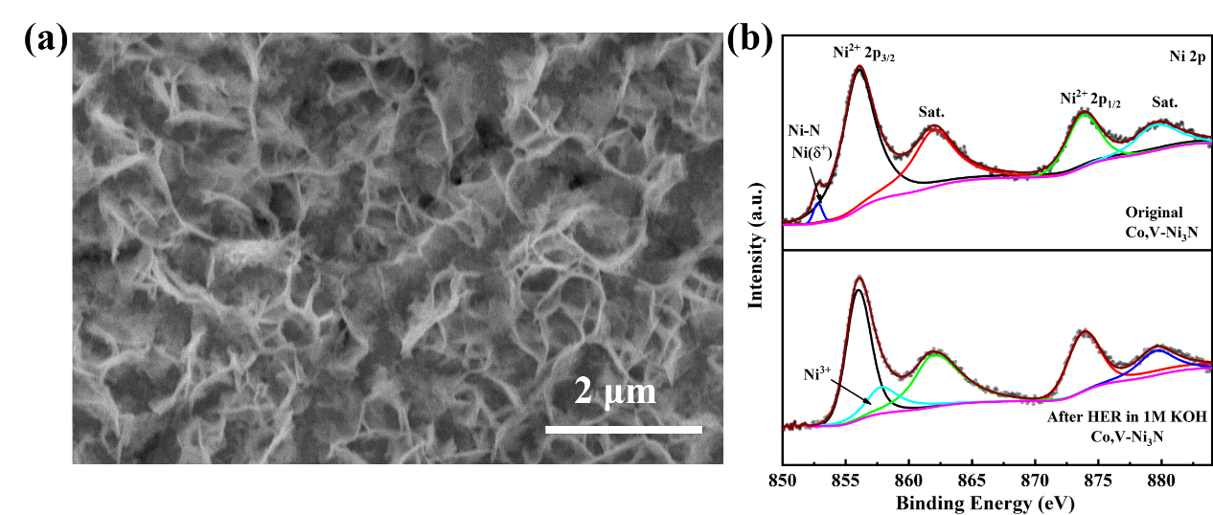
Supplementary Figure 36. (a) SEM and (b) XPS of Co,V-Ni₃N after HER.
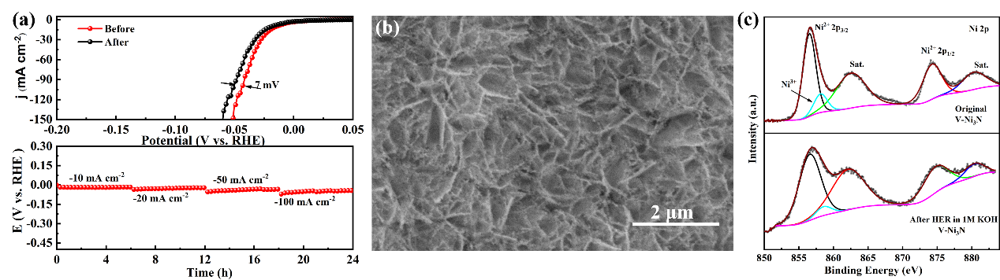
Supplementary Figure 37. (a) The stability test of V-Ni₃N; (b) SEM and (c) XPS of V-Ni₃N after HER.
The overpotential after 3000 CV cycles was negligible higher than pre-test overpotential at 100 mA cm⁻² and the result of chronopotentiometry demonstrates preeminent stability of V-Ni₃N as well. As shown in Figure 36b-c, neither the macroscopic morphology nor the valence state of the elements on the V-Ni₃N surface has changed, which also proves that the catalyst has excellent catalytic stability and corrosion resistance.
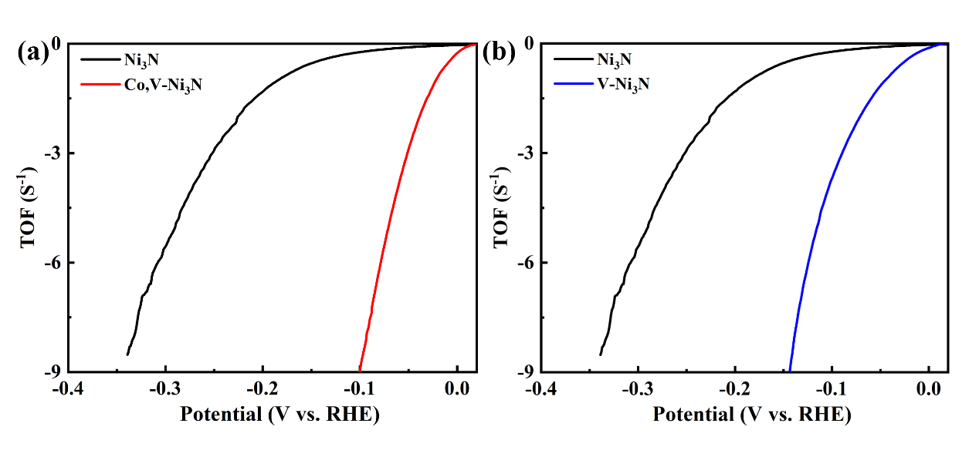
Supplementary Figure 38. The turn-over frequencies (TOF) of the Co,V-Ni₃N (a) and V-Ni₃N (b).
The turnover frequency (TOF) for HER was calculated based on a previously reported electrochemical CV method. ¹ We tested CV curve in the region of -0.2 to 0.6 V vs. RHE in 1 M KOH solution (pH =13.8). The integrated charge over the whole potential range should be proportional to the total number of active sites. Assuming a one-electron process for both reduction and oxidation process, the upper limit of active sites could be calculated. Figure 34 shows the polarization curves in 1 M KOH, normalized by the active sites and expressed in terms of TOF. TOF value at 100 mV in alkaline media of Co,V-Ni₃N, V-Ni₃N and Ni₃N are 8.78, 3.64 and 0.2 s⁻¹, respectively.
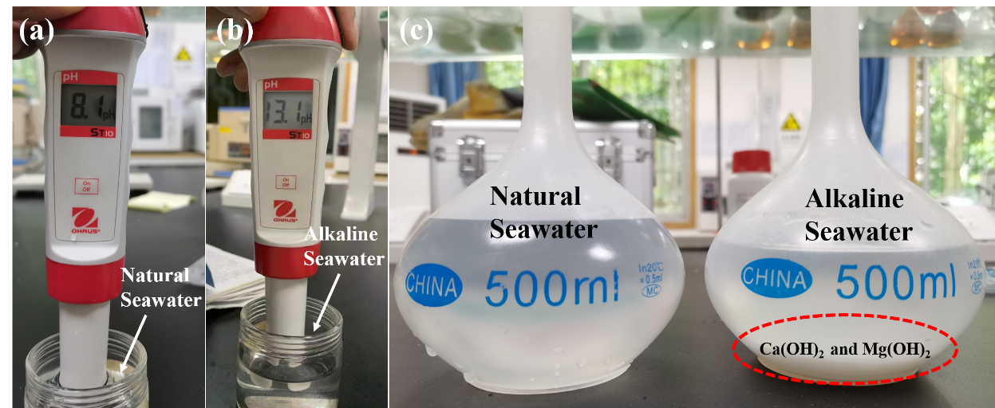
Supplementary Figure 39. (a,b) pH test of natural seawater and alkaline seawater; Photos of natural seawater and alkaline seawater.
After adding KOH to the seawater, Mg²⁺ and Ca²⁺ cations precipitate out as insoluble hydroxides.
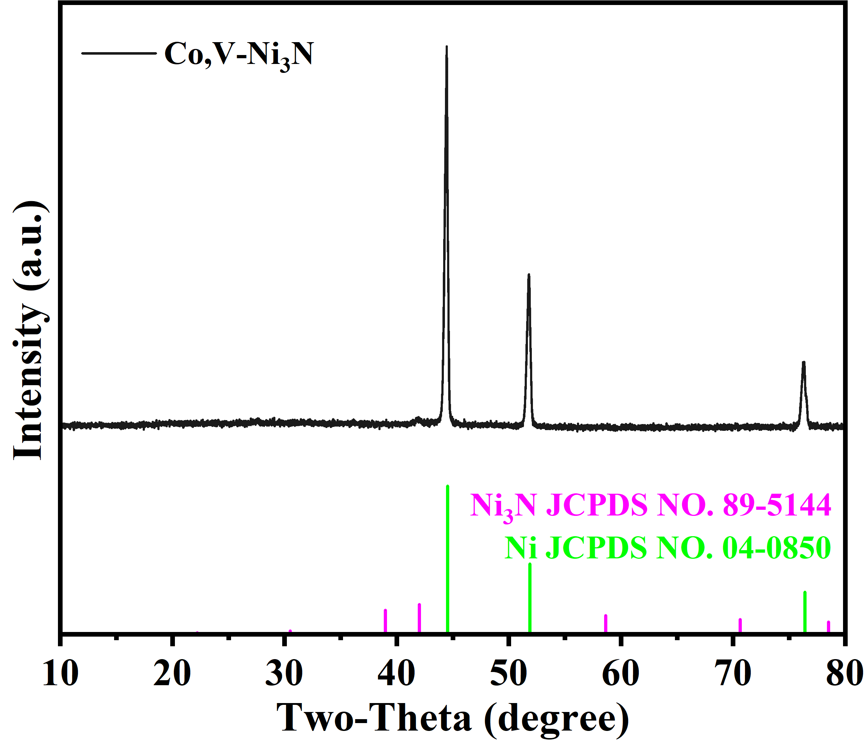
Supplementary Figure 40. XRD of Co,V-Ni₃N after HER in alkaline seawater.
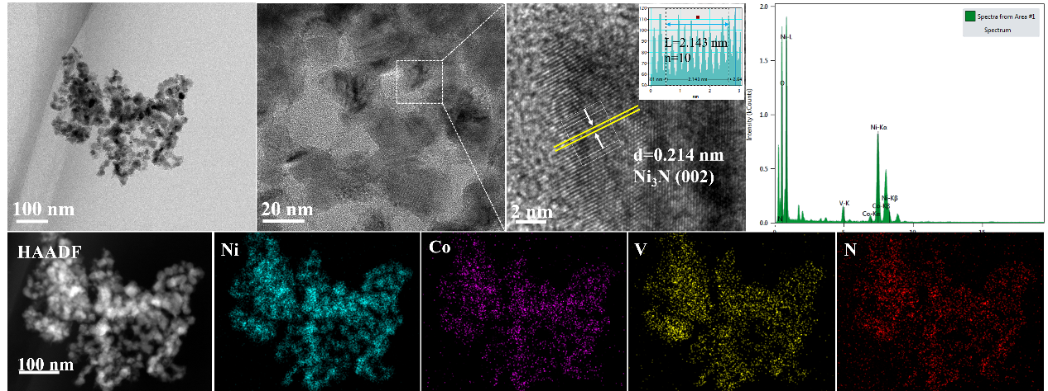
Supplementary Figure 41. TEM images of Co,V-Ni₃N after HER in alkaline seawater.
Supplementary Table 8. Comparison of the HER (η₁₀) performance of V-Ni₃N and Co,V-Ni₃N with other reported electrocatalysts.
Catalysts | Electrolytes | η₁₀  (mV) | Tafel slope  (mV dec¹) | Reference
Ni₃N/NF | 1M KOH | 121 | 109 | Electrochimica Acta 2016, 191,841.
Co-Ni₃N | 1M KOH | 30 | 41.6 | J Phys. Chem. Lett.  2021, 12 (6), 1581-1587.
NiMo HNRs/Ti mesh | 1M KOH | 92 | 76 | J. Mater. Chem. A 2015, 3, 20056.
Ni₃N-VN/NF | 1M KOH | 64 | 37 | Advanced Materials 2019, 31 (23).
Ru/Ni₃N–Ni | 1M KOH | 53 | 32.4 | Chem. Commun. 2020, 56 (15), 2352-2355.
Ni/Co₂N | 1M KOH | 16.2 | 60.5 | ACS Applied Materials& Interfaces 2020
Fe-Ni₃C-2%  nanosheets | 1M KOH | 292 | 43 | Angew.Chem.Int. Ed. 2017, 56,12566.
Epitaxial in-growth Co-Ni₃N | 1M KOH | 194 | 156 | Advanced Materials 2018, 30 (13).
MOF-Derived Ni₃N | 1M KOH+0.5M Urea | 47 | 67 | ACS Sustainable Chemistry & Engineering 2020, 8 (19), 7414-7422.
V doped Co₄N | 1M KOH | 37 | 44 | Angew. Chem. Int. Ed. 2018, 57 (18), 5076-5080.
Ni₃N/C | 1M KOH | 64 | 48 | Angew. Chem. Int. Ed. 2019, 58 (22), 7445-7449.
N-Ni | 1M KOH | 96 | N/A | J. Am. Chem. Soc. 2017, 139, 12283.
MoO₃/Ni–NiO | 1M KOH | 62 | 59 | Advanced Materials.2020 32(39)
High-Valance State  Doped Ni₃N | 1M KOH | Mo:12  W:40  V:10 | 64  118  110 | ACS Catal. 2019, 9, 9332−9338
CeO2/Co4N | 1M KOH | 30 | 66 | Applied Catalysis B: Environmental 277 (2020) 119282
RuNi‐NCNFs | 1M KOH | 35 | 30 | Adv. Sci.  2020, 7, 1901833
Co-Mo₅N₆ | 1M KOH | 19 | 12 | Adv. Energy Mater.  2020,10, 2002176
V-Ni₃N | 1M KOH | 15 | 37 | This work
Co,V-Ni₃N | 1M KOH | 10 | 43 | This work

Supplementary Table 9. Comparison of the HER (η₁₀₀) performance of V-Ni₃N and Co,V-Ni₃N with other reported electrocatalysts.
Catalysts | Electrolytes | η₁₀₀  (mV) | Tafel slope  (mV dec¹) | Reference
Cr-Co₄N NR/CC | 1M KOH | 100 | 38.1 | Adv. Energy Mater. 2019, 1902449
Ni₃N NS | 0.5M H₂SO₄ | 100 | 59.79 | J. Mater. Chem. A 2016, 4, 17363
Cu_{x}Ni_{4−x}N/NF | 1M KOH | 111 | 86 | J. Mater. Chem. A 2017, 5,24850-2485
NiFeLDH@Ni₃N | 1M KOH | 142 | 79 | J. Mater. Chem. A 2020,8, 17202
CoNi/CoFe₂O₄/NF | 1M KOH | 189 | 96 | J. Mater. Chem. A 2018, 6, 19221
Sn-Ni₃S₂/NF | 1M KOH | 171 | 55.6 | ACS Appl. Mater. Interfaces 2018, 10, 40568-40576
P-Co-Ni-S/NF | 1M KOH | 187.4 | 125.3 | ACS Appl. Mater. Interfaces 2018, 10, 8, 7087-7095
NF-Ni₃S₂/MnO₂ | 1M KOH | 197 | 69 | Appl. Catal., B, 2019,254, 329-338.
Co,V-Ni₃N | 1M KOH | 70 | 43 | This work

Supplementary Table 10. Comparison of the HER (η₁₀) performance of Co,V-Ni₃N with other reported non-noble metals electrocatalysts in seawater.
Catalysts | Electrolytes | η₁₀  (mV) | Tafel slope  (mV dec¹) | Reference
Mo₅N₆ | natural seawater | 257 | N/A | ACS Nano 2018, 12, 12761
NiCoN|Ni_{x}P|NiCoN | natural seawater | 165 | 139.2 | ACS Energy Lett. 2020, 5, 2681.
Mn–NiO–Ni | natural seawater | 170 | N/A | Energy Environ. Sci. 2018, 11, 1898
NiCoP/NF | natural seawater | 287 | N/A | ACS Appl. Energy Mater. 2019, 2, 3910.
Ni₅P₄@Ni^{2+δ}O_{δ}(O  H)_{2−δ} | natural seawater | 144 | 108 | Appl. Catal. B 2019, 251, 181
Co,V-Ni₃N | 1 M KOH seawater | 41 | 46 | This work

Supplementary References:
1. Merki, D., Fierro, S., Vrubel, H. & Hu, X. Amorphous molybdenum sulfide films as catalysts for electrochemical hydrogen production in water. Chem. Sci. 2, 1262 (2011).
2. Jin, H., Zhang, H., Chen, J., Mao, S., Jiang, Z., Wang, Y. A general synthetic approach for hexagonal phase tungsten nitride composites and their application in the hydrogen evolution reaction. J. Mater. Chem. A 6, 10967-10975 (2018).
3. Popczun, E. J., Mckone, J. R., Read, C. G., Biacchi, A. J., Wiltrout, A. M., Lewis, N. S. Nanostructured nickel phosphide as an electrocatalyst for the hydrogen evolution reaction. J. Am. Chem. Soc. 135, 9267-9270 (2013).
4. Zhang, B. et al. Dual-Descriptor Tailoring: The Hydroxyl Adsorption Energy-Dependent Hydrogen Evolution Kinetics of High-Valance State Doped Ni₃N in Alkaline Media. ACS Catal. 9, 9332-9338, (2019).
5. Song, F. et al. Interfacing nickel nitride and nickel boosts both electrocatalytic hydrogen evolution and oxidation reactions. Nat. Commun. 9, 4531, (2018).

