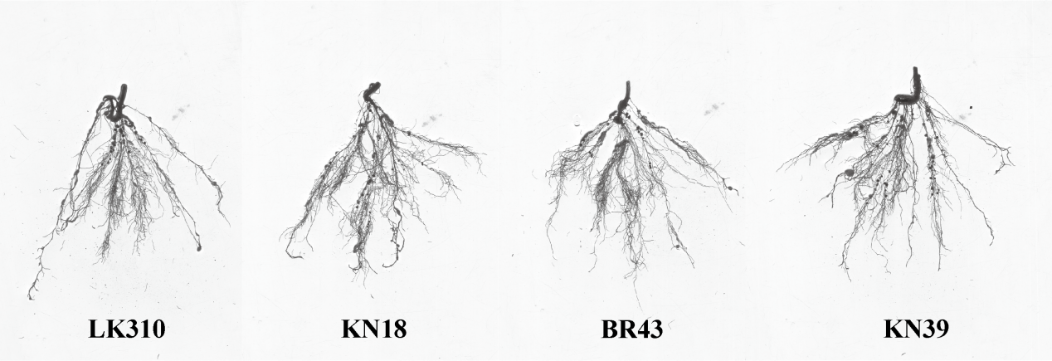
Fig.2 Phenotypic changes of soybean seedlings at 105 kg·hm⁻² phosphorus supply intensity .

