Supplementary Information (SI)
for the article ‘Perceiving justice in the AI city:
Global evidence from an eye-tracking study of autonomous mobility’

This Supplementary Information provides additional methodological details, tables, and figures supporting the analyses reported in the main text. It includes extended model specifications, diagnostic tests, descriptive and inferential data summaries, and metadata descriptions of all aggregated datasets. The contents of this Supplementary Information are outlined below.

Contents
- Supplementary Methods
- Robustness and sensitivity analyses
- Supplementary Figures and Tables
- Additional references

1. Supplementary Methods
1.1 Participants and experimental design
As outlined in the main text, the study employed a semi-experimental online design that combined large-scale eye-tracking with an attitudinal survey to examine how people perceive social diversity and justice in AI-based mobility systems. The following section provides extended information on participant recruitment, sampling logic, and experimental procedures.
Participants were recruited via the CINT crowdsourcing platform, which provides access to opt-in research panels in over 130 countries. Recruitment followed a stratified quota system based on national census data for gender, age, and education. The final sample comprised 1,272 valid participants from 22 cities worldwide, distributed across Europe, Asia, Africa, and the Americas. City selection followed two criteria: (1) participation in international AV testing or smart city ¹, and (2) representation in the IESE Cities in Motion Index ². These criteria ensured variation in both technological exposure and socio-economic context. In the selected cities of two countries, the initial response rates were low, so additional participants were recruited from a second city in each country. As a result, two cities were represented from Germany (Stuttgart and Berlin) and two from the United States (New York and Los Angeles). While the overall sample size is large enough to analyse associations between individual characteristics (for example, perceptions of social differences across sociodemographic groups), the number of observations varies substantially across the participating cities. Because of this uneven distribution, we rely primarily on Bayesian estimation, which provides more stable inference under variable group sizes, rather than regular probabilistic multilevel modelling. Detailed demographic and contextual distributions are presented in Tables S1-S3.
To validate the online setup, a smaller in-lab study (N = 16) was conducted prior to large-scale data collection, using a high-precision eye-tracker (Eyelink Portable Duo, 2000 Hz). This pilot phase helped to adjust the online system, refine scenario clarity, and verify that fixation parameters were consistent across devices. Participants in both studies provided informed consent prior to participation, and all procedures adhered to institutional ethical standards.
During the online experiment, participants viewed a series of paired traffic scenarios under two conditions: autonomous (AV) and non-autonomous (non-AV). The order of exposure between the conditions was randomised across participants. Participants were presented with seven parallel scenarios under both AV and non-AV conditions, featuring different combinations of intersectional social categories. Following Crenshaw’s ³ ⁴ intersectional framework, we used gender and race intersecting with other social categories to capture how multiple axes of identity shape perceptions of justice in AI-mediated mobility. These stimuli enabled subsequent analyses to focus both on broader social dimensions (e.g., gender) and on specific subcategories (e.g., woman, man), by aggregating the individual category occurrences shown across scenarios.
Furthermore, when race and nationality were used as intersecting categories, they were operationalised using distinct visual cues. Race was depicted through skin-tone variation, while nationality was represented through flag symbols to present the country of origin. These cues were designed to be visually independent to avoid conflating national identity with racial appearance. Also, these cues were included only to support controlled experimental comparison and are not meant to imply fixed or essential characteristics of any group.
We aimed to keep all category representations as visually neutral as possible to avoid unintended cues or stereotyping effects. Neutrality was assessed in preliminary pilot studies and through pre- and post-interviews in the in-lab experiment. For this reason, we used textual or symbolic overlays instead of visual cues where appropriate (for example, a vaccination symbol rather than a face mask), and we restricted visual depictions to categories that can be meaningfully and ethically represented (such as people with reduced mobility),
Stimuli were generated using a Python-based randomisation script to ensure balanced representation of social categories and scenario features. Each trial began with a 40-point calibration sequence across three background colours (grey, black, white), followed by a 9-point validation check to confirm gaze accuracy. Data from participants whose calibration error exceeded 2.5 degrees of visual angle or who failed attention checks were excluded from analysis (n = 64). We ensured that all visual stimuli were matched in terms of sharpness and overall clarity so that no low-level saliency cues (such as contrast or blur differences) could bias category effects.

1.2 Measures and indicators
The analytical framework distinguishes between two dimensions of justice: perceived justice in AI-based mobility (Justice Index) and normative orientation toward justice (Justice Value). Both are grounded in Taylor’s ⁵ relational concept of data justice, which emphasises recognition, inclusion, and agency within algorithmic systems. The Justice Index was derived from six highly correlated survey items capturing perceived inclusion, representation, and justice in AI-managed mobility (Cronbach’s α = 0.89). Full item wording is reported in Supplementary Table S4 and S5.
To summarise attentional patterns across multiple social categories, a Diversity Attention Index (DAI) was constructed using factor-analytic techniques. Fixation time variables for each diversity category (nationality, residence, income, gender, age, reduced mobility, micromobility, and COVID-19 status) were z-standardised within participants to ensure comparability. Since the study examined two distinct technological settings and aimed to explain visual attention patterns to social diversity within each, separate indices were computed for autonomous (AV) and non-autonomous (non-AV) contexts. Intercorrelations among the eight diversity variables were high in both the AV and non-AV contexts (r = .52–.61, all p < .001), indicating a shared attentional orientation toward social difference. Bartlett’s test of sphericity confirmed factorability (p < .001), and the Kaiser–Meyer–Olkin (KMO) measure of sampling adequacy was 0.936 for the AV context and 0.931 for the non-AV context, indicating excellent suitability for factor analysis. Principal component extraction yielded a clear one-factor solution according to both the Kaiser criterion (eigenvalue > 1) and the Cattell scree test, explaining 63.9% of the total variance in the AV context and 67.6% in the non-AV context. The two indices were strongly correlated (Spearman ρ = 0.85), indicating a high degree of cross-contextual stability in attentional orientations toward social diversity. Correlations between indices and respondents’ socio-demographic attributes (age, gender, education, minority status, region) were examined using Spearman coefficients. Full correlation matrices and descriptive analysis are presented in Supplementary Figures S1, S4, S5, S6 and Tables S9 and S10.
To account for individual and contextual differences, the models included four theoretically grounded control variables. AI experience captured the cognitive dimension, reflecting participants’ familiarity with and understanding of AI systems. Trust in automation and perceived safety represented affective factors linked to emotional confidence in algorithmic decision-making. Although both variables were initially included in the model, they were strongly correlated; therefore, only the trust variable was retained in the final model. Minority status served as a social-identity indicator, capturing positional sensitivity to justice and inclusion. Region accounted for contextual variation in cultural and infrastructural conditions.
Since the notion of minority may vary across cultures, participants were asked to indicate whether they belong to a national minority group in their country of residence. We also considered the possibility that these layered marginalities (such as minority status or income) might strengthen the observed effects. However, we did not include interactions between these background variables in our final model to reduce analytical noise, as the study’s quasi-experimental design and the use of visual scenarios were built around the idea of intersectionality between categories.
These measures were z-standardised prior to analysis and included in the Bayesian models described in the Main text in Section 1.3.

1.3 Analytical approach
The analysis proceeded in three stages. First, fixation time data were aggregated by participant and social category to examine baseline differences in visual attention across diversity dimensions and between technological contexts (autonomous versus non-autonomous).
We decided to use total fixation time as the primary indicator of visual attention in our analysis. In eye-tracking research, visual attention is typically quantified through fixation- and gaze-based indicators. Predefined Areas of Interest (AOIs) are regions of the image that we defined and marked in advance (for example, areas indicating gender) in order to analyse where and for how long participants direct their attention. Using predefined Areas of Interest (AOIs), fixation-based metrics such as fixation duration, fixation count and gaze-transition frequency are the most widely employed, with fixation duration being the dominant measure in recent studies ⁷. Fixations are brief periods during which the eyes remain relatively stable and information is actively processed, usually lasting from a few tens to several hundred milliseconds depending on task demands ⁶. Gaze-based indicators, often termed dwell time or glance duration, measure the total time the gaze remains within an AOI from entry to exit ⁶. Whereas fixation measures isolate discrete moments of information uptake, gaze indicators capture aggregated viewing patterns, including brief glances and saccadic movements, and therefore provide a more general estimate of how attention is distributed across visual elements.
In this study, fixation time was chosen over gaze-based measures for both conceptual and methodological reasons. Conceptually, fixation time offers a more intuitively interpretable indicator of visual attention, as it captures the period during which a participant’s focus remains stably directed at a single element; longer fixations typically reflect deeper attentional engagement and cognitive processing⁸. Practically, fixation duration also helps to identify elements that attract interest or pose difficulty, signalling increased mental effort or curiosity. Methodologically, prior research shows that gaze-based measures are highly sensitive to noise and reduced precision in online or webcam-based eye-tracking environments ⁹. Because these metrics rely on the continuous detection of eye movements within an AOI, they can be distorted by tracking errors, momentary signal loss, signal instability, or head movements. Similar concerns have been documented in recent studies using online eye-tracking, which highlight the susceptibility of gaze-based indicators to jitter and estimation inaccuracies ¹⁰ ¹¹ ⁹. In contrast, aggregated fixation durations are less vulnerable to these fluctuations, as they rely on temporally stable periods of gaze. This makes fixation-based metrics more robust and reliable under varying data-quality conditions, particularly in remote experimental settings. Although gaze and pupil metrics can provide valuable insights into cognitive states in simulated and gamified tasks, fixation measures constitute a crucial part of the same attentional process. Fixation time, in particular, is widely used and intuitively interpretable in attention research ¹², thereby increasing the transparency and comparability of our study with existing literature.
In the context of our study, where participants viewed complex, socially diverse stimuli across autonomous and non-autonomous mobility conditions, our analytical goal was to assess the duration of attentional engagement with specific social cues rather than the frequency of brief glances. Fixation time is widely interpreted as a proxy for deeper cognitive processing rather than mere eye-movement behaviour, and it therefore provides the most conceptually meaningful and empirically robust measure of sustained attention in this setting. This metric allowed us to capture how long participants focused on social-category cues, whereas shorter glances and scanning patterns – better reflected in gaze-based indicators – would not have provided the depth of insight required for our research aims.
Mean fixation times were compared using paired-samples T-test, enabling identification of attributes (e.g., gender, age, disability, income) that elicited systematically different levels of attention. Descriptive comparisons were visualised in Supplementary Figure S1, S2, and S3. To minimise reading-direction related first-fixation side-bias, each scenario was presented in a mirrored left-right layout, with both options (A and B) shown simultaneously and symmetrically aligned on the screen. Because all key visual elements (pedestrians, passengers, vehicle, arrows) appeared in comparable positions across the two panels and the order of scenarios was fully randomized, any culturally shaped left-to-right first-fixation tendencies could not systematically drive the attentional patterns observed.
Third, two hierarchical Bayesian regression models were estimated to explain justice perceptions. The dependent variables were (1) Justice_index, reflecting perceived justice in AI-based mobility, and (2) Justice_value, representing normative justice orientation. Predictors included AV_index, nonAV_index, perceptions of safety and trust in automation, with region and city specified as random intercepts. Models were estimated using the brms package in R (version 2.19) with a No-U-Turn Sampler (NUTS) algorithm and four MCMC chains of 4,000 iterations each (2,000 warm-up). Weakly informative normal priors (mean = 0, SD = 1) were applied to regression coefficients, and half-Cauchy priors (scale = 1) were used for group-level variances.
Model diagnostics confirmed convergence (R̂ < 1.01; effective sample size > 3,000 for all parameters) and satisfactory posterior predictive fit (Bayesian R² = 0.41 and 0.38, respectively). For robustness, parallel models were re-estimated using Hamiltonian Monte Carlo, yielding nearly identical posterior distributions. Sensitivity analyses showed consistent effect directions when using unstandardised predictors and alternative justice measures.
Together, this multi-stage analytical framework integrates descriptive, correlational, and hierarchical modelling approaches to trace how visual attention to diversity and individual-level dispositions jointly shape justice perceptions in AI-based mobility contexts.

2. Robustness and Sensitivity Analyses
Supplementary Figure S1 illustrates the conceptual structure of the analytical framework. It clarifies how visual attention in autonomous and non-autonomous contexts (AV and non-AV indices) relates to perceived justice, while accounting for theoretically grounded covariates capturing affective (trust, safety), sociodemographic (age, minority status), and contextual (region) influences. These covariates were selected based on established theoretical models of trust in automation, social identity, and cultural variation in diversity perception, ensuring that estimated associations between attention and justice are not confounded by emotional, positional, or contextual background factors. Posterior predictive checks indicated satisfactory model fit, and convergence diagnostics (R̂ < 1.01; effective sample size > 3,000) confirmed the stability of the estimated effects across chains.
To validate the stability of the findings, we re-estimated the main model using the normative justice measure (justice value) instead of perceived justice (justice index). Normative justice captures respondents’ value-based orientations toward fairness in data-driven systems and was measured with a single attitudinal item. In contrast, the justice index used as the primary outcome in this study reflects situational fairness evaluations formed in response to the experimental stimuli. Because the experiment was designed to examine perceptual mechanisms triggered by visual exposure, perceived justice was conceptually the more appropriate primary outcome. A conceptual and statistical comparison showed a moderate correlation between the two justice dimensions (r = .42, p < .001), indicating that they are related yet capture distinct constructs.
Supplementary Figure S7 presents city-level mean values for both justice measures (justice index and justice value) across AV and non-AV conditions, along with linear fits and uncertainty intervals. Across all scenarios, the two measures showed positive but weak correlations, indicating that they are related yet capture distinct evaluative processes. In both mobility conditions, the association between justice index and justice value remained small and statistically non-credible, suggesting that cities’ situational fairness evaluations do not meaningfully align with their value-based orientations toward justice in either automated or non-automated mobility contexts. Supplementary Figure Sx extends this analysis by examining country-level associations between the Diversity Attention Index (DAI) and both justice constructs. The overall pattern remained consistent: perceived justice showed shallow, non-credible slopes in both AV and non-AV scenarios, while justice value demonstrated virtually no association with either DAI indicator. These results reinforce that value-based fairness orientations operate independently of context-specific perceptual engagement, whereas situational justice assessments are weakly and inconsistently linked to visual attention patterns.
Together, these analyses provide two layers of validation. First, they confirm construct distinctiveness: the perceived justice index reflects immediate, stimulus-driven evaluations, whereas the justice value captures broader normative orientations that are culturally embedded and stable. Second, they demonstrate robustness to outcome specification: substituting one justice measure for the other does not alter the substantive conclusions. Justice perceptions – whether situational or value-based – are largely unrelated to diversity-directed visual attention, underscoring the conceptual distinction between seeing diversity and valuing fairness.
In addition, across both justice measures, the pattern of between-group variation was similar across cities and regions, although ANOVA F-tests showed slightly lower values for normative justice (F = 3.811 across cities; F = 6.226 across regions) than for the perceived justice index (F = 4.986 across cities; F = 9.632 across regions). This suggests that normative, value-based justice orientations are more stable across contexts than situational justice evaluations, likely because long-term value commitments vary less across settings than immediate, stimulus-driven perceptions. See Table S11 and S12.

3. Supplementary Figures and Tables
This section presents all supplementary figures and tables referenced in the text. Each figure and table includes a descriptive caption and, where relevant, short notes regarding statistical tests or analytical context.

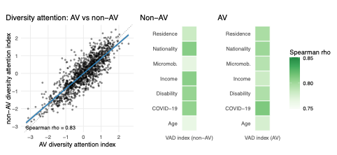
a b c

Figure S1. Diversity attention across AV and non-AV scenes
a) Correlation between AV and non-AV diversity-attention indices (Spearman ρ = 0.83).
b) Category-specific VAD index in non-AV scenes.
c) Category-specific VAD index in AV scenes.
Note. Normality tests indicated significant deviations (Shapiro–Wilk, p < .001), though scatterplots suggested approximate linearity.

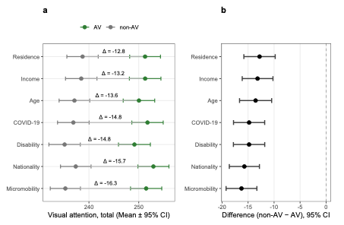

Figure S2. Visual attention to social diversity cues in autonomous (AV) and non-autonomous (non-AV) urban scenes.
a) Mean fixation times (ms) for AV and non-AV conditions across seven diversity categories; values shown with 95% confidence intervals. (b) Paired differences (non-AV – AV) with 95% confidence intervals; negative values indicate greater attention in AV scenes.
Note. Both panels are based on paired-sample comparisons (N ≈ 1,250 per category). Panel (a) shows absolute fixation levels, while panel (b) isolates the mean differences to highlight the relative effect of AV versus non-AV conditions.

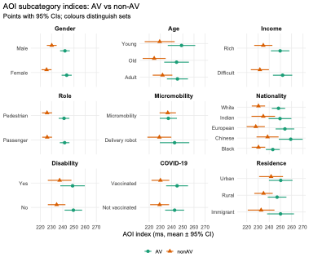
Figure S3. Indices of AOI subcategories in AV and non-AV contexts
Notes. Blue markers represent non-AV, green markers represent AV, and grey lines connect paired values. The AOI index is expressed in milliseconds (mean ±95% CI).

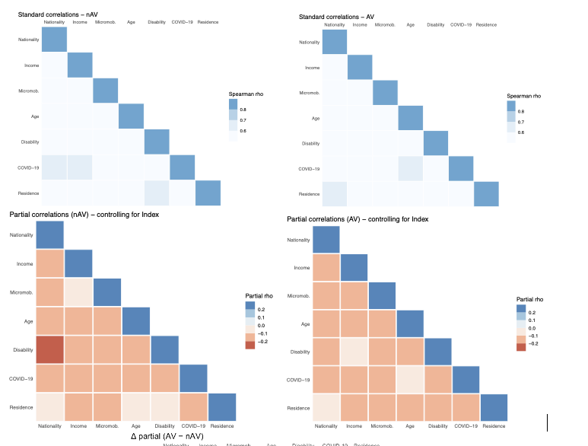
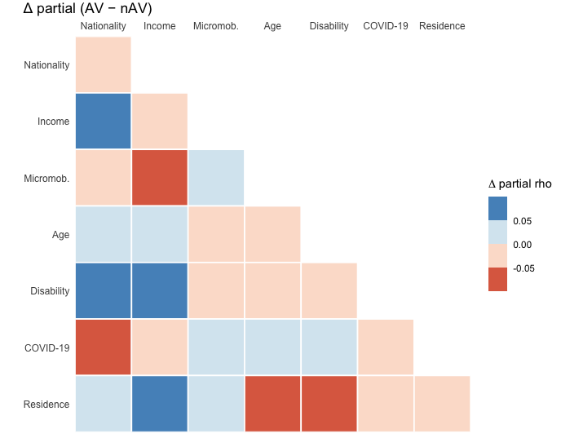
Figure S4. Correlations among diversity dimensions in AV and non-AV contexts
a). Standard correlations — lower triangle
b) Partial correlations (controlling for index) – lower triangle
c) Difference in partial correlations (AV – non-AV) – lower triangle

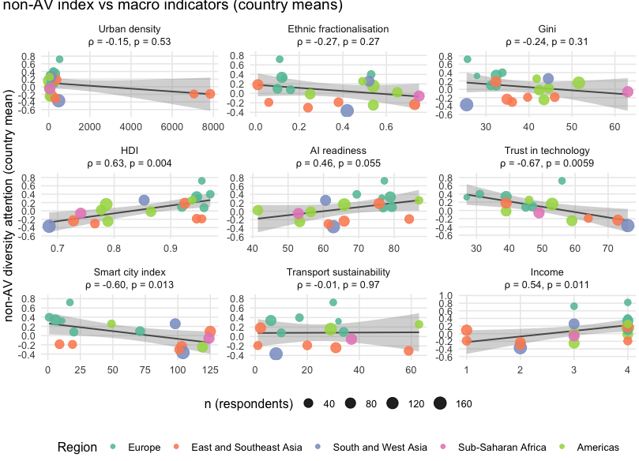 | 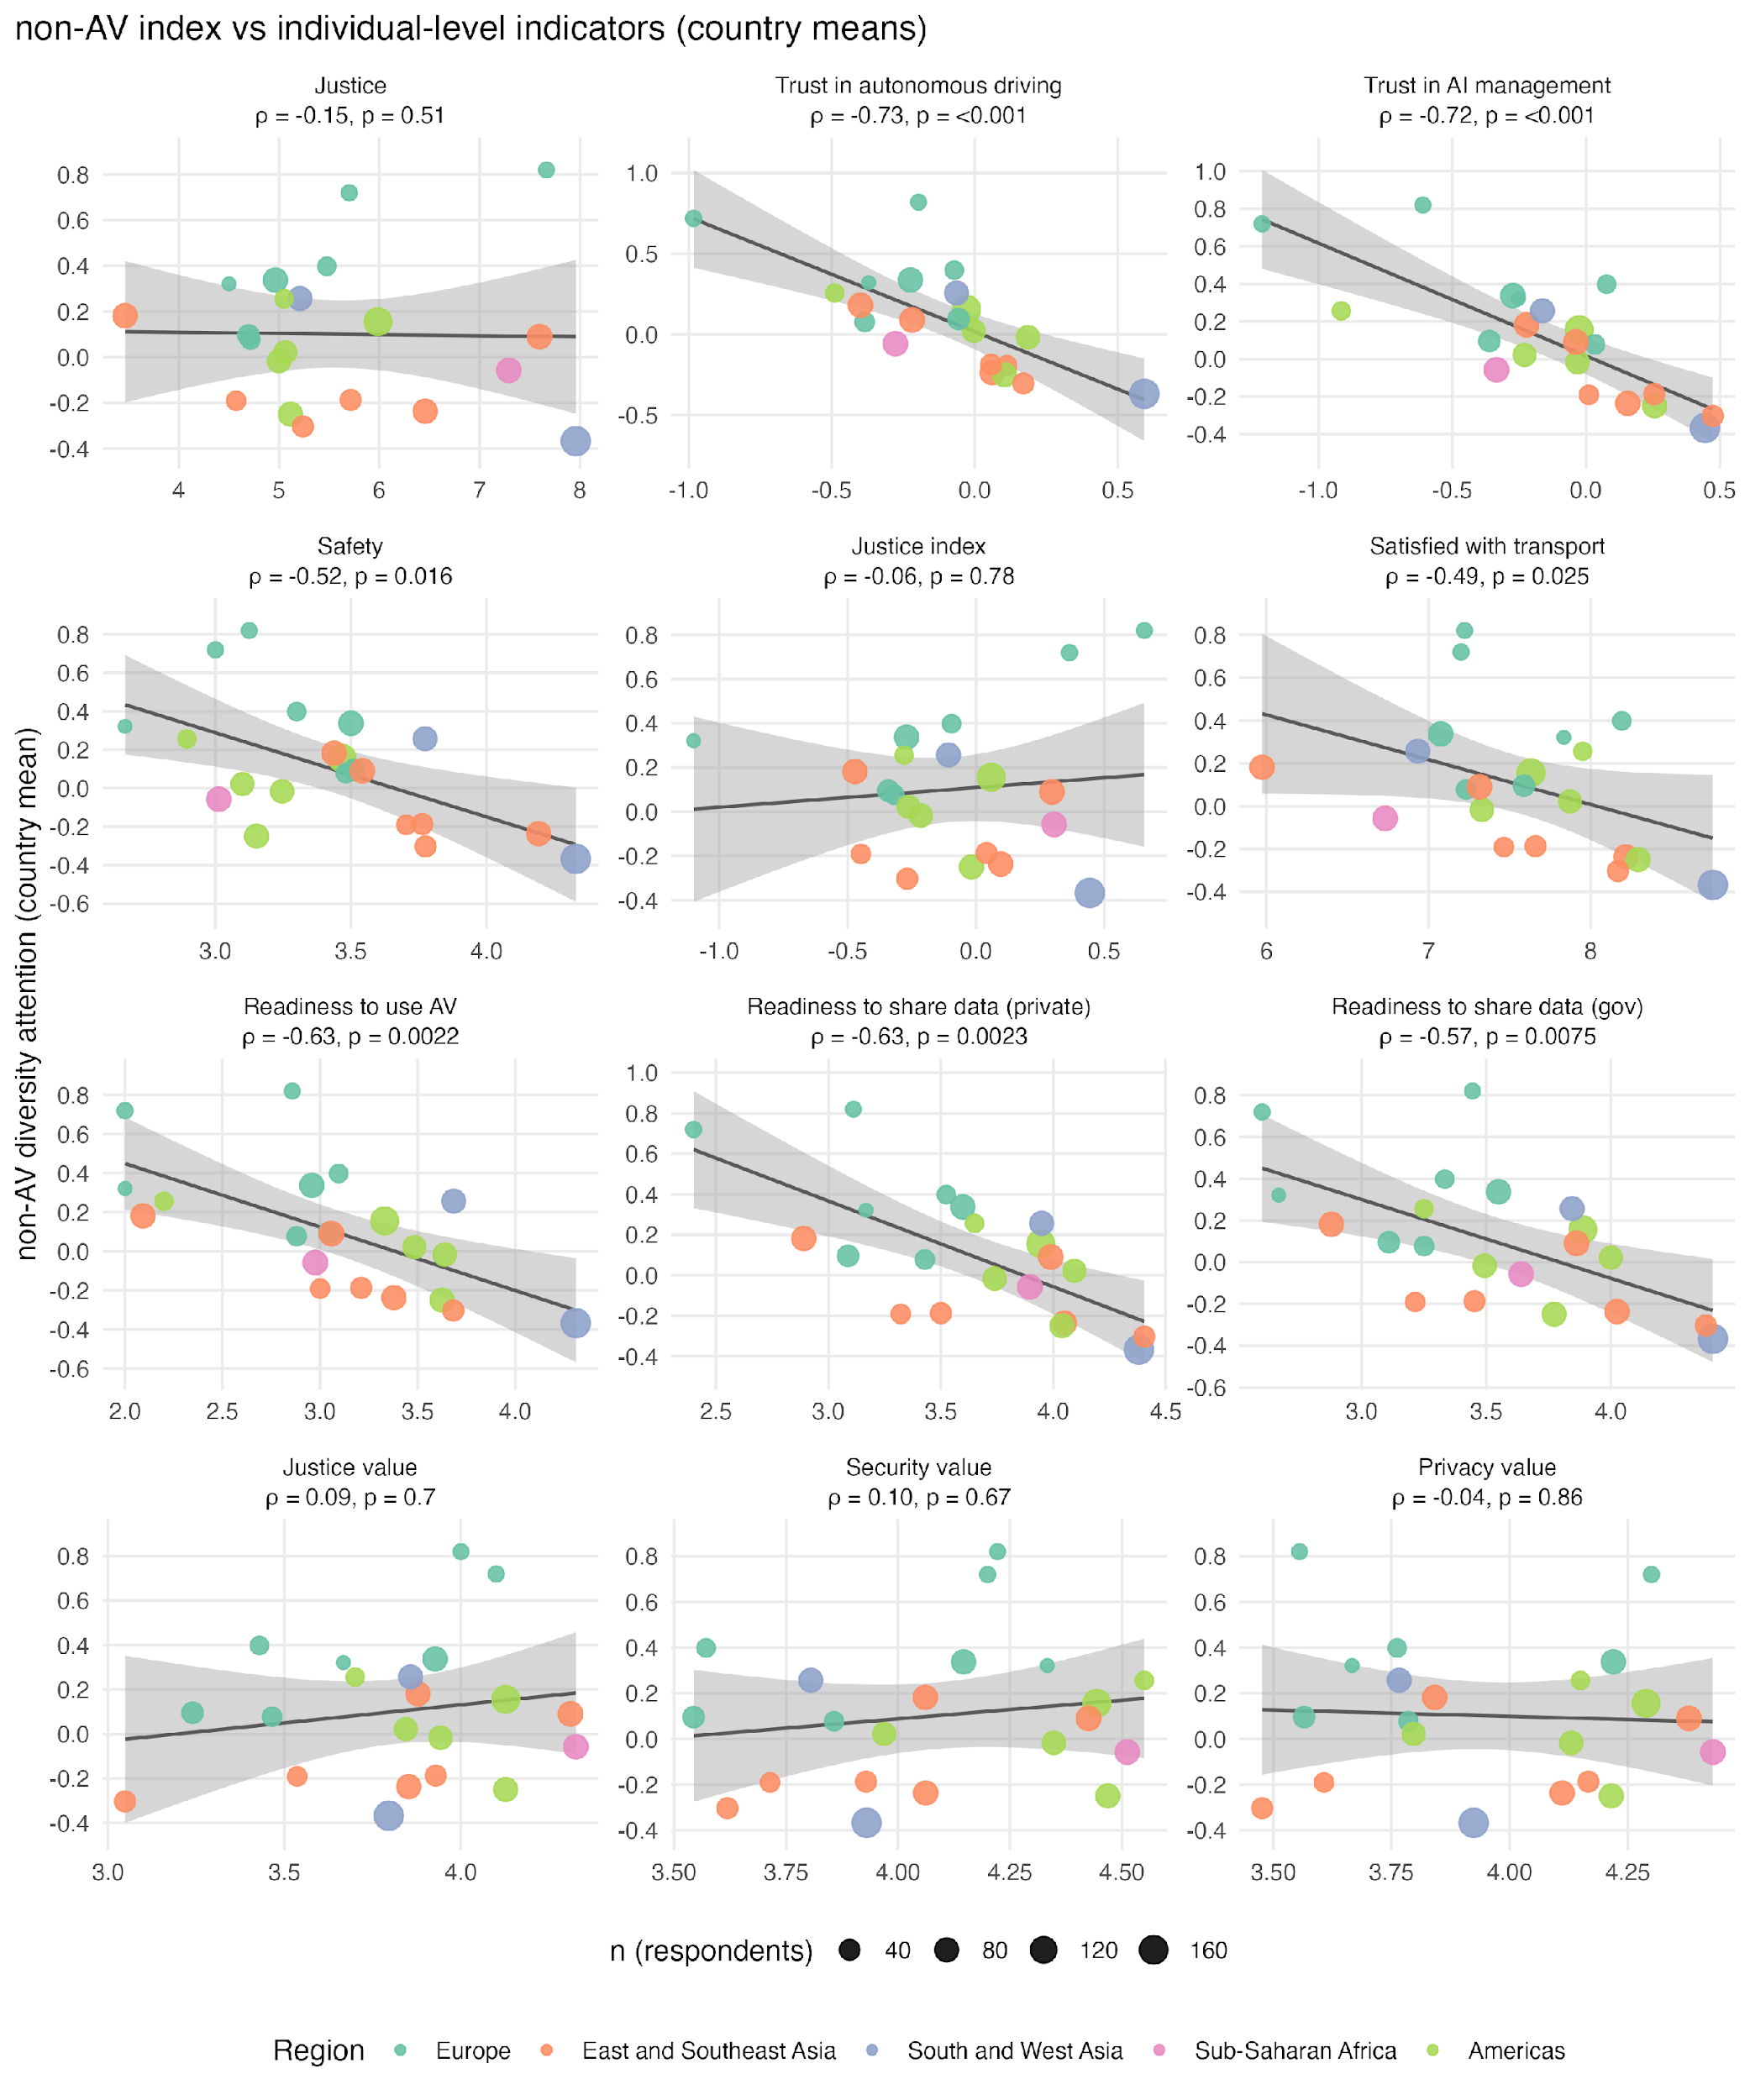
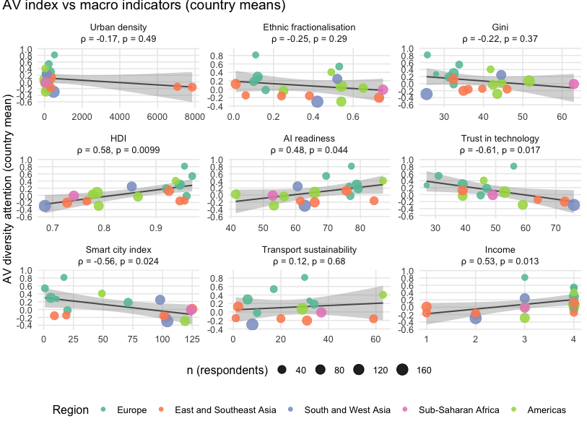 | 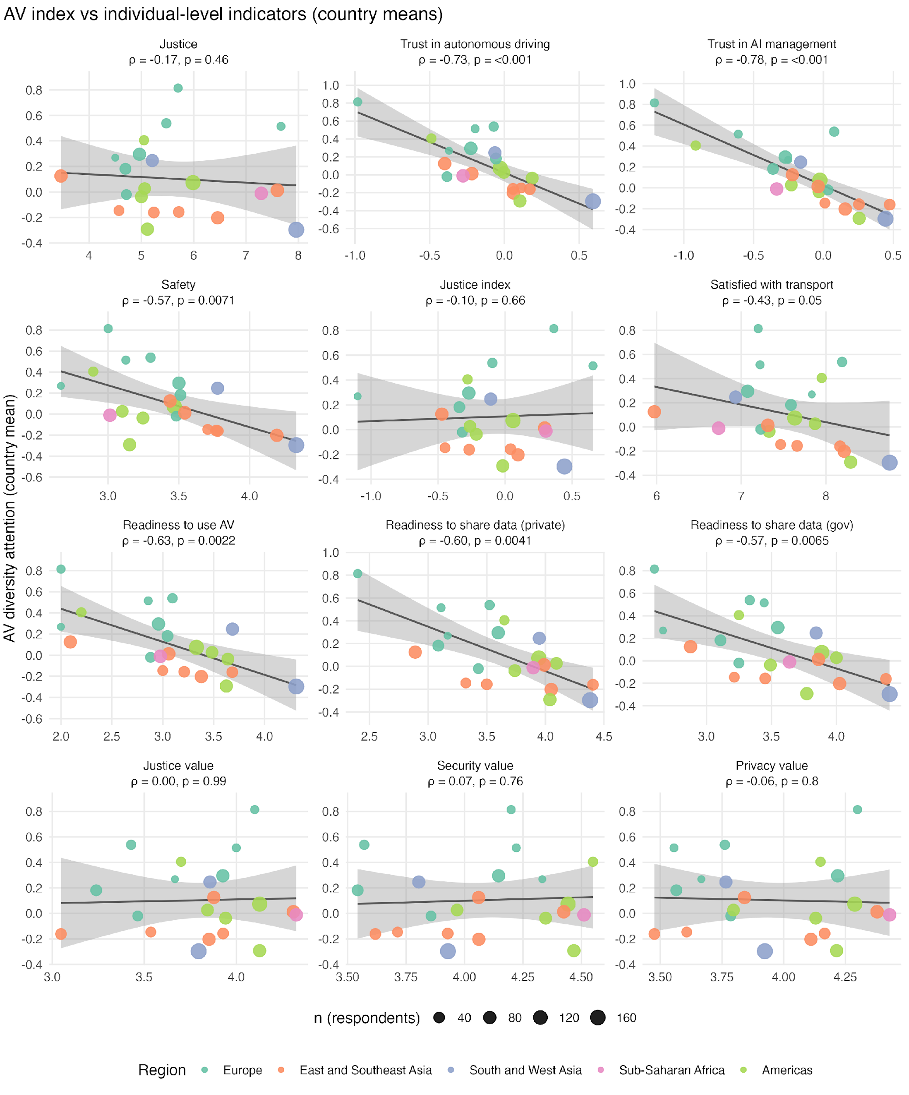

Figure S5. Associations between diversity-attention index and macro-level (above) and micro-level indicators (below) (country means)
Note: Dots show city/country means; colour distinguishes cities/countries (see legend) and dot size reflects the number of respondents in that country. The grey line is ordinary least squares fit with a 95% confidence ribbon for visual guidance. Each panel reports the Spearman correlation (ρ) between the index and the macro / micro indicator / single variables, with a bootstrap 95% confidence interval and two-sided p-value. Axes are on the raw scales of the indicators; no additional transformations were applied.

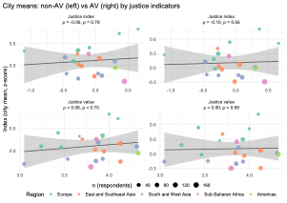
Figure S6. Region-level associations between diversity attention and justice indicators
across AV and non-AV contexts
Notes. Each point represents a city mean (z-score) by region. Shaded bands show 95% confidence intervals for linear fits. Correlation coefficients (ρ) and p-values indicate no systematic relationship between diversity attention and either justice index or justice value, suggesting that attention and justice perceptions may operate independently at the aggregate level.

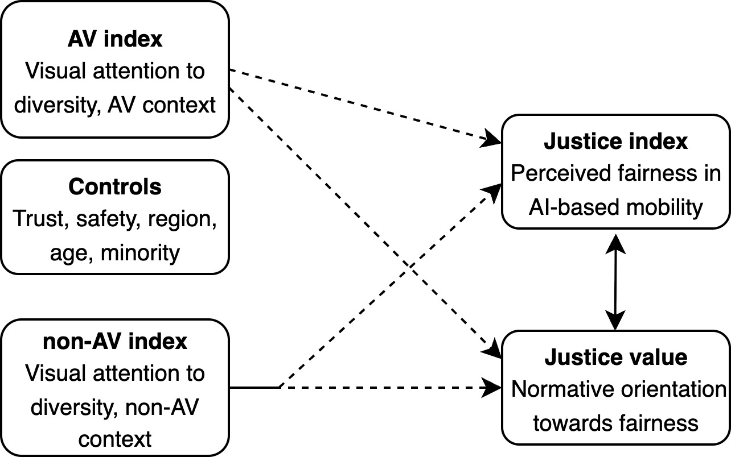
Figure S7. Synthetic path model of determinants of justice value
Notes. All paths are standardised β coefficients; solid lines indicate significant associations. Variables represent: Trust in AV (confidence in autonomous systems), Region (city-level grouping), Minority (self-reported minority status), AI experience (familiarity with AI-based systems), AV and non-AV indices (visual attention measures in respective contexts).

Table S1. Demographic distribution of the study sample
 |  | N | %
Age | 15–29 | 385 | 30
 | 30–44 | 513 | 40
 | 45–59 | 268 | 21
 | 60+ | 110 | 9
AI awareness | Low awareness | 768 | 60
 | High awareness | 508 | 40
Children | No | 566 | 44
 | Yes | 697 | 55
Education | Other education | 410 | 32
 | Higher education | 850 | 67
Gender | Male | 754 | 41
 | Female | 522 | 59
Income | Comfortable / can handle | 954 | 75
 | Difficult | 266 | 21
Marital status | Married / cohabiting | 766 | 60
 | Single | 510 | 40
Belong to minority group | No | 698 | 68
 | Yes | 380 | 32
Religion | Believer | 857 | 67
 | Non-believer | 344 | 27
Note. Missing values were excluded from the analysis. AI awareness refers to whether the respondent has previously participated in AI-related surveys conducted on the Cint platform. Belonging to a minority group is based on respondents’ self-assessment, as are the income and religion variables.

Table S2. Contextual distribution across participating cities
City | CMI | Urban density | Ethnic fractionalisation | Gini | HDI | AI readiness | Trust in technology | Smart city index | Urban accessibility index | Income
ARG Buenos Aires | 3 | 17 | 0,25 | 42,4 | 0,865 | 56,4 | 39 |  |  | 4
BRA São Paulo | 4 | 25 | 0,54 | 51,6 | 0,786 | 65,89 | 53 |  | 29 | 4
CHE Zurich | 2 | 222 | 0,53 | 33,8 | 0,97 | 69,42 | 31 | 1 | 17 | 4
DEU Stuttgart/Berlin | 3 | 240 | 0,16 | 32,4 | 0,959 | 76,9 | 45 | 20 | 10 | 4
ECU Guayaquil | 5 | 72 | 0,65 | 44,6 | 0,777 | 41,46 |  |  |  | 3
FIN Helsinki | 3 | 18 | 0,13 | 27,9 | 0,948 | 76,48 | 27 | 11 | 32 | 4
FRA Paris | 1 | 124 | 0,1 | 31,2 | 0,92 | 79,36 | 47 | 71 | 34 | 4
GBR London | 1 | 279 | 0,12 | 32,4 | 0,946 | 78,88 | 39 | 6 | 6 | 4
HKG Hong Kong |  | 7060 | 0,06 | 39,7 | 0,955 |  | 64 | 19 | 1 | 4
IDN Jakarta | 4 | 147 | 0,73 | 34,9 | 0,728 | 65,85 | 73 | 103 | 31 | 2
IND Kolkata | 5 | 479 | 0,42 | 25,5 | 0,685 | 62,81 | 76 | 104 | 8 | 2
ISL Reykjavik | 1 |  |  |  |  |  |  |  |  | 4
JPN Tokyo | 1 | 343 | 0,01 | 32,3 | 0,925 | 75,75 | 39 |  | 2 | 4
MEX Mexico City | 3 | 66 | 0,54 | 43,5 | 0,789 | 53,29 | 59 | 119 |  | 3
NLD Amsterdam |  | 526 | 0,11 | 25,7 | 0,955 | 77,23 | 56 | 17 | 30 | 3
PHL Manila | 5 |  |  |  |  |  |  | 125 |  | 1
SGP Singapore |  | 7851 | 0,38 | 46 | 0,946 | 84,25 |  | 9 | 20 | 1
TUR Ankara | 4 | 110 | 0,52 | 44,5 | 0,853 | 60,6 |  | 98 |  | 3
USA New York/LA | 1 | 37 | 0,49 | 41,8 | 0,938 | 87,03 | 46 | 49 | 63 | 4
VNM Ho Chi Minh | 4 | 318 | 0,24 | 36,1 | 0,766 | 61,42 |  | 101 | 59 | 2
ZAF Johannesburg | 4 | 51 | 0,75 | 63 | 0,741 | 52,91 | 49 | 124 | 37 | 3
Note. Empty cells indicate that no data were available for the respective index. CMI refers to the City Mobility Index². Urban density ¹³, ethnic fractionalisation ¹⁴, the Gini index ¹⁵ , the Human Development Index ¹⁶, Smart City Readiness, AI Readiness ¹⁷, urban accessibility index ¹⁸ , and the Trust in Technology Index ¹⁹ provide contextual information describing broader city characteristics. While our sampling strategy primarily aimed to ensure variation in ethnic diversity and levels of autonomous vehicle (AV) deployment, these additional indices are included to illustrate further contextual differences across cities.

Table S3. Sample distribution across the four UN regions
Region | City | Frequency | Region Total | Region Percent (of 1276)
Americas | ARG Buenos Aires | 69 | 374 | 29,3
 | BRA São Paulo | 142
 | ECU Guayaquil | 64
 | MEX Mexico City | 79
 | USA New York, Los Angeles | 20
Europe | CHE Zurich | 21 | 202 | 15,8
 | DEU Stuttgart, Berlin | 28
 | FIN Helsinki | 6
 | FRA Paris | 46
 | GBR London | 82
 | ISL Reykjavik | 9
 | NLD Amsterdam | 10 | 202
East and Southeast Asia | HKG Hong Kong | 28 | 362 | 28,4
 | IDN Jakarta | 81 | 362
 | JPN Tokyo | 82 | 362
 | PHL Manila | 87 | 362
 | SGP Singapore | 42 | 362
 | VNM Ho Chi Minh City | 42 | 362
South and West Asia | IND Kolkata | 171 | 248 | 19,4
 | TUR Ankara | 77
Sub-Saharan Africa | ZAF Johannesburg | 86 | 86 | 6,7
Note. We selected five regions to improve comparability, using the United Nations regional classification as the basis. Individual cities had fewer respondents, but regional differences may reflect legal, cultural and geopolitical contexts that shape how mobility, social diversity and AI technologies are understood. Africa is presented as a separate region because, although technological developments often follow European models, it remains internally diverse.

Table S4. Descriptive metadata
Field | Description
Database name | AV_FixTime_Online&In-lab_Study_Metadata
Purpose | Contains participant-level data from eye-tracking experiments examining fixation times across scenario categories in autonomous vehicle (AV) and non-AV conditions.
Experiment type | (i) In-lab experiment using stationary infrared eye-tracking; (ii) Online experiment using webcam-based eye-tracking.
Sample size | Online experiment: N = 1,276; In-lab experiment: N = 16.
Experimental settings | Two settings: (1) AV (autonomous vehicle) – fully automated, no driver; (2) non-AV (manual vehicle) – human-driven.
Scenario description | AV setting: participants viewed an autonomous public shuttle that suddenly experienced brake failure and faced two options — (A) hit pedestrians, saving passengers, or (B) crash into a barrier (sacrificing passengers) , saving pedestrians. Non-AV scenarios were identical except for the presence of a human driver (who was not sacrificed in any case).
Stimulus format | Paired images representing the two decision options (left = A, right = B). Question: “Which group of people do you think the vehicle will save first?” Participants selected between passengers and pedestrians.
Diversity representation | Scenarios depicted passengers and pedestrians differing in nationality, residence, income, gender, age, reduced mobility, micromobility use, and COVID-19 vaccination status.
Data content | Aggregated fixation time (ms) by area of interest (AOI), linked with participant demographics, scenario characteristics, and contextual metadata (city, region).

Table S5. Structural metadata
Variable | Description / Coding
participant_id | Unique participant identifier.
database_format | Flat table: one row per participant; columns represent demographic, socioeconomic, and fixation variables.
fixation_time_[category] | Total fixation time (ms) by scenario and diversity category.
a_nationality, n_nationality | Nationality category (AV/non-AV).
a_income, n_income | Income category (AV/non-AV).
a_micromobility, n_micromobility | Micromobility use category (AV/non-AV).
a_age, n_age | Age category (AV/non-AV).
a_disability, n_disability | Disability or reduced mobility (AV/non-AV).
a_COVID19, n_COVID19 | COVID-19 vaccination status (AV/non-AV).
a_residence, n_residence | Residence status (urban/rural).
participant_tags | Indicator of prior participation in similar studies.
city, country | Location metadata.
age, gender, education, minority status | Demographic attributes (self-reported).
justice experience | A summation index was constructed from respondents’ agreement with six statements about data-related justice in society. Each item was rated on a 1–4 agreement scale (from completely disagree to completely agree), with 88 coded as don’t know.
justice value | The justice value reflects respondents’ ratings of how important socially justified activities and decisions related to data use are. The item was measured on a 1–5 scale, ranging from completely insignificant to very important.
trust | A summation index was created based on respondents’ trust ratings across six levels of vehicle automation (Levels 0–5). Each item was rated on a scale from 1 (do not trust at all) to 5 (trust completely), with 88 coded as do not know.
security | The security value reflects respondents’ ratings of how important security-related considerations are, including cyber security, reducing people’s insecurity and ensuring a sense of security. The item was measured on a 1–5 scale, ranging from completely insignificant to very important.

Table S6. Visual attention to social-diversity cues in AV vs non-AV scenes (paired, within-respondent).
Values are Mean ± SD. Δ = non-AV − AV (95% CI). Effect size = Cohen’s dz. Rows ordered by |Δ|.
Topic | N | AV  (Mean ± SD) | non-AV (Mean ± SD) | Δ (95% CI) | t(df) | p | Cohen's dz (95% CI)
Micromobility | 1254 | 251.7 ± 56.4 | 235.6 ± 54.8 | −16.1 (−19.1, −13.1) | 10.66 (1253) | <.001 | 0.30 (0.24, 0.36)
Nationality | 1250 | 253.4 ± 55.8 | 237.8 ± 55.5 | −15.6 (−18.52, −12.70) | 10.53 (1249) | <.001 | 0.30 (0.24, 0.35)
COVID-19 | 1253 | 252.2 ± 56.5 | 237.5 ± 57.0 | −14.8 (−17.75, −11.78) | 9.69 (1252) | <.001 | 0.27 (0.22, 0.33)
Disability | 1249 | 250.0 ± 57.1 | 235.2 ± 56.8 | −14.8 (−17.85, −11.84) | 9.69 (1248) | <.001 | 0.27 (0.22, 0.33)
Income | 1253 | 251.9 ± 56.8 | 238.7 ± 56.9 | −13.2 (−16.15, −10.23) | 8.74 (1252) | <.001 | 0.25 (0.19, 0.30)
Age | 1250 | 250.5 ± 56.3 | 237.2 ± 55.7 | −13.4 (−16.47, −10.28) | 8.48 (1249) | <.001 | 0.24 (0.18, 0.30)
Residence | 1250 | 251.8 ± 55.4 | 239.0 ± 56.6 | −12.7 (−15.75, −9.74) | 8.32 (1249) | <.001 | 0.24 (0.18, 0.29)
Note. Paired t-tests on within-respondent differences; dz uses the SD of paired differences. Negative Δ indicates greater visual attention in AV scenes. N varies by topic due to missingness.

Table S7. Statistical comparison of AOI subcategory indices in AV and non-AV contexts
Group | Level | n (pairs) | Mean AV | 95% CI AV | Mean non-AV | 95% CI non-AV | Diff (AV - non-AV) | 95% CI Diff | t | df | p (formatted)
Gender | Female | 903 | 246.0717 | [241.3, 250.8] | 226.4011 | [221.8, 231.0] | 19.6705459 | [14.1, 25.2] | 6.92051878 | 902 | <0.001
 | Male | 938 | 243.4848 | [238.9, 248.0] | 229.7787 | [225.2, 234.4] | 13.7061053 | [8.3, 19.1] | 5.00269008 | 937 | <0.001
Age | Adult | 203 | 242.9852 | [229.4, 256.6] | 242.3461 | [229.6, 255.1] | 0.6391626 | [-17.2, 18.5] | 0.07065098 | 202 | 0.944
 | Old | 105 | 267.5333 | [248.7, 286.3] | 243.9238 | [225.8, 262.0] | 23.6095238 | [-0.4, 47.6] | 1.94829199 | 104 | 0.054
 | Young | 79 | 265.7025 | [242.1, 289.3] | 224.5316 | [200.3, 248.8] | 41.1708861 | [9.7, 72.7] | 2.60253067 | 78 | 0.011
Income | Difficult | 246 | 257.2795 | [244.8, 269.7] | 230.7605 | [219.7, 241.8] | 26.5189702 | [10.3, 42.7] | 3.22462105 | 245 | 0.001
 | Rich | 268 | 249.6502 | [238.2, 261.1] | 233.6107 | [222.6, 244.7] | 16.0394900 | [1.5, 30.6] | 2.17483353 | 267 | 0.031
Role | Passenger | 878 | 242.7824 | [238.3, 247.3] | 225.5896 | [220.9, 230.3] | 17.1927265 | [11.8, 22.6] | 6.27278303 | 877 | <0.001
 | Pedestrian | 834 | 243.8840 | [238.9, 248.9] | 227.4564 | [222.7, 232.2] | 16.4276365 | [10.8, 22.0] | 5.74160205 | 833 | <0.001
Mobility | Delivery robot | 92 | 236.9130 | [217.2, 256.6] | 224.9348 | [204.8, 245.1] | 11.9782609 | [-14.0, 38.0] | 0.91442563 | 91 | 0.363
 | Micromobility | 360 | 235.0641 | [225.2, 244.9] | 236.0099 | [226.6, 245.4] | -0.9457870 | [-13.8, 11.9] | -0.14479051 | 359 | 0.885
Nationality/  race | Black | 540 | 246.0148 | [238.6, 253.5] | 232.1898 | [225.0, 239.4] | 13.8249846 | [4.5, 23.2] | 2.90776628 | 539 | 0.004
 | Chinese | 150 | 278.4867 | [263.3, 293.6] | 247.3000 | [231.8, 262.8] | 31.1866667 | [12.8, 49.5] | 3.35993048 | 149 | <0.001
 | European | 266 | 261.6071 | [250.0, 273.2] | 231.5714 | [220.3, 242.8] | 30.0357143 | [16.2, 43.9] | 4.26056070 | 265 | <0.001
 | Indian | 125 | 251.4080 | [233.6, 269.3] | 248.7680 | [231.6, 265.9] | 2.6400000 | [-18.7, 24.0] | 0.24464793 | 124 | 0.807
 | White | 592 | 250.4768 | [243.5, 257.4] | 231.3098 | [224.4, 238.2] | 19.1670373 | [10.2, 28.2] | 4.18172246 | 591 | <0.001
Disability | Yes | 113 | 249.5708 | [229.5, 269.6] | 238.5752 | [221.6, 255.5] | 10.9955752 | [-14.8, 36.8] | 0.84423920 | 112 | 0.400
 | No | 292 | 255.8075 | [244.9, 266.7] | 239.8398 | [229.2, 250.5] | 15.9676941 | [1.7, 30.2] | 2.20106744 | 291 | 0.029
Covid-19 | Not vaccinated | 194 | 248.7156 | [235.8, 261.6] | 236.5494 | [223.8, 249.3] | 12.1662371 | [-3.1, 27.4] | 1.57040712 | 193 | 0.118
 | Vaccinated | 208 | 251.2668 | [237.5, 265.0] | 232.3682 | [220.7, 244.0] | 18.8986378 | [2.9, 34.9] | 2.33083542 | 207 | 0.021
Residence | Immigrant | 101 | 264.1485 | [243.8, 284.5] | 244.8119 | [224.1, 265.5] | 19.3366337 | [-6.9, 45.5] | 1.46499324 | 100 | 0.146
 | Rural | 268 | 247.3256 | [235.8, 258.8] | 231.8846 | [220.5, 243.3] | 15.4409204 | [1.9, 29.0] | 2.23930749 | 267 | 0.026
 | Urban | 118 | 254.7712 | [237.4, 272.1] | 236.5254 | [218.5, 254.6] | 18.2457627 | [-5.9, 42.4] | 1.49717638 | 117 | 0.137
Notes. The table reports mean AOI values (ms), standard deviations, and sample sizes for each subcategory, as well as statistical test results (p-values, 95% confidence intervals, and effect sizes where applicable). These values correspond to the visualised results in Figure 2 and provide detailed evidence of differences between AV and non-AV conditions.

Table S8. Subgroup means (95% CI) and one-way ANOVA for AV and non-AV indices.
Factor | Level | N (AV) | Mean (AV) | SD (AV) | 95% CI (AV) | N  (non-AV) | Mean  (non-AV) | SD  (non-AV) | 95% CI (non-AV) | F (AV) | df (AV) | p (AV) | F  (non-AV) | df  (non-AV) | p  (non-AV)
age | 18–29 | 373 | 0.08 | 0.85 | [-0.01, 0.16] | 371 | 0.02 | 0.84 | [-0.07, 0.10] | 6.61 | 3, 1241 | <0.001 | 8.25 | 3, 1234 | <0.001
age | 30–44 | 500 | -0.14 | 0.97 | [-0.23, -0.06] | 498 | -0.14 | 0.97 | [-0.22, -0.05] | 6.61 | 3, 1241 | <0.001 | 8.25 | 3, 1234 | <0.001
age | 45–59 | 263 | 0.14 | 0.99 | [0.02, 0.26] | 261 | 0.2 | 0.97 | [0.09, 0.32] | 6.61 | 3, 1241 | <0.001 | 8.25 | 3, 1234 | <0.001
age | 60+ | 109 | 0.06 | 1.01 | [-0.13, 0.25] | 108 | 0.11 | 1.03 | [-0.08, 0.31] | 6.61 | 3, 1241 | <0.001 | 8.25 | 3, 1234 | <0.001
AI awareness | Low awareness | 756 | 0.04 | 0.94 | [-0.03, 0.11] | 747 | 0.08 | 0.92 | [0.02, 0.15] | 3.62 | 1, 1248 | 0.0572 | 14.47 | 1, 1241 | <0.001
AI awareness | High awareness | 494 | -0.06 | 0.97 | [-0.15, 0.02] | 496 | -0.13 | 0.97 | [-0.21, -0.04] | 3.62 | 1, 1248 | 0.0572 | 14.47 | 1, 1241 | <0.001
children | No | 559 | 0.12 | 0.88 | [0.05, 0.19] | 557 | 0.11 | 0.91 | [0.04, 0.19] | 16.18 | 1, 1248 | <0.001 | 14.42 | 1, 1241 | <0.001
children | Yes | 691 | -0.1 | 0.99 | [-0.17, -0.02] | 686 | -0.09 | 0.97 | [-0.16, -0.02] | 16.18 | 1, 1248 | <0.001 | 14.42 | 1, 1241 | <0.001
education | Other education | 136 | -0.17 | 0.95 | [-0.33, -0.01] | 134 | -0.1 | 0.92 | [-0.26, 0.06] | 4.41 | 1, 1193 | 0.0359 | 1.72 | 1, 1185 | 0.19
education | Higher education | 1059 | 0.01 | 0.94 | [-0.04, 0.07] | 1053 | 0.01 | 0.95 | [-0.04, 0.07] | 4.41 | 1, 1193 | 0.0359 | 1.72 | 1, 1185 | 0.19
gender | Male | 741 | -0.01 | 0.99 | [-0.08, 0.06] | 735 | 0 | 0.98 | [-0.07, 0.07] | 0.1 | 1, 1248 | 0.754 | 0.02 | 1, 1241 | 0.889
gender | Female | 509 | 0.01 | 0.9 | [-0.07, 0.09] | 508 | 0 | 0.9 | [-0.08, 0.07] | 0.1 | 1, 1248 | 0.754 | 0.02 | 1, 1241 | 0.889
income | Comfortable | 933 | -0.03 | 0.96 | [-0.09, 0.03] | 929 | -0.03 | 0.96 | [-0.09, 0.03] | 4.55 | 1, 1194 | 0.0331 | 4.87 | 1, 1189 | 0.0274
income | Difficult | 263 | 0.11 | 0.89 | [0.01, 0.22] | 262 | 0.11 | 0.89 | [0.01, 0.22] | 4.55 | 1, 1194 | 0.0331 | 4.87 | 1, 1189 | 0.0274
marital | Married / cohabiting | 1176 | -0.01 | 0.95 | [-0.06, 0.05] | 1169 | -0.01 | 0.94 | [-0.06, 0.05] | 0.94 | 1, 1248 | 0.332 | 1.51 | 1, 1241 | 0.22
marital | Single | 74 | 0.1 | 0.97 | [-0.12, 0.33] | 74 | 0.13 | 1.08 | [-0.12, 0.38] | 0.94 | 1, 1248 | 0.332 | 1.51 | 1, 1241 | 0.22
minority | No | 786 | 0.05 | 0.95 | [-0.01, 0.12] | 777 | 0.08 | 0.93 | [0.02, 0.15] | 9.12 | 1, 1151 | 0.00259 | 21.96 | 1, 1145 | <0.001
minority | Yes | 367 | -0.13 | 0.96 | [-0.23, -0.03] | 370 | -0.19 | 0.96 | [-0.29, -0.10] | 9.12 | 1, 1151 | 0.00259 | 21.96 | 1, 1145 | <0.001
religion | Believer | 1087 | -0.02 | 0.95 | [-0.07, 0.04] | 1080 | -0.02 | 0.95 | [-0.07, 0.04] | 4.08 | 1, 1174 | 0.0437 | 4.01 | 1, 1167 | 0.0456
religion | Non-believer | 89 | 0.2 | 0.97 | [-0.01, 0.40] | 89 | 0.19 | 0.99 | [-0.01, 0.40] | 4.08 | 1, 1174 | 0.0437 | 4.01 | 1, 1167 | 0.0456
region | Europe | 200 | 0.29 | 0.91 | [0.16, 0.41] | 199 | 0.29 | 0.95 | [0.16, 0.43] | 6.15 | 4, 1241 | <0.001 | 7.56 | 4, 1234 | <0.001
region | East and Southeast Asia | 359 | -0.06 | 0.9 | [-0.15, 0.03] | 357 | -0.06 | 0.9 | [-0.15, 0.03] | 6.15 | 4, 1241 | <0.001 | 7.56 | 4, 1234 | <0.001
region | South and West Asia | 243 | -0.13 | 0.99 | [-0.25, -0.00] | 242 | -0.18 | 1 | [-0.30, -0.05] | 6.15 | 4, 1241 | <0.001 | 7.56 | 4, 1234 | <0.001
region | Sub-Saharan Africa | 84 | -0.01 | 0.9 | [-0.21, 0.18] | 84 | -0.06 | 0.91 | [-0.26, 0.14] | 6.15 | 4, 1241 | <0.001 | 7.56 | 4, 1234 | <0.001
region | Americas | 360 | -0.01 | 0.98 | [-0.11, 0.09] | 357 | 0.02 | 0.93 | [-0.07, 0.12] | 6.15 | 4, 1241 | <0.001 | 7.56 | 4, 1234 | <0.001

Table S9. Spearman correlations between macro indicators and diversity attention indices (AV and non-AV).
 | AV |  |  |  | Non-AV
Macro indicator | ρ | P | N | 95% CI | ρ | p | N | 95% CI
Urban density | -0.17 | .491 | 19 | [-0.58, 0.34] | -0.15 | .528 | 19 | [-0.58, 0.38]
Ethnic fractionalisation | -0.25 | .295 | 19 | [-0.61, 0.21] | -0.27 | .268 | 19 | [-0.64, 0.21]
Gini | -0.22 | .371 | 19 | [-0.67, 0.27] | -0.24 | .312 | 19 | [-0.69, 0.29]
HDI | 0.58 | .010 | 19 | [0.10, 0.88] | 0.63 | .004 | 19 | [0.21, 0.90]
AI readiness | 0.48 | .044 | 18 | [0.03, 0.78] | 0.46 | .055 | 18 | [0.03, 0.75]
Trust in technology | -0.61 | .017 | 15 | [-0.91, -0.04] | -0.67 | .006 | 15 | [-0.93, -0.12]
Smart city index | -0.56 | .024 | 16 | [-0.85, -0.07] | -0.60 | .013 | 16 | [-0.85, -0.13]
Transport sustainability | 0.12 | .676 | 15 | [-0.42, 0.58] | -0.01 | .970 | 15 | [-0.52, 0.51]
Income | 0.53 | .013 | 21 | [0.13, 0.77] | 0.54 | .011 | 21 | [0.14, 0.78]
Notes: Spearman’s ρ with two-tailed p-values; 95% confidence intervals from nonparametric bootstrap (R = 2000). Data computed on country means. AV = autonomous-vehicle diversity index; non-AV = non-autonomous-vehicle diversity index.

Table S10. Spearman correlations between micro indicators and diversity attention indices (AV and non-AV).
 | AV |  |  |  | Non-AV
Individual-level indicator | ρ | p | N | 95% CI | ρ | p | N | 95% CI
Justice | -0.17 | .45 | 22 | [-0.56, 0.28] | -0.22 | .32 | 22 | [-0.65, 0.27]
Trust in autonomous driving | -0.68 | <0.001 | 22 | [-0.87, -0.34] | -0.56 | .0065 | 22 | [-0.87, -0.12]
Trust in AI management | -0.72 | <0.001 | 22 | [-0.94, -0.36] | -0.54 | .0092 | 22 | [-0.89, -0.05]
Safety | -0.55 | .0078 | 22 | [-0.85, -0.10] | -0.48 | .024 | 22 | [-0.79, -0.02]
Justice index | -0.11 | .62 | 22 | [-0.57, 0.36] | -0.14 | .54 | 22 | [-0.63, 0.37]
Satisfied with transport | -0.41 | .06 | 22 | [-0.78, 0.09] | -0.53 | .01 | 22 | [-0.82, -0.09]
Readiness to use AV | -0.59 | .0038 | 22 | [-0.82, -0.21] | -0.48 | .024 | 22 | [-0.82, -0.02]
Readiness to share data (private) | -0.58 | .0046 | 22 | [-0.80, -0.20] | -0.66 | <0.001 | 22 | [-0.87, -0.30]
Readiness to share data (gov) | -0.56 | .0066 | 22 | [-0.80, -0.18] | -0.60 | .003 | 22 | [-0.84, -0.23]
Justice value | 0.01 | .98 | 22 | [-0.43, 0.44] | 0.15 | .52 | 22 | [-0.31, 0.55]
Security value | 0.06 | .79 | 22 | [-0.39, 0.51] | 0.12 | .59 | 22 | [-0.31, 0.51]
Privacy value | -0.07 | .76 | 22 | [-0.52, 0.37] | -0.09 | .68 | 22 | [-0.57, 0.38]
Notes: Spearman’s ρ with two-tailed p-values; 95% confidence intervals from nonparametric bootstrap (R = 2000). Data computed on country means. AV = autonomous-vehicle diversity index; non-AV = non-autonomous-vehicle diversity index.

Table S11. Descriptive statistics for perceived justice (justice index) and normative justice (justice value) across world regions
 | Justice index |  |  | Justice value
Region | Mean | SD | F-value | Mean | SD | F-value
Europe | -0,24 | 0,983 | 9,632* | 3,66 | 1,229 | 6,226*
Americas | -0,084 | 1,06 |  | 4,02 | 1,132
East & Southeast Asia | -0,067 | 0,98 |  | 3,86 | 1,209
South & West Asia | 0,287 | 0,895 |  | 3,81 | 1,249
Sub-Saharan Africa | 0,304 | 0,934 |  | 4,33 | 1,089
Total | 0,002 | 0,999 |  | 3,9 | 1,2
Note. The table reports regional means and standard deviations for both the perceived justice index and the normative justice value. The final columns provide ANOVA F-values; both tests are statistically significant at the 0.001 level. Normative justice shows lower between-group variability than perceived justice, reflecting the greater stability of value-based orientations compared with situational evaluations.

Table S12. Descriptive statistics for perceived justice (justice index) and normative justice (justice value) across cities
 | Justice index |  |  | Justice value
City | Mean | SD | F-value | Mean | SD | F-value
ARG Buenos Aires | -0,215 | 1,042 | 4,986 | 3,94 | 1,083 | 3,811
BRA São Paulo | 0,059 | 1,078 |  | 4,13 | 1,084
CHE Zurich | -0,095 | 0,858 |  | 3,43 | 1,287
DEU Stuttgart/Berlin | -0,319 | 1,081 |  | 3,46 | 1,071
ECU Guayaquil | -0,262 | 1,185 |  | 3,84 | 1,237
FIN Helsinki | -1,100 | 0,982 |  | 3,67 | 1,211
FRA Paris | -0,341 | 0,825 |  | 3,24 | 1,463
GBR London | -0,271 | 1,054 |  | 3,93 | 1,097
HKG Hong Kong | -0,448 | 0,783 |  | 3,54 | 0,962
IDN Jakarta | 0,096 | 0,992 |  | 3,85 | 1,388
IND Kolkata | 0,443 | 0,754 |  | 3,8 | 1,274
ISL Reykjavik | 0,656 | 0,321 |  | 4 | 1,225
JPN Tokyo | -0,472 | 0,871 |  | 3,88 | 0,974
MEX Mexico City | -0,018 | 0,901 |  | 4,13 | 1,136
NLD Amsterdam | 0,364 | 0,906 |  | 4,1 | 0,876
PHL Manila | 0,296 | 0,948 |  | 4,31 | 1,134
SGP Singapore | 0,041 | 0,830 |  | 3,93 | 1,022
TUR Ankara | -0,107 | 1,092 |  | 3,86 | 1,2
USA New York/Los Angeles | -0,280 | 1,103 |  | 3,7 | 1,218
VNM Ho Chi Minh City | -0,268 | 1,113 |  | 3,05 | 1,306
ZAF Johannesburg | 0,304 | 0,934 |  | 4,33 | 1,089
Note. The table reports city-level means and standard deviations for both the perceived justice index (JI) and the normative justice value (JV), with all values rounded to three decimal places. The final two columns provide space for manually entered ANOVA F-values (p-values omitted, as all tests were statistically significant at the 0.001 level). Normative justice shows lower between-city variability than perceived justice, indicating that value-based justice orientations are more stable across contexts than situational, stimulus-driven justice evaluations.

4. Additional references
1. Bloomberg Philantropies. Taming the Autonomous Vehicle: A Primer for Cities. (2017).
2. Motion, C. in. IESE Cities in Motion Index 2020 - Cities in Motion. https://blog.iese.edu/cities-challenges-and-management/2020/10/27/iese-cities-in-motion-index-2020/ (2020).
3. Crenshaw, K. Mapping the Margins: Intersectionality, Identity Politics, and Violence against Women of Color. Stanford Law Review 43, 1241–1299 (1991).
4. Crenshaw, K. Mapping the Margins: Intersectionality, Identity Politics, and Violence against Women of Color. Stanford Law Review 43, 1241–1299 (1991).
5. Taylor, L. What is data justice? The case for connecting digital rights and freedoms globally. Big Data & Society 4, (2017).
6. Holmqvist, K. et al. Eye Tracking: A Comprehensive Guide to Methods and Measures. (Oxford University Press, Oxford, 2011).
7. Pan, Y. et al. Lane-change intention prediction using eye-tracking technology: A systematic review. Applied Ergonomics 103, 103775 (2022).
8. Liu, X. & Cui, Y. Eye tracking technology for examining cognitive processes in education: A systematic review. Computers & Education 229, 105263 (2025).
9. Wass, S. V., Smith, T. J. & Johnson, M. H. Parsing eye-tracking data of variable quality to provide accurate fixation duration estimates in infants and adults. Behav Res 45, 229–250 (2013).
10. Bogdan, P. C., Dolcos, S., Buetti, S., Lleras, A. & Dolcos, F. Investigating the suitability of online eye tracking for psychological research: Evidence from comparisons with in-person data using emotion–attention interaction tasks. Behav Res 56, 2213–2226 (2024).
11. Schneegans, T., Bachman, M. D., Huettel, S. A. & Heekeren, H. Exploring the Potential of Online Webcam-based Eye Tracking in Decision-Making Research and Influence Factors on Data Quality. Preprint at https://doi.org/10.31234/osf.io/zm3us (2021).
12. Tóthová, M. & Rusek, M. Eye Tracking in Science Education Research: Comprehensive Literature Review. Sci & Educ https://doi.org/10.1007/s11191-025-00644-1 (2025) doi:10.1007/s11191-025-00644-1.
13. Population density. World Bank Open Data https://data.worldbank.org (2022).
14. Most Diverse Countries 2025. World Population Review https://worldpopulationreview.com/country-rankings/most-diverse-countries (2025).
15. Gini index. (2025).
16. United Nations. Human Development Index. Human Development Reports https://hdr.undp.org/data-center/human-development-index (2023).
17. 2024 Government AI Readiness Index. Oxford Insights https://oxfordinsights.com/ai-readiness/ai-readiness-index/ (2024).
18. World Bank. Urban Accessibility Index. (2010).
19. Edelman Trust Institute. Trust in Technology Index. (2024).

