Supplementary

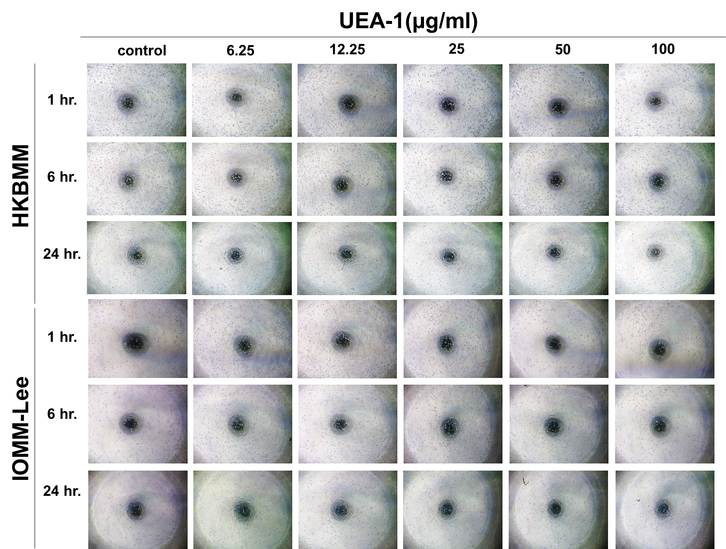

Figure S1 Cell aggregation assay

