Supplementary materials
An innovative Prosopis cineraria pod aqueous waste as natural inhibitor for enhancing unsaturated lipids production in yeast cell using banana peel

Shivani Chaturvedi^{1*}, Prashant Kumar^{2,3}, Deepak Kumar^{2,3}, Naziya Syed², Madhuri Gupta^{2,3}, Chandan Singh Chanotiya^{2, 3} , Prasant Kumar Rout^{2,3}, Sunil Kumar Khare¹

¹Enzyme and Microbial Biochemistry Laboratory, Department of Chemistry, Indian institute of Technology Delhi, New Delhi 110016, India
²Phytochemistry Division, CSIR-Central Institute of Medicinal and Aromatic Plants, Lucknow, Uttar Pradesh 226015, India
³Academy of Scientific and Innovative Research (AcSIR), Gaziabad-220025, Uttar Pradesh, India

*Author of correspondence (Dr. ShivaniChaturvedi)
Email:shivani.d123@gmail.com

Table S1. Paired Samples Test for Lipid by ANOVA SPSS software
Lipid | Paired Differences |  |  | 95% Confidence Interval of the Difference
Lipid | Mean | Std. Deviation | Std. Error Mean | Lower | Upper | t | df | Sig. (2 tailed)
Control-CIn | -8.53200 | .34084 | .15243 | -8.95521 | -8.10879 | -55.974 | 4 | .000
Control-NInEA | -1.17200 | .93219 | .41689 | -2.32946 | -.01454 | -2.811 | 4 | .048
Control-NInhx | -2.31200 | .87308 | .39045 | -3.39607 | -1.22793 | -5.921 | 4 | .004
Control-NInSox | -2.00000 | .61939 | .27700 | -2.76908 | -1.23092 | -7.220 | 4 | .002
Control-NInCL | -1.83600 | .36501 | .16324 | -2.28922 | -1.38278 | -11.248 | 4 | .002
Control-NInSC | -1.41720 | .56033 | .25059 | -14.86774 | -13.47626 | -56.555 | 4 | .000

Table S2. Paired Samples Test for Biomass by ANOVA SPSS software

Biomass | Paired Differences |  |  | 95% Confidence Interval of the Difference
Biomass | Mean | Std Deviation | Std. Error Mean | Lower | Upper | t |  | df | Sig. (2-tailed)
control - CIn | -.40200 | .30581 | .13676 | -.78171 | -.02229 |  | -2.939 | 4 | .042
control - NinEA | -2.35600 | .41962 | .18766 | -2.87703 | -1.83497 |  | -12.555 | 4 | .000
control - NinHx | -3.58600 | .33239 | .14865 | -3.99871 | -3.17329 |  | -24.124 | 4 | .000
control - NinSOX | -3.42000 | .52264 | .23373 | -4.06894 | -2.77106 |  | -14.632 | 4 | .000
control - NinCL | -.11200 | 22016 | .09846 | -.38536 | .16136 |  | -1.138 | 4 | 319
control - NinSC | -3.11460E1 | 1.41074 | .63090 | -32.89766 | -29.39434 |  | -49.367 | 4 | 000

Table S3. Correlation analysis using ANOVA SPSS software among the fatty acids (Pearson correlation sig 2-tailed)
 | Myristic (14:0) | Palmitic (16:0) | Stearic (18:0) | Oleic (18:1) | Linolic (18:2) | Linolenic (18:3) | Arachidonic (20:0) | Ecosenoic (20:1) | Behanic (22:0) | Lignoceric (24:0)
Myristic (14:0) | 1
Palmitic (16:0) | -.861* | 1
Stearic (18:0) | -.258 | .464 | 1
Oleic (18:1) | .073 | .020 | -.307 | 1
Linolic (18:2) | .575 | -.175 | .528 | -.092 | 1
Linolenic (18:3) | -.387 | .621 | .192 | -.370 | .123 | 1
Arachidonic (20:0) | -.119 | -.138 | .397 | -.380 | -.101 | -.270 | 1
Ecosenoic (20:1) | -.426 | .592 | .449 | -.410 | -.039 | .557 | .135 | 1
Behanic (22:0) | .909** | -.607 | -.098 | .242 | .746 | -.251 | -.394 | -.379 | 1
Lignoceric (24:0) | -.255 | .021 | -.633 | .727 | -.697 | -.308 | -.120 | -.394 | -.304 | 1
*. Correlation is significant at the 0.05 level (2-tailed), **. Correlation is significant at the 0.01 level (2-tailed)

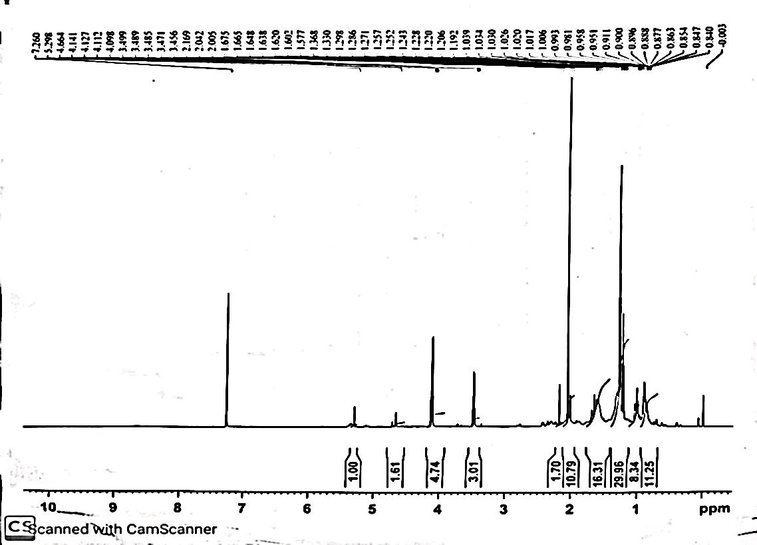

Aromatic group

Methyl and alkane groups

Alcoholic groups

Aldehydes and Ketones groups

Figure S1: ¹H NMR spectra of yeast oil under the influence of natural inhibitor for visualization of functional group present in the produced fatty oil.

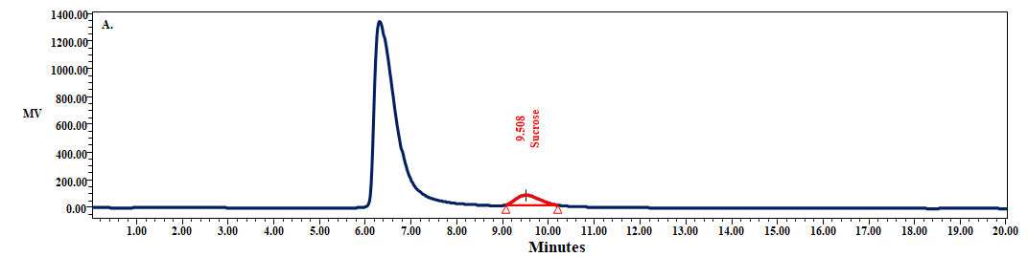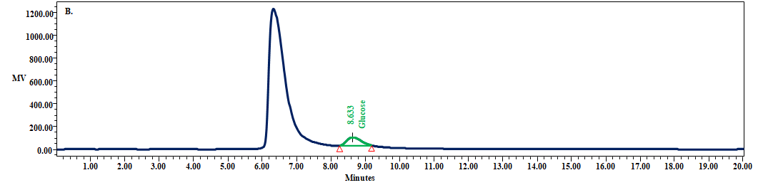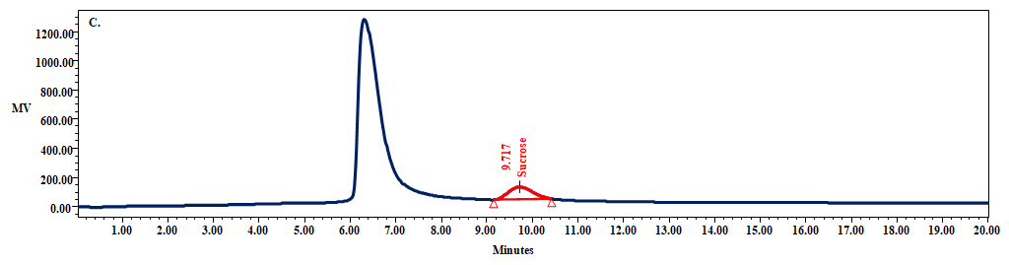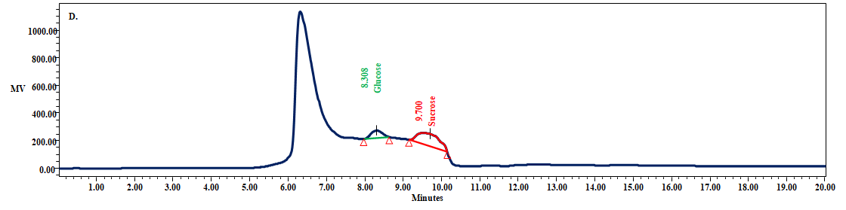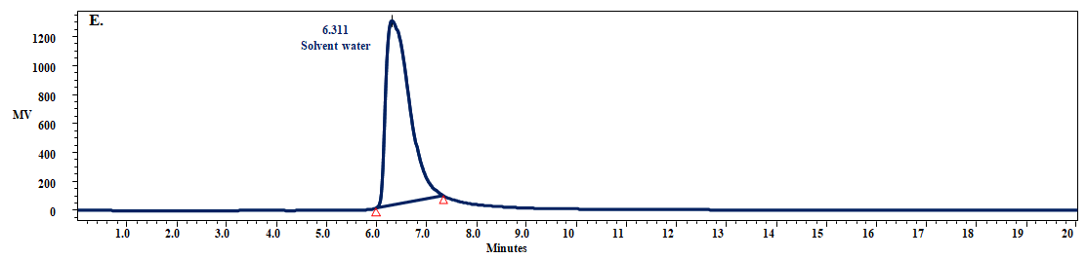

Figure S2: HPLC spectra of (A) Sucrose; (B) Glucose; (C) Sucrose isolated from P. cineraria; (D) P. cineraria pod waste PPT; (E) Solvent
Thermogravimetric analysis (TGA)
TGA evaluation of fatty oils was done using Mettler-Toledo TGA/DSC 1 Star system. For this, about 0.45 mg yeast oil, soybean oil and its fatty acids and winged bean fatty acids sample were taken in the silica crucible and run the analysis in the following temperature program of 50-500°C (5ºC/min), under nitrogen flow rate of 40 ml/min as purge gas. The acquired TGA data were further evaluated through differential thermogravimetric (DTG) for clear interpretation results.
Figure S3: Devolatilization pattern of P. cineraria pod waste, P. cineraria isolated sucrose precipitates, glucose, sucrose, (A) TGA, (B) First derivative graph for weight loss maxima visualization.

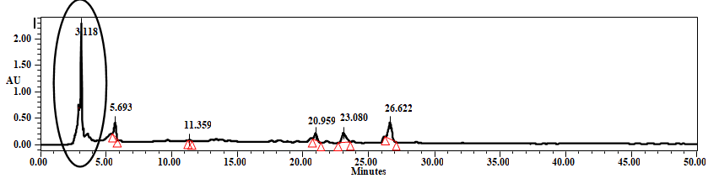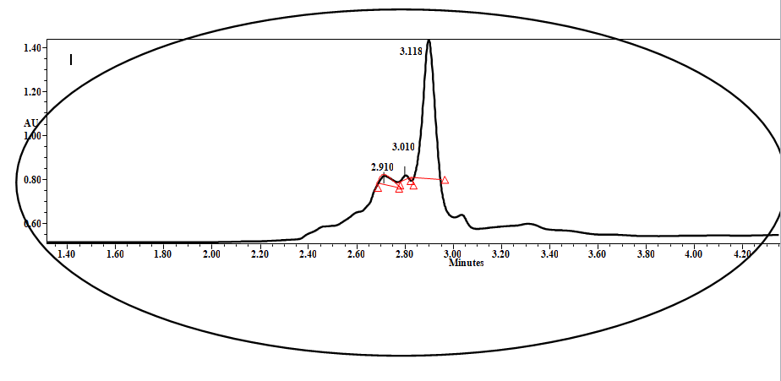

a.

b.
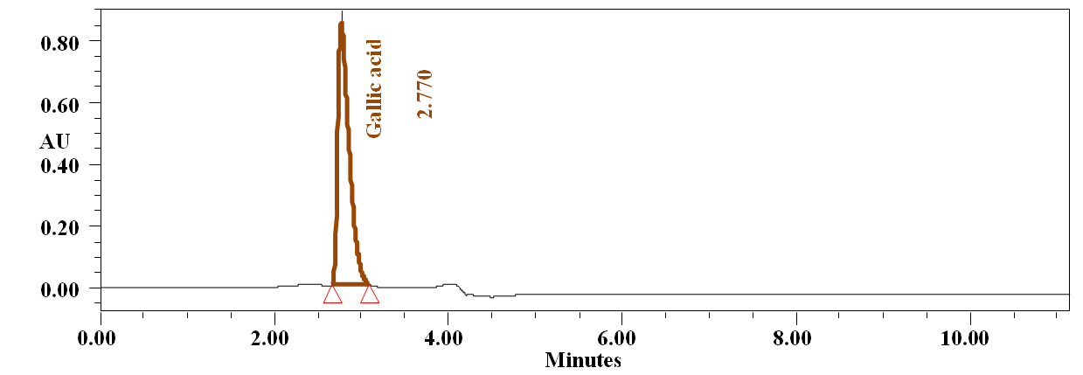
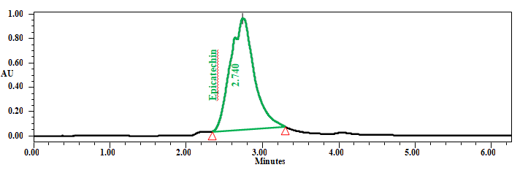
c.
d.
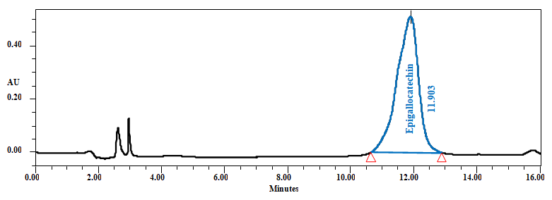
f.
e.
d.
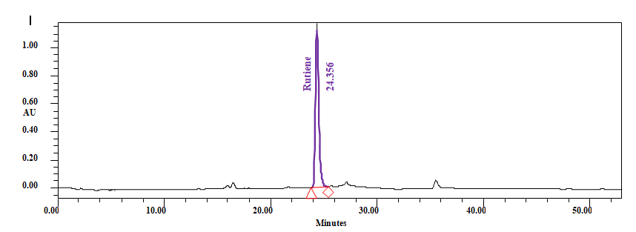
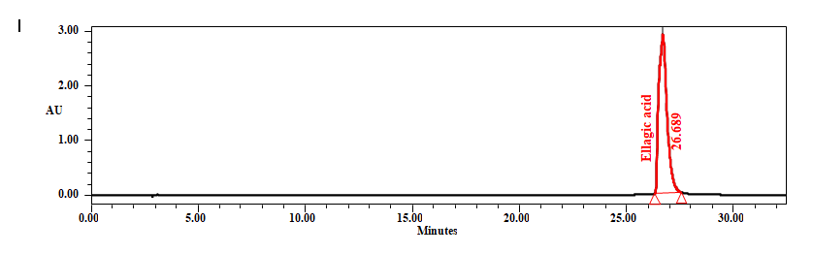
Figure S4: HPLC chromatograms of (a) P. cineraria pod waste, (b) epictachin (c) Gallic acid (d) epigalocatachin (e) Rutiene (f) Ellagic acid

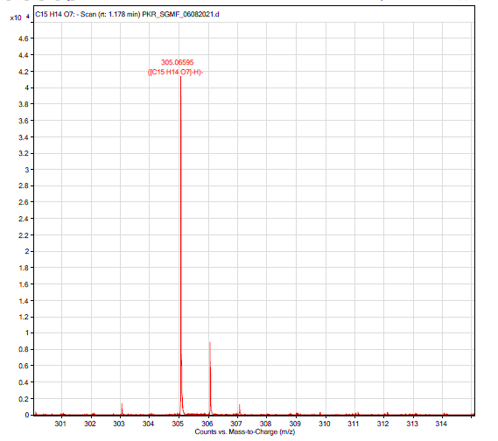
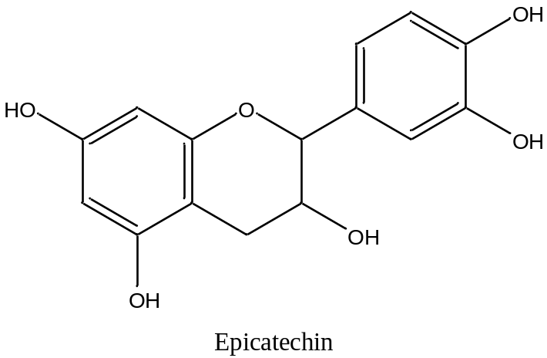
a.

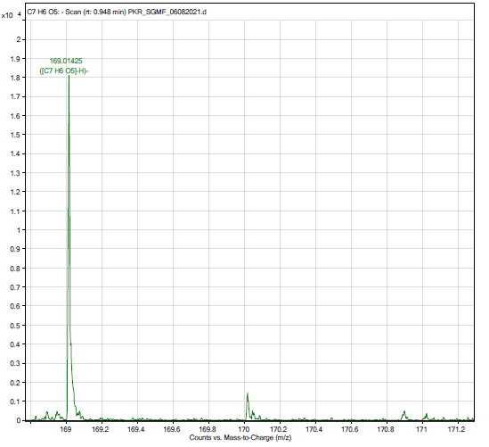
b.
O
H
H
O
H
O
O
O
H
G
a
l
l
i
c
a
c
i
d

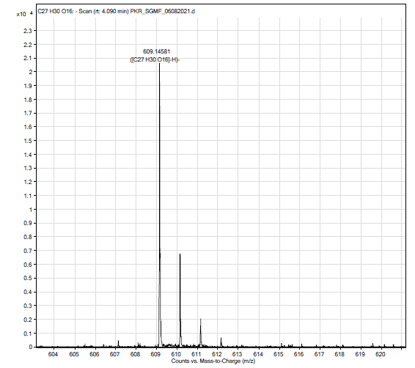
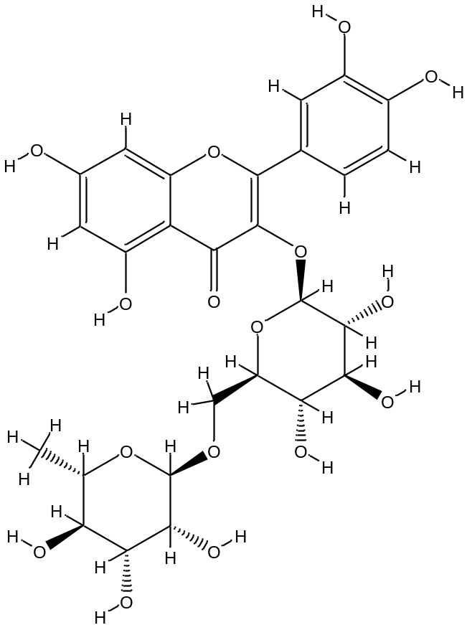Figure S5: Isotopic mass of (a) Epigallocatechin, Epicatechin (b) Gallic acid and (c) Rutin
c.
a.
b.
a.

