SUPPLEMENTARY MATERIALS
Figure S1. Boxplots describing dry plant productivity in both intensively (Int) and extensively managed soils (Ext) in grasses, forbs, and N fixer-associated plants. Different letters disclose significant differences among treatments and soil types (p-value < 0.05).

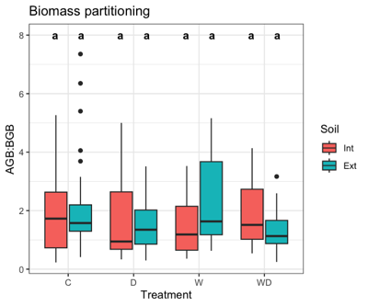

Figure S2. Boxplots describing dry plant biomass partitioning in both intensively (Int) and extensively managed soils (Ext). Different letters disclose significant differences among treatments and soil types (p-value < 0.05).

Figure S4. Boxplots describing microbial nitrogen (N) stocks both in intensively (Int) and extensively managed soils (Ext). Grasses, forbs, and N-fixing associated plants are displayed separately. Different letters disclose significant differences among treatments and soil types (p-value < 0.05).

Figure S3. Boxplots describing nitrogen (N) concentration in aboveground and belowground tissues; both in intensively (Int) and extensively managed soils (Ext). Grasses, forbs, and N-fixing associated plants are displayed separately. Different letters disclose significant differences among treatments and soil types (p-value < 0.05).

