Supplemental Information for:

Assessing the Nutritional and Environmental Impacts of Major UK Food and Beverage Manufacturers

Contents:
Figures S1-5

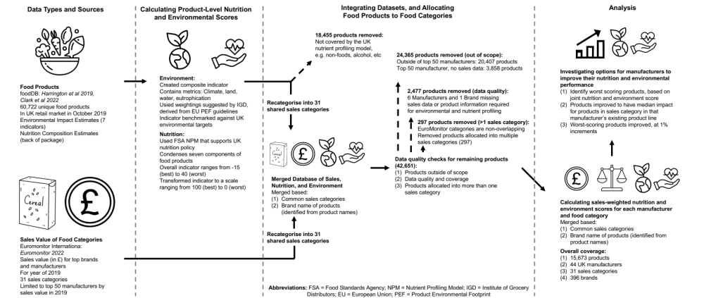
Figure S1. Flow chart of depicting data types and sources, method to calculating nutritional and environmental scores of products, approach to integrating the Euromoitor and foodDB datasets, reasons products were removed from the analysis, and analysis.

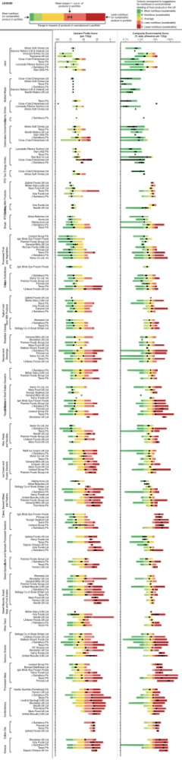
Figure S2. Nutritional and environmental impacts per 100g for all manufacturer by food category combinations. Coloured bars indicate the range of impacts in the product portfolio, and range from the most sustainable (nutritious; left side of the bar) to the least sustainable (nutritious) product (right side of the bar). Colours correspond with the A (dark green; best) to E (dark red; worst) letter bandings recommendations for UK food-related nutritional or environmental labelling. Black point indicates mean impact of all products for that food category and manufacturer, and error bars show one standard error around the mean. Food categories and manufacturers are ordered by overall sustainability, from top to bottom.

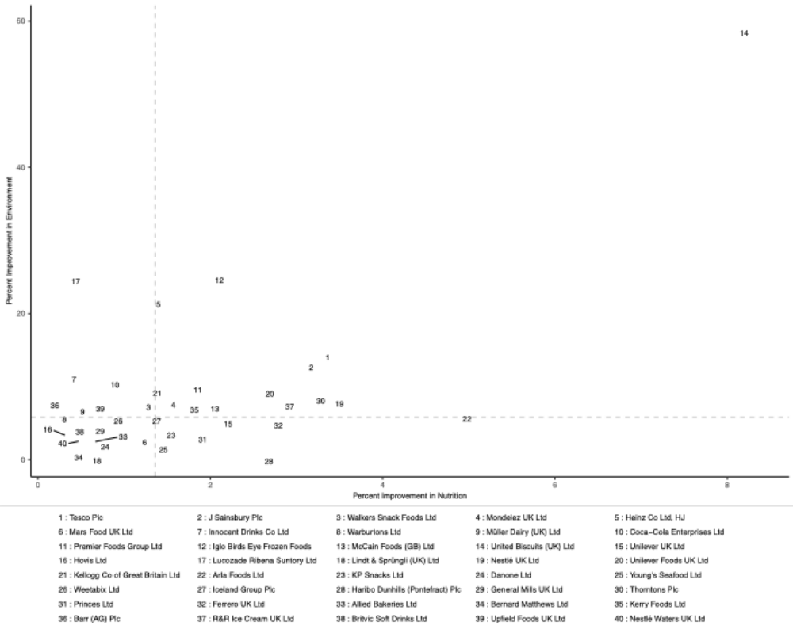
Figure S3. Potential reductions in nutritional and environmental impacts if manufacturers were to improve the 10% of their products that are most harmful to nutrition or environment. Products selected were improved to have impacts that are equivalent to the median nutritional or environmental impact of products sold by that manufacturer in that category, and were selected based on their joint nutritional and environmental impacts, their distance from median impacts in the same category, and the contribution of the product to total sales value of the manufacturer. Numbers correspond with manufacturers (key on bottom of figure), with manufacturers ordered by market size (1 is largest market share; 40 is smallest market share). Horizontal and vertical dashed lines indicate the median potential improvement in environment or nutrition across all 44 manufacturers examined. Four manufacturers are not shown in the figure, because they had no potential to improve their impacts on either nutritional or environment. These are Danone Waters (0% improvement in nutrition, 51.1% improvement in environment), Red Bull (0% for both nutrition and environment), Saputo Cheese (0% for nutrition, 0.6% for environment), and Tropicana (0% for nutrition, 18.1% for environment). Figure is plotted with linear axes; Fig 3 is a version of this figure with log-log axes.

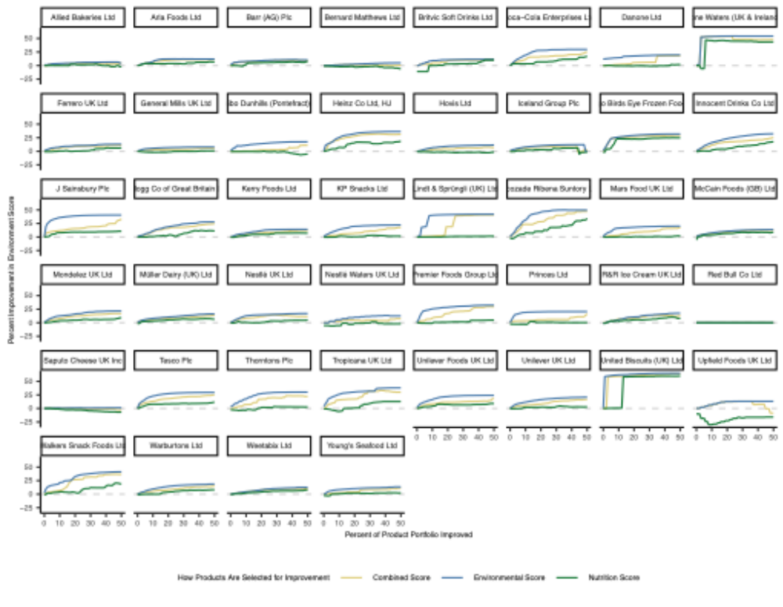
Figure S4. Estimated capacity for manufacturers to improve their environmental performance (y-axis), when improving a set percentage of their entire product portfolio (x-axis), when selecting products based on their joint nutritional and environmental impact (Combined Score; yellow line), environmental impact (blue line); or nutritional impact (green line). Products selected for improvement were those with largest capacity to improve overall manufacturer-level performance, based on their impact (joint, environmental, or nutritional), the distance of their impact from the median impacts of products in the same category, and the contribution of the product to total sales value of the manufacturer. These products were improved to have impacts that are equivalent to the median nutritional or environmental impact of products sold by that manufacturer in that category.

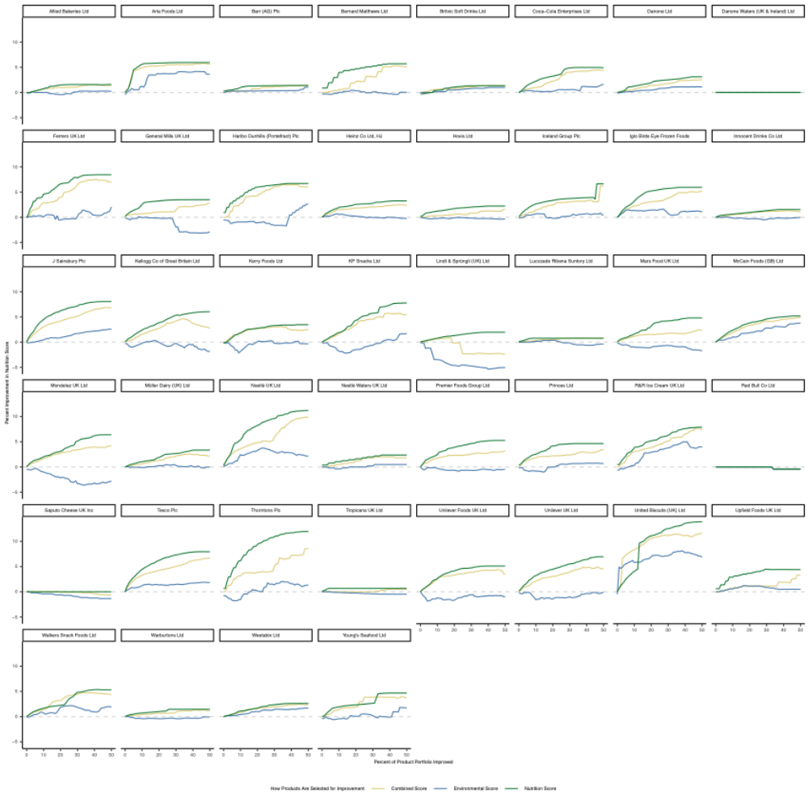
Figure S5. Estimated capacity for manufacturers to improve their nutritional performance (y-axis), when improving a set percentage of their entire product portfolio (x-axis), when selecting products based on their joint nutritional and environmental impact (Combined Score; yellow line), environmental impact (blue line); or nutritional impact (green line). Products selected for improvement were those with largest capacity to improve overall manufacturer-level performance, based on their impact (joint, environmental, or nutritional), the distance of their impact from the median impacts of products in the same category, and the contribution of the product to total sales value of the manufacturer. These products were improved to have impacts that are equivalent to the median nutritional or environmental impact of products sold by that manufacturer in that category.

