Composites of covalently linked lignin and cellulose from one feedstock

Shida Zuo^{1,2}, Lars William Schick¹, Suthawan Muangmeesri¹, Saranya Chitsomkhuan¹, Lenny Haddad¹, Joseph S. M. Samec^{1,2,*}.

¹ Department of Chemistry, Stockholm University, Stockholm 114 18, Sweden
² Wallenberg Initiative Materials Science for Sustainability, Department of Chemistry, Stockholm University, Stockholm 114 18, Sweden

Supplementary Information

Contents

Chemicals and Materials 3
Supplementary characterizations 3
Calculation of SL yield 5
Supplementary tables 5
Table S1: Compositional analysis of poplar and rapeseed straw 5
Table S2: Determination of β–O–4 content and S/G ratio in lignins of poplar and rapeseed straw 5
Supplementary figures 6
Figure S1: Mechanical properties of ESLP from rapeseed straw 6
Appendixes 7
¹H–¹³C HSQC NMR spectrum of SL (poplar) 7
¹H–¹³C HSQC NMR spectrum of ESL(poplar) 8
¹H–¹³C HSQC NMR spectrum of SL (rapeseed straw) 9
¹H–¹³C HSQC NMR spectrum of ESL(rapeseed straw) 10

Chemicals and Materials
Poplar (Populus trichocarpa clone 23.4), was originally provided by the Swedish University of Agricultural Sciences, Uppsala, Sweden. Rapeseed straw was provided by Albin Gunnarson’s Fornåsa gård, south of Sweden. 2,6-Dimethoxyphenol (syringol, 99%), formic acid (≥ 88%), epichlorohydrin (ECH, ≥ 99%), sulfuric acid (95%), acetone (99.5%), ethanol (99.9%), tetrabutylammonium bromide (TBAB, 99%), sodium hydroxide (NaOH, AR), sodium chloride (NaCl), sodium sulfate (Na₂SO₄), barium carbonate (BaCO₃), ethanethiol (EtSH, 97%), boron trifluoride-diethyl etherate (BF3·Et2O, 1.0 M in tetrahydrofuran), tetracosane (99.0%), bis(trimethylsilyl)trifluoroacetamide (BSTFA, 99.0%), dichloromethane (DCM, 99.4%), dimethyl sulfoxide-d₆ (DMSO-d₆, 99.8%), 4-dimethylaminopyridine (DMAP, ≥ 99%), chloroform-d (99.8%), anhydrous pyridine, Chromium (III) acetylacetonate (Cr(acac)₃, 99.99%), N-Hydroxy-5-norbornene-2,3-dicarboxylic acid imide (NHND, 97%), 2-Chloro-4,4,5,5-tetramethyl-1,3,2-dioxaphospholane (TMDP, )were purchased from either VWR International or Merck. All chemicals were used as received.

Supplementary characterizations
NMR analysis
³¹P NMR spectra were recorded on a Bruker AVANCE 500 spectrometer equipped with a 5-mm broadband observe (BBO) probe. The experiments were run according to a standard method reported on Nature Protocol⁴³.
Two dimensional heteronuclear single-quantum coherence (HSQC) NMR spectra were recorded on Bruker AVANCE 500 spectrometer equipped with a 5-mm BBO probe. Samples were dissolved in DMSO-d₆ in a concentration of 50 mg in 0.5 mL. HSQC spectra were recorded at 298 K using Bruker’s standard hsqcedetgpsisp2.3 pulse program (acquisition times 64 ms and 6 ms in ¹H and ¹³C dimensions, respectively; inter-scan relaxation delay 1 s). Data processing was performed using Bruker’s Topspin 4.5.0 software.
Compositional analysis of lignin and biomass
Lignin and sugar content in biomass and pulp from reactive fractionation were quantified using a two-stage sulfuric acid hydrolysis following the National Renewable Energy Laboratory (NREL) standard protocol⁵¹. Sugars were quantified using High Performance Liquid Chromatography (HPLC) on an Agilent 1200 system equipped with a refractive index detector and a 300 × 7.8 mm (L × ID) Aminex HPX–87P column operated at 85 °C using water as the eluent.
Thioacidolysis was used to determine β–O–4 content of native lignin. The reagent for thioacidolysis was prepared by mixing EtSH, BF₃·Et₂O, and dioxane in a 2.5 mL/0.7 mL/ 20 mL ratio and then diluting with dioxane to a 25 mL final volume. Biomass (40 mg, powder) was mixed with 4 mL of the reagent in a sealed tube. The mixture was heated at 100 °C for 4 h, then cooled in an ice bath. The reaction was quenched with saturated NaHCO₃, and the pH was adjusted to 1–3 with 1 M HCl. The mixture was extracted sequentially with DCM, water, and brine, dried over anhydrous Na₂SO₄, filtered, and concentrated under reduced pressure. The residue was dissolved in ethyl acetate (EtOAc, 5 mL). An aliquot (0.5 mL) was combined with 0.1 mL of a tetracosane-in-EtOAc solution (10 g L⁻¹, internal standard) in a 5 mL vial, and the solvent was evaporated. The dry residue was silylated with BSTFA (0.1 mL) and pyridine (0.1 mL) at 60 °C for 30 min. The derivatized sample was analyzed by GC–MS/FID.
Mechanical characterization
Tensile properties were measured on an Instron 5960 testing system with a 1 kN load cell in accordance with ISO527-3 with slightly modification. The test was done at an operating speed of 5 mm min⁻¹. The wet strength was tested by immersing samples in water for 15 min and then go for test. The results are based on three replicates.
Scanning electron microscope (SEM) analysis
The morphology of native biomass, fractions obtained from reactive fractionation, and the corresponding composites was observed using scanning electron microscopy (SEM, JEOL JSM 7000F). Samples were sputter-coated with gold and imaging was performed under high vacuum at an accelerating voltage of 5–20 kV.
FTIR analysis
FTIR spectra of lignin fractions, cellulose pulp, and composites were recorded using a Varian 670 spectrometer equipped with an ATR (attenuated total reflectance) accessory. Samples were analyzed in solid form without further preparation. Spectra were collected in the range of 4000–400 cm⁻¹ with a resolution of 4 cm⁻¹ and averaged over 32 scans for each measurement. The characteristic absorption bands were assigned based on literature values to identify functional groups associated with syringolation, epoxidation, and covalent bonding between ESL and cellulose. In addition, kinetic experiment was applied on ESLFP* and ESLFP. Samples reacted for 0, 10, 20, 30, 40, 50 and 60 min were analyzed using FTIR to monitor the chemical group change during the reaction.
X-ray photoelectron spectroscopy (XPS) analysis
XPS measurements were performed using Kratos AXIS Supra+ X-ray Photoelectron spectrometer. Samples were mounted on conductive carbon tape and analyzed under ultra-high vacuum. High-resolution spectra were recorded for the C 1s. All spectra were charge-corrected using the C–C/C–H component at 284.8 eV as reference. Peak fitting and deconvolution were performed using CasaXPS software. The evolution of carbon components (C1: C–C/C–H; C2: C–O; C3: C=O; C4: O–C=O) was used to evaluate chemical interactions between ESL and cellulose and to confirm epoxide ring-opening during composite formation.
Surface wettability analysis
The surface wettability (contact angle) of ESLFP and hot-pressed pulp was visualized using KRÜSS drop shape analyzer DSA25. Water was dropped to the surface of samples and contact angle after different time was measured.
Gel permeation chromatography (GPC) analysis
GPC analysis was performed on a Prominence-I, LC-2030C system (SHIMADZU) equipped with a UV detector at 280 nm.
Thermogravimetric analysis (TGA)
TGA was conducted on a Discovery TGA system (TA) to evaluate the thermal stability of native poplar, SL, and ESL. Approximately 10 mg of each dried sample was placed in a platinum pan and heated from room temperature to 800 °C at a rate of 10 °C min⁻¹ under a constant nitrogen flow to prevent oxidative degradation. Derivative thermogravimetric (DTG) curves were used to determine the temperature corresponding to the maximum rate of weight loss (T_{max}). The progressive shift in T_{max} was analyzed to assess the effect of syringolation and epoxidation on the thermal stability of lignin and its derivatives.

Calculation of SL yield
The theoretical maximum yield of SL was estimated as follows:
The β-O-4 content of native poplar lignin is 47.1% from thioacidolysis and the S/G ratio was 1.90. The Klason lignin content of poplar was 28.1%. Therefore, the average molecular weight (MW) of native lignin unit is:
MW_{L} = (226 × 1.9 + 196.0 × 1.0)/2.9 = 215.7 g mol⁻¹
After syringolation, the average MW is:
MW_{SL’} = MW_{L} + 136.0 = 351.7 g mol⁻¹
The formylation of SL was reported as 90%, therefore, the average MW of SL is:
MW_{SL} = (MW_{SL’} + 28.0) × 0.9 + MW_{SL’} × 0.1 = 376.9 g mol⁻¹
The theoretical maximum yield is:
Y_{SL-max} = Lignin content × 0.471 × MW_{SL} / MW_{L} + lignin content × (1-0.471) = 38.0%
The Y_{SL-max} of rapeseed straw is calculated to 26.3% according to the same process above.

Supplementary figures
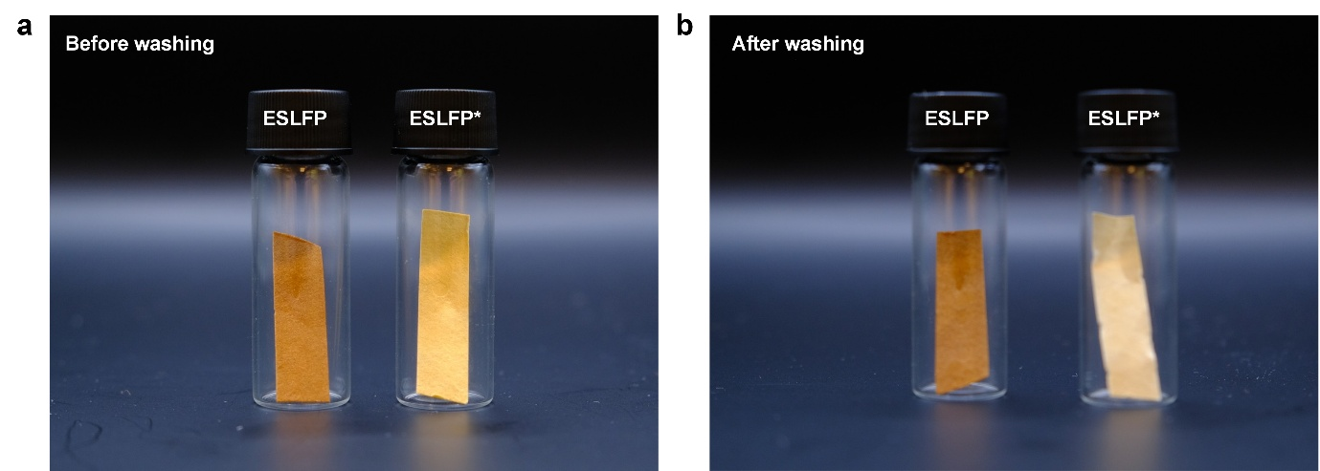

Figure S1: Photographs of ESLFP and ESLFP*. Photographs of ESLFP and ESLFP* a before and b after acetone washing.

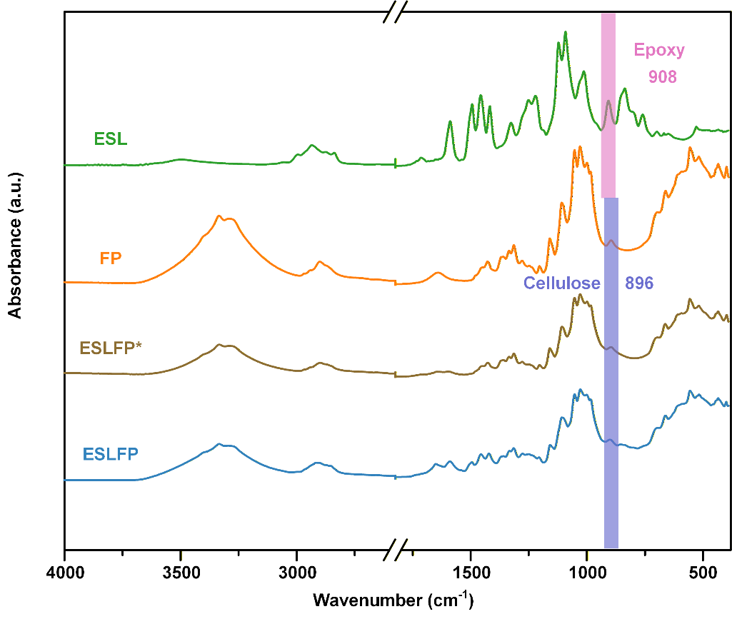

Figure S2: FTIR analysis of ESL, FP, ESLFP* and ESLFP.

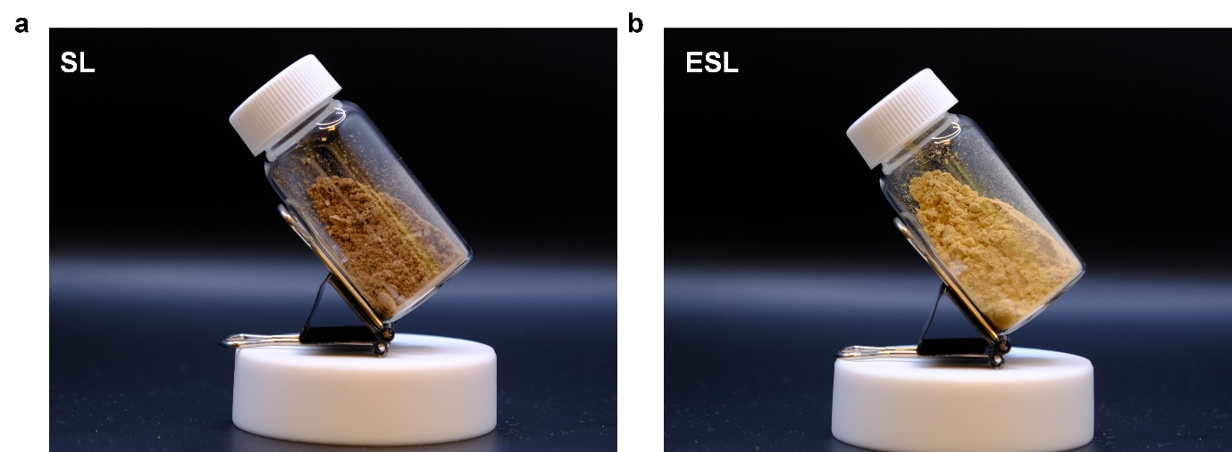

Figure S3: Photographs of SL and ESL produced from rapeseed straw.

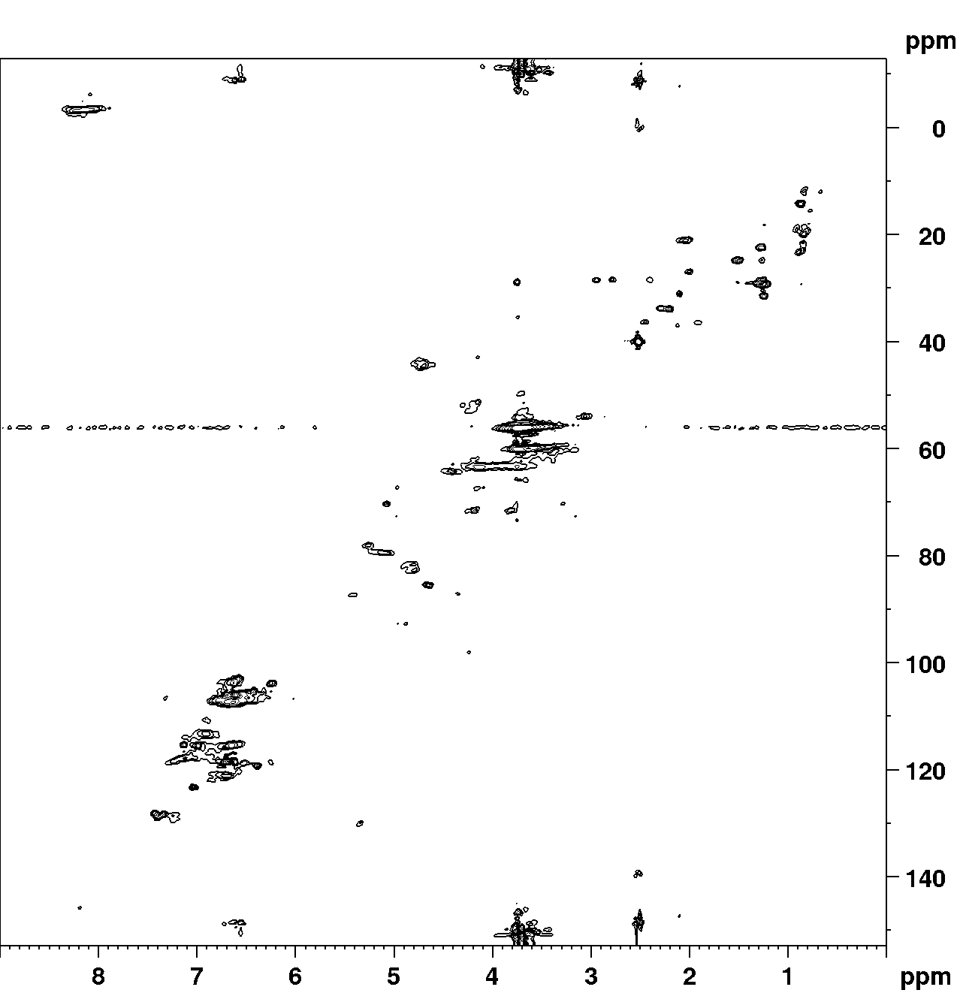

Figure S4: ¹H–¹³C HSQC NMR spectrum of SL (rapeseed straw).

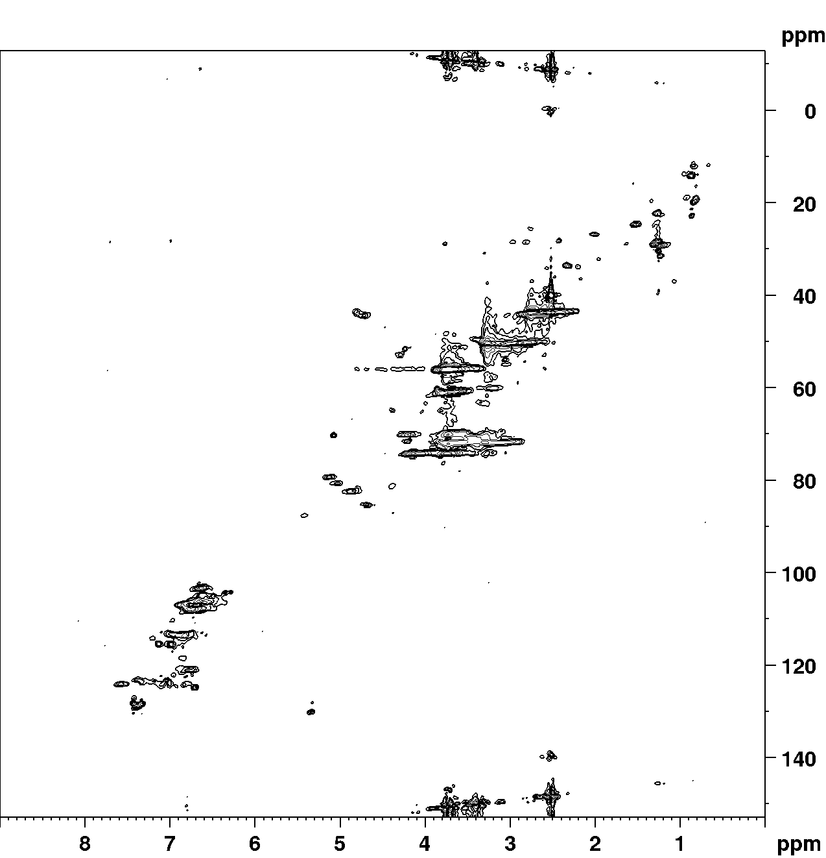

Figure S5: ¹H–¹³C HSQC NMR spectrum of ESL (rapeseed straw).

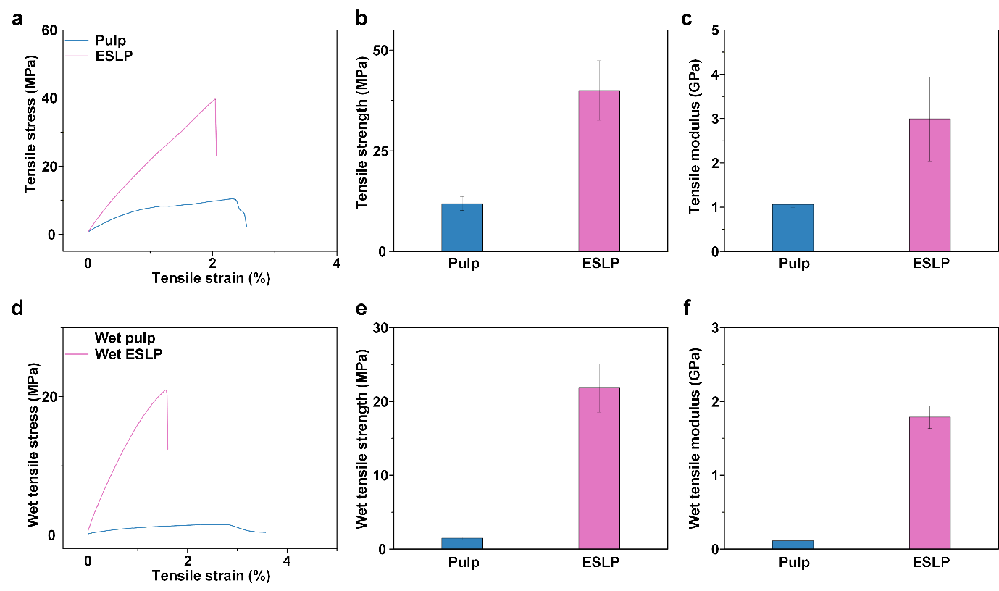

Figure S6: Mechanical properties of ESLP from rapeseed straw. a Tensile stress-strain curves of ESLP and pulp of rapeseed straw. b Tensile strength and c modulus of ESLP and pulp of rapeseed straw. d Wet tensile stress-strain curves of ESLP and pulp of rapeseed straw. e Wet tensile strength and f modulus of ESLP and pulp of rapeseed straw.

Supplementary tables

Table S1. Compositional analysis of poplar and rapeseed straw.
 | Cellulose (%) | Hemicellulose (%) | Lignin (%) | Ash (%)
Poplar | 47.7 | 14.9 | 28.1 | 0.2
Rapeseed straw | 34.4 | 18.2 | 18.5 | 2.0

Table S2. Determination of β–O–4 content and S/G ratio in lignins of poplar and rapeseed straw.
 | β–O–4 (%) | S/G
Poplar | 47.1 | 1.90
Rapeseed straw | 56.8 | 1.77

Appendixes
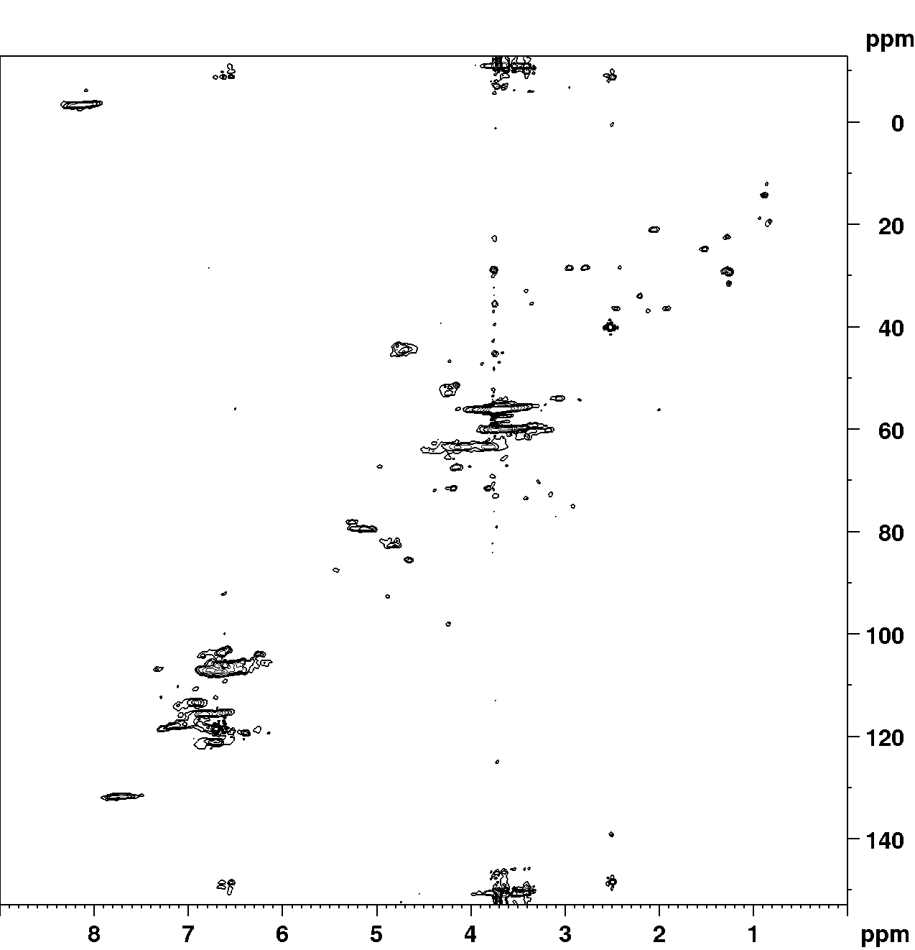

¹H–¹³C HSQC NMR spectrum of SL (poplar)

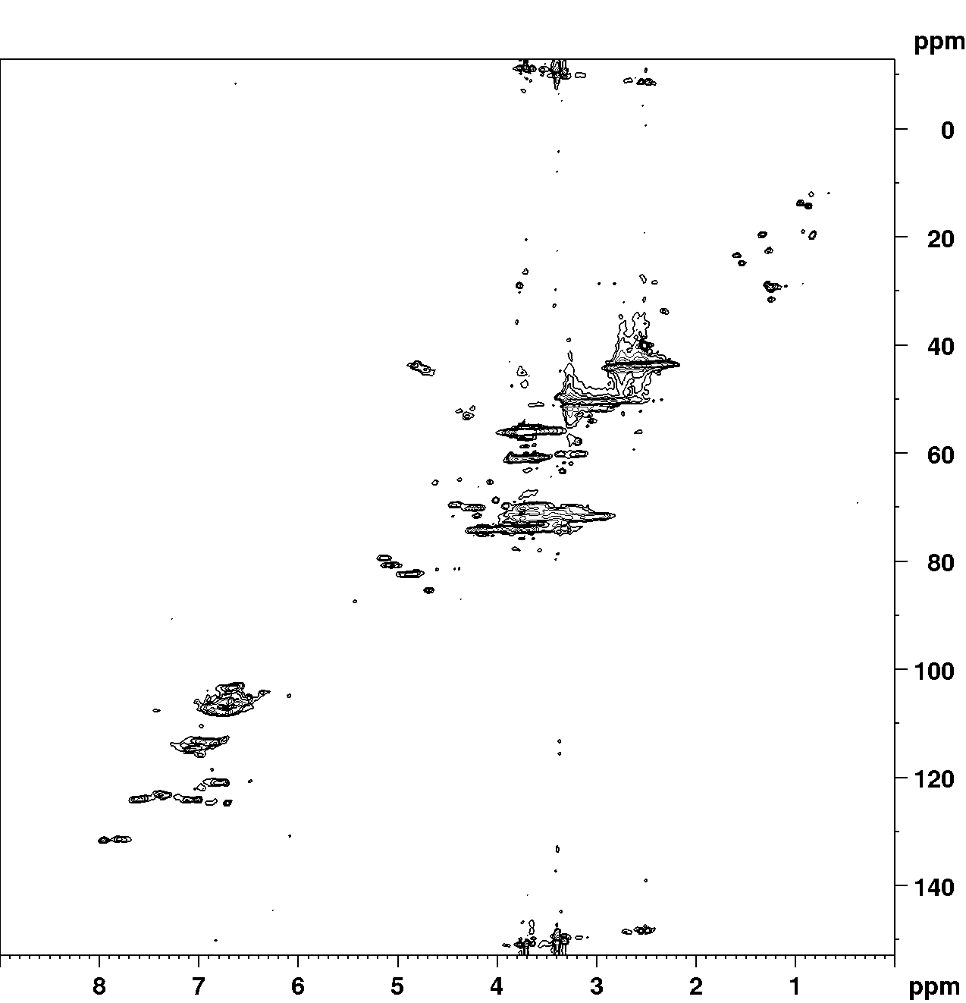

¹H–¹³C HSQC NMR spectrum of ESL (poplar)

