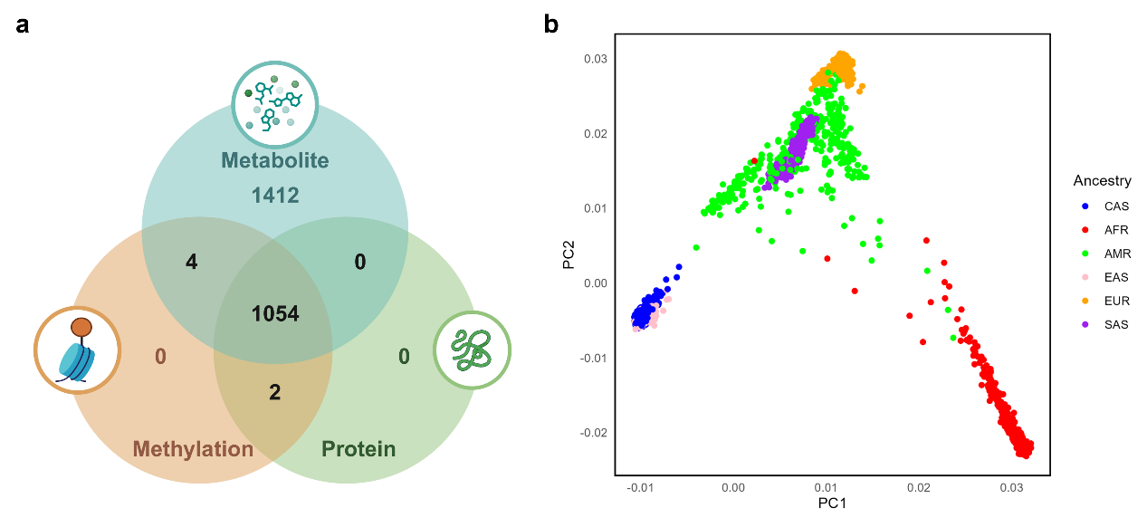
Figure S1: Omics data detection in the CAS cohort and its genetic relatedness to East Asian populations.
a, Venn diagram of multi-omics detection in the CAS cohort. All samples underwent genotyping, with 1,060 samples analyzed for methylation, 1,056 for proteins, and 2,470 for metabolites. b, Genotype clustering plot using the CAS cohort samples and the 1000 Genomes Project. Points are colored by population origin. CAS Cohort and EAS from 1000 Genomes Project cluster well together.

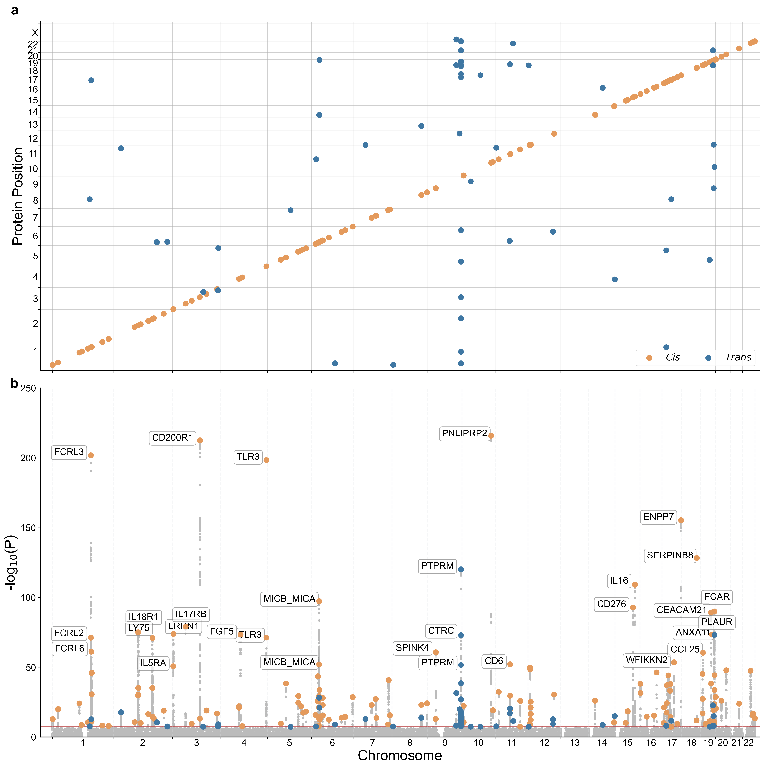
Figure S2: Overview of pQTL associations with inflammation-related proteins.
a. The position of pQTL versus the position of protein coding gene. b. The Manhattan plot show genetic associations with plasma proteins. For each sentinel pQTL, the associated protein was annotated. The orange dots represent cis-pQTLs, while the blue dots represent trans-pQTLs. pQTLs, protein quantitative trait loci. The red line denotes genome-wide significance level P-value < 5 ×10⁻⁸.

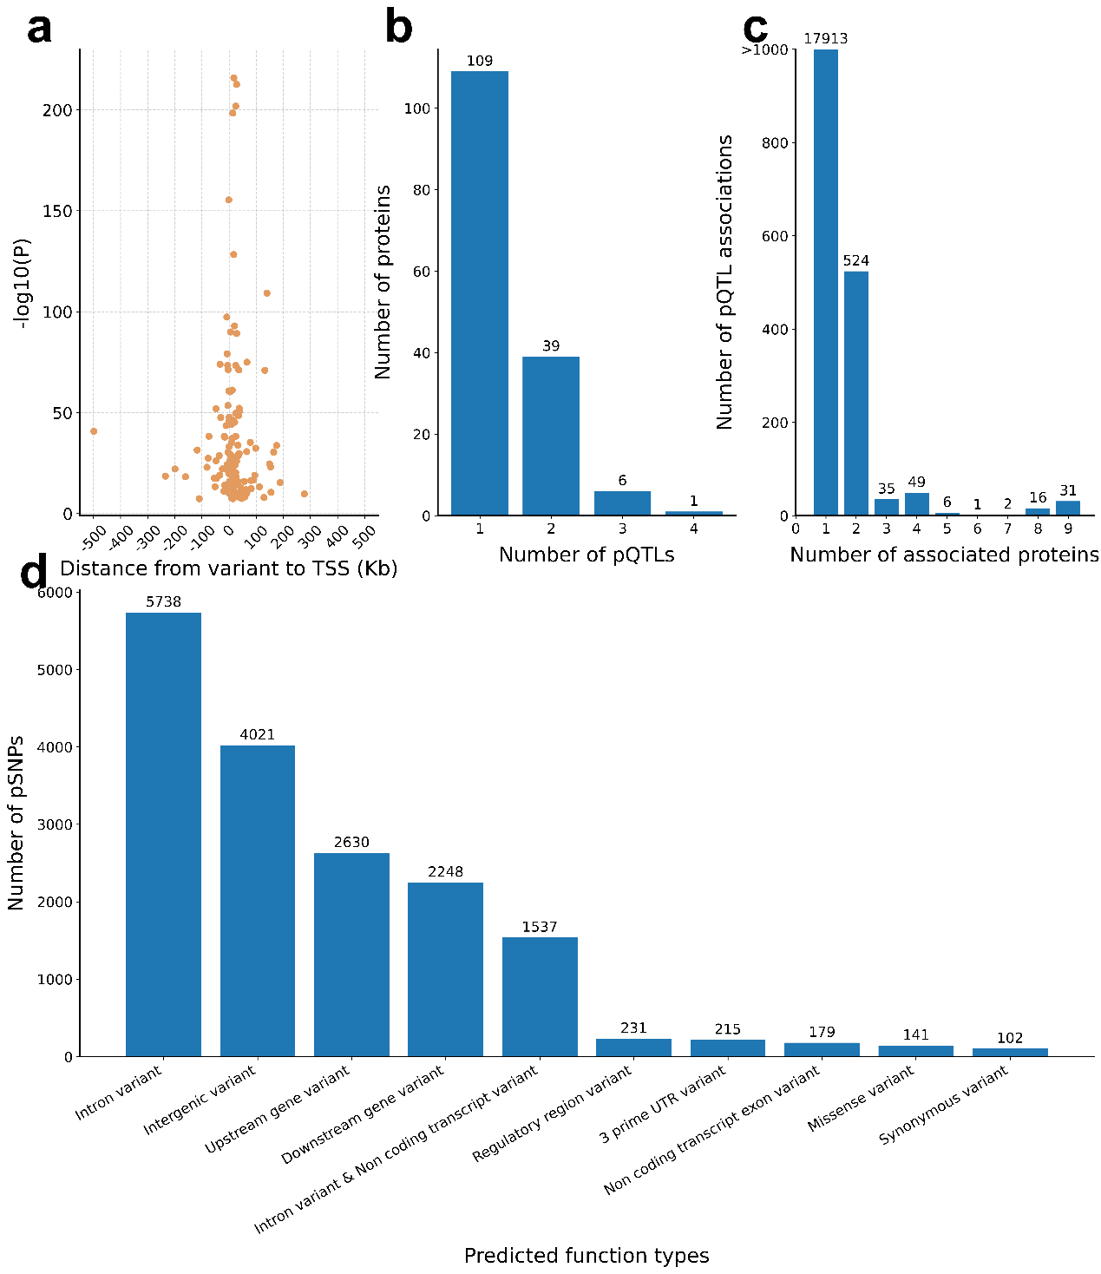
Figure S3: Genomic characteristics and distribution of identified pQTLs.
a, The distance of the sentinel cis-pQTL to the transcript start site (TSS) of the associated protein-coding gene. b, The number of independent pQTLs per protein. c, The pleiotropy of associations. d, The number of predicted functional annotation classes of identified pSNPs.

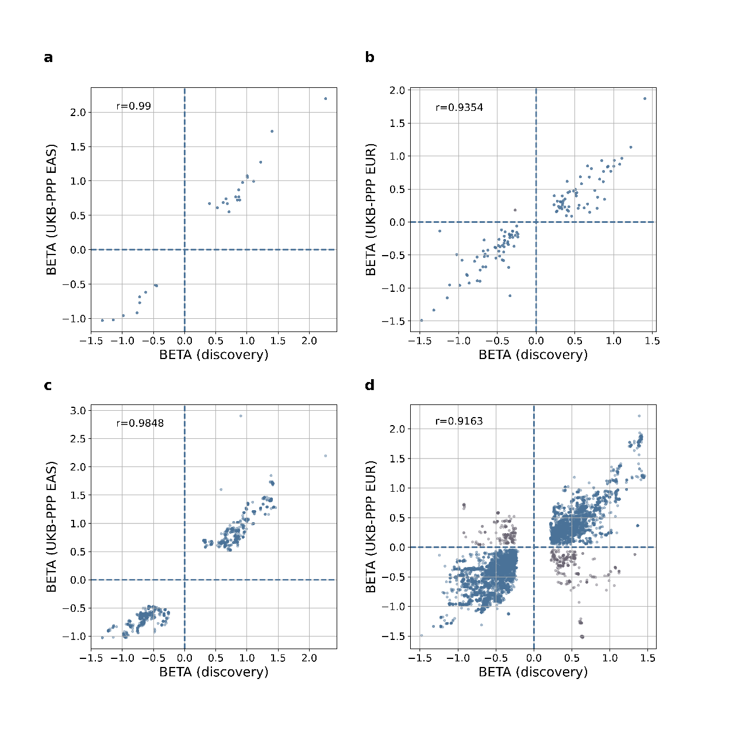
Figure S4: Correlation of independent pQTLs effect size between the CAS cohort and the UKB-PPP East Asian (a) and European (b) populations. Correlation of significant associations effect size between the CAS cohort and the UKB-PPP East Asian (c) and European (d) populations. r denotes the Pearson correlation coefficient.

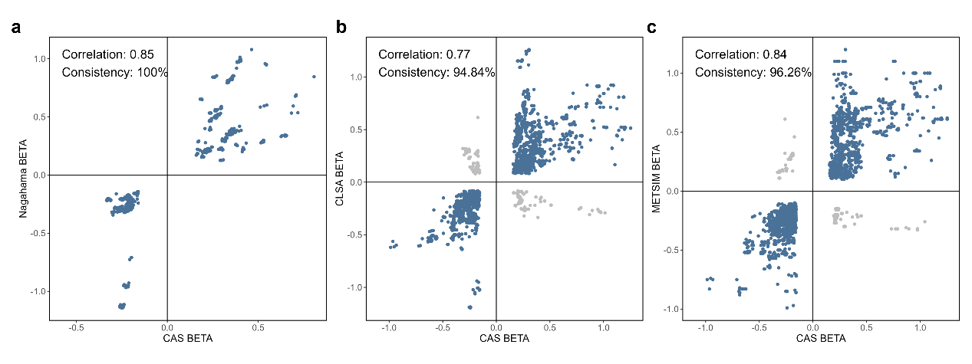
Figure S5: Scatterplot to examine the correlation and consistency of BETA direction in metabQTL within CAS compared to external cohorts. a: compared with the Nagahama study, b: compared with CLSA, and c: compared with METSIM.

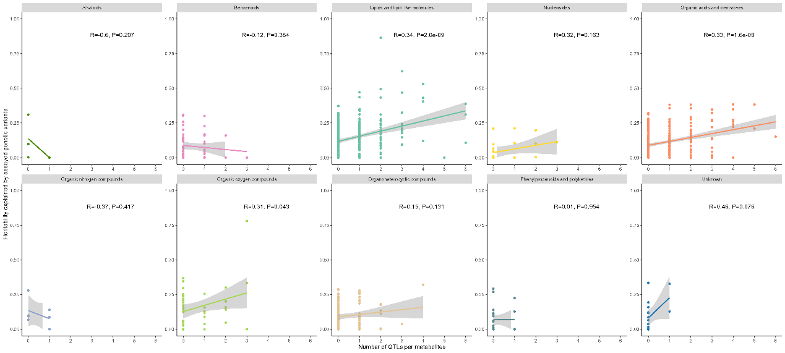
Figure S6: Scatterplot comparing the relationship between genetic heritability and the number of metabQTLs within each superclass. The Pearson’s correlation coefficient and the corresponding P-value are displayed on the plot. The 95% confidence intervals for the linear regression line are indicated.

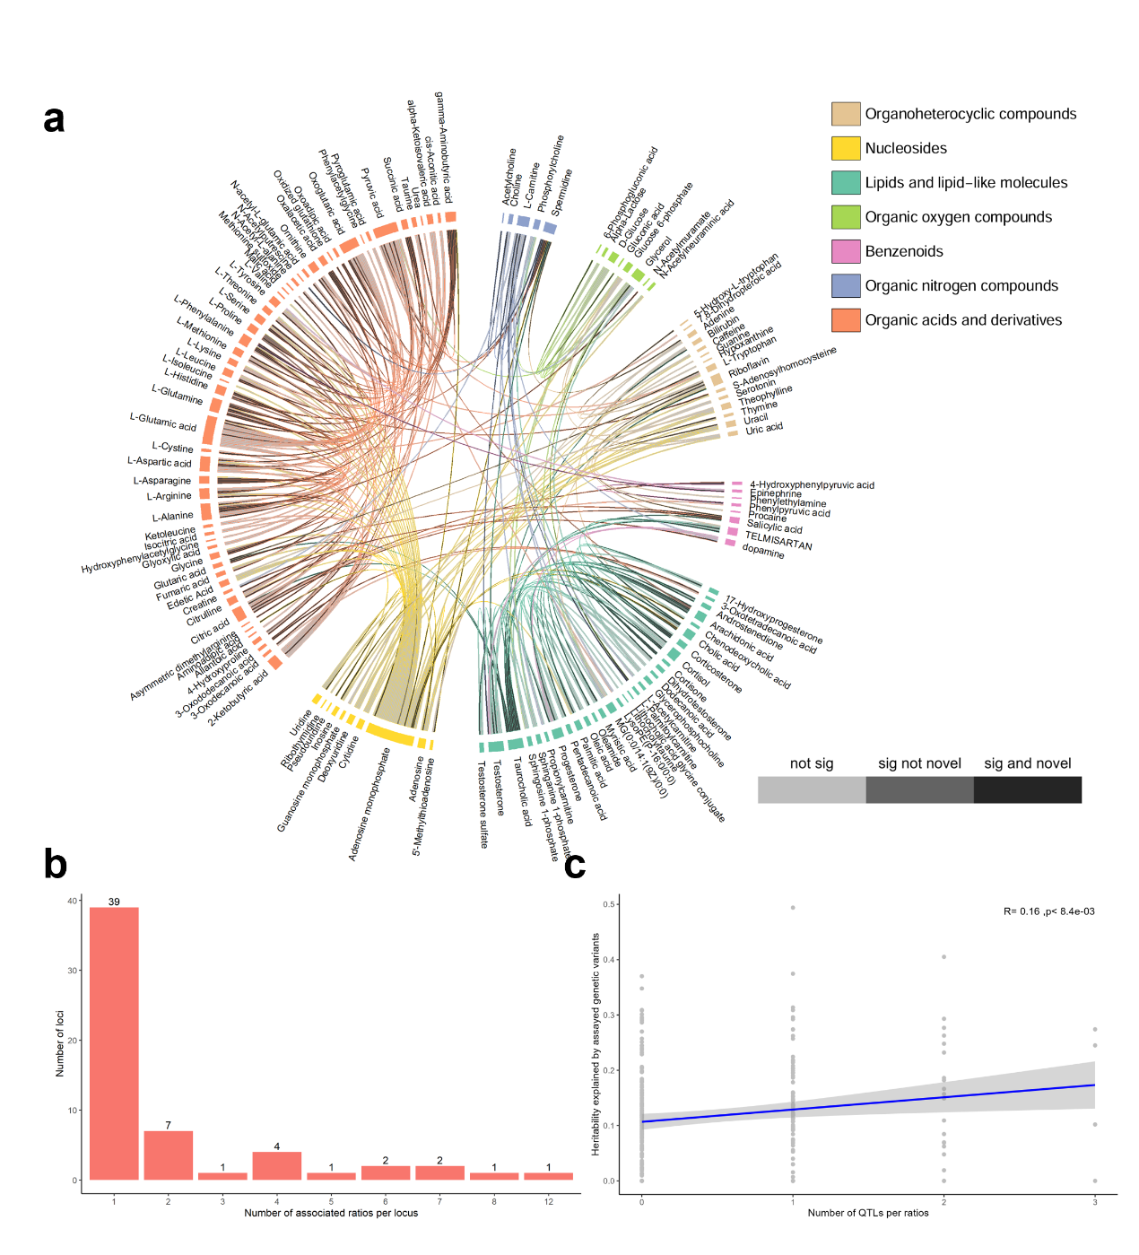
Figure S7: Summary of metabolite ratios.
a, Distribution of metabolite ratio QTLs. Black chords represent ratios with significant QTLs identified as novel in this study. Dark gray chords indicate ratios with significant QTLs that were previously reported, while light gray chords represent ratios without significant QTLs. b, The number of ratios associated with each locus, demonstrating the pleiotropic effects of loci on metabolite regulation. c, Relationship between the number of QTLs and the heritability explained by genetic variants for each ratio. Each point represents a metabolite. Pearson’s correlation coefficient and the corresponding P-value are displayed on the plot. The 95% confidence intervals for the linear regression line are indicated.
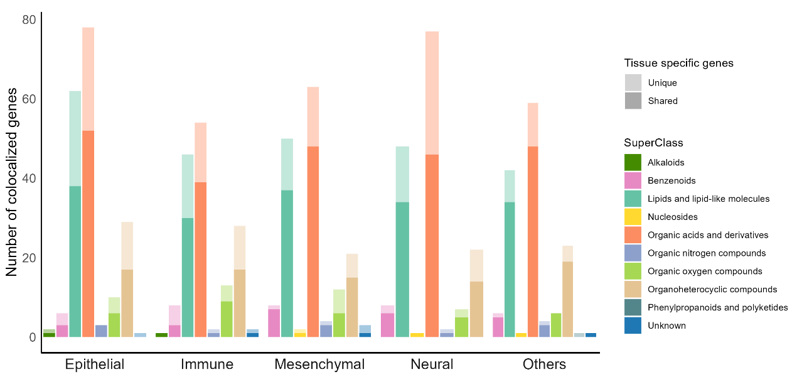
Figure S8: Distribution of colocalized genes between eQTL (GTEx) and metabQTLs across superclasses and tissue categories. In the plot, metabolite-gene colocalization signals found in a single category are represented in lighter colors, while those found across multiple categories are indicated with darker colors.

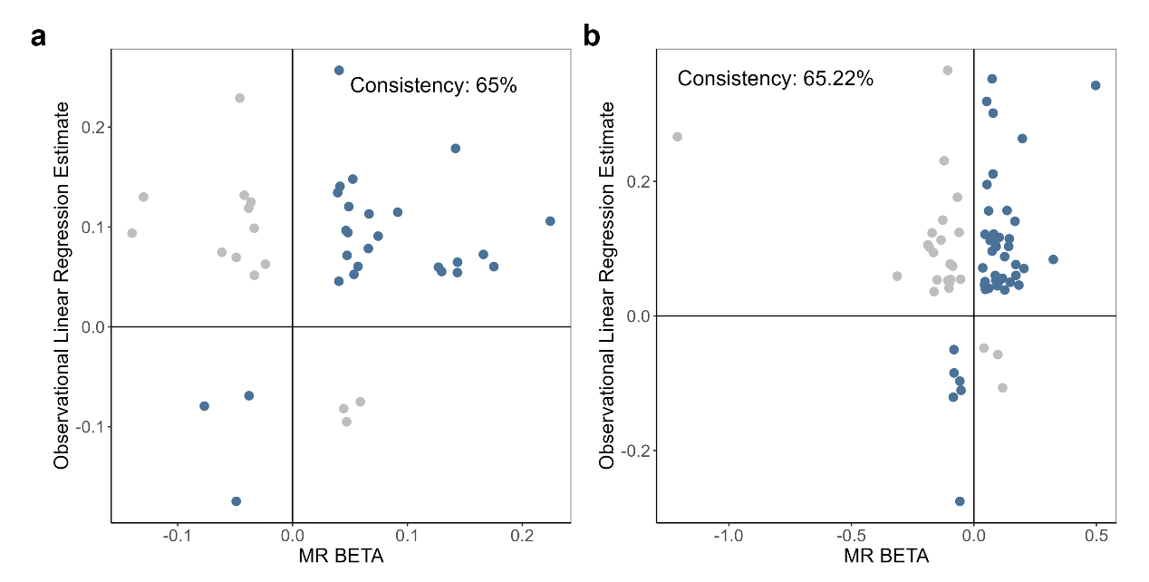
Figure S9: Scatter plot to examine whether the regression coefficients aligned with the direction of the MR beta estimates.
a, Scatter plot of protein-trait. b, Scatter plot of metabolite-trait. MR: Mendelian randomization.

