Nature Cell Biology
November 24, 2025

The Cys/N-degron pathway mediates secretory autophagy under oxidative stress

Su Bin Kim^{1*}, Ji Su Lee^{1*}, Su Jin Lee^{1*}, Hye Yeon Kim^{1*}, Minje Kang², Min Ju Lee¹, Ah Jung Heo³, Do Hyun Han⁴, Seok-Ho Hong^{2,5§}, Yong Tae Kwon^{1,6,7,8§}, Chang Hoon Ji^{1,6§}

¹Cellular Degradation Biology Center and Department of Biomedical Sciences, College of Medicine, Seoul National University, Seoul 03080, Korea.

²Department of Internal Medicine, School of Medicine, Kangwon National University, 1 Kangwondaehak-gil, Chuncheon, Gangwon‑do 24431, Korea.

³Goethe University Frankfurt, Medical Faculty, Institute of Biochemistry II, Theodor-Stern-Kai 7, 60590 Frankfurt am Main, Germany.

⁴Proteomics Core Facility, Biomedical Research Institute, Seoul National University Hospital, 71 Daehak-ro, Seoul 03082, Korea

⁵KW-Bio Co., Ltd, 32 Sichunggil-ro, Wonju, Gangwon-do 24348, Korea.

⁶AUTOTAC Bio Inc., 225 Gasan digital 1-ro, Seoul 08501, Korea.

⁷Ischemic/Hypoxic Disease Institute, Seoul National University Medical Research Center, Seoul National University, Seoul 03080, Korea.

⁸SNU Dementia Research Center, Medical Research Center, Seoul National University, Seoul 03080, Korea.

*These authors equally contributed to this work.

§Correspondence:

Chang Hoon Ji. Department of Biomedical Sciences, College of Medicine, Seoul National University, Seoul 03080, Korea
Telephone: 82-2-6328-1121. Fax: 82-2-3673-2167. Email: changhoon.ji@snu.ac.kr.

Yong Tae Kwon. Department of Biomedical Sciences, College of Medicine, Seoul National University, Seoul 03080, Korea

Telephone: 82-2-740-8547. Fax: 82-2-3673-2167. Email: yok5@snu.ac.kr.

Seok-ho Hong. Department of Internal Medicine, School of Medicine, Kangwon University, Chuncheon, 24431, Korea

Telephone: 82-33-250-7819. Fax: 82-33-244-2367. Email: shhong@kangwon.ac.kr.

Extended Data Figures and Figure Legends
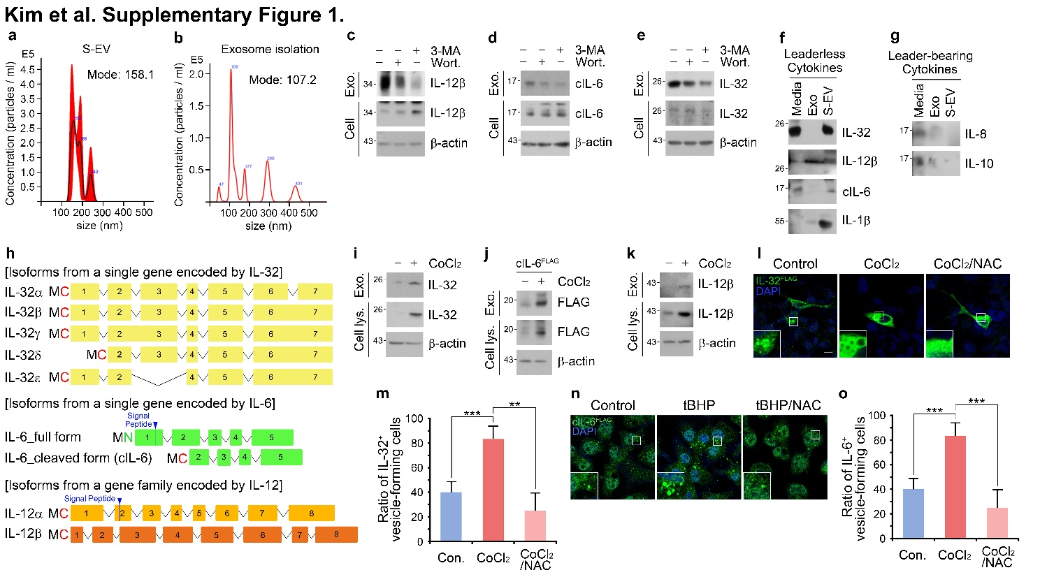
Extended Data Fig. 1 Nt-Cys cytokines are specifically secreted via exosomes in response to oxidative stress. a and b Nanoparticle tracking analysis (NTA) distribution of exosomes purified by ultracentrifugation (S-EV) and PEG-based exosome isolation solution (Exo) from A549 cells. c Immunoblotting of intracellular and extracellular fractions of IL-12β in A549 cells with 3-MA (20 mM, 24 h), or wortmannin (10 µM, 24 h). d and e Same as c, but with indicated cytokines.
f and g Immunoblotting of cytokines in media precipitated by TCA and exosome fractions purified by PEG-based isolation kit (Exo) or size-exclusion fractionation (S-EV). h Sequences of isoforms from a gene encoded by IL-32, IL-6, and IL-12β with the indication of their N-terminal residues. i Immunoblotting of intracellular and extracellular fractions of IL-32 in HepG2 and A549 cells with CoCl₂ (250 μM, 24 h). j and k Same as i, but with cIL-6^{FLAG} and IL-12β in A549 cells.
l Immunostaining of transiently overexpressed IL-32^{FLAG} in HeLa cells treated with CoCl₂ and NAC (500 µM, 6 h). Scale bar, 10 µm. m Quantification of l (29 cells). n Immunostaining of transiently overexpressed cIL-6^{FLAG} in HeLa cells treated with tBHP (250 µM, 6 h) and NAC. Scale bar, 10 µm. o Quantification of n (150 cells). Error bars represent SEM (n = 7 replicates). **p<0.01, ***p<0.001 using the one-way ANOVA.

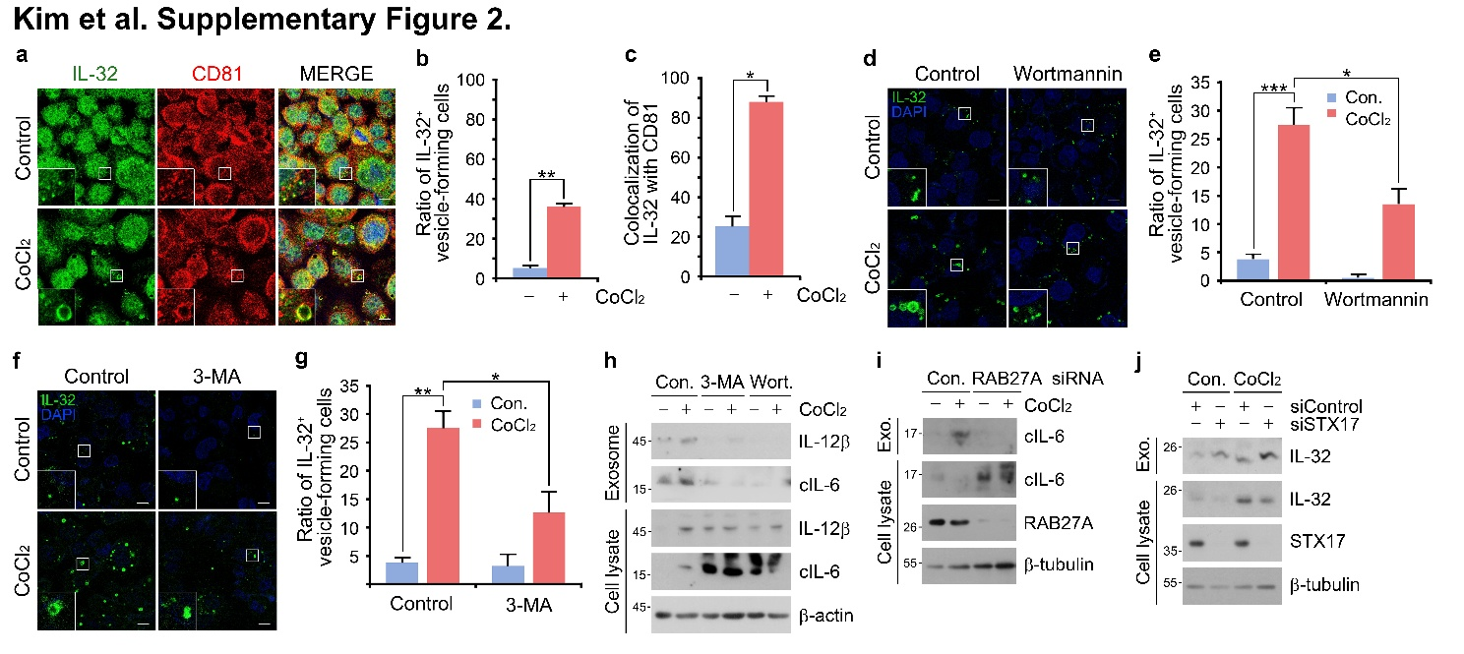
Extended Data Fig. 2 Nt-Cys cytokines are specifically secreted via secretory autophagy in response to oxidative stress. a Co-localization analysis in HepG2 cells treated with or without CoCl₂ (250 µM, 24 h). Scale bar, 10 µm. b and c Quantification of a (102 cells). d Immunostaining analysis in HepG2 cells treated with CoCl₂, wortmannin (10 µM, 24 h), or both. Scale bar, 10 µm. e Quantification of d (471 cells). f Same as d, but with 3-MA (20 mM, 24 h). Scale bar, 10 µm. g Quantification of f (348 cells). h Immunoblotting of intracellular and exosome fractions of cIL-6 and IL-12β in A549 cells with CoCl₂, 3-MA, or wortmannin. i Immunoblotting of intracellular and exosome fractions of cIL-6 in A549 cells with CoCl₂ under RAB27A interference. j Same as i, but with IL-32 in A549 cells under STX17 interference. Error bars represent SEM (n = 3 replicates). *p<0.05, **p<0.01, ***p<0.001 using the t-test or one-way ANOVA.

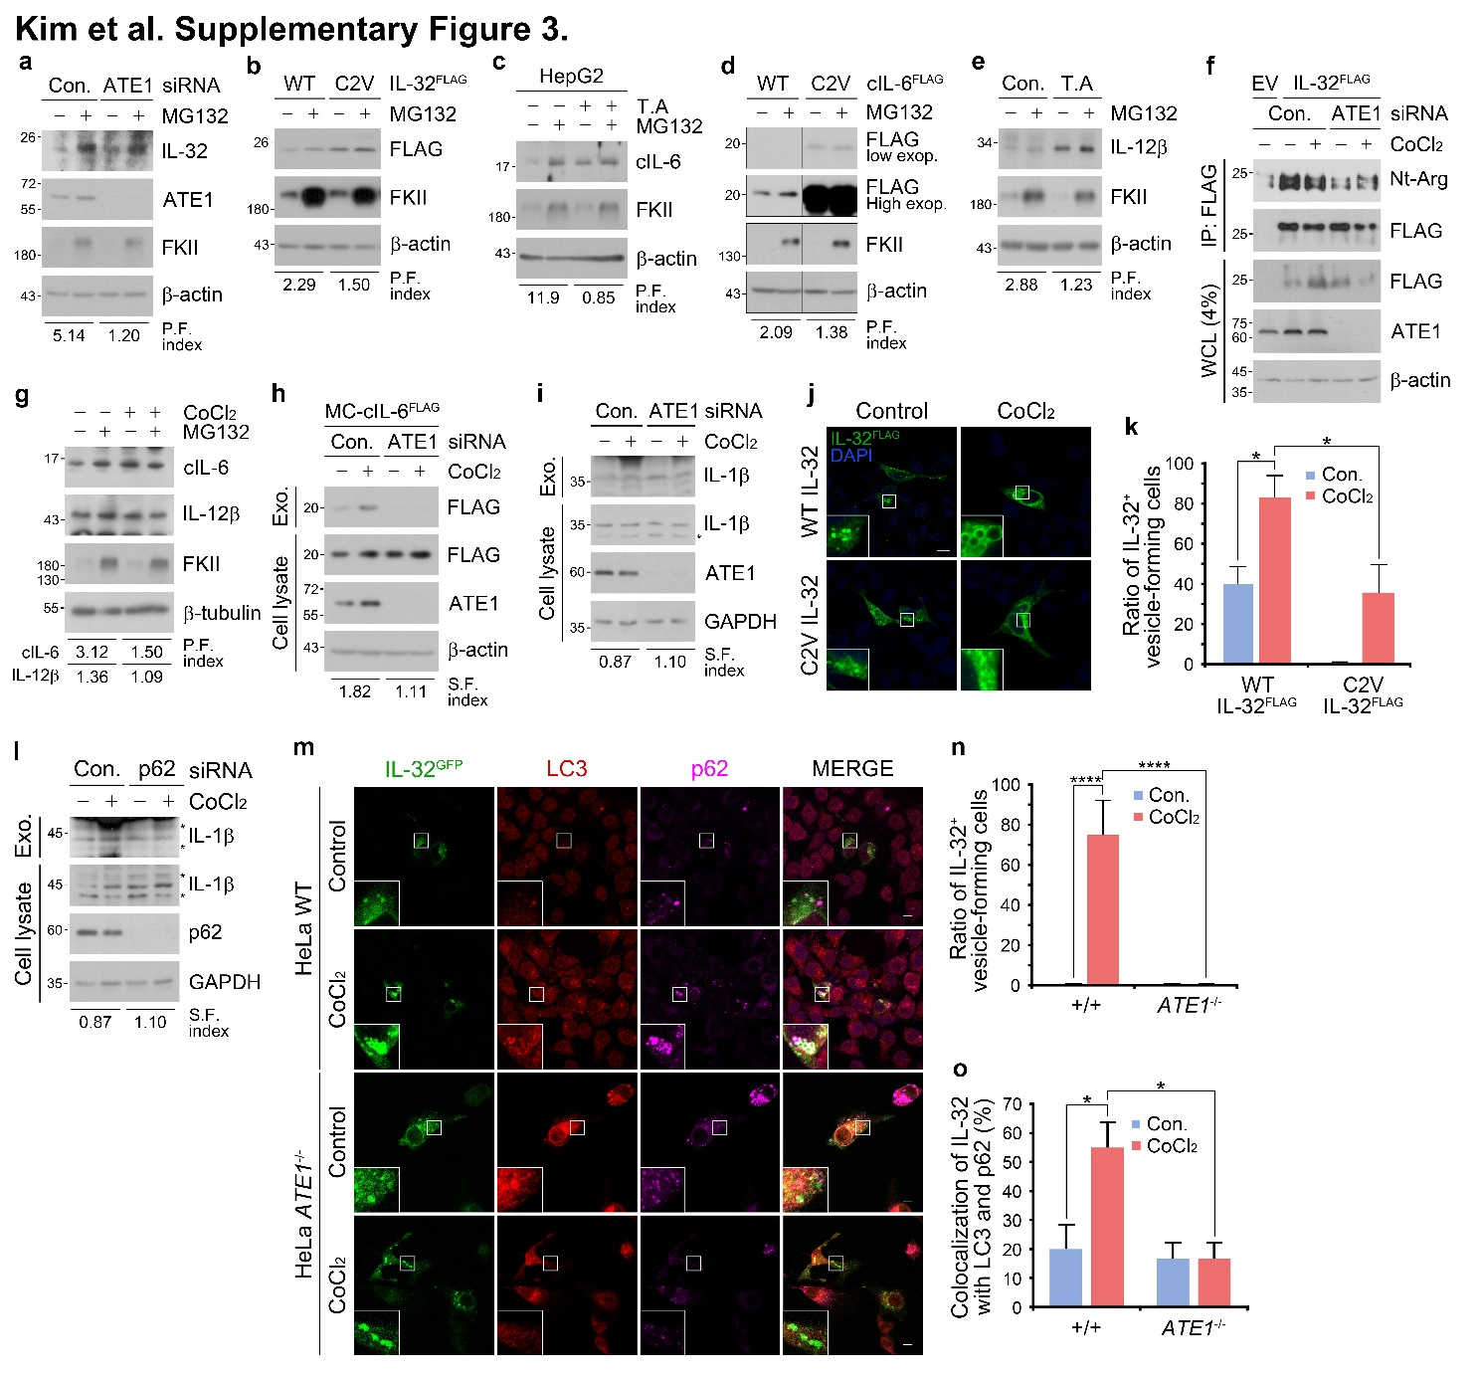
Extended Data Fig. 3 Nt-Arginylation and p62 mediate proteolysis and secretion of Nt-Cys cytokines. a Immunoblotting of endogenous IL-32 in A549 cells with MG132 (10 μM, 6 h) under ATE1 interference compared to control. b Immunoblotting of HEK 293T cells transfected with wild-type or C2V-IL-32^{FLAG} and treated with MG132. c Immunoblotting of endogenous cIL-6 in HepG2 cells with MG132, tannic acid (30 μM, 24 h), or both. d Same as b, but transfected with wild-type or C2V-cIL-6^{FLAG} and treated with MG132. e Same as c, but with IL-12β in A549 cells. f Co-IP of Nt-Arg of IL-32 in HEK293T cells transfected with IL-32^{FLAG} and CoCl₂ (250 μM, 24 h) treatment under ATE1 siRNA compared to control. g Immunoblotting analysis of cIL-6 and IL-12β with the treatment of MG132, CoCl₂, or both. h Immunoblotting of intracellular and exosome fractions of cIL-6 in MC-cIL6^{FLAG} expressing A549 cells with CoCl₂ under ATE1 interference. i Same as h, but immunoblotting of IL-1β in A549 cells. j Immunostaining of IL-32 in wild-type and C2V mutant IL-32^{FLAG} expressing HeLa cells with CoCl₂. Scale bar, 10 µm. k Quantification of j (220 cells). l Same as i, but under p62 siRNA interference. m Immunostaining of IL-32, LC3, and p62 in IL-32^{GFP} expressing Wild-type and ATE1^{-/-} HeLa cells with CoCl₂. Scale bar, 10 µm. n-o Quantification of m (280 cells). Error bars represent SEM (n = 7~8 replicates). *p<0.05, ****p<0.0001 using the one-way ANOVA or t-test.

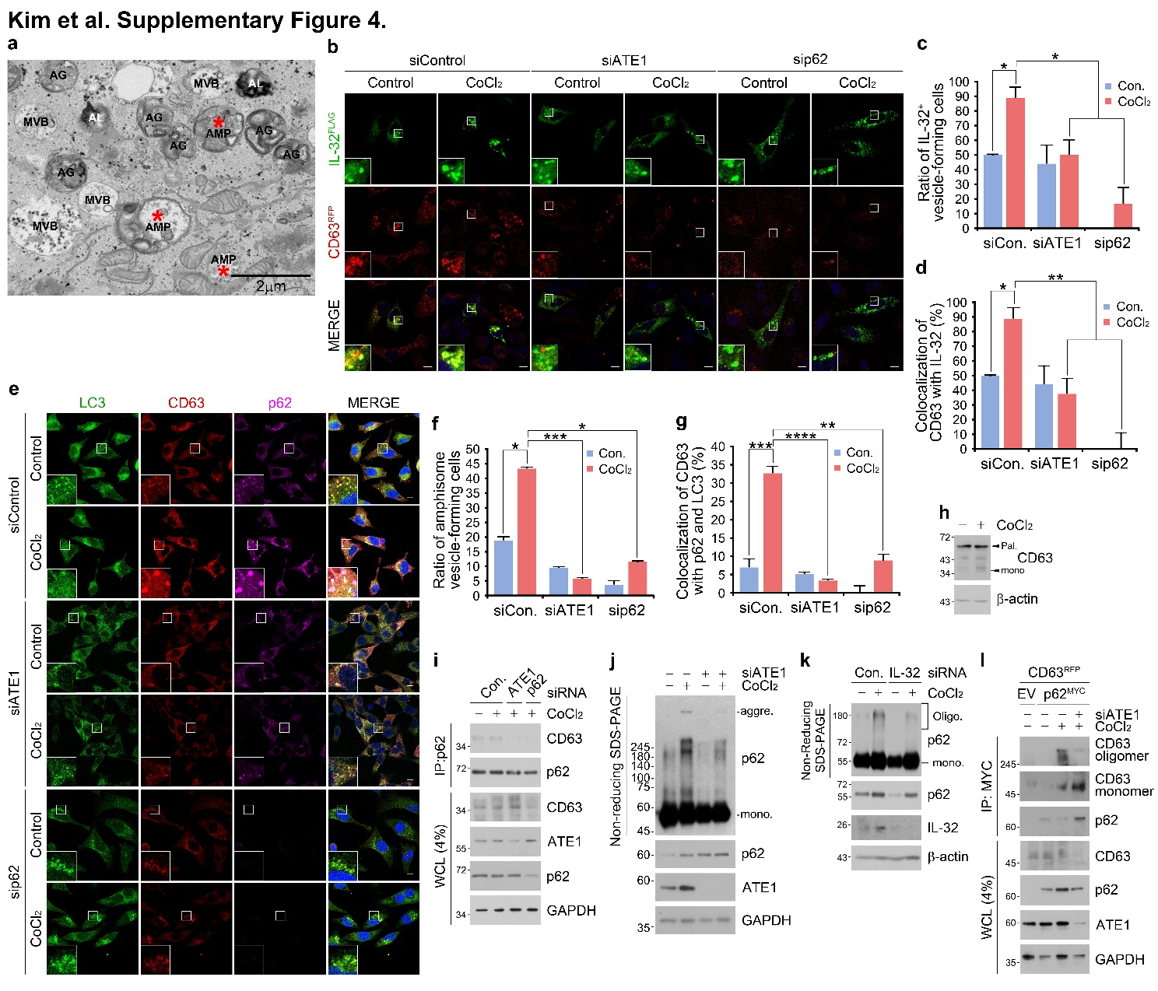
Extended Data Fig. 4 p62 and CD63 are required for the biogenesis of amphisomes and IL-32 targeting under oxidative stress. a Definition of transmission electron microscopy (TEM) structure of cytosolic vesicles in A549 cells with the treatment of CoCl₂ (250 μM, 24 h). Scale bar, 2 µm. b Colocalization assay of IL-32 and CD63 in IL-32^{FLAG}, CD63^{RFP}-transfected HeLa cells with treatment of CoCl₂ and genetic interference of ATE1 or p62. Scale bar, 10 µm. c and d Quantification of b (320 cells). e Co-localization analysis of LC3, CD63, and p62 in CD63^{RFP}-transfected HeLa cells with CoCl₂ treatment under ATE1 or p62 siRNA interference. Scale bar, 10 µm. f and g Quantification of e (692 cells). h Immunoblotting of CD63 in A549 cells with CoCl₂ treatment. i Co-IP of p62 with CD63 in A549 cells with CoCl₂ under ATE1 and p62 siRNA interference. j p62 oligomerization assay in A549 cells with CoCl₂ under ATE1 siRNA interference. k Same as j, but under IL-32 siRNA interference. l Co-IP of p62 with oligomeric CD63 in p62^{MYC} and CD63^{RFP} overexpressed A549 cells with CoCl₂ under ATE1 siRNA interference. Error bars represent SEM (n = 5~6 replicates). *p<0.05, **p<0.01, ****p<0.0001 using one-way ANOVA or t-test.

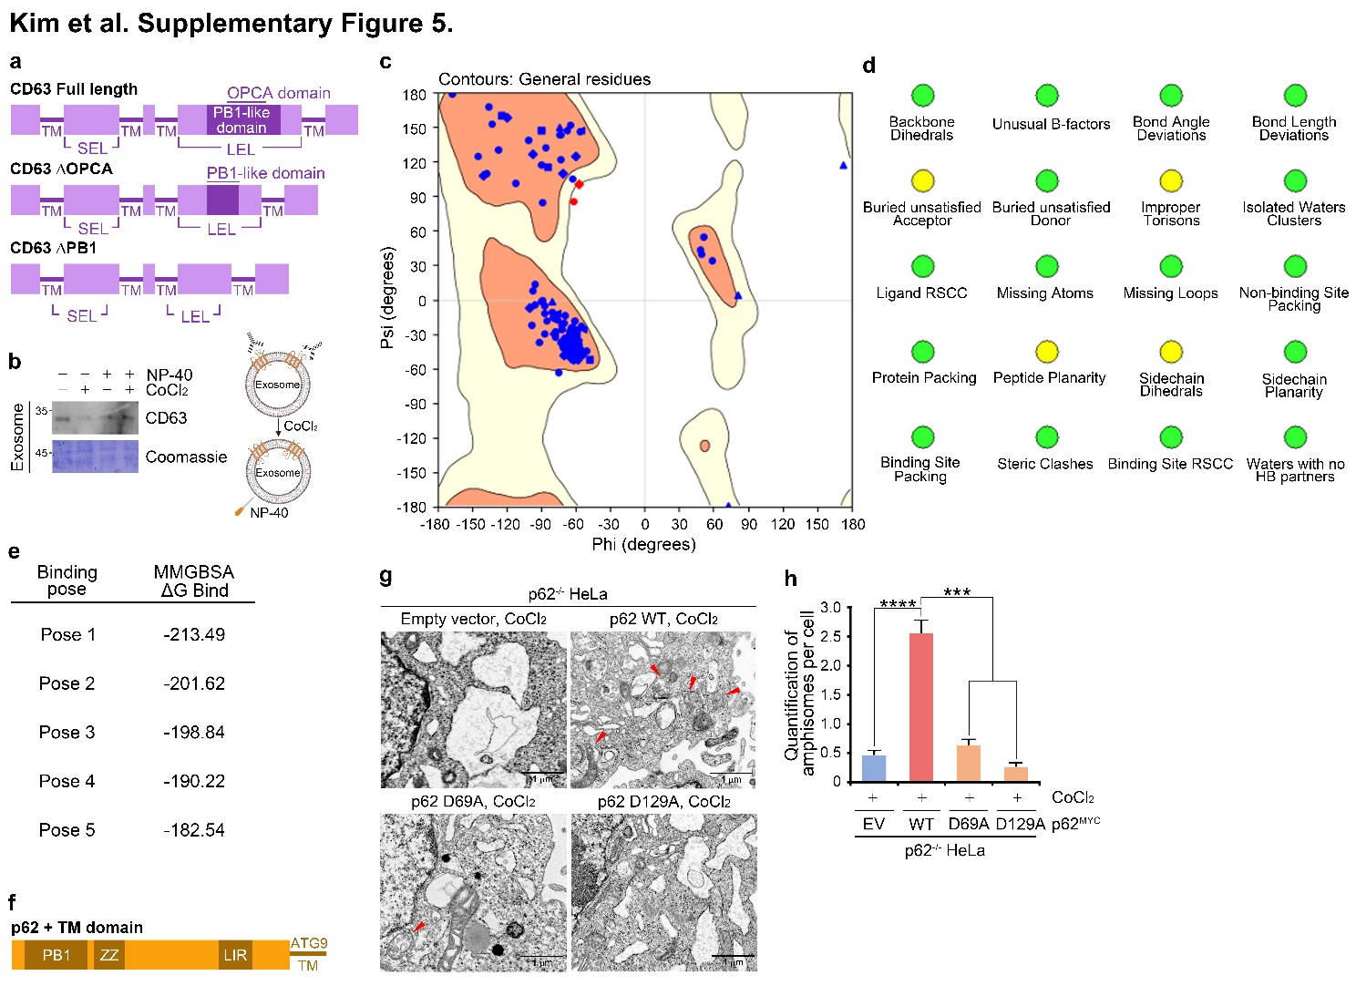
Extended Data Fig. 5 p62 oligomerization is required for the biogenesis of amphisomes under oxidative stress. a Schematic of recombinant CD63 constructs. b Immunoblotting of the exosomal CD63 originated from A549 in the presence or absence of CoCl₂ (250 μM, 24 h) using a CD63 antibody whose epitope is the CD63 LEL domain. Exosomes were permeabilized with 10 % NP-40 in digitonin-based lysis buffer. c The Ramachandran plots of the modeled CD63 structure generated by Alphafold 3. d Structure reliability analysis of the modeled CD63 structure generated by Alphafold 3. e MMGBSA ΔG bind scores (kcal/mol) of the top 5 binding poses of p62 PB1 domain and CD63 PB1 domain. f Schematic of the p62 construct inserted with the ATG9 TM domain. g TEM of A549 cells transfected with WT, D69A, or D129A p62 and treatment of CoCl₂ (250 μM, 24 h) compared to control. The amphisomes or MVBs are indicated by red arrows. Scale bars, 1 μm. h Quantification of g (188 cells). Error bars represent SEM (n = 3 replicates). ***p<0.001, ****p<0.0001 using the paired t-test.

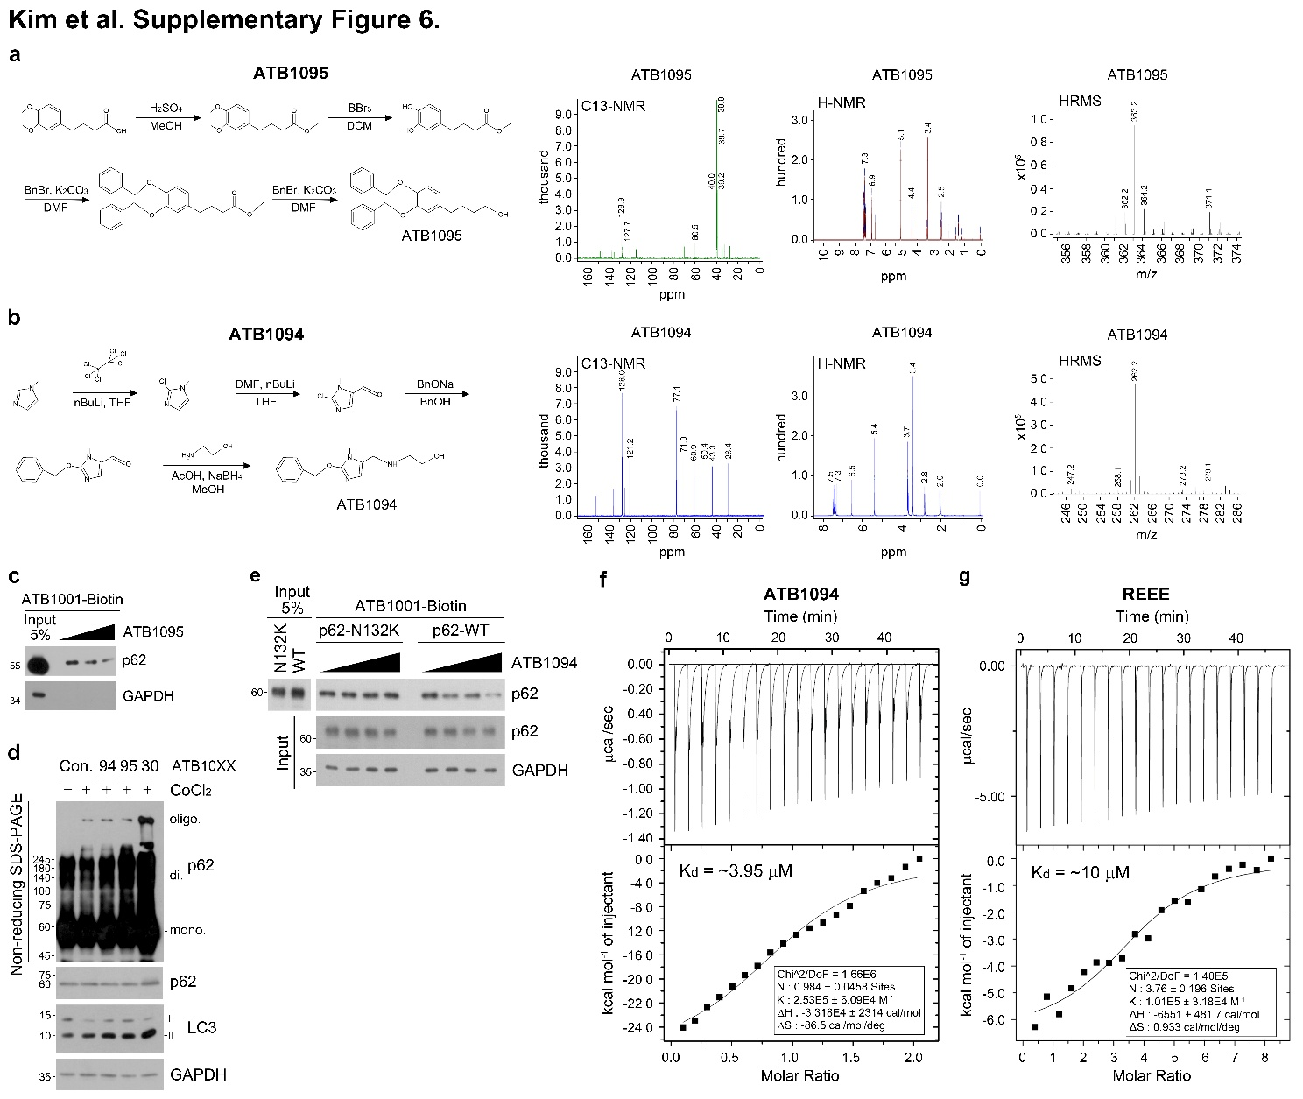
Extended Data Fig. 6 Characterization of p62 antagonists. a and b Synthesis processes, C13-NMR, H-NMR, and HRMS of ATB1095 and ATB1094. Reagents and conditions are described in the ‘Materials and Methods’ section. c Competitive pulldown assay of p62^{MYC} plasmid overexpressed lysate from 293T cells with a serial concentration of ATB1095 (2 h). d Immunoblotting of oligomer and monomer of p62 in A549 cells with CoCl₂ (250 μM, 24 h), ATB1094, ATB1095, or ATB1030 (10 μM, 24 h). e Same as c, but with wild-type or N132K p62^{MYC} plasmid overexpressed lysate from HEK293T cells. f and g Isothermal titration calorimetry (ITC) of ATB1094 and REEE peptide.

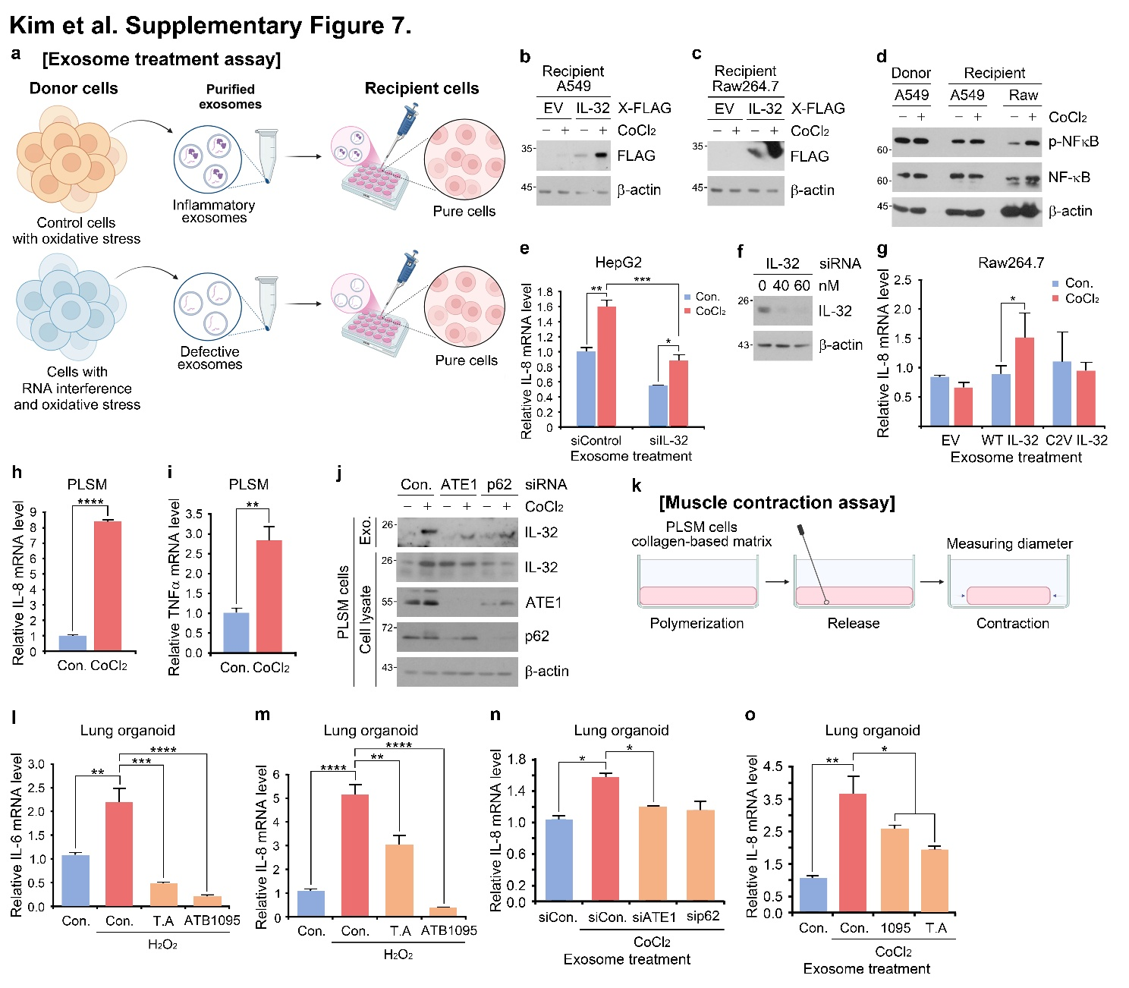
Extended Data Fig. 7 The Arg/N-degron pathway regulates paracrine inflammatory signaling in oxidative stress-induced lung inflammatory models. a Description of the sample preparation of the exosome treatment assay (ETA). b Immunoblotting of IL-32 and IL-6 in A549 cells treated with exosomes originating from IL-32^{FLAG} or cIL-6^{FLAG}-transfected Raw264.7 cells with CoCl₂ (250 μM, 24 h). c Same as b, but in Raw264.7 cells. d Immunoblotting of p-NF-κB, NF-κB in donor A549 cells in the absence or presence of CoCl₂ and recipient A549 and Raw264.7 cells. e Relative mRNA level of IL-8 in HepG2 cells treated with exosomes originating from cells under IL-32 knockdown and CoCl₂ treatment compared with control. f Immunoblotting of IL-32 in HepG2 cells under dose-dependent IL-32 interference compared to control. g Relative mRNA level of IL-8 in Raw264.7 cells treated with exosomes originating from wild-type and C2V IL-32^{FLAG}-transfected cells with CoCl₂. h Relative mRNA level of IL-8 in PLSM cells treated with or without CoCl₂. i Same as h, but with TNFα. j Immunoblotting of intracellular and extracellular fractions of IL-32, ATE1, and p62 in PLSM cells under ATE1 or p62 interference compared to control. k Schematic illustration of the muscle cell contraction assay. l Relative mRNA level of IL-6 in lung organoids treated with H₂O₂ (500 μM, 21 h), tannic acid (30 μM, 24 h), or ATB1095 (10 μM, 24 h). m Same as l, but with IL-8. n Relative mRNA level of IL-8 in lung alveolar organoids treated with exosomes originating from cells under ATE1 or p62 knockdown and CoCl₂ treatment compared with control. o Same as n, but with CoCl₂, ATB1095, and tannic acid. Error bars represent SEM (n = 3 replicates). *p<0.05, **p<0.01, ***p<0.001, ****p<0.0001 using the one-way ANOVA or t-test.

