Improving MR thermometry for microwave ablations: Quantitative assessment of target temperature and ablation duration

Supplementary Materials

Supplementary Methods

Histological sample analysis
Representative tissues from different ablation temperatures and control tissues were obtained and sectioned at 8 µm thickness using a cryostat (Leica Biosystem cryostat CM1510, Wetzlar, Germany) for histological analysis. Cryosections were stained with a solution of reduced NADH (nicotinamide adenine dinucleotide) and NBTC (nitro blue tetrazolium chloride) to assess cellular metabolic activity and differentiate between vital and non-vital cells, as previously described by Neumann et al. (1991) [30, 31]. Additionally, consecutive frozen sections from the same specimens were stained with hematoxylin and eosin (H&E) to evaluate tissue maintenance. Slides were scanned using a digital slide scanner (Pannoramic Scan II, 3D Histech Ltd., Budapest, Hungary), and photographs were captured using SlideViewer 2.8 software (3D Histech Ltd., Budapest, Hungary) at 0.3× magnification.

Supplementary Tables

Supplementary Table S1: Likert score results of MRI thermometry maps
 | MWA duration | 60°C | 80°C | 100°C | 120°C
Temperature maps | 5:00 min | 2.00 | 2.00 | 2.00 | 1.00
Temperature maps | 7:30 min | 3.00 | 2.50 | 2.00 | 1.00
Temperature maps | 10:00 min | 2.00 | 2.00 | 1.00 | 2.00
Temperature maps | 15:00 min | 3.00 | 3.00 | 2.00 | 2.00
Thermal dose maps | 5:00 min | 3.00 | 2.25 | 2.00 | 2.00
Thermal dose maps | 7:30 min | 3.00 | 2.50 | 2.50 | 1.00
Thermal dose maps | 10:00 min | 2.25 | 3.00 | 2.00 | 2.00
Thermal dose maps | 15:00 min | 4.00 | 3.00 | 2.00 | 1.50
Overall | 5:00 min | 2.50 | 2.12 | 2.00 | 1.50
Overall | 7:30 min | 3.00 | 2.50 | 2.25 | 1.00
Overall | 10:00 min | 2.12 | 2.50 | 1.50 | 2.00
Overall | 15:00 min | 3.50 | 3.00 | 2.00 | 1.75

Supplementary Table S2. Roundness index of lesions on thermometry maps
 | 60°C | 80°C | 100°C | 120°C
5:00 min | 1.05 | 1.20 | 1.45 | 1.50
7:30 min | 1.15 | 1.12 | 1.35 | 1.55
10:00 min | 1.20 | 1.20 | 1.35 | 1.50
15:00 min | 1.17 | 1.25 | 1.43 | 1.75
(ratio of long and short axes of the lesion perpendicular to the needle on thermometry maps reformatted para-sagittally)

Supplementary Table S3. Intraclass correlation between the two readers
Intraclass correlation (ICC) values
 | Averaged measurements |  | Single measurements |  | ICC matrix
 | ICC coefficent (95%CI) | p-value | ICC coefficent (95%CI) | p-value
Thermal dose map | 0.998 (0.997-0.999) | <0.001 | 0.997 (0.993-0.998) | <0.001 | 0.997
Temperature map | 0.997 (0.993-0.998) | <0.001 | 0.993 (0.986-0.997) | <0.001 | 0.994
Likert scale | 0.981 (0.962-0.991) | <0.001 | 0.963 (0.927-0.982) | <0.001 | 0.963
Roundness Index | 0.921 (0.838-0.961) | <0.001 | 0.853 (0.731-0.926) | <0.001 | 0.853
(p-values calculated using two-way random effects model for absolute agreement)

Supplementary Figures

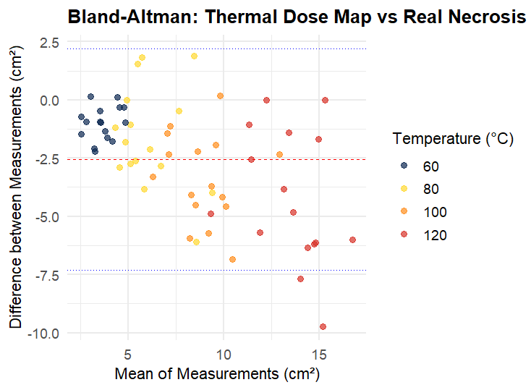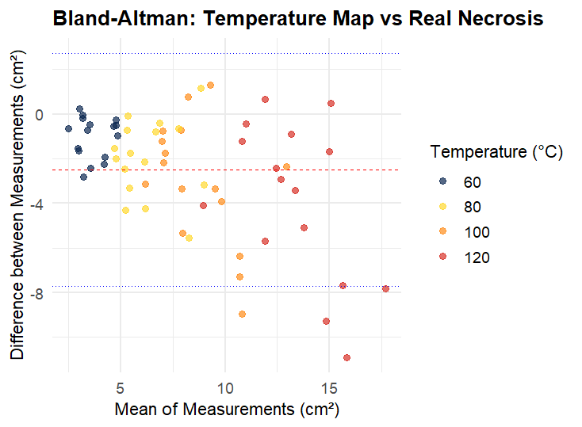
Supplementary Figure S1. Bland-Altman plots comparing MRI-derived maps with real necrosis area. (a) Thermal dose map vs real necrosis; (b) Temperature map vs real necrosis. Data points are color-coded by temperature category (60°C in red, 80°C in green, 100°C in blue, and 120°C in purple). Each temperature category comprises 16 measurements (4 MWA durations × 2 repetitions × 2 readers). The red dashed line indicates the mean bias, blue dotted lines represent the 95% limits of agreement.

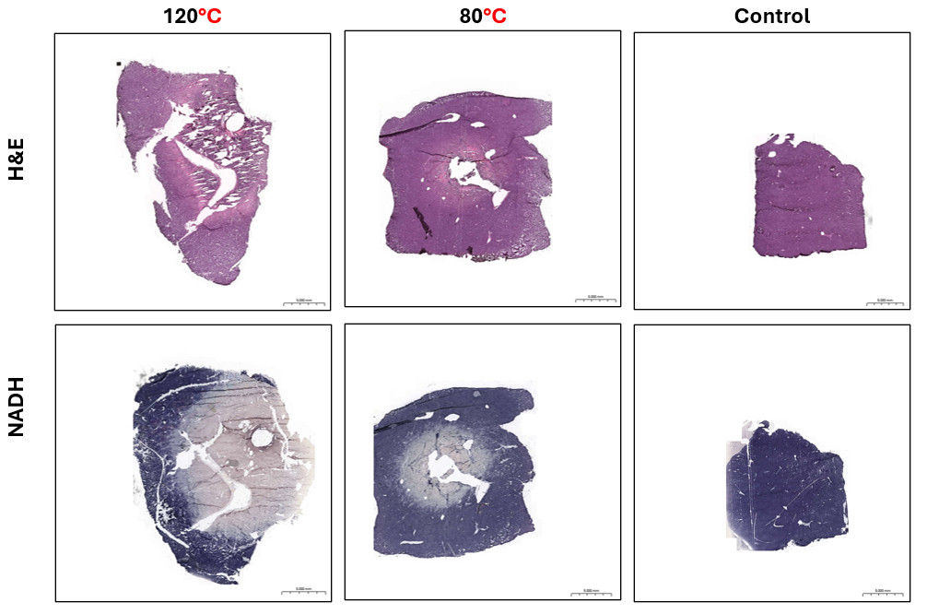
120°C
80°C
Control
Supplementary Figure S2. Representative H&E and NADH staining of ablation and control tissues (×0.3 magnification)

