Supplementary materials：
Seasonal Analysis of Water Conservation using SWAT Model
Since the InVEST model only provides annual water conservation volume, we used the SWAT model evaluation results to analyze the intra-annual water conservation capacity. According to the SWAT model evaluation results, the water conservation capacity in each season shows distinct characteristics (Figure 1). The water conservation capacities for spring, summer, autumn, and winter in the region were -15.25 mm, 100.78 mm, 47.26 mm, and -14.45 mm, respectively. The order of water conservation capacity from largest to smallest is summer > autumn > spring > winter. Summer has the highest water conservation capacity, while winter has the lowest.
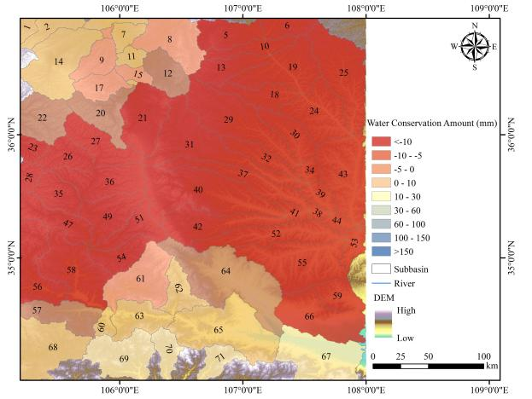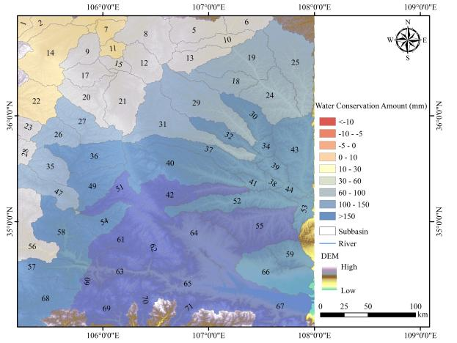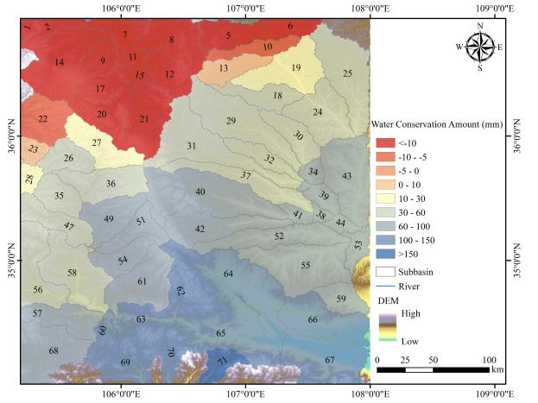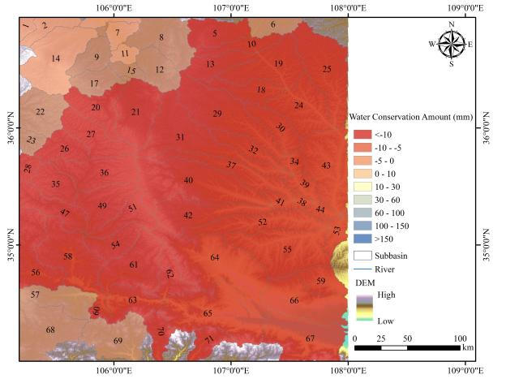
a:spring
b:summer
c:autumn
d:winter
Figure 1. Spatial distribution of seasonal variations in water conservation capacity in the Liupan Mountain area simulated by SWAT.
As shown in Figure 2, taking the two hydrological stations Jingheyuan and Fenglingge as examples, over the twenty years, the overall trend shows that the variation cycles of water conservation capacity at the two stations are highly consistent, exhibiting significant seasonal characteristics. From January to April, the water conservation volume is generally at a low level, with small numerical fluctuations, and negative values occur in some months, indicating that water consumption in the ecosystem may exceed replenishment during this period. Starting in May, the water conservation volume begins to rise rapidly, reaching its annual peak from July to September and remaining at a high level, which is closely related to increased precipitation during the rainy season. After October, the water conservation volume shows a rapid decline until December, when it falls back to negative values again. This pattern fully reflects the characteristic that the water conservation function is driven by climatic factors, with its accumulation peak highly coinciding with the period of abundant precipitation, and the decay period consistent with the trend of decreasing temperature and reduced precipitation.
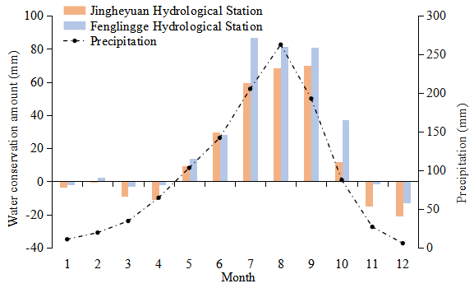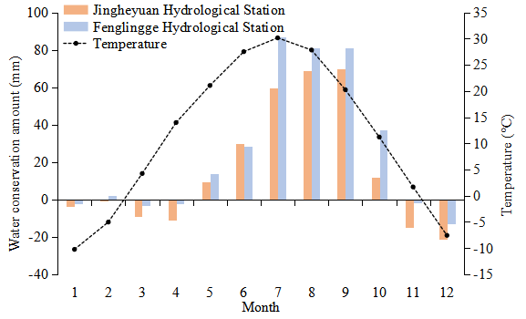
Figure 1. Monthly variation characteristics of water conservation capacity in the Liupan Mountain area simulated by SWAT.

