Supplementary Material

List of Supplementary Tables and Figures

Table S1. Comparisons between survivors and non-survivors based on 90-day outcomes.
Table S2. Comparisons between survivors and non-survivors based on 365-day outcomes.
Figure S1. Kaplan-Meier survival curves comparing EASIX tertiles within 90 days after admission.
Figure S2. Restricted cubic spline analysis of EASIX and 90-day all-cause mortality in critically ill CHD based on Cox proportional hazards model 3.
Figure S3. Subgroup analysis forest plots for 90-day mortality.

TableS1. Comparisons between survivors and non-survivors based on 90-day outcomes
Characteristics | Overall (n = 2468) | Survivors  (n = 1909) | Non-survivors  (n = 559) | p.value
Age | 73 (64-81) | 72 (63-81) | 76 (68-82) | <0.001
Sex (%)
Female | 836 (33.87) | 630 (33.00) | 206 (36.85) | 0.101
Male | 1632 (66.13) | 1279 (67.00) | 353 (63.15)
Race (%)
Black | 154 (6.24) | 115 (6.02) | 39 (6.98) | 0.349
White | 2039 (82.62) | 1573 (82.40) | 466 (83.36)
Others | 275 (11.14) | 221 (11.58) | 54 (9.66)
BMI | 27.682 (24.251-31.831) | 27.777 (24.36-31.807) | 27.287 (23.933-31.929) | 0.078
Comorbidities
Respiratory failure (%) | 1137 (46.07) | 745 (39.03) | 392 (70.13) | <0.001
Arterial fibrillation (%) | 1090 (44.17) | 810 (42.43) | 280 (50.09) | 0.002
Hypertension (%) | 900 (36.47) | 731 (38.29) | 169 (30.23) | 0.001
AKI (%) | 1244 (50.41) | 837 (43.84) | 407 (72.81) | <0.001
Stroke (%) | 249 (10.09) | 200 (10.48) | 49 (8.77) | 0.271
T2DM (%) | 963 (39.02) | 729 (38.19) | 234 (41.86) | 0.129
Heart failure (%) | 1310 (53.08) | 982 (51.44) | 328 (58.68) | 0.003
Myocardial infarction (%) | 856 (34.68) | 656 (34.36) | 200 (35.78) | 0.570
illness severity scores
SOFA | 6 (3-9) | 5 (3-8) | 8 (5-11) | <0.001
APSIII | 47 (35-62) | 43 (32-55) | 63 (49-79) | <0.001
SAPSII | 40 (32-50) | 37 (31-46) | 48 (40-59) | <0.001
OASIS | 34 (28-40) | 32 (27-38) | 39 (32-45) | <0.001
Laboratory tests
Hemoglobin(g/dL) | 10.4 (8.97-11.972) | 10.55 (9.1-12.1) | 9.85 (8.5-11.425) | <0.001
RBC (×10⁶/µL) | 3.47 (3.03-4.02) | 3.51 (3.08-4.07) | 3.33 (2.865-3.875) | <0.001
WBC (×10³/µL) | 11.4 (8.5-15.6) | 11.12 (8.4-15.05) | 12.63 (8.835-17.69) | <0.001
INR | 1.3 (1.17-1.57) | 1.27 (1.15-1.5) | 1.45 (1.2-1.9) | <0.001
PT(sec) | 14.24 (12.8-17.135) | 14 (12.7-16.3) | 15.85 (13.4-20.77) | <0.001
APTT(sec) | 36 (29.26-54.83) | 35.125 (28.95-53.1) | 38.1 (30.175-62.015) | <0.001
FBG (mg/dL) | 135.33 (112-176) | 132 (111-169.625) | 148 (119-193) | <0.001
Potassium (mEq/L) | 4.17 (3.87-4.53) | 4.15 (3.87-4.5) | 4.25 (3.87-4.64) | 0.001
Sodium (mEq/L) | 138.5 (135.67-141) | 138.5 (136-141) | 138.33 (134.67-141.33) | 0.154
Serum creatinine(mg/dL) | 1.2 (0.87-1.77) | 1.1 (0.85-1.6) | 1.53 (1.04-2.33) | <0.001
EASIX | 1.129 (0.206-2.089) | 0.917 (0.09-1.823) | 1.9 (0.922-2.826) | <0.001
LDH(U/L) | 296 (219-435) | 280 (207-393) | 388 (271-557.5) | <0.001
Platelet(×10³/µL) | 180 (133-237) | 180.8 (136.5-235) | 175 (121.215-241.75) | 0.212
Therapeutic
Invasive ventilation (%) | 2212 (89.63) | 1705 (89.31) | 507 (90.70) | 0.387
Antihypertensive drugs(%) | 2107 (85.37) | 1658 (86.85) | 449 (80.32) | <0.001
Glucocorticoid(%) | 647 (26.22) | 426 (22.32) | 221 (39.53) | <0.001
Data are presented as median (IQR) or frequencies (percentages). Abbreviation: EASIX, Endothelial Activation and Stress Index; BMI, body mass index; AKI, acute kidney injury; T2DM, type 2 diabetes mellitus; RBC, red blood cell; WBC, white blood cells; INR, international normalized ratio; PT, prothrombin time; APTT, activated partial thromboplastin time; FBG, fasting blood glucose; LDH, lactate dehydrogenase; SOFA, sequential organ failure assessment; SAPS II, simplified acute physiological score II; APS III, acute physiology score III; OASIS, oxford acute severity of illness score.

TableS2. Comparisons between survivors and non-survivors based on 365-day outcomes
Characteristics | Overall (n = 2468) | Survivors  (n = 1876) | Non-survivors  (n = 592) | p.value
Age | 73 (64-81) | 72 (63-81) | 76 (67-82) | <0.001
Sex (%)
Female | 836 (33.87) | 616 (32.84) | 220 (37.16) | 0.059
Male | 1632 (66.13) | 1260 (67.16) | 372 (62.84)
Race (%)
Black | 154 (6.24) | 109 (5.81) | 45 (7.60) | 0.194
White | 2039 (82.62) | 1551 (82.68) | 488 (82.43)
Others | 275 (11.14) | 216 (11.51) | 59 (9.97)
BMI | 27.682 (24.251-31.831) | 27.776 (24.372-31.803) | 27.295 (23.886-31.949) | 0.062
Comorbidities
Respiratory failure (%) | 1137 (46.07) | 729 (38.86) | 408 (68.92) | <0.001
Arterial fibrillation (%) | 1090 (44.17) | 793 (42.27) | 297 (50.17) | 0.001
Hypertension (%) | 900 (36.47) | 722 (38.49) | 178 (30.07) | <0.001
AKI (%) | 1244 (50.41) | 813 (43.34) | 431 (72.80) | <0.001
Stroke (%) | 249 (10.09) | 197 (10.50) | 52 (8.78) | 0.258
T2DM (%) | 963 (39.02) | 708 (37.74) | 255 (43.07) | 0.023
Heart failure (%) | 1310 (53.08) | 958 (51.07) | 352 (59.46) | <0.001
Myocardial infarction (%) | 856 (34.68) | 644 (34.33) | 212 (35.81) | 0.541
illness severity scores
SOFA | 6 (3-9) | 5 (3-8) | 8 (5-11) | <0.001
APSIII | 47 (35-62) | 43 (32-55) | 62 (49-79) | <0.001
SAPSII | 40 (32-50) | 37 (30-46) | 48 (40-59) | <0.001
OASIS | 34 (28-40) | 32 (27-38) | 39 (32-45) | <0.001
Laboratory tests
Hemoglobin(g/dL) | 10.4 (8.97-11.972) | 10.58 (9.127-12.15) | 9.875 (8.5-11.362) | <0.001
RBC (×10⁶/µL) | 3.47 (3.03-4.02) | 3.53 (3.09-4.08) | 3.32 (2.86-3.86) | <0.001
WBC (×10³/µL) | 11.4 (8.5-15.6) | 11.15 (8.43-15.07) | 12.37 (8.728-17.515) | <0.001
INR | 1.3 (1.17-1.57) | 1.27 (1.15-1.5) | 1.435 (1.2-1.9) | <0.001
PT(sec) | 14.24 (12.8-17.135) | 14 (12.7-16.27) | 15.8 (13.4-20.618) | <0.001
APTT(sec) | 36 (29.26-54.83) | 35.1 (28.93-52.95) | 38.225 (30.225-62.455) | <0.001
FBG (mg/dL) | 135.33 (112-176) | 131.67 (111-169.1) | 148.415 (118.938-193) | <0.001
Potassium (mEq/L) | 4.17 (3.87-4.53) | 4.15 (3.87-4.5) | 4.25 (3.885-4.65) | 0.001
Sodium (mEq/L) | 138.5 (135.67-141) | 138.5 (136-141) | 138.29 (134.67-141.347) | 0.257
Serum creatinine(mg/dL) | 1.2 (0.87-1.77) | 1.1 (0.85-1.6) | 1.535 (1.05-2.33) | <0.001
EASIX | 1.129 (0.206-2.089) | 0.906 (0.086-1.81) | 1.903 (0.932-2.823) | <0.001
LDH(U/L) | 296 (219-435) | 279 (207-393) | 380 (269-548.25) | <0.001
Platelet(×10³/µL) | 180 (133-237) | 181.29 (137.31-235) | 173.335 (120.502-240.378) | 0.095
Therapeutic
Invasive ventilation (%) | 2212 (89.63) | 1674 (89.23) | 538 (90.88) | 0.286
Antihypertensive drugs(%) | 2107 (85.37) | 1629 (86.83) | 478 (80.74) | <0.001
Glucocorticoid(%) | 647 (26.22) | 410 (21.86) | 237 (40.03) | <0.001
Data are presented as median (IQR) or frequencies (percentages).
Abbreviation: EASIX, Endothelial Activation and Stress Index; BMI, body mass index; AKI, acute kidney injury; T2DM, type 2 diabetes mellitus; RBC, red blood cell; WBC, white blood cells; INR, international normalized ratio; PT, prothrombin time; APTT, activated partial thromboplastin time; FBG, fasting blood glucose; LDH, lactate dehydrogenase; SOFA, sequential organ failure assessment; SAPS II, simplified acute physiological score II; APS III, acute physiology score III; OASIS, oxford acute severity of illness score.
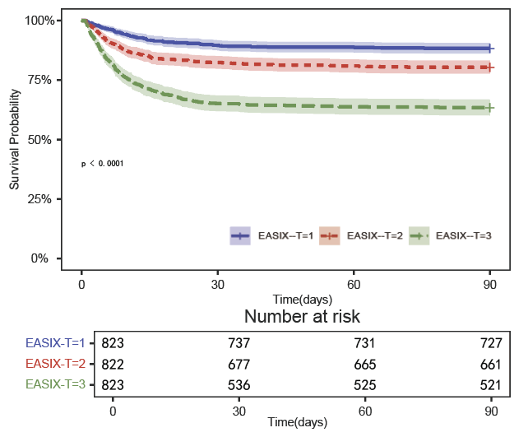
Figure S1. Kaplan-Meier survival curves comparing EASIX tertiles within 90 days after admission.

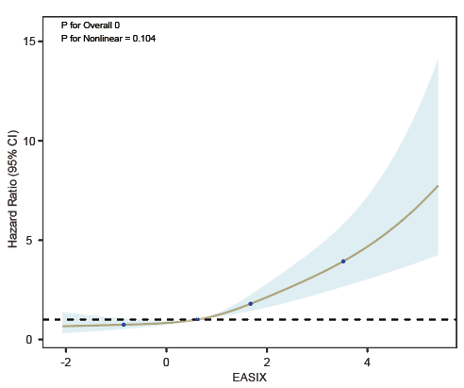
Fig S2. Restricted cubic spline analysis of EASIX and 90-day all-cause mortality in critically ill CHD based on Cox proportional hazards model 3. Cox proportional hazards model 3: adjusted for sex, age, race,BMI, respiratory failure, arterial fibrillation, hypertension, AKI, stroke, hypertension, T2DM, heart failure, myocardial infarction, hemoglobin, RBC, WBC, PT, APTT, FBG, potassium, sodium, serum creatinine, platelet, SOFA, SAPS II, APS III, OASIS, invasive ventilation, antihypertensive drug and glucocorticoid.
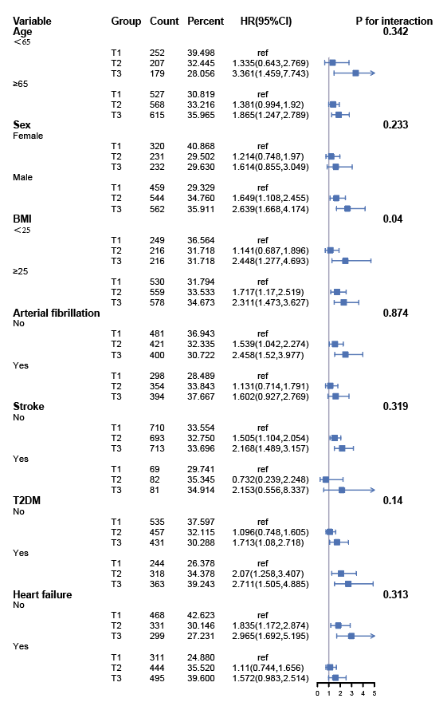
Figure S3. Subgroup analysis forest plots for 90-day mortality

