Supplementary Figure 1
Figure S1. Cell Communication in Vaginal Tissue and Small Molecule Screening for hVEOs
a. Violin plots displaying the expression of canonical markers for each cell type (n = 21). The horizontal line within each box represents the median, and the top and bottom of each box indicate the 75th and 25th percentiles. A two-sided Wilcoxon rank-sum test was applied to assess the significance of gene expression differences (p < 0.05). Cell types: epithelial cells (EP), fibroblasts (FIB), smooth muscle cells (SMC), myoepithelial cells (MEP), endothelial cells (EC), lymphatic endothelial cells (LEC), macrophages (MΦ), T cells (TC), B cells (BC), plasma B cells (PB), mast cells (MAST). Scale bars, 100 μm (if applicable).​ b. CellChat visualization outputs for different analytical tasks. In the hierarchy plot and circle plot, different colors represent distinct cell groups. In the bubble plot, colors are proportional to the number of interactions, with dark green corresponding to the highest values (scRNA-seq data).​ c. CellChat visualization outputs for different analytical tasks. In the bubble plot, colors are proportional to interaction strength, with dark green corresponding to the highest values (scRNA-seq data).​ d. Morphological changes of hVEOs on Day 2 (D2), Day 4 (D4), Day 6 (D6), and Day 8 (D8) under different treatments (Ctrl, A-83-01, SB202190, Forskolin, Y27632, A+S, A+S+Y, A+S+Y+F). Scale bar, 100 μm.

Supplementary Figure 2
Figure S2. UMAP of hVEOs and Vaginal Epithelial Cell Cycle
a-b. UMAP visualization of cell cycle phases of hVEOs epithelial cells (EpC). Cells in phase G1 are illustrated in red, those in G2/M stage in blue, and S-phase cells in green.

Supplementary Figure 3
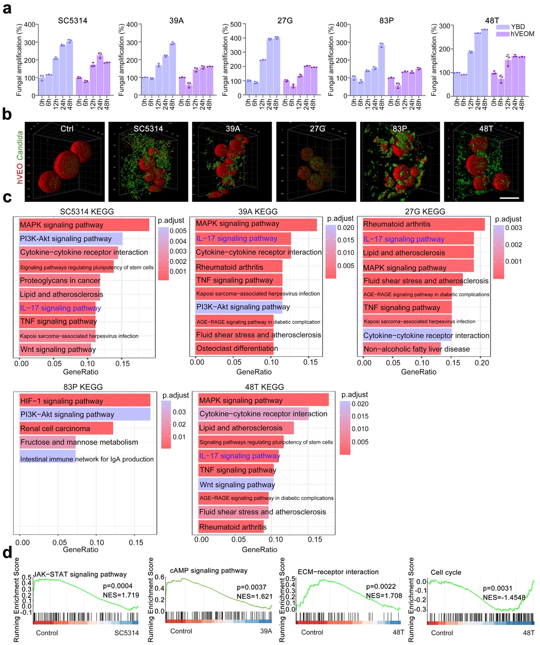
Figure S3. Co-culture of hVEOs and Candida strains
a. Generation times of Candida species in YPD medium or hVEOM (hVEO medium, used for organoid infections) measured by 12 h growth curves. All values are presented as the mean ± s.d. of n = 3 independent experiments. No statistically significant differences in growth were observed between species in either YPD medium or hVEOM (one-way ANOVA with Greenhouse-Geisser correction and Tukey’s multiple comparisons test) (n = 3).​ b. Three-photon 3D imaging of the spatial distribution of hVEOs (red, human vaginal epithelial organoids) and Candida strains (green) in the control group (Ctrl) and groups infected with different Candida strains (SC5314, 39A, 27G, 83P, 48T). Red indicates hVEOs structure, and green traces Candida strains. Scale bars, 100 μm.​ c. KEGG pathway comparisons of significantly altered biological pathways in hVEOs between the control group and Candida-infected groups (SC5314, 39A, 27G, 83P, 48T) (scRNA-seq data).​ d. GSEA plots of KEGG pathway enrichment analysis: Candida-infected versus uninfected hVEOs (control group) (scRNA-seq data).

Supplementary Table 1∣Antibodies used in this paper.
Antibody Name | Company | Cat No. | Immuogen | Host species
CDH1/ECAD | BD Bioscience | 610182 | human | Mouse, mAb
Ki67 | Abcam | Ab16667 | human | Rabbit, mAb
P63 | CST | 67825 | human | Rabbit, mAb
FLG | Abcam | ab254530 | human | Mouse, mAb
CK7 | Santa Cruz | sc23876 | human | Mouse, mAb
CK10 | Proteintech | 18343-1-AP | human | Rabbit, pAb
CK14 | Abcam | Ab181595 | human | Rabbit, mAb
ER-α | Abcam | Ab16660 | human | Rabbit, mAb
Note: mAb, monoclonal antibody; pAb, polyclonal antibody

Supplementary Table 2∣ Candida strains sources and properties.
ID | Gender | Donor | Gene Up/Down
SC5314 | Candida albicans | - | 359 up  294 down
39A | Candida albicans | Shang | 151 up  19 down
83P | Candida parapsilosis | Shang | 98 up  5 down
27G | Candida glabrata | Li | 110 up  6 down
48T | Candida tropicalis | Li | 617 up  294 down

