Supporting Information for
Visible Colorimetric Dosimetry of UV and Ionizing Radiations by a Dual-Module Photochromic Nanocluster
Huangjie Lu,^{1,2,†} Jian Xie,^{4,†} Xin-Xu Wang,³ Yaxing Wang,⁴ Zi-Jian Li,^{1,2} Kariem Diefenbach,¹ Qing-Jiang Pan, ^{3,}* Jian-Qiang Wang,^{1,2,5} Shuao Wang,^{4,}* and Jian Lin^{1,2,}*

¹ Key Laboratory of Interfacial Physics and Technology, Shanghai Institute of Applied Physics, Chinese Academy of Sciences, 2019 Jia Luo Road, Shanghai 201800, China.
Email: linjian@sinap.ac.cn (Jian Lin)
² University of Chinese Academy of Sciences, No.19(A) Yuquan Road, Shijingshan District, Beijing, 100049, China.
³ Key Laboratory of Functional Inorganic Material Chemistry (Ministry of Education), School of Chemistry and Materials Science, Heilongjiang University, Harbin 150080, China.
Email: panqjitc@163.com (Qing-Jiang Pan)
⁴ School for Radiological and Interdisciplinary Sciences (RAD-X) and Collaborative Innovation Center of Radiation Medicine of Jiangsu Higher Education Institutions, Soochow University, 199 Ren’ai Road, Suzhou 215123, China.
Email: shuaowang@suda.edu.cn (Shuao Wang)
⁵ Dalian National Laboratory for Clean Energy, Dalian 116023, China.
† These authors contributed equally to this work.

Table of contents

Figures
Figure S1. Structure of the hexameric [Th₆(OH)₄O₄(H₂O)₆]¹²⁺ core. The Th atoms are shown in green; carbon atoms are shown in gray; and the O atoms from μ₃-OH/-O, H₂O, and bridging carboxylate groups are shown in pink, blue, and red, respectively.
Figure S2. PXRD patterns of simulated and as-synthesized Th-SINAP-100 samples.
Figure S3. UV-Vis absorption spectra of Th-SINAP-100 before and after (a) β and (b) γ-ray irradiations.
Figure S4. Evolution of the UV-Vis absorption spectra and color of TPC from 0 to 70 min upon 365 nm UV irradiation.
Figure S5. Photoluminescence spectra and color of Th-SINAP-100 before and after (a) 200 KGy doses of β-ray and (b) 100 KGy doses of γ-ray irradiation.
Figure S6. (a) Snapshots of TPC ligand upon 365 nm UV irradiation. (b) Evolution of the PL spectra of TPC ligand upon 365 nm UV irradiation. (c) CIE chromaticity coordinates of TPC ligand as a function of irradiation time.
Figure S7. The stability measurement of UV radiation induced radicals. Inset: the PL spectra of Th-SINAP-100 showing that PL modulation is not reversible under ambient conditions.
Figure S8. FTIR spectra of Th-SINAP-100 before and after irradiation with UV, β-, and γ-ray.
Figure S9. The thermogravimetric analysis data showing that Th-SINAP-100 is thermally stable up to 150 ℃. The weight loss from 30−150 °C is 3.55%, corresponding to the departure of hydration water molecules. The weight loss from 150−300 °C is 9.70%, corresponding to the departure of coordinating water molecules and formic acid.
Figure S10. EPR spectra of TPC ligand before and after UV irradiation.
Figure S11. Orbital diagrams of the 392 nm electron transitions for TS-d1 from the TD-DFT calculations.
Figure S12. (a) Density of States (DOS) of TS-d1. (b) The diagrams of selected orbitals of TS-d1. (c) Density of States (DOS) of TS-m1. (d) The diagrams of selected orbitals of TS-m1.

Tables
Table S1. Crystallographic data for Th-SINAP-100 (nonirradiated, a 2 hours UV, and 200kGy γ-ray irradiated sample).
Table S2. The CIE chromaticity coordinates (x, y) of PL upon irradiation with different UV dose for Th-SINAP-100 and TPC ligand.
Table S3. The comparison of γ and β radiation resistance in MOFs.
Table S4. Selected bond distances (Å) of Th-SINAP-100.
Table S5. Optimized bond lengths (Å) for the experimentally-synthesized complex (TS) and three theoretical models (TS-m1 and TS-d1), compared with experimental values.
Table S6. Bond orders of the experimentally-synthesized complex (TS) and two theoretical modes (TS-m1 and TS-d1).
Table S7. Calculated absorptions of the molecular models and TPC ligand at the TD-DFT level.

References

Figures
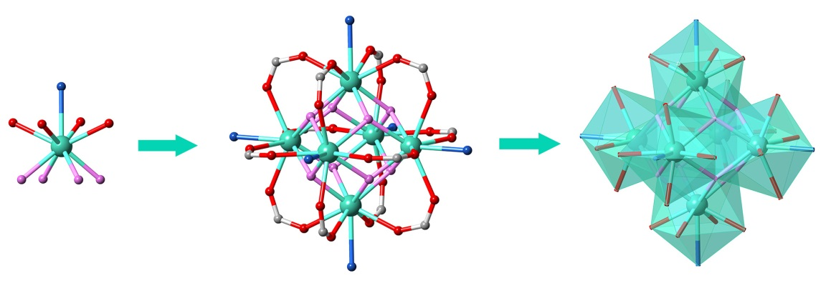
Figure S1. Structure of the hexameric [Th₆(OH)₄O₄(H₂O)₆]¹²⁺ core. The Th atoms are shown in green; carbon atoms are shown in gray; and the O atoms from μ₃-OH/-O, H₂O, and bridging carboxylate groups are shown in pink, blue, and red, respectively.

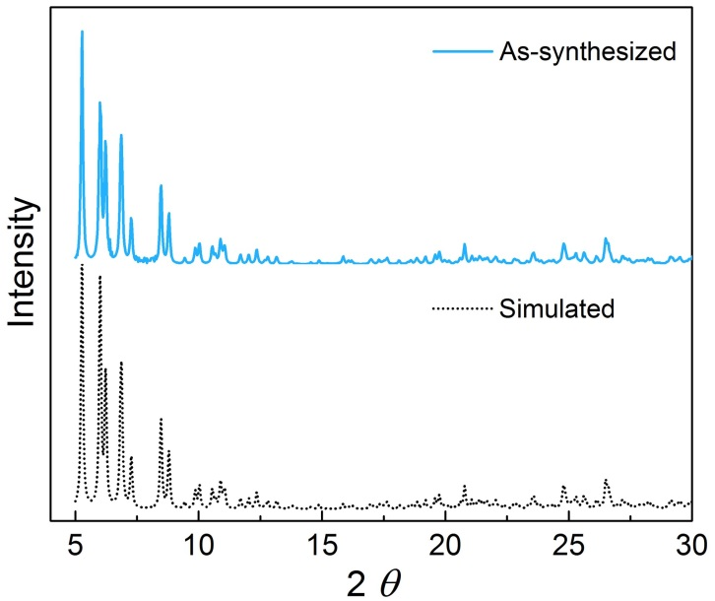
Figure S2. PXRD patterns of simulated and as-synthesized Th-SINAP-100 samples.

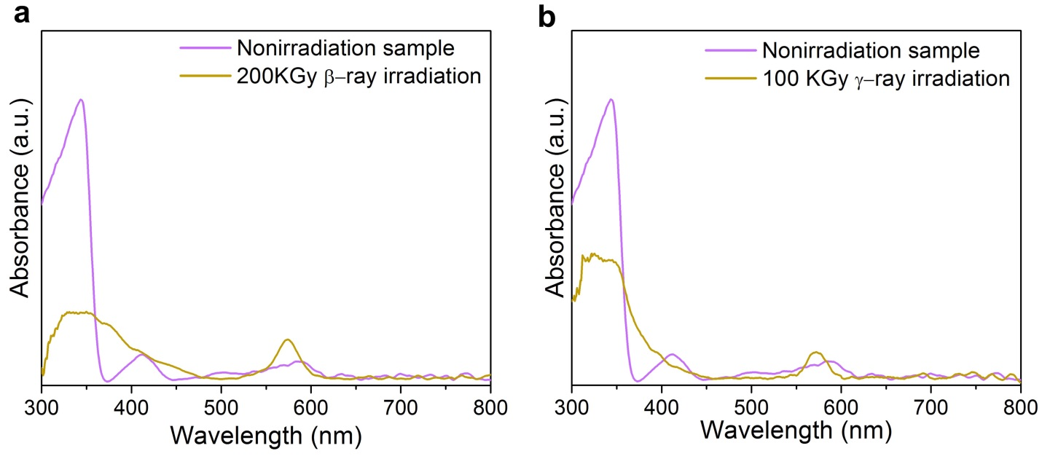
Figure S3. UV-Vis absorption spectra of Th-SINAP-100 before and after (a) β and (b) γ-ray irradiations.

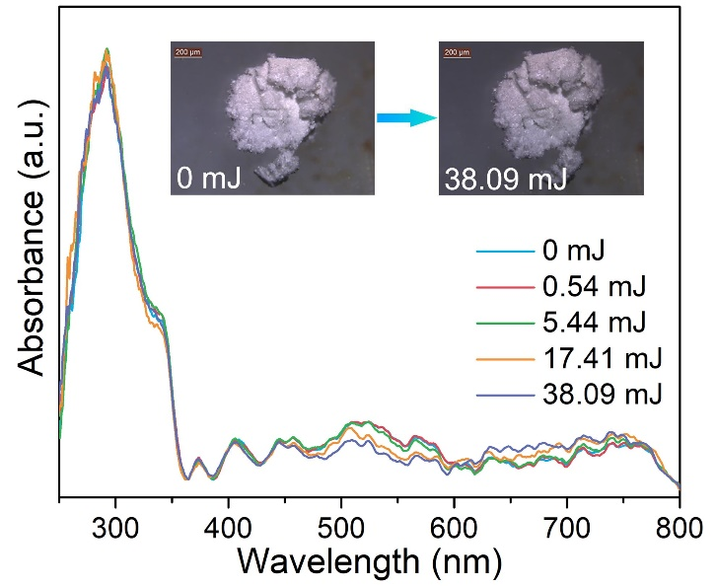
Figure S4. Evolution of the UV-Vis absorption spectra and color of TPC from 0 to 70 min upon 365 nm UV irradiation.
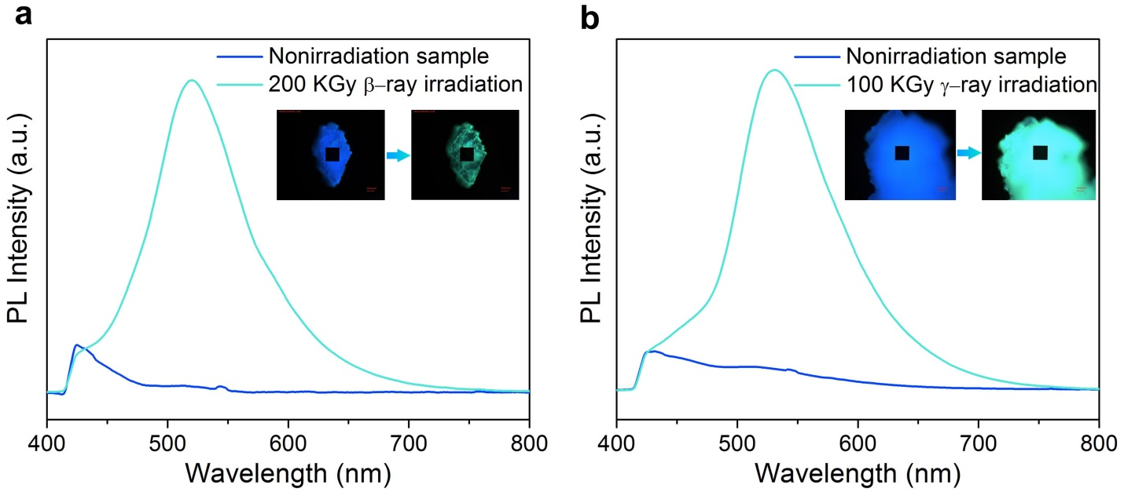
Figure S5. Photoluminescence spectra and color of Th-SINAP-100 before and after (a) 200 KGy doses of β-ray and (b) 100 KGy doses of γ-ray irradiation.

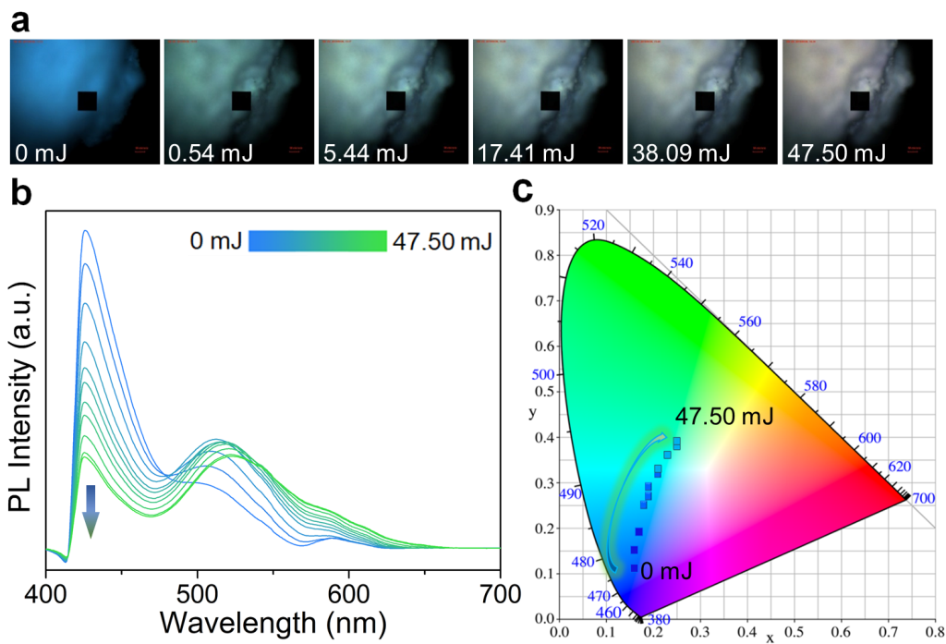

Figure S6. (a) Snapshots of TPC ligand upon 365 nm UV irradiation. (b) Evolution of the PL spectra of TPC ligand upon 365 nm UV irradiation. (c) CIE chromaticity coordinates of TPC ligand as a function of irradiation time.
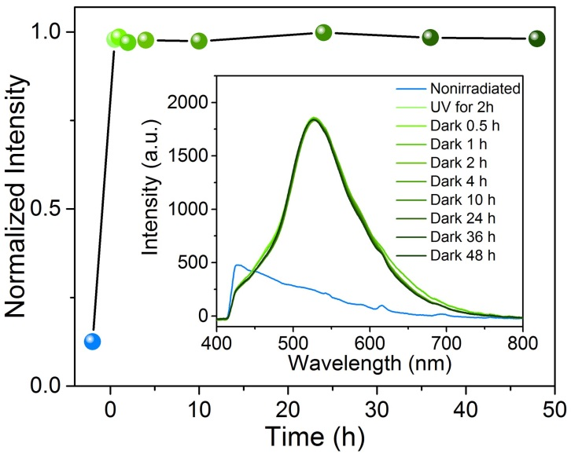
Figure S7. The stability measurement of UV radiation induced radicals. Inset: the PL spectra of Th-SINAP-100 showing that PL modulation is not reversible under ambient conditions.

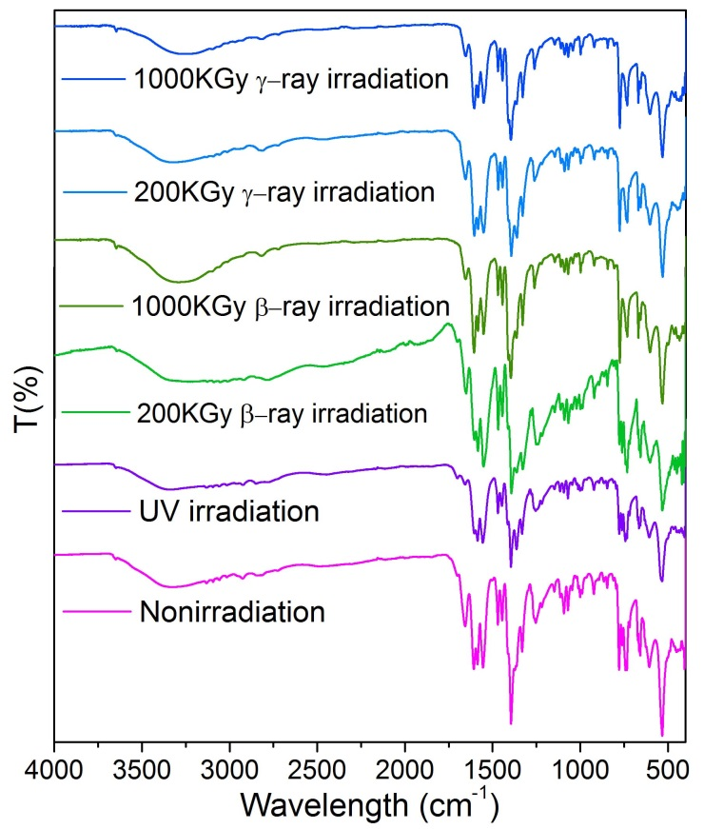
Figure S8. FTIR spectra of Th-SINAP-100 before and after irradiation with UV, β-, and γ-ray.

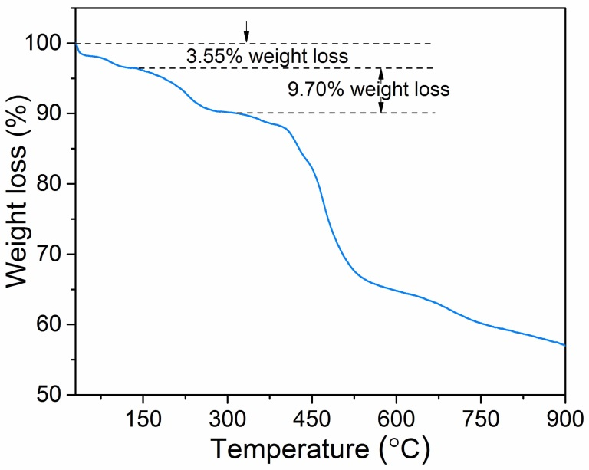
Figure S9. The thermogravimetric analysis data showing that Th-SINAP-100 is thermally stable up to 150 ℃. The weight loss from 30−150 °C is 3.55%, corresponding to the departure of hydration water molecules. The weight loss from 150−300 °C is 9.70%, corresponding to the departure of coordinating water molecules and formic acid.

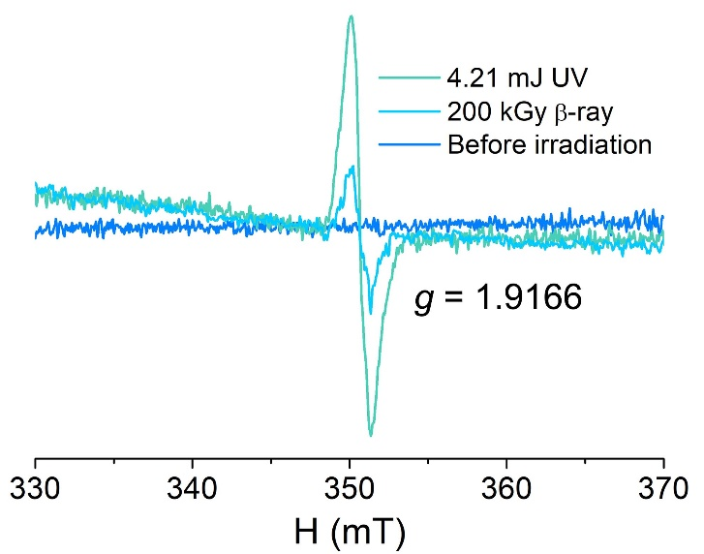
Figure S10. EPR spectra of TPC ligand before and after UV irradiation.

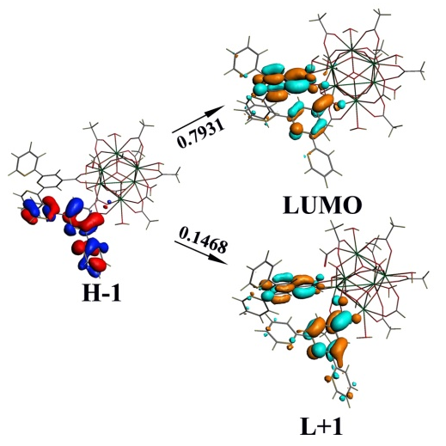
Figure S11. Orbital diagrams of the 392 nm electron transitions for TS-d1 from the TD-DFT calculations.

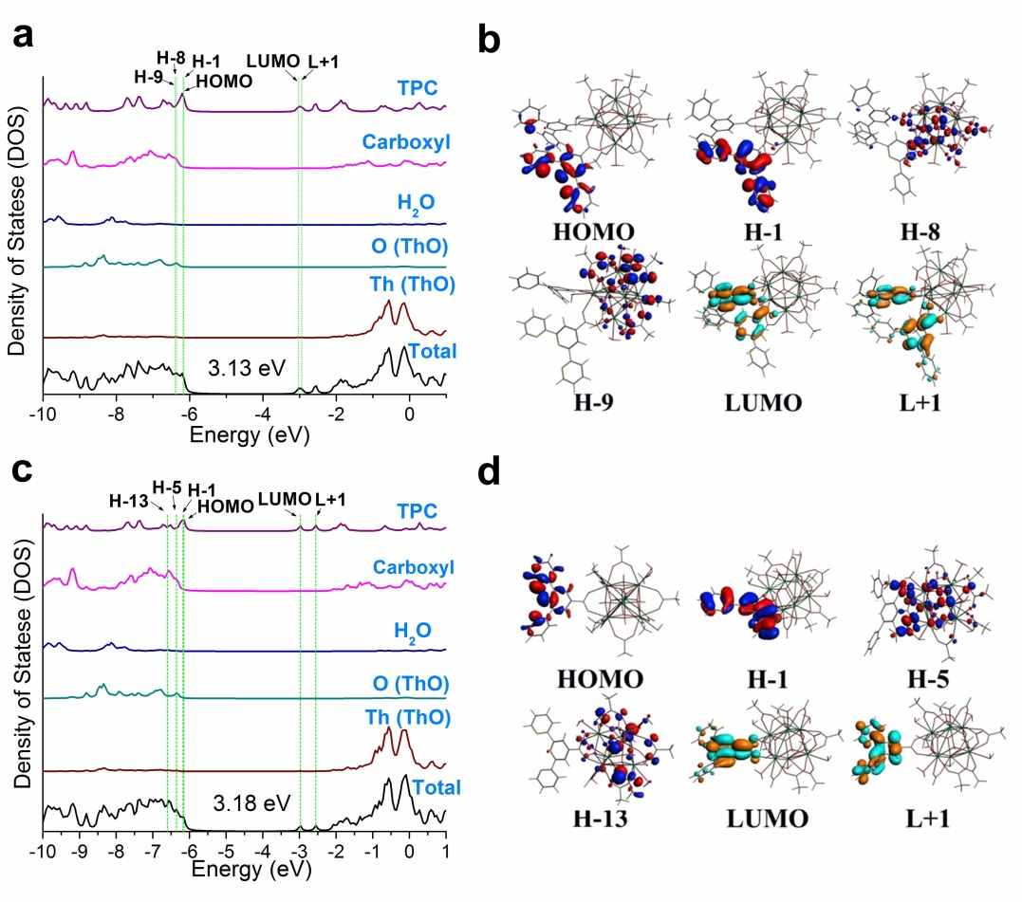

Figure S12. (a) Density of States (DOS) of TS-d1. (b) The diagrams of selected orbitals of TS-d1. (c) Density of States (DOS) of TS-m1. (d) The diagrams of selected orbitals of TS-m1.

Tables
Table S1. Crystallographic data for Th-SINAP-100 (nonirradiated, a 2 hours UV, and 200kGy γ-ray irradiated sample).

 | Dataset 1 |  | Dataset 2
Sample | Before  UV | After  UV | Before  γ-ray | After  γ-ray
Mass | 4049.80 | 4049.8 | 4134.47 | 4134.47
Color | Purple, | Orange | Purple, | Orange
Habit | Block | Block | Block | Block
Space group | P$\overline{1}$ | P$\overline{1}$ | P$\overline{1}$ | P$\overline{1}$
a (Å) | 14.5147(15) | 14.5035(11) | 14.5258(11) | 14.500(6)
b (Å) | 17.2275(18) | 17.2237(14) | 17.2459(16) | 17.173(7)
c (Å) | 18.484(2) | 18.4425(14) | 18.5038(15) | 18.368(9)
α (deg) | 107.723(5) | 107.615(2) | 107.681(3) | 106.984(15)
β (deg) | 99.215(5) | 99.169(3) | 99.357(3) | 99.480(16)
γ (deg) | 111.643(5) | 111.597(2) | 111.482(3) | 111.525(16)
V (Å³) | 3893.6(7) | 3887.5(5) | 3908.7(6) | 3875(3)
Z | 1 | 1 | 1 | 1
T (K) | 296(2) | 296(2) | 296(2) | 296(2)
λ (Å) | 0.71073 | 0.71073 | 0.71073 | 0.71073
Max 2θ (deg) | 55.23 | 55.35 | 55.19 | 55.17
ρ_{calcd} (g cm⁻³) | 1.727 | 1.778 | 1.756 | 1.772
μ (Mo Ka) | 0.71073 | 0.71073 | 0.71073 | 0.71073
R₁ | 0.0446 | 0.0423 | 0.0313 | 0.0374
wR₂  Rint  GOF | 0.1287  0.0761  1.036 | 0.1292  0.0640  1.061 | 0.1019  0.0392  1.069 | 0.1096  0.0528  1.052

Table S2. The CIE chromaticity coordinates (x, y) of PL upon irradiation with different UV dose for Th-SINAP-100 and TPC ligand.
Dosage (mJ) | Th-SINAP-100 CIE coordinates (x, y) | Dosage (mJ) | Ligand CIE coordinates (x, y)
0 | (0.21,0.23) | 0 | (0.16,0.11)
1.75×10⁻³ | (0.21,0.25) | 2.99×10⁻¹ | (0.16,0.15)
4.08×10⁻³ | (0.21,0.26) | 9.97×10⁻¹ | (0.17,0.19)
5.85×10⁻³ | (0.21,0.28) | 2.72 | (0.18,0.25)
1.17×10⁻² | (0.21,0.30) | 4.79 | (0.19,0.27)
1.75×10⁻² | (0.21,0.32) | 7.17 | (0.19,0.29)
3.51×10⁻² | (0.22,0.37) | 11.24 | (0.21,0.32)
1.40×10⁻¹ | (0.23,0.40) | 15.38 | (0.21,0.33)
3.16×10⁻¹ | (0.26,0.44) | 25.82 | (0.23,0.36)
5.26×10⁻¹ | (0.28,0.46) | 41.44 | (0.25,0.38)
7.02×10⁻¹ | (0.30,0.47) | 47.50 | (0.25,0.39)
8.77×10⁻¹ | (0.30,0.48)
1.05 | (0.30,0.48)
1.23 | (0.31,0.49)
1.44 | (0.31,0.49)
1.75 | (0.31,0.50)
2.11 | (0.32,0.49)
2.81 | (0.32,0.49)
3.51 | (0.32,0.49)
4.21 | (0.31,0.49)

Table S3. The comparison of γ and β radiation resistance in MOFs.
MOFs | β irradiation | γ irradiation | Reference
Th-SINAP-100 | 1 MGy | 1000 kGy | This work
[(CH₃)₂NH₂][UO₂(L1)] | 200 kGy | N/A | 1
SCU-100 | 100 kGy | N/A | 2
SCU-101 | 200 kGy | N/A | 3
FJSM-InMOF | 200 kGy | N/A | 4
{[Ni₃Th₆(μ₃-O)₄(μ₃-OH)₄(IN)₁₂)(H₂O)₁₂]·(OH)₆·5DMF·2H₂O}_{n} | 400 kGy | 100 kGy | 5
SCU-200 | N/A | 200 kGy | 6
SIFSIX-3-Cu | 50 kGy | 50 kGy | 7
MIL-100(Al) | N/A | 2000 kGy | 8

Table S4. Selected bond distances (Å) of Th-SINAP-100.
 | atoms |  | nonirradiated | Irradiated  (UV) | nonirradiated | Irradiated  (γ-ray)
Th−O_{W} | Th1 | −O1 | 2.637(6) | 2.641(5) | 2.638(4) | 2.646(5)
Th−O_{W} | Th2 | −O5 | 2.686(7) | 2.688(7) | 2.695(6) | 2.710(10)
Th−O_{W} | Th3 | −O13 | 2.693(6) | 2.691(6) | 2.690(5) | 2.683(6)
Th−O_{oxo/hydroxo} | Th1 | −O3 | 2.380(7) | 2.378(6) | 2.381(5) | 2.385(6)
Th−O_{oxo/hydroxo} | Th2 | −O3 | 2.407(7) | 2.395(6) | 2.393(5) | 2.395(6)
Th−O_{oxo/hydroxo} | Th3 | −O3 | 2.363(6) | 2.369(6) | 2.371(4) | 2.375(5)
Th−O_{oxo/hydroxo} | Th1 | −O9 | 2.365(6) | 2.384(6) | 2.380(4) | 2.387(5)
Th−O_{oxo/hydroxo} | Th2 | −O9 | 2.357(7) | 2.338(7) | 2.340(6) | 2.343(6)
Th−O_{oxo/hydroxo} | Th3 | −O9 | 2.362(7) | 2.356(6) | 2.367(5) | 2.363(6)
Th−O_{oxo/hydroxo} | Th1 | −O16 | 2.406(7) | 2.401(7) | 2.405(5) | 2.406(6)
Th−O_{oxo/hydroxo} | Th2 | −O16 | 2.386(6) | 2.385(7) | 2.387(5) | 2.377(6)
Th−O_{oxo/hydroxo} | Th3 | −O16 | 2.391(7) | 2.379(7) | 2.378(6) | 2.380(6)
Th−O_{oxo/hydroxo} | Th1 | −O18 | 2.410(7) | 2.409(7) | 2.405(6) | 2.408(6)
Th−O_{oxo/hydroxo} | Th2 | −O18 | 2.371(6) | 2.372(6) | 2.380(4) | 2.376(5)
Th−O_{oxo/hydroxo} | Th3 | −O18 | 2.374(7) | 2.384(6) | 2.382(5) | 2.380(6)
Th−O_{TPC} | Th1 | −O2 | 2.553(5) | 2.560(5) | 2.560(4) | 2.564(5)
Th−O_{TPC} | Th2 | −O4 | 2.433(6) | 2.438(6) | 2.434(4) | 2.430(5)
Th−O_{TPC} | Th2 | −O6 | 2.464(6) | 2.464(5) | 2.469(4) | 2.459(5)
Th−O_{TPC} | Th1 | −O7 | 2.513(6) | 2.508(5) | 2.509(4) | 2.512(5)
Th−O_{TPC} | Th2 | −O8 | 2.527(6) | 2.529(5) | 2.522(4) | 2.525(6)
Th−O_{TPC} | Th3 | −O10 | 2.475(6) | 2.472(5) | 2.476(4) | 2.479(5)
Th−O_{TPC} | Th1 | −O11 | 2.497(6) | 2.492(5) | 2.490(4) | 2.494(5)
Th−O_{TPC} | Th3 | −O12 | 2.477(6) | 2.474(5) | 2.470(4) | 2.472(5)
Th−O_{HCOO} | Th3 | −O14 | 2.490(7) | 2.495(6) | 2.500(5) | 2.503(6)
Th−O_{HCOO} | Th2 | −O15 | 2.510(6) | 2.514(6) | 2.519(5) | 2.508(5)
Th−O_{HCOO} | Th1 | −O17 | 2.502(6) | 2.496(5) | 2.504(4) | 2.516(5)
Th−O_{HCOO} | Th3 | −O19 | 2.550(6) | 2.543(6) | 2.554(4) | 2.564(5)
ª Four types of oxo atoms include O_{oxo/hdroxo} (thorium cluster), O_{TPC} (TPC ligand), O_{HCOO} (HCOO ligand), and O_{W} (water).

Table S5. Optimized bond lengths (Å) for the experimentally-synthesized complex (TS) and three theoretical models (TS-m1 and TS-d1), compared with experimental values.
 |  | Th-O_{oxo/hdroxo} ª | Th-O_{TPC} | Th-O_{HCOO} | Th-O_{W}
TS | Calc. | 2.278-2.539  (2.413) ^{b} | 2.469-2.568  (2.493) | 2.420-2.600  (2.515) | 2.720-2.754  (2.735)
 | Expt. | 2.332-2.399  (2.383) | 2.458-2.528  (2.497) | 2.422-2.554  (2.466) | 2.644-2.691  (2.672)
TS-m1 | Calc. | 2.293-2.537  (2.421) | 2.461-2.590  (2.526) | 2.442-2.577  (2.490) | 2.717-2.735  (2.730)
TS-d1 | Calc. | 2.288-2.735  (2.445) | 2.449-2.573  (2.490) | 2.306-2.593  (2.485) | 2.517-2.747  (2.660)
ª Four types of oxo atoms include O_{oxo/hdroxo} (thorium cluster), O_{TPC} (TPC ligand), O_{HCOO} (HCOO ligand), and O_{W} (water).
^{b} The average value in parentheses

Table S6. Bond orders of the experimentally-synthesized complex (TS) and two theoretical modes (TS-m1 and TS-d1).
 | Th-O_{C} | Th-O_{T} | Th-O_{L} | Th-O_{W}
TS | 0.40-0.80  (0.59) ª | 0.45-0.56  (0.53) | 0.34-0.39  (0.37) | 0.42-0.57  (0.49)
TS-m1 | 0.41-0.77  (0.58) | 0.44-0.53  (0.49) | 0.39  (0.39) | 0.45-0.58  (0.53)
TS-d1 | 0.41-0.76  (0.59) | 0.45-0.55  (0.52) | 0.38-0.39  (0.39) | 0.43-0.58  (0.50)
ª The average value in parentheses

Table S7. Calculated absorptions of the molecular models and TPC ligand at the TD-DFT level.
 | λ(nm)ª | λ(nm)^{b} | E(eV)^{b} | f ^{c} | Configuration | Weight > 0.1 | Expt.
TS-d1 | 392 | 392 | 3.16 | 0.0085 | H-1→LUMO | 0.7931 | 410
 |  |  |  |  | H-1→L+1 | 0.1468
 | 360 | 366 | 3.39 | 0.0380 | H-5→L+1 | 0.5211 | 340
 |  |  |  |  | H-6→L+1 | 0.2232
 |  | 364 | 3.41 | 0.1504 | H-1→L+1 | 0.4127
 |  |  |  |  | H-7→L+1 | 0.2443
 |  | 363 | 3.42 | 0.0528 | H-7→L+1 | 0.7383
 |  |  |  |  | H-1→L+1 | 0.1345
 |  | 361 | 3.43 | 0.0532 | H-10→LUMO | 0.3368
 |  |  |  |  | H-8→L+1 | 0.2505
 |  |  |  |  | H-4→L+1 | 0.1118
 |  | 360 | 3.45 | 0.0251 | H-10→LUMO | 0.6183
 |  |  |  |  | H-8→L+1 | 0.1303
 |  | 357 | 3.47 | 0.1019 | H-8→L+1 | 0.5451
TS-m1 | 382 | 382 | 3.25 | 0.0035 | HOMO→LUMO | 0.9119 | 410
 | 365 | 367 | 3.38 | 0.0484 | H-5→LUMO | 0.7312 | 340
 |  |  |  |  | H-1→LUMO | 0.2345
 |  | 365 | 3.40 | 0.1971 | H-1→LUMO | 0.6760
 |  |  |  |  | H-5→LUMO | 0.2560
TPC | 400 | 401 | 3.09 | 0.0138 | H-1→LUMO | 0.9820 | 406
 | 394 | 394 | 3.15 | 0.0201 | H-1→L+1 | 0.9911 | 373
 | 343 | 343 | 3.62 | 0.2397 | H-2→LUMO | 0.9034 | 342
 |  | 332 | 3.74 | 0.0459 | H-4→LUMO | 0.4783
 |  |  |  |  | H-2→L+1 | 0.2027
 |  |  |  |  | H-5→L+1 | 0.1273
 | 282 | 323 | 3.83 | 0.1092 | H-4→L+1 | 0.5832 | 291
 |  |  |  |  | H-5→LUMO | 0.3094
 |  | 312 | 3.98 | 0.1139 | H-5→L+1 | 0.4961
 |  |  |  |  | H-2→L+1 | 0.3366
 |  | 283 | 4.38 | 0.1693 | H-7→LUMO | 0.7412
 |  | 282 | 4.39 | 0.5424 | H-7→L+1 | 0.6908
 |  |  |  |  | H-2→L+3 | 0.1121
 |  | 264 | 4.70 | 0.1561 | H-2→L+4 | 0.6100
 |  |  |  |  | H-3→L+4 | 0.1823
 |  | 262 | 4.73 | 0.0689 | H-3→L+4 | 0.7634
 |  |  |  |  | H-2→L+4 | 0.1146
 |  | 258 | 4.81 | 0.0385 | H-9→LUMO | 0.4605
 |  |  |  |  | H-8→L+1 | 0.2398
 |  |  |  |  | H-6→L+3 | 0.2127
 |  | 250 | 4.96 | 0.0771 | H-7→L+2 | 0.4723
 |  |  |  |  | HOMO→L+5 | 0.2058
 |  |  |  |  | H-10→L+1 | 0.1124
ª The simulated absorption band (nm).
^{b} Calculated absorption transitions in nm, eV and cm^{–1}.
^{c} Oscillator strength (f), which was multiplied by 100.

Refrences
1. Wang, Y., et al. Umbellate Distortions of the Uranyl Coordination Environment Result in a Stable and Porous Polycatenated Framework That Can Effectively Remove Cesium from Aqueous Solutions. J. Am. Chem. Soc. 137, 6144–6147 (2015).

2. Sheng, D., et al. Efficient and Selective Uptake of TcO₄– by a Cationic Metal–Organic Framework Material with Open Ag⁺ Sites. Environ. Sci. Technol. 51, 3471–3479 (2017).

3. Zhu, L., et al. Identifying the Recognition Site for Selective Trapping of ⁹⁹TcO₄– in a Hydrolytically Stable and Radiation Resistant Cationic Metal–Organic Framework. J. Am. Chem. Soc. 139, 14873-14876 (2017).

4. Gao, Y.-J., Feng M.-L., Zhang B., Wu Z.-F., Song Y., Huang X.-Y. An easily synthesized microporous framework material for the selective capture of radioactive Cs+ and Sr2+ ions. J. Mater. Chem. A 6, 3967-3976 (2018).

5. Xu, H., et al. High Uptake of ReO₄⁻ and CO₂ Conversion by a Radiation-Resistant Thorium–Nickle [Th₄₈Ni₆] Nanocage-Based Metal–Organic Framework. Angew. Chem. Int. Ed. 58, 6022-6027 (2019).

6. Liu, H., et al. Emergence of Radical-Stabilizing Metal-Organic Framework as a New Type of Radio-Photoluminescence Dosimeter. Angew. Chem. Int. Ed. 59, 1-7 (2020).

7. Elsaidi, S.K., et al. Radiation-resistant metal-organic framework enables efficient separation of krypton fission gas from spent nuclear fuel. Nat. Commun. 11, 3103 (2020).

