Supplementary Material
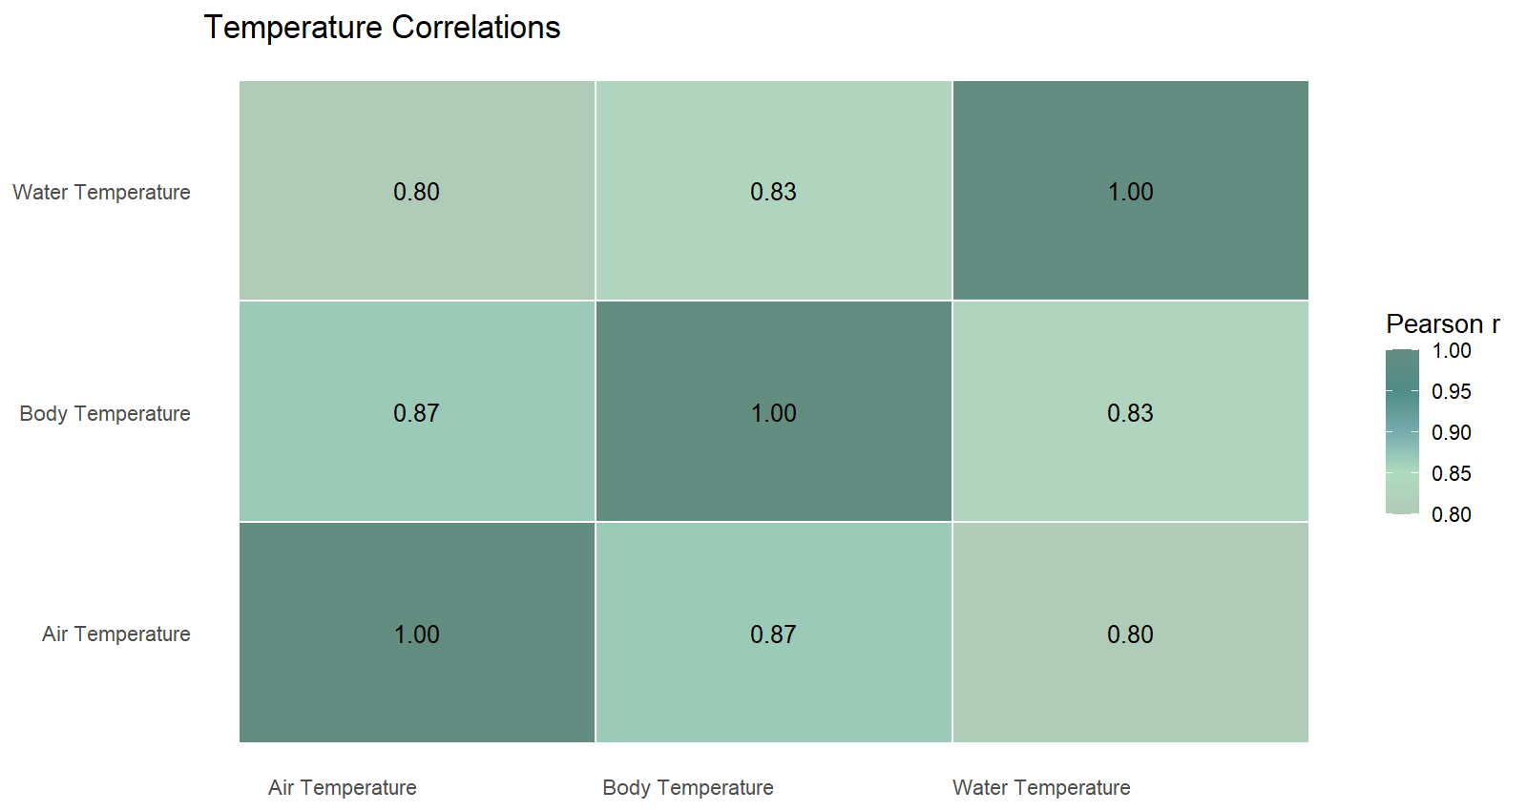
Supplementary Figure 1. Pearson correlation coefficients (r) among temperature variables: body temperature, air temperature, and water temperature. Because all temperature variables were highly correlated (r ≥ 0.80), the color scale was rescaled to emphasize relative differences within this high-correlation range (r = 0.80 – 1.00). All displayed correlations are statistically significant (p < 0.001).

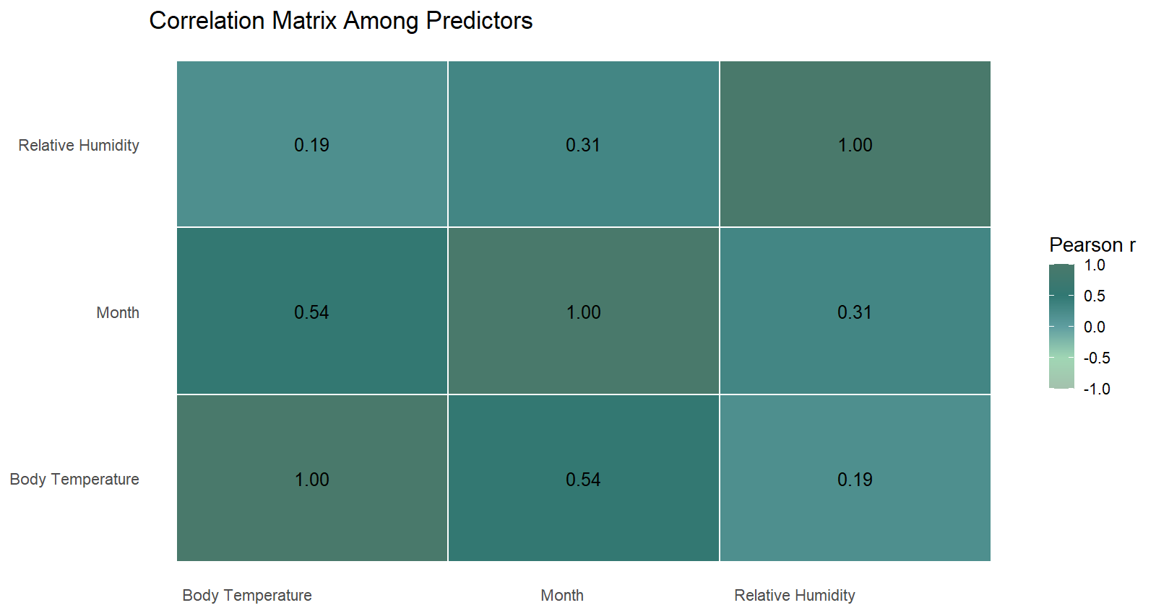
Supplementary Figure 2. Pearson correlation coefficients (r) among continuous predictors included in mixed-effect models: body temperature, relative humidity, and month. Tile colors follow a gradient centered on r = 0, and values are printed within each cell for clarity. All correlations are statistically significant (p < 0.01).

Response Variable | Predictor | Estimate (b) | 95% CI | Test statistic | p value | Direction / Interpretation | Notes
Bd Prevalence (GLMM, binomial) | Fire severity | –0.254 | — | z = –1.133 | 0.257 | Non-significant, negative trend | Suggests lower prevalence with higher fire severity
 | Body temperature | –0.170 | — | z = –2.049 | 0.041 | Significant, negative | Higher body temps associated with lower Bd prevalence
 | Relative humidity | –0.002 | — | z = –0.072 | 0.942 | NS | —
 | Month | 0.157 | — | z = 2.191 | 0.028 | Significant, positive | Bd prevalence decreased from Oct → Mar
 | Random effect (site) | Var = 8.1 × 10⁻¹⁵ | — | — | — | Negligible variability among sites
 | Model fit | AIC = 119.8; BIC = 139.4; logLik = –53.9; Deviance = 107.8
Supplementary Table 1. Summary of generalized linear mixed effects model results assessing the effects of fire severity and environmental variables on Bd infection prevalence in Mixophyes balbus.

Response Variable | Predictor | Estimate (b) | 95% CI | p value | Direction / Interpretation | Notes
Bd Infection Intensity (LMM, log-transformed ITS-1 copies) | Fire severity | –0.269 | –0.515 to –0.030 | 0.036 | Significant, negative | Higher severity → lower infection intensity
 | Body temperature | –0.089 | –0.172 to –0.011 | 0.034 | Significant, negative | Higher temps → lower intensity
 | Relative humidity | –0.002 | –0.030 to 0.026 | 0.879 | NS | —
 | Month | 0.054 | –0.002 to 0.114 | 0.069 | Marginal (+), NS | —
 | Intercept | 2.534 | — | 0.096 | — | —
 | Random effect (site) | Var = 0.089 (95% CI 0.000–0.641) | — | — | Some variability among sites
 | Residual variance | 3.025 (95% CI 1.565–1.925) | — | — | — | —
 | Descriptive means | Unburnt = 1074.42 ± 6344.58 ITS-1; Burnt = 9.34 ± 63.64 ITS-1 | — | — | — | Values on log scale in Figure 3
Supplementary Table 2. Summary of mixed-effects linear regression model results assessing the effects of fire severity and environmental variables on Bd infection prevalence in Mixophyes balbus.

Response Variable | Predictor | F (df) | p value | Direction / Interpretation | Notes
Body Condition (ANOVA on Scaled Mass Index) | Fire severity category | F(3,195) = 2.38 | 0.071 | Marginal, non-significant | Males from higher-severity sites showed slightly lower body condition
Supplementary Table 3. Summary of ANOVA results assessing the effects of fire severity on body condition (scaled-mass index) in adult male Mixophyes balbus.

Response Variable | Predictor / Comparison | Test | Statistic | p value | Direction / Interpretation
Species Richness | Fire severity category | ANOVA |  | all p > 0.57 | No difference in richness across severity levels
Species Diversity (Shannon Index) | Fire severity category | ANOVA | F(3,20) = 1.67 | 0.21 | Diversity did not differ significantly between severities
Supplementary Table 4. Summary of ANOVA results assessing the effects of fire severity on species diversity metrics across all sites.

Species | Burnt Sites Count | Unburnt Sites Count
Mixophyes balbus | 297 | 134
Litoria barringtonensis | 121 | 158
Pseudophryne coriacea | 128 | 5
Assa darlingtoni | 7 | 51
Crinia signifera | 39 | 1
Litoria subglandulosa | 4 | 3
Philoria pughi | 6 | 0
Litoria wilcoxii | 1 | 3
Pseudophryne bibronii | 2 | 2
Limnodynastes fletcheri | 2 | 1
Limnodynastes dumerilii | 3 | 0
Lechriodus fletcheri | 3 | 0
Litoria verreauxii | 2 | 0
Mixophyes fasciolatus | 2 | 0
Limnodynastes peronii | 1 | 0
Limnodynates dumerilii | 0 | 1
Litoria caerulea | 1 | 0
Litoria chloris | 1 | 0
Mixophyes iteratus | 0 | 1
Litoria peronii | 1 | 0
Supplementary Table 5. Counts of amphibian species observed at burnt (FESM 1–3) and unburnt (FESM 0) sites following the 2019–2020 wildfires. Observations are based on visual and auditory detections aggregated across all surveys. Species are ordered by total number of observations.

