Figure 1
GC–MS chromatogram of P. serratifolia extract with major phytochemicals (eugenol, β-sitosterol, lupeol).
The GC–MS profile revealed several bioactive phytoconstituents—predominantly eugenol, β-sitosterol, and lupeol—serving as natural reducing and capping agents. Their functional groups (–OH, –C=O, –C=C–) participate in the conversion of Ag⁺ to Ag⁰ and stabilize nascent nanoparticles. The abundant terpenoids and phenolics explain the strong reductive potential of the extract, forming the chemical foundation for subsequent nanoparticle synthesis.

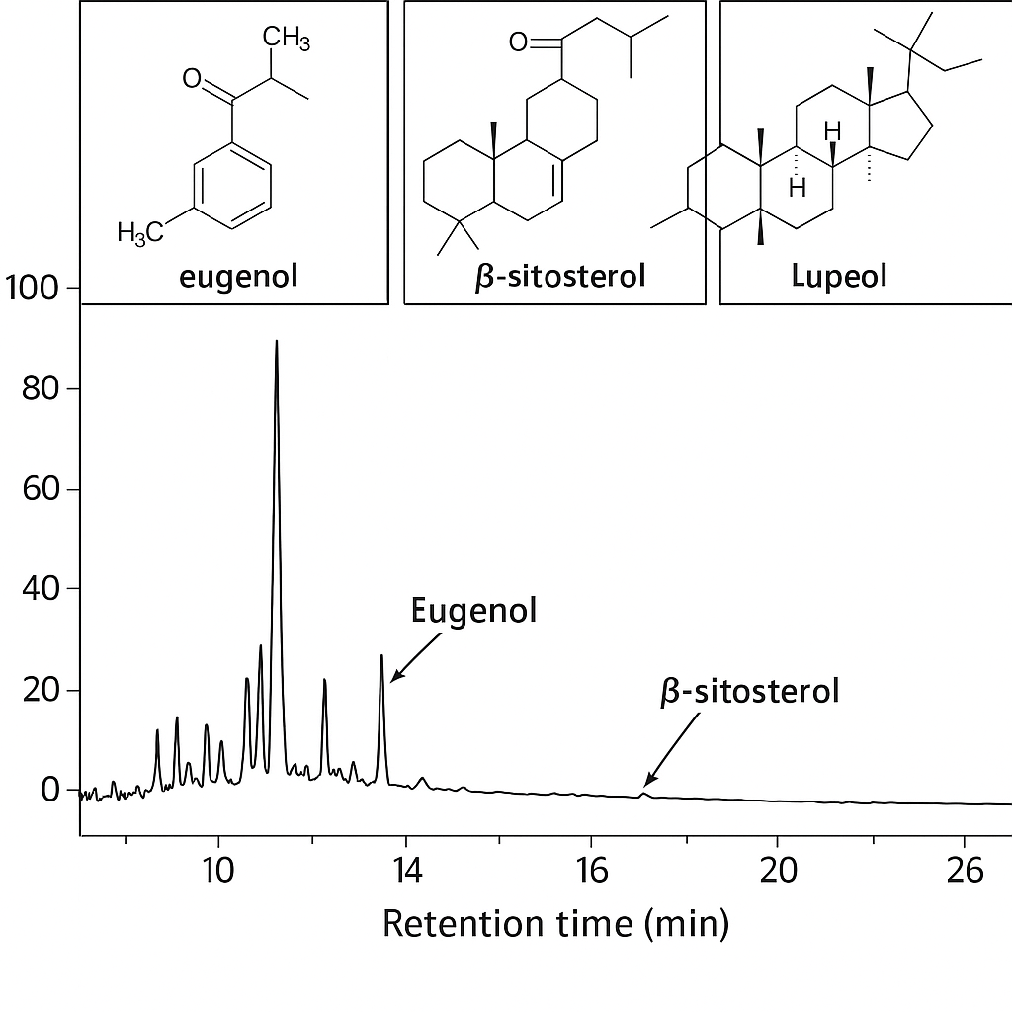

Figure 2
(a) UV–Vis spectra (Extract / AgNP / Alg–AgNC) ; (b) FTIR spectra.
Panel (a) shows the characteristic SPR band of biogenic AgNPs at 430 nm and its red-shift to 434 nm after encapsulation in alginate, confirming nanoparticle stabilization within the polymer matrix. Panel (b) illustrates the functional-group interactions: the shift of O–H and C=O vibrations (3410 → 3400 cm⁻¹; 1630 → 1608 cm⁻¹) and the emergence of COO⁻ stretching (1418 cm⁻¹) signify coordination between alginate carboxylates and the silver surface. Together these spectra validate successful composite formation and long-term optical stability.
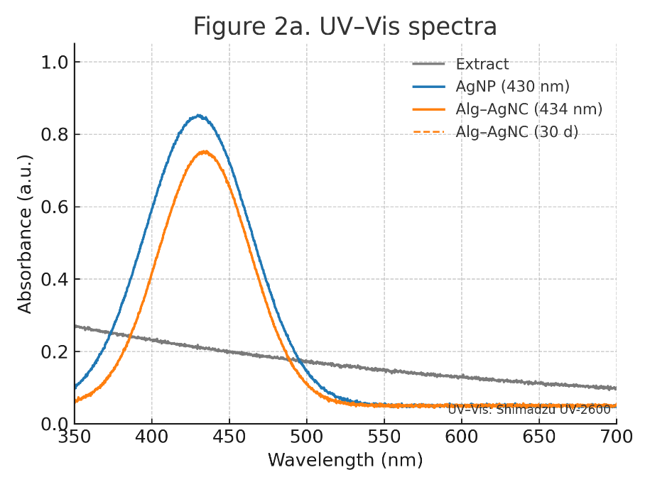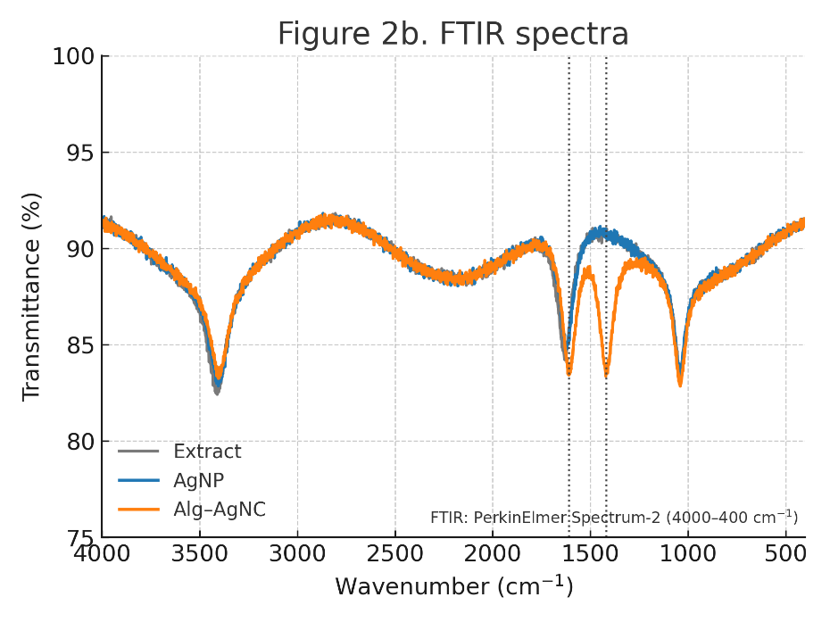

Figure 3
SEM, TEM, SAED + histogram (a–f)
SEM images show quasi-spherical AgNPs (20–50 nm) and a porous alginate network embedding uniformly dispersed silver particles. TEM micrographs confirm spherical morphology (average 28 ± 5 nm) and polymer encapsulation. The SAED pattern displays concentric rings indexed to fcc Ag (111), (200), (220), (311), evidencing high crystallinity, while the size-distribution histogram indicates narrow particle dispersion—collectively affirming structural integrity of the Alg–AgNC system.

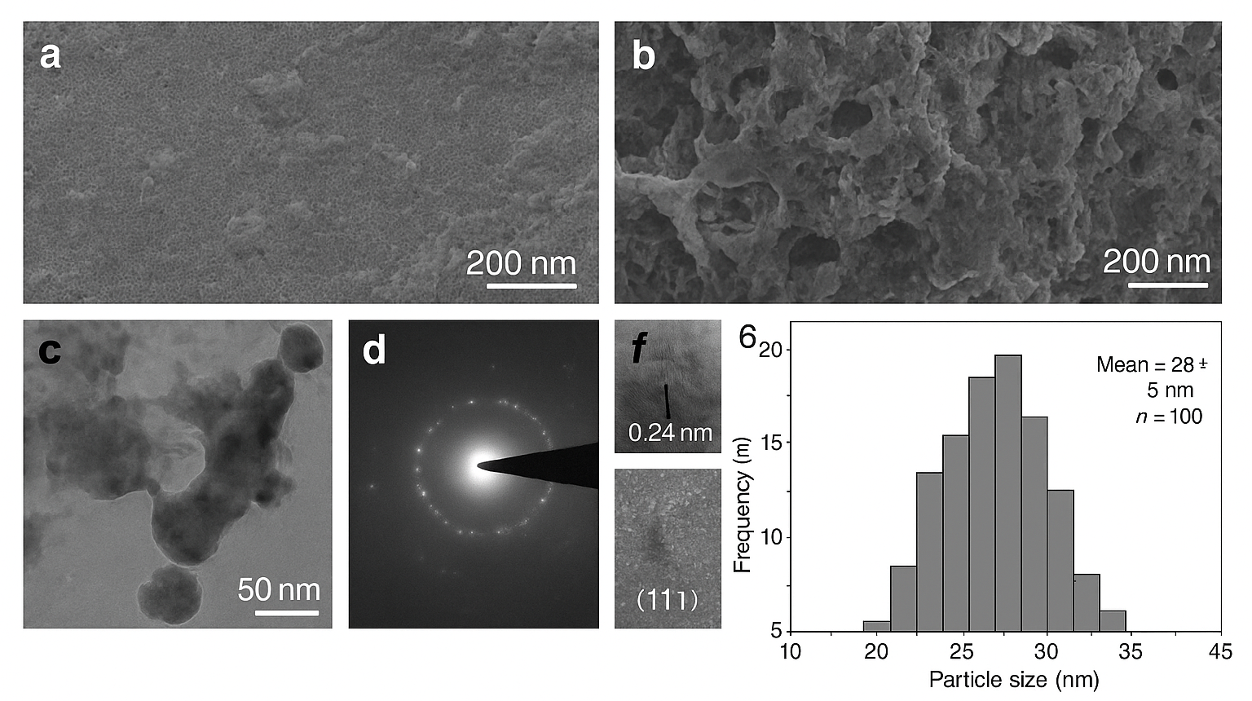

Figure 4
(a) Zeta potential; (b) Stress–strain; (c) UV–Vis stability.
The zeta-potential histogram (panel a) shows a charge shift from –20 mV (AgNPs) to –32 mV (Alg–AgNC), implying enhanced electrostatic stability from alginate carboxylates. Stress–strain data (panel b) reveal increased tensile strength (2.4 MPa vs 1.6 MPa) and elongation (20 %), proving polymer reinforcement. UV–Vis monitoring over 30 days (panel c) shows negligible SPR decay in Alg–AgNC, confirming exceptional colloidal and mechanical stability.

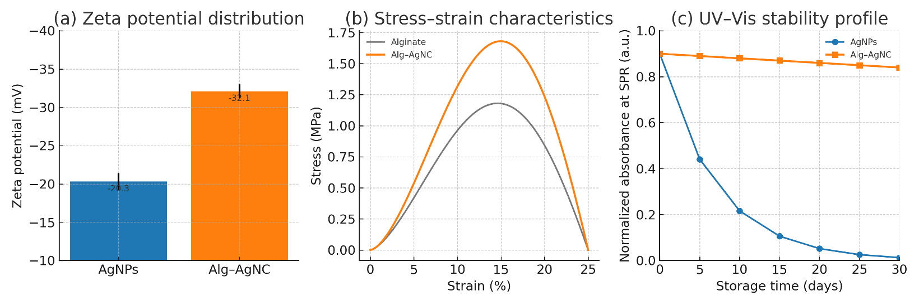

Figure 5

(a) Agar-well diffusion plates; (b) Bar chart of inhibition zones.
Agar-well diffusion assays demonstrate clear inhibition zones against E. coli (22.5 mm) and S. aureus (21.8 mm) for the Alg–AgNC hydrogel, markedly larger than those of plain AgNPs (~14 mm). The bar chart quantifies this enhancement, attributing it to sustained Ag⁺ release and synergistic phytochemical-polymer effects. The results confirm broad-spectrum bactericidal efficacy and superior bioactivity of the composite.
