Table of Contents
1. Random Forest Modelling (CSMD Model) 2
1.1 Data & Setup 2
1.2 Feature selection (VSURF) 3
1.3 Model tuning and final parameters 3
1.4 Threshold selection 4
1.5 Feature importance 6
2. Comparative analyses 8
2.1 Purpose and scope 8
2.2 Common workflow shared across all comparisons 8
2.3 Slum Severity Index (SSI) 9
2.3.1 Data and coverage 9
2.3.2 Method 10
2.3.3 Results 10
2.4 Million Neighbourhoods (MN) 12
2.4.1 Data and coverage 12
2.4.2 Method 12
2.4.3 Results 13
2.5 World Resource Institute (WRI) Intra urban Land Use 14
2.5.1 Data and coverage 14
2.5.2 Method 15
2.5.3 Results 15
References 17

1. Random Forest Modelling (CSMD Model)

1.1 Data & Setup
We used the 21 built-environment indicators from City Segments v1 (population/area, parcels & access, roads & connectivity, buildings & morphology) plus a categorical regional code (REG1_GHSL: Africa, Asia, Latin America and the Caribbean (LAC)) as an additional predictor. All segments with complete values across these indicators were retained. The regional code was one-hot encoded; all other variables were left on their native scales.
IDEABench reference data were rasterized city-wide and overlaid with City segments. A segment was labelled morphologically deprived (1) if > 30% of its area overlapped the IDEABench deprived class; otherwise, it was labelled as non-deprived (0). Non-built-up was grouped with non-deprived. Per-city counts used for modelling are reported in Table 1.
We created a fixed 80/20 holdout and sorted the exact indices for replication. No segment appears in both sets. The pre-processing steps include (a) segments with any missing predictor were excluded, (b) no normalization/standardization was applied, and (c) all random seeds were fixed (42). For reproducibility, holdout indices, the exact file list used, CV fold indices, best hyper-parameters, final model binaries, and feature importance ranking were saved.
Table 1: Training data by city. City, country, region, total segments considered, number (and %) labelled deprived, and non-deprived segments for each of the eight training cities; bottom row shows totals across all training cities.
City Name | Country | Region Name | Region Code | Total segments | Deprived-like segments | Non-deprived segments
Lagos | Nigeria | Africa | 2 | 9386 | 189 | 9197
Nairobi | Kenya | Africa | 2 | 2926 | 1241 | 1682
Jakarta | Indonesia | Asia | 1 | 15131 | 510 | 11301
Mumbai | India | Asia | 1 | 9993 | 850 | 8545
Buenos Aires | Argentina | LAC | 3 | 15672 | 854 | 14579
Medellin | Colombia | LAC | 3 | 2444 | 249 | 2154
Mexico City | Mexico | LAC | 3 | 16769 | 563 | 11901
Salvador | Brazil | LAC | 3 | 2037 | 729 | 1080
Total |  |  |  | 74358 | 5185 | 60439

1.2 Feature selection (VSURF)
We ran VSURF (Genuer et al., 2015) on full candidate set (21 indicators + REG1_GHSL) to identify a stable, parsimonious predictor subset. To reduce single-run instability, VSURF was executed three times with different forest sizes (ntree = 800, 1000, 1200) while keeping all other defaults and a fixed seed (42). For each run we recorded both selection stages (varselect.pred, varselect.interp). The final predictor set is the intersection of the three varselect.pred lists (i.e., variables consistently retained for prediction across ntree settings).
Taking the overlap across ntree settings favours variables that are consistently informative, improving robustness without inflating dimensionality. We keep REG1_GHSL to capture broad regional context while preserving a single global model. The 10 selected predictors are i5_par_area; i1_pop_area; B_AVG_SEG; i9_roads_par; i6_paru_area; i8_paru_par; PARU_A_SEG; B_AREA_SEG; B_CV_SEG; REG1_GHSL.

1.3 Model tuning and final parameters
We tuned a scikit-learn Random Forest classifier over the following range:
- n_estimators: 150-2000
- max_depth: 10-25
- min_samples_leaf: 1-10
- min_samples_split: 2-11
- max_features: {“sqrt”, 0.5}
- bootstrap: {True, False}
- class_weight: {“balanced”, “balanced_subsample”}
All other parameters used library defaults.
Data were split once (with random_state=42) into an 80/20 train-holdout. With the 80% training set, we ran a randomized/grid search with stratified 5-fold CV and fixed seeds. Model selection criterion was mean ROC-AUC across CV folds. The selected model was refit on the full 80% training data and then evaluated on the untouched 20% holdout for all reported metrics and curves.
The final configuration is stored in a json file; the parameters are: n_estimators: 1350; max_depth: 16; min_samples_leaf: 9; min_samples_split: 8; max_features: “sqrt”; bootstrap: True; class_weight: “balanced”. Figure 1 shows the ROC curve on the true holdout (Area Under Curve (AUC) = 0.874).
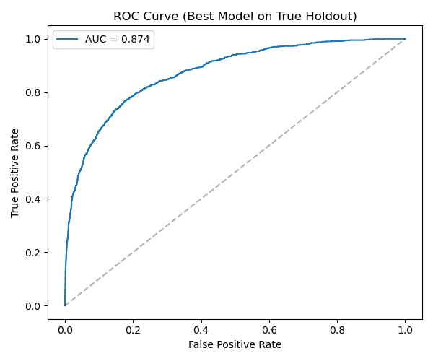
Figure 1: ROC curve on the true holdout (AUC = 0.874)

1.4 Threshold selection
The Random Forest (RF) outputs a probability for the ‘morphologically deprived-like’ class per segment. Because missed detections are more costly than false alarms in this application, we prioritized recall while limiting losses in precision/F1. We swept the decision threshold from 0 to 1 in steps of 0.01 on the true holdout and inspected the metric curves. The curves (Figure 2) show the expected precision-recall trade-off. We selected the threshold of 0.4 for headline results as a pragmatic balance near the F1 plateau where recall is high without excessive drop in precision. Confusion matrix at threshold of 0.4 (Figure 3) reports the 2 x 2 counts on the untouched holdout, providing the operating point used throughout the main text.
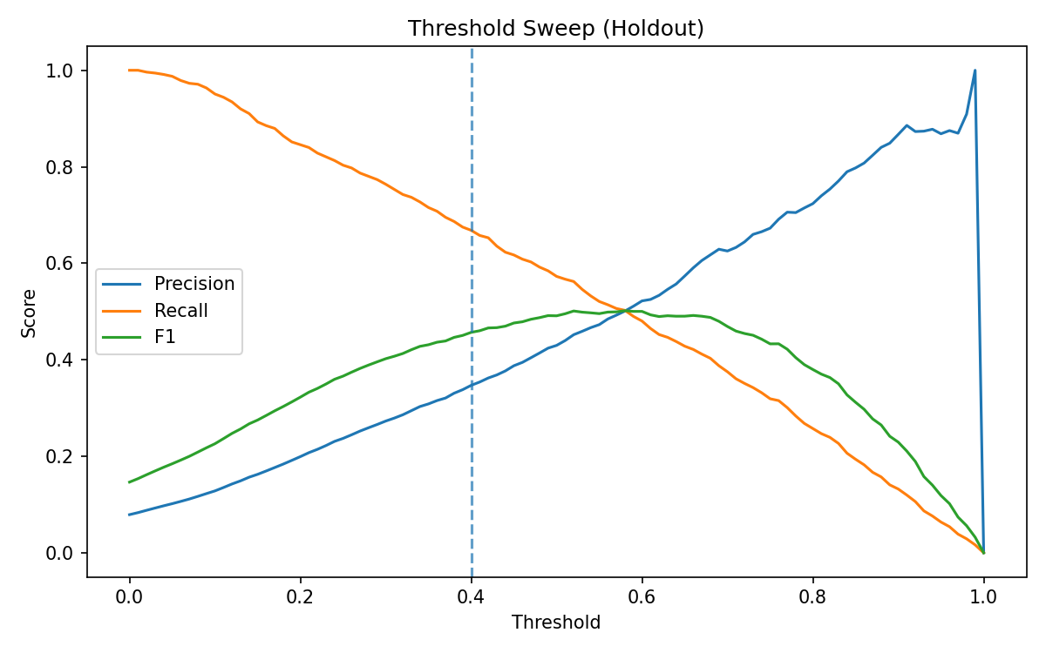
Figure 2: Precision/Recall/F1 vs decision threshold (holdout)
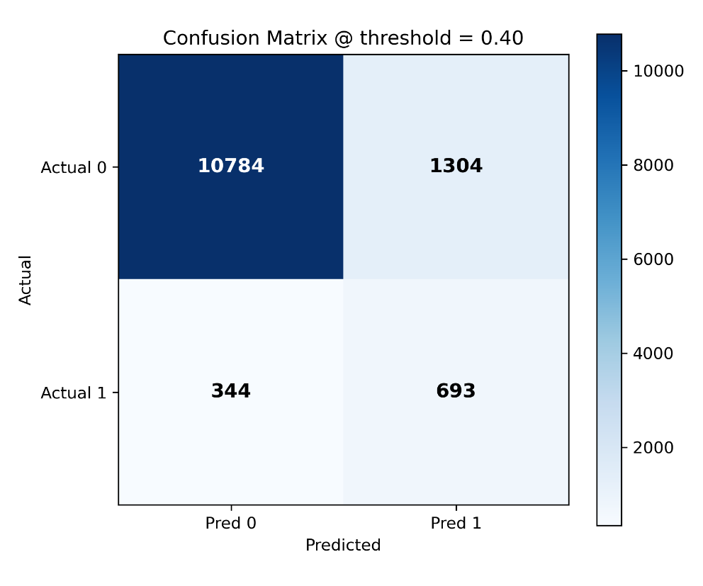
Figure 3: Confusion matrix on the true holdout at threshold of 0.4.
Our dataset is class-imbalanced (non-deprived >> deprived segments). To examine behaviour under balanced prevalence, we performed a balanced evaluation. In this evaluation, for each of 50 repeats, we kept all deprived holdout samples and randomly sampled an equal number of non-deprived samples. We computed metrics per repeat and averaged the results. Figure 4 shows the averaged confusion matrix at threshold of 0.4. The balanced performance metrics are (mean ± SD):
- Precision: 0.86 ± 0.01
- Recall: 0.67 ± 0.00
- F1: 0.75 ± 0.00
- Accuracy: 0.78 ± 0.00
- Specificity: 0.89 ± 0.01
MCC (Mathews Correlation Coefficient) is 0.56 indicating a moderate-strong predictive relationship when classes are equally represented.
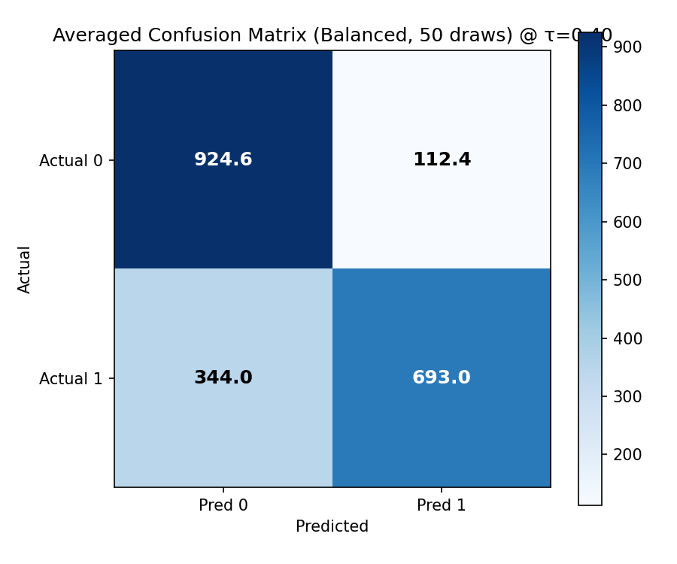
Figure 4: Averaged confusion matrix over 50 balanced draws at threshold of 0.4.

1.5 Feature importance
We report mean decrease in impurity (MDI) importances from the final RF model (Figure 5), averaged across trees and normalized to sum to 1. This provides a stable, model-internal ranking of predictors used in splits.
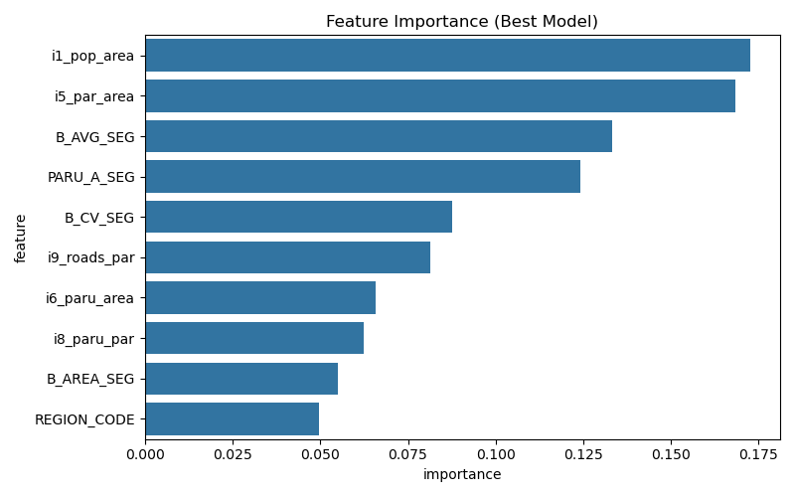
Figure 5: Feature importance ranking

2. Comparative analyses

2.1 Purpose and scope
This section reports the comparative analyses performed between our CSMD (City Segment Morphological Deprivation) model outputs and three independent references datasets representing different conceptual dimensions of urban deprivation, (i) the Slum Severity Index (SSI) which is a service related deprivation model, (ii) the Million Neighbourhoods (MN) which is an infrastructure-access indicator based on building-to-street connectivity, and (iii) the World Resources Institute (WRI) Urban Land-Use dataset v1 which is a morphology based land-use classification derived from Sentinel-2 imagery.
The objective of these comparisons is to quantify the level of spatial correspondence between the binary morphological deprivation labels produced by our CSMD model and those derived from each external dataset, using identical segment-level units. The analyses are contextual rather than validation exercises, as each dataset captures different underlying dimensions (service access, infrastructure connectivity, or physical form).
All comparisons were executed at the city-segment level, restricted to countries and segments with valid data in both CSMD and the external source. For each country-dataset pair, deprivation labels were aligned spatially, and standard classification metrics like precision, recall, F1-score, and balanced accuracy were computed. The results are reported as country-level boxplots and global pooled summaries in section 2.3 to 2.5. Methodological steps common to all three datasets, including data alignment, thresholding, and metric computation, are described in section 2.2.

2.2 Common workflow shared across all comparisons
External products (raster’s or block polygons) were spatially aligned to the city segments v1 units. For raster sources, per-pixel values were clipped to segment boundaries and summarised at segment level; for block-type sources, block attributes were overlaid and aggregated to segments. All layers were harmonized to WGS84 for overlay and to EPSG:6933 (equal-area) for any area-weighted computations. Invalid/self-intersecting geometries were repaired using a buffer-based fix prior to overlay. Mutual-coverage masks were applied so that metrics are computed only where both the external dataset and the CSMD labels have valid data (dataset-specific masking policies are detailed in each subsection).
Only segments with valid overlap with the external dataset were retained. Country-level reporting required a minimum sample size; where applicable (e.g., SSI), countries with < 250 intersecting segments were excluded from per-country summaries, while pooled statistics used the union of retained countries.
Continuous or fractional indicators derived from external datasets were converted to binary segment labels using a proportion-threshold rule of the form ‘proportion ≥ τ’. Unless otherwise stated in the dataset-specific sections, thresholds were explored over τ ∈ {0.1, 0.2, 0.3} to assess stability under inclusive (0.1), moderate (0.2), and conservative (0.3) cut-offs. Dataset-specific variants (e.g., MN block-level k thresholds and segment-level majority rules; WRI informality indicators; SSI mean vs element-based summaries) are defined in their respective sections.
For each country-dataset pair, CSMD (reference) and external (comparison) binary labels were cross-tabulated at the segment level to obtain TP (True Positives), FP (False Positives), TN (True Negatives), FN (False Negatives). From these we report:
- Precision = TP / (TP + FP)
- Recall = TP / (TP + FN)
- F1 = harmonic mean of precision and recall
- Balanced accuracy = average of recall for positives and recall for negatives

2.3 Slum Severity Index (SSI)

2.3.1 Data and coverage
We used the Slum Severity Index (SSI) data (Li et al., 2025) which operationalizes the four UN-Habitat slum indicators; water, sanitation, housing durability, and living space adequacy (SpaceDef) and a combined SSI index (0-4) at 100m resolution across sub-Saharan Africa (SSA). Source raster’s were accessed via Google Earth Engine / Zenodo and exported per country as 5-band GeoTIFFs (bands: water, sanitation, housing, SpaceDef, combined SSI), organized into country folders aligned with our city segments structure.

2.3.2 Method
SSI country raster’s (5 bands: water, sanitation, housing, SpaceDef, combined SSI; 100m) were exported and stacked per country, then clipped to the union of the city segments. We applied a signal-policy mask: retain a segment only if it contains ≥ 1 valid SSI pixel (to avoid treating no-coverage as non-deprived). All layers were harmonized in WGS84; invalid geometries were repaired prior to overlay. Countries with < 250 retained segments were excluded from country-level reporting. For each retained segment we computed:
- p_any: share of valid pixels with SSI ≥ 1 (any deprivation present)
- m_ssi: mean SSI (0-4)
- p_space: share of valid pixels with SpaceDef > 0
- valid_px: count of valid SSI pixels used for quality control
Each summary was converted to a binary SSI derived label using τ ∈ {0.1, 0.2, 0.3}:
- Any-pixel rule: segment is positive if p_any ≥ τ
- Mean-SSI rule: segment is positive if m_ssi ≥ τ
- SpaceDef-only rule: segment is positive if p_space ≥ τ
Thresholds were evaluated separately for each rule. SSI-derived binary labels were spatially aligned to CSMD segment labels. For each country x rule x τ, we computed the metrics defined in section 3.2.

2.3.3 Results
Figure 6 shows the country-level distributions of precision, recall, and F1 for the three SSI-derived labelling rules; Mean-SSI, SpaceDef, and Any-pixel, evaluated at three thresholds. Results are highly consistent across thresholds, indicating that the comparative alignment is stable to changes in τ. Median recall remains high for all rules (~0.94-0.96 for Mean-SSI and Any-pixel, ~0.86-0.88 for SpaceDef), while precision and F1 differ more noticeably.
The SpaceDef rule achieves higher precision (0.59-0.61) and F1 (0.66-0.68) than either Mean-SSI or Any-pixel (precision = 0.37-0.39; F1 = 0.53-0.55). The stronger alignment arises because both the CSMD model and SpaceDef dimension emphasize morphological compactness and density patterns, whereas Mean-SSI or Any-pixel incorporate broader service-related deprivations (e.g., water, sanitation), which extend beyond the spatial characteristics captured by the CSMD framework.
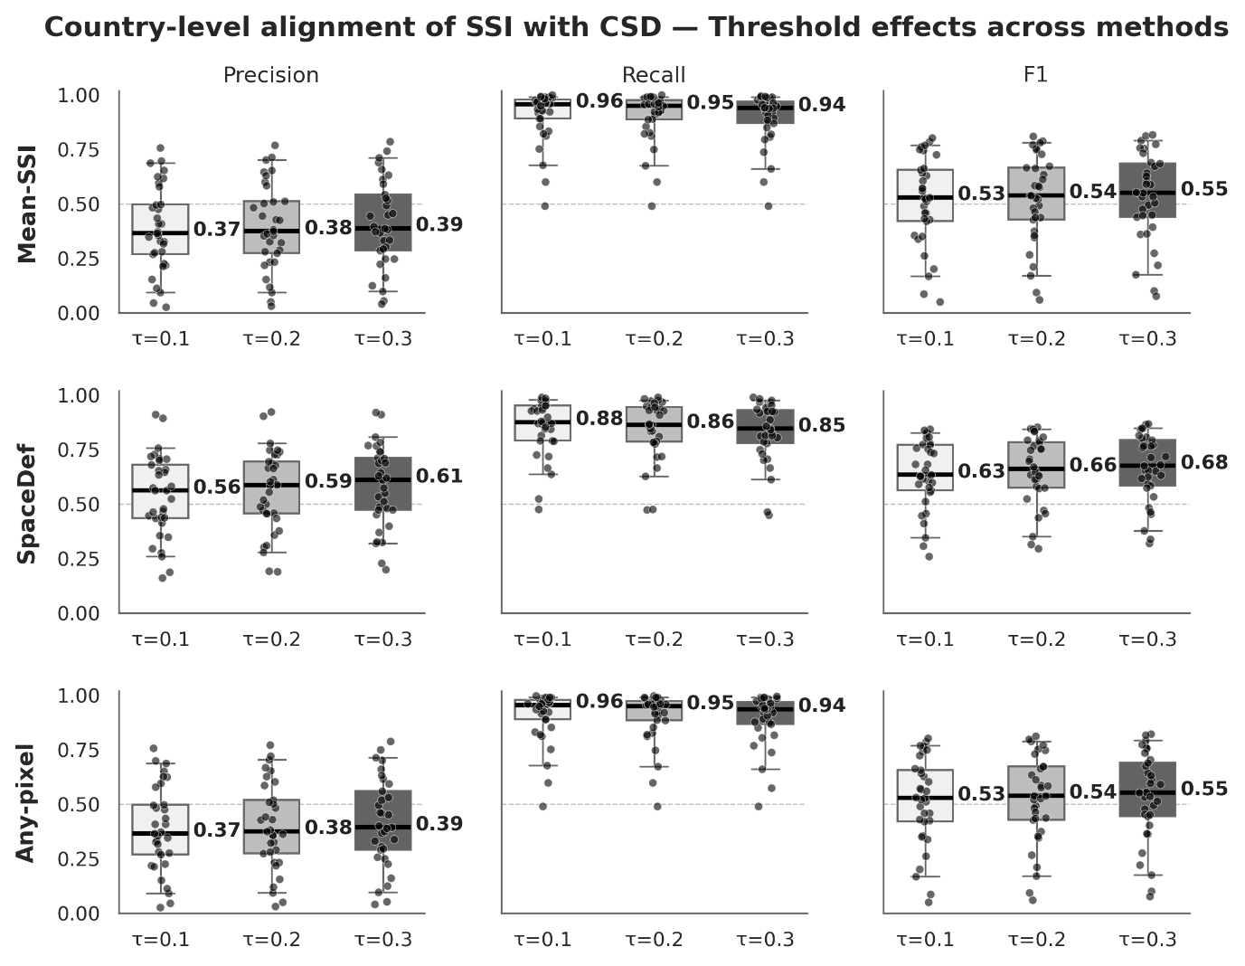
Figure 6: Country-level alignment of SSI with CSMD under three rules (rows) and thresholds (columns). Boxes show interquartile ranges with medians annotated; dots represent per-country values.

Table 2: All (n= 33) segment and population coverage of SSI rules compared with CSMD
Rule | Threshold | Total_Segments | RF_Deprived_Seg | Rule_Deprived_Seg | Total_Pop_M | RF_Deprived_Pop_M | Rule_Deprived_Pop_M | RF_Deprived_Pop_% | Rule_Deprived_Pop_%
Mean-SSI | 0.1 | 342602 | 121181 | 252245 | 441.54 | 135.19 | 342.74 | 30.62 | 77.62
Mean-SSI | 0.2 | 342602 | 121181 | 244079 | 441.54 | 135.19 | 327.71 | 30.62 | 74.22
Mean-SSI | 0.3 | 342602 | 121181 | 232409 | 441.54 | 135.19 | 307.91 | 30.62 | 69.74
SpaceDef | 0.1 | 342602 | 121181 | 147859 | 441.54 | 135.19 | 187.93 | 30.62 | 42.56
SpaceDef | 0.2 | 342602 | 121181 | 140411 | 441.54 | 135.19 | 169.83 | 30.62 | 38.46
SpaceDef | 0.3 | 342602 | 121181 | 133358 | 441.54 | 135.19 | 154.75 | 30.62 | 35.05
Any-pixel | 0.1 | 342602 | 121181 | 251861 | 441.54 | 135.19 | 341.55 | 30.62 | 77.35
Any-pixel | 0.2 | 342602 | 121181 | 242526 | 441.54 | 135.19 | 323.98 | 30.62 | 73.38
Any-pixel | 0.3 | 342602 | 121181 | 229057 | 441.54 | 135.19 | 300.11 | 30.62 | 67.97
Population reported in millions.
Table 2 summarizes the corresponding segment and population coverage for each rule and threshold. While Mean-SSI and Any-pixel flag roughly three-quarters of the total population as deprived, SpaceDef identifies a smaller but more selective subset (~35-43% of total population), consistent with its higher precision and closer spatial correspondence to the CSMD labels.

2.4 Million Neighbourhoods (MN)

2.4.1 Data and coverage
We used the Million Neighbourhoods (MN) (Bettencourt & Marchio, 2025) dataset, a block-level characterization of settlement form and infrastructure access for sub-Saharan Africa (SSA). MN defines blocks as polygons bounded by mapped streets and assigns each block a k-complexity index (depth of access from buildings to the street network), with higher k indicating progressively poorer access (e.g., k > 3). The dataset was built from Ecopia building footprints (2022), OpenStreetMap roads, and auxiliary population/household sources (LandScan, WorldPop, DHS). Coverage spans ~9.8 million blocks, >415 million buildings, ~50 nations, and 2,190 urban areas in SSA.
Data were obtained from the MN download portal (https://www.millionneighborhoods.africa/download) as Parquet files and converted to per-country GeoPackages (GPKG) for processing. We retained identifiers (country_name, urban_id), block geometry, k_complexity, and related attributes; all layers were harmonized to WGS84 and geometries validated/repaired prior to overlay. For this study, we included 45 SSA countries that overlap our city segments, restricting analysis to MN blocks within the city segment extent (blocks outside were discarded).

2.4.2 Method
Each MN block carries a k-complexity index representing the number of successive ‘building layers’ separating the most inaccessible building from the nearest mapped street. Blocks were assigned a binary deprived label when k exceeded a defined threshold. Two block-level thresholds were tested: k > 0.3 (moderate access deficit) and k > 0.5 (severe access deficit). These thresholds correspond to the mid- and upper-range cut-offs used in the MN framework to delineate poor street access and infrastructural exclusion.
Because MN blocks and city segments differ spatially, block-level deprivation labels were aggregated to the segment scale using a three-step rule set:
- Full-cover rule: if a single block covers ≥ 90% of a segments area, the segment inherits that block’s label.
- Centroid-majority rule (default): if multiple blocks intersect, all blocks whose centroids fall inside the segment are counted; the share of high-k (deprived) blocks is computed.
- Coverage-share fallback: if no centroids fall within or if a tie occurs, an area-weighted share of deprived blocks is calculated.
This hierarchy ensures consistent results across segments that overlap one or multiple MN blocks, accounting for spatial misalignments between the two units.
After aggregation, a segment was labelled deprived if the proportion of deprived blocks within it exceeded a majority threshold (τ). Three thresholds were evaluated: τ ∈ {0.1, 0.2, 0.3}. Combined with the two block-level k thresholds, this yielded six parameter combinations for comparison.

2.4.3 Results
Figure 7 reports country-level precision, recall, and F1 for MN-derived segment labels under two block-level cut offs (k > 0.3 and k > 0.5) and three segment majority thresholds (τ = 0.1, 0.2, 0.3). Medians are annotated in each box. For k > 0.3, median precision is 0.39-0.41, recall decreases from 0.32 to 0.22 as τ increases, and F1 is 0.28-0.30. For k > 0.5, median precision is around 0.40, recall around 0.05, and F1 around 0.10 across τ. Distributions are broadly similar across τ within each k-level. Table 3 provides the corresponding global scale and population coverage for each parameter combination.

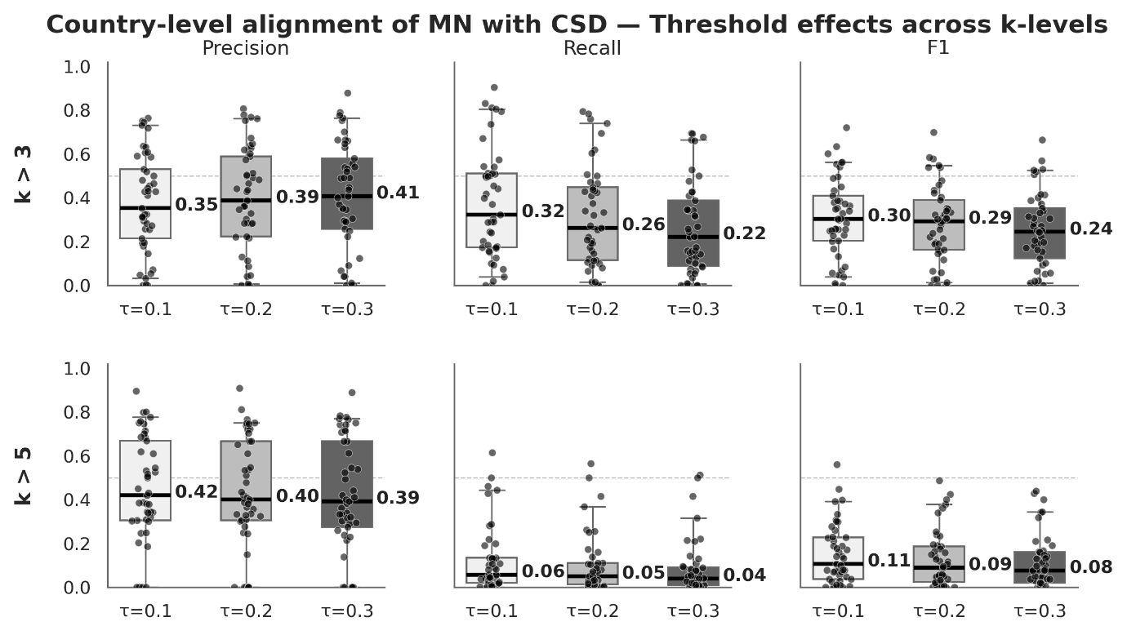
Figure 7: Country-level alignment of MN with CSMD across thresholds at two k-levels (rows). Boxes show interquartile ranges with medians annotated; dots are per-country values.

Table 3: All (n=45) segment and population coverage for MN rules compared with CSMD.
Rule | Threshold | Total_Segments | RF_Deprived_Seg | Rule_Deprived_Seg | Total_Pop_M | RF_Deprived_Pop_M | Rule_Deprived_Pop_M | RF_Deprived_Pop_% | Rule_Deprived_Pop_%
K > 0.3 | 0.1 | 600512 | 213698 | 178754 | 775.21 | 244.8 | 317.31 | 31.58 | 40.93
K > 0.3 | 0.2 | 600512 | 213698 | 140102 | 775.21 | 244.8 | 232.39 | 31.58 | 29.98
K > 0.3 | 0.3 | 600512 | 213698 | 108982 | 775.21 | 244.8 | 179.24 | 31.58 | 23.12
K > 0.5 | 0.1 | 600512 | 213698 | 29150 | 775.21 | 244.8 | 93.99 | 31.58 | 12.12
K > 0.5 | 0.2 | 600512 | 213698 | 22610 | 775.21 | 244.8 | 72.32 | 31.58 | 9.33
K > 0.5 | 0.3 | 600512 | 213698 | 18410 | 775.21 | 244.8 | 61.11 | 31.58 | 7.88
Population reported in millions

2.5 World Resource Institute (WRI) Intra urban Land Use

2.5.1 Data and coverage
We used the WRI Urban Land-Use v1 dataset, a 5-m, Sentinel-2 derived, computer-vision classification delivered as per-city categorical raster’s (Guzder-Williams et al., 2023). From its land-use/morphology classes, we retained only the two categories used as proxies for informal/deprived built form: informal subdivision and atomistic based on previous studies using this dataset (Friesen et al., 2025). Source tiles were accessed from the public Google Earth Engine collection and exported as GeoTIFFs, then mosaicked per country for processing in this study. All raster’s are in WGS84 and were organized into country folders mirroring the city segments structure.
For our analysis, we included 48 countries spanning around 100 cities across Africa, Asia, and Latin America and the Caribbean (limited to cities overlapping the city segments footprint). Segments were retained only where valid WRI pixels were present (mutual-coverage mask with CSMD), ensuring that country-level metrics reflect areas with data from both sources.

2.5.2 Method
From the country mosaics, we computed p_informal for each city segment which is the share of valid 5-m pixels classified as (informal subdivision + atomistic) within the segment footprint. Raster’s and segments are harmonized in WGS84, with invalid geometries repaired prior to overlay.
Segments were assigned a WRI-derived deprivation label using a proportion threshold τ ∈ {0.1, 0.2, 0.3}: a segment is labelled deprived if p_informal ≥ τ. Mutual-coverage masking was applied so that only segments with ≥ 1 valid WRI pixel and a valid CSMD label enter the comparison.

2.5.3 Results
Figure 11 shows the country-level distributions of precision, recall, and F1 for the WRI-derived p_informal rule at different thresholds. Results remain consistent across thresholds, indicating stable behaviour with respect to the proportion cut-off. Median precision is low (0.28-0.33), while recall is substantially higher (0.66-0.50) and gradually decreases as τ increases. The resulting F1 medians range between 0.28 and 0.31. Overall, the WRI-derived labels capture a larger share of areas classified as deprived by CSMD, producing high recall but comparatively low precision. Table 4 summarises the corresponding global scale and population coverage for each threshold.
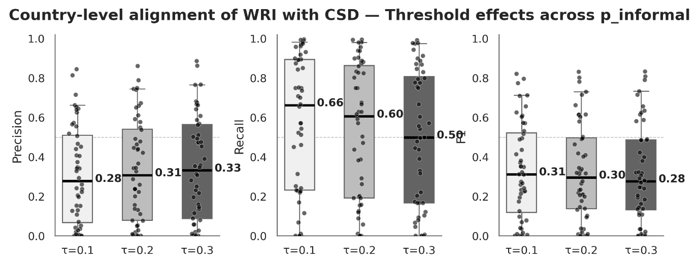
Figure 8: Country-level alignment of WRI (p_informal) with CSMD across thresholds. Boxes represent interquartile ranges with medians annotated; dots are per-country values.

Table 4: All (n=48) segment and population coverage for WRI (p_informal) compared with CSMD
Rule | Threshold | Total_Segments | RF_Deprived_Seg | Rule_Deprived_Seg | Total_Pop_M | RF_Deprived_Pop_M | Rule_Deprived_Pop_M | RF_Deprived_Pop_% | Rule_Deprived_Pop_%
p_informal | 0.1 | 335782 | 98492 | 163248 | 477.58 | 133.12 | 220.8 | 27.87 | 46.23
p_informal | 0.2 | 335782 | 98492 | 146888 | 477.58 | 133.12 | 186.23 | 27.87 | 38.99
p_informal | 0.3 | 335782 | 98492 | 134506 | 477.58 | 133.12 | 163.2 | 27.87 | 34.17
Population reported in millions

References
Bettencourt, L. M. A., & Marchio, N. (2025). Infrastructure deficits and informal settlements in sub-Saharan Africa. Nature, 645(8080), 399–406. https://doi.org/10.1038/s41586-025-09465-2
Friesen, J., Georganos, S., & Haas, J. (2025). Differences in walking access to healthcare facilities between formal and informal areas in 19 sub-Saharan African cities. Communications Medicine, 5(1), 41. https://doi.org/10.1038/s43856-025-00746-5
Genuer, R., Poggi, J.-M., Tuleau-Malot, C., & Tuleau, C. (2015). VSURF: An R Package for Variable Selection Using Random Forests. The R Journal, 7(2), 19–33. https://doi.org/10.34894/VQ1DJA
Guzder-Williams, B., Mackres, E., Angel, S., Blei, A. M., & Lamson-Hall, P. (2023). Intra-urban land use maps for a global sample of cities from Sentinel-2 satellite imagery and computer vision. Computers, Environment and Urban Systems, 100, 101917. https://doi.org/10.1016/j.compenvurbsys.2022.101917
Li, C., Yu, L., Ndugwa, R., Bailey, A. J., Zhang, X., Oloo, F., Chimimba, E. G., Deng, X., & Wright, J. (2025). Mapping urban slums and their inequality in sub-Saharan Africa. Nature Cities, 1–12. https://doi.org/10.1038/s44284-025-00276-0

