Table 2.1 Subreddit Lists and Comments Counts

Subreddit Lists and Comments Counts
Subreddit | Count
Psychonaut | 828
shrooms | 494
microdosing | 422
LSD | 349
TherapeuticKetamine | 341
Ayahuasca | 321
Psychedelics | 189
MDMA | 162
PsilocybinMushrooms | 96
DMT | 52
PsychedelicTherapy | 48
ketamine | 33
Ibogaine | 32
MagicMushrooms | 17
1P_LSD | 7
iboga | 2
Total | 3393

Table 2.2 Descriptive Statistical Results (RQ1)
Descriptive Statistical Results (RQ1)
 |  | Study |  |  | Reference
Category | Variable | M | SD | Skew. | M | SD
Broad | Analytic | 29.73 | 8.34 | 1.05 | 35.21 | 16.03
Broad | Authentic | 72.07 | 12.96 | -0.29 | 61.74 | 20.09
Broad | Clout | 38.89 | 17.23 | 0.23 | 31.39 | 19.14
Broad | Tone | 42.45 | 16.22 | 0.48 | 33.53 | 19.07
Linguistic | i | 5.21 | 1.50 | 0.12 | 5.24 | 2.15
Linguistic | we | 0.41 | 0.45 | 3.79 | 0.54 | 0.53
Linguistic | shehe | 0.39 | 0.43 | 1.92 | 0.62 | 1.26
Linguistic | they | 0.63 | 0.29 | 0.30 | 1.04 | 0.71
Psych. | emo_pos | 1.02 | 0.45 | 1.17 | 0.19 | 0.25
Psych. | emo_neg | 1.17 | 0.43 | 0.40 | 1.02 | 0.53
Psych. | family | 0.70 | 0.45 | 1.78 | 0.70 | 0.45
Psych. | friends | 0.16 | 0.14 | 1.15 | 0.14 | 0.23
Psych. | causation | 1.90 | 0.42 | -0.07 | 0.59 | 0.50
Psych. | insight | 3.48 | 0.60 | 0.56 | 0.59 | 0.50
Expand. | visual | 0.74 | 0.31 | 0.69 | 1.68 | 0.32
Expand. | feeling | 0.81 | 0.30 | 0.53 | 0.15 | 0.15
Expand. | illness | 0.27 | 0.24 | 1.52 | 0.15 | 0.15
Expand. | wellness | 0.35 | 0.22 | 1.25 | 0.15 | 0.15
Expand. | mental_illness | 0.79 | 0.37 | 0.41 | 0.15 | 0.15
Expand. | sexual | 0.03 | 0.06 | 3.24 | 0.15 | 0.15
Expand. | food | 0.58 | 0.39 | 0.92 | 0.15 | 0.15
Expand. | past focus | 4.33 | 1.21 | 0.82 | 0.15 | 0.15
Expand. | present focus | 5.32 | 0.90 | -0.60 | 0.15 | 0.15
Expand. | future focus | 1.54 | 0.40 | 0.07 | 0.15 | 0.15
Expand. | risk | 0.37 | 0.19 | 1.24 | 0.01 | 0.20
Expand. | auditory | 0.28 | 0.19 | 0.66 | 0.37 | 0.37

Table 2.3 Distribution of LIWC Variables
Distribution of LIWC Variables across the corpus, offering further insight into linguistic patterns observed in the dataset
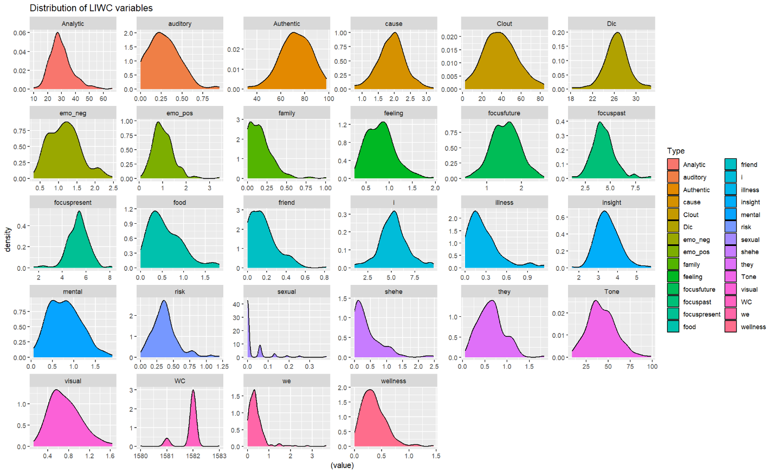

Table 2.4 Inferential Statistical Results (RQ2)
Inferential Statistical Results (RQ2)
Category | Variable |  | t | p | d | Magnitude |  | BF10 | BF01 | Evidence Level
Broad |  | Analytic | -10.52 | <0.001 | -0.43 | Small | >100 |  |  | Extreme for H1
Broad |  | Authentic | 15.57 | <0.001 | 0.61 | Medium | >100 |  |  | Extreme for H1
Broad |  | Clout | 11.41 | <0.001 | 0.41 | Small | >100 |  |  | Extreme for H1
Broad |  | Tone | 13.75 | <0.001 | 0.50 | Medium | >100 |  |  | Extreme for H1
Linguistic |  | i | -0.42 | 0.68 | -0.02 | Trivial | 0.04 |  | 23.32 | Strong for H0
Linguistic |  | we | -7.22 | <0.001 | -0.27 | Small | >100 |  |  | Extreme for H1
Linguistic |  | shehe | -23.95 | <0.001 | -1.03 | Large | >100 |  |  | Extreme for H1
Linguistic |  | they | -17.45 | <0.001 | -0.74 | Medium | >100 |  |  | Extreme for H1
Psych. |  | emo_pos | 7 | <0.001 | 0.27 | Small | >100 |  |  | Extreme for H1
Psych. |  | emo_neg | 20.9 | <0.001 | 0.78 | Medium | >100 |  |  | Extreme for H1
Psych. |  | family | -19.63 | <0.001 | -0.85 | Large | >100 |  |  | Extreme for H1
Psych. |  | friends | -8.36 | <0.001 | -0.34 | Small | >100 |  |  | Extreme for H1
Psych. |  | causation | 9.38 | <0.001 | 0.37 | Small | >100 |  |  | Extreme for H1
Psych. |  | insight | 29.75 | <0.001 | 1.18 | Large | >100 |  |  | Extreme for H1
Psych. |  | visual | -10.58 | <0.001 | -0.43 | Small | >100 |  |  | Extreme for H1
Expand. |  | auditory | -7.10 | <0.001 | -0.29 | Small | >100 |  |  | Extreme for H1
Expand. |  | feeling | 23.32 | <0.001 | 0.88 | Large | >100 |  |  | Extreme for H1
Expand. |  | illness | 8.43 | <0.001 | 0.32 | Small | >100 |  |  | Extreme for H1
Expand. |  | wellness | 48.94 | <0.001 | 1.53 | Large | >100 |  |  | Extreme for H1
Expand. |  | mental_illnes | 79.48 | <0.001 | 2.29 | Large | >100 |  |  | Extreme for H1
Expand. |  | sexual | -17.90 | <0.001 | -0.80 | Large | >100 |  |  | Extreme for H1
Expand. |  | food | -5.78 | <0.001 | -0.24 | Small | >100 |  |  | Extreme for H1
Expand. |  | past focus | -4.29 | <0.001 | -0.17 | Trivial | >100 |  |  | Extreme for H1
Expand. |  | present focus | -1.78 | 0.08 | -0.07 | Trivial | 0.19 |  | 5.29 | Moderate for H0
Expand. |  | future focus | 20.18 | <0.001 | 0.79 | Large | >100 |  |  | Extreme for H1
Expand. |  | illness | 8.43 | <0.001 | 0.32 | Small | > 100 |  |  | Extreme for H1
Expand. |  | risk | 13.69 | <0.001 | 0.53 | Medium | >100 |  |  | Extreme for H1

