Supplementary Figure 1. Brain regions with grey matter structures significantly predicted by dyslexia-related PGI (FDR-corrected). Colors represent standardized β values from the general linear models. Top: volume, including bilateral fusiform, left insula, bilateral lateral occipital, bilateral precentral, left rostral anterior cingulate, bilateral superior temporal, right postcentral, right transverse temporal, brainstem, bilateral thalamus, and bilateral ventral DC. Middle: surface area, including left insula, left lingual, left pericalcarine, left rostral anterior cingulate, left superior frontal, and right pericalcarine; Bottom: cortical thickness, including left fusiform, left inferior parietal, left insula, bilateral lateral occipital, bilateral parsorbitalis, bilateral postcentral, bilateral precentral, right cuneus, and right supramarginal
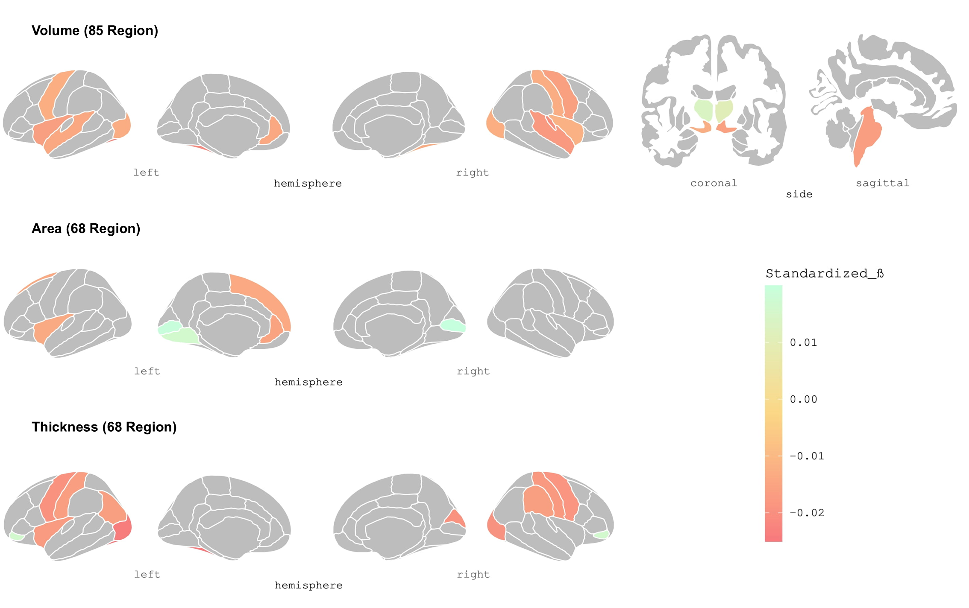

Supplementary Figure 2. White Matter Network of the Left Insula. The white matter network was constructed using a consistency-thresholding strategy, retaining the top 30% of the most consistently observed edges across subjects. In the network of the left insula, connections were identified between the left insula and regions in the left temporal, parietal, and frontal areas, as well as parietal regions in the right hemisphere. L: left hemisphere, R: right hemisphere; BSTS: banks of the superior temporal sulcus, ENT: entorhinal cortex, FUS: fusiform gyrus, IP: inferior parietal lobule, IT: inferior temporal gyrus, LOC: lateral occipital cortex, LOF: lateral orbitofrontal cortex, MOF: medial orbitofrontal cortex, MT: middle temporal gyrus, PO: pars opercularis, ORB: pars orbitalis, PT: pars triangularis, PCE: postcentral gyrus, PCR: precentral gyrus, PCU: precuneus, RFC: rostral middle frontal gyrus, SF: superior frontal gyrus, SP: superior parietal lobule, ST: superior temporal gyrus, SMA: supramarginal gyrus, TP: temporal pole, TT: transverse temporal gyrus.
Supplementary Figure 3. Vertex-wise regression maps of the left insula in surface-based analysis after adjusting for covariates.
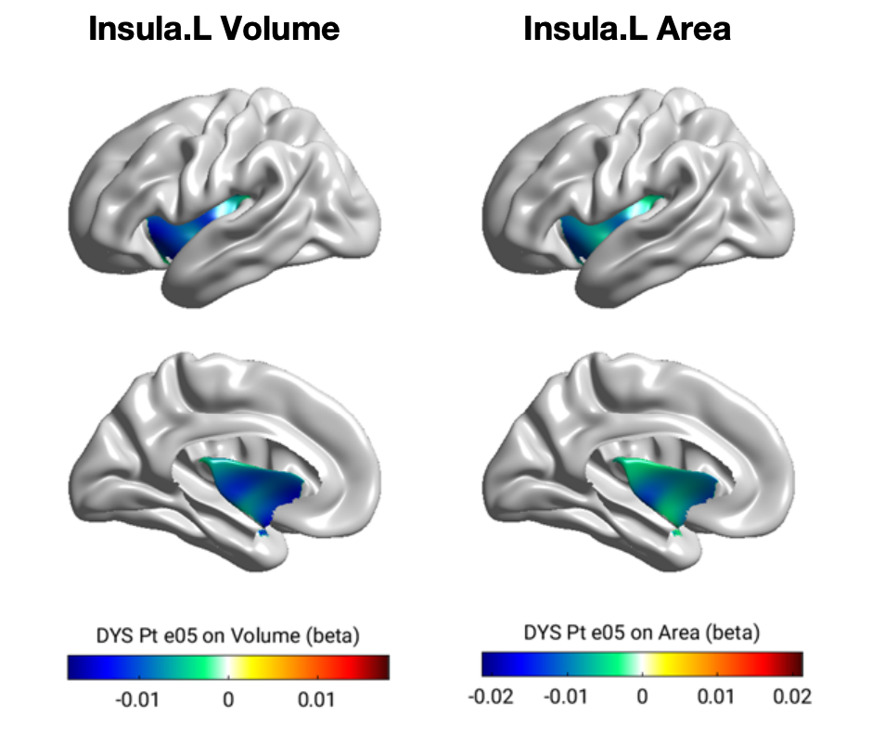
Supplementary Figure 4. Residual binned scatter plot of the metrics of the left insula and phonological memory and reading ability. A: The correlation between the left insula and digit span task in the UKB dataset. B: The correlation between the left insula and the word reading task in the GS dataset.
