Table S1: Accuracy and RT in Different Conditions
 | TI |  | Sham
 | Pre-test | Post-test | Pre-test | Post-test
RT: Low memory load | 708±36ms | 640±27ms | 679±29ms | 628±26ms
RT: High memory load | 1196±69ms | 1064±60ms | 1063±56ms | 1030±60ms
ACC: Low memory load | 95.96±0.01 | 95.76±0.01 | 93.16±0.02 | 91.76±0.02
ACC: High memory load | 68.12±0.02 | 68.52±0.02 | 66.60±0.02 | 66.40±0.02

Table S2: Brain Activation In High Memory Load
Region | Cluster size | Peak Z value | Peak MNI coordinates
Encoding TI:Pre-test
L:MOG,SPG,IPL,FFG,PoCG,IOG,PreCG,SFG,PCUN,MTG,ROL | 2507 | 6.59 | -27,-85,14
R:SPG,MOG,FFG,PoCG,SOG,SFG,IOG,PreCG,IPL,ITG,LING,MFG,CAL | 2814 | 6.58 | 21,-70,56
PCL,SMA,PoCG,PreCG,ORB,PCUN.L | 632 | 5.03 | -12,-25,77
R:IFGOperc,PreCG | 136 | 4.74 | 54,11,32
L:PUT,CAU,PAL | 79 | 4.15 | -21,-1,11
R:MFG,SFG | 119 | 3.86 | 42,50,23
Encoding TI:Post-test
L:MOG,SPG,IPL,PoCG,PreCG,IOG,SFG,SOG,PCUN,MTG,  SMA,CAL | 2775 | 6.79 | -21,-94,-1
R:SPG,MOG,FFG,PoCG,SOG,SFG,IPL,  IOG,PCUN,ITG,MFG,LING,MFG,  IFGtriang | 2695 | 6.72 | 30,-55,53
Encoding Sham:Pre-test
R:SPG,MOG,FFG,SFG,SOG,PoCG,ITG,  IPL,IOG,PreCG,LING,PCUN,CAL,ANG | 2483 | 6.69 | 21,-91,-7
L:MOG,SPG,IPL,IOG,SFG,SOG,PCUN,  PoCG,LING | 1692 | 6.42 | -24,-52,50
R:PreCG,IFGOper | 114 | 5.44 | 51,8,32
R:PUT,PAL,THA | 83 | 5.04 | 24,5,2
L:PreCG,IFGOper | 104 | 4.98 | -48,5,32
L:PUT,CAU,PAL | 112 | 4.98 | -24,5,5
L:SFG,PreCG,MFG | 217 | 4.90 | -21,-4,53
L:PCL,PCUN,SMA | 113 | 4.36 | -9,-31,74
Encoding Sham:Post-test
L:MOG,SPG,IPL,IOG,FFG,SOG,LING,  CAL,PCUN,PoCG | 1539 | 6.31 | -21,-88,-13
R:SPG,MOG,FFG,SOG,IOG,PoCG,LING,IPL,ITG,CAL,PCUN,SMG,ANG | 1663 | 6.21 | 18,-91,-7
L:SFG,MFG,PoCG,IFGOper | 285 | 5.18 | -45,2,32
R:SFG,MFG,PreCG | 209 | 4.52 | 27,-1,50
Retention TI:Pre-test
SFGmed.L,ORBmid,ACC | 355 | 6.00 | 0,50,-10
PCUN,LING,PCG,DCG | 279 | 5.32 | -9,-52,17
L:PreCG,SMA,SFG,PoCG,PCL | 377 | 5.30 | -6,-10,59
L:ANG,MOG,MTG,IPL | 167 | 4.76 | -45,-73,29
R:TMG,TPOmid,STG,ITG | 98 | 4.64 | 60,-4,-19
Retention TI:Post-test
ORBmid,SFGmed,ACG | 228 | 5.17 | 0,53,-7
SMA,PCL.L,PreCG.L | 237 | 4.73 | -6,-4,59
PoCG.L,SFG.L | 171 | 4.65 | -33,-13,59
Retention Sham:Pre-test
SMA,PreCG,PoCG,SFG,DCG,MFG | 1861 | 5.74 | -30,-25,62
ORBmid,ACG,SFGmed,OLF | 280 | 5.06 | 0,56,-7
L:ANG,MOG,MTG,IPL | 86 | 4.06 | -48,-73,32
Retention Sham:Post-test
SMA,SFG,PreCG,PoCG,DCG,PCL | 1243 | 5.95 | -15,-1,65
R:PreCG,PoCG | 144 | 3.54 | 42,-25,68
Retrieval TI:Pre-test
PoCG,IPL,SPG,PreCG,SMA,INS.L,  PCUN,ROL,MOG,SFG,DCG,SMG,SOG,PUT.L | 6172 | 6.89 | -45,-31,50
R:MFG,SFG,IFGtriang | 384 | 5.75 | 45,41,29
R:FFG,ITG,IOG | 451 | 5.56 | 30,-46,-25
R:IFGtriang,INS,PUT,ROL | 93 | 4.94 | -30,56,14
R:SFG,MFG | 174 | 4.38 | 27,8,59
Retrieval TI:Post-test
SMA,SFGmed,L:IPL,PreCG,INS,ROL,  SMG,DCG,PUT,THA | 4922 | 7.53 | -51,-28,47
R:PoCG,SPG,MOG,IPL,IFGOper,PCUN,  INS,SMG,SOG,PreCG,ANG,ROL | 2827 | 7.25 | 33,-40,41
R:FFG,LING,CAL,MTG | 671 | 5.39 | 54,-52,-10
R:SFG,MFG | 254 | 5.06 | 27,5,53
L:LING,FFG,CAL,MOG,PCUN | 196 | 4.34 | -24,-61,2
Retrieval Sham:Pre-test
R:SPG,MOG,IPL,PCUN,PoCG,SOG,  ANG,SMG,CAL | 1772 | 7.05 | 27,-64,41
L:PoCG,IPL,SPG,PreCG,INS,ROL,MOG,PCUN,SMG,PUT,SOG | 2391 | 6.03 | -42,-31,41
R:FFG,ITG,LING | 229 | 5.28 | 30,-64,-10
R:INS,IFGOper,ROL,PreCG,IFGtriang,  PUT | 419 | 5.15 | 30,26,-1
R:SFG,MFG | 146 | 4.58 | 33,8,65
SFGmed,DCG | 259 | 4.58 | 3,29,41
MFG.R,SFG | 125 | 4.50 | 48,38,29
Retrieval Sham:Post-test
R:SPG,PoCG,MOG,IPL,PCUN,SOG,  SMG,ANG,CUN | 1713 | 6.87 | 39,-37,41
L:PoCG,IPL,SPG,MOG,ROL,PreCG,  PCUN,PUT,INS,SOG | 2338 | 6.59 | -36,-46,38
R:IFGOper,PreCG,IFGtriang | 138 | 4.88 | 51,11,32
SFGmed,DCG,SMA.L | 259 | 4.38 | 0,23,47
FFG.R,LING.R | 187 | 4.23 | 27,-49,-13
R:SFG,MFG | 111 | 4.05 | 30,11,56
L:SFG,MFG | 168 | 3.91 | -24,-7,74

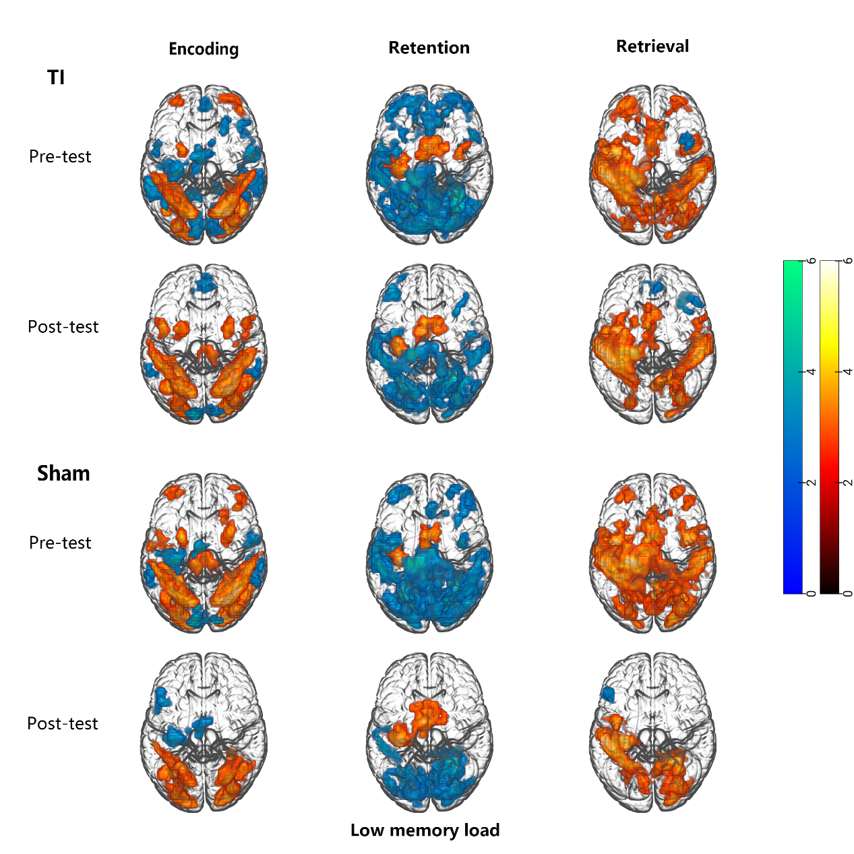
Figure S1. Activation patterns in low memory load tasks.
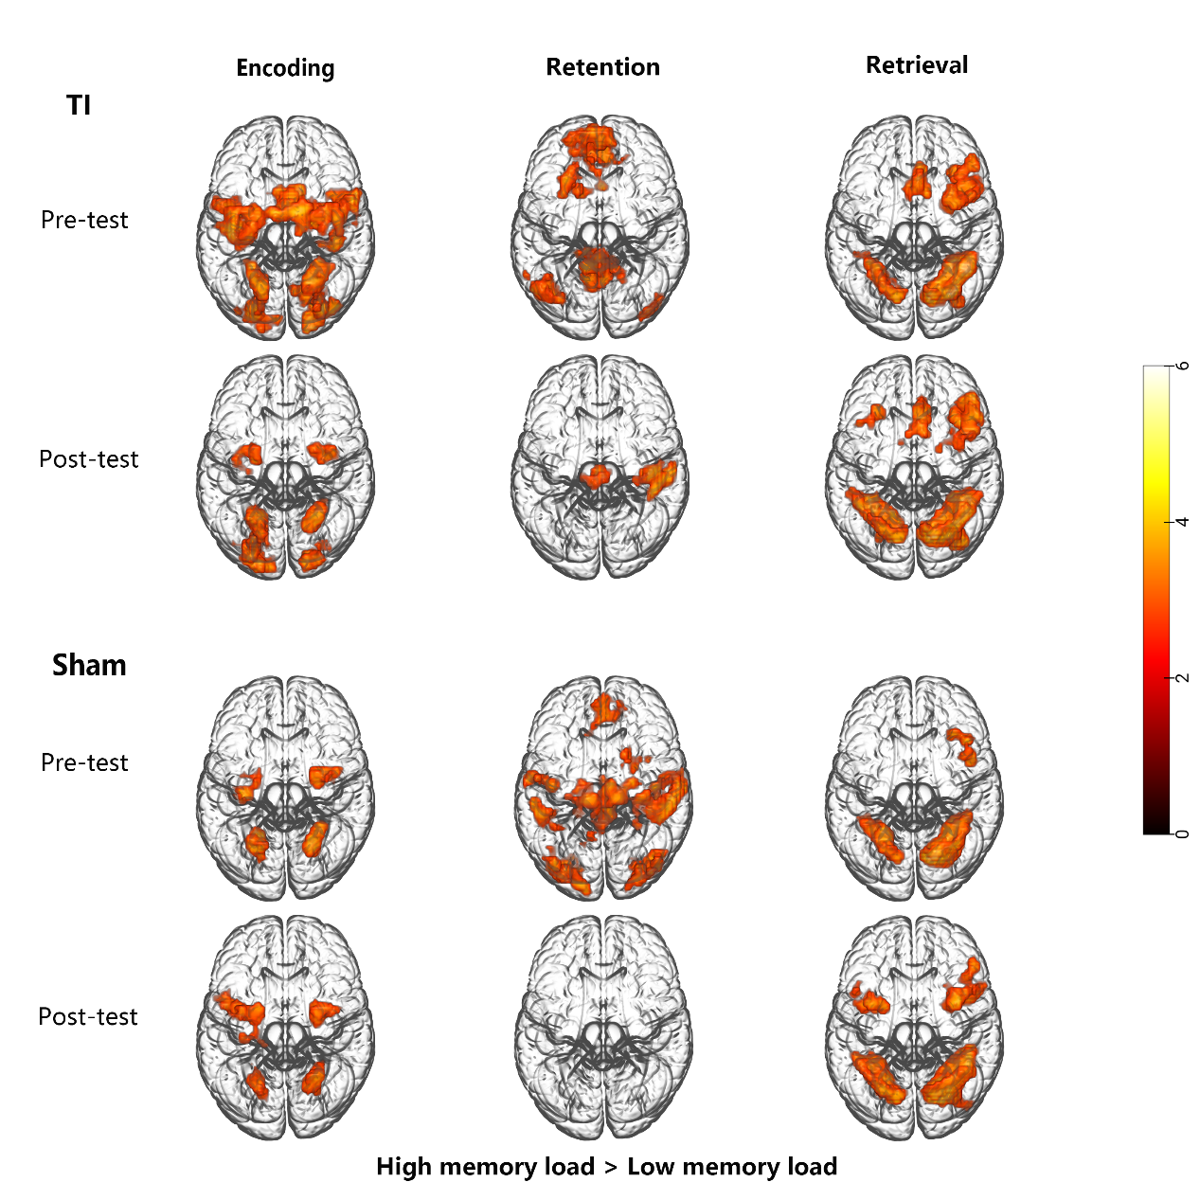
Figure S2. High memory load recruited greater activation in the working memory network compared to low memory load, while concurrently suppressing the DMN.

