Table S1: Composition of wood and bark samples, used in this study, determined by GC/MS analyses. Compounds of each class are listed in ascending order of retention time.
Class | Compound | SOW | SOB | MTW | MTB
Alchools | Glycerol |  |  | X | X
Alchools | 1-Hexadecanol |  | X
Alchools | cis-9, 1-Tetradecenol |  | X
Alchools | Octacosanol |  | X |  | X
Alkenes | 3-Tetradecene |  | X
Alkenes | 3-Octadecene |  | X
Alkenes | 3-Eicosene |  | X
Sugar derivatives | Hydroxymethylfurfural |  |  |  | X
Sugar derivatives | L-Lyxose |  | X
Sugar derivatives | 1,6-anhydro-  β-D-Glucopyranose |  | X |  | X
Fatty acids | Caproic acid |  |  |  | X
Fatty acids | Enanthic acid |  |  |  | X
Fatty acids | Capric acid |  |  |  | X
Fatty acids | Azelaic acid |  |  |  | X
Fatty acids | Myristic acid |  |  |  | X
Fatty acids | Pentadecanoic acid |  |  | X | X
Fatty acids | Palmitic acid |  | X | X | X
Fatty acids | Margaric Acid |  |  | X | X
Fatty acids | Linoleic Acid | X | X | X | X
Fatty acids | Oleic Acid | X | X | X | X
Fatty acids | Stearic Acid | X | X | X | X
Fatty acids | Arachidic acid |  |  | X | X
Fatty acids | Behenic acid |  |  | X | X
Fatty acids | Erucic acid |  | X
Fatty acids | Lignoceric acid |  |  | X | X
Sterols | 3β-4,6-Cholestadienol |  | X
Sterols | β-Sitosterol |  | X | X | X
Sterols | Lanosterol |  |  | X | X
Sterols | Cholest-4-en-3-ol | X | X | X | X
Sterols | Lanosterol acetate |  |  |  | X
Sterols | Campesterol |  |  | X
Phenolic compounds | Resorcinol |  |  | X | X
Phenolic compounds | Syringol |  |  |  | X
Phenolic compounds | Hydroquinone |  |  | X
Phenolic compounds | Catechol |  |  | X | X
Phenolic compounds | p-Salicylic acid |  |  | X | X
Phenolic compounds | 3,4-Dimethoxyphenol |  |  |  | X
Phenolic compounds | o-Xylorcinol |  |  | X
Phenolic compounds | Protocatechualdehyde |  |  | X
Phenolic compounds | Antiarol |  |  | X | X
Phenolic compounds | β-Resorcylaldehyde |  |  | X
Phenolic compounds | Coniferyl alcohol |  |  |  | X
Phenolic compounds | 2,4-Dihydroxybenzaldehyde |  |  | X
Phenolic compounds | Hexylresorcinol |  |  | X
Phenolic compounds | Tyrosine |  |  | X
Phenolic compounds | Oxyresveratrol |  |  | X
Phenolic compounds | Benzyl alcohol |  |  | X
Vitamins | δ-Tocopherol |  |  |  | X
Vitamins | γ-Tocopherol |  |  |  | X
Vitamins | α-Tocopherol |  |  |  | X
Coumarins | Umbelliferone |  |  | X | X
Coumarins | Methyl ostruthin |  |  |  | X
Coumarins | Ostruthin |  |  |  | X
Coumarins | Daphnetin |  |  | X
Coumarins | Scopoletin |  |  | X | X
Coumarins | Esculetin |  |  | X | X
Terpenes | Dehydroabietic acid |  |  | X | X
Terpenes | Sesquirosefuran |  |  |  | X
Terpenes | β-Amyrone |  | X | X | X
Terpenes | 24-Norursa-3,12-diene |  | X
Terpenes | Lupeol |  | X
Terpenes | β-Amyrin |  | X | X | X
Terpenes | Glutinol |  | X
Terpenes | Copalol |  | X
Terpenes | Simiarenol |  | X
Terpenes | Humulenol-II |  | X
Others | Benzaldehyde |  | X
Others | Benzaldehyde diethylacetal |  | X
Others | δ-Cyclogeraniolene |  |  | X | X
Others | Fumaric acid |  |  |  | X

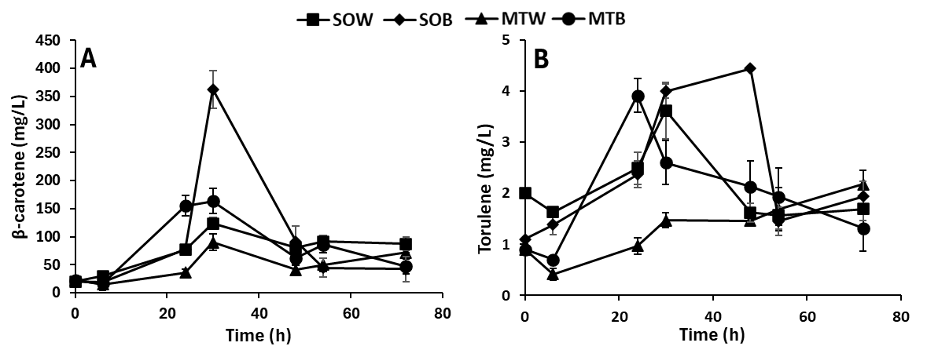
Figure S1: Development of (A) β-carotene and (B) torulene production by R. toruloides from SOW, SOB, MTW, and MTB hydrolysates. Values are the means ± SD of three independent experiments.

