APPENDIX B
Systematic Literature Review: Included Studies

B.1 Complete Reference List
This appendix presents the complete reference list of all 68 peer-reviewed journal articles included in the systematic literature review. Studies are listed alphabetically by first author and include main bibliographic details. All included studies met the eligibility criteria specified in Appendix A and underwent full-text assessment for relevance to regenerative urban design.
The original extracted data subject to analysis for each publication can be found at https://doi.org/10.5281/zenodo.17682966
Table B1. Complete list of included studies (n=68)
Author(s) | Year | Title | Journal | Publisher
Agboola et al | 2023 | Built environment transformation in Nigeria: the effects of a regenerative framework | Journal of Asian Architecture and Building Engineering | Taylor & Francis
Ahmed | 2023 | Re-Exploring Vernacular Architecture from the Lens of Regenerative Thinking: a Case Study Gharb Sohail Village in Egypt | Journal of Sustainable Architecture and Civil Engineering | Kaunas University of Technology
Ahmed | 2023 | Developing a tailored tool to assess regenerative development and design within the built environment | Journal of Green Building | Allen Press
Attia | 2016 | Towards regenerative and positive impact architecture: A comparison of two net zero energy buildings | Sustainable Cities and Society | Elsevier
Axinte et al | 2019 | Regenerative city-regions: a new conceptual framework | Regional Studies, Regional Science | Taylor & Francis
Baper et al | 2020 | Towards Regenerative Architecture: Material Effectiveness | International Journal of Technology | Universitas Indonesia
Benites and Osmond | 2021 | Bioconnections as Enablers of Regenerative Circularity for the Built Environment | Urban Planning | Cogitatio Press
Benne and Mang | 2015 | Working regeneratively across scales—insights from nature applied to the built environment | Journal of Cleaner Production | Elsevier
Benyus et al | 2022 | Ecological performance standards for regenerative urban design | Sustainability Science | Springer Nature
Blanco et al | 2022 | Towards regenerative neighbourhoods: An international survey on urban strategies promoting the production of ecosystem services | Sustainable Cities and Society | Elsevier
Blanco et al | 2021 | Urban Ecosystem-Level Biomimicry and Regenerative Design: Linking Ecosystem Functioning and Urban Built Environments | Sustainability | MDPI
Camrass | 2022 | Urban regenerative thinking and practice: a systematic literature review | Building Research & Information | Routledge
Cianchi et al | 2023 | The efficacy of biodiversity and ecosystem assessment approaches for informing a regenerative approach to built development | Integrated Environmental Assessment and Management | Wiley Periodicals
Cole | 2012 | Transitioning from green to regenerative design | Building Research & Information | Routledge
Conte and Monno | 2016 | The Regenerative Approach to Model an Integrated Urban-Building Evaluation Method | International Journal of Sustainable Built Environment | Elsevier
Craft et al | 2021 | Developing a Decision-Making Framework for Regenerative Precinct Development | Sustainability | MDPI
Craft et al | 2022 | Understanding decision-making in regenerative precinct developments | Journal of Cleaner Production | Elsevier
Crowley et al | 2021 | Towards a necessary regenerative urban planning: Insights from community-led initiatives for ecocity transformation | CIDADES, Comunidades e Territórios | ISCTE, Instituto Universitário de Lisboa
Delpy et al | 2021 | Ecosystem Services Assessment Tools for Regenerative Urban Design in Oceania | Sustainability | MDPI
Du Plessis and Brandon | 2015 | An ecological worldview as basis for a regenerative sustainability paradigm for the built environment | Journal of Cleaner Production | Elsevier
Du Plessis and Cole | 2011 | Motivating Change - Shifting the Paradigm | Building Research & Information | Routledge
East | 2020 | The transition from sustainable to regenerative development | Ecocycles | European Ecocycles Society
Fahmy et al | 2019 | Regenerative Architecture as a Paradigm for Enhancing the Urban Environment | Port-Said Engineering Research Journal | Faculty of Engineering - Port Said University
Farouk Hassan et al | 2022 | Regenerative urban heritage model: Scoping review of paradigms’ progression | Ain Shams Engineering Journal | Ain Shams University; Elsevier
Forsberg and De Souza | 2021 | Implementing Regenerative Standards in Politically Green Nordic Social Welfare States: Can Sweden Adopt the Living Building Challenge? | Sustainability | MDPI
Gasperin et al | 2021 | Strategic Planning of Resilient and Regenerative Cities: A Case Study on How New Generations May Contribute | Journal on Innovation and Sustainability | RISUS
Gibbons et al | 2018 | Regenerative Development as an Integrative Paradigm and Methodology for Landscape Sustainability | Sustainability | MDPI
Gibbons et al | 2020 | The development, application, and refinement of a Regenerative Development Evaluation Tool and indicators | Ecological Indicators | Elsevier
Girard | 2014 | The regenerative city and wealth creation/conservation: the role of urban planning | International Journal Global Environmental Issues | Inderscience Enterprises Ltd.
Gou and Xie | 2017 | Evolving green building: triple bottom line or regenerative design? | Journal of Cleaner Production | Elsevier
Haselsteiner et al | 2021 | Drivers and Barriers Leading to a Successful Paradigm Shift toward Regenerative Neighborhoods | Sustainability | MDPI
He and Reith | 2022 | (Re)Defining Restorative and Regenerative Urban Design and Their Relation to UNSDGs—A Systematic Review | Sustainability | MDPI
Hes et al | 2018 | Evaluating the Practice and Outcomes of Applying Regenerative Development to a Large-Scale Project in Victoria, Australia | Sustainability | MDPI
Horemans | 2023 | Gestures for interdependence: Expanding regenerative design through spatial dramaturgies for the unseen, the unheard, and the unfelt | Journal of Chinese Architecture and Urbanism | AccScience Publishing
Horn and Proksch | 2022 | Symbiotic and Regenerative Sustainability Frameworks: Moving Towards Circular City Implementation | Frontiers in Built Environment | Frontiers
Ibrahim and Ahmed | 2022 | Investigating Regenerative Ideation within Sustainable Development Goals | Sustainability | MDPI
Javanmard and Nava | 2024 | Regenerative architecture in Practice: A multifaceted exploration of cladding systems to meet LEED standards | Energy & Buildings | Elsevier
Kamrowska-Zaluska and Obracht-Prondzyńska | 2018 | The Use of Big Data in Regenerative Planning | Sustainability | MDPI
Lewin | 2013 | Regenerative Urban Community Design | Journal of Green building | Allen Press
Lucchi | 2023 | Regenerative Design of Archaeological Sites: A Pedagogical Approach to Boost Environmental Sustainability and Social Engagement | Sustainability | MDPI
Mang and Reed | 2012 | Designing from place: a regenerative framework and methodology | Building Research & Information | Taylor & Francis
Morseletto | 2020 | Restorative and regenerative: Exploring the concepts in the circular economy | Journal of Industrial Ecology | Wiley Periodicals
Naboni et al | 2019 | A digital workflow to quantify regenerative urban design in the context of a changing climate | Renewable and Sustainable Energy Reviews | Elsevier
Pavez et al | 2024 | Towards a Regenerative Design Project Delivery Workflow: A Critical Review | Sustainability | MDPI
Pedersen Zari | 2015 | Ecosystem services analysis: Mimicking ecosystem services for regenerative urban design | International Journal of Sustainable Built Environment | Elsevier
Pedersen Zari | 2009 | An architectural love of the living: bio-inspired design in the pursuit of ecological regeneration and psychological wellbeing | Sustainable Development and Planning | WIT press
Pedersen Zari | 2012 | Ecosystem Services Analysis for the Design of Regenerative Built Environments | Building Research & Information | Routledge
Pedersen Zari and Hecht | 2020 | Biomimicry for Regenerative Built Environments: Mapping Design Strategies for Producing Ecosystem Services | Biomimetics | MDPI
Peponi and Morgado | 2020 | Smart and Regenerative Urban Growth: A Literature Network Analysis | International Journal of Environmental Research and Public Health
Peponi and Morgado | 2021 | Transition to Smart and Regenerative Urban Places (SRUP): Contributions to a New Conceptual Framework | Land | MDPI
Petrovski et al | 2021 | Implementing Regenerative Design Principles: A Refurbishment Case Study of the First Regenerative Building in Spain | Sustainability | MDPI
Plaut et al | 2016 | Regenerative Development through LENSES with a case study of Seacombe West | Environment Design Guide (EDG) | Australian Institute of Architects
Plaves et al | 2024 | Regenerative design: Research, practice, and implementation in the built environment | Proceedings of the Institution of Civil Engineers: Urban Design and Planning | Emerald Publishing
Quintero et al | 2021 | Sustainability Assessment of the Anthropogenic System in Panama City: Application of Biomimetic Strategies towards Regenerative Cities | Biomimetics | MDPI
Rahman et al | 2024 | Regenerating Place: Highlighting the Role of Ecological Knowledge | Organization & Environment | Sage
Roggema and Junco | 2024 | Reconciling the Mismatch: Creating a Regenerative Framework for Regional Planning | Land | MDPI
Sala Benites et al | 2023 | Inquiry on Perceptions and Practices of Built Environment Professionals Regarding Regenerative and Circular Approaches | Buildings | MDPI
Sala Benites et al | 2023 | A neighbourhood-scale conceptual model towards regenerative circularity for the built environment | Sustainable Development | Wiley
Sala Benites et al | 2023 | A Future-Proof Built Environment through Regenerative and Circular Lenses—Delphi Approach for Criteria Selection | Sustainability | MDPI
Schurig and Turan | 2021 | The concept of a ‘regenerative city’: How to turn cities into regenerative systems | Journal of Urban Regeneration and Renewal | Henry Stewart Publications
Smithwick et al | 2023 | Regenerative landscape design: an integrative framework to enhance sustainability planning | Ecology and Society | Resilience Alliance
Thomson and Newman | 2018 | Urban fabrics and urban metabolism – from sustainable to regenerative cities | Resources, Conservation and Recycling | Elsevier
Thomson and Newman | 2020 | Cities and the Anthropocene: Urban governance for the new era of regenerative cities | Urban Studies | Sage
Thomson and Newman | 2016 | Geoengineering in the Anthropocene through Regenerative Urbanism | Geosciences | MDPI
Thomson et al | 2022 | Nature-Positive Design and Development: A Case Study on Regenerating Black Cockatoo Habitat in Urban Developments in Perth, Australia | Urban Science | MDPI
Toner et al | 2023 | Integrating Ecological Knowledge into Regenerative Design: A Rapid Practice Review | Sustainability | MDPI
Williams and Williams | 2019 | Values-Based Architecture as a Regenerative Approach to the Human-Environment Relationship | International Journal of Design & Nature and Ecodynamics | WIT press
Ziervogel et al | 2016 | Moving from Adaptive to Transformative Capacity: Building Foundations for Inclusive, Thriving, and Regenerative Urban Settlements | Sustainability | MDPI
_______________
Note: All studies listed were published between 2007-2024 and retrieved from Web of Science and Scopus databases. Complete search methodology and PRISMA flow diagram are provided in Appendix A. Studies are ordered alphabetically by the surname of the first author.

B.2 Main Statistical Findings
There is a trend of increasing publications on regenerative urban design between 2009 and 2024, with peaks in 2012 (3 publications), 2016 (5) and 2021 (12) (Figure B1). 2012 marked the first year that the Building Research & Information (BRI) journal published a specific issue with research articles on Regenerative design and development. The BRI journal of Routledge with five publications is only second to MDPI´s Sustainability journal with more than tree times more publications, having published most on the topic (17) (Figure B2). MDPI (24), Elsevier (12) and the Taylor&Francis group, including Routledge (7), are the leading publishers based on the number of publications from the 68 articles reviewed (Figure B3). Most of the research within the collection originates from authors in Australia (17) and the USA (8) (Figure B4). This signifies where the scientific discourse is geographically most represented. As for the dominant journals, publishers and geographical locations, this information is an opportunity for researchers and practitioners to directly engage with the academic discourse where it is most present. At the same time, this displays potential bias and specific cultural context within the literature that might not accurately represent other global contexts, perspectives and disciplines in relation to regenerative urban design. Interestingly, most acknowledged funding came from national programs (12), the university (11) or European union programs (6)(Figure B5). Moreover, 22% of the reviewed publications (15 of 68) proposed an original definition for regenerative urban design, while the remainder drew upon 97 distinct sources (Figure B6).

Figure B1. Number of publications between 2009 and 2024
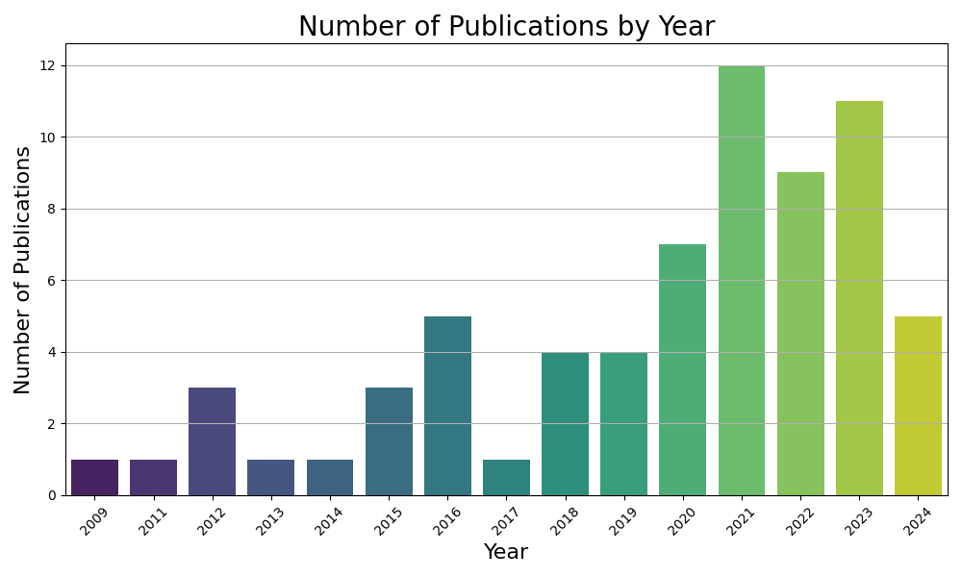
Figure B2. Journals by number of publications between 2009 and 2024
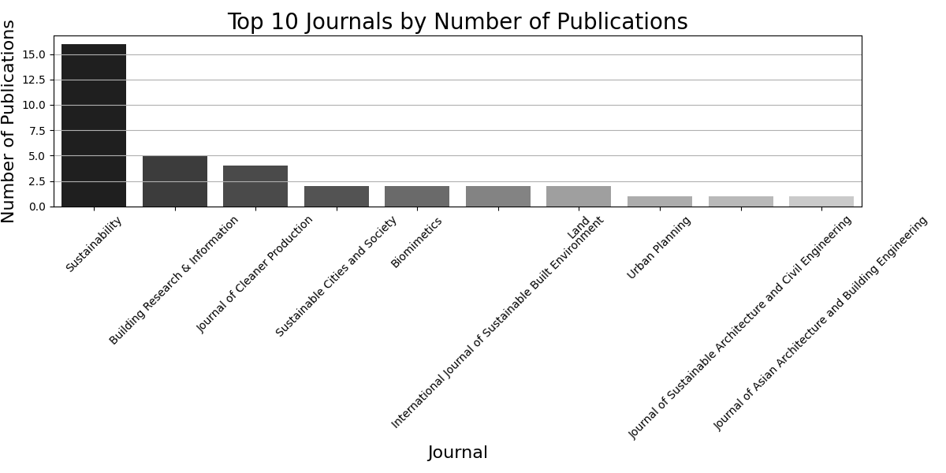

Figure B3. Publishers by number of publications between 2009 and 2024
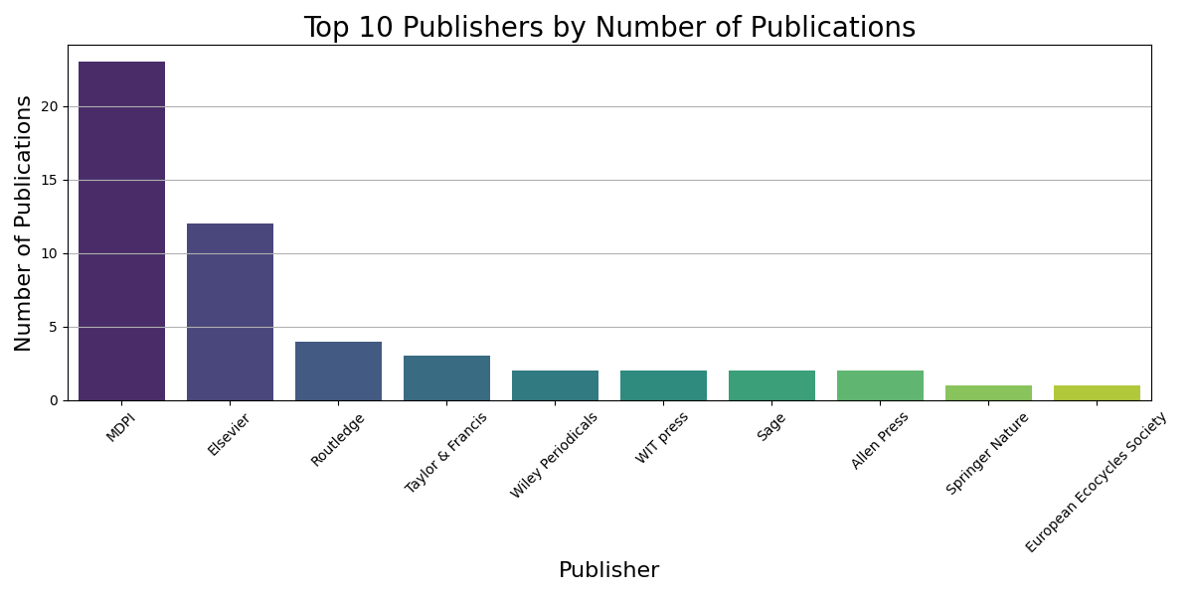
Figure B4. Country associated to lead author´s university affiliation by number of publications between 2009 and 2024
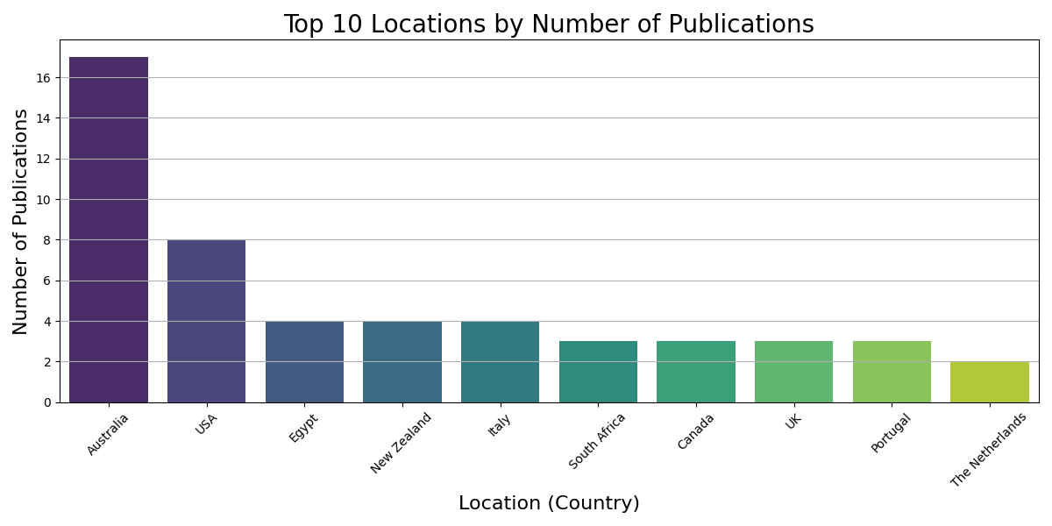
Figure B5. Funding types acknowledged by number of publications between 2009 and 2024

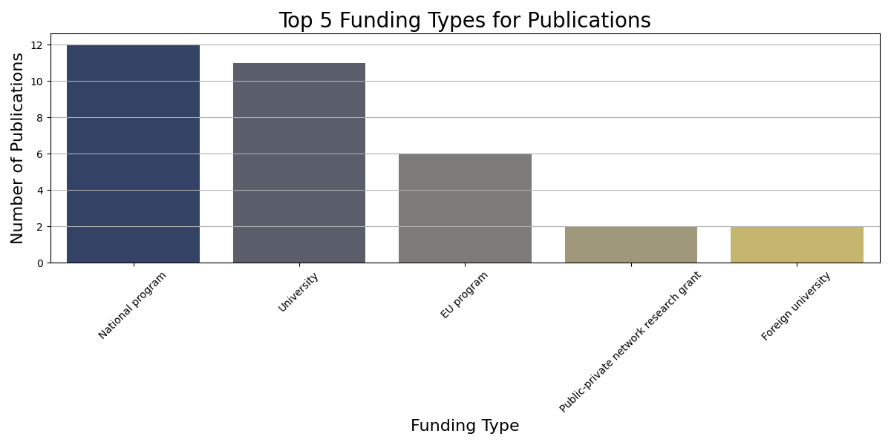

Figure B6. 98 distinct sources used for the definition of regenerative urban design
List of all unique cited authors
for regenerative urban design definition
from reviewed publications (n=68) in alphabetical order
Agyeman et al (2003)
Attia (2018)
Baper (2013)
Benne and Mang (2015)
Benyus (1997)
Berawi (2017)
Bergquist et al (2019)
Blanco et al. (2021)
Bonyad et al (2018)
Brown (2012)
Brown (2016)
Brown et al (2018)
Camrass (2020)
Camrass (2021)
Clegg (2012)
Cohen (2006)
Cole (2012)a
Cole (2012)b
Cole (2015)
Cole and Fedoruk (2014)
Cole et al (2013)
Craft et al (2021)
De Botton (2008)
De Wolf (2024)
Du Plessis (2012)
Du Plessis (2022)
Du Plessis and Brandon (2015)
Eisenberg and Reed (2003)
Ellen MacArthur Foundation (2013)
El-Sayed and Cloutier (2022)
Evans and Jones (2008)
Ferreira (2008)
Fleming (2013)
Foissac et al (2023)
Forsberg and De Souza (2021)
Gibbons (2020)
Gibbons et al (2018)
Girardet (1999)
Girardet (2010)
Girardet (2015)
Grose (2014)
Haggard (2002)
Haselsteiner et al (2021)
Hes and Du Plessis (2014 & 2015)
Hillman (2006)
Hoxie (2012)
International Council on Monuments and Sites (ICOMOS) (2011)
Jenkin and Zari (2009)
Kellert et al (2008)
Krone (1992)
Littman (2009)
Lyle (1994&1996)
Lyle (1999)
Mang and Haggard (2016)
Mang and Reed (2011)
Mang and Reed (2012)
Mang and Reed (2013)
Mang and Reed (2015)
Mang and Reed (2020)
Manson (2016)
Milani (2000)
Morseletto (2020)
Muñoz and Branzei (2021)
Naboni et al (2019)
Nagle et al (2024)
Newman (2020)
Own Definition
Pawlyn (2011)
Pedersen Zari & Jenkin (2010)
Pedersen Zari (2009)
Pedersen Zari (2012)
Pedersen Zari (2018)
Peretti et al (2019)
Plaut et al (2017)
Pyke (2011)
Rahman et al (2020)
Reed (2007)
Reed and Haggard (2020)
Renger et al (2015)
Robinson and Cole (2015)
Russel (2013)
Sala Benites et al (2023)
Sanford (2011)
Senge (2010)
Sertyesilisik (2017)
Sonetti et al (2019)
Steiner et al (2013)
Taleb (2012)
Thomson (2018)
Thomson et al (2016)
Tiber et al (2023)
Van der Ryn (1996)
Van der Ryn and Cowan (2007)
Vyas and Slaughter (2009)
Wahl (2016)
Waldron et al (2013)
World Future Council (2013)
Zhang et al (2015)
Total 98

